**SIMULACIONES**

**Workflow Documentation**

**December/2018**

**Angelo Breda**

Contents

INSTALLATION 2

MODEL MANAGEMENT WITH *SIMULACIONES* INTERFACE 3

Starting A Project 3

Editing Grid Domain 4

Setting Routing/Conduction Parameters 5

Set Parameters For Groups Of Cells 6

Set Parameters For Single Cells 7

Embankments 8

Culverts 8

Monitoring Link 9

Rainfall Data 9

Water Depth 11

Initial Condition 12

Running Set Up 12

Generating Model Input Files 13

INPUT FILES 14

vincul.dat 15

param.dat 16

anpanta.dat 19

contab.dat 19

contar.dat 19

gase.dat 20

gener.dat 20

h1h2.dat 20

hrugosi.dat 21

inicial.dat 21

lluvia.dat 21

OUTPUT FILES 23

last_state.txt 23

depths_*****.txt 23

veloc_*****.txt and flows_*****.txt 23

# INSTALLATION

To make *Simulaciones* work in Windows 10 follow the steps below:

1. Copy *Simulaciones* files to your computer. Let say C:\Simulaciones\
2. Go to https://www.ocxme.com/ to search and download the files listed below:

* comctl32.ocx
* comdlg32.ocx
* mschrt20.ocx
* msflxgrd.ocx

1. Copy all these files to:

* C:\Windows\System32
* C:\Windows\SysWOW64

1. Open a prompt command window as administrator and type the following command for each file name in step 2 (do not type the “” characters):

* regsvr32 “file.ocx”

1. Run *Simulaciones* executable (should work!)

Note: Your system must use the “.” (dot) as decimal separator.

# MODEL MANAGEMENT WITH *SIMULACIONES* INTERFACE

The program Simulaciones is an interface to prepare all inputs necessary to run the hydrodynamic model. There are many options to deal with the grid domain, cell’s information, types and series of input data. This main section will guide you through the main steps to create a simulation using rainfall and water levels data; a domain with both land and river type cells; parameters specialisation and; some structures.

## Starting A Project

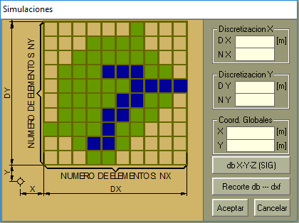The best way to start a new project is to have at hand a Digital Elevation Model in an ASCII like file. The image in Figure 2 shows a DEM file example.

The first line has two values, the longitudinal (coordinate *x*) length of cells, $∆x$, and the latitudinal (coordinate *y*) width of cells, $∆y$. In the example of Figure 2 each cell of the grid is 20 m long and 20 m wide ( $∆x$ = 20; $∆y$ = 20).

From the second line on, it follows the 3D coordinates, (*x*, *y*, *z*), of each cell in the grid. One must observe that *x* and *y* coordinates are related to the central point of the cell.

Figure 1 – DEM loading screen

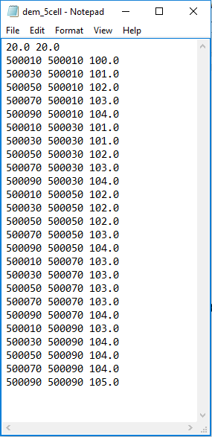Once the DEM file is ready, the next step is to load it on *Simulaciones* (See). Thus, do as it follows:

1. Open *Simulaciones*;
2. Go to Dominio > Configurar;
3. The screen of Figure 1 must open to you. Click in the button db Z-Y-Z (SIG);
4. Search on your computer for the DEM file and load it;
5. Click in Aceptar.

Probably you have ended up with a large green area on *Simulaciones* interface. Let colour it due to elevation.

1. Go to Visualización, Entorno;
2. Click in the circle to set MDT. I recommend to set on Borde ELEM as well;
3. Click in Aplicar. You probably must see a better map after it (like Figure 3);
4. Click in Descargar to close the visualisation setup screen.

Now save your project! At Archivo go to Guardar. In the file explorer select a folder and define a name to your project. **Do not forget** to add the extension *.hid* to the file name.

Figure 2 – DEM file for a 5x5 cell grid

## Editing Grid Domain

Cells in *Simulaciones* can be turned off/on or have its type changed from land to river and *vice versa*.

If some cells are not necessary in the simulation (out of watershed limit, for example), it is a good idea to remove them from the domain to avoid unnecessary computational work. To do so:

1. Go to Definir > Elementos > Valle > Individual;
2. Click in the cells that you want to remove or re-include in the domain. The removed cell will become transparent;
3. After changes done, go to Definir > Elementos > Valle > Detener;

When a DEM file is loaded to initialise a project, all cells in the domain are set as terrain type by default. To change some cells to river type you must:

1. Go to Definir > Elementos > Rio;
2. Select those cells that will have their type changed to river. Remember that only top, bottom, left and right cells are considered as adjacent cells, thus cells in the diagonal never have a link. This is important when drawing a stream.
3. After changes done, go to Definir > Elementos > Detener;

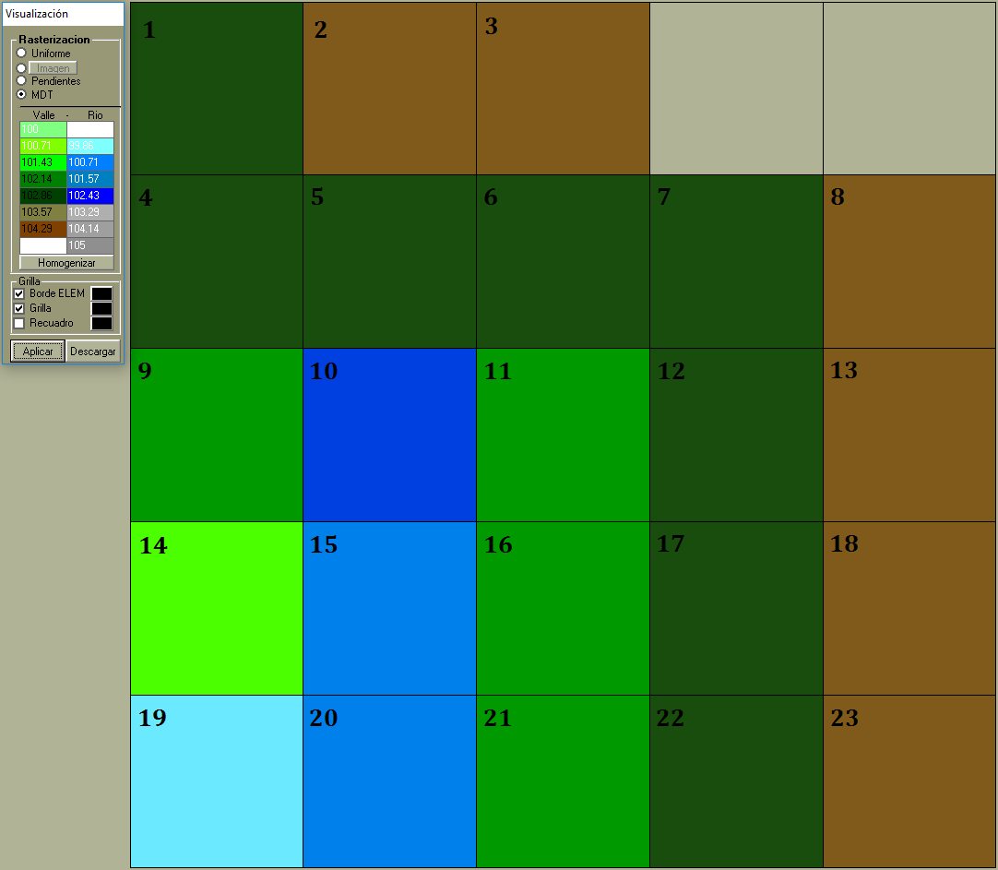

Figure 3 – Cell’s grid map. Among the 23 active cells, blueish cells are river type and other are land type. Transparent cells in the top left are deactivated cells (will not be processed).

If you have drawn a stream but want to change back some to land type again, just do the same procedure, now clicking on river cells so they switch to land type.

In Figure 3 one can see the cells’ map from the 5x5 example grid. The visualisation was changed to better distinguish river from land cells. In this picture, the cell’s number was drawn in the corner of each active cell. Thus, in this example, the simulation will run over 23 cells, of which 4 are river type (cells 10, 15, 19 and 20).

## Setting Routing/Conduction Parameters

The hydrodynamic model demands many parameters, some cell-related, some link-related. Anyway, some few parameters need to be defined for the entire domain. Others may have a default value, but that needed to be changed for some cells.

One group of parameters that needed to be defined domain-wide are the land-phase routing/conduction ones. To define their values go to Características > de la Conduccíon. The screen of Figure 4 will show up.

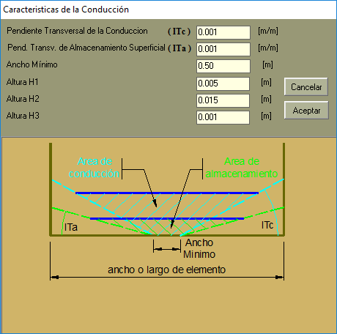As one can see there are six parameters to be defined here:

Figure 4 – Land-phase Routing/Conduction parameters screen

* The first parameter (*Pendiente Transversal de la Conduccion*) is the lateral slope used when the model computes flow velocity between cells ($ls_{C}$). Its value is given by elevation increase for each 1 m along the cell’s width;
* The second parameter (*Pend. Transv. de Almacenamiento Superficial*) is the lateral slope used to compute water storage in the cell ($ls_{S}$). Like the first parameter, its value is the elevation increase for each 1 m along the cell’s width;
* The third parameter (*Ancho Mínimo*) is the minimum width of the conduction section or, as usually named, the bottom width ($B_{M}$);
* Parameters four and five are used when computing cell’s water storage. Heigh $H1$ is the height until where the channel lateral slope is $ls_{S}$. After this level, the channel bed increase until height $H2$ where water surface width reach the cell’s width itself;
* The last parameter, height $H3$, is a correction level applied to all *z*-values provided in the DEM file. Actually, it does not hold any physical meaning, and it is recommend to set as 0.001 m to neutralize a same-value constant that it arbitrarily added in the model code.

## Set Parameters For Groups Of Cells

You can create groups of cells so that different parameters or inputs can be assigned to each group. Each group must have a name and a selection of cells, which by its turn can be a single selection or ranged selection. Let see the examples below:

Group A = 1,10-15

RainGroup = 2-5,12-23

There are two groups, one named “Group A” and other “RainGroup”. The first spans over cells 1 to 10, plus cell 15. The second group is made of cells 2, 5 to 12 and cell 23. So one can see that the comma symbol is used to define a range of cells while the hyphen is used to concatenate another selection in the same group.

To create groups and set the parameters' values for them:

1. Go to Características > Por Rango;
2. Click in Editar rangos;
3. The box above this button will become available for edition. Insert as many groups as you want following the rule explained above.
4. Once finished, click in Actulizar Archivo de rangos. This will save your groups.
5. Select one of the groups. The selection of cells should be displayed in the field Rango Considerado;
6. Check the boxes for those parameters you want to assign values. Write the values in the rectangles beside the parameter name (see Figure 5). A short description of some of the parameters:
   * *Manning Valle* = Manning’s surface roughness coefficient, $n_{L}$. It is applied to the land-phase flow computation;
   * *Manning Rio* = Manning’s channel roughness coefficient, $n_{C}$. It is applied to channel-phase flow computation;
   * *BF* = Channel bottom width, $B$. Used only on river-type cells, thus, it does not substitutes $B_{M}$;
   * *Talud* = Channel lateral slope, $S_{C}$. Used only on river-type cells, thus, it does not substitutes ${ls}_{C}$, nor $ls_{S}$;
   * *Prof* = Channel depth, $D_{C}$. Used only on river-type cells, thus, it does not substitutes $H1$, nor $H2$;
7. Click in Aceptar. An information screen will pop up to display how many cells have their parameters assigned. Resume it clicking in OK.
8. If you want, select another group and repeat the assignment process. Otherwise, click in Salir to exit.

It is always recommended that you save your project after change any input or parameter to avoid repeating it in case the program crashes.

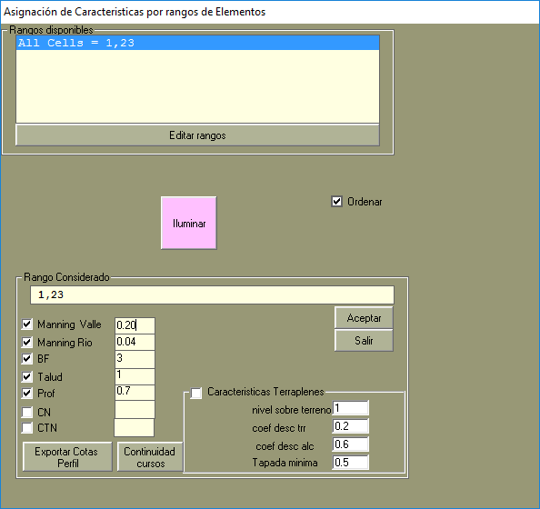

Figure 5 – Editing parameters for groups of cells

## Set Parameters For Single Cells

If for some reason some particular cells need a different parameter-value, one can change it directly in the grid map.

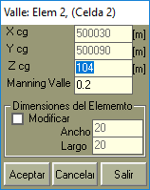

Figure 6 – Editing parameters for land-type cell

To set new parameters to land-type cells do:

1. Go to Características > Elementos > Manual > Valle;
2. Click in the cell you want to edit. A small screen like Figure 6 will pop up.
3. You are allowed to review the *z* coordinate and the land-phase Manning’s $n_{L}$ parameter. If you want to change cell’s dimension check the box Modificar first, then edit the width (Ancho) and the length (Largo);
4. Click in Aceptar.

To change river-cell parameters, the procedure is almost the same. The only difference is the menu to allow river-cell editing: Características > Elementos > Manual > Rio.

## Embankments

When talking about structures in *Simulaciones,* one have to understand that it means a different model to compute the flow between linked cells.

The first structure is a complete blockage between cells. Actually, it is represented by simply removing the link between the cells. To do so, go to Definir > Vinculaciones Restringidas > Totalmente. Then, click in one cell of the pair where the blockage will take place, then click in the other cell. Keeping doing this between cells that you want to remove any water exchange. Once finished go to the same menu to de-activated this structure placement. Note that instead of Totalmente you will find the word Detener.

Another structure is a levee or embankment. To include a levee between two cells and define its parameters do as follow:

1. 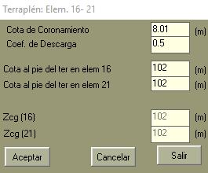Go to Definir > Vinculaciones Restringidas > Terraplén;

Figure 7 – Screen to edit levees/embankments features

1. Click in one of the cells of the selected pair, then in the other. Keep doing this in the other pairs that a levee is necessary;
2. Stop inserting levee in the same menu sequence, but note that Terraplén changed to Detener;
3. To edit the embankment parameters go to Características > Vinculaciones Parciales > Manual > Terraplén;
4. Click in one cell, then in the adjacent cell, which has a levee between them. A small screen like Figure 7 will pop up;
5. The following four parameters can be changed:
   * *Cota de Coronamiento* = Elevation at the top of the crest ($z_{top}$);
   * *Coef. De Descarga* = Discharge coefficient ($c_{d}$) for overtop flow;
   * *Cota al pie del ter … #* = Elevation at the bottom of the levee in cell #.
6. Once edited click in Aceptar to save and exit the screen. If there are other levee links to be changed, do it again for each pair of cells linked with an embankment.

## Culverts

The last weir structure is a spillway/culvert facility. When a culvert is installed, *Simulaciones* conveys the water flux through a minor rigid channel which can be controlled by a gate or not. The procedure to include a culvert is similar to that one to include a levee:

1. Go to Definir > Vinculaciones Restringidas > Alcantarilla/Vertedero;
2. Select the interface between two cells to insert the culvert. Click in one of the cells than the other one. Keep doing it for all links were a culvert is needed;
3. Stop inserting going to the same menu of step 1. Note that Alcantarilla/Vertedero changed to Detener;
4. To edit the features of each culvert go to Características > Vinculaciones Parciales > Manual > Alcantarilla/Vertedero;
5. Click on the cells, one then other, where the interface was defined as a culvert. A screen like in Figure 8 will pop up;
6. 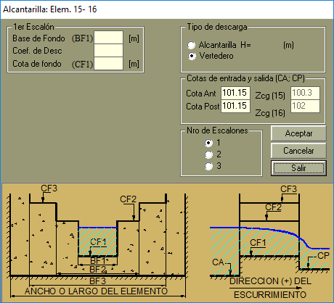The following parameters can be changed:

Figure 8 – Screen to edit culvert features

* + *Nro de Escalones* = Number of steps (up to 3 steps). By default only one step is selected. If changed to two or three, then the bottom width, discharge coefficient and bottom elevation must be set for each step;
  + *Base de Fondo* = Step’s bottom width;
  + *Coef. de Desc.* = Step’s discharge coefficient;
  + *Cota de fondo* = Step’s bottom elevation;
  + *Cota Ant/Post* = Elevation before/after the culvert;
  + *Tipo de descarga (Alcantarilla/ Vertedero)* = Discharge gadget (Gated/Free spillway). If a gated culvert is selected it is necessary to specify the height of the gate opening (below this height is where the water can flow through);

1. After making the desired changes, conclude the editing by clicking on Aceptar.

Note that what defines the height of each step is the bottom elevation of the next step. If there is any step above, the height is virtually infinite.

Again, it is a good moment to save your project.

## Monitoring Link

A virtual monitoring gauge must be included on an interface between two cells, so that during the execution of the hydrodynamic model, one can observe its variables along the entire run. To include a monitoring gauge do as follow:

1. Go to Param. De Entrada > Vinculación de Monitoreo;
2. A small screen will pop up with two fields to be filled. Put the cell (Elem) number of one of the linked cells in one box and the number of the second cell in the other box;
3. Click in Aceptar to close the screen.

## Rainfall Data

First, one must understand how *Simulaciones* receives rainfall data. Thinking on a two-column file, the first column holds the rainfall intensity (mm / 3600s) and the second holds the interval length (s). Hence, the program will understand that for a given interval duration it will be observed an accumulated rainfall given by intensity x time. Therefore, there is no fixed time-interval length while inputting the rainfall data. However, the intensity must hold the same unit for all records.

To insert a rainfall series do as follow:

1. Go to Param. de Entrada > Hietogramas;
2. A screen like Figure 9 will pop up;

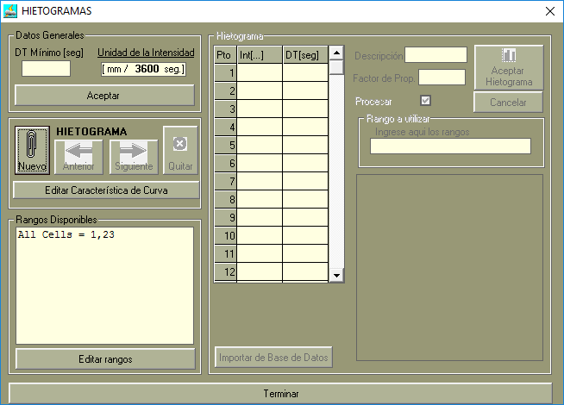

Figure 9 – Rainfall data inputting screen

1. Define a minimum interval length in the box below DT Mínimo [seg]. Click Aceptar;
2. Add a new rainfall data series by clicking in Nuevo;
3. Choose one of the groups of cells available in Rangos Disponibles by just clicking on it. If another group is necessary, add it by clicking on Editar rangos (see how to create a group in page 7). Note that the group’s name will automatically fill the Descripción field while the cell’s selection goes to Rango a utilizar;
4. Insert the rainfall data in the spreadsheet-like field in the centre of the screen. The first column is for rainfall intensity and the second for interval length. If this data is stored in a text file it can be uploaded via Importar de Base de Datos button;
5. Check the box Procesar and click in Aceptar Hietograma;
6. If you want to insert another data series for another group of cells go back to step 4. If you want to review the data series of one of the series, first select it by the arrow beside the Nuevo button, then click in Editar Característica de Curva. The selected data series can be deleted by clicking in Quitar;
7. Click in Terminar to finishing the rainfall data insertion.

## Water Depth

Usually, the model can be forced by providing a rainfall series or water depth or discharge boundary conditions, or both. The following step introduces the procedure to include water depth series as boundary condition:

1. Go to Param. de Entrada > Condiciones de Borde;
2. In the new screen, Figure 10, click in Nuevo;

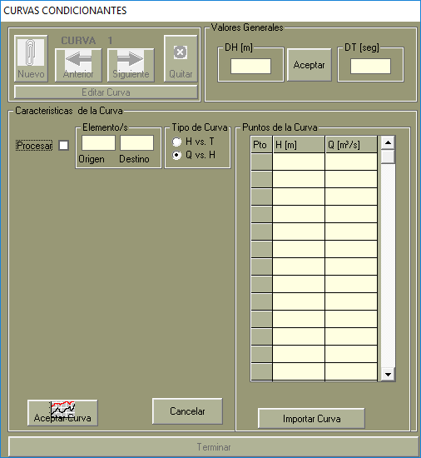

Figure 10 – Inserting boundary conditions (HxT or QxH) screen

1. Check the box Procesar;
2. Inside the box Elemento/s, put the numbers of adjacent cells which link will receive the boundary condition;
3. Select the type of boundary condition:
   * H vs. T = Water depth *versus* time;
   * Q vs. H = Discharge *versus* level (rating curve);
4. If a HxT type was selected, define the time-step in the field DT [seg] for the water ~~level~~ depth series. If a QxH was selected, define the level-step of the rating curve in DH [m] field. Click in Aceptar button between these fields.
5. In the panel Puntos de la Curva, insert pairs of (time, water ~~level~~ depth) if the boundary conditions if HxT type. Note that time must grow with each new point and that the difference between two points cannot be less than the DT defined above. Similarly, if the boundary condition is QxH, provide (water ~~level~~ depth, discharge) points with water ~~levels~~ depths increasing in, at least, DH m from one point to another;
6. Click in Aceptar Curva in the bottom left of the screen. If you want to add another curve click in Nuevo, or in Quitar if you want to remove it, or in Editar Curva to redraw it;
7. Once finished click in Terminar.

The data inputted in step 7 can be loaded from a text file, as long as it follows the same disposition of the manual insert.

Save your project.

## Initial Condition

The most common setup is to set all cells with a null water depth (complete dry). To do so, go to Param. de Entrada > Alturas Iniciales. Then, keep selected the option Inicializar altuiras en cero para todos los elementos, and press the Aceptar button. That simple.

## Running Set Up

To define the model runtime parameters go to Param. de Entrada > Datos de Procesamiento. A screen like Figure 11 will pop up. Then, do as follow:

1. Define a 5-length word to name your simulation run in the field Titulo Corrida;
2. Check the boxes Existe historia previa if the simulation will start from a previous one, and Imprimir Resultados if you want that all output data generated in the run to be saved in a text file (not recommended);
3. Check the circle Lluvia Neta;
4. The parameters Tolerancia (Tolerance) and Iteraciones (Iterations) may be changed if different precision or run-time length is need. Actually the default values are the recommended ones;
5. *Simulaciones* demands that the whole simulation must be divided into four intervals. Each one has its own time-step and its duration. Thus, if you do not want to change it over time, use the same time-step on all intervals, and split the total simulation period in four parts;
6. Set a time-step to use in the main output files (it is not substituted by the option Imprimir Resultados) in the last box at the bottom of the screen;
7. Click in Aceptar.

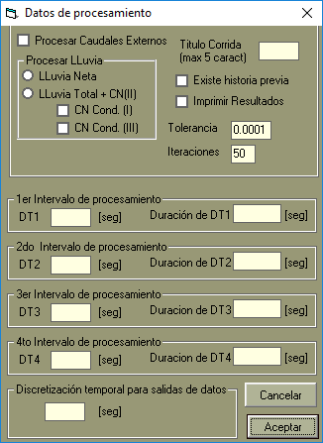

Figure 11 – Model running set up screen

Save your project! Now you have defined a basic collection of inputs and parameters to run *Simulaciones*.

## Generating Model Input Files

*Simulaciones* interface help to manage the large number of input files that the hydrodynamic model expects to run properly. If all the settings and inputs were introduced as described in this document, one could order the interface to generate such files.

Go to Procesamiento > Compilar Archivos *.DAT. If any error prompt appears, check the information log to find what should be fixed. If nothing went wrong a folder with the same name of the project would be created. All the input files will be saved in this folder and the content of each one is described in the following sections.

# INPUT FILES

To help the description of input files a small domain was created in *Simulaciones* using all the features related above to produce these files. Figure 12 shows the cell-grid domain with the information of each cell.

In the land-type cells **dx** and **dy** variables (m) represents the length and the width of each cell respectively, and **Z** is the cell’s bottom elevation (m). The Manning’s roughness coefficient, **n**, is the roughness for the land-phase.

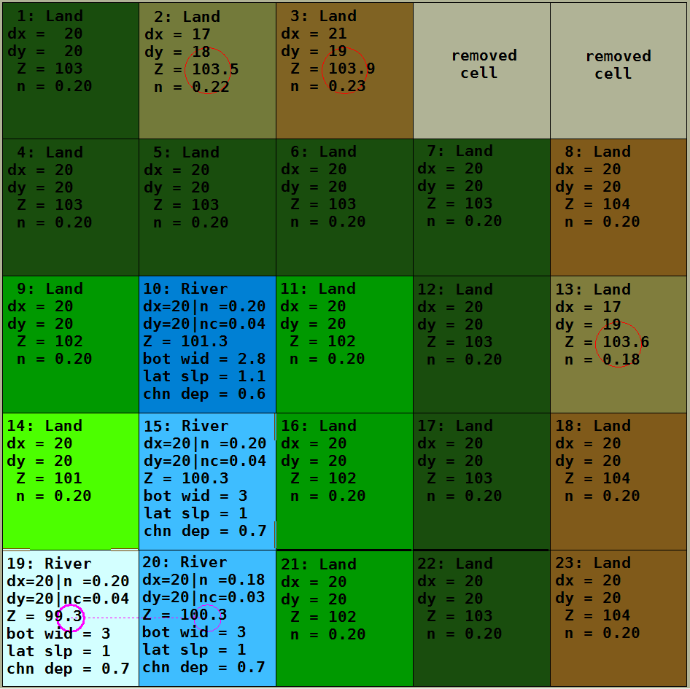

Figure 12 – Cell characteristics for an example run of the hydrodynamic model

When the cell is a river-type one, **dx**, **dy**, **Z** and **n** hold the same meaning of land-type cells. The roughness in the channel-phase is given by **nc**. The last three channel properties are the bottom width (m), lateral slope (m/m) and channel depth (m). One must be advised that cell’s bottom elevation is located in the bottom of the channel. Thus, the land-phase elevation is at **Z** + **chn dep**.

The land-phase micro-channel properties set for this run are those shown in Figure 4, which are the following:

* Lateral slope for channel-flow computation, $ls_{C}$ = 0.001 m/m
* Lateral slope for cell water storage computation, $ls_{S}$ = 0.001 m/m
* Minimum bottom width, $B_{M}$ = 0.50 m
* Height of micro-channel, $H1$ = 0.005 m
* Height which water reach cell’s border, $H2$ = 0.015 m
* Adjustment height, $H3$ = 0.001 m

Some structures were added to the domain. In the links between cells 16|21 and 17|22 a levee avoid the flow unless overtopped. At links 14|19 and 15|16 a culvert was introduced to control the discharge between these cells. Their properties as other related to the model run as a whole will be reported along the input files.

## vincul.dat

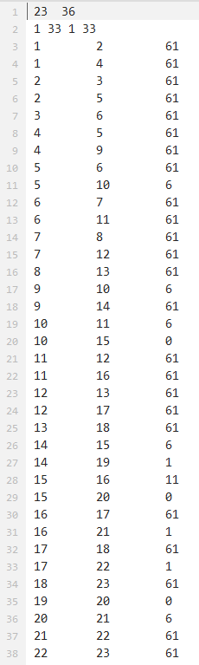The vincul.dat file holds all information regarding cell’s properties (Figure 12) as the link type between them. The content of this file was split into two images because of its format.

In Figure 13 one can see the first 38 lines of vincul.dat. The first line shows, respectively, the number of cells, $NC$, and the number of links, $NL$. This last count how many connections/interfaces between adjacent cells are present in the domain.

The second line informs the model how many and which links were selected as monitoring gauges. The first number informs how many inflow links were selected ($nl_{in}$), then the next $nl_{in}$ values are the selected link’s numbers. After, but still in the same line, there is the number of outflow links selected ($nl_{out}$) and the $nl_{out}$ link’s number. In the current example only one link, the 33rd, was selected as both in/out flow monitoring. One can find that it is the link between cells 19 and 20 (line 35).

After the first two lines it follows $NL$ lines to inform the type of each link. As one can see on Figure 13, the first two columns are cell’s number. Usually the links are sorted in such waa y to follow the own grid’s cell numbering scheme. Thus, starting at cell 1, it will list the links related to this cell. So the first link is between cell 1 and 2 (right side of cell 1) and the second link is between cell 1 and 4 (bottom side of cell 1). Once all links of cell 1 were listed, it moves to the next cell. Thus, the third link is between cell 2 and cell 3 (right side of cell 2). The fourth link is between cell 2 and cell 5 (bottom side of cell 2). This logic keeps going until reach the last link with the last cell. If there is a full restriction between two cells (see section Embankments), the link between them is simple removed from the list.

The third column between lines 3 and $NL$ +2 is the link-type code. There are 5 types of links as follow:

* **61 = land to land**: Both cells are land-type and no structure controls the flow between them;

Figure 13 – Upper content of vincul.dat

* **6 = river to land**: One of the cells are river-type, and the other is land-type, but no structure controls the flow between them;
* **0 = river to river**: Both cells are river-type, and no structure controls the flow between them;
* **1 = no-gated spillway**: A free spillway constricts the flow between linked cell;
* **11 = culvert (spillway with gate)**: A spillway structure controls the flow between linked cells, but it must be conveyed through the opening gate height.

After the link-type list it follows the information set for each cell of the domain (Figure 14). Generally speaking, such information is found between lines $NL + 3$ and $NL + NC + 2$. The information hold in each column in this part of the file is:

* 1st col.: Cell’s number;
* 2nd col.: Boundary condition status (1 if controlled by bound. condition, 0 otherwise);
* 3rd col.: Cell’s bottom level, $z$ [m] (channel’s bottom for river cells);
* 4th col.: Cell’s $x$ coordinate (longitude at the middle of the regular-size cell);
* 5th col.: Cell’s $y$ coordinate (latitude at the middle of the regular-size cell);
* 6th col.: Cell’s width, $∆y$ [m];
* 7th col.: Cell’s length, $∆x$ [m];
* 8th col.: Channel bottom width, $B$ [m] (set as 0 for land-type cells);
* 9th col.: Channel lateral slope, $S_{C}$ [m] (set as 0 for land-type cells);
* 10th col.: Channel depth, $D_{C}$ [m] (set as 0 for land-type cells);

The values of $B$, $S_{C}$ and $D_{C}$ for land-type cells were defined by $B_{M}$, $ls_{S}$ or $ls_{C}$ and $H1$ respectively (see section Setting Routing/Conduction Parameters). Moreover, the coordinate system is not important in the model computation, as distances and widths are provided separately.

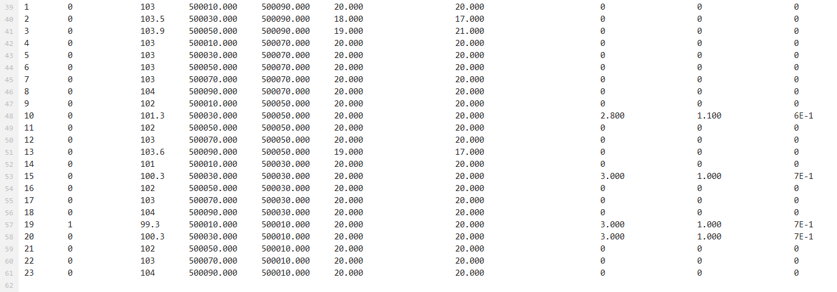

Figure 14 – Lower content of vincul.dat file

## param.dat

This file has all link-related parameters that control the flow between cells. Figure 15 shows the content of param.dat file used in the current example.

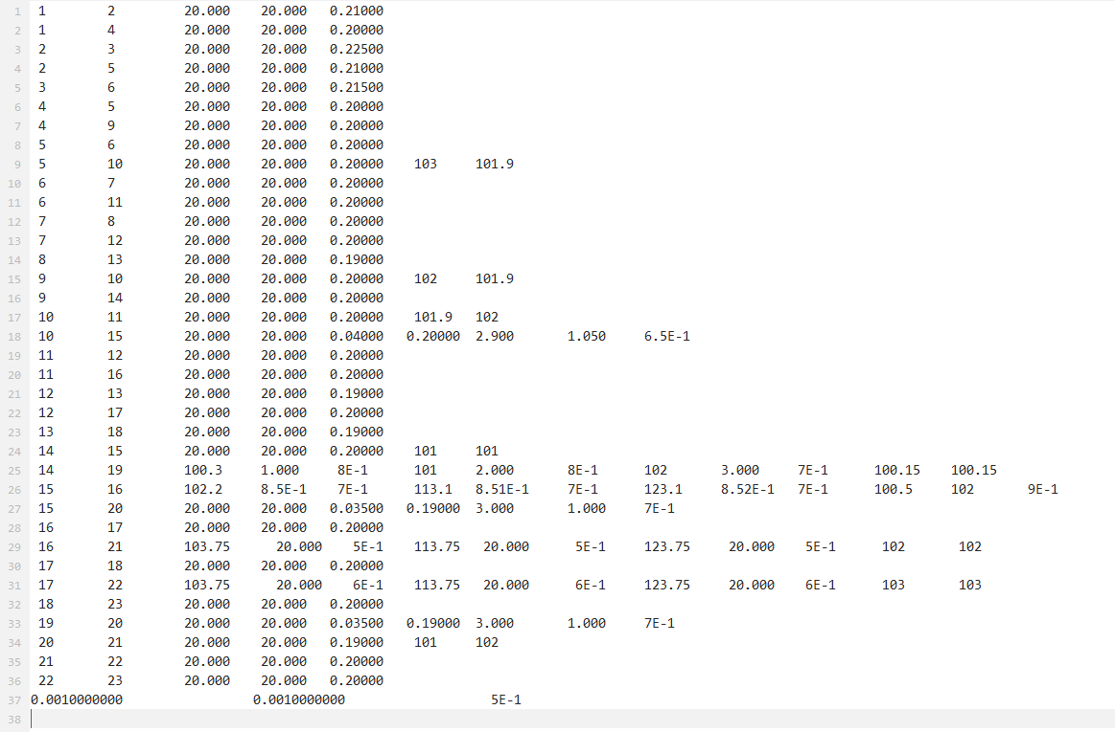

Figure 15 – param.dat file content

As one can see in the picture above, the number of parameters change regarding the link-type. Only the first two columns have the same field to all links, which is the number of the linked cells. The other parameters are explained for each link type.

*Land to land (#61)*

* 3rd col.: distance between the centre of cells, $L$ [m];
* 4th col.: interface section width, $W$ [m];
* 5th col.: average Manning’s roughness coefficient, $n_{L}$ [s/m1/3].

Before proceeding for the next link type, one must note that when *Simulaciones* write these parameters it not necessarily match with the parameter defined for each linked cell. The distance between cells and the interface width reflects the information of the regular grid dimension. It does not taking in account changes in $∆x$ and/or $∆y$ of any linked cell. On the other hand, the roughness coefficient is an average between the values of both cells.

*River to land (#6)*

* 3rd col.: distance between the centre of cells, $L$ [m];
* 4th col.: interface section width, $W$ [m];
* 5th col.: land-phase average Manning’s roughness coefficient, $\overline{n_{L}}$ [s/m1/3];
* 6th col.: elevation of land-phase in the first cell, $z_{1}$ [m];
* 7th col.: elevation of land-phase in the second cell, $z_{2}$ [m].

Regarding the elevation in the 6th and 7th columns of river-to-land links, one must identify that it holds the same value of bottom elevation, $z$, for land-type cells. However, it refers to the bottom elevation plus the channel depth at river-type cells ($z+D_{C}$).

*River to river (#0)*

* 3rd col.: distance between the centre of cells, $L$ [m];
* 4th col.: interface section width, $W$ [m];
* 5th col.: channel-phase average Manning’s roughness coefficient, $\overline{n_{C}}$ [s/m1/3];
* 6th col.: land-phase average Manning’s roughness coefficient, $\overline{n_{L}}$ [s/m1/3];
* 7th col.: average channel bottom width, $\overline{B}$ [m];
* 8th col.: average channel lateral slope, $\overline{S_{C}}$ [m/m];
* 9th col.: average channel depth, $\overline{D_{C}}$ [m].

When an spillway or a culvert control the link, the same parameters apply to both. The only difference is that culvert have an additional parameter related to the gate opening height. In the current example a spillway was placed between cells 14 and 19, while a culvert controls the flow between cells 15 and 16. Their properties, defined as described in Culverts section, are presented at Table 1.

Table 1 – Spillway/Culvert properties at links 14-19 and 15-16

|  |  |  |  |  |  |  |  |  |  |  |  |
| --- | --- | --- | --- | --- | --- | --- | --- | --- | --- | --- | --- |
| Link | Step 1 | | | Step 2 | | | Step 3 | | | Downstream elevation (m) | Upstream elevation (m) |
| Bottom width (m) | Discharge coefficient (-) | Bottom elevation (m) | Bottom width (m) | Discharge coefficient (-) | Bottom elevation (m) | Bottom width (m) | Discharge coefficient (-) | Bottom elevation (m) |
| 14-19 | 1.0 | 0.8 | 100.3 | 2.0 | 0.8 | 101 | 3.0 | 0.7 | 102 | 100.15 | 100.15 |
| 15-16 | 0.85 | 0.70 | 102.2 | n.d. | n.d. | n.d. | n.d. | n.d. | n.d. | 100.5 | 102.0 |

* n.d. = not defined

** link 15-16 have a gate opening height of 0.90 m

*Spillway/Culvert (#1/#11)*

* 3rd col.: step 1 bottom elevation, $z_{S1}$ [m];
* 4th col.: step 1 bottom width, $W_{S1}$ [m];
* 5th col.: step 1 discharge coefficient, $c_{S1}$ [adim.];
* 6th col.: step 2 bottom elevation, $z_{S2}$ [m]. If not defined, is auto set as $z_{S1}$ + 10 m;
* 7th col.: step 2 bottom width, $W_{S2}$ [m]. If not defined is auto set as $W_{S1}$ + 0.01 m;
* 8th col.: step 2 discharge coefficient, $c_{S2}$ [adim.]. If not defined is auto set as $c_{S1}$;
* 9th col.: step 3 bottom elevation, $z_{S3}$ [m]. If not defined, is auto set as $z_{S2}$ + 10 m;
* 10th col.: step 3 bottom width, $W_{S3}$ [m]. If not defined is auto set as $W_{S2}$ + 0.01 m;
* 11th col.: step 3 discharge coefficient, $c_{S3}$ [adim.]. If not defined is auto set as $c_{S2}$;
* 12th col.: downstream terrain elevation, $z_{down}$ [m];
* 13th col.: upstream terrain elevation, $z_{up}$ [m];
* (culvert only) 14th col.: gate opening height, $G$ [m];

The model sees embankments as spillways, mathematically speaking. Thus, the same set of parameters are used for links controlled by embankments with some conceptual changes.

*Embankment (#1)*

* 3rd col.: embankment overtopping level, $z_{top}$ [m];
* 4th col.: regular grid-cell width;
* 5th col.: discharge coefficient;
* 6th to 11th col.: same as spillway when steps 2 and 3 parameters are not defined, with the difference that the width does not change;
* 12th col.: downstream terrain elevation, $z_{down}$ [m];
* 13th col.: upstream terrain elevation, $z_{up}$ [m];

Looking back to Figure 12 one can see that embankments were placed in the links 16-21 and 17-22. By data in Figure 15 both links have a $z_{top}$ = 103.75 m. Meanwhile, the discharge coefficient at 16-21 is 0.50 whilst at 17-22 is 0.60.

The last line of param.dat stores the 3 first parameters defined for land-phase routing. Are they:

1. Lateral slope of the inner channel, used for flow computation: $ls_{C}$;
2. Lateral slope of the inner channel, used for storage computation, $ls_{S}$;
3. Bottom width of the inner channel, $B_{M}$.

## anpanta.dat

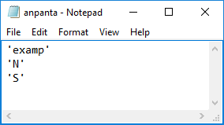This file contains part of the run-time setup. Figure 16 shows the anpanta.dat content, what takes information defined in Running Set Up section. The first line holds the title/name of the run. The second will have an ‘S’ if the box to continue from a previous run was check, otherwise there it will have an ‘N’. The third line informs if all programs outputs (at each solved time-step) have to be recorded in a text file. Thus, ‘S’ means yes and ‘N’ means no.

Figure 16 – anpanta.dat content

The content of this file is not exactly the same when running a new version of the hydrodynamic executable. In this case, the option in the second line still defines the same option. The difference is that in the older version it would read the water depths from the file “althis.res”, while in the new version it reads from “last_state.txt”. The third line define if the program will write output files for water velocity and discharge data. If it is an “S” or “s” these output files are created, otherwise only the water level output file is created.

## contab.dat

This file will not be used as any rating curve was provided as a boundary condition.

## contar.dat

This file stores water depths time series provided in Water section. Figure 17 shows the content generated in this file.

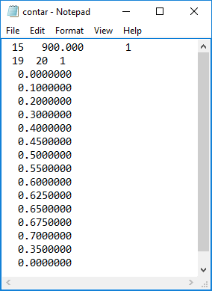The first line holds three parameters in the following sequence: number of records in the data series; time-step between records; number of water level series. In the example case there is only one series, which have 15 records “measured” at every 900 seconds. Therefore, if other input series would be introduced, all of them should have the same number of records and the same time-step.

Figure 17 – contar.dat content

The second line holds other three parameters: origin cell number, destiny cell number, active status. Note that these parameters are related to the following data series only. The active status is 1 for active boundary condition (will be used) or 0 for inactive one (will not be used). From the third line on there are the 15 records related to the first data series.

For two or more data series the file content scheme is as follow:

* Line 1:
  + Number of records (N), records time-step (DT), number of series (S);
* Lines 2, N + 3, 2*N + 4, 3*N + 5, … [$i=j\left(N+1\right)+2$] where $i$ is the line number and $j$ the series’ number:
  + Number of origin cell, number of destiny cell, active status (0 = off, 1 = on)
* Lines 3 to N+2, 4+N to 3+2*N, …, [ $i_{1}=2+j+\left(j-1\right)N$ to $i_{N}=1+j(N+1)$] where $i_{1}$ is the line number for the first record and $i_{N}$ the line of the last record of the th series:
  + Data records from the th series

## gase.dat

There are only two lines in this file, both holding values inputted in Running Set Up. In the first line it is the tolerance error (m) used to check convergence in the matrix solver used in the model. The second line have the maximum number of iterations that the solver can use to reach convergence.

In the present example it was used the default values: 0.0001 m and 50 iterations, respectively.

## gener.dat

This single-line file store regular grid dimension parameters in the following order: cell’s length $∆x$, cell’s width $∆y$, number of rows plus 2, number of columns plus 2. These parameters are used for grid consistency and sorting procedures only.

## h1h2.dat

This file stores the values of $H1$, $H2$ and $H3$ (see section Setting Routing/Conduction Parameters) in this respective order, all in the single line of the file. It is possible that whilst creating this file *Simulaciones* change some or all values to 0.0001 m, without a properly acquaintance of the user.

## hrugosi.dat

**This file is not created with *Simulaciones***. It must be copied from a previous simulation or created a new one.

Three parameters are stored in this file: $h_{lim}$, $n_{ref}$, $h_{ref}$, in this respective order. All of them are used for correction of Manning's roughness coefficient, $n_{C}$, due to low depth in the channel. Hence, they are used only for river-river flow computations. Below follows a brief description of each parameter:

* $h_{lim}$ is a threshold value. At depths above this value, the $n_{C}$ value is the one provide by the input files;
* $n_{ref}$ and $h_{ref}$ are constant values for roughness and water depth, respectively, used in the logarithm-shape correction function.

The default values are $h_{lim}=0.60$, $n_{ref}=0.10$ and $h_{ref}=0.12$.

## inicial.dat

This file groups some running-setup variables and the initial water depths on each cell of the active domain. Thus, the setup variables comes from section Running Set Up whilst the initial values where set all to zero at Initial Condition.

The first line have two integer values, both used for Yes/No options. The first value informs if there is a file containing external flow data series to input in the model. The second value informs if rainfall data is available as well. Both values can be a zero, 0, for a negative answer or a one, 1, for positive answer.

The second line holds information about the time-steps and interval duration along the simulation. The first 4 values are the hydrodynamic model time-step, in seconds, to be adopted on each interval. The next four values, 5 to 8, are the length of each interval also given in seconds. The ninth value is the printing time-step (s), which means that results will be written in the main output files at this frequency.

From the third line on there is no standard format. It just need to have a sequence of $NC$ values organized in any matrix-like shape. These values are the water levels in each cell, from cell one to $NC$, at the initial time of the simulation.

## lluvia.dat

This file holds all information about rainfall data as provided in the steps of section Rainfall Data. However, before explaining the file content one must know what data was inserted in the model. Table 2 shows two rainfall series that were created using the *Simulaciones* interface.

Table 2 – Rainfall series provided for the example simulation

|  |  |  |  |  |
| --- | --- | --- | --- | --- |
| Rain1: cells 4 to 6 | |  | Rain2: cells 9 to 11 | |
| Intensity (mm/h) | Duration (s) |  | Intensity (mm/h) | Duration (s) |
| 5 | 900 |  | 0 | 7200 |
| 0 | 7200 |  | 3 | 900 |
| 10 | 900 |  | 9 | 900 |
| 2 | 1800 |  | 16 | 900 |
|  |  |  | 4 | 900 |

As explained in the section Rainfall Data, pairs of (intensity, duration) are provided to inform how long each rainfall rate endured. Using Rain1 as example, the first 900 s recorded rainfall at a rate of 5 mm per hour (thus, 5/4 mm in 15 minutes). After, a period of 3 hours (7200 s) without any rain was recorded. Next, 10 mm/h occurred along 15 minutes, followed by half-hour with a 2 mm/h rainfall intensity.

Now let look the lluvia.dat content in Figure 18.

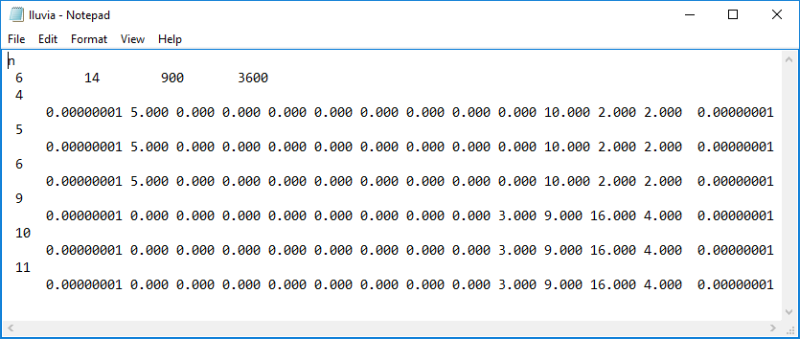

Figure 18 – lluvia.dat content

The first line has the letter “n” on it, which means rainfall data will not be replicated.

The second line has the values of four parameters in the following order: Number of cells with rainfall data; the number of records in the data series; rainfall records interval; rainfall intensity time length. As one can follow in Figure 18 there are 6 cells that will receive rainfall (cells 4, 5, 6, 9, 10 and 11). In the sequence, each series have 14 records but note that the first and the last value are almost-null values. These two extra records are automatically added to ensure that the first and last records are zero, which is requested by the kinematic filter applied on rainfall data. The last two parameters were defined in the interface, both given in seconds.

The file continues with couples of two lines for each cell that will receive rainfall. The first line of the couple holds the cell number only while the second line have the 14 records assigned to that cell. What matters most here is that the rainfall data is still rain intensity (mm/h). However, the program equally distributes this rate when the length provided of one data is longer than the defined records interval. See that the last input in Rain1 is 2 mm/h along 1800 s. Thus, for cells 4, 5 and 6 there are two records with 2 mm/h, as each one extends for 900 s.

# OUTPUT FILES

The old version of the hydrodynamic model, usually associated with the w111114.f code, create many ASCII files using “.res” as the extension. These files are used by *Simulaciones* to feed its plot screens.

On the other hand, the new model version creates only 2 or 4 files, depending on if it was set to save the water velocity and discharge data. All these files as ASCII text files, with the classic “.txt” extent. Below, you can see the description of each of these files.

## last_state.txt

This file stores the water depths in the last time step ran by the model. In the first line it is stored the time step, in seconds, in which the following water depth data was computed. In the second line we have the water depths, as float numbers, from the first to the last cell. These ones are saved with free format, thus depending with which text processor you open this file, you may see just a single endless line or it wrapped in many rows.

## depths_*****.txt

This file stores the water depths for all the cells at every printing time-step, *dt* (see inicial.dat description). In the real name of this file, the sequence of 5 * characters is replaced with the simulation name, which was defined in the first row of anpanta.dat file.

The first line holds two information. The first data is the number of elements, in this case, the number of cells (*NC*) were water depths are calculated. The second is the value of the printing time-step (*dt*), exactly as read from inicial.dat file (second row, last column). From the second line on, each line will have *NC* values of water depths, always ordered from the first to the last cell. Therefore, the second line have the water depths at t = *dt*, the third line has water depths at t = 2 x *dt*, the fourth line has at t = 3 x *dt* and so on until reaching the end of the simulation. Again, the code uses a free format to write the values, thus the content may look different depending on which text processor you use to open the file.

## veloc_*****.txt and flows_*****.txt

These file stores the water velocities and the discharge for all the links at every printing time-step (see inicial.dat description), respectively. However, differently from the depths_*****.txt file, these ones save the average value along the printing time-step, instead of the instantaneous values on the time step. In the real name of this file the sequence of 5 * characters is replaced with the simulation name, which was defined in the first row of anpanta.dat file.

The first line hold two information. The first data is the number of elements, in this case, the number of links (*NL*) were velocity and discharge are calculated. The second is the value of the printing time-step (*dt*), exactly as read from inicial.dat file (second row, last column). From the second line on, each line will have *NL* values of water velocity/discharge, always ordered from the first to the last link. Therefore, the second line have the average velocity/discharge between t = 0 and t = *dt*, the third line has averages between t = *dt* and t = 2 x *dt*, the fourth line has for t = 3 x *dt* and so on until reaching the end of the simulation. Again, the code uses a free format to write the values, thus the content may look different depending on which text processor you use to open the file.