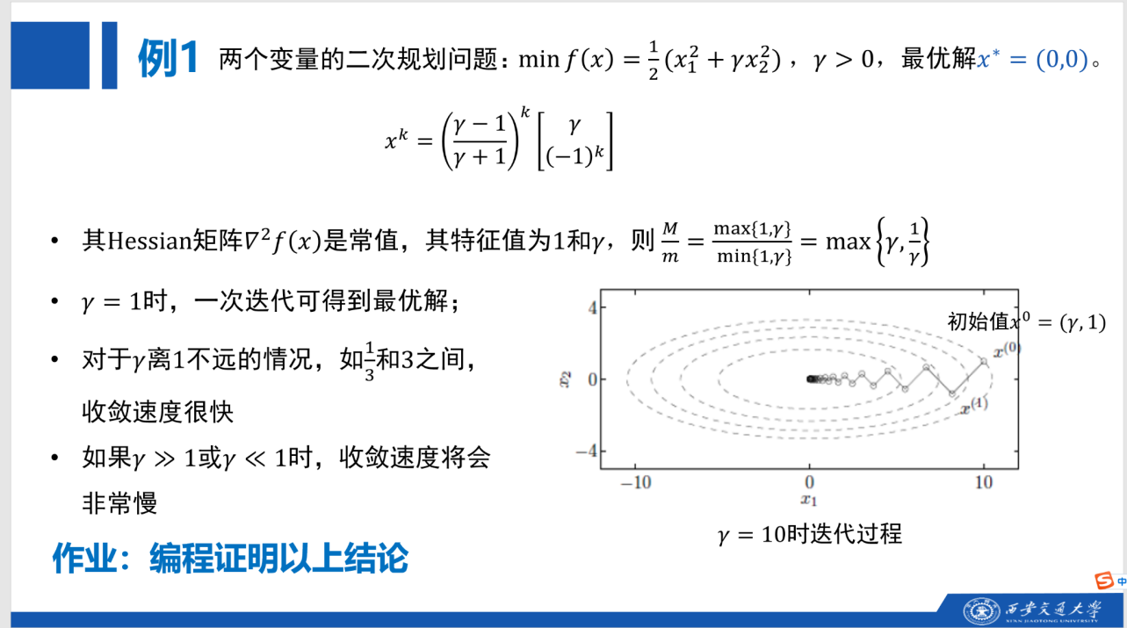

解：

1. 梯度与最优解
题目为
$$minf\left(x\right)=\frac{1}{2}\left(x_{1}^{2}+γx_{2}^{2}\right), γ>0$$
其梯度和 Hessian 矩阵为
$$∇f\left(x\right)=\left[\begin{matrix}x_{1} \\ γx_{2}\end{matrix}\right], ∇^{2}f\left(x\right)=\left[\begin{matrix}1 & 0 \\ 0 & γ\end{matrix}\right]$$
令 $∇f\left(x\right)=0$，得
$$x_{1}=0, γx_{2}=0$$
因为 $γ>0$，所以
$$x^{∗}=\left(0,0\right)$$
Hessian 矩阵特征值为 $1$ 和 $γ$，因此
$$\frac{M}{m}=\frac{max\{1,γ\}}{min\{1,γ\}}=max\left\{γ,\frac{1}{γ}\right\}$$

2. 精确直线搜索下的迭代公式
取初始点
$$x^{0}={\left(γ,1\right)}^{T}$$
负梯度方向为
$$d^{k}=−∇f\left(x^{k}\right)$$
精确直线搜索步长为
$$t_{k}=arg\min_{t≥0}f\left(x^{k}+td^{k}\right)=\frac{∇f{\left(x^{k}\right)}^{T}∇f\left(x^{k}\right)}{∇f{\left(x^{k}\right)}^{T}∇^{2}f\left(x^{k}\right)∇f\left(x^{k}\right)}$$
若
$$x^{k}={\left(\frac{γ−1}{γ+1}\right)}^{k}\left[\begin{matrix}γ \\ {\left(−1\right)}^{k}\end{matrix}\right],$$
则
$$∇f\left(x^{k}\right)=γ{\left(\frac{γ−1}{γ+1}\right)}^{k}\left[\begin{matrix}1 \\ {\left(−1\right)}^{k}\end{matrix}\right]$$
代入步长公式得
$$t_{k}=\frac{2}{γ+1}$$
于是
$$x^{k+1}=x^{k}−t_{k}∇f\left(x^{k}\right)={\left(\frac{γ−1}{γ+1}\right)}^{k+1}\left[\begin{matrix}γ \\ {\left(−1\right)}^{k+1}\end{matrix}\right]$$
因此题目中的迭代公式成立。

3. Python 代码

import math
import numpy as np
import matplotlib.pyplot as plt
EPS = 5e-13
MAX_ITER = 100000
GAMMAS = [1.0, 3.0, 1.0/3.0, 10.0, 100.0, 0.01]
def f(x, gamma):
return 0.5 * (x[0] ** 2 + gamma * x[1] ** 2)
def grad(x, gamma):
return np.array([x[0], gamma * x[1]], dtype=float)
def exact_step(x, gamma):
g = grad(x, gamma)
H = np.diag([1.0, gamma])
return float(np.dot(g, g) / np.dot(g, H @ g))
def solve(gamma, eps=EPS, max_iter=MAX_ITER):
x = np.array([gamma, 1.0], dtype=float)
errors = []
for k in range(max_iter + 1):
errors.append(f(x, gamma))
if np.linalg.norm(grad(x, gamma)) < eps:
return k, x, f(x, gamma), np.linalg.norm(grad(x, gamma)), errors
t = exact_step(x, gamma)
x = x - t * grad(x, gamma)
return max_iter, x, f(x, gamma), np.linalg.norm(grad(x, gamma)), errors
def main():
print("gamma\tM/m\t|r|\tk\tx1\tx2\tf(x)\t||grad||")
all_errors = []
for gamma in GAMMAS:
k, x, fx, gn, errors = solve(gamma)
cond = max(1.0, gamma) / min(1.0, gamma)
r_abs = abs((gamma - 1.0) / (gamma + 1.0))
all_errors.append((gamma, errors))
print(f"{gamma:.6g}\t{cond:.6g}\t{r_abs:.6g}\t{k}\t{x[0]:.6e}\t{x[1]:.6e}\t{fx:.6e}\t{gn:.6e}")
plt.figure(figsize=(7, 4.6))
for gamma, errors in all_errors:
plt.semilogy(errors, label=f"gamma={gamma:.6g}")
plt.xlabel("iteration k")
plt.ylabel("f(x^k)-f*")
plt.title("Error curves for exact line search")
plt.grid(True, which="both", linestyle="--", linewidth=0.5)
plt.legend(fontsize=8)
plt.tight_layout()
plt.savefig("quadratic_error_curve.png", dpi=220)
if __name__ == "__main__":
main()
plt.show()

4. 运行结果
停止条件取
$$∥∇f\left(x^{k}\right)∥_{2}<5×{10}^{−13}$$
$$γ$$ | $$M/m$$ | $$\left|\frac{γ−1}{γ+1}\right|$$ | 迭代次数 $k$
1 | 1 | 0 | 1
3 | 3 | 0.5 | 43
$$1/3$$ | 3 | 0.5 | 40
10 | 10 | 0.818182 | 155
100 | 100 | 0.980198 | 1664
0.01 | 100 | 0.980198 | 1204
误差曲线如下：
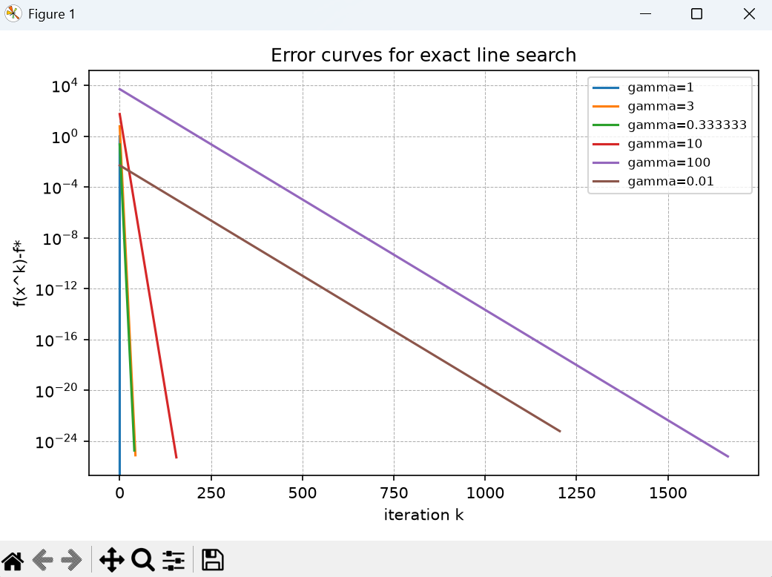

5. 结论
- 当 $γ=1$ 时，$\left|\frac{γ−1}{γ+1}\right|=0$，一次迭代即可到达最优解
- 当 $γ$ 离 $1$ 不远时，例如 $γ=3$ 或 $γ=1/3$，收敛较快
- 当 $γ≫1$ 或 $γ≪1$ 时，$\left|\frac{γ−1}{γ+1}\right|$ 接近 $1$，收敛明显变慢
- 实验结果与题目结论一致

