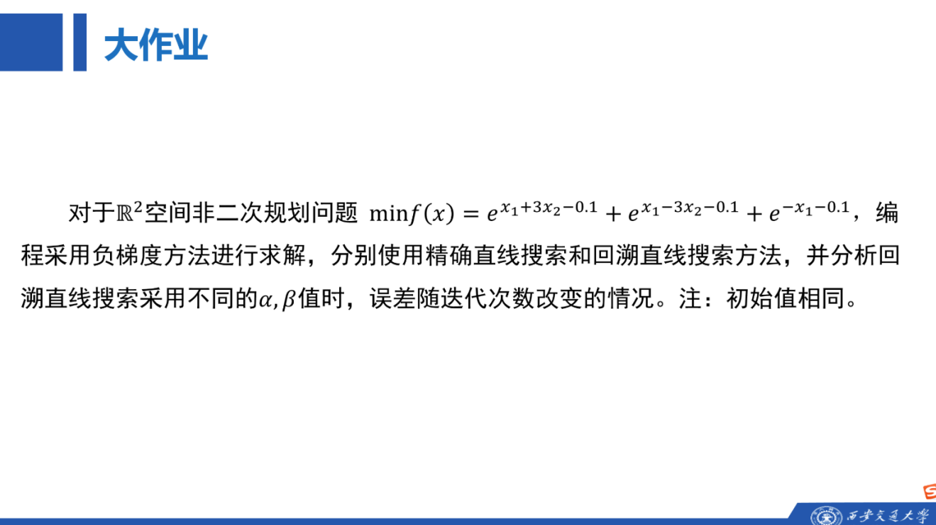

解

1. 梯度与最优解
令
$$u_{1}=x_{1}+3x_{2}−0.1, u_{2}=x_{1}−3x_{2}−0.1, u_{3}=−x_{1}−0.1$$
则
$$∇f\left(x\right)=\left[\begin{matrix}e^{u_{1}}+e^{u_{2}}−e^{u_{3}} \\ 3e^{u_{1}}−3e^{u_{2}}\end{matrix}\right]$$
由 $∇f\left(x\right)=0$ 得
$$e^{u_{1}}=e^{u_{2}}⇒x_{2}=0,$$
$$2e^{x_{1}−0.1}=e^{−x_{1}−0.1}⇒x_{1}^{∗}=−\frac{1}{2}ln2$$
所以
$$x^{∗}=\left(−\frac{1}{2}ln2,0\right)≈\left(−0.34657359,0\right),$$
$$f^{∗}=2\sqrt{2}e^{−0.1}≈2.5592666967$$

2. 负梯度法
取相同初始点
$$x^{0}={\left(1,1\right)}^{T}$$
负梯度方向为
$$d^{k}=−∇f\left(x^{k}\right)$$
精确直线搜索：
$$t_{k}=arg\min_{t≥0}f\left(x^{k}+td^{k}\right)$$
回溯直线搜索：从 $t=1$ 开始，直到满足
$$f\left(x^{k}+td^{k}\right)≤f\left(x^{k}\right)+αt∇f{\left(x^{k}\right)}^{T}d^{k}$$
停止条件：
$$∥∇f\left(x^{k}\right)∥_{2}<{10}^{−6}$$

3. Python代码

import math
import numpy as np
import matplotlib.pyplot as plt
# 目标函数 f(x)=exp(x1+3x2-0.1)+exp(x1-3x2-0.1)+exp(-x1-0.1)
def f(x):
x1, x2 = float(x[0]), float(x[1])
return (math.exp(x1 + 3*x2 - 0.1)
+ math.exp(x1 - 3*x2 - 0.1)
+ math.exp(-x1 - 0.1))
# 梯度
def grad(x):
x1, x2 = float(x[0]), float(x[1])
e1 = math.exp(x1 + 3*x2 - 0.1)
e2 = math.exp(x1 - 3*x2 - 0.1)
e3 = math.exp(-x1 - 0.1)
return np.array([e1 + e2 - e3, 3*e1 - 3*e2], dtype=float)
# 理论最优解和最优值
x_star = np.array([-0.5 * math.log(2.0), 0.0])
f_star = f(x_star)
# 黄金分割法，用于精确直线搜索的一维凸函数极小化
def golden_section(phi, left, right, tol=1e-10, max_iter=200):
r = (math.sqrt(5.0) - 1.0) / 2.0
c = right - r * (right - left)
d = left + r * (right - left)
fc, fd = phi(c), phi(d)
for _ in range(max_iter):
if abs(right - left) < tol:
break
if fc < fd:
right, d, fd = d, c, fc
c = right - r * (right - left)
fc = phi(c)
else:
left, c, fc = c, d, fd
d = left + r * (right - left)
fd = phi(d)
return (left + right) / 2.0
def exact_line_search(x, d):
phi0 = f(x)
def phi(t):
return f(x + t*d)
b = 1.0
try:
phib = phi(b)
except OverflowError:
phib = float('inf')
if phib >= phi0:
return golden_section(phi, 0.0, b)
a = 0.0
while b < 1024:
nb = 2.0 * b
try:
phinb = phi(nb)
except OverflowError:
phinb = float('inf')
if phinb >= phib:
return golden_section(phi, a, nb)
a, b, phib = b, nb, phinb
return golden_section(phi, a, b)
# 负梯度法
def gradient_descent(x0, method="exact", alpha=0.1, beta=0.5,
tol=1e-6, max_iter=10000):
x = np.array(x0, dtype=float)
errors = []
for k in range(max_iter + 1):
errors.append(max(f(x) - f_star, 1e-16))
g = grad(x)
if np.linalg.norm(g) < tol:
break
d = -g
if method == "exact":
t = exact_line_search(x, d)
else:
t = 1.0
gd = float(np.dot(g, d))
while f(x + t*d) > f(x) + alpha * t * gd:
t *= beta
x = x + t*d
return x, f(x), np.linalg.norm(grad(x)), k, errors
def main():
x0 = np.array([1.0, 1.0])
cases = [
("exact", "exact line search", None, None),
("backtracking", "backtracking alpha=0.01 beta=0.5", 0.01, 0.5),
("backtracking", "backtracking alpha=0.10 beta=0.5", 0.10, 0.5),
("backtracking", "backtracking alpha=0.25 beta=0.5", 0.25, 0.5),
("backtracking", "backtracking alpha=0.10 beta=0.8", 0.10, 0.8),
("backtracking", "backtracking alpha=0.40 beta=0.8", 0.40, 0.8),
]
print("x* =", x_star)
print("f* =", f_star)
print()
all_errors = []
for method, name, alpha, beta in cases:
if method == "exact":
x, fx, gn, iters, errors = gradient_descent(x0, method="exact")
else:
x, fx, gn, iters, errors = gradient_descent(
x0, method="backtracking", alpha=alpha, beta=beta
)
all_errors.append((name, errors))
print(name)
print("迭代次数 =", iters)
print("x =", x)
print("f(x) =", fx)
print("f(x)-f* =", fx - f_star)
print("||grad|| =", gn)
print()
plt.figure(figsize=(7, 4.5))
for name, errors in all_errors:
plt.semilogy(errors, label=name)
plt.xlabel("iteration k")
plt.ylabel("error f(x^k)-f*")
plt.title("error curve for different line searches")
plt.grid(True, which="both", linestyle="--", linewidth=0.5)
plt.legend(fontsize=8)
plt.tight_layout()
plt.savefig("error_curve.png", dpi=220)
if __name__ == "__main__":
main()

4. 运行结果
各方法得到的近似解均接近
$$x^{∗}≈\left(−0.34657359,0\right)$$
方法 | 参数 | 迭代次数 | $$f\left(x\right)−f^{∗}$$
精确直线搜索 | - | 21 | $$2.31×{10}^{−14}$$
回溯直线搜索 | $$α=0.01,β=0.5$$ | 33 | $$3.69×{10}^{−14}$$
回溯直线搜索 | $$α=0.10,β=0.5$$ | 32 | $$6.13×{10}^{−14}$$
回溯直线搜索 | $$α=0.25,β=0.5$$ | 32 | $$2.31×{10}^{−14}$$
回溯直线搜索 | $$α=0.10,β=0.8$$ | 35 | $$3.29×{10}^{−14}$$
回溯直线搜索 | $$α=0.40,β=0.8$$ | 24 | $$4.71×{10}^{−14}$$
误差曲线如下：
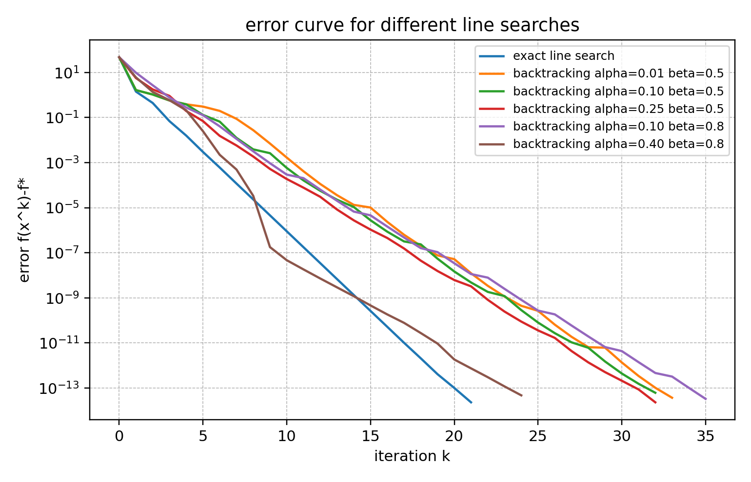

5. 结论
- 精确直线搜索和回溯直线搜索都能收敛到
$$x^{∗}≈\left(−0.34657359,0\right), f^{∗}≈2.5592666967$$
- 精确直线搜索每次步长更接近当前方向上的最优步长，本实验迭代次数为 21 次
- 回溯直线搜索的 $α,β$ 会影响步长选择。$β$ 越接近 1，步长缩小越慢；$α$ 越大，下降条件越严格。本实验中 $α=0.40,β=0.8$ 的迭代次数较少
- 从误差曲线看，各组参数的误差整体均随迭代次数下降，说明负梯度法对该凸优化问题有效

