**Figure 3.2 Logical Data Model**

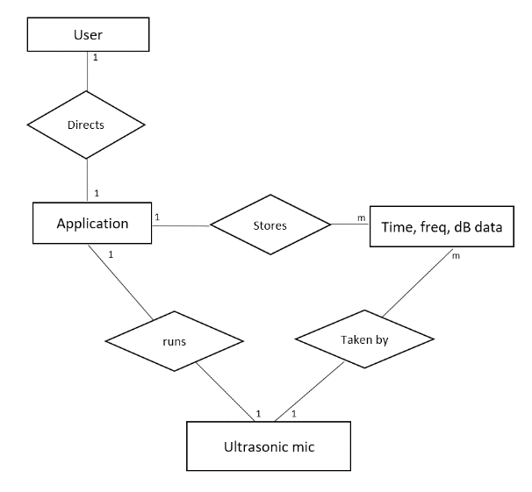

Acceleration and time data.

MBHW

MBA