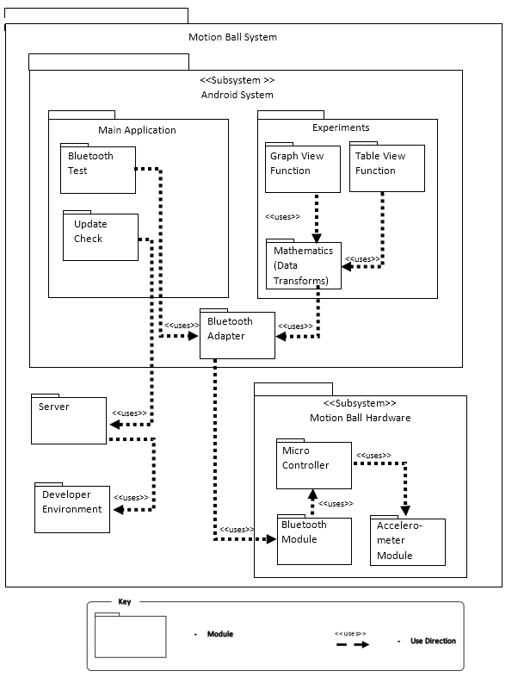**Figure 4.1- Decomposition and Uses View**