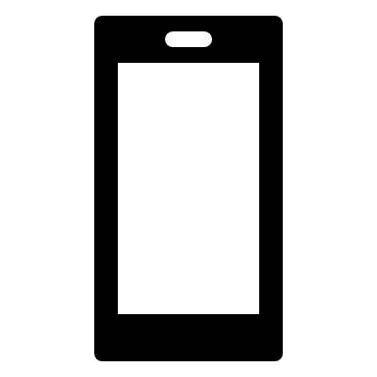

Data Handler

(See Below)

Graph View

Table View

Single User

Development



MotionBall Hardware

Data Collection

Bluetooth Transmission

MotionBall App



Windows PC

Embedded System

Android Phone

Cloud Storage



Process

Data Handler

Bluetooth reception + time taken

Acceleration Vector Calculation

Velocity Vector Calculation

Position Calculation

Application element

Event

Provided Interface

Required Interface

Motion Ball System

<<Subsystem >> Android System

Experiments

Main Application

Graph View Function

Table View Function

Bluetooth Test

<<uses>>

Update Check

Mathematics (Data Transforms)

<<uses>>

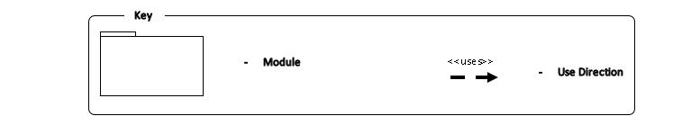

<<uses>>

<<uses>>

Accelero-meter Module

<<uses>>

<<uses>>

<<uses>>

<<uses>>

<<uses>>

Bluetooth Adapter

Developer Environment

Server

Bluetooth Module

Micro Controller

<<Subsystem>> Motion Ball Hardware

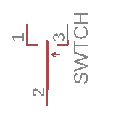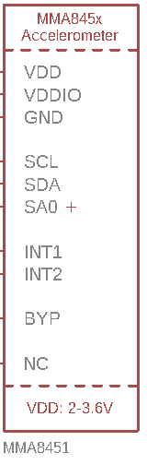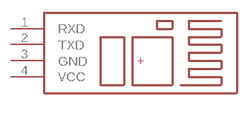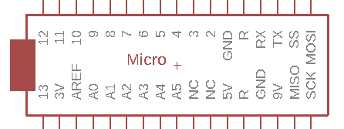

HC-05

5V