Small vessel disease burden in acute ischemic stroke - the role of physical activity and vascular risk factors

These are the planned analyses, tables and figures for the main article.

Drop all the questions and save them for a later specific publication.

Agreed upon scoring overview:

| Annotation | modified Huijts et al 2013 |
| --- | --- |
| Microbleeds subscore | |
| 0 | 0 |
| 1 | 1 |
| 2-4 | 1 |
| 5-10 | 1 |
| >10 | 1 |
| Lacunes subscore | |
| 0 | 0 |
| 1 | 1 |
| 2 | 1 |
| 3-5 | 1 |
| >5 | 1 |
| WMH subscore | |
| 0: Absent | 0 |
| 1: Punctate foci | 0 |
| 2: Beginning confluence | 1 |
| 3: Large confluent areas | 1 |
| Atrophy subscore | |
| 0: No atrophy | 0 |
| 1: Mild | 0 |
| 2: Moderate | 1 |
| 3: Severe | 1 |

# Baseline table

| **Characteristic** | **Overall** N = 762 | **Q1** N = 191 | **Q2** N = 191 | **Q3** N = 189 | **Q4** N = 191 | **p-value***1* |
| --- | --- | --- | --- | --- | --- | --- |
| SVD score, Median (IQR) | 1 (0 – 2) | 1 (0 – 2) | 1 (0 – 2) | 1 (0 – 2) | 0 (0 – 1) | <0.001 |
| SVD score features |  |  |  |  |  |  |
| Microbleeds (≥1), n (%) | 149 (20) | 42 (22) | 37 (19) | 47 (25) | 23 (12) | 0.012 |
| Lacunes (≥1), n (%) | 241 (32) | 71 (37) | 60 (31) | 61 (32) | 49 (26) | 0.12 |
| Begininng-large confluenting areas of WMH (Fazekas 2-3), n (%) | 243 (32) | 78 (41) | 69 (36) | 58 (31) | 38 (20) | <0.001 |
| Moderate-severe global atrophy (GCA 2-3), n (%) | 221 (29) | 98 (51) | 53 (28) | 47 (25) | 23 (12) | <0.001 |
| Age, Median (IQR) | 71 (62 – 79) | 77 (67 – 84) | 74 (65 – 80) | 70 (63 – 76) | 64 (55 – 73) | <0.001 |
| Female sex, n (%) | 279 (37) | 85 (45) | 89 (47) | 58 (31) | 47 (25) | <0.001 |
| Living alone, n (%) | 203 (27) | 70 (37) | 54 (29) | 45 (24) | 34 (18) | <0.001 |
| Missing | 4 | 1 | 2 | 1 | 0 |  |
| Smoking, n (%) |  |  |  |  |  | 0.59 |
| never | 269 (36) | 57 (31) | 75 (40) | 69 (38) | 68 (36) |  |
| current | 211 (28) | 56 (31) | 45 (24) | 53 (29) | 57 (30) |  |
| prior | 262 (35) | 70 (38) | 66 (35) | 62 (34) | 64 (34) |  |
| Missing | 20 | 8 | 5 | 5 | 2 |  |
| High alcohol consumption, n (%) | 69 (9.2) | 19 (10) | 19 (10) | 20 (11) | 11 (5.8) | 0.31 |
| Missing | 15 | 6 | 4 | 3 | 2 |  |
| Hypertension, n (%) | 418 (55) | 123 (64) | 114 (60) | 96 (51) | 85 (45) | <0.001 |
| Diabetes, n (%) | 85 (11) | 27 (14) | 27 (14) | 19 (10) | 12 (6.3) | 0.041 |
| Previous ischemic event, n (%) | 97 (13) | 30 (16) | 24 (13) | 27 (14) | 16 (8.4) | 0.16 |
| Atrial fibrillation, n (%) | 116 (15) | 34 (18) | 29 (15) | 29 (15) | 24 (13) | 0.57 |
| Previous MI, n (%) | 58 (7.6) | 11 (5.8) | 13 (6.8) | 19 (10) | 15 (7.9) | 0.44 |
| Pre-stroke mRS, n (%) |  |  |  |  |  |  |
| 0 | 605 (79) | 121 (63) | 150 (79) | 159 (84) | 175 (92) |  |
| 1 | 89 (12) | 29 (15) | 22 (12) | 23 (12) | 15 (7.9) |  |
| 2 | 61 (8.0) | 35 (18) | 18 (9.4) | 7 (3.7) | 1 (0.5) |  |
| 3 | 7 (0.9) | 6 (3.1) | 1 (0.5) | 0 (0) | 0 (0) |  |
| *1*Kruskal-Wallis rank sum test; Pearson's Chi-squared test | | | | | | |

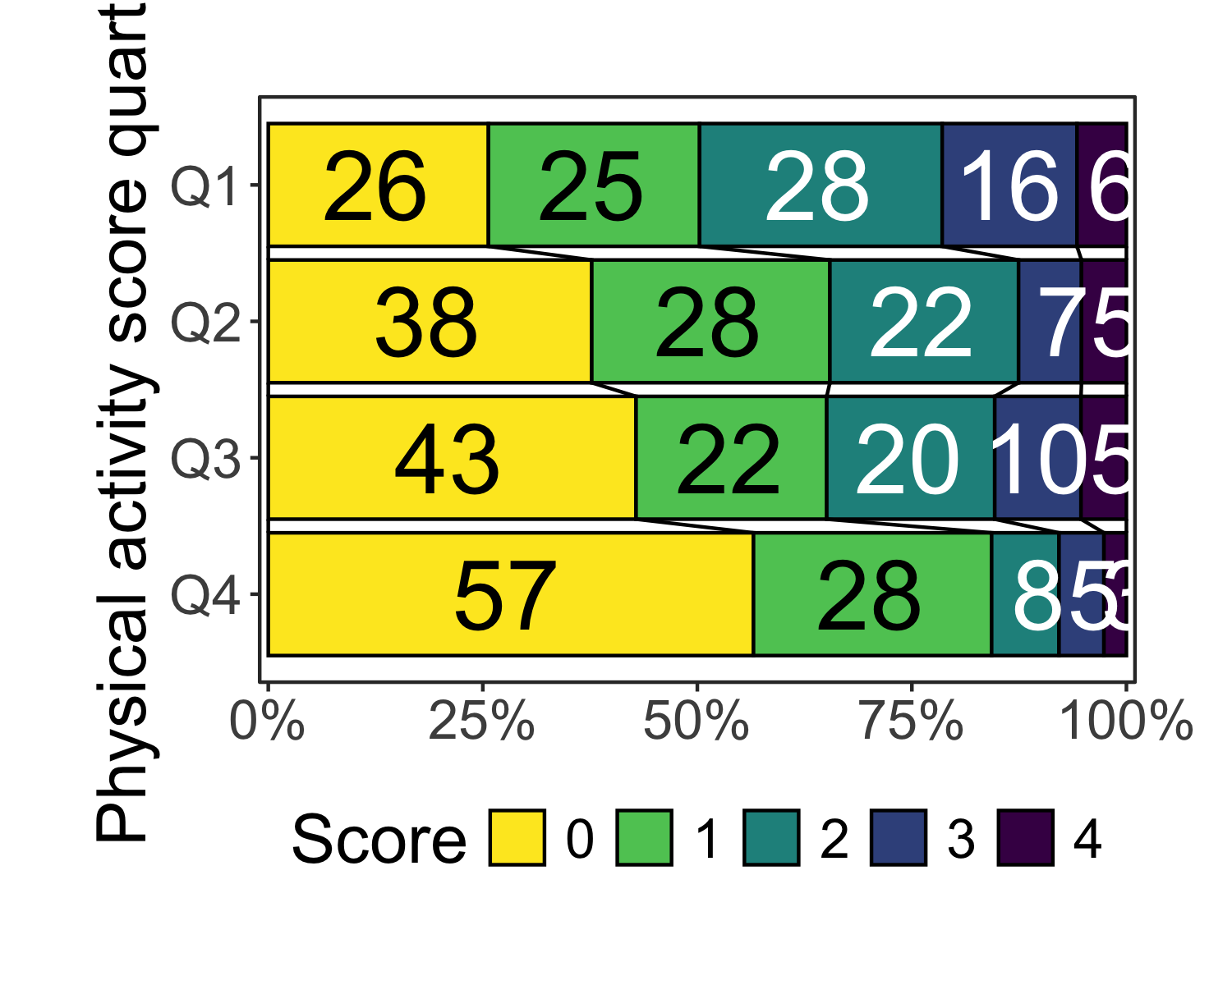

## Baseline table and distribution stratified by sex

|  | FEMALE | | | | | |
| --- | --- | --- | --- | --- | --- | --- |
| **Characteristic** | **Overall** N = 279 | **Q1** N = 85 | **Q2** N = 89 | **Q3** N = 58 | **Q4** N = 47 | **p-value***1* |
| SVD score, Median (IQR) | 1 (0 – 2) | 2 (1 – 2) | 1 (0 – 2) | 1 (0 – 2) | 0 (0 – 1) | <0.001 |
| SVD score features |  |  |  |  |  |  |
| Microbleeds (≥1), n (%) | 57 (20) | 20 (24) | 15 (17) | 15 (26) | 7 (15) | 0.37 |
| Lacunes (≥1), n (%) | 77 (28) | 26 (31) | 24 (27) | 16 (28) | 11 (23) | 0.85 |
| Begininng-large confluenting areas of WMH (Fazekas 2-3), n (%) | 118 (42) | 48 (56) | 38 (43) | 23 (40) | 9 (19) | <0.001 |
| Moderate-severe global atrophy (GCA 2-3), n (%) | 77 (28) | 44 (52) | 19 (21) | 10 (17) | 4 (8.5) | <0.001 |
| Age, Median (IQR) | 75 (64 – 80) | 79 (73 – 85) | 77 (69 – 80) | 71 (61 – 76) | 65 (49 – 72) | <0.001 |
| Living alone, n (%) | 120 (43) | 41 (48) | 38 (43) | 29 (51) | 12 (26) | 0.041 |
| Missing | 1 | 0 | 0 | 1 | 0 |  |
| Smoking, n (%) |  |  |  |  |  | 0.90 |
| never | 113 (42) | 31 (39) | 37 (44) | 24 (43) | 21 (45) |  |
| current | 70 (26) | 20 (25) | 20 (24) | 17 (30) | 13 (28) |  |
| prior | 85 (32) | 29 (36) | 28 (33) | 15 (27) | 13 (28) |  |
| Missing | 11 | 5 | 4 | 2 | 0 |  |
| High alcohol consumption, n (%) | 17 (6.3) | 8 (9.9) | 3 (3.5) | 6 (11) | 0 (0) | 0.032 |
| Missing | 9 | 4 | 3 | 2 | 0 |  |
| Hypertension, n (%) | 157 (56) | 58 (68) | 51 (57) | 28 (48) | 20 (43) | 0.018 |
| Diabetes, n (%) | 20 (7.2) | 9 (11) | 6 (6.7) | 3 (5.2) | 2 (4.3) | 0.56 |
| Previous ischemic event, n (%) | 34 (12) | 13 (15) | 10 (11) | 8 (14) | 3 (6.4) | 0.48 |
| Atrial fibrillation, n (%) | 43 (15) | 17 (20) | 14 (16) | 7 (12) | 5 (11) | 0.44 |
| Previous MI, n (%) | 16 (5.7) | 4 (4.7) | 6 (6.7) | 5 (8.6) | 1 (2.1) | 0.53 |
| Pre-stroke mRS, n (%) |  |  |  |  |  |  |
| 0 | 215 (77) | 50 (59) | 72 (81) | 50 (86) | 43 (91) |  |
| 1 | 31 (11) | 13 (15) | 9 (10) | 6 (10) | 3 (6.4) |  |
| 2 | 28 (10) | 18 (21) | 7 (7.9) | 2 (3.4) | 1 (2.1) |  |
| 3 | 5 (1.8) | 4 (4.7) | 1 (1.1) | 0 (0) | 0 (0) |  |
| *1*Kruskal-Wallis rank sum test; Pearson's Chi-squared test; Fisher's exact test | | | | | | |

|  | MALE | | | | | |
| --- | --- | --- | --- | --- | --- | --- |
| **Characteristic** | **Overall** N = 483 | **Q1** N = 106 | **Q2** N = 102 | **Q3** N = 131 | **Q4** N = 144 | **p-value***1* |
| SVD score, Median (IQR) | 1 (0 – 2) | 1 (0 – 2) | 1 (0 – 2) | 1 (0 – 2) | 0 (0 – 1) | <0.001 |
| SVD score features |  |  |  |  |  |  |
| Microbleeds (≥1), n (%) | 92 (19) | 22 (21) | 22 (22) | 32 (24) | 16 (11) | 0.030 |
| Lacunes (≥1), n (%) | 164 (34) | 45 (42) | 36 (35) | 45 (34) | 38 (26) | 0.066 |
| Begininng-large confluenting areas of WMH (Fazekas 2-3), n (%) | 125 (26) | 30 (28) | 31 (30) | 35 (27) | 29 (20) | 0.27 |
| Moderate-severe global atrophy (GCA 2-3), n (%) | 144 (30) | 54 (51) | 34 (33) | 37 (28) | 19 (13) | <0.001 |
| Age, Median (IQR) | 70 (61 – 77) | 74 (64 – 81) | 73 (64 – 78) | 70 (63 – 76) | 64 (57 – 73) | <0.001 |
| Living alone, n (%) | 83 (17) | 29 (28) | 16 (16) | 16 (12) | 22 (15) | 0.013 |
| Missing | 3 | 1 | 2 | 0 | 0 |  |
| Smoking, n (%) |  |  |  |  |  | 0.55 |
| never | 156 (33) | 26 (25) | 38 (38) | 45 (35) | 47 (33) |  |
| current | 141 (30) | 36 (35) | 25 (25) | 36 (28) | 44 (31) |  |
| prior | 177 (37) | 41 (40) | 38 (38) | 47 (37) | 51 (36) |  |
| Missing | 9 | 3 | 1 | 3 | 2 |  |
| High alcohol consumption, n (%) | 52 (11) | 11 (11) | 16 (16) | 14 (11) | 11 (7.7) | 0.26 |
| Missing | 6 | 2 | 1 | 1 | 2 |  |
| Hypertension, n (%) | 261 (54) | 65 (61) | 63 (62) | 68 (52) | 65 (45) | 0.023 |
| Diabetes, n (%) | 65 (13) | 18 (17) | 21 (21) | 16 (12) | 10 (6.9) | 0.012 |
| Previous ischemic event, n (%) | 63 (13) | 17 (16) | 14 (14) | 19 (15) | 13 (9.0) | 0.37 |
| Atrial fibrillation, n (%) | 73 (15) | 17 (16) | 15 (15) | 22 (17) | 19 (13) | 0.85 |
| Previous MI, n (%) | 42 (8.7) | 7 (6.6) | 7 (6.9) | 14 (11) | 14 (9.7) | 0.60 |
| Pre-stroke mRS, n (%) |  |  |  |  |  |  |
| 0 | 390 (81) | 71 (67) | 78 (76) | 109 (83) | 132 (92) |  |
| 1 | 58 (12) | 16 (15) | 13 (13) | 17 (13) | 12 (8.3) |  |
| 2 | 33 (6.8) | 17 (16) | 11 (11) | 5 (3.8) | 0 (0) |  |
| 3 | 2 (0.4) | 2 (1.9) | 0 (0) | 0 (0) | 0 (0) |  |
| *1*Kruskal-Wallis rank sum test; Pearson's Chi-squared test | | | | | | |

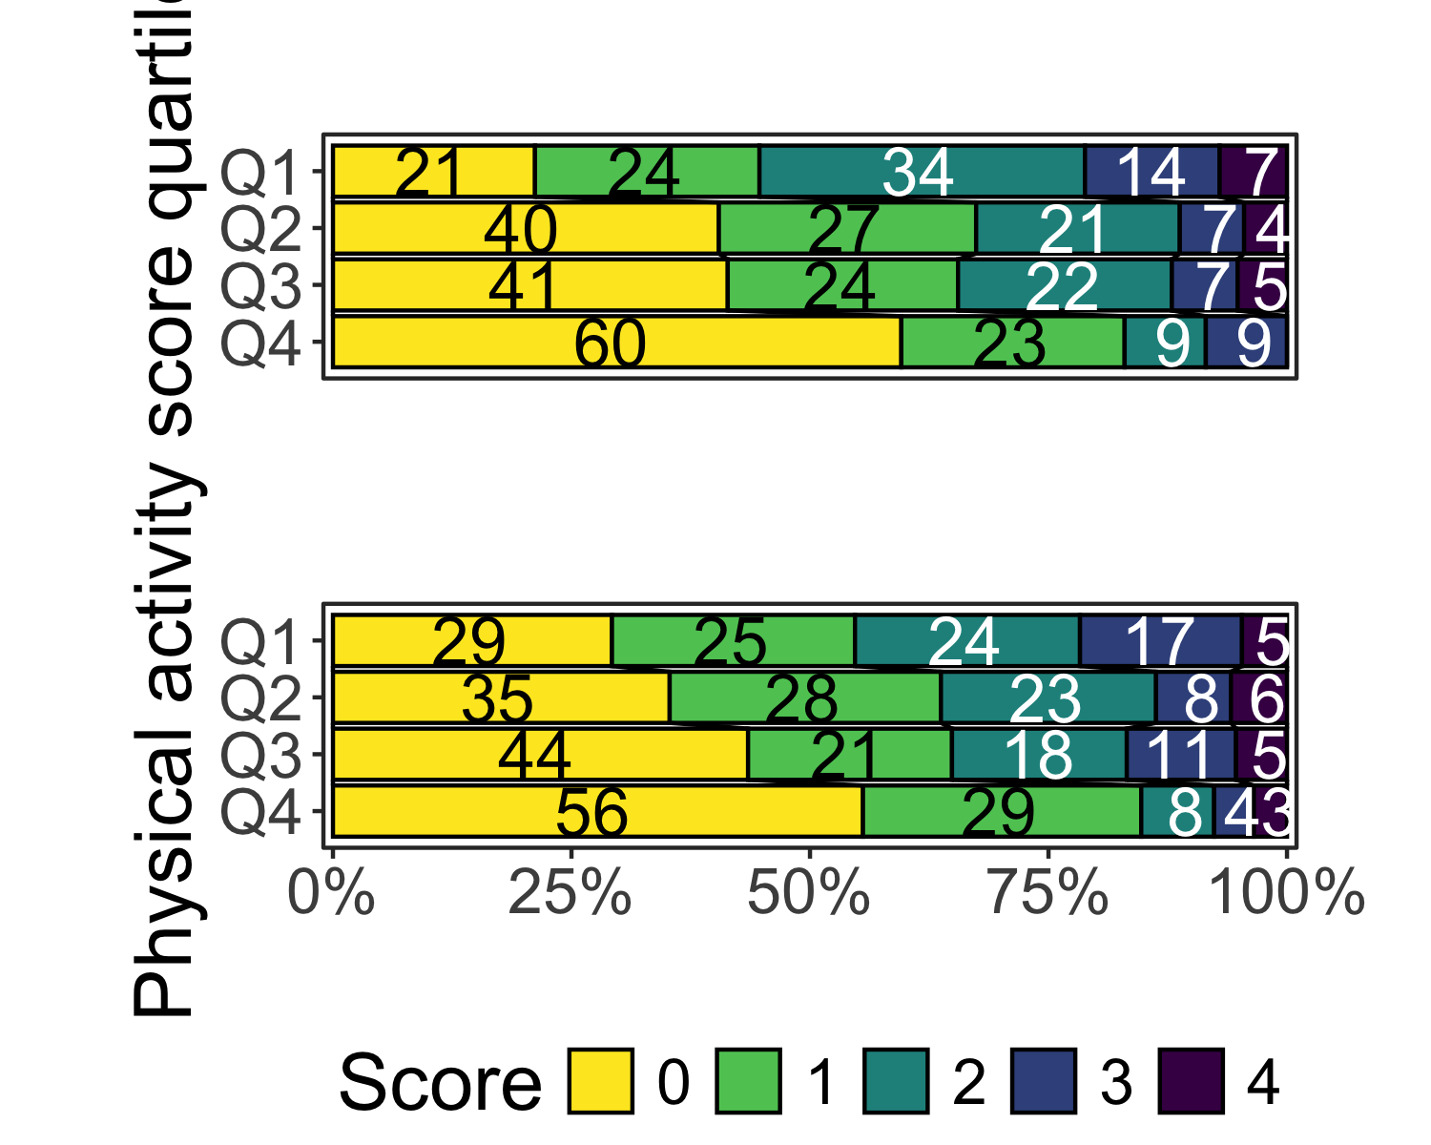

# Regression analyses

Below are a few simple comparisons of splitting PASE by overall PASE or stratified by sex.

# A tibble: 3 × 7  
 edf logLik AIC BIC deviance df.residual nobs  
 <int> <dbl> <dbl> <dbl> <dbl> <dbl> <dbl>  
1 7 -1042. 2098. 2131. 2084. 755 762  
2 9 -954. 1925. 1967. 1907. 753 762  
3 21 -889. 1820. 1916. 1778. 712 733

|  | Univariable | Minimal | Multivariable |
| --- | --- | --- | --- |
| **Characteristic** | **OR** **(95% CI)***1* | **OR** **(95% CI)***1* | **OR** **(95% CI)***1* |
| Pre-stroke PA quartile |  |  |  |
| Q1 | — | — | — |
| Q2 | 0.57 (0.39 to 0.81) | 0.64 (0.44 to 0.93) | 0.63 (0.43 to 0.93) |
| Q3 | 0.52 (0.36 to 0.75) | 0.79 (0.53 to 1.16) | 0.86 (0.57 to 1.29) |
| Q4 | 0.26 (0.17 to 0.37) | 0.51 (0.33 to 0.76) | 0.56 (0.36 to 0.87) |
| *1*OR = Odds Ratio, CI = Confidence Interval | | | |
| Ordinal regression models of SVD burden score as main outcome with PASE score as the main exposure. | | | |

|  | Univariable | Minimal | Multivariable |
| --- | --- | --- | --- |
| **Characteristic** | **OR** **(95% CI)***1* | **OR** **(95% CI)***1* | **OR** **(95% CI)***1* |
| Pre-stroke PA quartile |  |  |  |
| Q1 | — | — | — |
| Q2 | 0.57 (0.39 to 0.81) | 0.64 (0.44 to 0.93) | 0.63 (0.43 to 0.93) |
| Q3 | 0.52 (0.36 to 0.75) | 0.79 (0.53 to 1.16) | 0.86 (0.57 to 1.29) |
| Q4 | 0.26 (0.17 to 0.37) | 0.51 (0.33 to 0.76) | 0.56 (0.36 to 0.87) |
| Age |  | 1.09 (1.07 to 1.10) | 1.09 (1.07 to 1.11) |
| Female sex |  | 0.84 (0.63 to 1.12) | 0.86 (0.62 to 1.18) |
| Living alone |  |  | 1.05 (0.75 to 1.47) |
| Smoking |  |  |  |
| never |  |  | — |
| current |  |  | 1.51 (1.04 to 2.20) |
| prior |  |  | 1.36 (0.97 to 1.90) |
| High alcohol consumption |  |  | 1.32 (0.83 to 2.07) |
| Hypertension |  |  | 1.81 (1.35 to 2.45) |
| Diabetes |  |  | 1.33 (0.85 to 2.07) |
| Previous ischemic event |  |  | 2.06 (1.36 to 3.14) |
| Atrial fibrillation |  |  | 0.56 (0.37 to 0.83) |
| Previous MI |  |  | 0.52 (0.30 to 0.88) |
| Pre-stroke mRS |  |  |  |
| 0 |  |  | — |
| 1 |  |  | 1.04 (0.68 to 1.59) |
| 2 |  |  | 0.98 (0.57 to 1.68) |
| 3 |  |  | 0.56 (0.14 to 2.28) |
| *1*OR = Odds Ratio, CI = Confidence Interval | | | |
| Ordinal regression models of SVD burden score as main outcome with PASE score as the main exposure. | | | |

#### Main analysis by sex

|  | Univariable | Minimal | | Multivariable | |
| --- | --- | --- | --- | --- | --- |
| **Characteristic** | **OR** **(95% CI)***1* | **OR** **(95% CI)***1* | **p-value** | **OR** **(95% CI)***1* | **p-value** |
| MALE | | | | | |
| Pre-stroke PA quartile |  |  |  |  |  |
| Q1 | — | — |  | — |  |
| Q2 | 0.72 (0.44 to 1.17) | 0.73 (0.44 to 1.20) | 0.21 | 0.71 (0.42 to 1.20) | 0.20 |
| Q3 | 0.60 (0.38 to 0.96) | 0.73 (0.45 to 1.19) | 0.21 | 0.86 (0.51 to 1.44) | 0.57 |
| Q4 | 0.31 (0.19 to 0.49) | 0.49 (0.30 to 0.80) | 0.005 | 0.58 (0.34 to 0.97) | 0.040 |
| FEMALE | | | | | |
| Pre-stroke PA quartile |  |  |  |  |  |
| Q1 | — | — |  | — |  |
| Q2 | 0.42 (0.24 to 0.72) | 0.56 (0.32 to 0.98) | 0.044 | 0.51 (0.27 to 0.95) | 0.034 |
| Q3 | 0.43 (0.23 to 0.78) | 0.94 (0.48 to 1.84) | 0.86 | 1.02 (0.48 to 2.13) | 0.96 |
| Q4 | 0.19 (0.09 to 0.38) | 0.59 (0.27 to 1.29) | 0.18 | 0.61 (0.26 to 1.43) | 0.26 |
| *1*OR = Odds Ratio, CI = Confidence Interval | | | | | |
| Ordinal regression models of SVD burden score as main outcome stratified by sex with PASE score as the main exposure. | | | | | |

#### Main analysis only prestroke mRS=0 and no previous event

|  | Univariable | Minimal | Multivariable |
| --- | --- | --- | --- |
| **Characteristic** | **OR** **(95% CI)***1* | **OR** **(95% CI)***1* | **OR** **(95% CI)***1* |
| Pre-stroke PA quartile |  |  |  |
| Q1 | — | — | — |
| Q2 | 0.59 (0.37 to 0.93) | 0.62 (0.39 to 1.00) | 0.65 (0.39 to 1.06) |
| Q3 | 0.55 (0.35 to 0.86) | 0.87 (0.54 to 1.41) | 1.03 (0.62 to 1.70) |
| Q4 | 0.30 (0.19 to 0.47) | 0.62 (0.38 to 1.02) | 0.78 (0.46 to 1.32) |
| *1*OR = Odds Ratio, CI = Confidence Interval | | | |
| Ordinal regression models of SVD burden score as main outcome with PASE score as the main exposure. | | | |

[[1]]

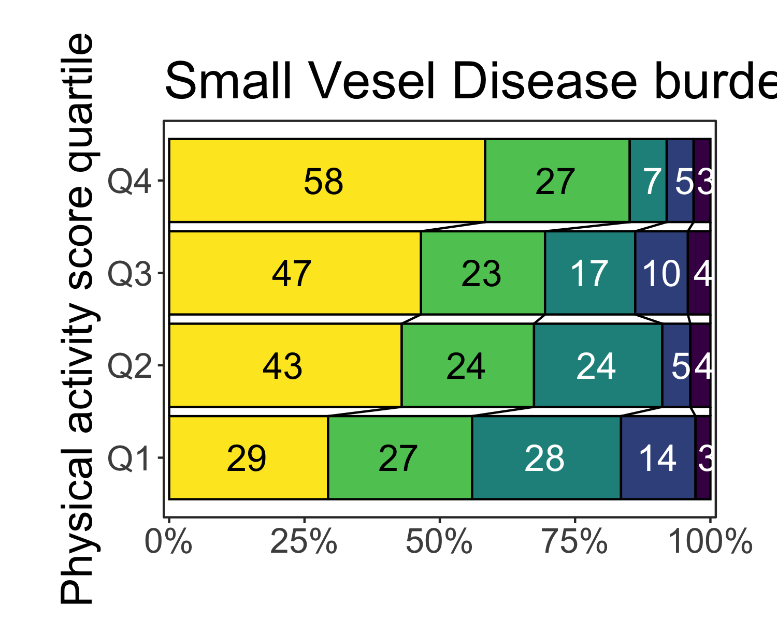

#### Distribution with age stratification

[[1]]

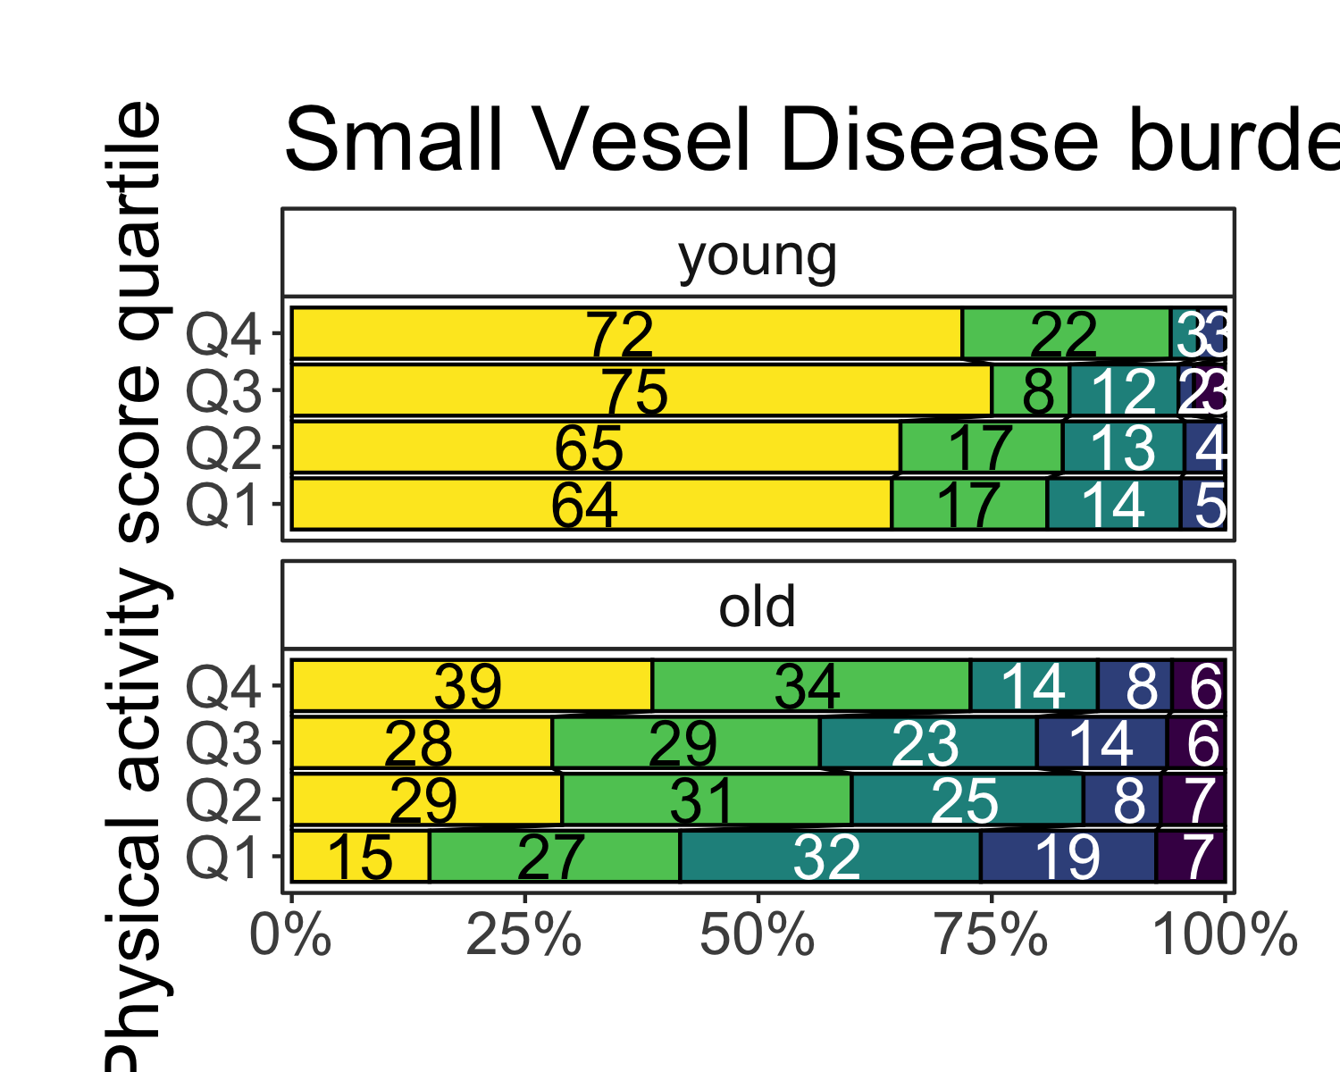

|  | Univariable | Minimal | Multivariable | |
| --- | --- | --- | --- | --- |
| **Characteristic** | **OR** **(95% CI)***1* | **OR** **(95% CI)***1* | **OR** **(95% CI)***1* | **p-value** |
| young (≤65) | | | | |
| Pre-stroke PA quartile |  |  |  |  |
| Q1 | — | — | — |  |
| Q2 | 0.94 (0.40 to 2.24) | 0.77 (0.32 to 1.85) | 0.61 (0.22 to 1.64) | 0.32 |
| Q3 | 0.63 (0.27 to 1.49) | 0.54 (0.23 to 1.30) | 0.83 (0.32 to 2.15) | 0.69 |
| Q4 | 0.63 (0.30 to 1.36) | 0.52 (0.24 to 1.13) | 0.75 (0.32 to 1.78) | 0.52 |
| old (>65) | | | | |
| Pre-stroke PA quartile |  |  |  |  |
| Q1 | — | — | — |  |
| Q2 | 0.50 (0.33 to 0.75) | 0.64 (0.42 to 0.96) | 0.62 (0.40 to 0.95) | 0.030 |
| Q3 | 0.57 (0.37 to 0.87) | 0.93 (0.59 to 1.45) | 0.94 (0.58 to 1.52) | 0.80 |
| Q4 | 0.32 (0.19 to 0.51) | 0.51 (0.31 to 0.84) | 0.50 (0.29 to 0.86) | 0.013 |
| *1*OR = Odds Ratio, CI = Confidence Interval | | | | |
| Ordinal regression models of SVD burden score as main outcome stratified by age (≤65 or >65 years of age) with PASE score as the main exposure. | | | | |

#### Baseline and distribution with trial stratification

| **Characteristic** | **Overall** N = 762 | **RESIST** N = 397 | **TALOS** N = 365 | **p-value***1* |
| --- | --- | --- | --- | --- |
| SVD score, Median (IQR) | 1 (0 – 2) | 1 (0 – 2) | 1 (0 – 2) | 0.006 |
| SVD score features |  |  |  |  |
| Microbleeds (≥1), n (%) | 149 (20) | 89 (22) | 60 (16) | 0.038 |
| Lacunes (≥1), n (%) | 241 (32) | 139 (35) | 102 (28) | 0.036 |
| Begininng-large confluenting areas of WMH (Fazekas 2-3), n (%) | 243 (32) | 122 (31) | 121 (33) | 0.47 |
| Moderate-severe global atrophy (GCA 2-3), n (%) | 221 (29) | 147 (37) | 74 (20) | <0.001 |
| Age, Median (IQR) | 71 (62 – 79) | 73 (63 – 80) | 70 (60 – 78) | <0.001 |
| Female sex, n (%) | 279 (37) | 143 (36) | 136 (37) | 0.72 |
| Living alone, n (%) | 203 (27) | 102 (26) | 101 (28) | 0.53 |
| Missing | 4 | 2 | 2 |  |
| Smoking, n (%) |  |  |  | 0.004 |
| never | 269 (36) | 157 (41) | 112 (31) |  |
| current | 211 (28) | 91 (24) | 120 (33) |  |
| prior | 262 (35) | 135 (35) | 127 (35) |  |
| Missing | 20 | 14 | 6 |  |
| High alcohol consumption, n (%) | 69 (9.2) | 43 (11) | 26 (7.3) | 0.074 |
| Missing | 15 | 8 | 7 |  |
| Hypertension, n (%) | 418 (55) | 241 (61) | 177 (48) | <0.001 |
| Diabetes, n (%) | 85 (11) | 46 (12) | 39 (11) | 0.69 |
| Previous ischemic event, n (%) | 97 (13) | 84 (21) | 13 (3.6) | <0.001 |
| Atrial fibrillation, n (%) | 116 (15) | 50 (13) | 66 (18) | 0.035 |
| Previous MI, n (%) | 58 (7.6) | 28 (7.1) | 30 (8.2) | 0.54 |
| Pre-stroke mRS, n (%) |  |  |  | 0.048 |
| 0 | 605 (79) | 306 (77) | 299 (82) |  |
| 1 | 89 (12) | 46 (12) | 43 (12) |  |
| 2 | 61 (8.0) | 42 (11) | 19 (5.2) |  |
| 3 | 7 (0.9) | 3 (0.8) | 4 (1.1) |  |
| *1*Wilcoxon rank sum test; Pearson's Chi-squared test; Fisher's exact test | | | | |

[[1]]



|  | Univariable | Minimal | Multivariable | |
| --- | --- | --- | --- | --- |
| **Characteristic** | **OR** **(95% CI)***1* | **OR** **(95% CI)***1* | **OR** **(95% CI)***1* | **p-value** |
| RESIST | | | | |
| Pre-stroke PA quartile |  |  |  |  |
| Q1 | — | — | — |  |
| Q2 | 0.45 (0.28 to 0.71) | 0.54 (0.34 to 0.88) | 0.49 (0.29 to 0.82) | 0.007 |
| Q3 | 0.43 (0.27 to 0.70) | 0.68 (0.41 to 1.13) | 0.68 (0.38 to 1.20) | 0.18 |
| Q4 | 0.30 (0.16 to 0.55) | 0.42 (0.22 to 0.80) | 0.39 (0.19 to 0.78) | 0.008 |
| TALOS | | | | |
| Pre-stroke PA quartile |  |  |  |  |
| Q1 | — | — | — |  |
| Q2 | 0.84 (0.47 to 1.51) | 0.89 (0.49 to 1.61) | 0.91 (0.48 to 1.73) | 0.78 |
| Q3 | 0.71 (0.40 to 1.26) | 1.03 (0.56 to 1.88) | 1.08 (0.56 to 2.08) | 0.82 |
| Q4 | 0.28 (0.16 to 0.48) | 0.60 (0.33 to 1.08) | 0.66 (0.35 to 1.25) | 0.20 |
| *1*OR = Odds Ratio, CI = Confidence Interval | | | | |
| Ordinal regression models of SVD burden score as main outcome stratified by trial (TALOS or RESIST) with PASE score as the main exposure. | | | | |

## Collinearity

$Minimal  
 GVIF Df GVIF^(1/(2*Df))  
pase_0_q 1.118269 3 1.018805  
age 1.096519 1 1.047148  
female_sex 1.056963 1 1.028087  
  
$Multivariable  
 GVIF Df GVIF^(1/(2*Df))  
age 1.339153 1 1.157218  
female_sex 1.194430 1 1.092900  
alone 1.187316 1 1.089640  
smoker 1.177645 2 1.041726  
alc_more 1.057068 1 1.028138  
hyperten 1.070810 1 1.034799  
diabetes 1.089418 1 1.043752  
ais_tci 1.056076 1 1.027655  
afib 1.081912 1 1.040150  
ami 1.039621 1 1.019618  
mrs_pre 1.242462 3 1.036845  
pase_0_q 1.226974 3 1.034680  
  
$Minimal  
 GVIF Df GVIF^(1/(2*Df))  
pase_0_q 1.086870 3 1.013981  
age 1.114576 1 1.055735  
female_sex 1.027530 1 1.013672  
  
$Multivariable  
 GVIF Df GVIF^(1/(2*Df))  
age 1.363665 1 1.167761  
female_sex 1.166529 1 1.080060  
alone 1.186442 1 1.089239  
smoker 1.181626 2 1.042606  
alc_more 1.058718 1 1.028940  
hyperten 1.068780 1 1.033818  
diabetes 1.091807 1 1.044896  
ais_tci 1.058808 1 1.028984  
afib 1.078634 1 1.038573  
ami 1.037333 1 1.018495  
mrs_pre 1.260556 3 1.039347  
pase_0_q 1.217929 3 1.033404

## Model performances

# Comparison of Model Performance Indices  
  
Name | Model | AIC (weights) | AICc (weights) | BIC (weights)  
------------------------------------------------------------------------  
Univariable | polr | 2098.2 (<.001) | 2098.4 (<.001) | 2130.7 (<.001)  
Minimal | polr | 1925.4 (<.001) | 1925.7 (<.001) | 1967.1 (<.001)  
Multivariable | polr | 1819.6 (0.120) | 1820.9 (0.120) | 1916.1 (0.120)  
Univariable | polr | 2095.1 (<.001) | 2095.2 (<.001) | 2127.5 (<.001)  
Minimal | polr | 1920.9 (<.001) | 1921.1 (<.001) | 1962.6 (<.001)  
Multivariable | polr | 1815.6 (0.880) | 1816.9 (0.880) | 1912.1 (0.880)  
  
Name | RMSE | Sigma  
-----------------------------  
Univariable | 1.504 | 1.657  
Minimal | 1.508 | 1.587  
Multivariable | 1.503 | 1.576  
Univariable | 1.504 | 1.656  
Minimal | 1.508 | 1.585  
Multivariable | 1.503 | 1.574

# A tibble: 1 × 7  
 edf logLik AIC BIC deviance df.residual nobs  
 <int> <dbl> <dbl> <dbl> <dbl> <dbl> <dbl>  
1 21 -889. 1820. 1916. 1778. 712 733

# A tibble: 1 × 7  
 edf logLik AIC BIC deviance df.residual nobs  
 <int> <dbl> <dbl> <dbl> <dbl> <dbl> <dbl>  
1 21 -887. 1816. 1912. 1774. 712 733

## Archive

### Baseline table and distribution based on stratified PASE cuts (by sex)

| **Characteristic** | **Overall** N = 762 | **Q1** N = 191 | **Q2** N = 191 | **Q3** N = 189 | **Q4** N = 191 | **p-value***1* |
| --- | --- | --- | --- | --- | --- | --- |
| SVD score, Median (IQR) | 1 (0 – 2) | 2 (1 – 2) | 1 (0 – 2) | 1 (0 – 2) | 0 (0 – 1) | <0.001 |
| SVD score features |  |  |  |  |  |  |
| Microbleeds (≥1), n (%) | 149 (20) | 42 (22) | 41 (21) | 38 (20) | 28 (15) | 0.25 |
| Lacunes (≥1), n (%) | 241 (32) | 78 (41) | 51 (27) | 62 (33) | 50 (26) | 0.006 |
| Begininng-large confluenting areas of WMH (Fazekas 2-3), n (%) | 243 (32) | 81 (42) | 60 (31) | 60 (32) | 42 (22) | <0.001 |
| Moderate-severe global atrophy (GCA 2-3), n (%) | 221 (29) | 98 (51) | 58 (30) | 43 (23) | 22 (12) | <0.001 |
| Age, Median (IQR) | 71 (62 – 79) | 76 (67 – 83) | 74 (66 – 80) | 70 (63 – 77) | 64 (55 – 73) | <0.001 |
| Female sex, n (%) | 279 (37) | 70 (37) | 70 (37) | 69 (37) | 70 (37) | >0.99 |
| Living alone, n (%) | 203 (27) | 66 (35) | 49 (26) | 45 (24) | 43 (23) | 0.033 |
| Missing | 4 | 1 | 2 | 1 | 0 |  |
| Smoking, n (%) |  |  |  |  |  | 0.24 |
| never | 269 (36) | 53 (29) | 71 (38) | 74 (40) | 71 (38) |  |
| current | 211 (28) | 59 (32) | 44 (24) | 53 (28) | 55 (29) |  |
| prior | 262 (35) | 71 (39) | 70 (38) | 59 (32) | 62 (33) |  |
| Missing | 20 | 8 | 6 | 3 | 3 |  |
| High alcohol consumption, n (%) | 69 (9.2) | 21 (11) | 20 (11) | 20 (11) | 8 (4.3) | 0.058 |
| Missing | 15 | 6 | 4 | 2 | 3 |  |
| Hypertension, n (%) | 418 (55) | 119 (62) | 116 (61) | 99 (52) | 84 (44) | <0.001 |
| Diabetes, n (%) | 85 (11) | 28 (15) | 26 (14) | 21 (11) | 10 (5.2) | 0.016 |
| Previous ischemic event, n (%) | 97 (13) | 31 (16) | 23 (12) | 29 (15) | 14 (7.3) | 0.039 |
| Atrial fibrillation, n (%) | 116 (15) | 30 (16) | 31 (16) | 33 (17) | 22 (12) | 0.40 |
| Previous MI, n (%) | 58 (7.6) | 10 (5.2) | 15 (7.9) | 17 (9.0) | 16 (8.4) | 0.53 |
| Pre-stroke mRS, n (%) |  |  |  |  |  |  |
| 0 | 605 (79) | 118 (62) | 156 (82) | 156 (83) | 175 (92) |  |
| 1 | 89 (12) | 31 (16) | 19 (9.9) | 24 (13) | 15 (7.9) |  |
| 2 | 61 (8.0) | 36 (19) | 16 (8.4) | 8 (4.2) | 1 (0.5) |  |
| 3 | 7 (0.9) | 6 (3.1) | 0 (0) | 1 (0.5) | 0 (0) |  |
| *1*Kruskal-Wallis rank sum test; Pearson's Chi-squared test | | | | | | |

[[1]]

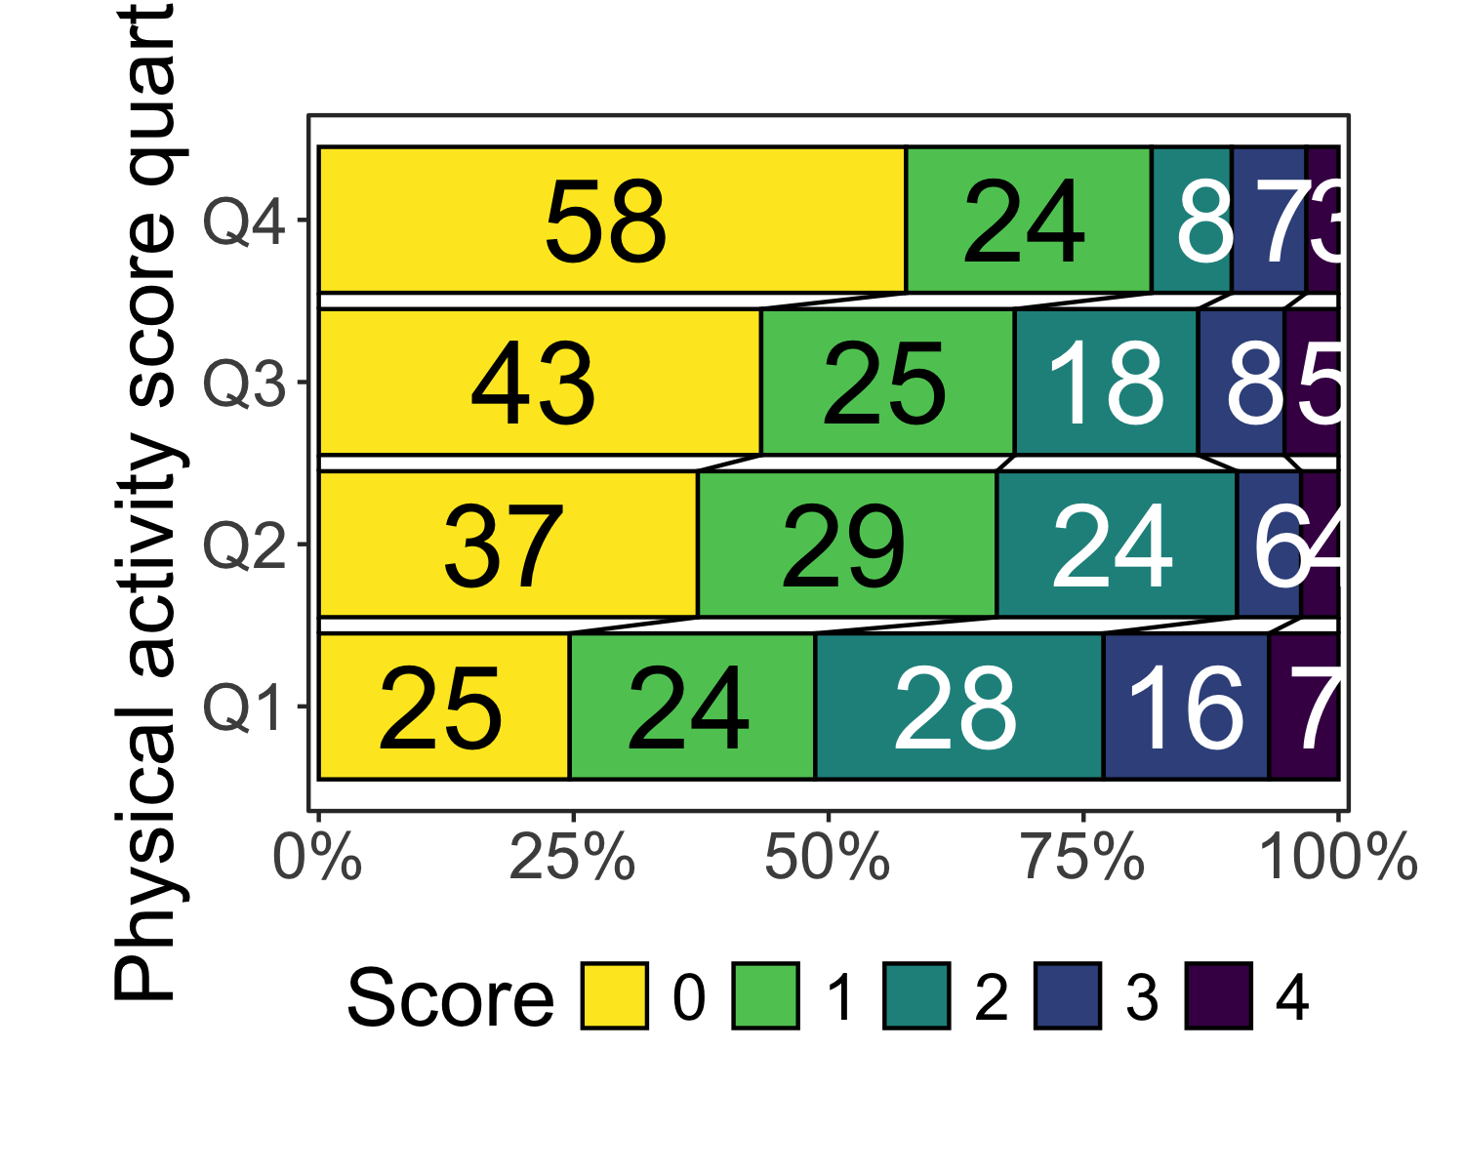

#### Main analysis with PASE cut stratified by sex

|  | Univariable | Minimal | Multivariable |
| --- | --- | --- | --- |
| **Characteristic** | **OR** **(95% CI)***1* | **OR** **(95% CI)***1* | **OR** **(95% CI)***1* |
| Pre-stroke PA quartile |  |  |  |
| Q4 | — | — | — |
| Q3 | 1.85 (1.26 to 2.72) | 1.29 (0.86 to 1.94) | 1.24 (0.81 to 1.90) |
| Q2 | 2.09 (1.44 to 3.06) | 1.05 (0.70 to 1.58) | 0.92 (0.60 to 1.40) |
| Q1 | 4.12 (2.82 to 6.06) | 2.04 (1.36 to 3.08) | 1.83 (1.18 to 2.84) |
| *1*OR = Odds Ratio, CI = Confidence Interval | | | |
| Ordinal regression models of SVD burden score as main outcome with PASE score quartiles cut stratified by sex as the main exposure. | | | |

### Multiple score versions

# Comparison of Model Performance Indices  
  
Name | Model | AIC (weights) | AICc (weights)  
------------------------------------------------------------------------  
atrophy | lm | 701.1 (>.999) | 701.2 (>.999)  
lacunes | lm | 974.5 (<.001) | 974.6 (<.001)  
microbleed | lm | 745.0 (<.001) | 745.1 (<.001)  
wmh | lm | 881.4 (<.001) | 881.5 (<.001)  
atrophy_lacunes | lm | 1501.2 (<.001) | 1501.3 (<.001)  
atrophy_microbleed | lm | 1275.1 (<.001) | 1275.2 (<.001)  
atrophy_wmh | lm | 1436.7 (<.001) | 1436.8 (<.001)  
lacunes_microbleed | lm | 1569.2 (<.001) | 1569.4 (<.001)  
lacunes_wmh | lm | 1643.9 (<.001) | 1644.1 (<.001)  
microbleed_wmh | lm | 1484.4 (<.001) | 1484.5 (<.001)  
atrophy_lacunes_microbleed | lm | 1866.5 (<.001) | 1866.6 (<.001)  
atrophy_lacunes_wmh | lm | 1961.9 (<.001) | 1962.0 (<.001)  
atrophy_microbleed_wmh | lm | 1798.0 (<.001) | 1798.2 (<.001)  
lacunes_microbleed_wmh | lm | 2015.0 (<.001) | 2015.1 (<.001)  
atrophy_lacunes_microbleed_wmh | lm | 2232.2 (<.001) | 2232.3 (<.001)  
  
Name | BIC (weights) | R2 | R2 (adj.) | RMSE | Sigma  
-----------------------------------------------------------------------------------  
atrophy | 733.5 (>.999) | 0.299 | 0.295 | 0.380 | 0.381  
lacunes | 1006.9 (<.001) | 0.045 | 0.039 | 0.454 | 0.456  
microbleed | 777.4 (<.001) | 0.029 | 0.022 | 0.391 | 0.392  
wmh | 913.8 (<.001) | 0.159 | 0.153 | 0.428 | 0.429  
atrophy_lacunes | 1533.6 (<.001) | 0.222 | 0.217 | 0.642 | 0.645  
atrophy_microbleed | 1307.5 (<.001) | 0.233 | 0.228 | 0.554 | 0.556  
atrophy_wmh | 1469.1 (<.001) | 0.315 | 0.311 | 0.615 | 0.618  
lacunes_microbleed | 1601.7 (<.001) | 0.052 | 0.046 | 0.671 | 0.674  
lacunes_wmh | 1676.4 (<.001) | 0.124 | 0.118 | 0.705 | 0.708  
microbleed_wmh | 1516.8 (<.001) | 0.128 | 0.122 | 0.635 | 0.638  
atrophy_lacunes_microbleed | 1898.9 (<.001) | 0.194 | 0.188 | 0.816 | 0.819  
atrophy_lacunes_wmh | 1994.4 (<.001) | 0.254 | 0.249 | 0.869 | 0.872  
atrophy_microbleed_wmh | 1830.5 (<.001) | 0.271 | 0.266 | 0.780 | 0.783  
lacunes_microbleed_wmh | 2047.4 (<.001) | 0.116 | 0.110 | 0.899 | 0.903  
atrophy_lacunes_microbleed_wmh | 2264.6 (<.001) | 0.229 | 0.224 | 1.037 | 1.041

### TOAST strat

| **Characteristic** | **Overall** N = 762 | **RESIST** N = 397 | **TALOS** N = 365 | **p-value***1* |
| --- | --- | --- | --- | --- |
| SVD score, Median (IQR) | 1 (0 – 2) | 1 (0 – 2) | 1 (0 – 2) | 0.006 |
| SVD score features |  |  |  |  |
| Microbleeds (≥1), n (%) | 149 (20) | 89 (22) | 60 (16) | 0.038 |
| Lacunes (≥1), n (%) | 241 (32) | 139 (35) | 102 (28) | 0.036 |
| Begininng-large confluenting areas of WMH (Fazekas 2-3), n (%) | 243 (32) | 122 (31) | 121 (33) | 0.47 |
| Moderate-severe global atrophy (GCA 2-3), n (%) | 221 (29) | 147 (37) | 74 (20) | <0.001 |
| Age, Median (IQR) | 71 (62 – 79) | 73 (63 – 80) | 70 (60 – 78) | <0.001 |
| Female sex, n (%) | 279 (37) | 143 (36) | 136 (37) | 0.72 |
| Living alone, n (%) | 203 (27) | 102 (26) | 101 (28) | 0.53 |
| Missing | 4 | 2 | 2 |  |
| Smoking, n (%) |  |  |  | 0.004 |
| never | 269 (36) | 157 (41) | 112 (31) |  |
| current | 211 (28) | 91 (24) | 120 (33) |  |
| prior | 262 (35) | 135 (35) | 127 (35) |  |
| Missing | 20 | 14 | 6 |  |
| High alcohol consumption, n (%) | 69 (9.2) | 43 (11) | 26 (7.3) | 0.074 |
| Missing | 15 | 8 | 7 |  |
| Hypertension, n (%) | 418 (55) | 241 (61) | 177 (48) | <0.001 |
| Diabetes, n (%) | 85 (11) | 46 (12) | 39 (11) | 0.69 |
| Previous ischemic event, n (%) | 97 (13) | 84 (21) | 13 (3.6) | <0.001 |
| Atrial fibrillation, n (%) | 116 (15) | 50 (13) | 66 (18) | 0.035 |
| Previous MI, n (%) | 58 (7.6) | 28 (7.1) | 30 (8.2) | 0.54 |
| Pre-stroke mRS, n (%) |  |  |  | 0.048 |
| 0 | 605 (79) | 306 (77) | 299 (82) |  |
| 1 | 89 (12) | 46 (12) | 43 (12) |  |
| 2 | 61 (8.0) | 42 (11) | 19 (5.2) |  |
| 3 | 7 (0.9) | 3 (0.8) | 4 (1.1) |  |
| Pre-stroke PA quartile, n (%) |  |  |  | <0.001 |
| Q4 | 191 (25) | 52 (13) | 139 (38) |  |
| Q3 | 189 (25) | 106 (27) | 83 (23) |  |
| Q2 | 191 (25) | 121 (30) | 70 (19) |  |
| Q1 | 191 (25) | 118 (30) | 73 (20) |  |
| toast, n (%) |  |  |  | <0.001 |
| Large artery disease | 101 (21) | 79 (20) | 22 (24) |  |
| Small vessel disease | 81 (17) | 65 (16) | 16 (17) |  |
| Cardioembolic | 79 (16) | 58 (15) | 21 (23) |  |
| Other | 187 (38) | 181 (46) | 6 (6.5) |  |
| Unknown | 41 (8.4) | 14 (3.5) | 27 (29) |  |
| Missing | 273 | 0 | 273 |  |
| *1*Wilcoxon rank sum test; Pearson's Chi-squared test; Fisher's exact test | | | | |

[[1]]

