Small vessel disease burden in acute ischemic stroke - the role of physical activity and vascular risk factors

These are the planned analyses, tables and figures for the main article.

Drop all the questions and save them for a later specific publication.

Agreed upon scoring overview:

| Annotation | modified Huijts et al 2013 |
| --- | --- |
| Microbleeds subscore | |
| 0 | 0 |
| 1 | 1 |
| 2-4 | 1 |
| 5-10 | 1 |
| >10 | 1 |
| Lacunes subscore | |
| 0 | 0 |
| 1 | 1 |
| 2 | 1 |
| 3-5 | 1 |
| >5 | 1 |
| WMH subscore | |
| 0: Absent | 0 |
| 1: Punctate foci | 0 |
| 2: Beginning confluence | 1 |
| 3: Large confluent areas | 1 |
| Atrophy subscore | |
| 0: No atrophy | 0 |
| 1: Mild | 0 |
| 2: Moderate | 1 |
| 3: Severe | 1 |

# Baseline table

| **Characteristic** | **Overall** N = 762*1* | **Q1** N = 191*1* | **Q2** N = 191*1* | **Q3** N = 189*1* | **Q4** N = 191*1* | **p-value***2* |
| --- | --- | --- | --- | --- | --- | --- |
| SVD score | 2.00 (1.00, 3.00) | 2.00 (1.00, 3.00) | 2.00 (1.00, 3.00) | 2.00 (1.00, 3.00) | 1.00 (1.00, 2.00) | <0.001 |
| SVD score features |  |  |  |  |  |  |
| Microbleeds (≥1) | 149 (20%) | 42 (22%) | 37 (19%) | 47 (25%) | 23 (12%) | 0.012 |
| Lacunes (≥1) | 241 (32%) | 71 (37%) | 60 (31%) | 61 (32%) | 49 (26%) | 0.12 |
| Begininng-widespread confluenting areas of WMH (Fazekas 2-3) | 243 (32%) | 78 (41%) | 69 (36%) | 58 (31%) | 38 (20%) | <0.001 |
| Moderate-Severe global atrophy (GCA 2-3) | 221 (29%) | 98 (51%) | 53 (28%) | 47 (25%) | 23 (12%) | <0.001 |
| Age | 71 (62, 79) | 77 (67, 84) | 74 (65, 80) | 70 (63, 76) | 64 (55, 73) | <0.001 |
| Female sex | 279 (37%) | 85 (45%) | 89 (47%) | 58 (31%) | 47 (25%) | <0.001 |
| Smoking |  |  |  |  |  | 0.6 |
| never | 269 (36%) | 57 (31%) | 75 (40%) | 69 (38%) | 68 (36%) |  |
| current | 211 (28%) | 56 (31%) | 45 (24%) | 53 (29%) | 57 (30%) |  |
| prior | 262 (35%) | 70 (38%) | 66 (35%) | 62 (34%) | 64 (34%) |  |
| Hypertension | 418 (55%) | 123 (65%) | 114 (60%) | 96 (51%) | 85 (45%) | <0.001 |
| Diabetes | 85 (11%) | 27 (14%) | 27 (14%) | 19 (10%) | 12 (6.3%) | 0.040 |
| Previous ischemic event | 97 (13%) | 30 (16%) | 24 (13%) | 27 (14%) | 16 (8.4%) | 0.14 |
| *1*Median (Q1, Q3); n (%) | | | | | | |
| *2*Kruskal-Wallis rank sum test; Pearson's Chi-squared test | | | | | | |

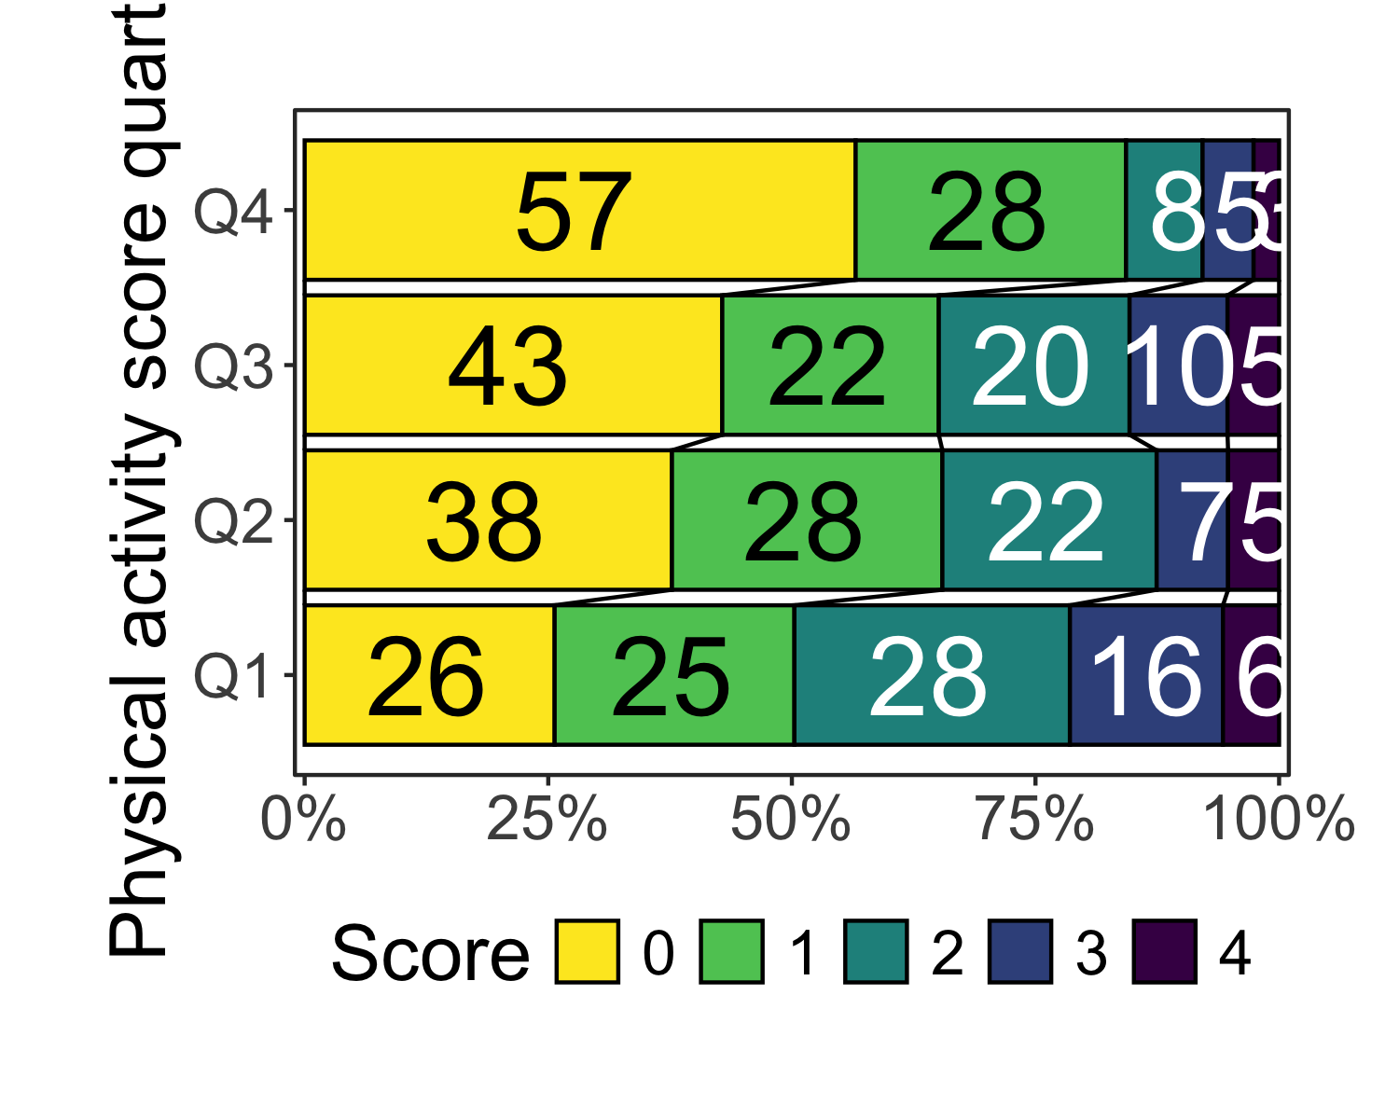

## Baseline table and distribution based on stratified PASE cuts (by sex)

| **Characteristic** | **Overall** N = 762*1* | **Q1** N = 191*1* | **Q2** N = 191*1* | **Q3** N = 189*1* | **Q4** N = 191*1* | **p-value***2* |
| --- | --- | --- | --- | --- | --- | --- |
| SVD score | 2.00 (1.00, 3.00) | 3.00 (2.00, 3.00) | 2.00 (1.00, 3.00) | 2.00 (1.00, 3.00) | 1.00 (1.00, 2.00) | <0.001 |
| SVD score features |  |  |  |  |  |  |
| Microbleeds (≥1) | 149 (20%) | 42 (22%) | 41 (21%) | 38 (20%) | 28 (15%) | 0.2 |
| Lacunes (≥1) | 241 (32%) | 78 (41%) | 51 (27%) | 62 (33%) | 50 (26%) | 0.006 |
| Begininng-widespread confluenting areas of WMH (Fazekas 2-3) | 243 (32%) | 81 (42%) | 60 (31%) | 60 (32%) | 42 (22%) | <0.001 |
| Moderate-Severe global atrophy (GCA 2-3) | 221 (29%) | 98 (51%) | 58 (30%) | 43 (23%) | 22 (12%) | <0.001 |
| Age | 71 (62, 79) | 76 (67, 83) | 74 (66, 80) | 70 (63, 77) | 64 (55, 73) | <0.001 |
| Female sex | 279 (37%) | 70 (37%) | 70 (37%) | 69 (37%) | 70 (37%) | >0.9 |
| Smoking |  |  |  |  |  | 0.2 |
| never | 269 (36%) | 53 (29%) | 71 (38%) | 74 (40%) | 71 (38%) |  |
| current | 211 (28%) | 59 (32%) | 44 (24%) | 53 (28%) | 55 (29%) |  |
| prior | 262 (35%) | 71 (39%) | 70 (38%) | 59 (32%) | 62 (33%) |  |
| Hypertension | 418 (55%) | 119 (63%) | 116 (61%) | 99 (52%) | 84 (44%) | <0.001 |
| Diabetes | 85 (11%) | 28 (15%) | 26 (14%) | 21 (11%) | 10 (5.2%) | 0.016 |
| Previous ischemic event | 97 (13%) | 31 (17%) | 23 (12%) | 29 (15%) | 14 (7.3%) | 0.033 |
| *1*Median (Q1, Q3); n (%) | | | | | | |
| *2*Kruskal-Wallis rank sum test; Pearson's Chi-squared test | | | | | | |

[[1]]

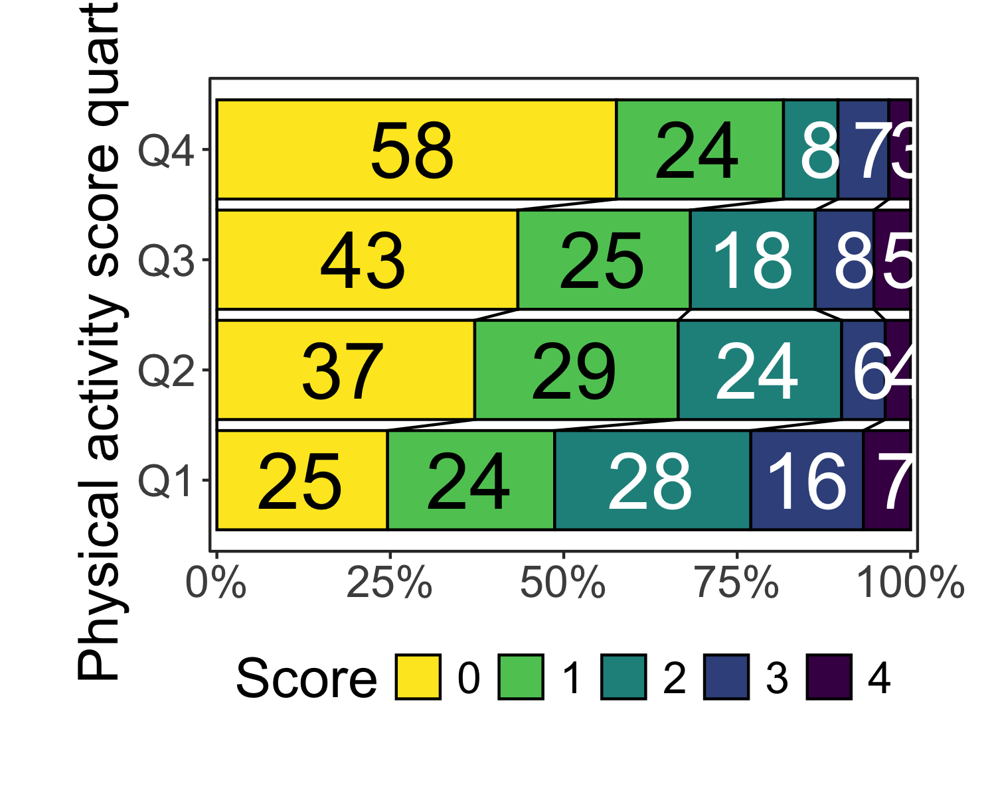

## Baseline table and distribution stratified by sex

|  | FEMALE | | | | | |
| --- | --- | --- | --- | --- | --- | --- |
| **Characteristic** | **Overall** N = 279*1* | **Q1** N = 85*1* | **Q2** N = 89*1* | **Q3** N = 58*1* | **Q4** N = 47*1* | **p-value***2* |
| SVD score | 2.00 (1.00, 3.00) | 3.00 (2.00, 3.00) | 2.00 (1.00, 3.00) | 2.00 (1.00, 3.00) | 1.00 (1.00, 2.00) | <0.001 |
| SVD score features |  |  |  |  |  |  |
| Microbleeds (≥1) | 57 (20%) | 20 (24%) | 15 (17%) | 15 (26%) | 7 (15%) | 0.4 |
| Lacunes (≥1) | 77 (28%) | 26 (31%) | 24 (27%) | 16 (28%) | 11 (23%) | 0.8 |
| Begininng-widespread confluenting areas of WMH (Fazekas 2-3) | 118 (42%) | 48 (56%) | 38 (43%) | 23 (40%) | 9 (19%) | <0.001 |
| Moderate-Severe global atrophy (GCA 2-3) | 77 (28%) | 44 (52%) | 19 (21%) | 10 (17%) | 4 (8.5%) | <0.001 |
| Age | 75 (64, 80) | 79 (73, 85) | 77 (69, 80) | 71 (61, 76) | 65 (49, 72) | <0.001 |
| Smoking |  |  |  |  |  | 0.9 |
| never | 113 (42%) | 31 (39%) | 37 (44%) | 24 (43%) | 21 (45%) |  |
| current | 70 (26%) | 20 (25%) | 20 (24%) | 17 (30%) | 13 (28%) |  |
| prior | 85 (32%) | 29 (36%) | 28 (33%) | 15 (27%) | 13 (28%) |  |
| Hypertension | 157 (56%) | 58 (68%) | 51 (57%) | 28 (48%) | 20 (43%) | 0.018 |
| Diabetes | 20 (7.2%) | 9 (11%) | 6 (6.7%) | 3 (5.2%) | 2 (4.3%) | 0.6 |
| Previous ischemic event | 34 (12%) | 13 (15%) | 10 (11%) | 8 (14%) | 3 (6.4%) | 0.5 |
| *1*Median (Q1, Q3); n (%) | | | | | | |
| *2*Kruskal-Wallis rank sum test; Pearson's Chi-squared test; Fisher's exact test | | | | | | |

|  | MALE | | | | | |
| --- | --- | --- | --- | --- | --- | --- |
| **Characteristic** | **Overall** N = 483*1* | **Q1** N = 106*1* | **Q2** N = 102*1* | **Q3** N = 131*1* | **Q4** N = 144*1* | **p-value***2* |
| SVD score | 2.00 (1.00, 3.00) | 2.00 (1.00, 3.00) | 2.00 (1.00, 3.00) | 2.00 (1.00, 3.00) | 1.00 (1.00, 2.00) | <0.001 |
| SVD score features |  |  |  |  |  |  |
| Microbleeds (≥1) | 92 (19%) | 22 (21%) | 22 (22%) | 32 (24%) | 16 (11%) | 0.030 |
| Lacunes (≥1) | 164 (34%) | 45 (42%) | 36 (35%) | 45 (34%) | 38 (26%) | 0.066 |
| Begininng-widespread confluenting areas of WMH (Fazekas 2-3) | 125 (26%) | 30 (28%) | 31 (30%) | 35 (27%) | 29 (20%) | 0.3 |
| Moderate-Severe global atrophy (GCA 2-3) | 144 (30%) | 54 (51%) | 34 (33%) | 37 (28%) | 19 (13%) | <0.001 |
| Age | 70 (61, 77) | 74 (64, 81) | 73 (64, 78) | 70 (63, 76) | 64 (57, 73) | <0.001 |
| Smoking |  |  |  |  |  | 0.6 |
| never | 156 (33%) | 26 (25%) | 38 (38%) | 45 (35%) | 47 (33%) |  |
| current | 141 (30%) | 36 (35%) | 25 (25%) | 36 (28%) | 44 (31%) |  |
| prior | 177 (37%) | 41 (40%) | 38 (38%) | 47 (37%) | 51 (36%) |  |
| Hypertension | 261 (54%) | 65 (62%) | 63 (62%) | 68 (52%) | 65 (45%) | 0.019 |
| Diabetes | 65 (13%) | 18 (17%) | 21 (21%) | 16 (12%) | 10 (6.9%) | 0.011 |
| Previous ischemic event | 63 (13%) | 17 (17%) | 14 (14%) | 19 (15%) | 13 (9.0%) | 0.3 |
| *1*Median (Q1, Q3); n (%) | | | | | | |
| *2*Kruskal-Wallis rank sum test; Pearson's Chi-squared test | | | | | | |

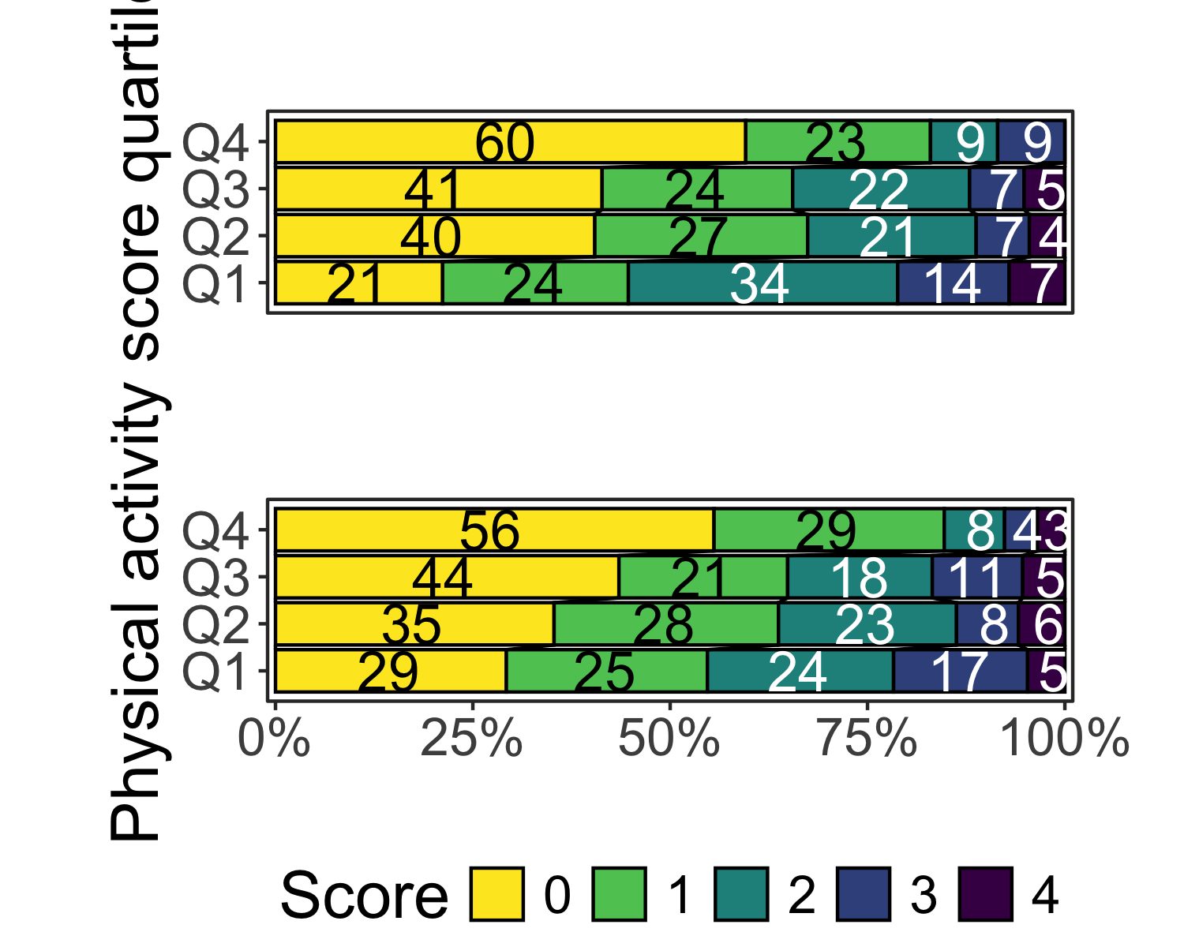

# Regression analyses

Below are a few simple comparisons of splitting PASE by overall PASE or stratified by sex.

|  | Univariable | | Minimal | | Multivariable | |
| --- | --- | --- | --- | --- | --- | --- |
| **Characteristic** | **OR***1* | **95% CI***1* | **OR***1* | **95% CI***1* | **OR***1* | **95% CI***1* |
| Pre-stroke PA quartile |  |  |  |  |  |  |
| Q4 | — | — | — | — | — | — |
| Q3 | 2.04 | 1.39, 3.00 | 1.56 | 1.04, 2.33 | 1.53 | 1.01, 2.32 |
| Q2 | 2.21 | 1.52, 3.23 | 1.27 | 0.85, 1.92 | 1.18 | 0.78, 1.79 |
| Q1 | 3.92 | 2.69, 5.73 | 1.98 | 1.31, 2.99 | 1.78 | 1.16, 2.73 |
| *1*OR = Odds Ratio, CI = Confidence Interval | | | | | | |
| Ordinal regression models of SVD burden score as main outcome with PASE score as the main exposure. | | | | | | |

#### Main analysis by sex

|  | Univariable | | Minimal | | | Multivariable | | |
| --- | --- | --- | --- | --- | --- | --- | --- | --- |
| **Characteristic** | **OR***1* | **95% CI***1* | **OR***1* | **95% CI***1* | **p-value** | **OR***1* | **95% CI***1* | **p-value** |
| MALE | | | | | | | | |
| Pre-stroke PA quartile |  |  |  |  |  |  |  |  |
| Q4 | — | — | — | — |  | — | — |  |
| Q3 | 1.98 | 1.26, 3.10 | 1.50 | 0.94, 2.40 | 0.092 | 1.50 | 0.92, 2.45 | 0.10 |
| Q2 | 2.35 | 1.47, 3.76 | 1.48 | 0.91, 2.43 | 0.12 | 1.37 | 0.82, 2.27 | 0.2 |
| Q1 | 3.27 | 2.06, 5.24 | 2.04 | 1.25, 3.34 | 0.005 | 1.81 | 1.09, 3.02 | 0.023 |
| FEMALE | | | | | | | | |
| Pre-stroke PA quartile |  |  |  |  |  |  |  |  |
| Q4 | — | — | — | — |  | — | — |  |
| Q3 | 2.22 | 1.07, 4.69 | 1.61 | 0.72, 3.59 | 0.2 | 1.54 | 0.68, 3.50 | 0.3 |
| Q2 | 2.17 | 1.11, 4.35 | 0.95 | 0.44, 2.04 | 0.9 | 0.83 | 0.38, 1.82 | 0.6 |
| Q1 | 5.20 | 2.63, 10.5 | 1.71 | 0.77, 3.76 | 0.2 | 1.55 | 0.69, 3.51 | 0.3 |
| *1*OR = Odds Ratio, CI = Confidence Interval | | | | | | | | |
| Ordinal regression models of SVD burden score as main outcome stratified by sex with PASE score as the main exposure. | | | | | | | | |

#### Main analysis with PASE cut stratified by sex

|  | Univariable | | Minimal | | Multivariable | |
| --- | --- | --- | --- | --- | --- | --- |
| **Characteristic** | **OR***1* | **95% CI***1* | **OR***1* | **95% CI***1* | **OR***1* | **95% CI***1* |
| Pre-stroke PA quartile |  |  |  |  |  |  |
| Q4 | — | — | — | — | — | — |
| Q3 | 1.85 | 1.26, 2.72 | 1.29 | 0.86, 1.94 | 1.27 | 0.84, 1.93 |
| Q2 | 2.09 | 1.44, 3.06 | 1.05 | 0.70, 1.58 | 0.96 | 0.63, 1.47 |
| Q1 | 4.12 | 2.82, 6.06 | 2.04 | 1.36, 3.08 | 1.86 | 1.22, 2.85 |
| *1*OR = Odds Ratio, CI = Confidence Interval | | | | | | |
| Ordinal regression models of SVD burden score as main outcome with PASE score quartiles cut stratified by sex as the main exposure. | | | | | | |

#### Distribution with age stratification

[[1]]

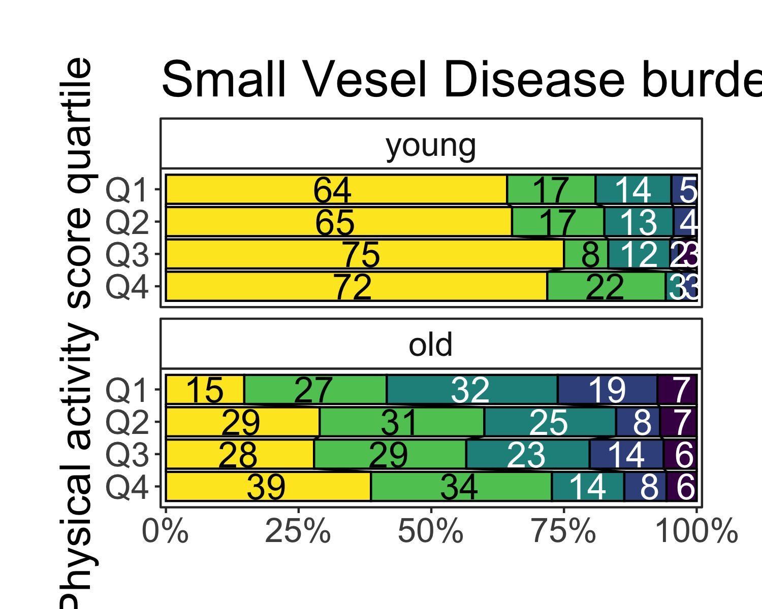

|  | Univariable | | Minimal | | Multivariable | | |
| --- | --- | --- | --- | --- | --- | --- | --- |
| **Characteristic** | **OR***1* | **95% CI***1* | **OR***1* | **95% CI***1* | **OR***1* | **95% CI***1* | **p-value** |
| young | | | | | | | |
| Pre-stroke PA quartile |  |  |  |  |  |  |  |
| Q4 | — | — | — | — | — | — |  |
| Q3 | 1.00 | 0.48, 2.04 | 1.05 | 0.49, 2.16 | 1.10 | 0.51, 2.37 | 0.8 |
| Q2 | 1.49 | 0.71, 3.07 | 1.48 | 0.69, 3.11 | 0.92 | 0.40, 2.10 | 0.8 |
| Q1 | 1.58 | 0.74, 3.31 | 1.93 | 0.88, 4.14 | 1.56 | 0.69, 3.54 | 0.3 |
| old | | | | | | | |
| Pre-stroke PA quartile |  |  |  |  |  |  |  |
| Q4 | — | — | — | — | — | — |  |
| Q3 | 1.80 | 1.10, 2.97 | 1.82 | 1.10, 3.02 | 1.84 | 1.09, 3.09 | 0.022 |
| Q2 | 1.57 | 0.97, 2.56 | 1.25 | 0.76, 2.06 | 1.25 | 0.75, 2.09 | 0.4 |
| Q1 | 3.17 | 1.96, 5.16 | 1.96 | 1.18, 3.27 | 1.87 | 1.11, 3.16 | 0.019 |
| *1*OR = Odds Ratio, CI = Confidence Interval | | | | | | | |
| Ordinal regression models of SVD burden score as main outcome stratified by age () with PASE score as the main exposure. | | | | | | | |

## Collinearity

$Minimal  
 GVIF Df GVIF^(1/(2*Df))  
pase_0_q 1.118267 3 1.018805  
age 1.096517 1 1.047147  
female_sex 1.056963 1 1.028087  
  
$Multivariable  
 GVIF Df GVIF^(1/(2*Df))  
age 1.207164 1 1.098710  
female_sex 1.089408 1 1.043747  
smoker 1.134613 2 1.032077  
hyperten 1.053810 1 1.026553  
diabetes 1.055384 1 1.027319  
ais_tci 1.007295 1 1.003641  
pase_0_q 1.147386 3 1.023179  
  
$Minimal  
 GVIF Df GVIF^(1/(2*Df))  
pase_0_q 1.086870 3 1.013981  
age 1.114576 1 1.055735  
female_sex 1.027530 1 1.013672  
  
$Multivariable  
 GVIF Df GVIF^(1/(2*Df))  
age 1.227305 1 1.107838  
female_sex 1.055927 1 1.027583  
smoker 1.137429 2 1.032716  
hyperten 1.052534 1 1.025931  
diabetes 1.056277 1 1.027753  
ais_tci 1.011766 1 1.005866  
pase_0_q 1.123096 3 1.019537

## Model performances

# Comparison of Model Performance Indices  
  
Name | Model | AIC (weights) | AICc (weights) | BIC (weights)  
------------------------------------------------------------------------  
Univariable | polr | 2098.2 (<.001) | 2098.4 (<.001) | 2130.7 (<.001)  
Minimal | polr | 1925.4 (<.001) | 1925.7 (<.001) | 1967.1 (<.001)  
Multivariable | polr | 1834.7 (0.091) | 1835.3 (0.091) | 1899.2 (0.091)  
Univariable | polr | 2095.1 (<.001) | 2095.2 (<.001) | 2127.5 (<.001)  
Minimal | polr | 1920.9 (<.001) | 1921.1 (<.001) | 1962.6 (<.001)  
Multivariable | polr | 1830.1 (0.909) | 1830.7 (0.909) | 1894.6 (0.909)  
  
Name | RMSE | Sigma  
-----------------------------  
Univariable | 1.504 | 1.657  
Minimal | 1.508 | 1.587  
Multivariable | 1.496 | 1.573  
Univariable | 1.504 | 1.656  
Minimal | 1.508 | 1.585  
Multivariable | 1.496 | 1.571

# A tibble: 1 × 7  
 edf logLik AIC BIC deviance df.residual nobs  
 <int> <dbl> <dbl> <dbl> <dbl> <dbl> <dbl>  
1 14 -903. 1835. 1899. 1807. 726 740

# A tibble: 1 × 7  
 edf logLik AIC BIC deviance df.residual nobs  
 <int> <dbl> <dbl> <dbl> <dbl> <dbl> <dbl>  
1 14 -901. 1830. 1895. 1802. 726 740