SVD analyses and data exploration

## Baseline data overview

Baseline overview including all available variables stratified by trial.

| **Characteristic** | **Overall** N = 762*1* | **RESIST** N = 397*1* | **TALOS** N = 365*1* | **p-value***2* |
| --- | --- | --- | --- | --- |
| Age | 71 (62, 79) | 73 (63, 80) | 70 (60, 78) | **<0.001** |
| Female sex | 279 (37%) | 143 (36%) | 136 (37%) | 0.7 |
| Pre-stroke PASE score | 108 (60, 161) | 91 (55, 127) | 133 (75, 196) | **<0.001** |
| Living alone | 203 (27%) | 102 (26%) | 101 (28%) | 0.5 |
| Smoking |  |  |  | **0.004** |
| never | 269 (36%) | 157 (41%) | 112 (31%) |  |
| current | 211 (28%) | 91 (24%) | 120 (33%) |  |
| prior | 262 (35%) | 135 (35%) | 127 (35%) |  |
| High alcohol consumption | 69 (9.2%) | 43 (11%) | 26 (7.3%) | 0.074 |
| Hypertension | 418 (55%) | 241 (61%) | 177 (49%) | **<0.001** |
| Diabetes | 85 (11%) | 46 (12%) | 39 (11%) | 0.7 |
| Previous TIA | 44 (5.8%) | 31 (7.9%) | 13 (3.6%) | **0.011** |
| Previous AIS | 64 (8.4%) | 64 (16%) | 0 (0%) | **<0.001** |
| Previous MI | 58 (7.6%) | 28 (7.1%) | 30 (8.3%) | 0.5 |
| Atrial fibrillation | 116 (15%) | 50 (13%) | 66 (18%) | **0.034** |
| Peripheral arterial disease | 24 (3.2%) | 14 (3.6%) | 10 (2.8%) | 0.5 |
| Active treatment | 363 (48%) | 189 (48%) | 174 (48%) | >0.9 |
| Admission NIHSS | 4.0 (2.0, 7.0) | 4.0 (2.0, 7.0) | 3.5 (2.0, 7.0) | >0.9 |
| Treated with tPA | 457 (60%) | 274 (69%) | 183 (51%) | **<0.001** |
| Treated with EVT | 100 (13%) | 64 (16%) | 36 (9.9%) | **0.012** |
| *1*Median (Q1, Q3); n (%) | | | | |
| *2*Wilcoxon rank sum test; Pearson's Chi-squared test | | | | |

## SVD data evaluation

Below, I will go through evaluating the SVD scores and subscores

### Distribution

Below are printed and SVD sub-score summmary table.

| **Characteristic** | **N = 762***1* |
| --- | --- |
| Microbleeds subscore |  |
| 0 | 613 (80%) |
| 1 | 66 (8.7%) |
| 2-4 | 51 (6.7%) |
| 5-10 | 15 (2.0%) |
| >10 | 17 (2.2%) |
| Lacunes subscore |  |
| 0 | 521 (68%) |
| 1 | 107 (14%) |
| 2 | 63 (8.3%) |
| 3-5 | 60 (7.9%) |
| >5 | 11 (1.4%) |
| Atrophy subscore |  |
| 0: No atrophy | 244 (32%) |
| 1: Mild | 297 (39%) |
| 2: Moderate | 196 (26%) |
| 3: Severe | 25 (3.3%) |
| WMH subscore |  |
| 0: Absent | 115 (15%) |
| 1: Punctate foci | 404 (53%) |
| 2: Beginning confluence | 168 (22%) |
| 3: Large confluent areas | 75 (9.8%) |
| *1*n (%) | |

I think we could consider simplifying some of the scores, as we do not have any basis to claim the difference in steps is proportional or based on any evidence.

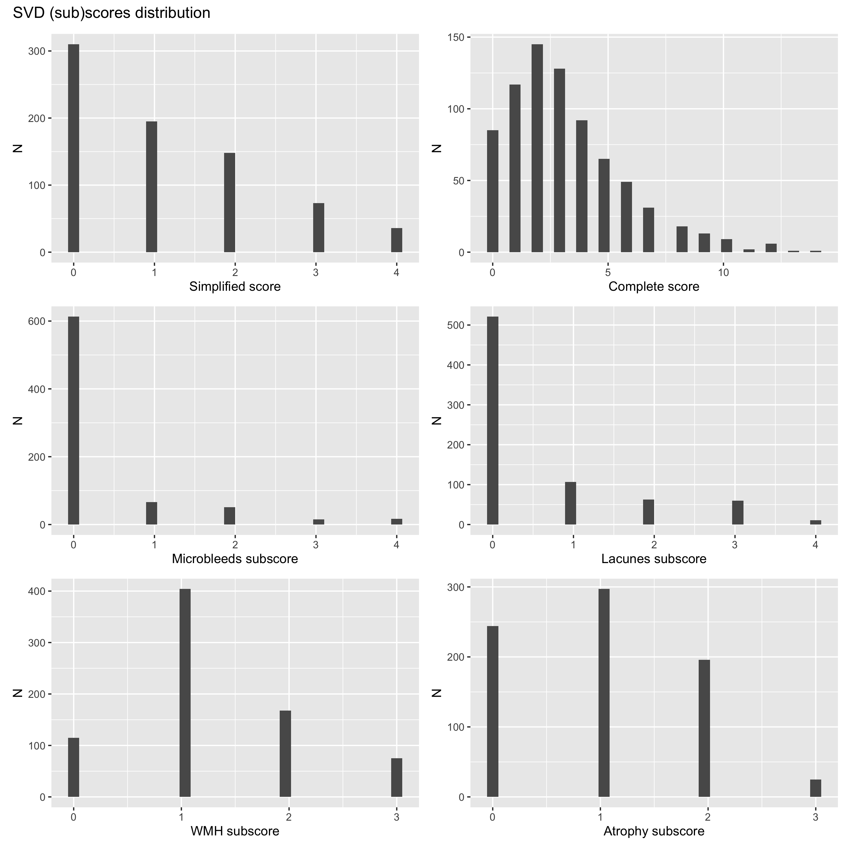

| Annotation | extended amended Olama et al 2020 | amended Olama et al 2020 | extended simple Olama et al 2020 | simple Olama et al 2020 | modified Huijts et al 2013 | Complete score | Best fit subscores | Clinical assumptions |
| --- | --- | --- | --- | --- | --- | --- | --- | --- |
| Microbleeds subscore | | | | | | | | |
| 0 | 0 | 0 | 0 | 0 | 0 | 0 | 0 | 0 |
| 1 | 1 | 1 | 1 | 1 | 1 | 1 | 0 | 0 |
| 2-4 | 1 | 1 | 1 | 1 | 1 | 2 | 0 | 1 |
| 5-10 | 1 | 1 | 1 | 1 | 1 | 3 | 0 | 1 |
| >10 | 1 | 1 | 1 | 1 | 1 | 4 | 1 | 2 |
| Lacunes subscore | | | | | | | | |
| 0 | 0 | 0 | 0 | 0 | 0 | 0 | 0 | 0 |
| 1 | 0 | 0 | 0 | 0 | 1 | 1 | 0 | 1 |
| 2 | 1 | 1 | 0 | 0 | 1 | 2 | 0 | 1 |
| 3-5 | 2 | 2 | 1 | 1 | 1 | 3 | 0 | 1 |
| >5 | 3 | 3 | 1 | 1 | 1 | 4 | 1 | 2 |
| WMH subscore | | | | | | | | |
| 0: Absent | 0 | 0 | 0 | 0 | 0 | 0 | 0 | 0 |
| 1: Punctate foci | 1 | 1 | 0 | 0 | 0 | 1 | 1 | 0 |
| 2: Beginning confluence | 2 | 2 | 1 | 1 | 1 | 2 | 1 | 1 |
| 3: Large confluent areas | 3 | 3 | 1 | 1 | 1 | 3 | 1 | 1 |
| Atrophy subscore | | | | | | | | |
| 0: No atrophy | 0 | 0 | 0 | 0 | 0 | 0 | 0 | 0 |
| 1: Mild | 1 | 0 | 0 | 0 | 0 | 1 | 0 | 0 |
| 2: Moderate | 2 | 0 | 1 | 0 | 1 | 2 | 1 | 1 |
| 3: Severe | 3 | 0 | 1 | 0 | 1 | 3 | 1 | 1 |

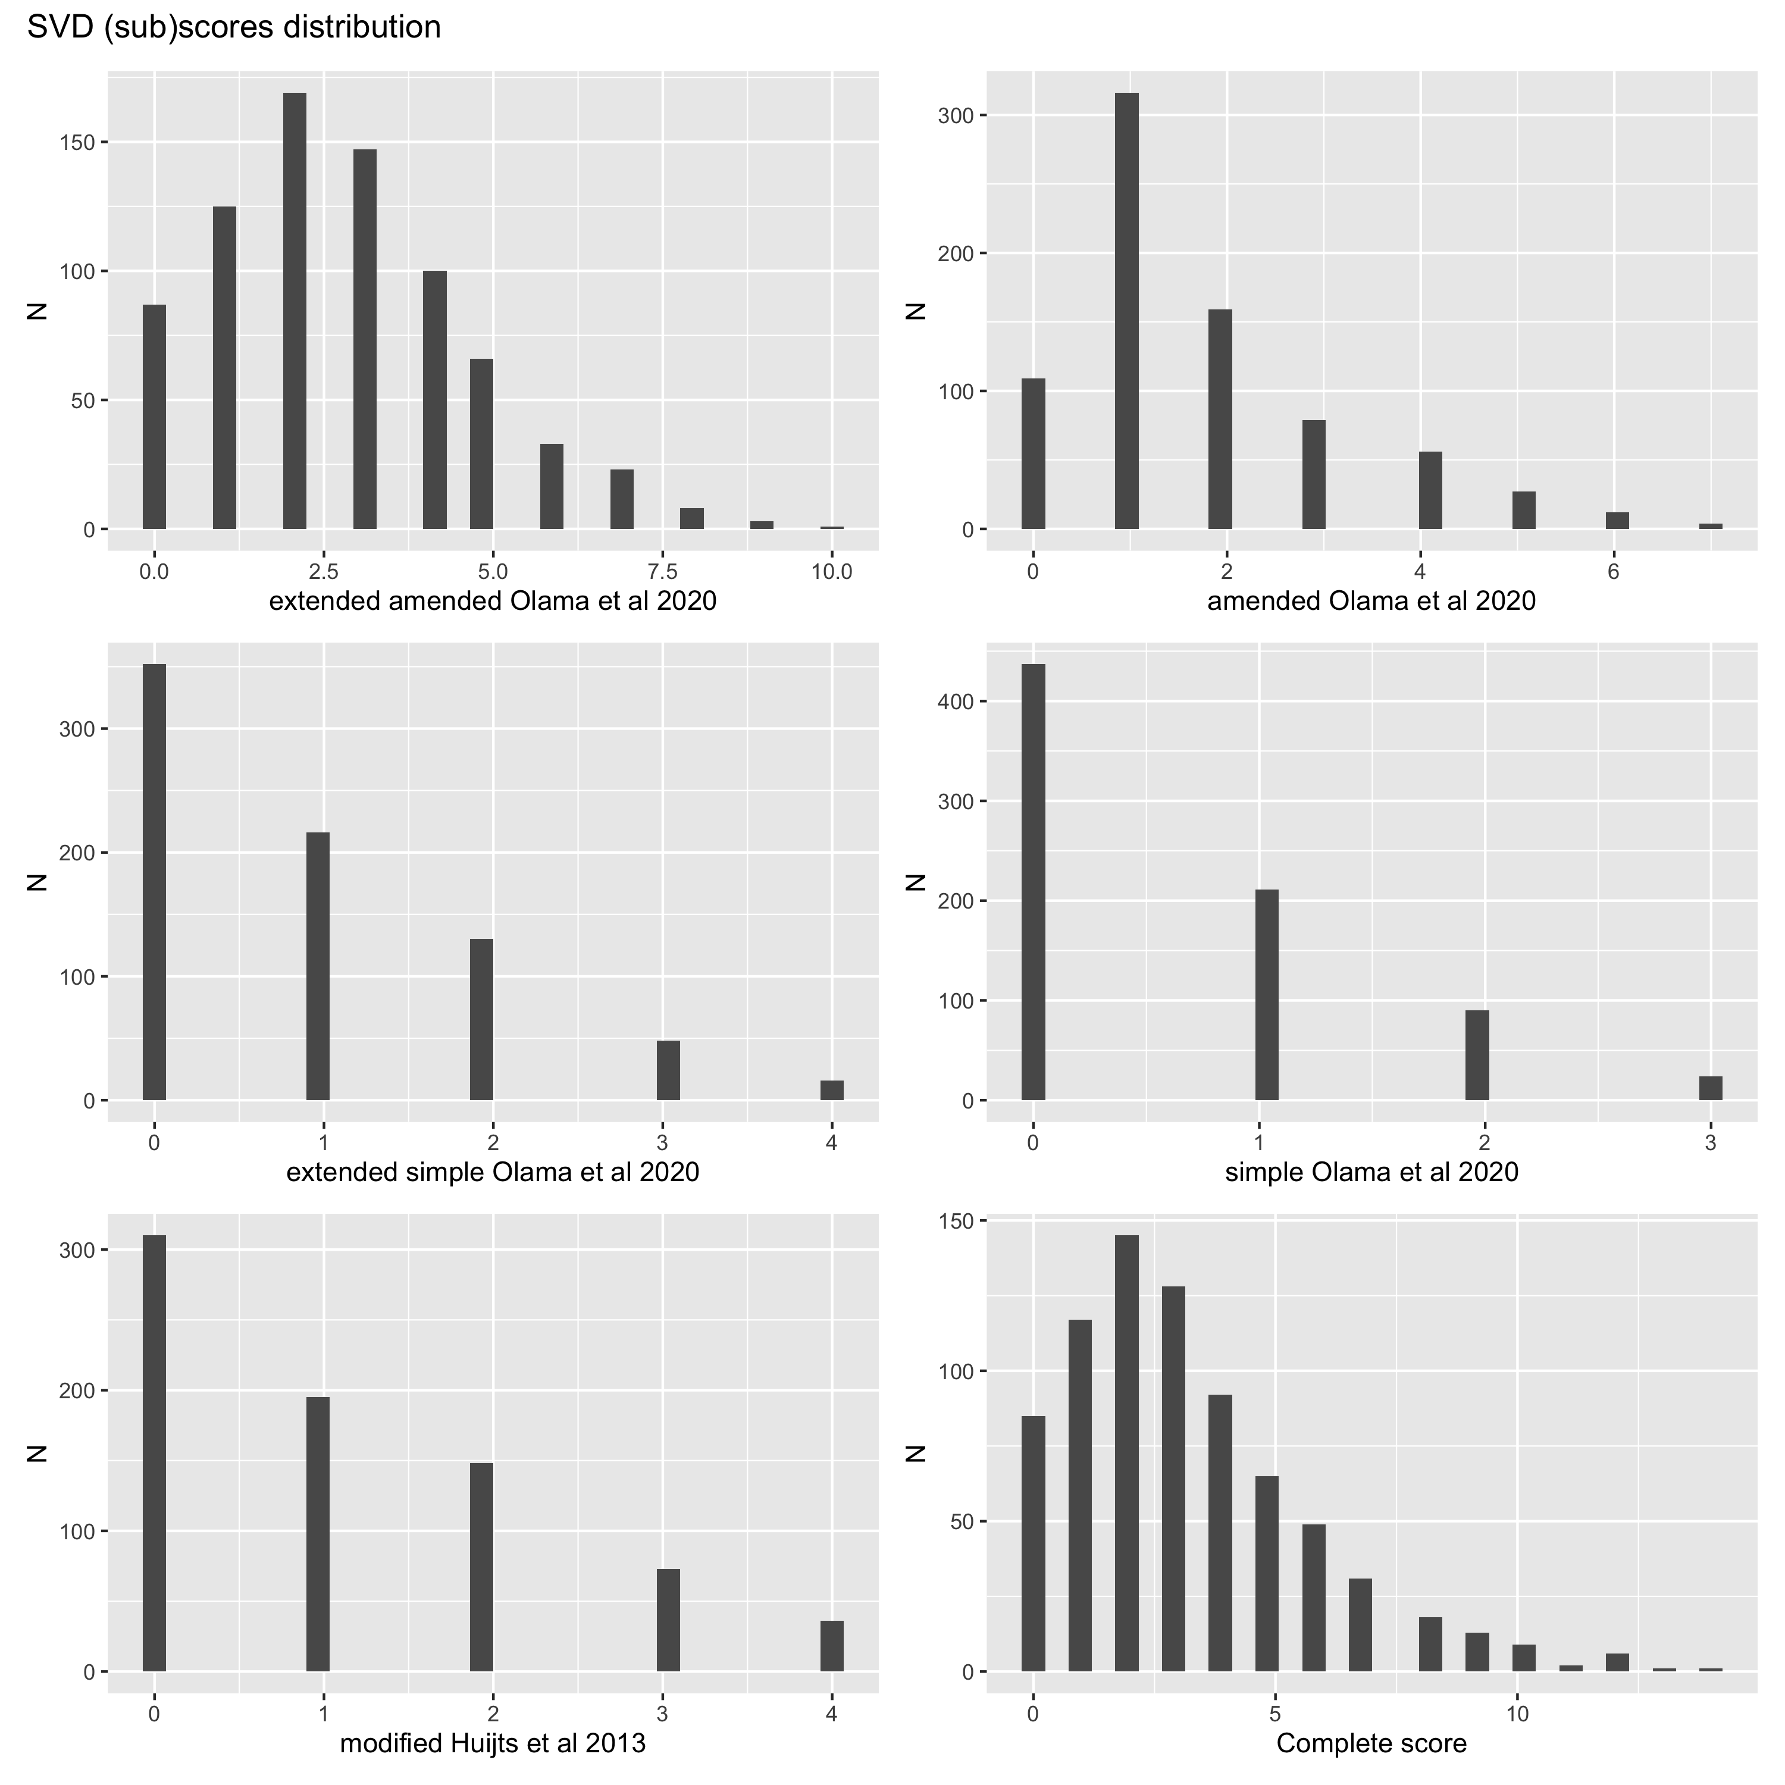

Note ‘extended Huijts et al’ is similar to our simple score.

### PA raw correlation

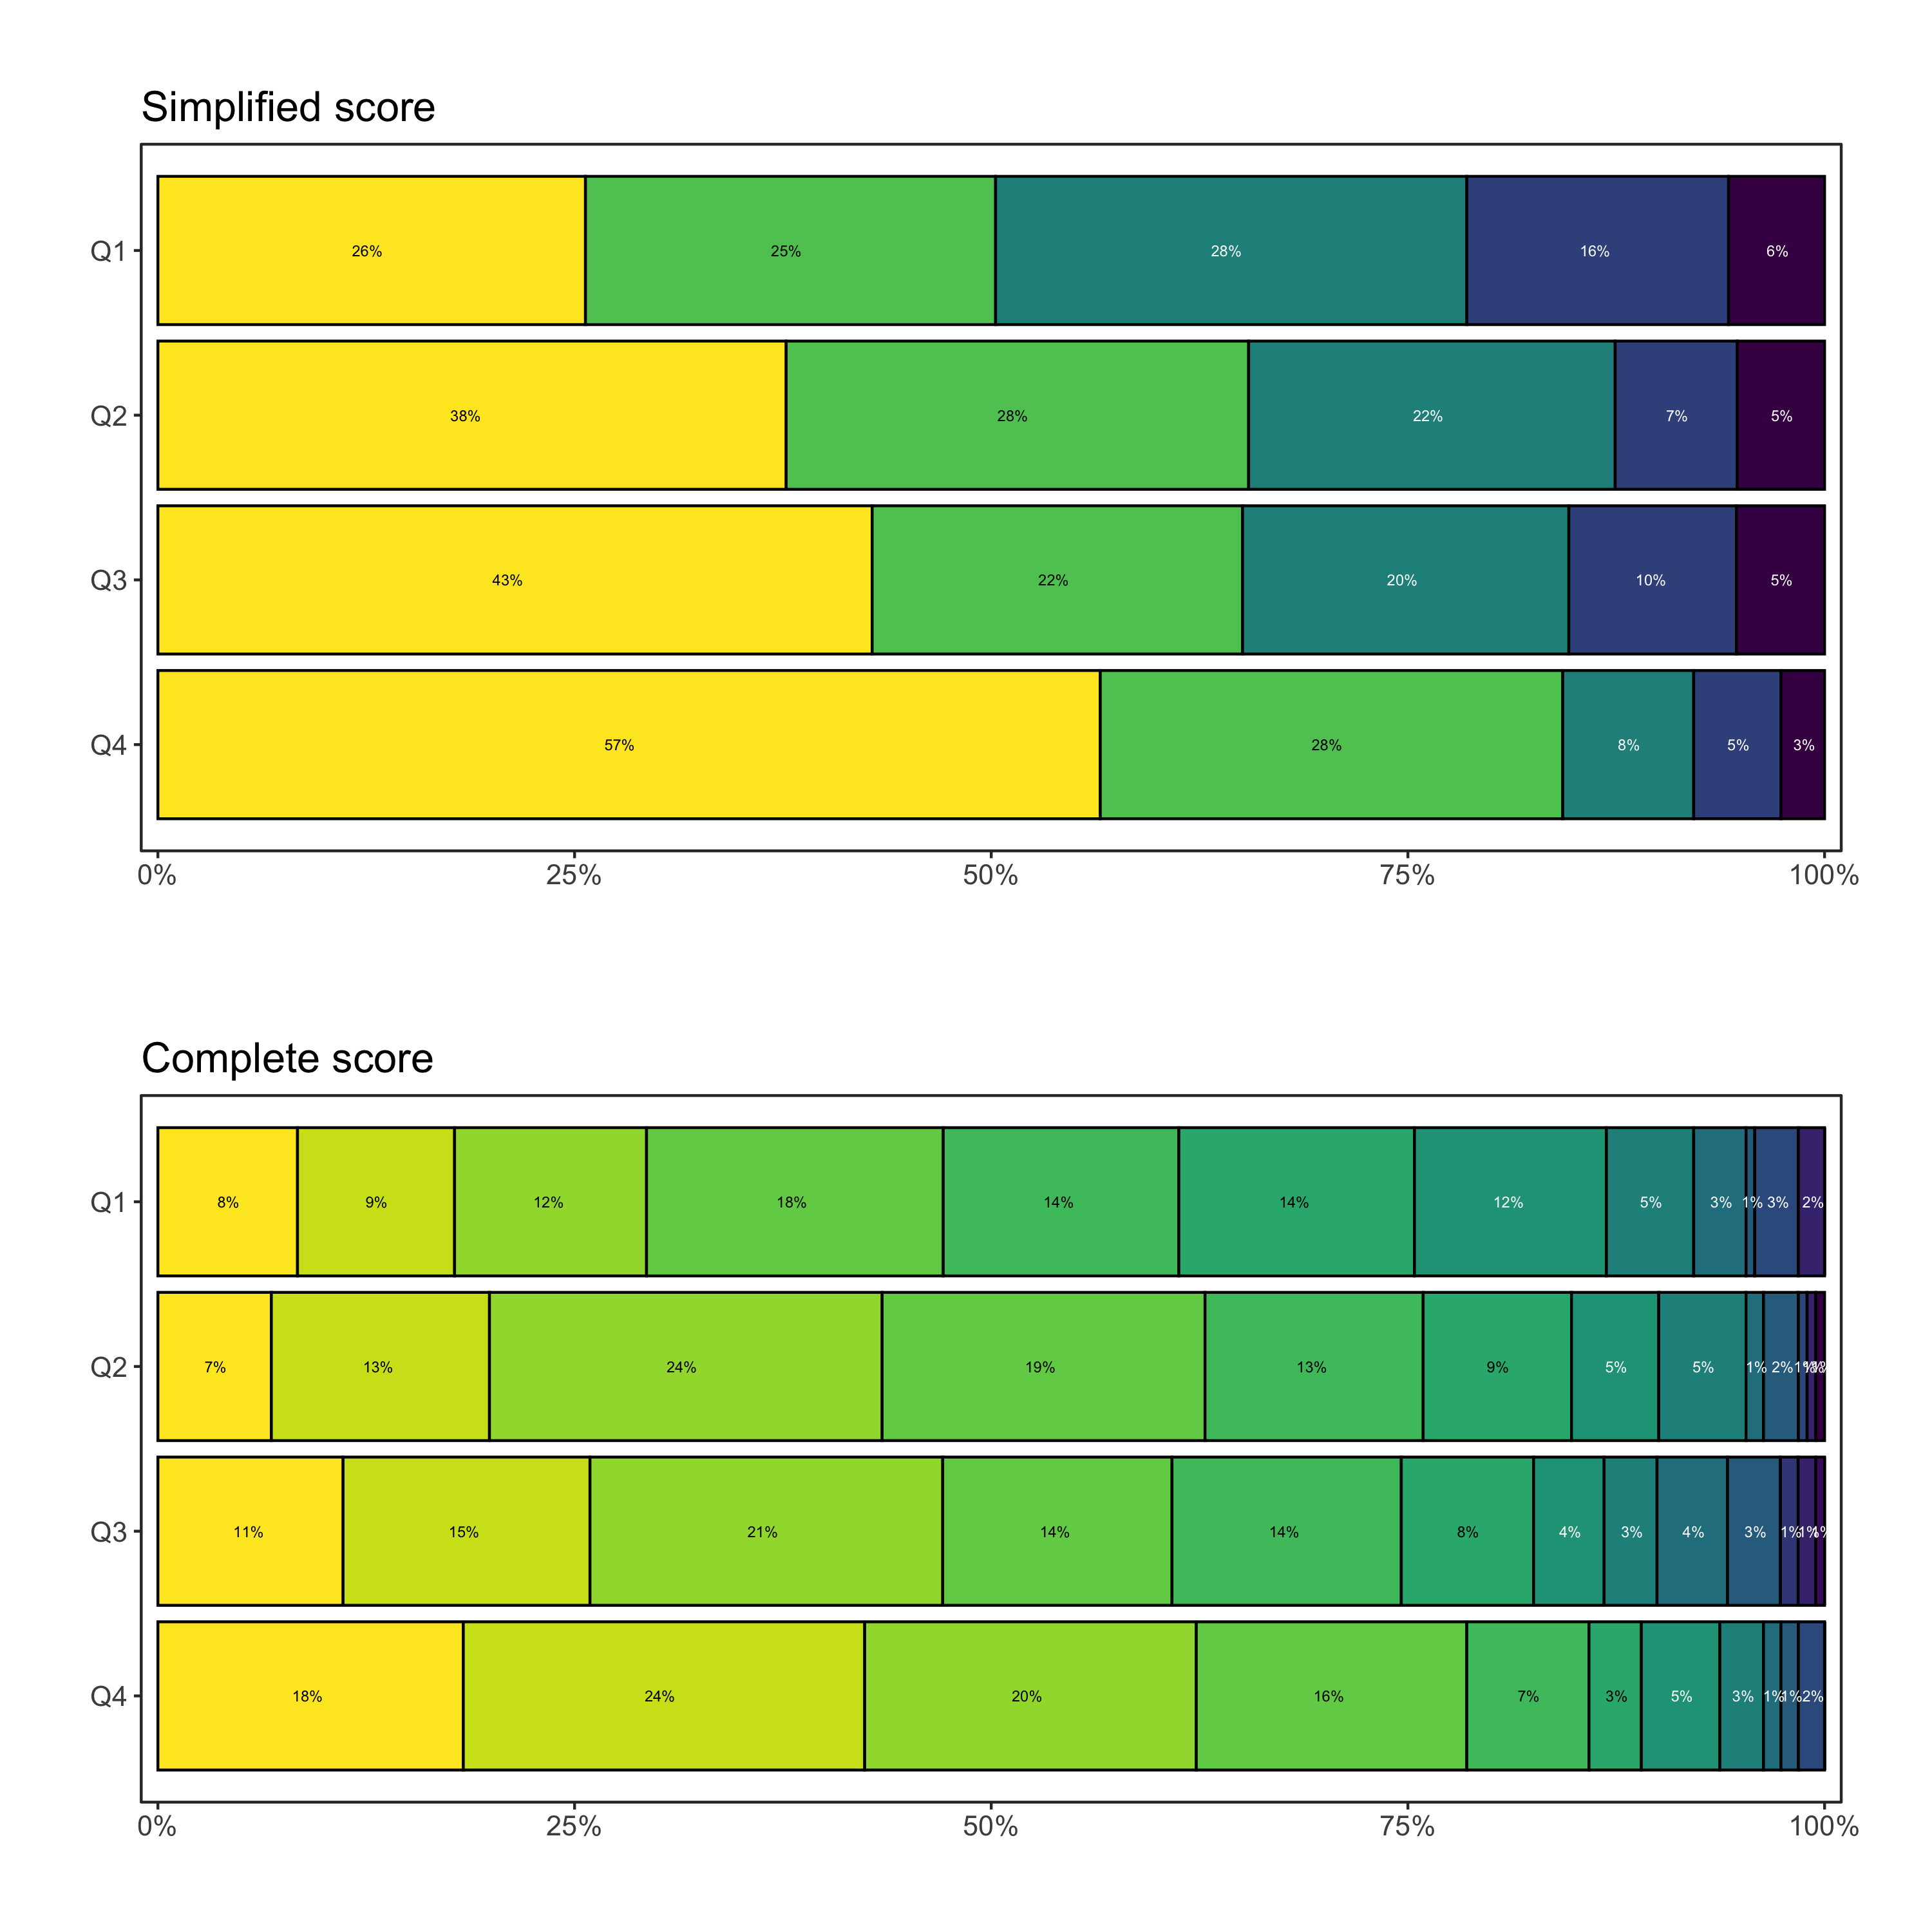

## Main analyses predefined complete OLR analyses

..with and without adjustments for all considered variables.

Stacked regression table of all analyses

|  | No PA adjustment | | With PA adjustment | |
| --- | --- | --- | --- | --- |
| **Characteristic** | **OR***1* | **95% CI***1* | **OR***1* | **95% CI***1* |
| **Simplified score** | | | | |
| Smoking |  |  |  |  |
| never | — | — | — | — |
| current | 1.63 | 1.14, 2.34 | 1.55 | 1.08, 2.23 |
| prior | 1.44 | 1.04, 2.00 | 1.41 | 1.02, 1.97 |
| Hypertension | 1.91 | 1.43, 2.54 | 1.88 | 1.41, 2.50 |
| Diabetes | 1.46 | 0.96, 2.22 | 1.40 | 0.92, 2.13 |
| Previous ischemic event | 2.28 | 1.52, 3.41 | 2.21 | 1.48, 3.31 |
| **Complete score** | | | | |
| Smoking |  |  |  |  |
| never | — | — | — | — |
| current | 1.43 | 1.03, 1.99 | 1.38 | 1.00, 1.92 |
| prior | 1.18 | 0.87, 1.60 | 1.17 | 0.86, 1.59 |
| Hypertension | 2.05 | 1.57, 2.68 | 2.03 | 1.55, 2.65 |
| Diabetes | 1.77 | 1.19, 2.63 | 1.69 | 1.14, 2.53 |
| Previous ischemic event | 2.46 | 1.67, 3.64 | 2.39 | 1.62, 3.53 |
| **Microbleeds subscore** | | | | |
| Smoking |  |  |  |  |
| never | — | — | — | — |
| current | 1.14 | 0.71, 1.81 | 1.13 | 0.70, 1.80 |
| prior | 0.93 | 0.60, 1.44 | 0.94 | 0.61, 1.45 |
| Hypertension | 1.90 | 1.29, 2.84 | 1.94 | 1.31, 2.90 |
| Diabetes | 1.18 | 0.67, 1.99 | 1.14 | 0.64, 1.94 |
| Previous ischemic event | 1.60 | 0.96, 2.58 | 1.55 | 0.93, 2.50 |
| **Lacunes subscore** | | | | |
| Smoking |  |  |  |  |
| never | — | — | — | — |
| current | 1.53 | 1.02, 2.29 | 1.49 | 0.99, 2.25 |
| prior | 1.23 | 0.85, 1.78 | 1.23 | 0.85, 1.77 |
| Hypertension | 1.82 | 1.32, 2.53 | 1.81 | 1.31, 2.53 |
| Diabetes | 1.81 | 1.15, 2.83 | 1.78 | 1.12, 2.79 |
| Previous ischemic event | 2.98 | 1.97, 4.49 | 2.94 | 1.94, 4.44 |
| **WMH subscore** | | | | |
| Smoking |  |  |  |  |
| never | — | — | — | — |
| current | 1.32 | 0.92, 1.91 | 1.32 | 0.91, 1.90 |
| prior | 1.29 | 0.92, 1.81 | 1.30 | 0.93, 1.82 |
| Hypertension | 1.59 | 1.19, 2.14 | 1.59 | 1.19, 2.15 |
| Diabetes | 1.14 | 0.74, 1.77 | 1.13 | 0.72, 1.75 |
| Previous ischemic event | 1.41 | 0.93, 2.14 | 1.39 | 0.91, 2.12 |
| **Atrophy subscore** | | | | |
| Smoking |  |  |  |  |
| never | — | — | — | — |
| current | 1.20 | 0.82, 1.76 | 1.08 | 0.73, 1.58 |
| prior | 1.07 | 0.76, 1.52 | 1.00 | 0.70, 1.42 |
| Hypertension | 1.75 | 1.29, 2.36 | 1.71 | 1.26, 2.32 |
| Diabetes | 1.80 | 1.13, 2.86 | 1.65 | 1.03, 2.64 |
| Previous ischemic event | 2.41 | 1.58, 3.69 | 2.30 | 1.51, 3.53 |
| *1*OR = Odds Ratio, CI = Confidence Interval | | | | |

### Collinearity

Checking assumptions for each minimal model shows a serious issue with multi collinearity. Other meassures are fine.

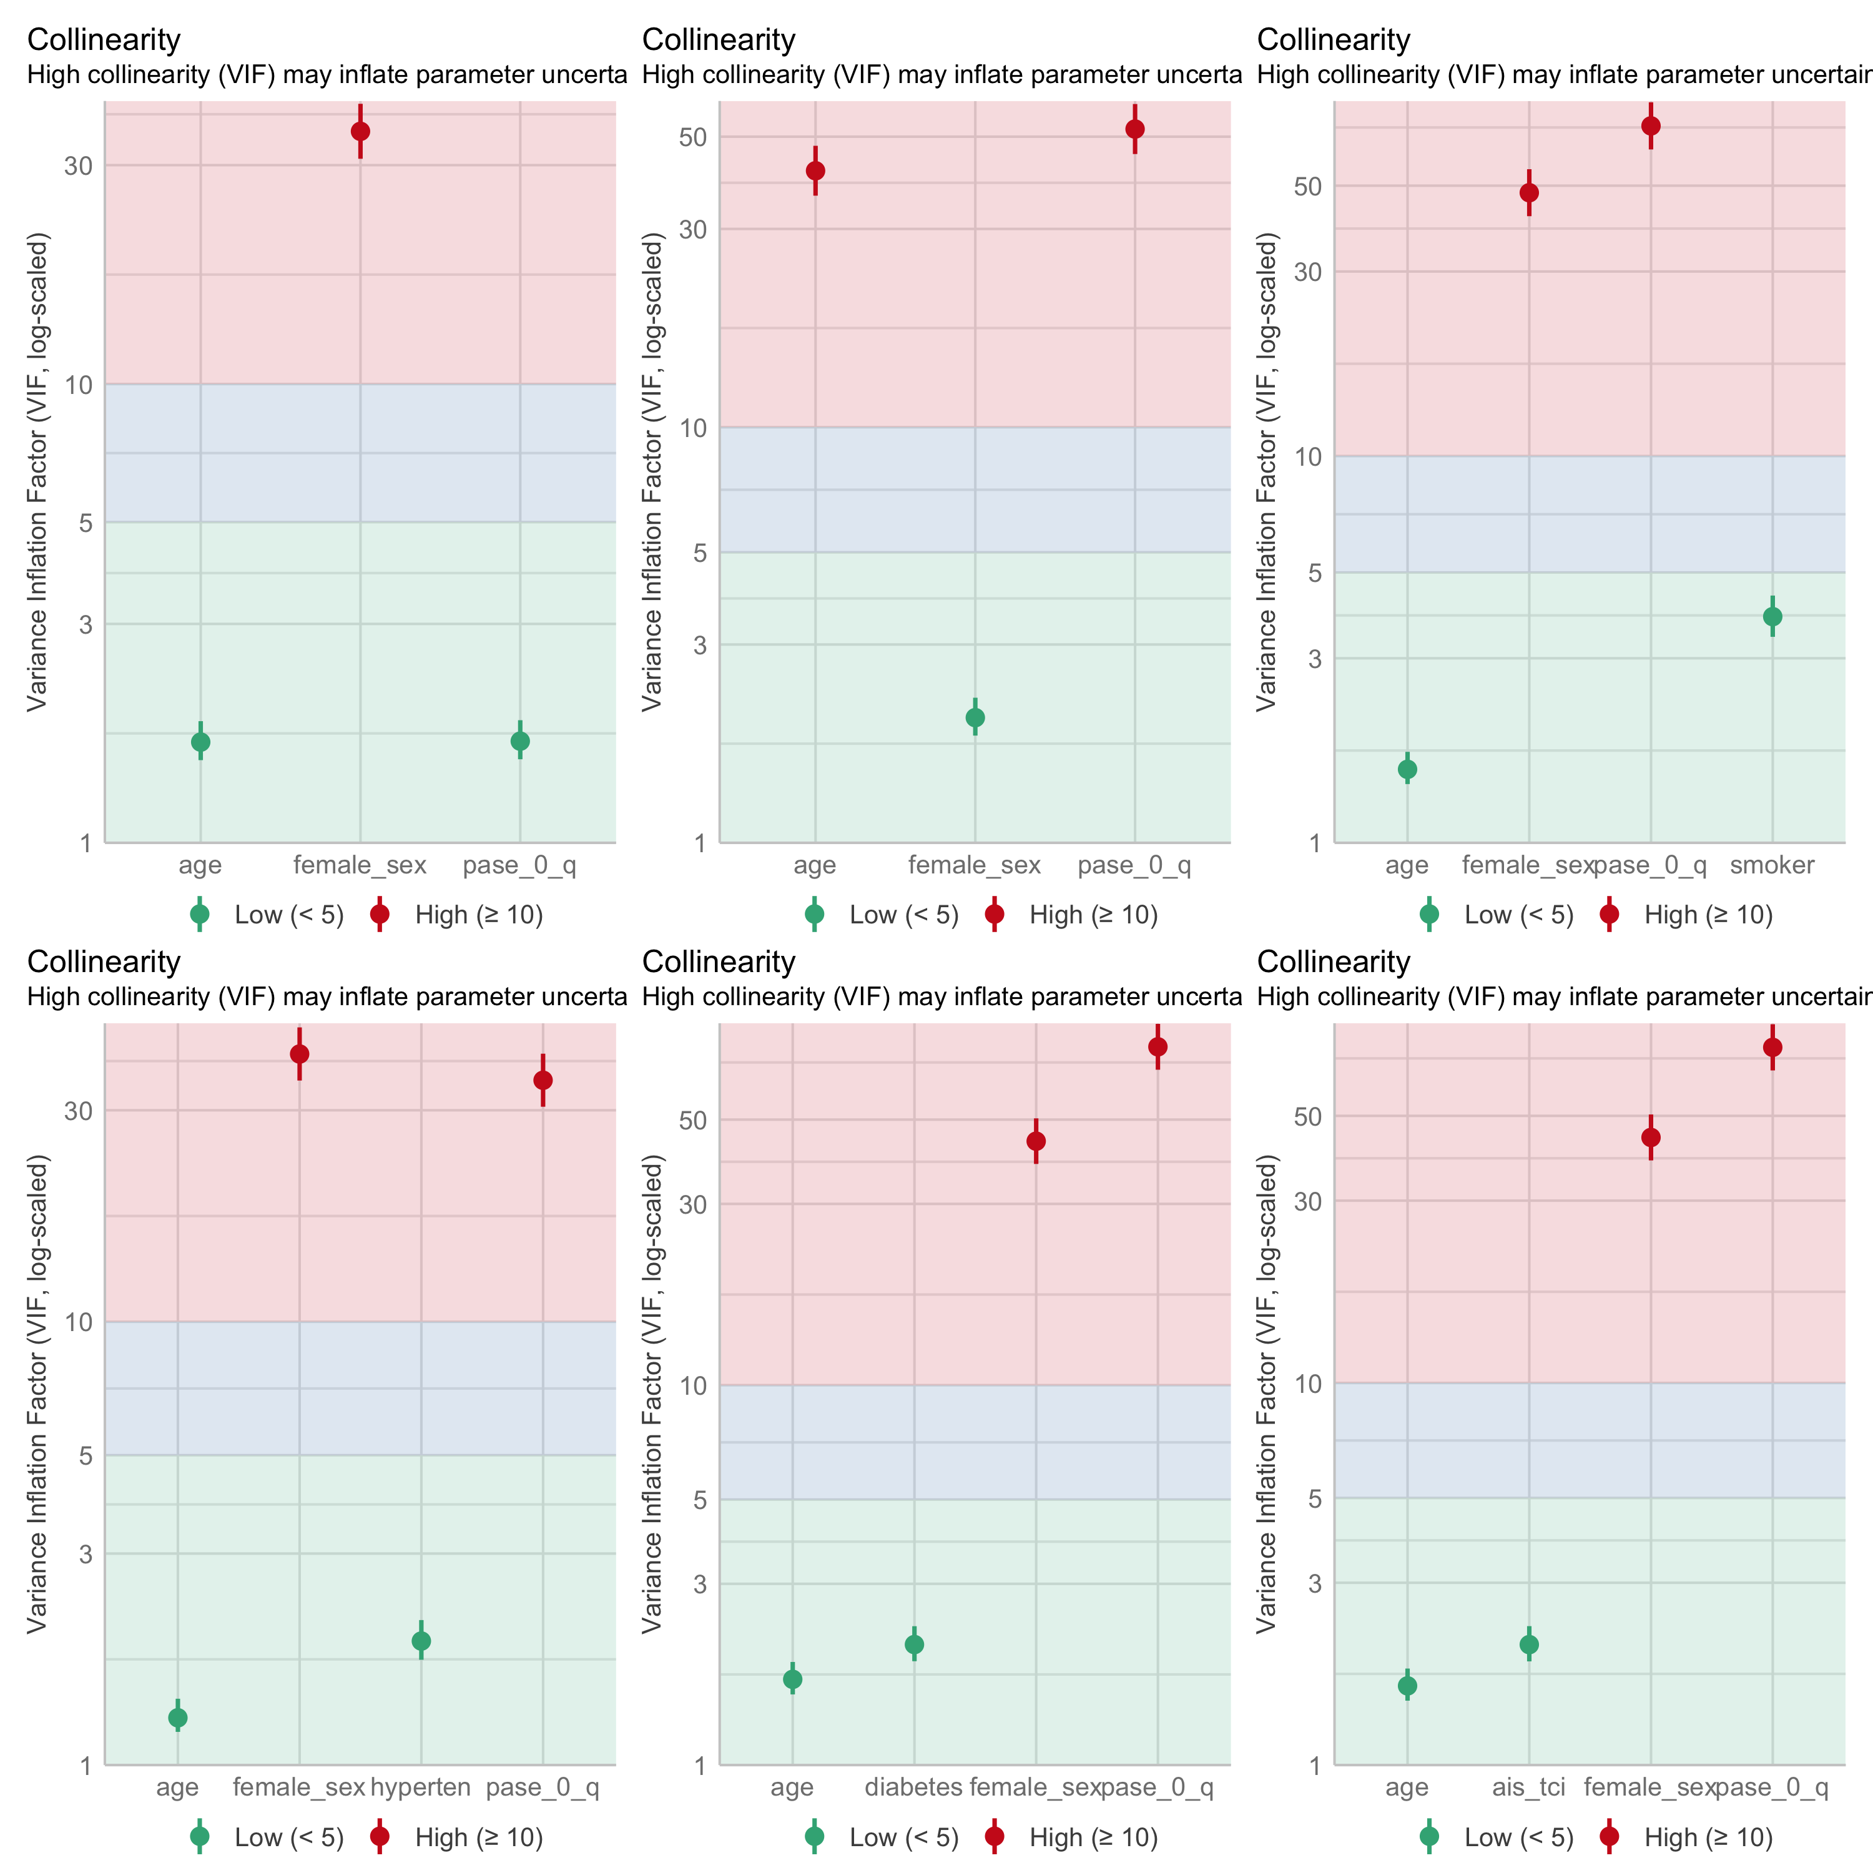

Collinearity check plots

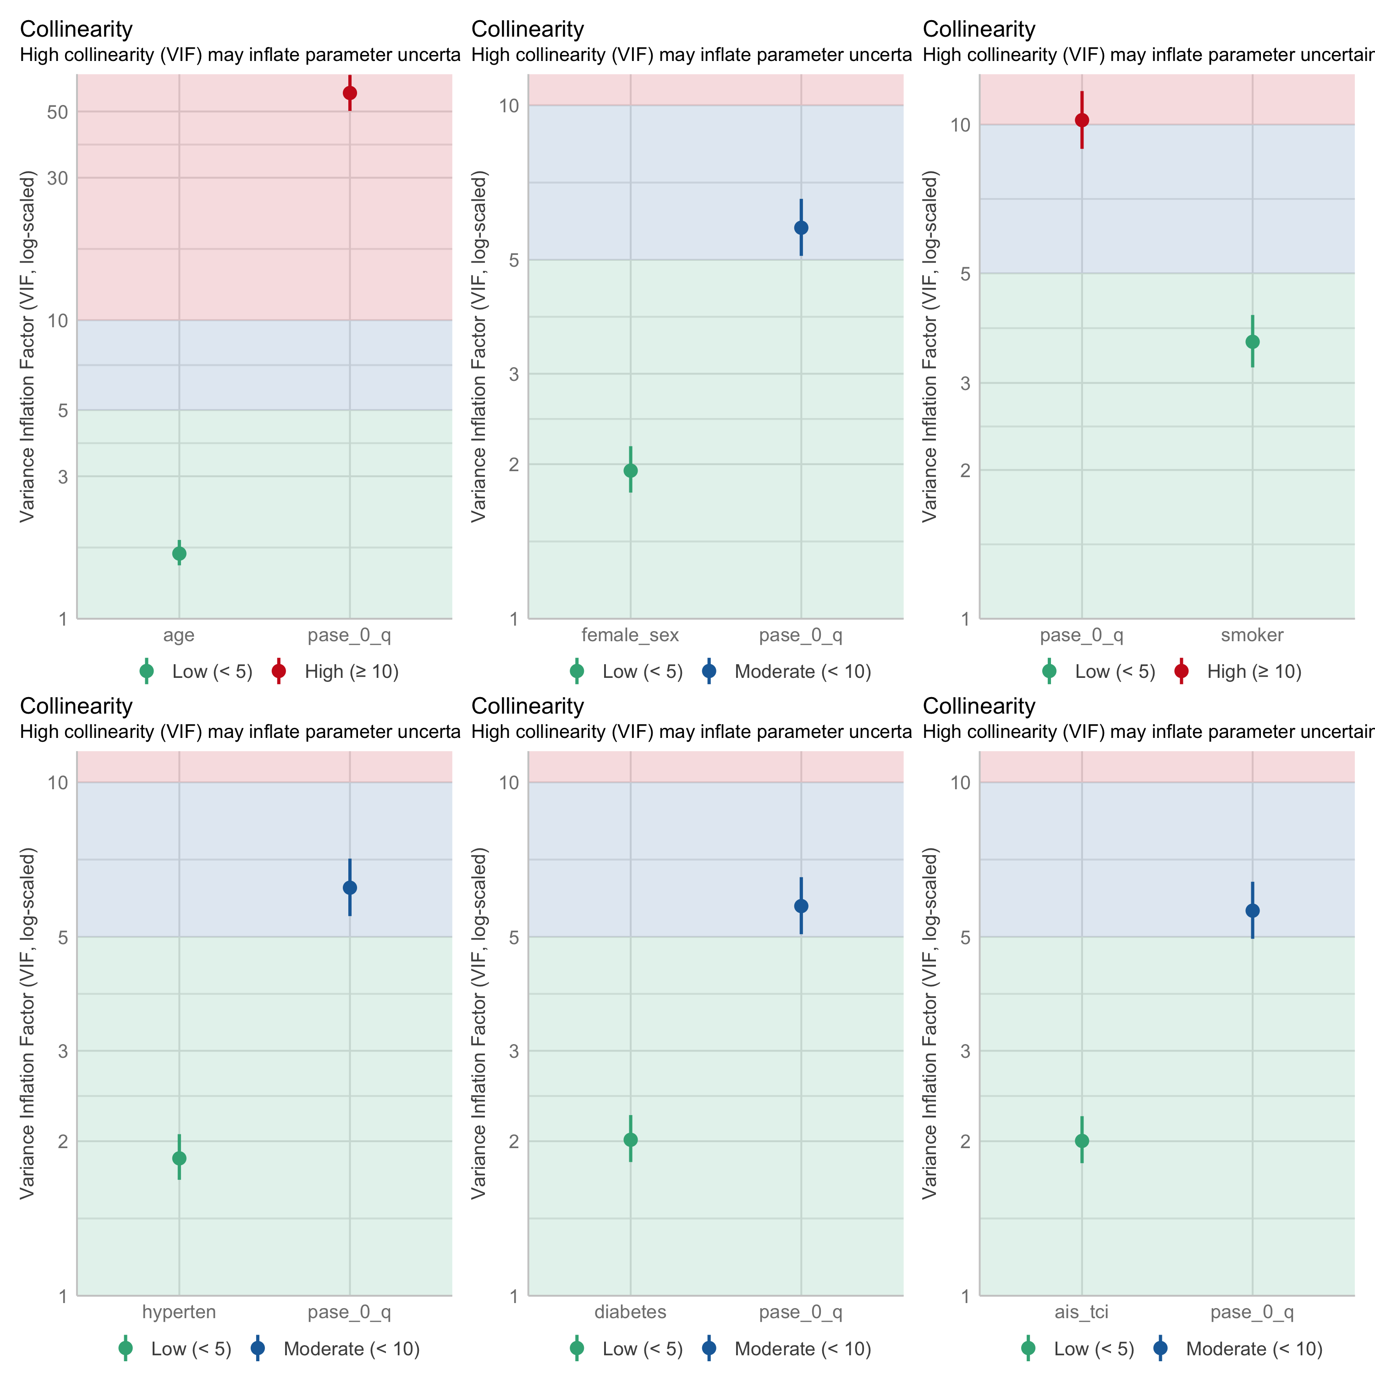

Collinearity check plots

This can be solved by feature/variable reduction and exclude age and sex as variables in the model, as these are independently correlated to PASE.

Comparing these plot panels, smoking shows to be affected by age/sex adjustments.

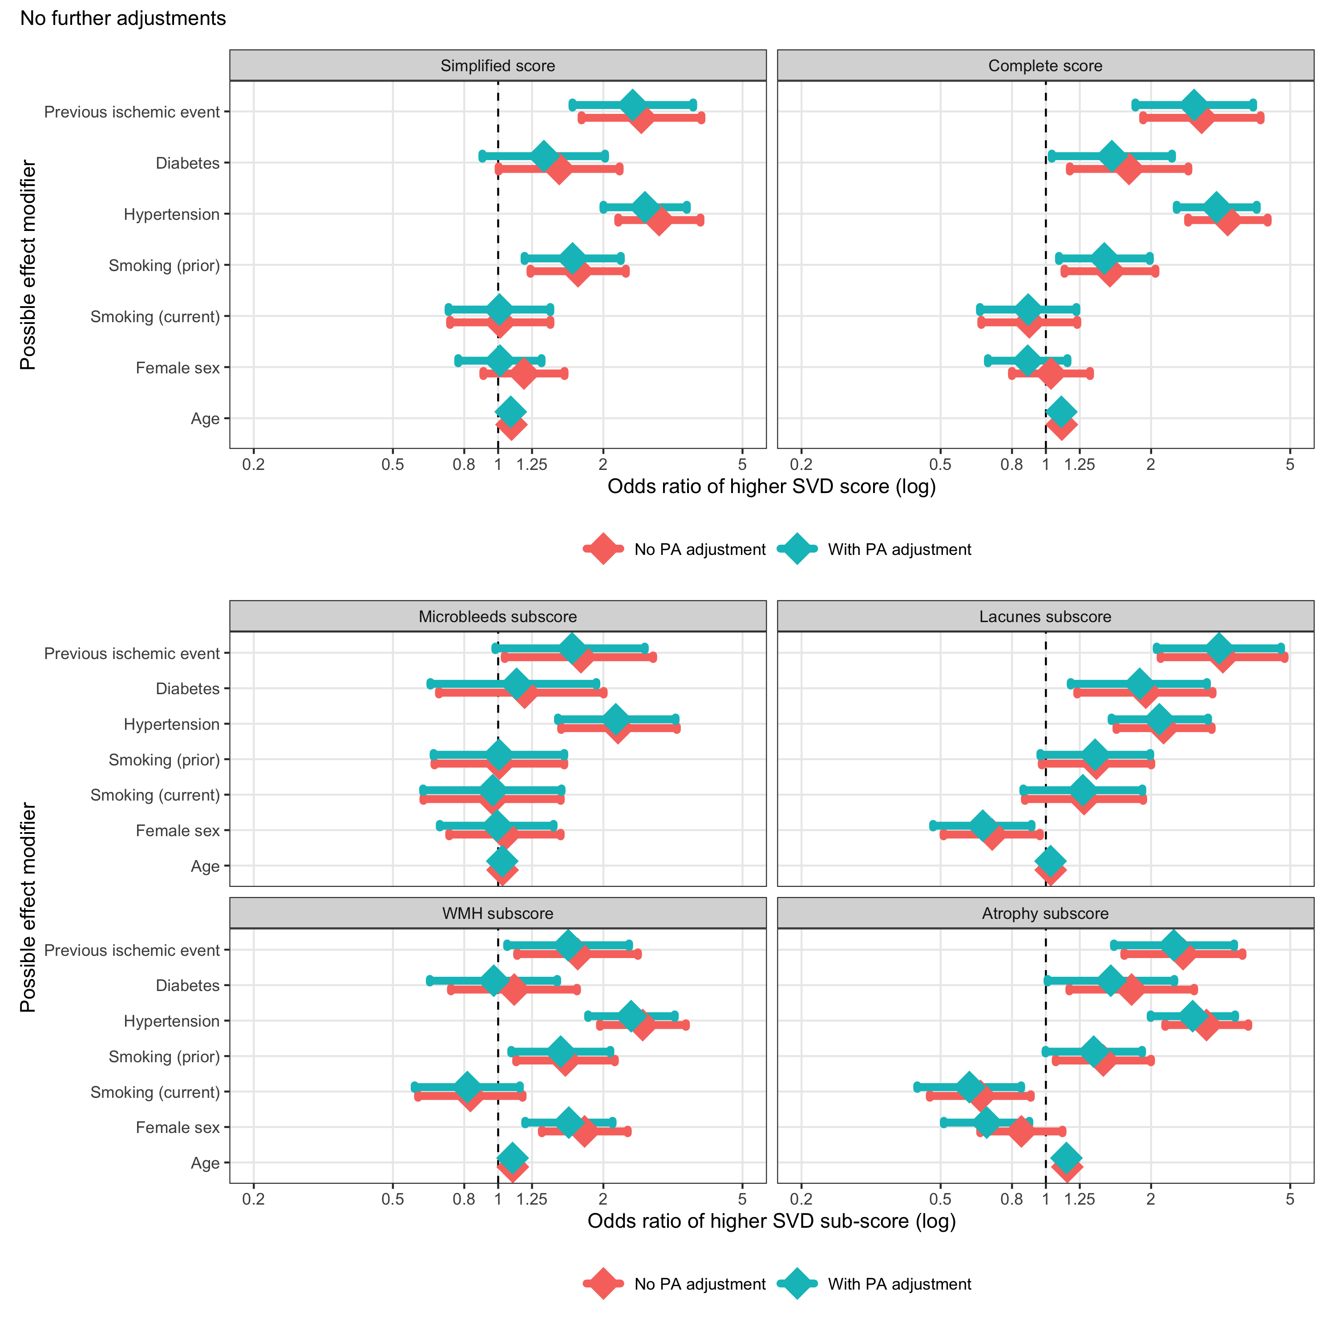

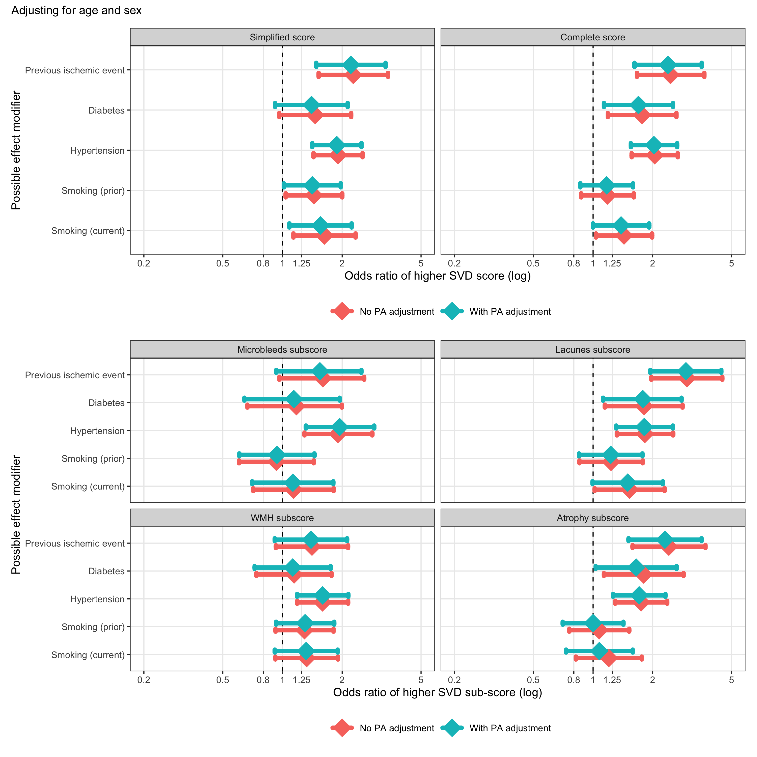

Apparently, this is due to a biased inclusion. Participants smoking are significantly younger, as the older smokers either stopped (prior) or died.

| **Characteristic** | **never** N = 269*1* | **current** N = 211*1* | **prior** N = 262*1* | **p-value***2* |
| --- | --- | --- | --- | --- |
| Simplified score |  |  |  | 0.006 |
| 0 | 127 (47%) | 90 (43%) | 88 (34%) |  |
| 1 | 60 (22%) | 63 (30%) | 65 (25%) |  |
| 2 | 45 (17%) | 40 (19%) | 59 (23%) |  |
| 3 | 24 (8.9%) | 11 (5.2%) | 36 (14%) |  |
| 4 | 13 (4.8%) | 7 (3.3%) | 14 (5.3%) |  |
| Female sex | 113 (42%) | 70 (33%) | 85 (32%) | 0.041 |
| Age | 72 (63, 80) | 64 (57, 74) | 74 (67, 81) | <0.001 |
| Hypertension | 140 (52%) | 105 (50%) | 159 (61%) | 0.037 |
| Diabetes | 28 (10%) | 18 (8.5%) | 37 (14%) | 0.14 |
| *1*n (%); Median (Q1, Q3) | | | | |
| *2*Pearson's Chi-squared test; Kruskal-Wallis rank sum test | | | | |

## Data evaluation

Ordinal logistic regression with PASE quartile as outcome indicates a strong correlation

Assumptions evaluation of a multivariable OLR model PASE stands out with high VIF indicating severe collinarity.

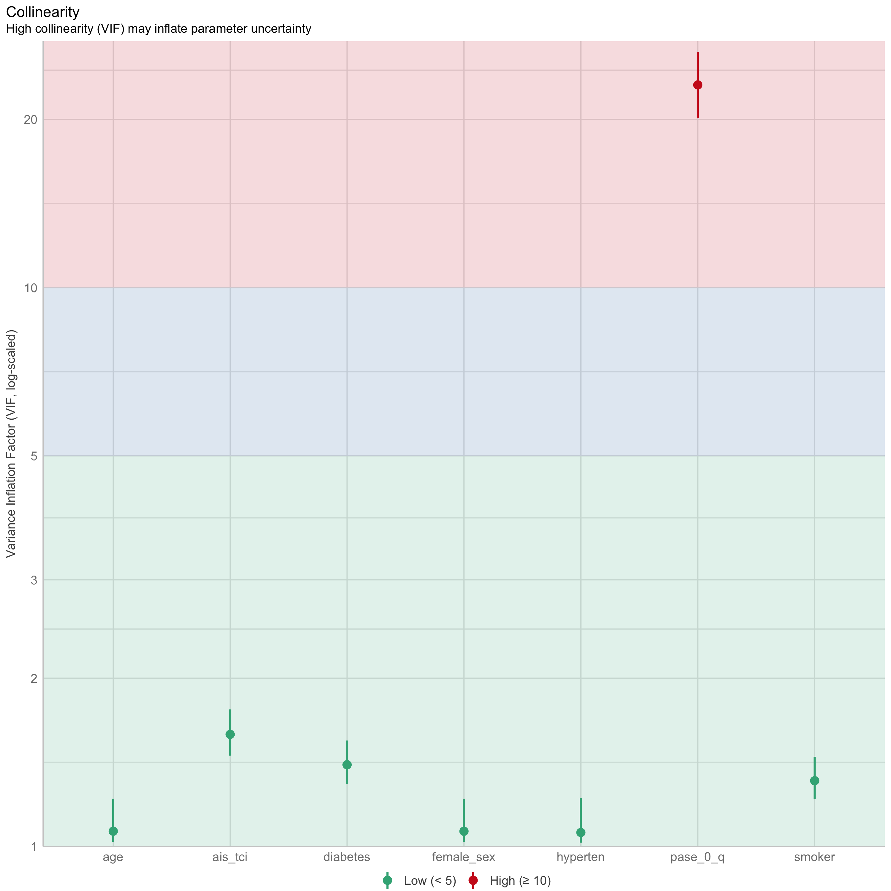

This needs further investigation

First step is a simple table overview

| **Characteristic** | **Q4** N = 191*1* | **Q3** N = 189*1* | **Q2** N = 191*1* | **Q1** N = 191*1* | **p-value***2* |
| --- | --- | --- | --- | --- | --- |
| Age | 64 (55, 73) | 70 (63, 76) | 74 (65, 80) | 77 (67, 84) | <0.001 |
| Female sex | 47 (25%) | 58 (31%) | 89 (47%) | 85 (45%) | <0.001 |
| Hypertension | 85 (45%) | 96 (51%) | 114 (60%) | 123 (65%) | <0.001 |
| Diabetes | 12 (6.3%) | 19 (10%) | 27 (14%) | 27 (14%) | 0.040 |
| Smoking |  |  |  |  | 0.6 |
| never | 68 (36%) | 69 (38%) | 75 (40%) | 57 (31%) |  |
| current | 57 (30%) | 53 (29%) | 45 (24%) | 56 (31%) |  |
| prior | 64 (34%) | 62 (34%) | 66 (35%) | 70 (38%) |  |
| Previous ischemic event | 16 (8.4%) | 27 (14%) | 24 (13%) | 30 (16%) | 0.14 |
| Simplified score |  |  |  |  | <0.001 |
| 0 | 108 (57%) | 81 (43%) | 72 (38%) | 49 (26%) |  |
| 1 | 53 (28%) | 42 (22%) | 53 (28%) | 47 (25%) |  |
| 2 | 15 (7.9%) | 37 (20%) | 42 (22%) | 54 (28%) |  |
| 3 | 10 (5.2%) | 19 (10%) | 14 (7.3%) | 30 (16%) |  |
| 4 | 5 (2.6%) | 10 (5.3%) | 10 (5.2%) | 11 (5.8%) |  |
| Complete score | 2.00 (1.00, 3.00) | 3.00 (1.00, 5.00) | 3.00 (2.00, 4.00) | 4.00 (2.00, 5.00) | <0.001 |
| *1*Median (Q1, Q3); n (%) | | | | | |
| *2*Kruskal-Wallis rank sum test; Pearson's Chi-squared test | | | | | |

Second step is univariable regression analyses with PASE as outcome

| **Characteristic** | **N** | **OR***1* | **95% CI***1* |
| --- | --- | --- | --- |
| Age | 762 | 1.05 | 1.04, 1.06 |
| Female sex | 762 | 1.92 | 1.48, 2.51 |
| Smoking | 742 |  |  |
| never |  | — | — |
| current |  | 1.04 | 0.75, 1.43 |
| prior |  | 1.16 | 0.85, 1.57 |
| Hypertension | 761 | 1.77 | 1.36, 2.29 |
| Diabetes | 761 | 1.73 | 1.16, 2.58 |
| Previous ischemic event | 758 | 1.46 | 1.00, 2.13 |
| *1*OR = Odds Ratio, CI = Confidence Interval | | | |

Univariable regression analyses

Age correlates strongly to PASE.

Third and last step is trying to take out age and sex.

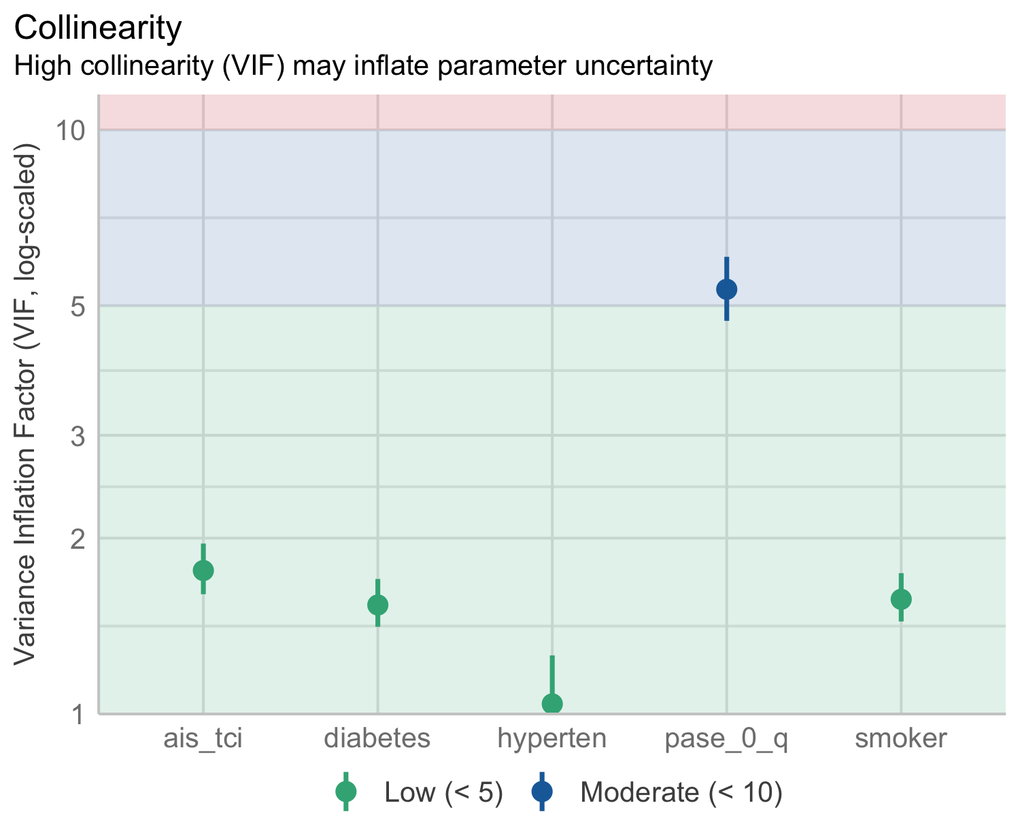

Comparing models shows the first is the better performing. Bum bum…

# Comparison of Model Performance Indices  
  
Name | Model | RMSE | Sigma | AIC weights | AICc weights | BIC weights | Performance-Score  
--------------------------------------------------------------------------------------------  
m1 | polr | 11.011 | 1.986 | 1.00 | 1.00 | 1.00 | 80.00%  
m2 | polr | 11.011 | 2.061 | 1.87e-49 | 2.13e-49 | 1.87e-47 | 20.00%

OLR with full SVD-score as outcome

|  | Univariable | | | Multivariable | |
| --- | --- | --- | --- | --- | --- |
| **Characteristic** | **N** | **OR***1* | **95% CI***1* | **OR***1* | **95% CI***1* |
| Smoking | 742 |  |  |  |  |
| never |  | — | — | — | — |
| current |  | 0.90 | 0.65, 1.23 | 0.90 | 0.65, 1.24 |
| prior |  | 1.52 | 1.13, 2.06 | 1.33 | 0.99, 1.80 |
| Hypertension | 761 | 3.31 | 2.55, 4.31 | 2.82 | 2.16, 3.70 |
| Diabetes | 761 | 1.73 | 1.17, 2.56 | 1.31 | 0.88, 1.95 |
| Previous ischemic event | 758 | 2.79 | 1.90, 4.11 | 2.29 | 1.54, 3.40 |
| Pre-stroke PA quartile | 762 |  |  |  |  |
| Q4 |  | — | — | — | — |
| Q3 |  | 2.09 | 1.46, 2.99 | 1.96 | 1.36, 2.84 |
| Q2 |  | 2.24 | 1.58, 3.19 | 1.88 | 1.31, 2.69 |
| Q1 |  | 3.64 | 2.54, 5.24 | 2.97 | 2.05, 4.31 |
| *1*OR = Odds Ratio, CI = Confidence Interval | | | | | |

Old model for reference

|  | Univariable | | | Multivariable | |
| --- | --- | --- | --- | --- | --- |
| **Characteristic** | **N** | **OR***1* | **95% CI***1* | **OR***1* | **95% CI***1* |
| Age | 762 | 1.11 | 1.10, 1.12 | 1.10 | 1.09, 1.12 |
| Female sex | 762 | 1.03 | 0.80, 1.34 | 0.73 | 0.56, 0.96 |
| Smoking | 742 |  |  |  |  |
| never |  | — | — | — | — |
| current |  | 0.90 | 0.65, 1.23 | 1.38 | 0.99, 1.92 |
| prior |  | 1.52 | 1.13, 2.06 | 1.11 | 0.82, 1.51 |
| Hypertension | 761 | 3.31 | 2.55, 4.31 | 1.87 | 1.42, 2.46 |
| Diabetes | 761 | 1.73 | 1.17, 2.56 | 1.58 | 1.05, 2.38 |
| Previous ischemic event | 758 | 2.79 | 1.90, 4.11 | 2.18 | 1.47, 3.26 |
| Pre-stroke PA quartile | 762 |  |  |  |  |
| Q4 |  | — | — | — | — |
| Q3 |  | 2.09 | 1.46, 2.99 | 1.50 | 1.03, 2.18 |
| Q2 |  | 2.24 | 1.58, 3.19 | 1.14 | 0.78, 1.66 |
| Q1 |  | 3.64 | 2.54, 5.24 | 1.58 | 1.07, 2.33 |
| *1*OR = Odds Ratio, CI = Confidence Interval | | | | | |

Further investigations of the relation between PASE and age.

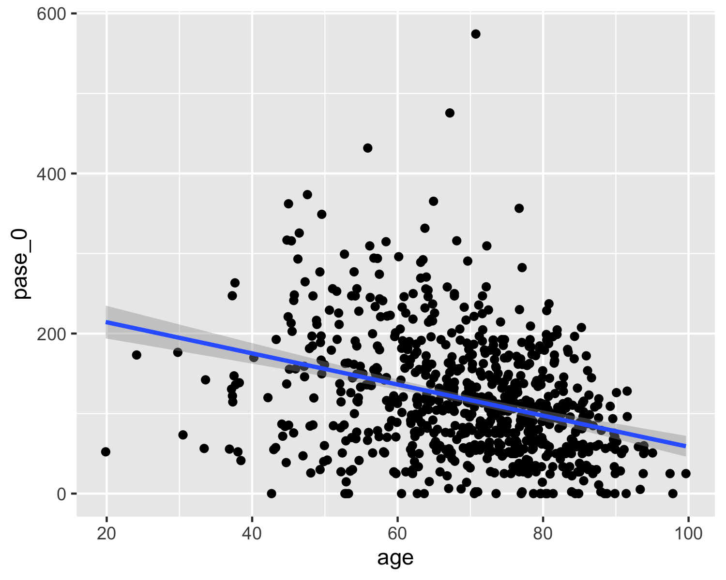

Test of polynomial fit shows 2. degree functions has best fit (lowest AIC)…

[1] 8673.765 8654.574 8655.426 8657.399 8659.127 8661.107

.. though both linear (1. degree) and 2. degree have significant p-value.

|  |  |  |  |
| --- | --- | --- | --- |
|  | pase 0 | | |
| Predictors | Estimates | CI | p |
| (Intercept) | 117.65 | 112.63 – 122.66 | **<0.001** |
| age [1st degree] | -683.62 | -822.01 – -545.22 | **<0.001** |
| age [2nd degree] | -326.49 | -464.89 – -188.10 | **<0.001** |
| age [3rd degree] | 75.44 | -62.96 – 213.83 | 0.285 |
| age [4th degree] | -11.68 | -150.08 – 126.71 | 0.869 |
| Observations | 762 | | |
| R2 | 0.133 | | |

Linear and 2. degree polynomial function visualised.

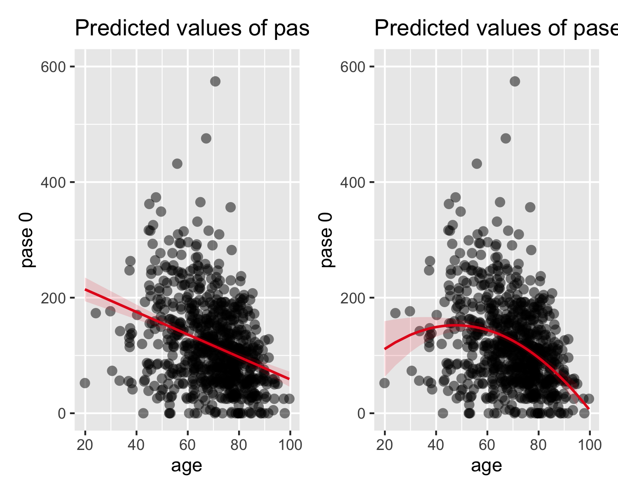

## Subscore steps

* Idea: evaluate different steps for all sub-scores to evaluate best correlation to clinical predictors for relevant cuts
* Same approach as the one employed to illustrate different scoring systems

Different cuts are pre-defined. For each predictor and each sub-score cut, a logistic or ordinal logistic model is created. For each predictor, the model performances are compared to yield the cut, with the best model fit. For each subscore, the cut ranking highest in most predictors is the “Best fit subscores”-scoring system.

Below an overview of the different scoring suggestions for microbleeds as an example:

| Annotation | mic_0_some | mic_0_1_more_many | mic_0_1_more | mic_few_more | mic_some_lots |
| --- | --- | --- | --- | --- | --- |
| 0 | 0 | 0 | 0 | 0 | 0 |
| 1 | 1 | 1 | 1 | 0 | 0 |
| 2-4 | 1 | 2 | 2 | 1 | 0 |
| 5-10 | 1 | 2 | 2 | 1 | 0 |
| >10 | 1 | 3 | 2 | 1 | 1 |

Comparisons for all subscore analyses

[1] "olama_simple_svd" "by_individual_best_fit" "olama_simple_ext_svd"   
[4] "huijts_simple_ext_svd" "clinical_assumption" "olama_amended_svd"   
[7] "olama_amended_ext_svd" "full_score_svd"

Highest ranked scoring systems in order of association to predictors.

| Annotation | simple Olama et al 2020 | Best fit subscores | extended simple Olama et al 2020 | modified Huijts et al 2013 |
| --- | --- | --- | --- | --- |
| Microbleeds subscore | | | | |
| 0 | 0 | 0 | 0 | 0 |
| 1 | 1 | 0 | 1 | 1 |
| 2-4 | 1 | 0 | 1 | 1 |
| 5-10 | 1 | 0 | 1 | 1 |
| >10 | 1 | 1 | 1 | 1 |
| Lacunes subscore | | | | |
| 0 | 0 | 0 | 0 | 0 |
| 1 | 0 | 0 | 0 | 1 |
| 2 | 0 | 0 | 0 | 1 |
| 3-5 | 1 | 0 | 1 | 1 |
| >5 | 1 | 1 | 1 | 1 |
| WMH subscore | | | | |
| 0: Absent | 0 | 0 | 0 | 0 |
| 1: Punctate foci | 0 | 1 | 0 | 0 |
| 2: Beginning confluence | 1 | 1 | 1 | 1 |
| 3: Large confluent areas | 1 | 1 | 1 | 1 |
| Atrophy subscore | | | | |
| 0: No atrophy | 0 | 0 | 0 | 0 |
| 1: Mild | 0 | 0 | 0 | 0 |
| 2: Moderate | 0 | 1 | 1 | 1 |
| 3: Severe | 0 | 1 | 1 | 1 |

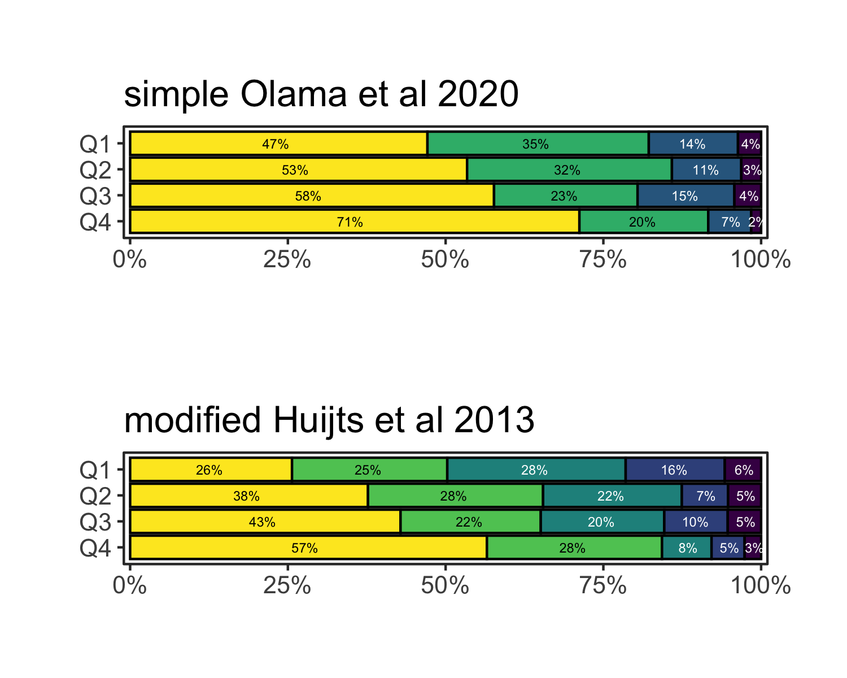

Based on the previous extensive testing, the

## Conclusion

* Due to collinearity, we should modify the analysis plan to take out age and sex from minimal analysis, as these are highly correlated to PASE score. Univariable/bivariable analysis should be included.
* A table with univariable and multivariable analyses could be included, though this poses a risk for multicollinearity as well.
* The issue around collinearity is a result on its own.
* Smoking patterns needs to be addressed on its own, and should be excluded from analyses due to a severe inclusion bias.