SVD analyses and data exploration

These are the planned analyses, tables and figures for the main article.

Drop all the questions and save them for a later specific publication.

Agreed upon scoring overview:

| Annotation | modified Huijts et al 2013 |
| --- | --- |
| Microbleeds subscore | |
| 0 | 0 |
| 1 | 1 |
| 2-4 | 1 |
| 5-10 | 1 |
| >10 | 1 |
| Lacunes subscore | |
| 0 | 0 |
| 1 | 1 |
| 2 | 1 |
| 3-5 | 1 |
| >5 | 1 |
| WMH subscore | |
| 0: Absent | 0 |
| 1: Punctate foci | 0 |
| 2: Beginning confluence | 1 |
| 3: Large confluent areas | 1 |
| Atrophy subscore | |
| 0: No atrophy | 0 |
| 1: Mild | 0 |
| 2: Moderate | 1 |
| 3: Severe | 1 |

# Baseline table

| **Characteristic** | **Overall** N = 762*1* | **Q1** N = 191*1* | **Q2** N = 191*1* | **Q3** N = 189*1* | **Q4** N = 191*1* | **p-value***2* |
| --- | --- | --- | --- | --- | --- | --- |
| Age | 71 (62, 79) | 77 (67, 84) | 74 (65, 80) | 70 (63, 76) | 64 (55, 73) | <0.001 |
| Female sex | 279 (37%) | 85 (45%) | 89 (47%) | 58 (31%) | 47 (25%) | <0.001 |
| Smoking |  |  |  |  |  | 0.6 |
| never | 269 (36%) | 57 (31%) | 75 (40%) | 69 (38%) | 68 (36%) |  |
| current | 211 (28%) | 56 (31%) | 45 (24%) | 53 (29%) | 57 (30%) |  |
| prior | 262 (35%) | 70 (38%) | 66 (35%) | 62 (34%) | 64 (34%) |  |
| Hypertension | 418 (55%) | 123 (65%) | 114 (60%) | 96 (51%) | 85 (45%) | <0.001 |
| Diabetes | 85 (11%) | 27 (14%) | 27 (14%) | 19 (10%) | 12 (6.3%) | 0.040 |
| Previous ischemic event | 97 (13%) | 30 (16%) | 24 (13%) | 27 (14%) | 16 (8.4%) | 0.14 |
| SVD score |  |  |  |  |  | <0.001 |
| 0 | 310 (41%) | 49 (26%) | 72 (38%) | 81 (43%) | 108 (57%) |  |
| 1 | 195 (26%) | 47 (25%) | 53 (28%) | 42 (22%) | 53 (28%) |  |
| 2 | 148 (19%) | 54 (28%) | 42 (22%) | 37 (20%) | 15 (7.9%) |  |
| 3 | 73 (9.6%) | 30 (16%) | 14 (7.3%) | 19 (10%) | 10 (5.2%) |  |
| 4 | 36 (4.7%) | 11 (5.8%) | 10 (5.2%) | 10 (5.3%) | 5 (2.6%) |  |
| Admission NIHSS | 4.0 (2.0, 7.0) | 5.0 (2.0, 9.0) | 3.0 (2.0, 8.0) | 4.0 (2.0, 8.0) | 3.0 (2.0, 5.0) | <0.001 |
| *1*Median (Q1, Q3); n (%) | | | | | | |
| *2*Kruskal-Wallis rank sum test; Pearson's Chi-squared test | | | | | | |

NIHSS fordeling er associeret til PASE, men ikke til SVD score(!)

[[1]]

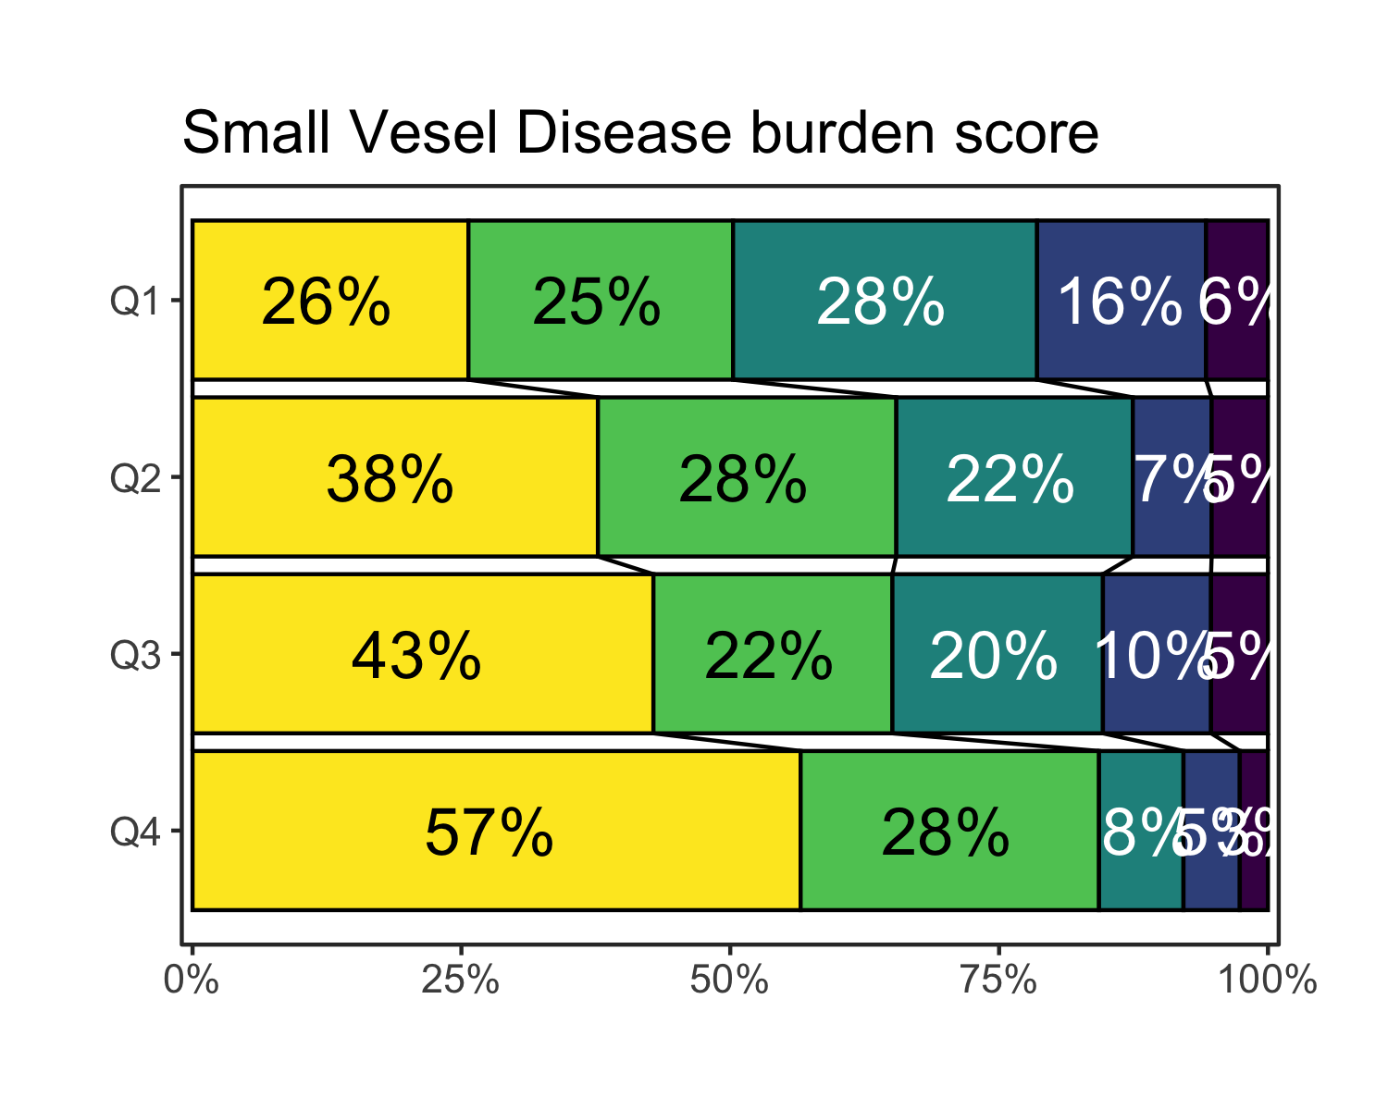

# Regression analyses

|  | No PA adjustment | | With PA adjustment | |
| --- | --- | --- | --- | --- |
| **Characteristic** | **OR***1* | **95% CI***1* | **OR***1* | **95% CI***1* |
| Smoking |  |  |  |  |
| never | — | — | — | — |
| current | 1.63 | 1.14, 2.34 | 1.55 | 1.08, 2.23 |
| prior | 1.44 | 1.04, 2.00 | 1.41 | 1.02, 1.97 |
| Hypertension | 1.91 | 1.43, 2.54 | 1.88 | 1.41, 2.50 |
| Diabetes | 1.46 | 0.96, 2.22 | 1.40 | 0.92, 2.13 |
| Previous ischemic event | 2.28 | 1.52, 3.41 | 2.21 | 1.48, 3.31 |
| *1*OR = Odds Ratio, CI = Confidence Interval | | | | |

### Independent correlations in multivariable analysis

|  | Univariable | | | Multivariable | |
| --- | --- | --- | --- | --- | --- |
| **Characteristic** | **N** | **OR***1* | **95% CI***1* | **OR***1* | **95% CI***1* |
| Age | 762 | 1.09 | 1.08, 1.11 | 1.08 | 1.07, 1.10 |
| Female sex | 762 | 1.19 | 0.91, 1.55 | 0.89 | 0.66, 1.20 |
| Smoking | 742 |  |  |  |  |
| never |  | — | — | — | — |
| current |  | 1.01 | 0.73, 1.41 | 1.57 | 1.09, 2.28 |
| prior |  | 1.69 | 1.24, 2.32 | 1.33 | 0.96, 1.86 |
| Hypertension | 761 | 2.89 | 2.21, 3.79 | 1.79 | 1.33, 2.40 |
| Diabetes | 761 | 1.50 | 1.00, 2.23 | 1.35 | 0.88, 2.08 |
| Previous ischemic event | 758 | 2.57 | 1.73, 3.81 | 2.08 | 1.38, 3.14 |
| Pre-stroke PA quartile | 762 |  |  |  |  |
| Q4 |  | — | — | — | — |
| Q3 |  | 2.04 | 1.39, 3.00 | 1.53 | 1.01, 2.32 |
| Q2 |  | 2.21 | 1.52, 3.23 | 1.18 | 0.78, 1.79 |
| Q1 |  | 3.92 | 2.69, 5.73 | 1.78 | 1.16, 2.73 |
| *1*OR = Odds Ratio, CI = Confidence Interval | | | | | |

### Complete simple interaction analyses

| **Characteristic** | **OR***1* | **95% CI***1* |
| --- | --- | --- |
| Age minimal interaction analysis | | |
| Age | 1.08 | 1.05, 1.12 |
| Pre-stroke PA quartile |  |  |
| Q4 | — | — |
| Q3 | 0.70 | 0.04, 11.3 |
| Q2 | 1.20 | 0.07, 19.6 |
| Q1 | 1.69 | 0.14, 21.3 |
| Female sex |  |  |
| FALSE | — | — |
| TRUE | 0.85 | 0.63, 1.13 |
| Age * Pre-stroke PA quartile |  |  |
| age * Q3 | 1.01 | 0.97, 1.05 |
| age * Q2 | 1.00 | 0.96, 1.04 |
| age * Q1 | 1.00 | 0.97, 1.04 |
| Female sex minimal interaction analysis | | |
| Female sex |  |  |
| FALSE | — | — |
| TRUE | 0.98 | 0.48, 1.94 |
| Pre-stroke PA quartile |  |  |
| Q4 | — | — |
| Q3 | 1.50 | 0.94, 2.40 |
| Q2 | 1.47 | 0.90, 2.42 |
| Q1 | 2.05 | 1.26, 3.35 |
| Age | 1.09 | 1.07, 1.10 |
| Female sex * Pre-stroke PA quartile |  |  |
| TRUE * Q3 | 1.08 | 0.43, 2.70 |
| TRUE * Q2 | 0.67 | 0.28, 1.62 |
| TRUE * Q1 | 0.85 | 0.36, 2.04 |
| Smoking minimal interaction analysis | | |
| Smoking |  |  |
| never | — | — |
| current | 1.28 | 0.62, 2.69 |
| prior | 1.76 | 0.86, 3.64 |
| Pre-stroke PA quartile |  |  |
| Q4 | — | — |
| Q3 | 1.87 | 0.93, 3.83 |
| Q2 | 0.97 | 0.49, 1.96 |
| Q1 | 2.30 | 1.11, 4.83 |
| Age | 1.09 | 1.08, 1.11 |
| Female sex |  |  |
| FALSE | — | — |
| TRUE | 0.85 | 0.63, 1.14 |
| Smoking * Pre-stroke PA quartile |  |  |
| current * Q3 | 0.81 | 0.29, 2.24 |
| prior * Q3 | 0.70 | 0.26, 1.86 |
| current * Q2 | 2.12 | 0.76, 5.93 |
| prior * Q2 | 1.13 | 0.44, 2.90 |
| current * Q1 | 1.28 | 0.47, 3.52 |
| prior * Q1 | 0.54 | 0.21, 1.39 |
| Hypertension minimal interaction analysis | | |
| Hypertension |  |  |
| FALSE | — | — |
| TRUE | 2.12 | 1.18, 3.83 |
| Pre-stroke PA quartile |  |  |
| Q4 | — | — |
| Q3 | 1.78 | 0.99, 3.20 |
| Q2 | 1.33 | 0.71, 2.47 |
| Q1 | 2.05 | 1.09, 3.88 |
| Age | 1.08 | 1.07, 1.10 |
| Female sex |  |  |
| FALSE | — | — |
| TRUE | 0.84 | 0.63, 1.12 |
| Hypertension * Pre-stroke PA quartile |  |  |
| TRUE * Q3 | 0.81 | 0.36, 1.81 |
| TRUE * Q2 | 0.89 | 0.40, 1.98 |
| TRUE * Q1 | 0.87 | 0.39, 1.96 |
| Diabetes minimal interaction analysis | | |
| Diabetes |  |  |
| FALSE | — | — |
| TRUE | 1.81 | 0.56, 5.38 |
| Pre-stroke PA quartile |  |  |
| Q4 | — | — |
| Q3 | 1.56 | 1.02, 2.38 |
| Q2 | 1.27 | 0.83, 1.96 |
| Q1 | 1.98 | 1.29, 3.06 |
| Age | 1.09 | 1.07, 1.10 |
| Female sex |  |  |
| FALSE | — | — |
| TRUE | 0.86 | 0.65, 1.16 |
| Diabetes * Pre-stroke PA quartile |  |  |
| TRUE * Q3 | 0.76 | 0.19, 3.23 |
| TRUE * Q2 | 0.72 | 0.19, 2.84 |
| TRUE * Q1 | 0.75 | 0.20, 2.98 |
| Previous ischemic event minimal interaction analysis | | |
| Previous ischemic event |  |  |
| FALSE | — | — |
| TRUE | 1.47 | 0.56, 3.73 |
| Pre-stroke PA quartile |  |  |
| Q4 | — | — |
| Q3 | 1.40 | 0.91, 2.16 |
| Q2 | 1.20 | 0.78, 1.86 |
| Q1 | 1.83 | 1.18, 2.85 |
| Age | 1.09 | 1.07, 1.10 |
| Female sex |  |  |
| FALSE | — | — |
| TRUE | 0.85 | 0.64, 1.14 |
| Previous ischemic event * Pre-stroke PA quartile |  |  |
| TRUE * Q3 | 2.13 | 0.63, 7.42 |
| TRUE * Q2 | 1.68 | 0.49, 5.88 |
| TRUE * Q1 | 1.34 | 0.42, 4.41 |
| All analyses adjusted for age and sex | | |
| *1*OR = Odds Ratio, CI = Confidence Interval | | |

### Merged table of adjustments and interact

|  | No PA adjustment | | With PA adjustment | | With PA interaction | |
| --- | --- | --- | --- | --- | --- | --- |
| **Characteristic** | **OR***1* | **95% CI***1* | **OR***1* | **95% CI***1* | **OR***1* | **95% CI***1* |
| Smoking |  |  |  |  |  |  |
| never | — | — | — | — | — | — |
| current | 1.63 | 1.14, 2.34 | 1.55 | 1.08, 2.23 | 1.28 | 0.62, 2.69 |
| prior | 1.44 | 1.04, 2.00 | 1.41 | 1.02, 1.97 | 1.76 | 0.86, 3.64 |
| Hypertension | 1.91 | 1.43, 2.54 | 1.88 | 1.41, 2.50 | 2.12 | 1.18, 3.83 |
| Diabetes | 1.46 | 0.96, 2.22 | 1.40 | 0.92, 2.13 | 1.81 | 0.56, 5.38 |
| Previous ischemic event | 2.28 | 1.52, 3.41 | 2.21 | 1.48, 3.31 | 1.47 | 0.56, 3.73 |
| All analyses adjusted for age and sex | | | | | | |
| *1*OR = Odds Ratio, CI = Confidence Interval | | | | | | |