**Cramer's V:**

Cramer's V was used to find the correlation between all possible pairs of labels (MSL, MSW, FC, BF, CHH, EMP). Results obtained are in the following table:-

|  |  |  |  |
| --- | --- | --- | --- |
| LABEL 1 | LABEL 2 | CHI 2 | CRAMER V |
| **MSL** | **CHH** | 411.67 | 0.57 |
| **FC** | **EMP** | 352.3 | 0.52 |
| **MSL** | **MSW** | 325.29 | 0.5 |
| **FC** | **BF** | 309.97 | 0.49 |
| **MSW** | **CHH** | 275.26 | 0.46 |
| **CHH** | **FC** | 236.61 | 0.43 |
| **MSL** | **FC** | 226.7 | 0.42 |
| **MSW** | **FC** | 218.42 | 0.41 |
| **BF** | **EMP** | 207.06 | 0.4 |
| **MSL** | **BF** | 182.88 | 0.38 |
| **MSW** | **BF** | 187.26 | 0.38 |
| **MSL** | **EMP** | 171.87 | 0.37 |
| **CHH** | **EMP** | 176.17 | 0.37 |
| **CHH** | **BF** | 169.03 | 0.36 |
| **MSW** | **EMP** | 78.11 | 0.25 |

**Interpretations:** From the above results we have interpreted that the following two sets are moderately correlated.

1) MSL, MSW and CHH

2) FC, EMP and BF

**Abbreviations:**

**MSL:** Main Source of Light

**MSW:** Main Source of Water

**BF:** Bathroom Facility

**CHH:** Condition of Household

**EMP:** Type of Employment

**Logistic Regression:**

NIGHTLIGHT and MODIS data were used to predict these census variables: MSL, MSW, FC, BF, CHH, EMP

**Feature Pre-processing:**

1. **Night Light Features:**

* Two sets of features were made from the nightlight values.
* **First Set**: Proportion of area under each nightlight intensity value in a district.
* District Area was obtained by adding the areas under all nightlight intensities of that district.
* **Second Set:** Intensity of nightlight value for a district.

1. **MODIS Features:**

* New features were made from existing MODIS features and sum of nightlight.
* **Crop Ratio:** Proportion of Cropland and Natural Vegetation area in a district.
* **Average Urban Nightlight:** Intensity of Nightlight in a district contributed by urban and Built-up area.
* **Urban Ratio:** Proportion of Urban and Built-up area in a district.
* **Natural:** Area under all Natural Vegetations and Forests including water in a district.
* **Crop Remain Ratio:** Ratio of Cropland and Natural Vegetation after removing the Natural area (calculated above) from the district area.
* **Urban Remain Ratio:** Ratio of Urban and Built-up after removing the Natural area (calculated above) from the districts area.
* **Forest:** Area under all the Forests in a district.
* **Grass Shrubs**: Area covered by Shrublands, Savannas and Grasslands.

**Feature Selection:**

Rich Feature Extraction (RFE) was used to find the top orders features. The ranks returned by RFE was then used to select some features to maximize our performance. P values were also calculated to interpret the importance of each feature.

**Results:**

|  |  |  |  |  |  |  |  |
| --- | --- | --- | --- | --- | --- | --- | --- |
| Sat Data | F1,ACC | FC | MSL | EMP | BF | MSW | CHH |
| NTL | f1,acc | 0.68,0.73 | 0.65,0.71 | 0.65,0.71 | 0.64,0.7 | 0.63,0.69 | 0.59,0.66 |
| MODI | f1,acc | 0.72,0.8 | 0.58,0.68 | 0.66,0.74 | 0.7,0.78 | 0.67,0.76 | 0.62,0.7 |
| NTL+MODI | f1,acc | 0.78,0.84 | 0.74,0.81 | 0.73,0.8 | 0.71,0.79 | 0.71,0.78 | 0.68,0.75 |

**Abbreviations:**

**Sat:** Satellite

**NTL:** Night Light Data

**F1:**  F1 score ; **ACC:** F1 Score and Accuracy

**Predicting Growth Labels (Decision Tree):**

Using census variables, we predict growth clusters. These census variables were predicted from Logistic Regression model previously built.

**Decision Tree Model:**

INPUT: Three of the predicted census variables from logistic regression: MSL,MSW,FC OUTPUT: Growth Clusters.

The dataset was highly imbalanced. This imbalance was taken into account while tuning the hyper parameters.

The number of districts showing the declining, stable and Increasing pattern are given under heading: counts, in the Results table.

**Results:**

|  |  |  |  |
| --- | --- | --- | --- |
| **GWOTH CLUSTERS** | **F1 SCORE** | **ACCURACY** | **COUNTS** |
| DECLINING | 0.29798 | 0.467433 | 105 |
| STABLE | 0.620579 | 0.547893 | 324 |
| INCREASING | 0.450331 | 0.681992 | 93 |

**Effects of Macro Events on Night Time Light:**

Some macro events were taken to find the effect of them on night time light.

**Events taken:**

* Cyclone Nilam
* South Indian Flood (2015)
* Kumbh Mela
* State Legislative Elections in India

**CYCLONE NILAM: OCTOBER 2012**

Mahabalipuram town in Kancheepuram district was highly affected from cyclone Nilam which occurred in last days of october 2012. The following graph is the plot of night time light values of Kancheepuram district from April 2012 to March 2017. 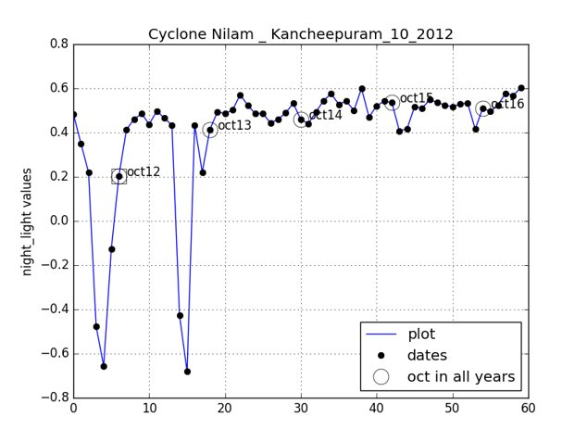

**Interpretation:** Nightlight value on October 2012 (marked with circle inside a square) is seem to be much lower than the nightlight values in october month of 2013-2017 years (marked with circles in a graph) as expected.

**SOUTH INDIAN FLOOD (2015):**

The southern parts of India (mainly, Tamil Nadu, Andhra Pradesh and Puducherry) were highly affected from the South Indian Flood which occurred in the November month of 2015. The following graph is the plot of night time light values from April 2012 to March 2017.

Thiruvallur district was chosen to study the effect of flood.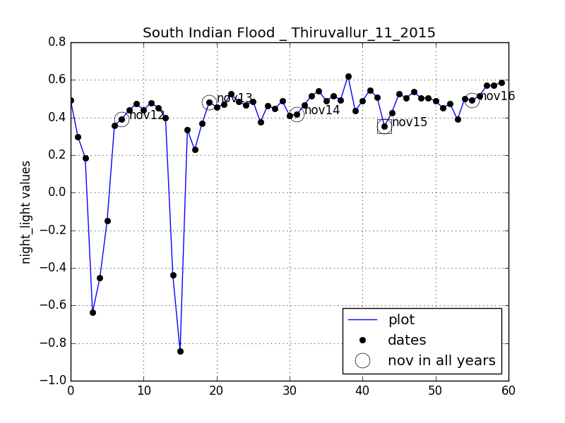

**Interpretation:** Nightlight value on November 2015 (marked with circle inside a square) is seem to be much lower than the nightlight value in November month of 2012-2014 and 2016 years (marked with circles in a graph). Although a much downfall in night time light values is not seen. The possible explanation is the heavy rainfall which occur every year in this zone of India.

The average rainfall of Thiruvallur district is 1104 mm with more than 50% of it has been received during Northeast Monsoon Period (From October to December).

**Legislative Assembly Elections in India:**

Members of the Vidhan Sabha (or Legislative/State Assembly) are chosen by the Indian electorates in these elections.

These elections are held after every Five years and are never carried out in the same year for all the states and the Union Territories.

Significant growth in Night time light is seen during the election period followed by sharp decline after these elections, for some states. Uttar Pradesh, Haryana, Punjab and Tamil Nadu were the states which follows this trend most closely.

**UTTAR PRADESH: FEBRUARY 2017**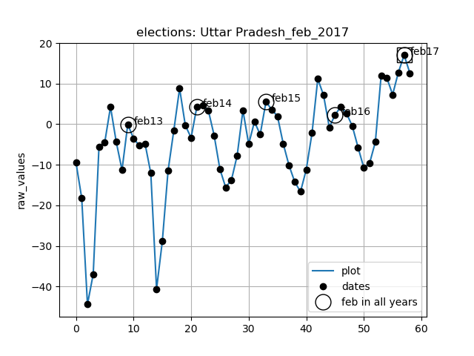

**HARYANA: OCTOBER 2014**

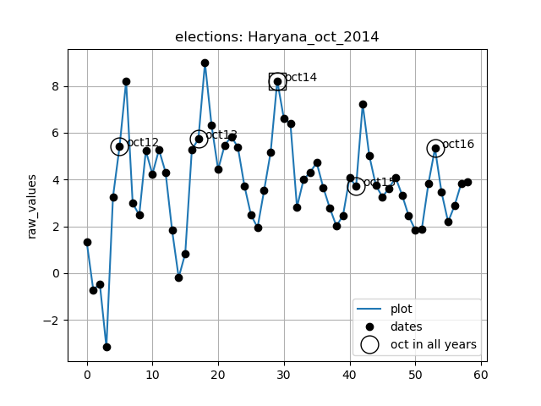

**PUNJAB: FEBRUARY 2014**

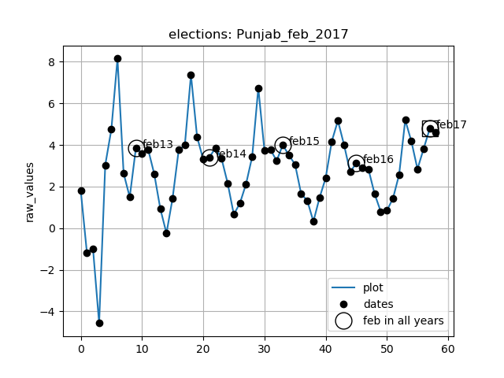

**TAMIL NADU: MAY 2016**

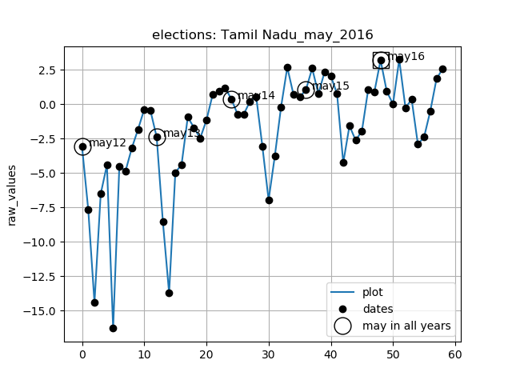

**Kumbh Mela:**

Kumbh mela is a large, mass hindu pilgrimage of faith. It occurs periodically in Allahbad, Haridwar, Nashik and Ujjain districts. Period is of 12 years for a district.

We studied night time light values of Nashik, Ujjain and Allahabad and found the significant growth in night time light values in Nashik and Ujjain but there is not much significant growth in Allahabad. The possible reason is Nashik and Ujjain are not much developed districts while Allahabad is very developed district and lot of events occurred in it compared to Nashik and Ujjain.

The plots of night time light values from April 2012 to March 2017 are in the following attached graphs.

**NASHIK : AUGUST 2015**

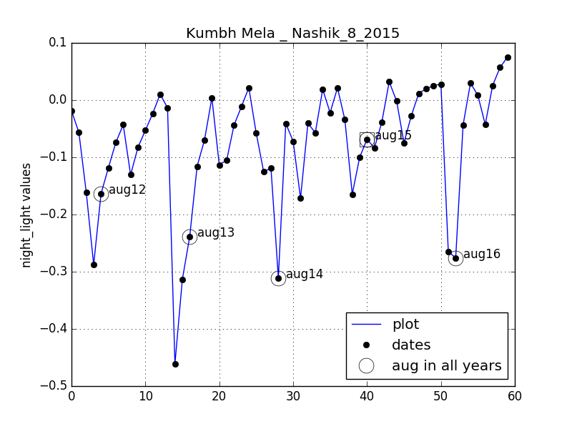

**UJJAIN: MAY 2016**

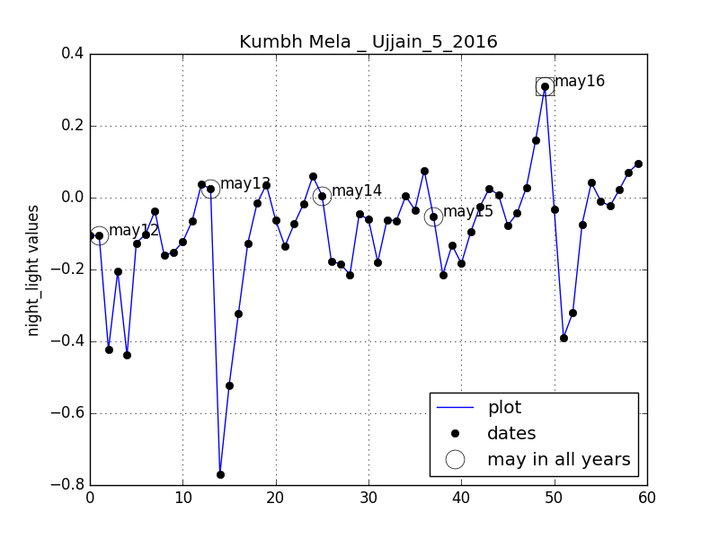

**ALLAHABAD: FEBRUARY 2013**

