**Project 1, Task 1: Report to Blackwell Electronics**

Spending Trends by Region and Comparison of Number of Items Purchased to Amount Spent

Anders Dowd - Spring 2022 Data Analytics Certification Program

1. *Overview*

Do customers of Blackwell Electronics spend more per transaction in different sales regions? If so, which are the highest and lowest sales regions? Does amount spent correlate to number of items purchased?

1. *Data*

Blackwell Electronics has provided sales data collected since launching their eCommerce website last year. We have 80000 entries that log five data points per transaction:

* The age of the customer making the purchase;
* The number of items purchased;
* The total sales amount;
* The region (north, south, east, or west) in which the purchase was made, represented as a number (1 through 4, respectively);
* Whether the purchase was made online or in-store, represented as a binary.

1. *Analysis*

Preliminary analysis of the provided data set indicates the average number of items purchased per transaction varies little between regions, while the amount spent per transaction varies dramatically depending on the region. Across all regions, customers averaged very close to 4.5 items per transaction. The region with the highest amount per transaction was the west, where customers averaged $1283.94 per transaction, significantly higher than those in the south who averaged $252.12. The north and east fall somewhere in between in their spending habits, coming in at $744.99 and $917.96 per transaction respectively. However, each region has a very high standard deviation compared to their mean amount, indicating a wide range of spending totals.

**Table 1:** Average Amount Spent Versus Number of Items Purchased By Region

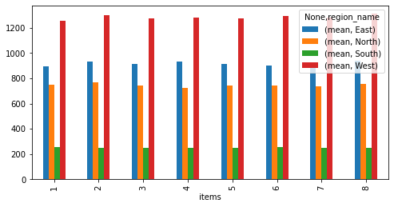

Indeed, when we examine the minimum and maximum amount spent in each region we get ranges of: $50.05 - $1999.80 in the north; $5.00 - $499.94 in the south; $50.13 - $3000.00 in the east; and $50.60 - $3000.00 in the west. One might expect more items purchased to translate into more money spent – that the low-end values of the item range would correspond to the low-end values of the amount range, and the two values would scale together. Interestingly, the number of items purchased appears to have little to no correlation to the amount spent, regardless of region. When we plot the values of ‘number of items purchased’ versus ‘amount spent’, we find data points across the entirety of each min-max range. Table 1 illustrates the average amount spent versus number of items purchased broken down by region. As you can see, the average amount stays relatively consistent within each region regardless of number of items purchased. In short, ‘amount spent’ is not a reliable predictor of ‘number of items purchased’, nor vice versa.

**Table 2:** Regional In-store Versus Online Sales Averages By Item Total

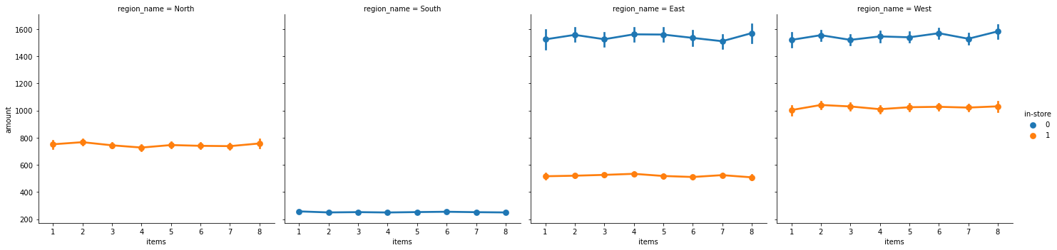

1. *Conclusion*

Of the variables available for analysis, region is the strongest single predictive indicator of spending habits. The west not only had the highest amount spent per transaction rate, but it had far more transactions than any other region. The north had the fewest transactions, but the second lowest average expenditure. The south had the lowest average expenditure. Furthermore, in the two regions that produced a combination of in-store and online sales (east and west), online sales tended to correlate with significantly greater transaction amounts. In answering the questions presented by the client, more unanswered questions are revealed. For instance: why did the north region perform all of its transactions in-store, while the south region was 100% online (see Table 2)? Examining the demographic breakdown of these regions in search of other correlations could yield a better understanding of sales trends.