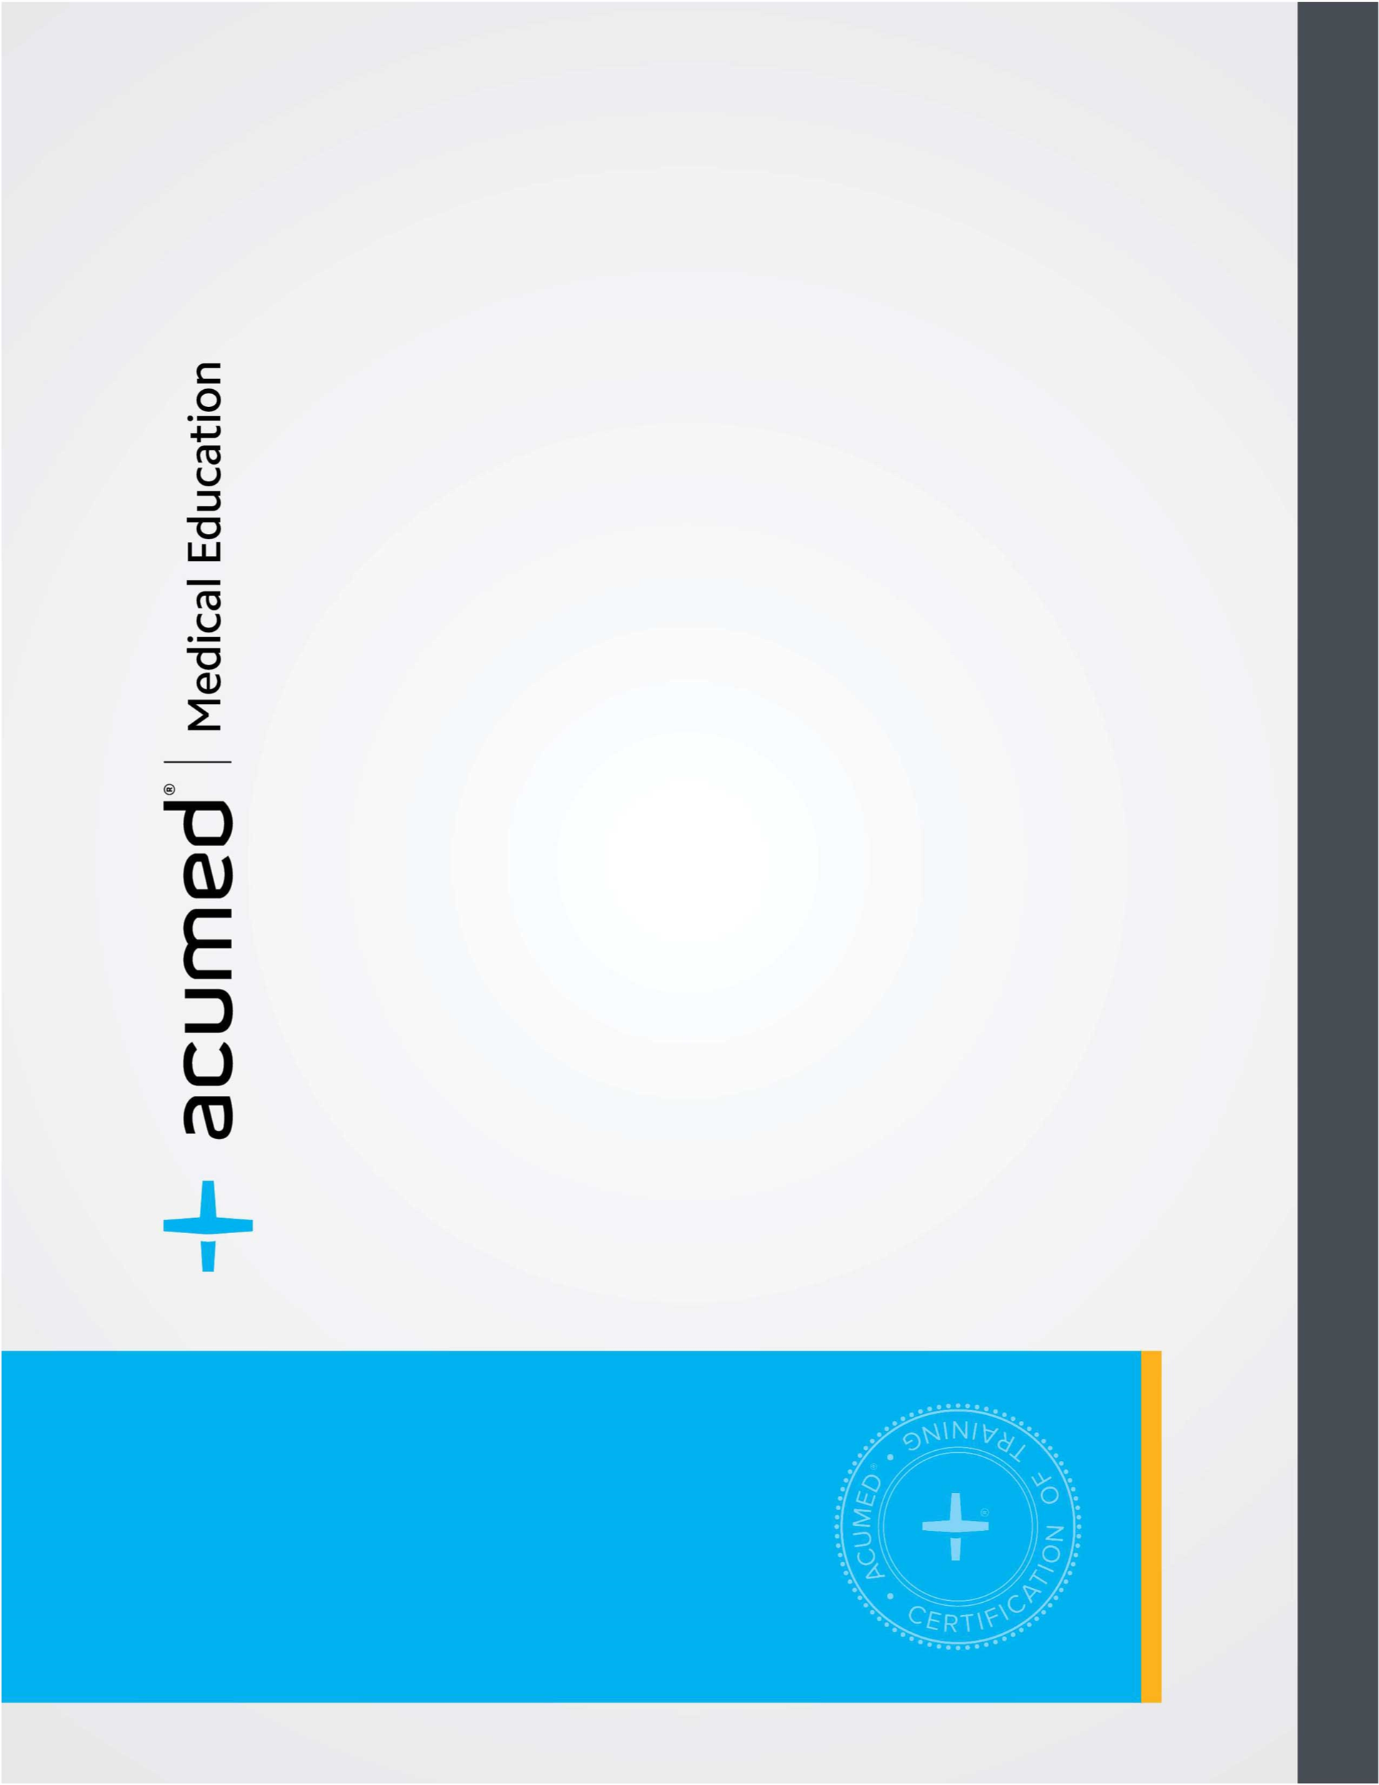

**Certificate of Completion**

This is to certify that

**Wendelin Widia Madhin, MD**

attended the Acumed Surgeon Training course

*Elbow Injury Symposium with Dr. O'Driscoll*

The course consisted of in-depth didactic lectures and case discussions.

Jakarta, Indonesia

February 27, 2024

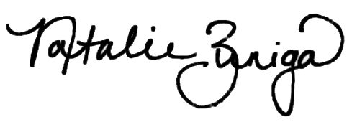

February, 2024

Natalie Zuniga

Director, Medical Education & Sales Training