CREATE TABLE Customer (CustomerID INT PRIMARY KEY , CustomerName VARCHAR(30), ContactNo INT, Address VARCHAR(30), City VARCHAR(30), PostalCode INT, Country VARCHAR(30));
INSERT INTO Customer VALUES (1, 'Aleena', '9876543210', 'Pamplaniyil', 'Pala', 682016, 'India');
INSERT INTO Customer VALUES (2, 'Marie', '9123456780', 'Thazhath', 'Pala', 682031, 'India');
INSERT INTO Customer VALUES (3, 'Suchitra', '9988776655', 'Moorankuzhiyil', 'Pala', 686001, 'India');
INSERT INTO Customer VALUES (4, 'Akhil', '9090909090', 'Chembarathiyil', 'Pala', 682020, 'India');
INSERT INTO Customer VALUES (5, 'kuriakose', '9012345678', 'Mandapathil', 'Washington', 680001, 'USA');
SELECT * FROM Customer;

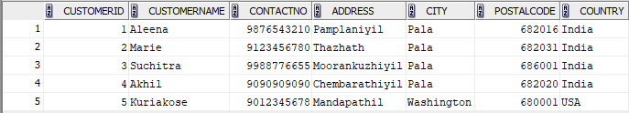

CREATE TABLE Employees (EmployeeID INT PRIMARY KEY, LastName VARCHAR(30), FirstName VARCHAR(30), BirthDate DATE, Photo VARCHAR2(30));
INSERT INTO Employees VALUES (11, 'Jack', 'Sumith', DATE '1987-05-11', 'photo1.jpg');
INSERT INTO Employees VALUES (12, 'Kuttan', 'Latha', DATE '1979-08-09', 'photo2.jpg');
INSERT INTO Employees VALUES (13, 'Joseph', 'Mathew', DATE '2001-02-13', 'photo3.jpg');
INSERT INTO Employees VALUES (14, 'Varghese', 'Thomas', DATE '1999-11-27', 'photo4.jpg');
INSERT INTO Employees VALUES (15, 'Narayanan', 'Arun', DATE '1994-07-01', 'photo5.jpg');
SELECT * FROM Employees;

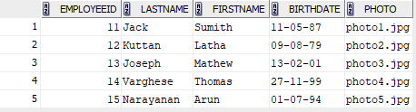

CREATE TABLE Orders (OrderID INT PRIMARY KEY,CustomerID INT, EmployeeID INT, OrderDate DATE, ShipperID INT,FOREIGN KEY (CustomerID)REFERENCES Customer(CustomerID),FOREIGN KEY (EmployeeID)REFERENCES Employees(EmployeeID));
INSERT INTO Orders VALUES (1011, 1, 11, DATE '2024-01-11', 101);
INSERT INTO Orders VALUES (1012, 2, 12, DATE '2024-01-25', 105);
INSERT INTO Orders VALUES (1013, 3, 13, DATE '2024-02-15', 103);
INSERT INTO Orders VALUES (1014, 4, 14, DATE '2024-02-10', 201);
INSERT INTO Orders VALUES (1015, 5, 15, DATE '2024-03-24', 203);
SELECT * FROM Orders;

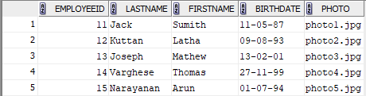
1.
SELECT * FROM customer order by CustomerName ASC;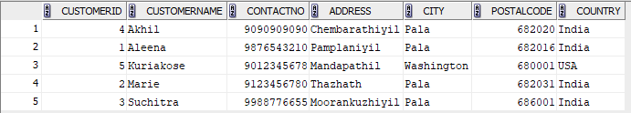

2.
SELECT *FROM Orders ORDER BY OrderDate ASC;
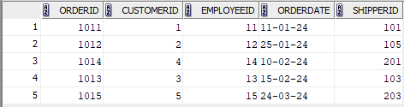
3.
SELECT * FROM Employees WHERE BirthDate > DATE '1980-01-01' ORDER BY BirthDate DESC;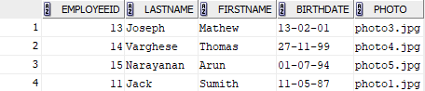
4.
5.
SELECT CustomerID, COUNT(OrderID) AS TotalOrders FROM Orders GROUP BY CustomerID;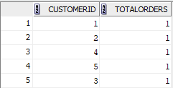
6.
select count(CustomerID),Country from Customer group by Country ;
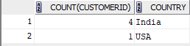
7.
8.
select count(CustomerID),City from Customer group by City having count(customerid)>3 ;
