
Output transformer for QRP Labs transceivers:
QDX, QDX-M and QMX
Assembly instructions
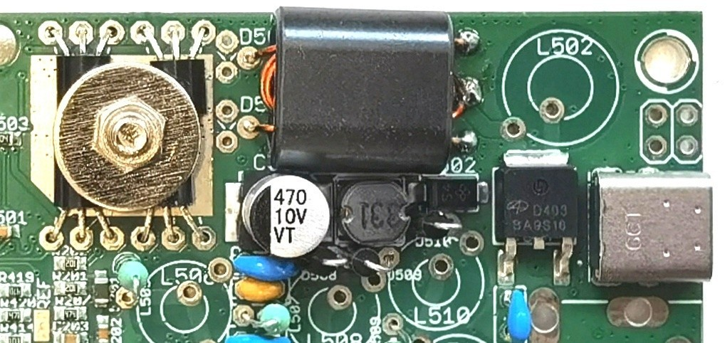

Contents
Contents 1
1. Introduction & background 2
2. RWTST for 12V transceivers (“Really Weird Twisted Sisters Transformer”) 4
3. WTST for 9V transceivers (“Weird Twisted Sisters Transformer”) 11
4. Conventional wound transformer assembly 16
5. Document Revision History 19

Introduction & background
QDX, QDX-M and QMX all use the same push-pull pair of BS170 transistors, which drive an output transformer wound from enameled wire on a ferrite binocular core. The transformer is wound with a 3:2 turns ratio for 12V supply operation and 3:3 if one wishes to use 9V supply. Supplied wire on recent kit batches is all 0.33mm and this provides the highest performance (older kits use 0.60mm wire).
The introduction of the high-bands QDX (20, 17, 15, 12, 11 and 10m) in December 2022 gave rise to a particular problem where approximately 30% of 9V the high-band units, and a smaller number of 12V units, exhibited a low output power and poor efficiency on the 10m band. Investigation involving swapping components one by one between a “good” and a “bad” unit, both with transformers wound neatly and carefully by the same person, revealed conclusively that the low power problem followed the binocular core. It is proposed that in some cases, perhaps due to component tolerances (ferrite material) there is a low-Q parasitic resonance which affects the 10m output power performance.
After a great deal of experimentation, Ross EX0AA designed what he called the WTST (Weird Twisted Sisters Transformer) for the 9V case, which completely eliminated the parasitic resonance and restored proper operation across all bands 20 to 10m. Furthermore there was a noticeable improvement in efficiency. Even on the low-bands QDX (80, 60, 40, 30 and 20m) the WTST method produces improved performance due to the improved coupling between the windings and improved symmetry.
Ross EX0AA later followed up with another design he called RWTST (Really Weird Twisted Sisters Transformer) for the 12V supply operation, having 3:2 ratio. Again this shows no parasitic resonance problem and improves performance on both low-band and high-band versions.
We are very grateful to Ross for his work on these transformers, which comprehensively solved a rather perplexing problem!
This document contains three descriptions (you build only one):
- WTST for 9V operation (3:3 ratio)
- RWTST for 12V operation (3:2 ratio)
- Conventional 9V (3:3 ratio) or 12V (3:2 ratio) transformer
RECOMMENDATION:
It’s strongly recommended to use WTST (9V) or RWTST (12V) for any high-band transceiver. It’s even recommended to use these improved transformers for low-band transceivers where the PA efficiency is also improved.
The old method (“conventional”) transformer is easier to build and still valid below 10 or 12m, there’s nothing wrong with it apart from this unfortunate parasitic resonance which can effect 10m.
So to re-iterate:
- These transformers apply to QDX, QDX-M or QMX
- For 12V operation we suggest RWTST
- For 9V operation we suggest WTST
- The conventional transformer may be used if desired
In all three cases, it is a good idea to de-burr the binocular core because sharp edges can damage the insulating enamel on the wire – however be careful since the ferrite is brittle and can easily be broken. So GENTLE scraping of the edges with something sharp like a knife is possible. All transformer methods use the same enameled copper wire, which may be 0.33mm (more recent kit batches) or 0.60mm (older kit batches).
IMPORTANT POINTS REGARDING TRANSFORMER INSTALLATION:
Regardless of the type of transformer wound, the following points are critical:
- Don’t use more wire then specified or necessary, because the wire is also used for other inductors in the kit and has been measured (plus some safety margin) accordingly.
- When the transformer is ready, bend all the wires to align them with the holes in the PCB.
- Cut the wires such that about 1cm will protrude down from the transformer towards the PCB.
- If using 0.60mm wire, scrape the wire enamel from this 1cm section. The enamel on the 0.60mm wire will be very difficult to remove using heat; so it is better to scrape it or sand it. If using 0.33mm wire, you can pre-tin the ends and burn the enamel off with a blob of hot solder, or you can burn the enamel off while soldering (hold the wire in the hole for longer).
- With 0.60mm wire DO NOT tin the wires before installing the transformer, because it will make it very difficult to get the thick 0.60mm wire through the PCB holes! If the wire you are using is 0.33mm it is fine to tin the wires before installing the transformer.
- It’s really necessary to use a drill to twist these wires, doing it by hand will not result in an even twist.
- Pictures in this document are shown with the wire quite lightly twisted. The tighter you can twist, the better the coupling will be, and the better symmetry between the two halves of the transformer, resulting in better performance. Therefore try to twist the wires more tightly than shown in these pictures, as long as they are still neat.
- The photographs show 0.60mm wire. However, all the more recent kit batches are supplied only with 0.33mm wire. With the 0.33mm wire we noticed a slight performance improvement (higher power output and efficiency). It is possible to twist the thinner 0.33mm wire more tightly and this probably contributes to higher coupling between windings.

RWTST for 12V transceivers (“Really Weird Twisted Sisters Transformer”)
Only for 12V operation!
Summary in pictorial form:
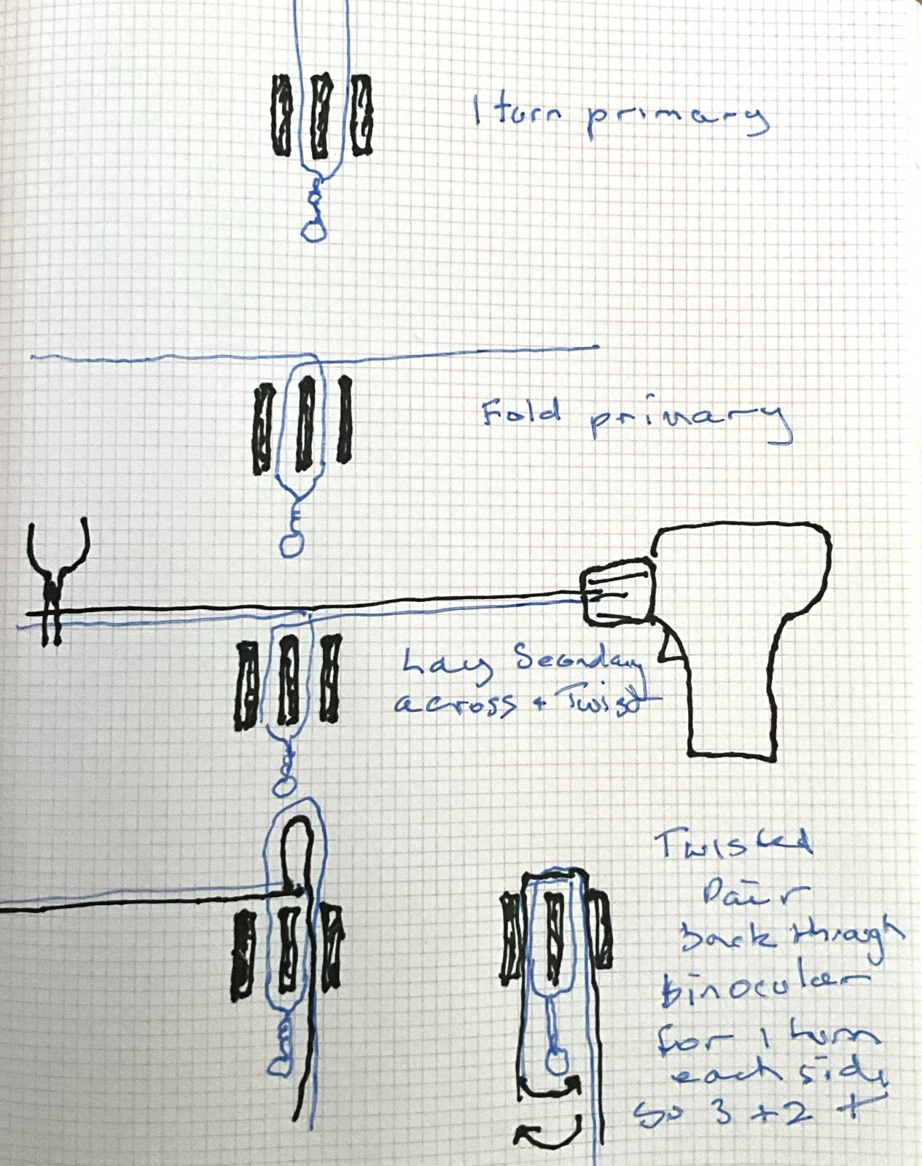
Step 1:
Cut approximately 25cm of 0.6mm copper enameled fold in two and twist the top of the fold for 2cm. Place each leg of the wire hairpin into each hole in the binocular:
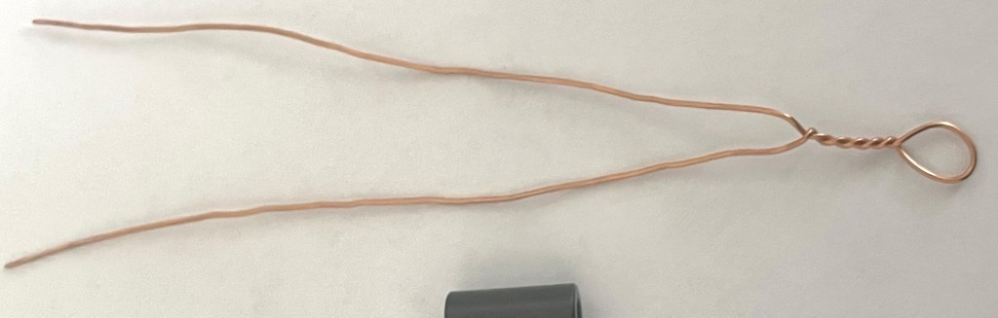
Step 2:
Fold each two wire protruding from the other end of the binocular across the opposite hole:
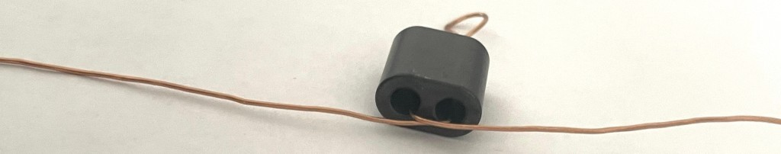
Step 3:
Cut another 20cm (approx) of wire and lay it equidistant across the holes as shown:
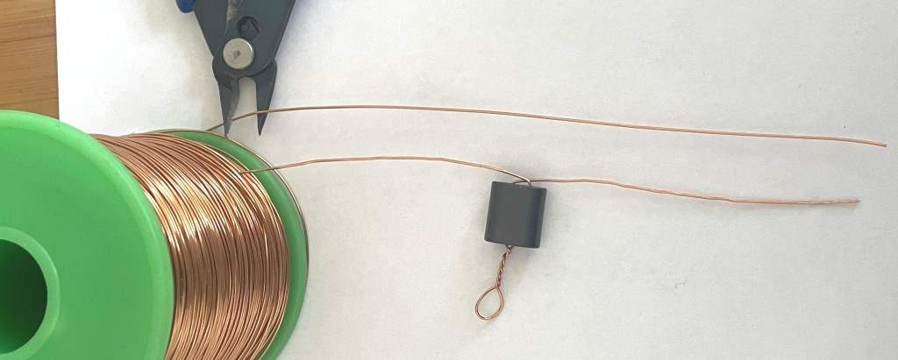
Step 4:
Clockwise twist each side of the wire laying across to each side of the two wires coming out of the binocular core and laying at across the other hole:
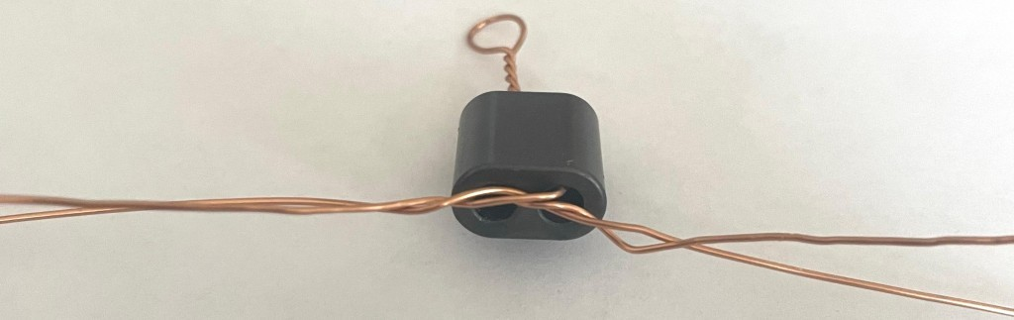
Step 5:
Loosely twist each side, put in electric drill chuck and firmly hold other ends of the two wires:
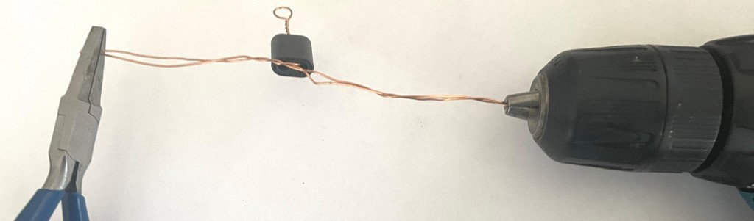
Step 6:
Carefully squeeze the drill trigger to get a neat twisted pair. It’s perfectly possible to do this by hand without the aid of a vise or other fixing.
Best performance is obtained when the twists are tight and symmetrical.
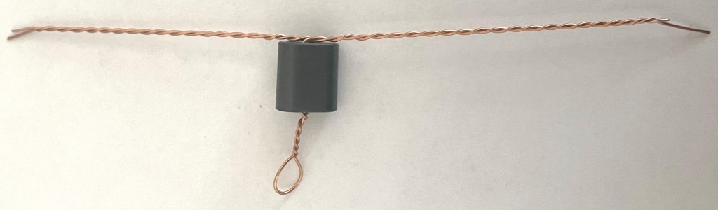
Step 7:
Push one side through so that the wire laying across and twisted, goes through the hole it was laying across the center, and NOT the hole it came through.
Note that it requires some force to push the wire through and in this process it is easy to scrape the enamel off the wire as it passes the hard edges of the binocular core hole entrances. This is not a show-stopper, it doesn’t matter if bare copper touches the ferrite material. On the other hand it certainly DOES matter if the bare copper wire touches other bare copper wires in the holes. So it’s better to avoid scraping any enamel off the wires. In other words take it slow.
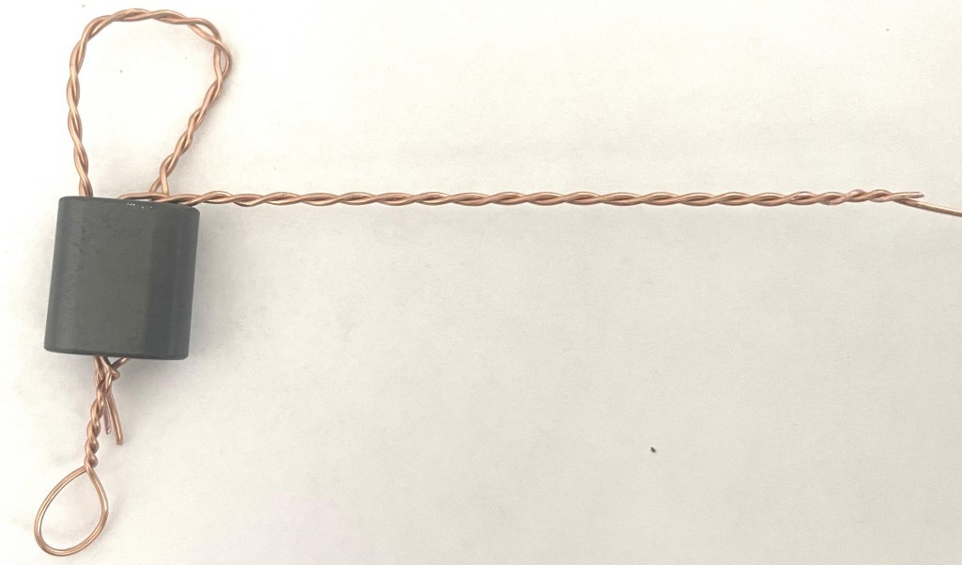
Step 8:
Pull the twisted pair tight all the way through the binocular:
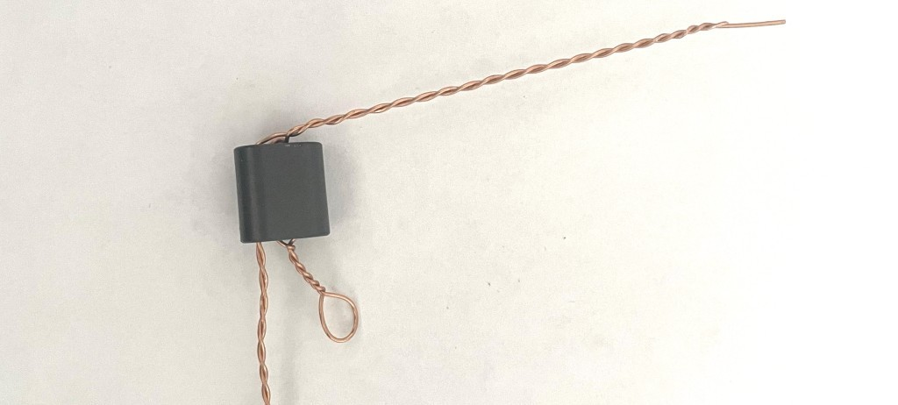
Step 9:
Push the second twisted pair through the hole it was laying at over:
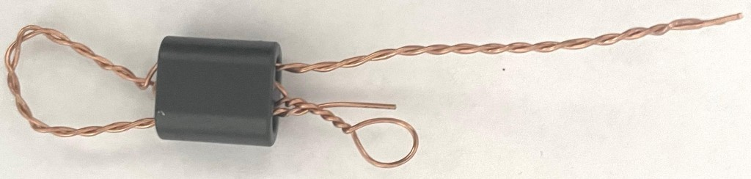
Step 10:
Carefully pull tight:
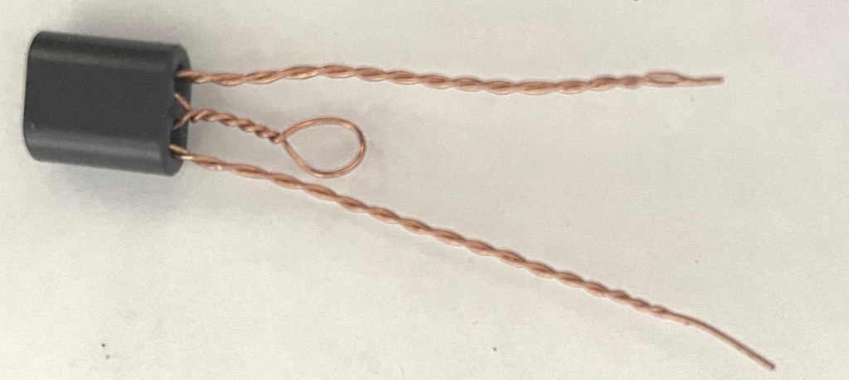
Step 11:
Slide one twisted pair back through the opposite hole away from the twisted hairpin loop:
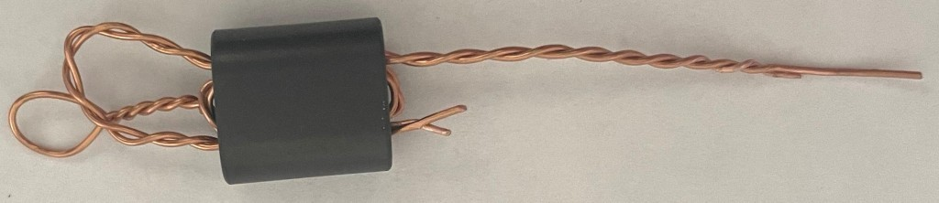
Step 12:
Slide the other twisted pair back through away from the twisted hairpin loop and pull both tight:
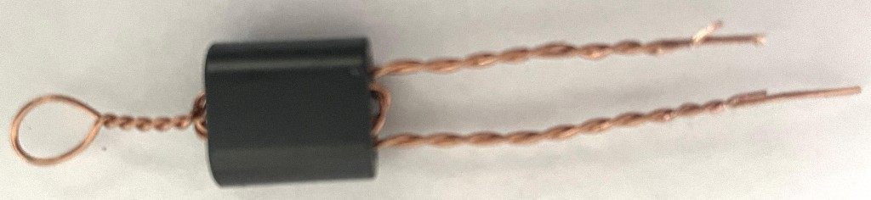
Step 13:
Untwist the two pairs at the opposite end of the binocular:
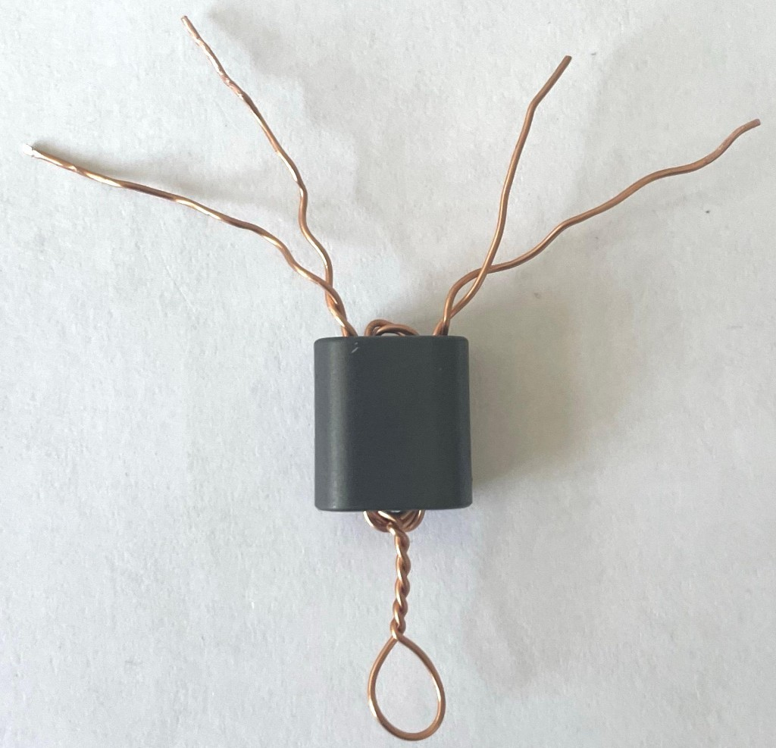
The bottom twisted hairpin loop is the primary, connecting to BS170 transistor drains. Two of the top four wires are the secondary winding, the other two with continuity to the twisted loop are twisted together to form the center tap.
Step 14:
Cut the twisted hairpin loop, and untwist the few turns outside the transformer core. Scrape the wire enamel from the ends of all the wires so that you can use a DVM in continuity mode (or test for zero resistance) to test the wires. Identify the two of the four wires on the right-hand side that have continuity between them. Splay these outward. These are the SECONDARY.
The remaining two wires in the middle are the primary center tap and should now be twisted together.
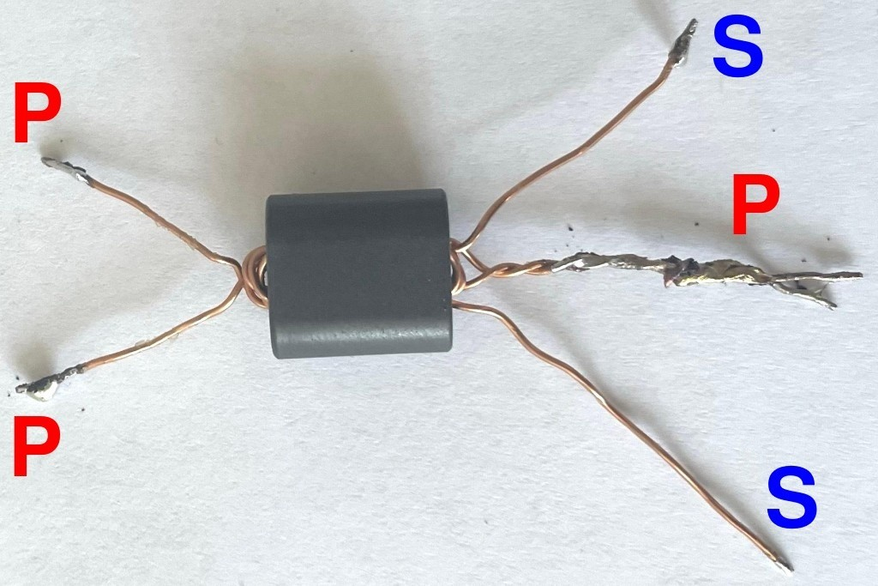
Now re-test with the DVM – points P (P is for primary) should all show continuity to each other; there should be continuity between points S (S is for secondary). But there must be NO continuity between P and S! If there is: you made a mistake, or you have copper wire shorts somewhere.
The Really Weird Twisted Sisters Transformer is now complete and ready for installation in your QDX / QDX-M / QMX PCB.
Remember: RWTST transformers are for the 12V Supply option build of QDX, QDX-M and QMX transceivers.

WTST for 9V transceivers (“Weird Twisted Sisters Transformer”)
Step 1:
Cut two lengths of wires, one 20cm, one 24cm approx
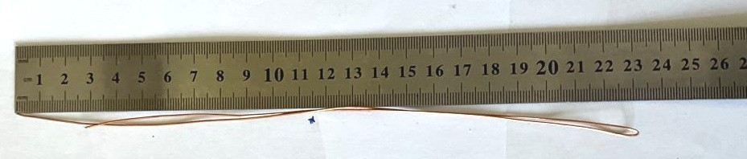
Step 2:
Make about a 2cm hairpin twist in the middle of the longer of the wires:
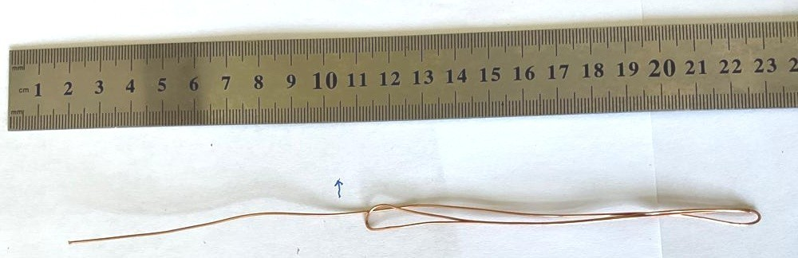
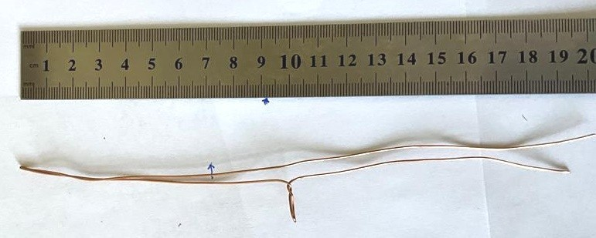
Step 3:
Use a small electric drill on slow mode, one end of the wire in the chuck and the other, making sure a tight parallel pair, firmly gripped by small pliers. Hold the trigger for short periods until a really nice even tight twist is obtained at about 3 twists per cm.
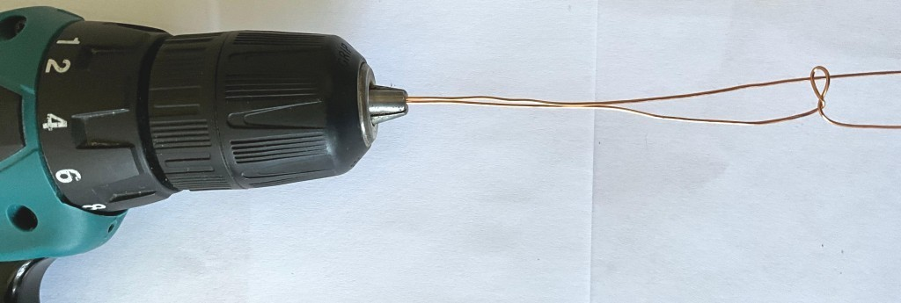
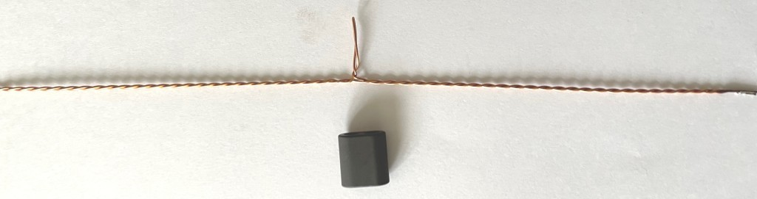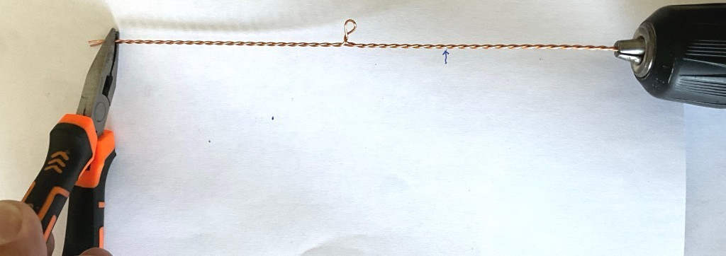
Step 4:
Bend the twisted pair in a hairpin with small 2cm twist at the top and two legs:
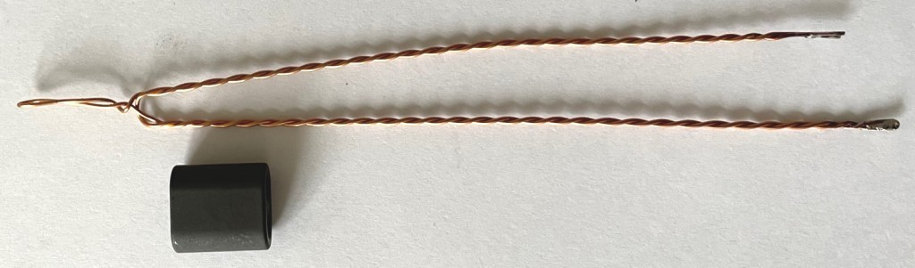
Step 5:
Pass each leg through the binocular. Wind a neat tight transformer half turn by half turn (very important for symmetry!) each side until each wire pair goes back through the binocular twice, giving 1 1/2 turns each pair.
It is very important to wind half a turn at a time, and try to lay the half-turns inside the holes as similarly as possible on each side; the better the symmetry, the better the performance will be! Remember: each time the twisted pair passes through one hole of the binocular, counts as half a turn.
- The initial pass of the hairpin through the holes is ½ a turn
- Passing each pair back through the opposite holes makes 1 turn total
- Passing the twisted pairs back again through the holes makes 1.5 turns
When the sections are joined together, it will make a 3:3 transformer as required, but with excellent symmetry and coupling between the windings, giving very good performance.
The following photo shows the result at 1 turn:
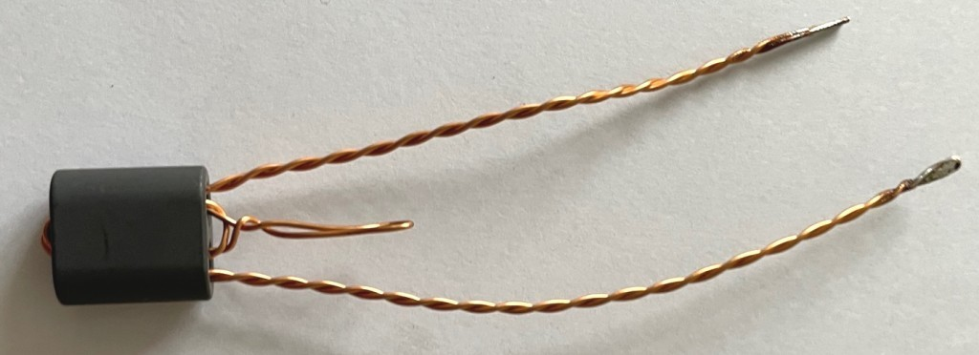
The following photo shows the result at 1.5 turns:
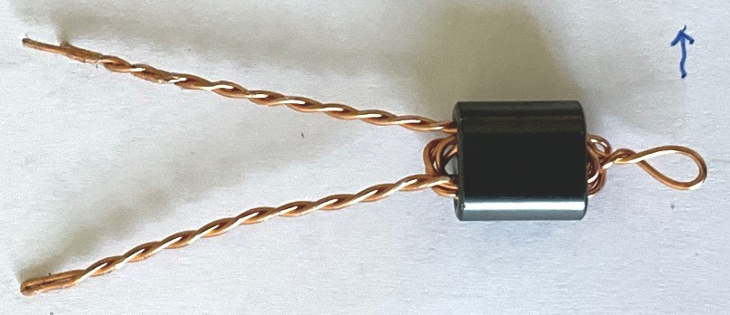
Step 6:
Untwist all the wires that are outside the binocular core.
Step 7:
Cut the hairpin loop.
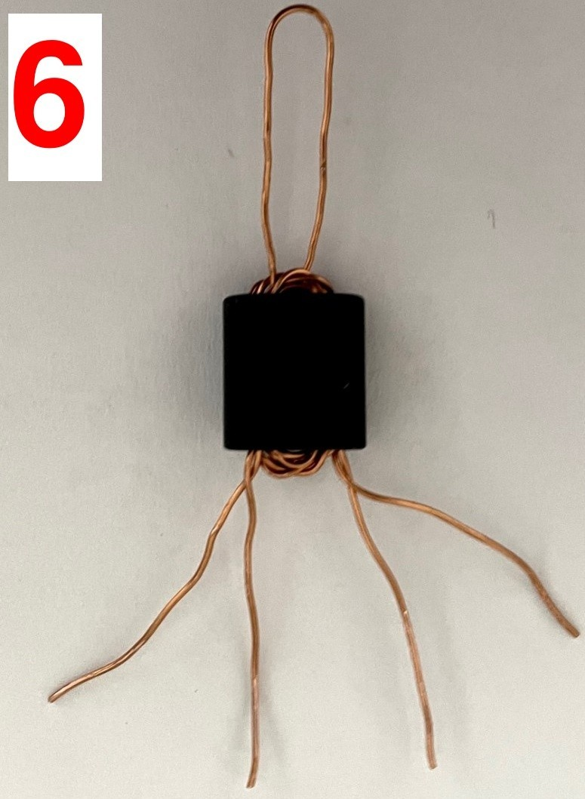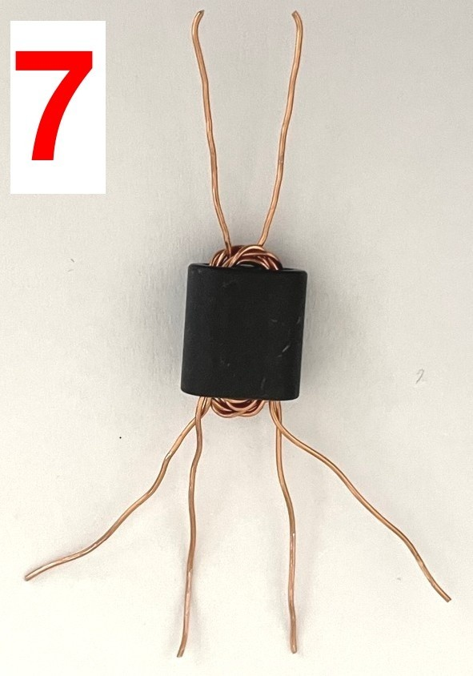
Step 8:
Scrape the wire enamel from the ends of all the wires so that you can use a DVM in continuity mode (or test for zero resistance) to test the wires. Identify the two of the four wires on the rightband side that have continuity between them. Splay these outward. These are the SECONDARY.
The remaining two wires in the middle are the primary center tap and should now be twisted together.
Now re-test with the DVM – points P (P is for primary) should all show continuity to each other; there should be continuity between points S (S is for secondary). But there must be NO continuity between P and S! If there is: you made a mistake, or you have copper wire shorts somewhere.
The Weird Twisted Sisters Transformer is now complete and ready for installation in your QDX / QDX-M / QMX PCB.
Remember: WTST transformers are for the 9V Supply option build of QDX, QDX-M and QMX transceivers. Do not use with 12V supply, it will fry the output transistors!

Conventional wound transformer assembly
Remember that the wire may also be used for other inductors in the transceiver so do not use it all (no more of it than necessary).
The transformer has two windings. The primary is always 3 turns center-tapped. The secondary is 3 turns for 9V supply operation, or 2 turns if building your transceiver for 12V operation. In the nomenclature of binocular cored transformers, “1 turn” means the wire passes through both sets of holes, ending up back at the end where it started.
Assembly of this transformer is best done in steps as follows. Please read all the steps before commencing the assembly:
Step 1:
Carefully unwrap the thick 0.6mm (AWG #22) wire, and straighten it ensuring no kinks.
Step 2:
Pass the wire through both holes, starting at the top left, as shown. This is the first turn of the 3turn primary winding.
Step 3:
Now pass the wire through the top hole of the binocular core, back from left to right. This is the next half-turn of the primary winding, bringing the number of turns so far to 1.5; now we must make the center tap.
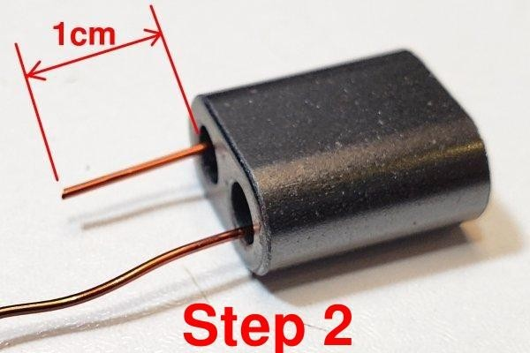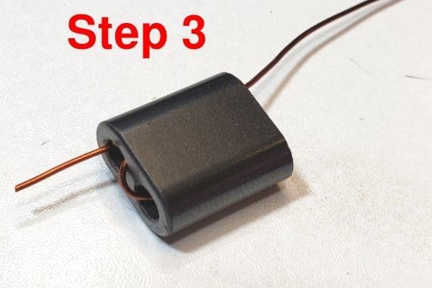
Step 4:
Now pass the wire back through the bottom hole of the binocular core, from right to left; but do not pull it tight. Leave a small loop as shown in the photograph. This will be soldered into the centertap pad on the PCB.
Step 5:
Wind the wire through both the top hole of the binocular core and the bottom hole, pulling it a little tight as normal; this forms the final turn of the 3-turn primary winding. You end up with the wire coming out of the bottom left hole as shown; cut it to about 1cm protrusion.
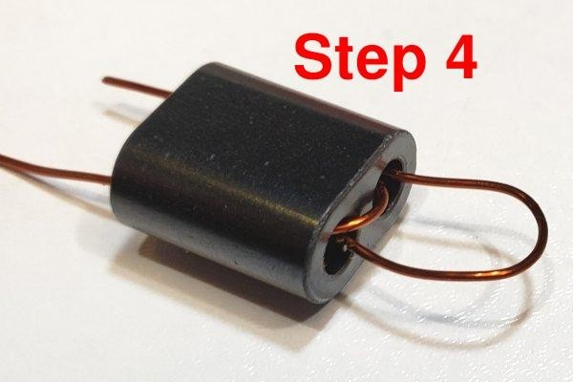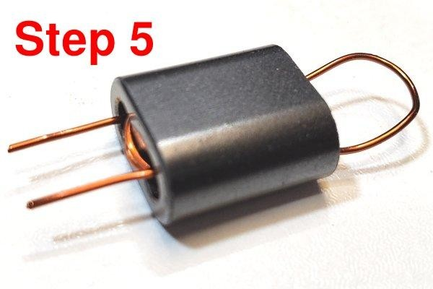
Step 6:
Squeeze together the center-tap to try to avoid subsequent confusion.
Step 7:
Start the 3-turn secondary winding by pushing the wire from right to left through the bottom hole of the binocular core, then from left to right through the top hole. This is the first turn.
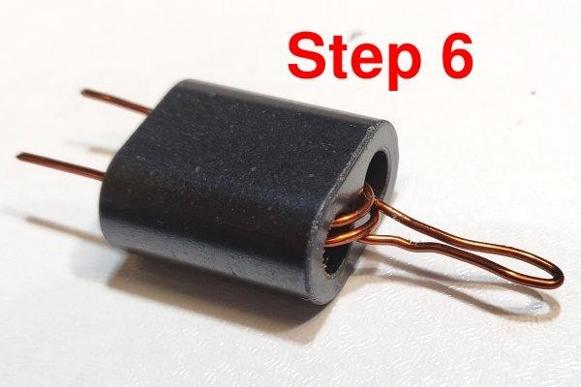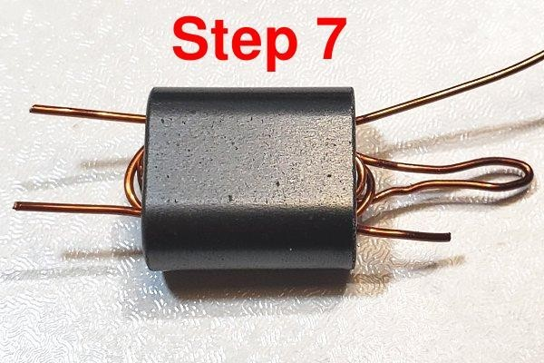
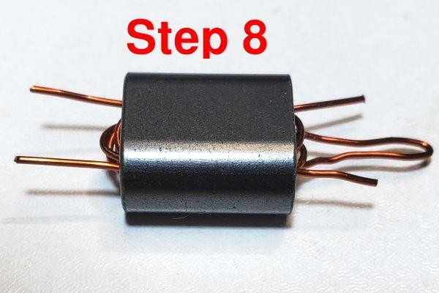
Step 8:
Push the wires through both holes two more times to create the second turn: right to left through the bottom hole, then left to right through the top hole. Now we have three turns on the secondary. Cut the wire leaving about 1cm spare.
Remember to wind only 2 turns secondary, if winding the transformer as 3:2 for 12V operation.
Please refer to page 4 for details of 9V or 12V operation choices.
Step 9:
Bend all the wires to point downward in the position they will need to be, to fit through the holes in the PCB
.
Step 10:
Now cut the center-tap loop; hopefully, as mine are in this photograph, these two wires formed by cutting the loop are LONGER than the two ends of the 3-turn secondary, so that you cannot mix anything up. These center wires can be twisted together tightly to make sure there is no confusion.
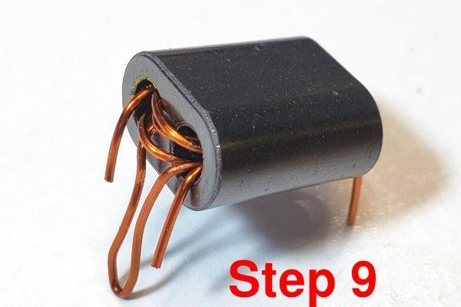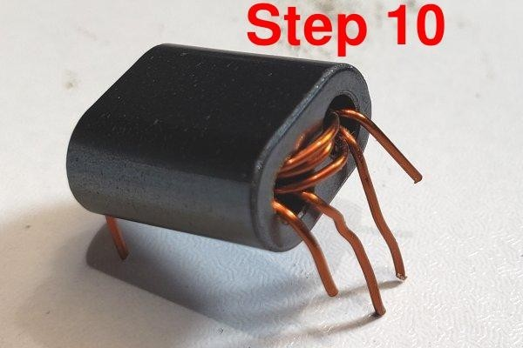
The transformer is now ready for installation in the PCB!
Make sure the number of secondary turns you wound matches the supply voltage you wish to use:
- 2 turns (3:2 ratio) for 12V supply operation
- 3 turns (3:3 ratio) for 9V supply operation
Do not use a 9V transformer (3:3 turns ratio) with 12V supply: this will most likely fry the PA transistors quite quickly.

Document Revision History
1.00 12-Sep-2023 | First version
1.00a 13-Sep-2023 | Corrections to minor typos
1.00b 13-Sep-2023 | One more typo (“WSTS” instead of “WTST”)
1.00c 19-Dec-2024 | Notes that 0.33mm wire may be supplied (not 0.60mm)

