ON Semiconductor
Is Now

To learn more about onsemi™, please visit our website at www.onsemi.com

onsemi and and other names, marks, and brands are registered and/or common law trademarks of Semiconductor Components Industries, LLC dba “onsemi” or its affiliates and/or subsidiaries in the United States and/or other countries. onsemi owns the rights to a number of patents, trademarks, copyrights, trade secrets, and other intellectual property. A listing of onsemi product/patent coverage may be accessed at www.onsemi.com/site/pdf/Patent-Marking.pdf. onsemi reserves the right to make changes at any time to any products or information herein, without notice. The information herein is provided “as-is” and onsemi makes no warranty, representation or guarantee regarding the accuracy of the information, product features, availability, functionality, or suitability of its products for any particular purpose, nor does onsemi assume any liability arising out of the application or use of any product or circuit, and specifically disclaims any and all liability, including without limitation special, consequential or incidental damages. Buyer is responsible for its products and applications using onsemi products, including compliance with all laws, regulations and safety requirements or standards, regardless of any support or applications information provided by onsemi. “Typical” parameters which may be provided in onsemi data sheets and/ or specifications can and do vary in different applications and actual performance may vary over time. All operating parameters, including “Typicals” must be validated for each customer application by customer’s technical experts. onsemi does not convey any license under any of its intellectual property rights nor the rights of others. onsemi products are not designed, intended, or authorized for use as a critical component in life support systems or any FDA Class 3 medical devices or medical devices with a same or similar classification in a foreign jurisdiction or any devices intended for implantation in the human body. Should Buyer purchase or use onsemi products for any such unintended or unauthorized application, Buyer shall indemnify and hold onsemi and its officers, employees, subsidiaries, affiliates, and distributors harmless against all claims, costs, damages, and expenses, and reasonable attorney fees arising out of, directly or indirectly, any claim of personal injury or death associated with such unintended or unauthorized use, even if such claim alleges that onsemi was negligent regarding the design or manufacture of the part. onsemi is an Equal Opportunity/Affirmative Action Employer. This literature is subject to all applicable copyright laws and is not for resale in any manner. Other names and brands may be claimed as the property of others.

AN531/D
MC1496 Balanced Modulator
Prepared by: Roy Hejhall
Applications Engineering

INTRODUCTION
The ON Semiconductor MC1496 monolithic balanced modulator makes an excellent building block for high frequency communications equipment.
The device functions as a broadband, double–sideband suppressed carrier balanced modulator without a requirement for transformers or tuned circuits. In addition to its basic application as a balanced modulator/demodulator, the device offers excellent performance as an SSB product detector, AM modulator/detector, FM detector, mixer, frequency doubler, phase detector, and more.
The article consists of a general description of the MC1496, its gain equations, biasing information, and circuits illustrating typical applications. It is followed by an appendix containing a detailed mathematical ac and dc analysis of the device.
Many readers may find that one of the circuits described in the article will fill the needs of their application. However, it is impossible to show typical circuits for every possible requirement, and the detailed analysis given in the appendix will assist the designer in developing an optimum circuit for any application within the basic capabilities of the MC1496.


http://onsemi.com

APPLICATION NOTE

MC1496 General Description
Figure 1 shows a schematic diagram of the MC1496. For purposes of the analysis, the following conventional assumptions have been made for simplification: (1) Devices of similar geometry within a monolithic chip are assumed identical and matched where necessary, and (2) transistor base currents are ignored with respect to the magnitude of collector currents; therefore, collector and emitter currents are assumed equal.
Referring to Figures 1 and 2, the MC1496 consists of differential amplifier Q5–Q6 driving a dual differential amplifier composed of transistors Q1, Q2, Q3 and Q4. Transistors Q7 and Q8 and associated bias circuitry form constant current sources for the lower differential amplifier
Q5–Q6.
The analysis of operation of the MC1496 is based on the ability of the device to deliver an output which is proportional to the product of the input voltages VX and VY. This holds true when the magnitudes of VX and VY are maintained within the limits of linear operation of the three differential amplifiers in the device. Expressed mathematically, the output voltage (actually output current, which is converted to an output voltage by an external load resistance), VO is given by
VO K VX VY ⁽¹⁾
Figure 1. MC1496 Schematic
 Semiconductor Components Industries, LLC, 2002 1 Publication Order Number:
January, 2002 – Rev. 3 AN531/D
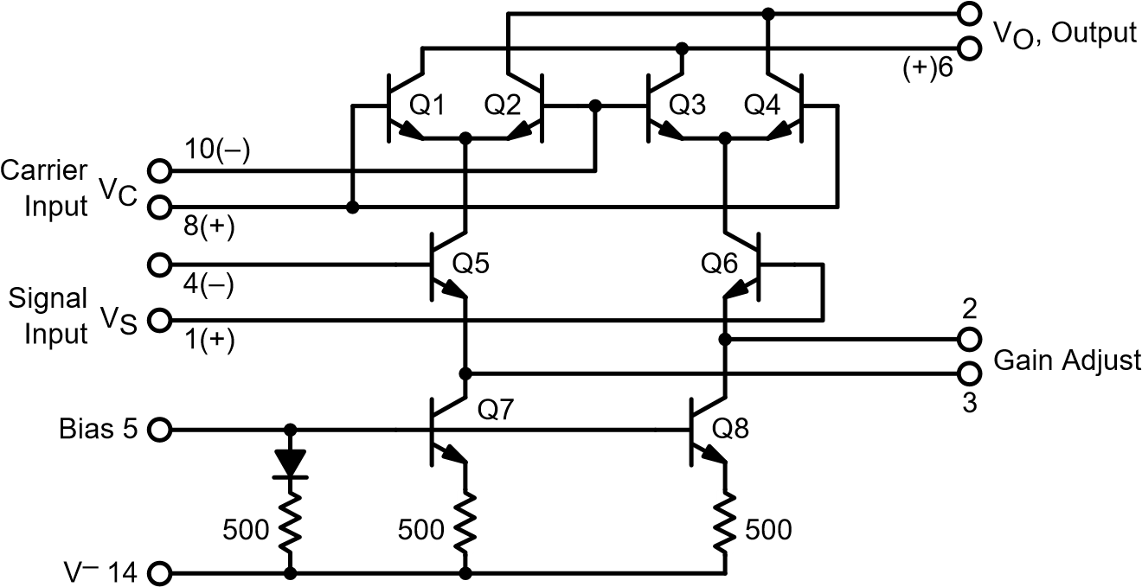
(–)12
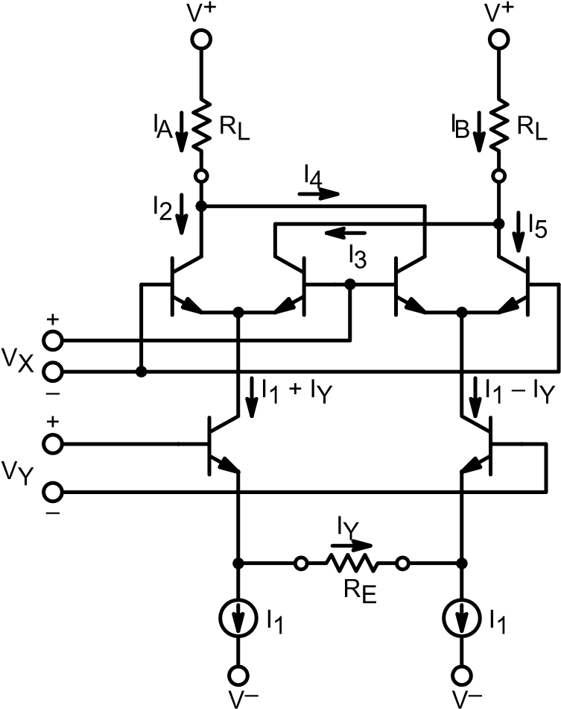

Figure 2. Analysis Model
where the constant K may be adjusted by choice of external components. A detailed description of how the MC1496 circuit configuration performs the basic function of multiplication as expressed by Equation (1) is contained in the references.
An example of a four–quadrant multiplier utilizing these principles is the ON Semiconductor MC1595, which has been described in a previous article.4 The MC1595 multiplier contains the basic circuit configuration of the MC1496 plus additional circuitry which results in linear multiplier operation over a large input voltage range. However, the less complex MC1496 has higher frequency response, greater versatility and is less expensive than the MC1595. For these reasons the MC1496 is preferred in many communications applications such as those to be described later in this note.

Device Operation
The most common mode of operation of the MC1496 consists of applying a high level input signal to the dual differential amplifiers, Q1, Q2, Q3, and Q4, (carrier input port) and a low level input signal to the lower differential amplifier, Q5 and Q6, (modulating signal input port). This results in saturated switching operation of carrier dual differential amplifiers, and linear operation of the modulating differential amplifier.
The resulting output signal contains only the sum and difference frequency components and amplitude information of the modulating signal. This is the desired condition for the majority of the applications of the MC1496.
Saturated operation of the carrier–input dual differential amplifiers also generates harmonics (which may be predicted by Fourier analysis, see Appendix). Reducing the carrier input amplitude to its linear range greatly reduces these harmonics in the output signal. However, it has the disadvantages of reducing device gain and causing the output signal to contain carrier signal amplitude variations.
The carrier input differential amplifiers have no emitter degeneration. Therefore, the carrier input levels for linear and saturated operation are readily calculated. (See Appendix.) The crossover point is in the vicinity of 15–20 mV rms, with linear operation below this level and saturated operation above it.
The modulating–signal differential amplifier has its emitters brought out to pins 2 and 3. This permits the designer to select his own value of emitter degeneration resistance and thereby tailor the linear dynamic range of the modulating–signal input port to a particular requirement. The resistor also determines device gain.
The approximate maximum level of modulating signal input for linear operation is given by the expression:
Vm(peak) I1 RE ⁽²⁾
where RE = resistance between pins 2 and 3, and I1 refers to the notation in the analysis model shown in Figure 2. Since base currents were assumed to be zero and transistors identical,
I1 I5 (3)
where I5 = current flowing into pin 5. Therefore, Equation
(2) becomes
Vy(peak) I5 RE ⁽⁴⁾
Device voltage gain (single ended output with respect to modulating signal input) is given by the expression (also see Appendix):
R^{L} f(m) ⁽⁵⁾ AV RE
where f(m) (1 ee–mm)(1eme–m) m VkTX
q
f(m) may be approximated for the two general cases of high and low level carrier operation, resulting in the following gain expressions: High level case (VX > 100 mV peak):
f(m) 1 (6)
therefore,
|AV| RREL (7)
The low–level case (VX < 50 mV peak) is given by:
f(m) –m2 (8)
therefore,
R
|AV| 2RLmE (9)
The foregoing expressions assume the condition RE >> re, where re is the dynamic emitter resistance of transistors Q5

and Q6. When I1 = 1 mA, re is approximately 26 ohms at room temperature.
There are numerous applications where it is desirable to set RE equal to some low value or zero. For this condition, Equations (7) and (9) can be expanded to the more general form: high–level VX:
|AV| _{RE}RL_{2re} (10)
low–level VX:
|AV| 2(RERLm 2re) (11)
Equations (10) and (11) summarize the single ended conversion voltage gains of the MC1496 with a dc input voltage (VX) at the carrier port. Operation with a differential output would increase the gains by 6 dB.
Equations (10) and (11) may be combined with Equations (26) and (29) in the Appendix to compute the conversion gain of the MC1496 operating as a double sideband suppressed carrier modulator (ac carrier input).
For a high level carrier input signal, the expressions for output voltage and voltage gain become
RL Vy
VO RE 2re n1 An[cos(nx y)t cos(nx ₍₁₂₎y)t]
where
An n 2 sin n

2
Solving Equation (12) for the sidebands around fX (n = 1) yields:
RL Vy
VO _{RE} _{2re}(0.637)[cos(x y)t cos(x y)t]
(13)
Equation (13) may be further simplified to give the voltage gain for the amplitude of each fundamental sideband:
VO Av R0.637E 2RrLe ⁽¹⁴⁾ Vy
For the low level VX case: RL Vy(cos y)t x(kTcosqx)t (15) V
^{VO} 2(RE 2re)
_{VO} RLVyVx[cos(kTxy)t cos(x y)t] ⁽¹⁶⁾
4 _{q} (RE 2re)
And the voltage gain for each sideband becomes:
VO RLVx(rms) (17)

Vy |Av| 2 2 kTq (RE 2re)
Equations (14) and (17) summarize the single ended conversion voltage gains of the MC1496 for low and high level ac carrier inputs. Note that these gain expressions are calculated for the output amplitude of each of the two desired sidebands. The composite output signal consists of the sum of these two sidebands in the low level case and in the high level case it is the sum of the sidebands of the carrier and all the odd numbered harmonics of the carrier.
Laboratory gain measurements have shown good correlation with Equations (10), (11), (14) and (17).

DC Bias
A significant portion of the DC bias circuitry for the MC1496 must be supplied externally. While this has the disadvantage of requiring several external components, it has the advantage of versatility. The MC1496 may be
operated with either single or dual power supplies at practically any supply voltage(s) a semiconductor system has available. Further, the external load and emitter resistors provide the designer with complete freedom in setting device gain.
The DC bias design procedure consists of setting bias currents and 4 bias voltage levels, which not exceeding absolute maximum voltage, current, and dissipation ratings.
The current levels in the MC1496 are set by controlling I5 (subscripts refer to pin numbers). For bias current design the following assumption may be made:
I¹⁴ I5 I6 I12 ₃
Since base currents may be neglected, I5 flows through a forward biased diode and a 500 Ω resistor to pin 14.
When pin 14 is grounded, I5 is most conveniently adjusted by driving pin 5 from a current source.
When pin 14 is connected to a negative supply, I5 may be set by connecting a resistor from pin 5 to ground (R5). The value of R5 may be computed from the following expression:
|V
R5 14I|5 500 (18)
where φ = the diode forward voltage, or about 0.75 Vdc at TA = 25°C.
The absolute maximum rating for I5 is 10 mA.
For all applications described in the article, bias current I5 has been set at 1 mA. The MC1496 has been characterized at this bias current and it is the recommended current unless there is a conflict with power dissipation requirements.
The 4 bias voltage levels that must be set up externally are:
pins 6 and 12 most positive; pins 8 and 10 next most positive; pins 1 and 4 next most positive; pin 14 most negative.
The intermediate voltage levels may be provided by a voltage divider(s) or any other convenient source such as ground in a dual power supply system.
It is recommended that the voltage divider be designed for a minimum current of 1 mA. Then I1, I4, I7, and I8 need not be considered in the divider design as they are transistor base currents.
Guidelines for setting up the bias voltage levels include maintaining at least 2 volts collector–base bias on all transistors while not exceeding the voltages given in the absolute maximum rating table;
30 Vdc [(V6,V12) (V8,V10)] 2 Vdc
30 Vdc [(V8,V10) (V1,V4)] 2.7 Vdc
30 Vdc [(V1,V4) (V5)] 2.7 Vdc
The foregoing conditions are based on the following assumptions:
V6 V12, V8 V10, V1 V4
The other consideration in bias design is total device dissipation, which must not exceed 680 mW and 575 mW at TA = 25°C, respectively, for the metal and ceramic dual in–line packages.
From the assumptions made above total device dissipation may be computed as follows:
PD 2 I5(V6 V14) I5(V5 V14) ⁽¹⁹⁾
For examples of various bias circuit designs, refer to Figures 3, 8 and 9.

Balanced Modulator
Figure 3 shows the MC1496 in a balanced modulator circuit operating with +12 and –8 volt supplies. Excellent gain and carrier suppression can be obtained with this circuit by operating the upper (carrier) differential amplifiers at a saturated level and the lower differential amplifier in a linear mode. The recommended input signal levels are 60 mV rms for the carrier and 300 mV rms for the maximum modulating signal levels.
For these input levels, the suppression of carrier, carrier harmonics, and sidebands of the carrier harmonics is given in Figures 4 and 5.
The modulating signal must be kept at a level to insure linear operation of lower differential amplifier Q5–Q6. If the signal input level is too high, harmonics of the modulating signal are generated and appear in the output as spurious sidebands of the suppressed carrier. For a maximum modulating signal input of 300 mV rms, the suppression of these spurious sidebands is typically 55 dB at a carrier frequency of 500 kHz.
Sideband output levels are shown in Figure 6 for various input levels of both carrier and modulating signal for the circuit of Figure 3.
Operating with a high level carrier input has the advantages of maximizing device gain and insuring that any amplitude variations present on the carrier do not appear on the output sidebands. It has the disadvantage of increasing some of the spurious signals.
Fourier analysis for a 50% duty cycle switching waveform at the carrier differential amplifiers predicts no even harmonics of the carrier (Appendix). However, the second harmonic of the carrier is suppressed only about 20 dB in the LF and HF range with a 60 mV carrier injection level, apparently due to factors such as the waveform not being a perfect square wave and slight mismatch between transistors. If the sine wave carrier signal is replaced with a 300 mV peak–to–peak square wave, an additional 15 dB of carrier, second–harmonic suppression is achieved. Attempting to accomplish the same result by increasing carrier sine–wave amplitude degrades carrier suppression due to additional carrier feedthrough with, however, no increase in the desired sideband output levels.
Operation with the carrier differential amplifiers in a linear mode theoretically should produce only the desired sidebands with no spurious outputs. Such linear operation is achieved by reducing the carrier input level to 15 mV rms or less.
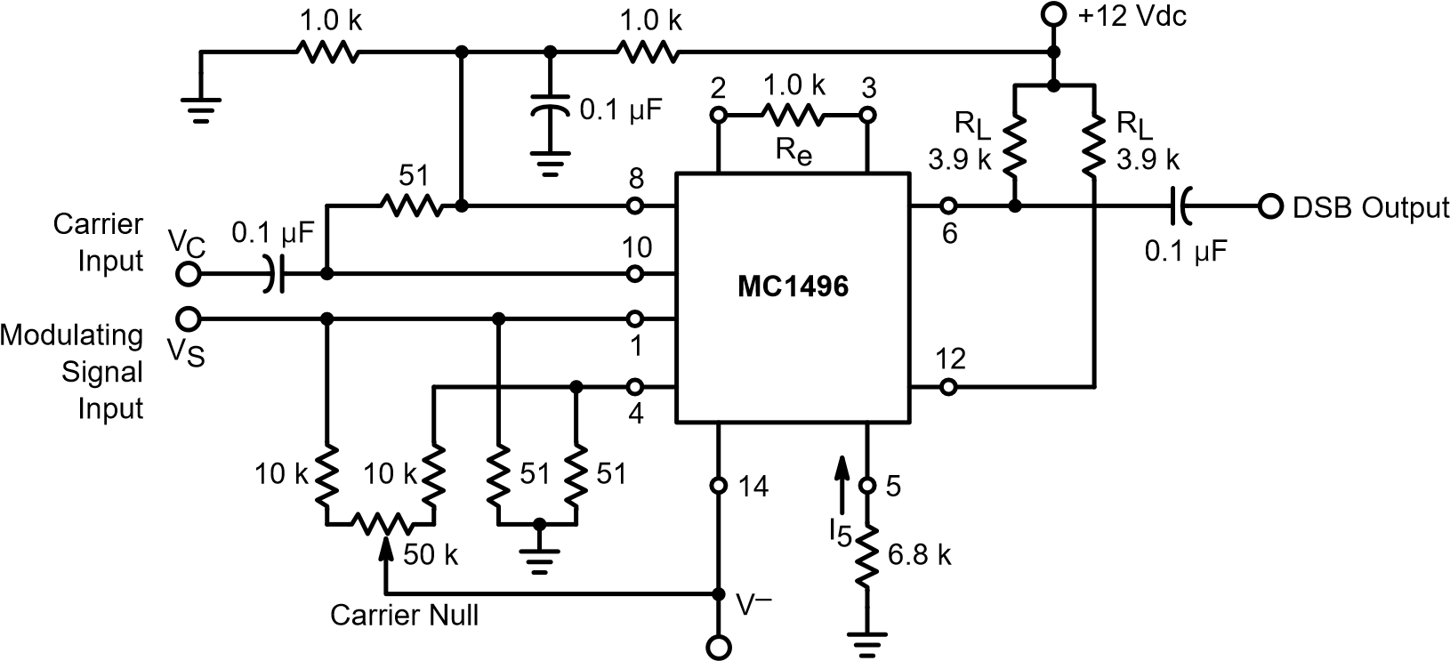
–8 Vdc
Figure 3. Balanced Modulator Circuit
This mode of operation does reduce spurious output levels significantly. Table 1 lists a number of the spurious output levels for high (60 mV) and low (10 mV) level carrier operation. Reduction of carrier injection from 60 mV to 10 mV decreased desired sideband output by 12.4 dB. This is in excellent agreement with the analysis in the Appendix, which predicts 12.5 dB.
f
C
2
f
C
50
5.0
0.1
0.005
0.5
1.0
10
f
3
C
0
60
50
40
30
20
10
70
f
C
, Carrier Frequency (MHz)
Suppression Below Each Fundamental
Carrier Sideband (dB)

Figure 4. Balanced Modulator Carrier Suppression versus Frequency
f
2
C

±
f
S
2
f
C

±
2
f
S
3
f
C

±
f
S
f
C
, Carrier Frequency (MHz)
50
10
1.0
5.0
0.050.1
0.5
0
60
50
40
30
20
10
70
Suppression Below Each Fundamental
Carrier Sideband (dB)

Figure 5. Balanced Modulator Suppression of Carrier Harmonic Sidebands versus Carrier Frequency
2.0
200
mV
400
Modulating Signal Input = 600 mV
Carrier Level (mV[rms])
1.6
0
0.8
0
0.4
1.2
100
50
150
100
mV
200
mV
300
mV
Output Amplitude of Each Sideband (V[rms])
Figure 6. Balanced Modulator Sideband Output versus Carrier and Modulating Signal Inputs. Single Ended Operation.

Table 1. Suppression in dB of Spurious Outputs Below Each Desired Sideband (fC fS) for High and Low Level Carrier Injection Voltages
 | fC | 2fC | 3fC | 2fC fS | 3fC fS
High Level  Carrier Input  60 mV(rms) | 66 dB | 35 dB | 70 dB | 43 dB | 19 dB
Low Level  Carrier Input  10 mV(rms) | 66 dB | 45 dB | 70 dB | 53 dB | 46 dB
Carrier Frequency = 500 kHz.
Modulating Signal = 1.0 kHz at 300 mV(rms). Circuit of Figure 3.
Spurious levels during low level operation are so low that they are affected significantly by the special purity of the carrier input signal. For example, initial readings for Table 1 were taken with a carrier signal generator which has second and third harmonics 42 and 45 dB below the fundamental, respectively. Additional filtering of the carrier input signal was required to measure the true second and third carrier–harmonic suppression of the MC1496.
The decision to operate with a low or high level carrier input would of course depend on the application. For a typical filter–type SSB generator, the filter would remove all spurious outputs except some spurious sidebands of the carrier. For this reason operation with a high level carrier would probably be selected to maximize gain and insure that the desired sideband does not contain any spurious amplitude variations present on the carrier input signal.
On the other hand, in a low frequency broadband balanced modulator spurious outputs at any frequency may be undesirable and low level carrier operation may be the best choice.
Good carrier suppression over a wide temperature range requires low dc resistances between the bases of the lower differential amplifier (pins 1 and 4) and ground. It is recommended that the values of these resistors not be increased significantly higher than the 51 ohms utilized in the circuit shown in Figure 3 in applications where carrier suppression is important over full operating temperature range of –40°C to +125°C. Where operation is to be over a limited temperature range, resistance values of up to the low kilohm range may be used.

Amplitude Modulator
The MC1496 balanced modulator circuit shown in Figure 3 will function as an amplitude modulator with just one minor modification. All that is necessary is to unbalance the carrier null to insert the proper amount of carrier into the output signal. However, the null circuitry used for balanced modulator operation does not provide sufficient adjustment range and must be modified. The resulting amplitude modulator is shown in Figure 7. This modulator will provide excellent modulation at any percentage from zero to greater than 100 percent.

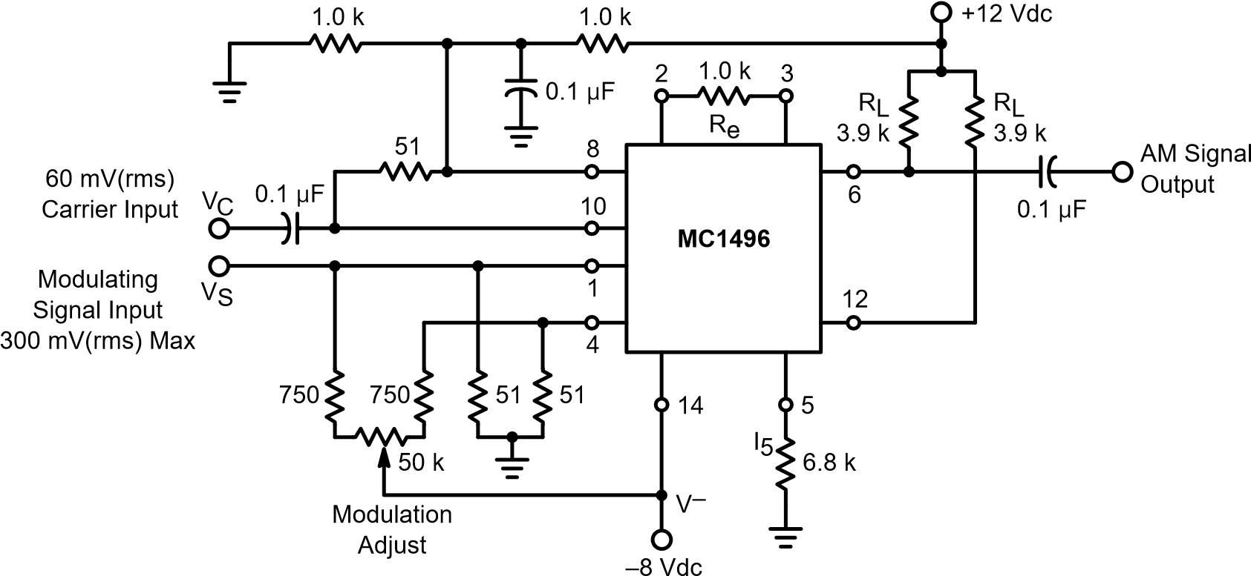
Figure 7. Amplitude Modulator 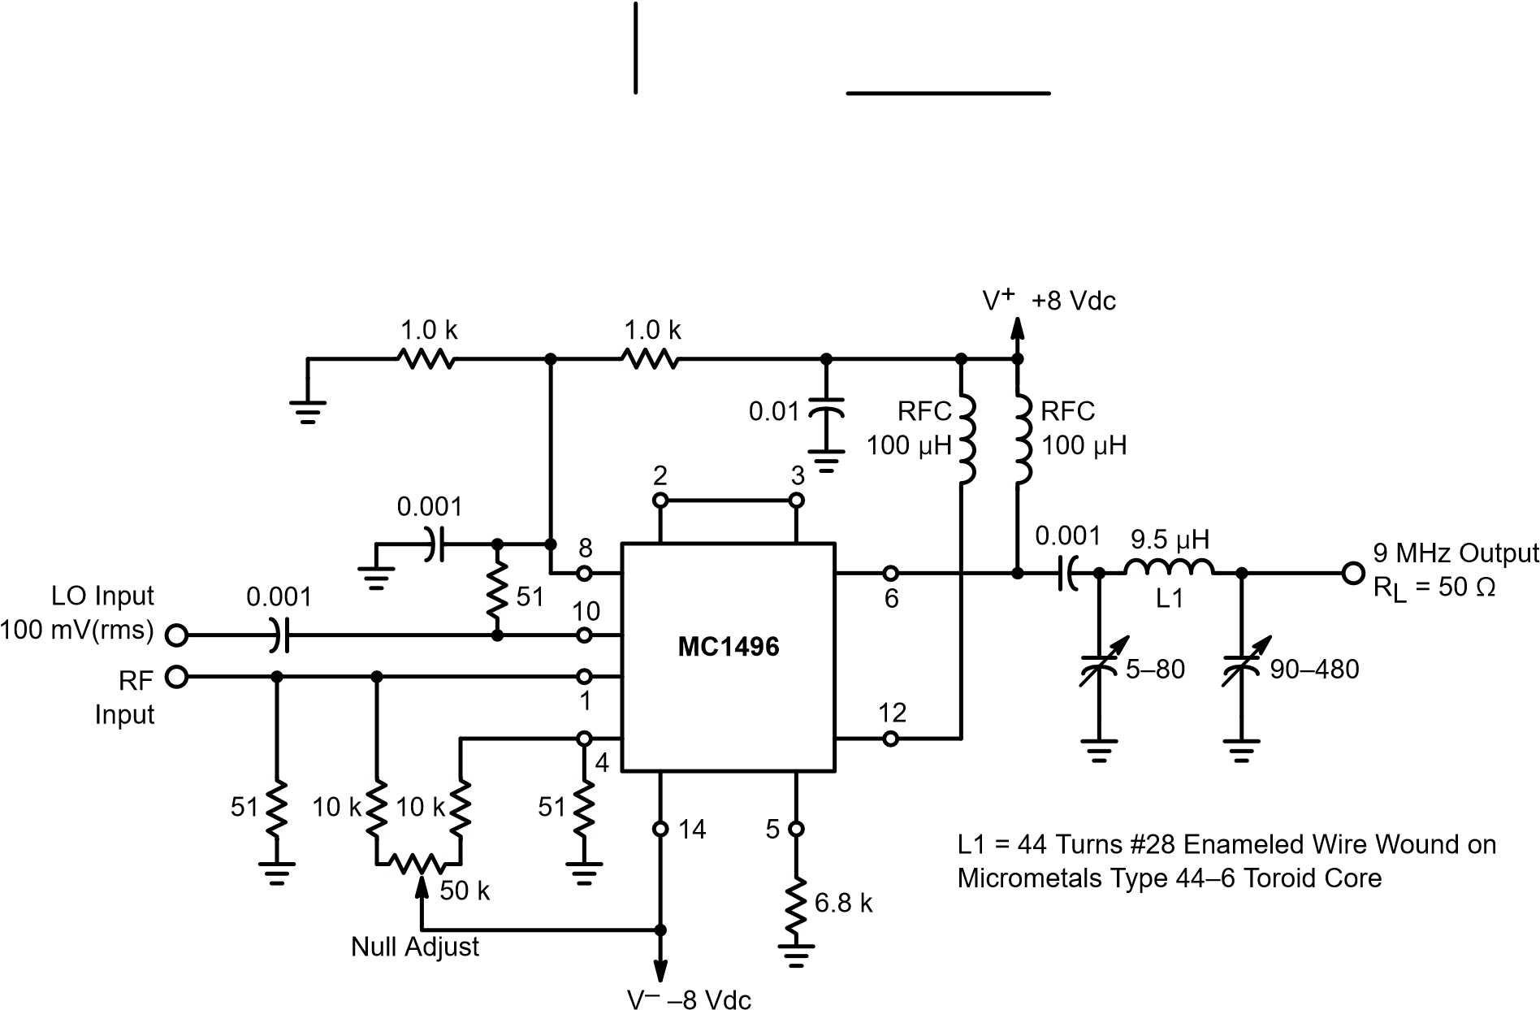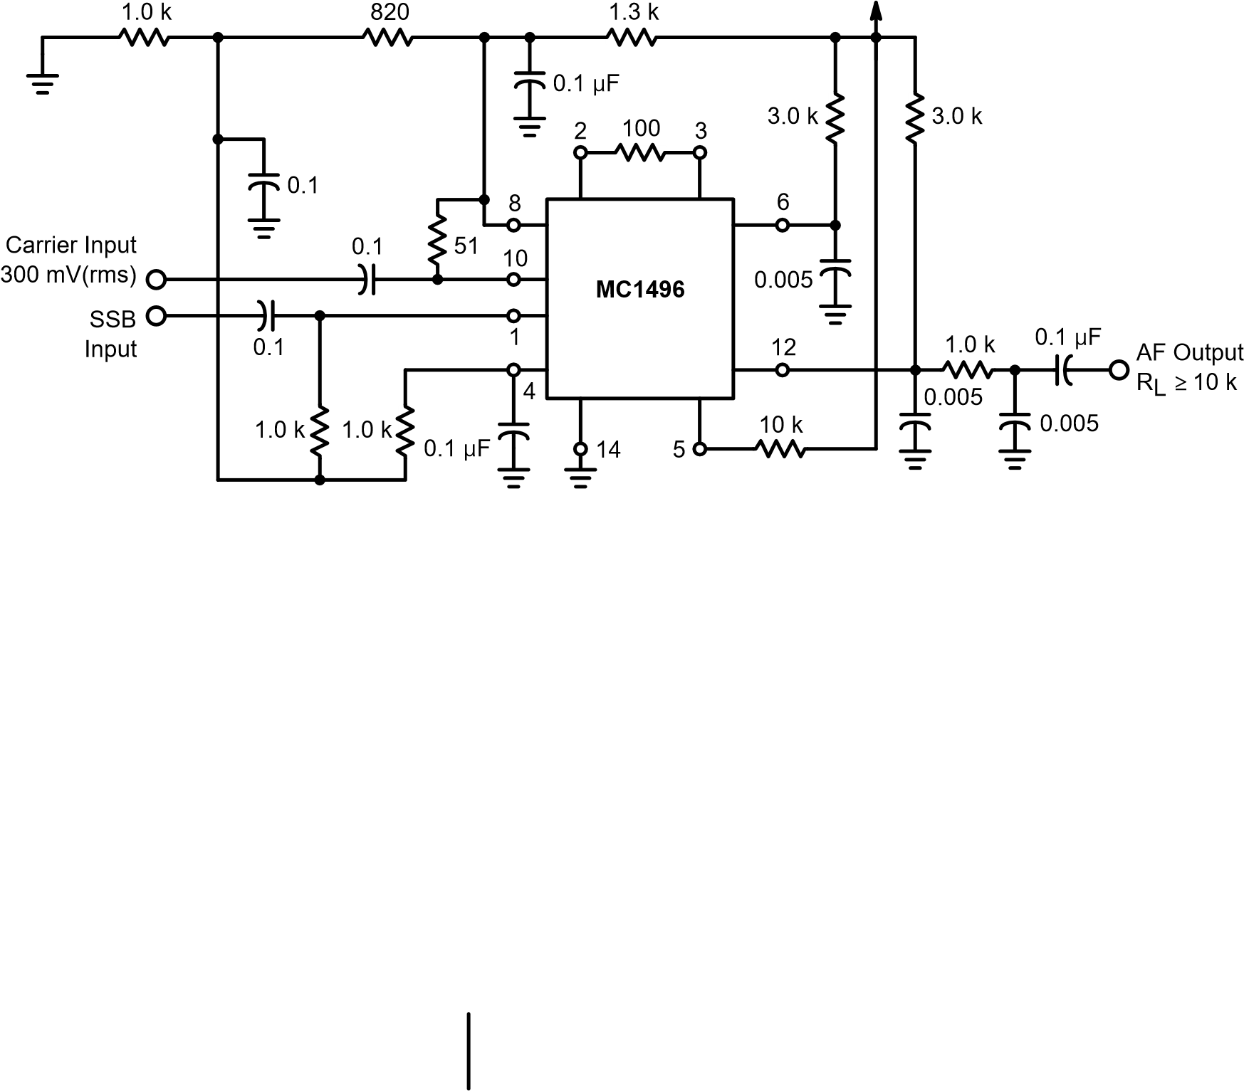Figure 8. Product Detector +12 Vdc Single Supply
+12 Vdc
Figure 9. Double Balanced Mixer, Broadband Inputs, 9 MHz Tuned Output

Product Detector
Figure 8 shows the MC1496 in an SSB product detector configuration. For this application, all frequencies except the desired demodulated audio are in the RF spectrum and can be easily filtered in the output. As a result, the carrier null adjustment need not be included.
Upper differential amplifiers Q1–Q2 and Q3–Q4 are again driven with a high level signal. Since carrier output level is not important in this application (carrier is filtered in the output) carrier input level is not critical. A high level carrier input is desirable to maximize gain of the detector and to remove any carrier amplitude variations from the output. The circuit of Figure 8 performs well with a carrier input level of 100 to 500 mV rms.
The modulated signal (single–sideband, suppressed carrier) input level to differential amplifier pair Q5–Q6 is maintained within the limits of linear operation. Excellent linearity and undistorted audio output may be achieved with an SSB input signal level range up to 100 mV rms. Again, no transformers or tuned circuits are required for excellent product detector performance from very low frequencies up to 100 MHz.
Another advantage of the MC1496 product detector is its high sensitivity. The sensitivity of the product detector shown in Figure 8 for a 9 MHz SSB signal input and a 10 dB signal plus noise to noise [(S + N)/N] ratio at the output is 3 microvolts. For a 20 dB (S + N)/N ratio audio output signal it is 9 microvolts.
For a 20 dB (S + N)/N ratio, demodulated audio output signal, a 9 MHz SSB input signal power of –101 dBm is required. As a result, when operated with an SSB receiver with a 50 ohm input impedance, a 0.5 microvolt RF input signal would require only 12 dB overall power gain from antenna input terminals to the MC1496 product detector.
Note also that dual outputs are available from the product detector, one from pin 6 and another from pin 12. One output can drive the receiver audio amplifiers while a separate output is available for the AGC system.

AM Detector
The product detector circuit of Figure 8 may also be used as an AM detector. The modulated signal is applied to the upper differential amplifiers while the carrier signal is applied to the lower differential amplifier.
Ideally, a constant amplitude carrier signal would be obtained by passing the modulated signal through a limiter ahead of the MC1496 carrier input terminals. However, if the upper input signal is at a high enough level (> 50 mV), its amplitude variations do not appear in the output signal. For this reason it is possible to use the product detector circuit shown in Figure 8 as an AM detector simply by applying the modulated signal to both inputs at a level of about 600 mV on modulation peaks without using a limiter ahead of the carrier input port. A small amount of distortion will be generated as the signal falls below 50 mV during modulation valleys, but it will probably not be significant in most applications. Advantages of the MC1496 AM detector include linear operation and the ability to have a detector stage with gain.

Mixer
Since the MC1496 generates an output signal consisting of the sum and difference frequencies of the two input signals only, it can also be used as a double balanced mixer. Figure 9 shows the MC1496 used as a high frequency mixer with a broadband input and a tuned output at 9 MHz. The 3 dB bandwidth of the 9 MHz output tank is 450 kHz.
The local oscillator (LO) signal is injected at the upper input port with a level of 100 mV rms. The modulated signal is injected at the lower input port with a maximum level of about 15 mV rms. Note that for maximum conversion gain and sensitivity the external emitter resistance on the lower differential amplifier pair has been reduced to zero.
For a 30 MHz input signal and a 39 MHz LO, the mixer has a conversion gain of 13 dB and an input signal sensitivity of 7.5 microvolts for a 10 dB (S + N)/N ratio in the 9 MHz output signal. With a signal input level of 20 mV, the highest spurious output signal was at 78 MHz (2 fLO) and it was more than 30 dB below the desired 9 MHz output. All other spurious outputs were more than 50 dB down.
As the input is broadband, the mixer may be operated at any HF and VHF input frequencies. The same circuit was operated with a 200 MHz input signal and a 209 MHz LO. At this frequency the circuit had 9 dB conversion gain and a 14 microvolt sensitivity.
Greater conversion gains can be achieved by using tuned circuits with impedance matching on the signal input port. Since the input impedance of the lower input port is considerably higher than 50 ohms even with zero emitter resistance, most of the signal input power in the broadband configuration shown is being dissipated in the 50 ohm resistor at the input port.
The circuit shown has the advantage of a broadband input with simplicity and reasonable conversion gain. If greater conversion gain is desired, impedance matching at the signal input is recommended.
The input impedance at the signal input port is plotted in Figures 10 and 11. The output impedance is also shown in Figure 12. Both of these curves indicate the complex impedance versus frequency for single ended operation.
The nulling circuit permits nulling of the LO signal and results in a few dB additional LO suppression in the mixer output. The nulling circuitry (the two 10 kΩ resistors and 50 kΩ potentiometer) may be eliminated when operating with a tuned output in many applications where the combination of inherent device balance and the output tank provide sufficient LO suppression.
The tuned output tank may be replaced with a resistive load to form a broadband input and output doubly–balanced mixer. Magnitude of output load resistance becomes a simple matter of tradeoff between conversion gain and output signal bandwidth. As shown in Figure 12, the single ended output capacitance of the MC1496 at 9 MHz is typically 5 pF.
1.0 5.0 10 50 100 1.0 5.0 10 50 100
3.0
2.0
1.0
0
5.0
4.0
c
ip
, Parallel Input Capacitance (pF)
–r
ip
+
r
ip
1.0
5.0
10
100
500
1.0
M
50
r
ip
, Parallel Input Resistance (k
Ω
)
f, Frequency (MHz) f, Frequency (MHz)
Figure 10. Signal–Port Parallel–Equivalent Input Figure 11. Signal–Port Parallel–Equivalent Input
Resistance versus Frequency Capacitance versus Frequency
0.1
140
14
12
10
8.0
6.0
4.0
0
100
10
120
0
20
40
1.0
80
2.0
100
60
f, Frequency (MHz)
c
op
r
op
, Parallel Output Resistance (k
Ω
)
c
op
, Parallel Output Capacitance (pF)
r
op
Figure 12. Single–Ended Output Impedance versus Frequency
With a 50 ohm output load, a 30 MHz input signal level of 20 mV, and 39 MHz LO signal level of 100 mV the conversion gain was –8.4 dB (loss). Isolation was 30 dB from input signal port to output port and 18 dB from LO signal port to output port.

Doubler
The MC1496 functions as a frequency doubler when the same signal is injected in both input ports. Since the output signal contains only ω1 ± ω2 frequency components, there will be only a single output frequency at 2ω1 when ω1 = ω2.
For operation as a broadband low frequency doubler, the balanced modulator circuit of Figure 3 need be modified only by adding ac coupling between the two input ports and reducing the lower differential amplifier emitter resistance between pins 2 and 3 to zero (tieing in 2 to pin 3). The latter modification increases the circuit sensitivity and doubler gain.
A low frequency doubler with these modifications is shown in Figure 13. This circuit will double in the audio and low frequency range below 1 MHz with all spurious outputs greater than 30 dB below the desired 2 fIN output signal.
For optimum output–signal spectral purity, both upper and lower differential amplifiers should be operated within their linear ranges. This corresponds to a maximum input signal level of 15 mV rms for the circuit shown in Figure 13.
If greater signal handling capability is desired the circuit may be modified by using a 1000 ohm resistance between pins 2 and 3 and a 10:1 voltage divider to reduce the input signal at the upper port to 1/10 the signal level at the lower port.
The MC1496 will also function very well as an RF doubler at frequencies up to and including UHF. Either a broadband or a tuned output configuration may be used.
Suppression of spurious outputs is not as good at VHF and UHF. However, in the broadband configuration, the desired doubled output is still the highest magnitude output signal when doubling from 200 to 400 MHz, where the spurious outputs are 7 dB or more below the 400 MHz output. Even at this frequency the MC1496 is still superior to a conventional transistor doubler before output filtering.
Figure 14 shows a 150 to 300 MHz doubler with output filtering. All spurious outputs are 20 dB or more below the desired 300 MHz output.
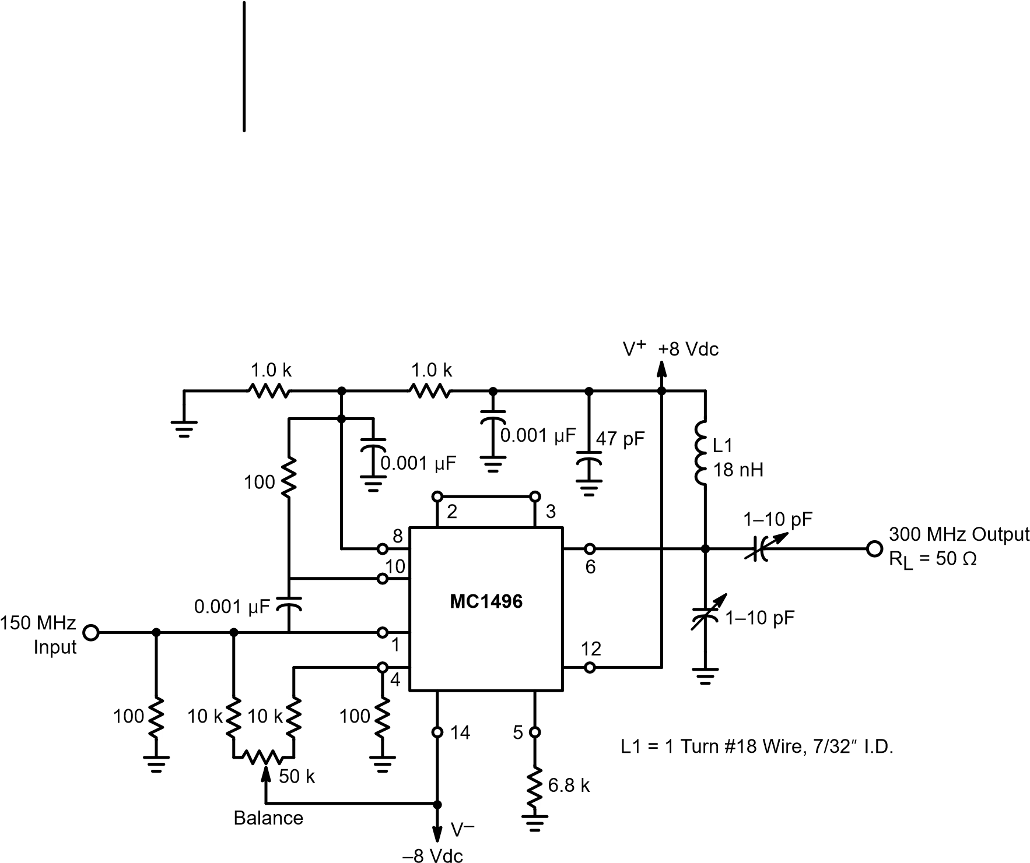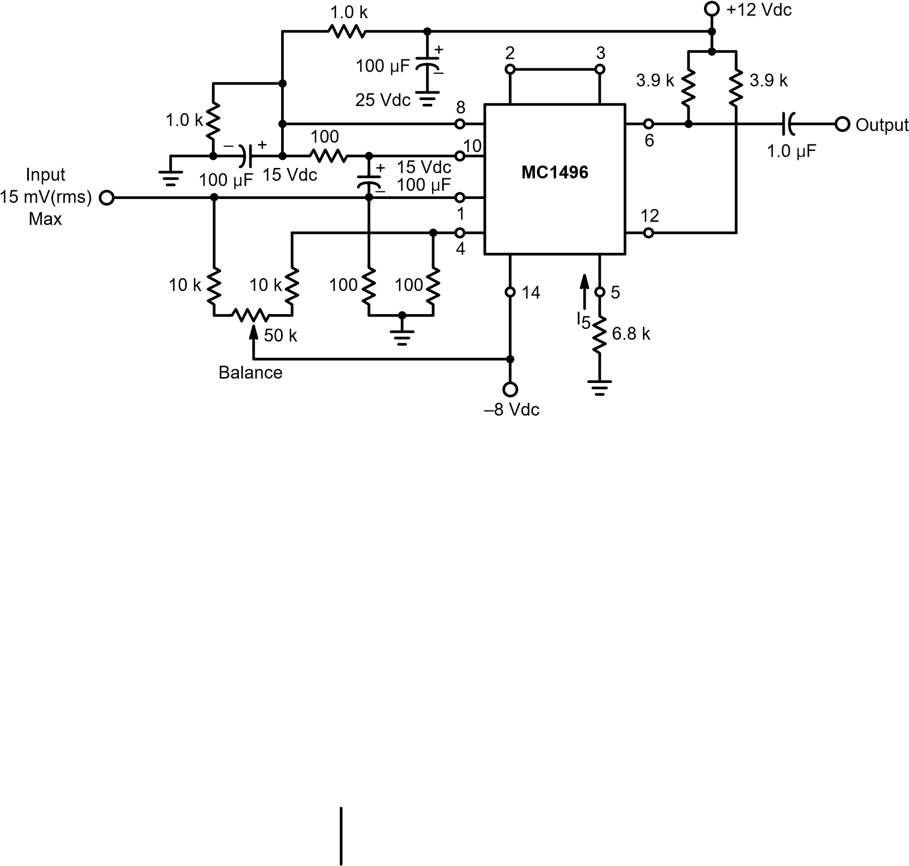Figure 13. Low Frequency Doubler
Figure 14. 150–300 MHz Doubler

FM Detector and Phase Detector
The MC1496 provides a dc output which is a function of the phase difference between two input signals of the same frequency, and can therefore be used as a phase detector. This characteristic can also be utilized to design an FM detector with the MC1496. All that is required is to provide a means by which the phase difference between the signals at the two input ports vary with the frequency of the FM signal.
Phase dependent FM detector operation can be explained by considering input and output currents for a high level signal at both input ports. These waveforms are shown in Figure 15 with inputs in phase at A and out of phase at B.
Since the output current is a constant times the product of the input currents, Figure 15 illustrates how a shift in phase between the two input signals causes a dc level shift in the output.
+1+1
Input 1
–1–1
+1+1
Input 2
–1–1
+1+1
Output
–1–1
A B
Inputs in Phase Inputs Out of Phase
Figure 15. Phase Detector Waveforms, High Level Inputs

Summary
A number of applications of the MC1496 monolithic balanced modulator integrated circuit have been explored. The basic device characteristics of providing an output signal at the sum and difference of the two input frequencies with options on gain and amplitude characteristics will undoubtedly lead to numerous other applications not discussed in this article.

References
- Gilbert, Barrie, “A DC–500 MHz Amplifier/
Multiplier Principle,” paper delivered at the International Solid State Circuits Conference, February 16, 1968.
- Gilbert, Barrie, “A Precise Four Quadrant
Multiplier with Subnanosecond Response,” IEEE Journal of Solid–State Circuits, Vol. SC–3, No. 4, December 1968.
- Bilotti, Alberto, “Applications of a Monolithic
Analog Multiplier,” IEEE Journal of Solid–State Circuits, Vol. SC–3, No. 4, December 1968.
- Renschler, E., “Theory and Application of a LinearFour–Quadrant Monolithic Multiplier,” EEE Magazine, Vol. 17, No. 5, May 1969.
- “Analysis and Basic Operation of the MC1595,”ON Semiconductor, Application Note AN489.

APPENDIX

AC and DC Analysis
With reference in Figure 2 of the text, the following equations apply:
V_{y} (1A)

Iy RE (dynamic emitter resistance.)when RE >> re, the transistor
I  I₂ 1 IVyx ,  1 e _{a}  I  I4 1 IyVx ,  1 e _{a}  where | I  1 e  I3 1 IyaVx,  _{I5} I1 IVy  1 e ax | (2A)
_{a} kT_{q} (3A)
(4A)
I1 Iy I1 Iy
IA I2 I4 1 em 1 e–m
I1 Iy I1 Iy
IB I3 I5 ₁ e–m ₁ em
where
Vx m _{a}
IA IB (I1 Iy)₁ 1_{e}m ₁ 1_{e}–m (5A)
(I1 Iy)₁ ¹_{e}–m ₁ ¹_{e}m
(I1 Iy)1(1eemm)(11eemm)
(I1 Iy)1(1eem–m)(11 ee–mm)
(I1 Iy)(e–m em)  Iy)(em e–m)

(1 em)(1 e–m)

I₁e–m I₁em I_{y}e–m I_{y}em
I1em I1e–m Iyem Iye–m
(1 em)(1 em)
2Iy(e–m em)

(1 em)(1 e–m)
Vo (IA IB)RL ^{(6A)}
2IyRL(e–m em)

(1 em)(1 e–m)
But,
V
I_{y} _{R}in_{E} (7A)
Therefore,
Vo 2RL e–m em ₍₈^{A)}
Vin RE (1 em₎₍₁ e–m)
recalling that
m V_{a}x VkTx
q
From this it can be seen that voltage gain is a function of the input level supplied to the upper four transistors:
Vo AV 2RREL[f(m)] (9A)
Vin and
2RLVy (10A)
Vo _{RE} [f(m)]
A curve of f(m) versus input level supplied to the upper quad differential amplifier is shown in Figure 16 of the text.
0
1.0
V
X
, (mV)
0.8
0.6
0.4
0
[
]
fm
300
200
100
0.2
500
400
]
[
fm

e
–m

e
m
(1

e
m
)(1

e
–m
)

a

[
]
kT
Q
m

V
DiffX
a
m

V
DiffY
a
V
X
versus fm
fm

e
–m

e
m
(1

e
m
)(1

e
–m
)

a = 18.9 (–55
°
C)
a = 26.0 (+25
°
C)
a = 34.7 (+125
°
C)

Figure 16. VX versus [fm]
The MC1496 is therefore a linear multiplier over the range of Vx for which [f(m)] is a linear function of Vx. This range of x can be obtained by inspection of Figure 16 and is approximately zero to 50 millivolts.
Examining the case of a small signal Vx input level mathematically yields: Assume
Then: | Vx a | (11A)
 | em 0.1 | (12A)
 | em 1 m | (13A)
e–m 1 m
[f(m)] (1(2m)m)(2 (1m)m) 4–2m m2 (14A)
2m ₄2m ₂m  4 m2  Therefore | (15A)
AV _{V}o_{y} 2_{R}R_{E}L(–m₂ )_{R}R_{E}Lm V | (16A)
RLVym RLVyVx  Vo RE REa | (17A)
Equation (17A) shows that the MC1496 is a linear multiplier when Vx ≤ 2.6 mV. However, as was observed by inspection of Figure 16 earlier, the device is capable of approximate linear multiplier operation when Vx ≤ 50 mV. For the case of a large signal Vx input level:
Vx a | (18A)
em 1 | (19A)
e–m 1
AV RELeem R2ERL 2R | (20A)
2RLVy  Vo RE | (21A)
^{m}
Equation (20A) indicates that in this mode the output level is independent of the level of Vx. This characteristic is useful in many communications applications of the MC1496.
Mathematical analysis for ac input signals is given below for two modes of operation which cover most applications of the MC1496. These modes are (1) Vx and Vy both low level sine waves, and (2) low level sine wave for Vy and a large signal input for Vx (either a high level sine wave or a square wave input) giving rise to a symmetrical switching operation of the upper differential amplifier quad, Q1, Q2, Q3, and Q4.
For sine wave input signals,
Vx Excosxt ^{(22A)}
Vy Eycosyt ^{(23A)}
where Ex and Ey are the peak values of the x and y input voltages, respectively. Therefore,
Vo KExEy(cosxt)(cosyt)  Performing this multiplication yields: | (24A)
KE E | (25A)
x y
Vo ₂ cos(x y)t cos(x y)t
The second mode of operation can be analyzed by assuming square wave switching function in the upper differential amplifiers and applying Fourier analysis.
e = E cos ω_{S}(t)
1
1
e
1
(
t
)
E
1
0
t
Input
1
S
t
t
Input
–1
e
1
(
t)S(t
)
t
Output
Lower
Upper
Multiplied

Figure 17. Input and Output Waveforms for a High Level Upper Input and Low Level Input Signals

The Fourier series form for the symmetrical square wave signal shown in Figure 17 is:
(26A) s(t) 2 A_{n}cosn_{x}t
n1
where the Fourier coefficients are

sinn (27A)
An n 2
2
The output voltage is therefore:
(28A)
ON Semiconductor Website: http://onsemi.com
Email: ONlit@hibbertco.com
For additional information, please contact your local
N. American Technical Support: 800–282–9855 Toll Free USA/Canada
Sales Representative.
http://onsemi.com  12 | AN531/D
Vo KEy An[cos(nx y)t cos(nx y)t]
n1
Note that Equation (25A) predicts that for low level input signals, the output signal consists of the sum and difference frequencies (ωx ± ωy) only, while Equation (28A) predicts that operation with a high level input for Vx input will yield outputs at frequencies ωx ± ωy, 3ωx ± ωy, 5ωx ± ωy, etc.

ON Semiconductor and are trademarks of Semiconductor Components Industries, LLC (SCILLC). SCILLC reserves the right to make changes without further notice to any products herein. SCILLC makes no warranty, representation or guarantee regarding the suitability of its products for any particular purpose, nor does SCILLC assume any liability arising out of the application or use of any product or circuit, and specifically disclaims any and all liability, including without limitation special, consequential or incidental damages. “Typical” parameters which may be provided in SCILLC data sheets and/or specifications can and do vary in different applications and actual performance may vary over time. All operating parameters, including “Typicals” must be validated for each customer application by customer’s technical experts. SCILLC does not convey any license under its patent rights nor the rights of others. SCILLC products are not designed, intended, or authorized for use as components in systems intended for surgical implant into the body, or other applications intended to support or sustain life, or for any other application in which the failure of the SCILLC product could create a situation where personal injury or death may occur. Should Buyer purchase or use SCILLC products for any such unintended or unauthorized application, Buyer shall indemnify and hold SCILLC and its officers, employees, subsidiaries, affiliates, and distributors harmless against all claims, costs, damages, and expenses, and reasonable attorney fees arising out of, directly or indirectly, any claim of personal injury or death associated with such unintended or unauthorized use, even if such claim alleges that SCILLC was negligent regarding the design or manufacture of the part. SCILLC is an Equal Opportunity/Affirmative Action Employer.

PUBLICATION ORDERING INFORMATION
Literature Fulfillment:  Literature Distribution Center for ON Semiconductor  P.O. Box 5163, Denver, Colorado 80217 USA  Phone: 303–675–2175 or 800–344–3860 Toll Free USA/Canada | JAPAN: ON Semiconductor, Japan Customer Focus Center  4–32–1 Nishi–Gotanda, Shinagawa–ku, Tokyo, Japan 141–0031 Phone: 81–3–5740–2700  Email: r14525@onsemi.com
Fax: 303–675–2176 or 800–344–3867 Toll Free USA/Canada

