**Intro to d3.js**: Relevant Links

**Repo for our workshop:**

<http://bit.ly/2ofmTCB>

**D3 API Documentation:**

<https://github.com/d3/d3/blob/master/API.md>

**MDN’s JavaScript Documentation:**

<https://developer.mozilla.org/en-US/docs/Web/JavaScript>

**Bl.ocks (the home for sharing d3 modules and examples):**

<https://bl.ocks.org/>

**SVG Documentation:**

<https://developer.mozilla.org/en-US/docs/Web/SVG>

**An example visualization:**

<https://ligo.northwestern.edu/media/mass-plot/index.html>

**ADVANCED D3:**

**Curve Interpolations:** <http://bit.ly/2xR9VxX>

**Voronoi:** <http://bit.ly/2gK35mi>

<https://bl.ocks.org/mbostock/4060366>

**Zooming:** <http://bit.ly/2f6WYsg>

**Brushing/Zooming:** <http://bit.ly/2lTjfef>

**Stacking:** <http://bl.ocks.org/mbostock/582915>

**Collision Constraint:** <http://bit.ly/2vOPk05>

**Dragging:** <http://bit.ly/2j6x5gH>

**“Each”:** <https://bl.ocks.org/mbostock/9490313>

**Dispatching** (super advanced): <https://bl.ocks.org/mbostock/5872848>

**Modules/Plugins** (*most* advanced): <https://bost.ocks.org/mike/d3-plugin>

**“Store-bought” (and other) viz solutions:**

**Plotly**: <https://plot.ly/>

**ggplot2**: <http://ggplot2.org/>

**Matplotlib**: <https://matplotlib.org/>

**Tableau**: <https://www.tableau.com/>

**Processing**: <https://processing.org/>

**Intro to d3.js**: Review Topics

**Most vizzies are *box-mix* cake**



**D3 is a tiramisu**



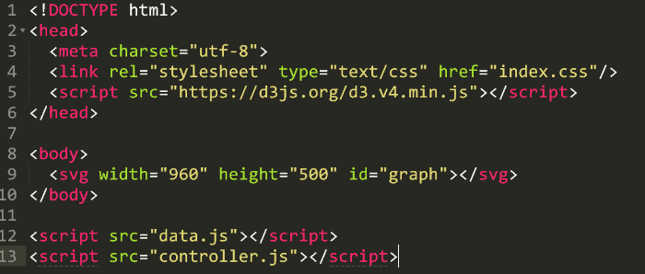Steps to starting with d3.js:

1. Build your environment:
   1. Set up your HTML
   2. Link your CSS file
   3. Link your libraries (d3 included)
   4. Link your main JavaScript
2. Examine your data:
   1. 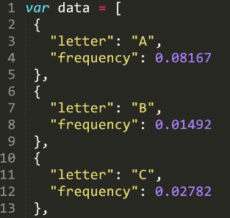Is it in the right format? Structured correctly?
   2. Do you need a web server or can you host it locally?
3. Link your data to your document:
   1. Will you load it in using d3 or will you load it in up front?
4. Create your starting element:
   1. Use an id to select it easily, make sure it is an <svg> type

Steps to every basic visualization in d3.js:

1. **Create your scales**: these convert your data (domain) into the pixel space of the web (range)
2. **Select** an element, then “selectAll” on its children (even if you haven’t made them yet)
3. Bind **data** to this selection and “enter” the data
4. 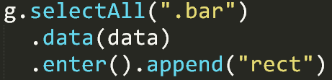**Append** an element (this appends one element per data piece):
   1. SVG types: rect, circle, text, etc
   2. Even HTML types work: div, p, span, etc
5. **Modify** styling, attributes, classes or interactivity to each element, based on the data
   1. .attr(“width”, function(d,i) { return x(d.frequency) }
6. Optional: Create an axis, title, interactive pieces, animations, etc