Datawrapper

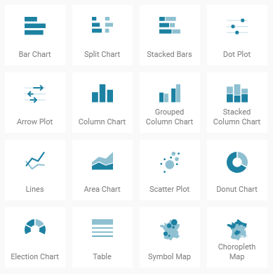Location: [www.datawrapper.de/](https://www.datawrapper.de/)

Use Case Considerations:

* If you need to produce a high-quality, interactive figure based on a CSV/XLS or spreadsheet data.
* If you intend for your data visualization to look like one of the following types on the right:
* If you want your data to be easily shared after you create your figure.
* If you want to develop a set of dataviz styles for future use.

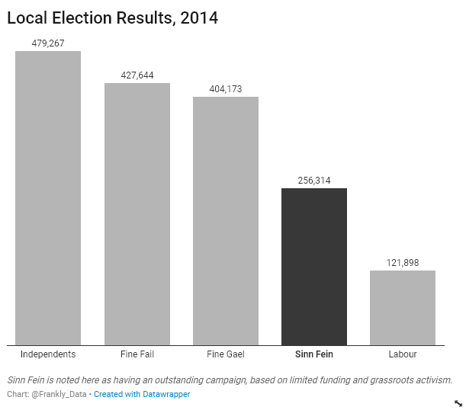

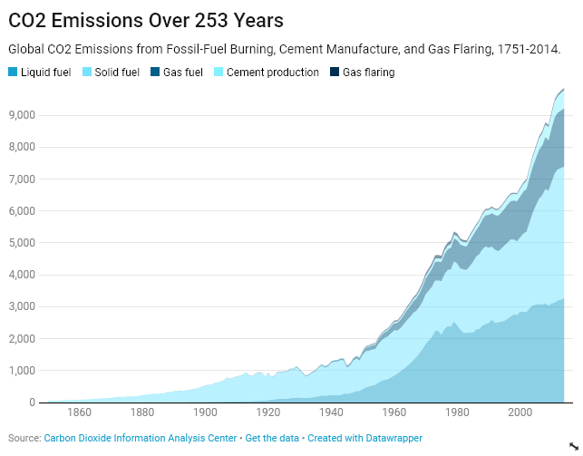

Steps:

