Adobe Illustrator

Use Case Considerations:

* If you need to produce a top-quality, static, vector figure.
* If you want to create SVG data for later use on the web.
* If you need to quickly iterate or draft ideas.
* If you want to improve a figure you already have rasterized.
* If you want to manually extract values from a figure with high accuracy.

Steps:

1. Start with a figure and create geometries over each element

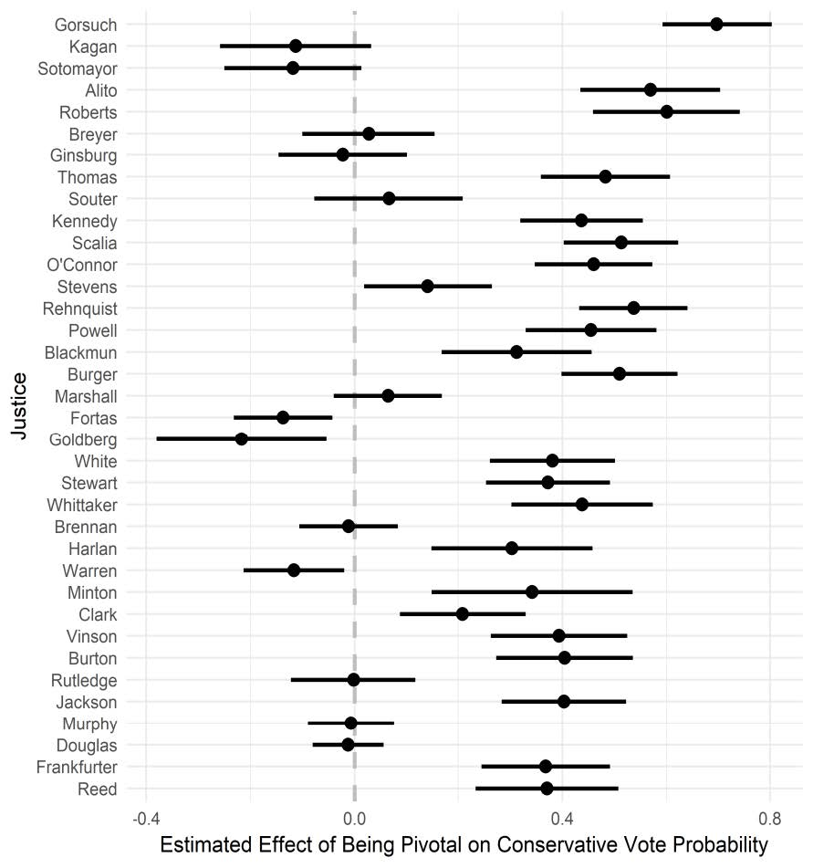 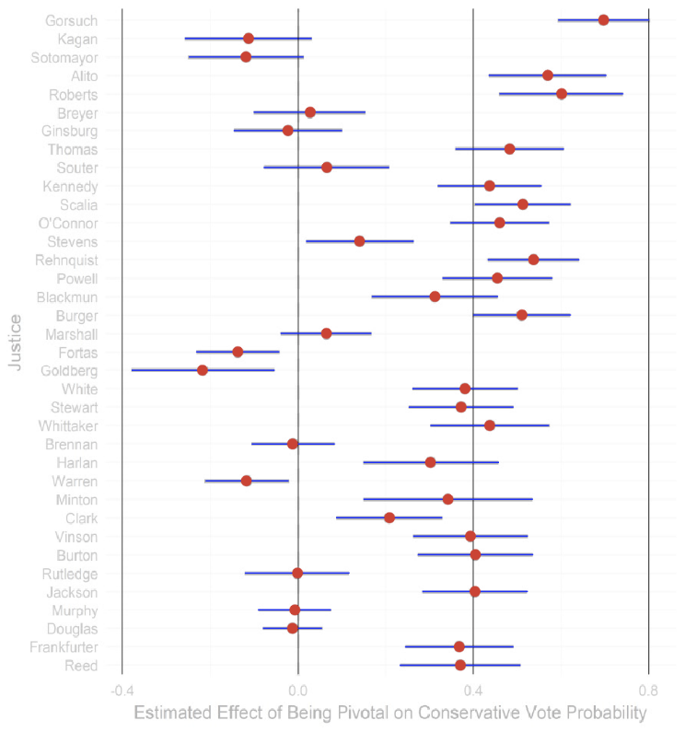

1. Make sure your layers look like this! (Names for each, as a group with geometries inside the group.) This is simply layers with sub-layers.

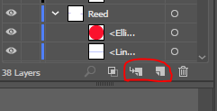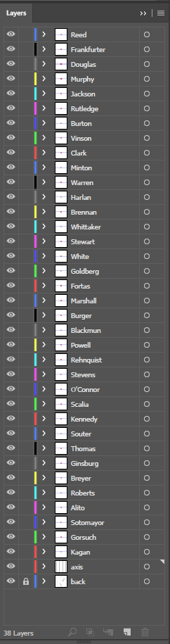 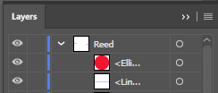

1. **Export As** (not “save as”) SVG

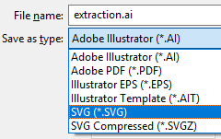

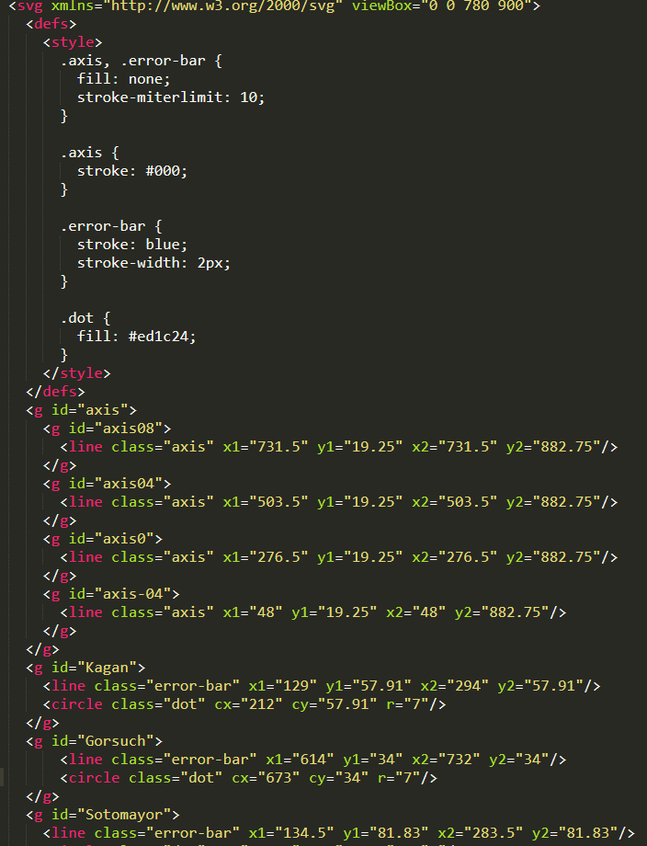

1. Use internal CSS or inline, font as SVG, imbed images (if you want them), and IDs as layer names

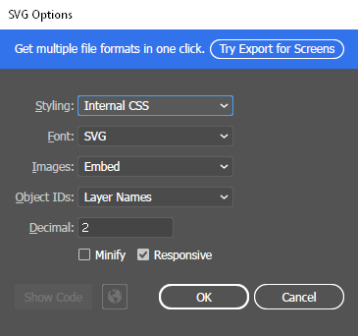

1. <- Edit the SVG as you see fit and drop it into an HTML file for use with D3 or JavaScript