FinVault AI
Technical Guide & Product Documentation

On-Device Financial Intelligence. Private by Design.

Version: 3.0
Date: April 2026
Classification: Confidential
Engine: Google Gemma 4 via LM Studio

Table of Contents
1. Executive Summary
2. Product Overview
3. System Architecture
4. Development Guide
5. Agent Engineering & LLM Configuration
6. Security Architecture
7. Deployment Guide
8. User Demo Guide
9. Product Roadmap
10. Appendix

1. Executive Summary
FinVault AI is a secure, on-device financial intelligence platform that delivers AI-powered accounting analysis without transmitting a single byte of data to external servers. Built on Google's Gemma 4 large language model running locally via LM Studio, FinVault AI provides three core capabilities: intelligent report generation, natural language data querying, and automated document OCR processing.
The platform is designed for financial professionals who handle sensitive accounting data and require enterprise-grade AI capabilities while maintaining complete data sovereignty. FinVault AI operates in air-gapped environments, requires no internet connection, and processes all data exclusively within the user's local machine.

Key Highlights
- 100% local processing — zero cloud dependency
- Google Gemma 4 (google/gemma-4-e4b) for state-of-the-art inference
- SOX, GDPR, and CCPA compliant by architecture
- Three integrated AI modules: Reports, Query, OCR
- Sub-second inference for most financial queries
- Air-gap compatible — works without internet

2. Product Overview

2.1 Report Generator
The Report Generator transforms raw accounting data (CSV/Excel) into professional financial reports. Users select from seven report types including Executive Summary, Expense Breakdown, Revenue Analysis, Budget Variance, Cash Flow, Accounts Payable/Receivable, and Custom Analysis. The AI analyzes the data, computes key metrics, and produces narratives with actionable insights.
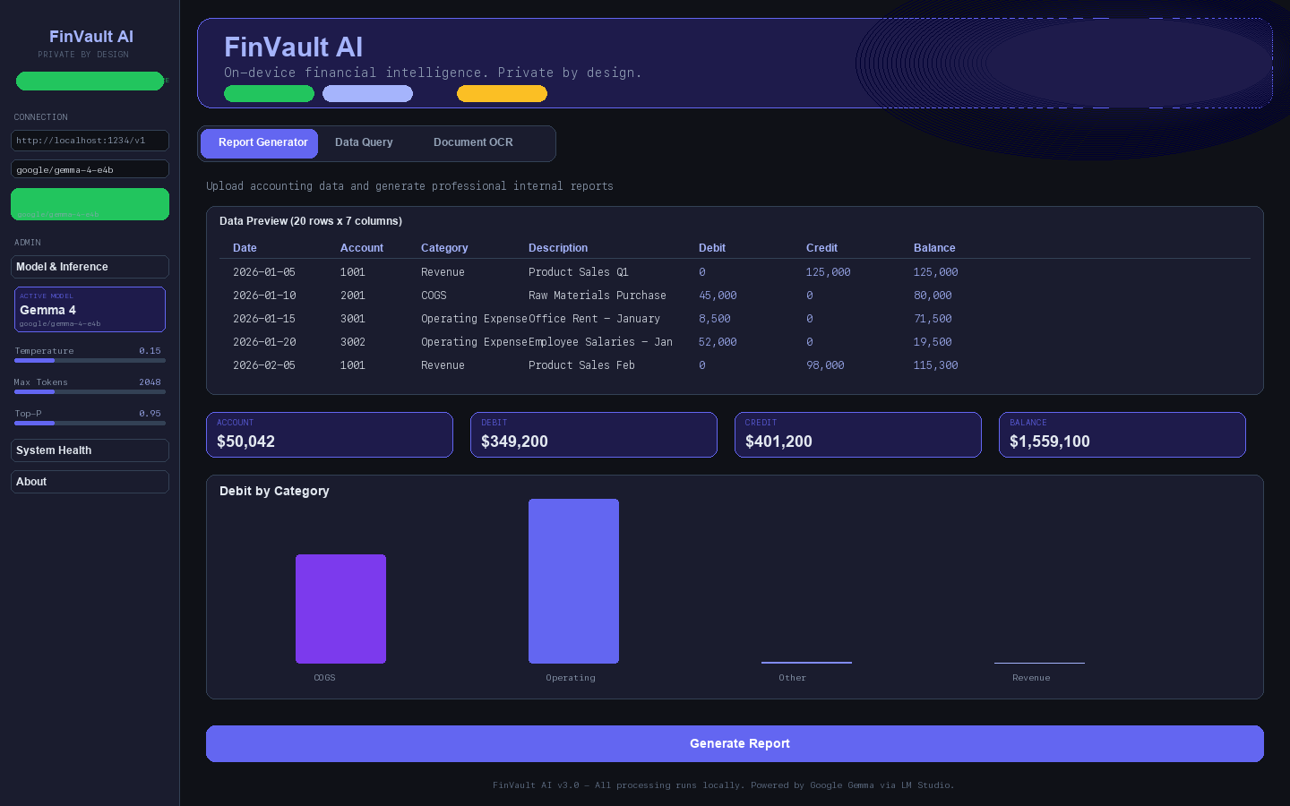
Figure 1: Report Generator with data preview, metrics, and chart visualization

2.2 Natural Language Data Query
The Data Query module provides a conversational interface for financial data analysis. Users ask questions in plain English (e.g., 'What is Q1 revenue?', 'Which category has the highest expenses?') and receive precise answers with step-by-step calculations. The chat maintains conversation context for follow-up questions and displays column metadata for transparency.
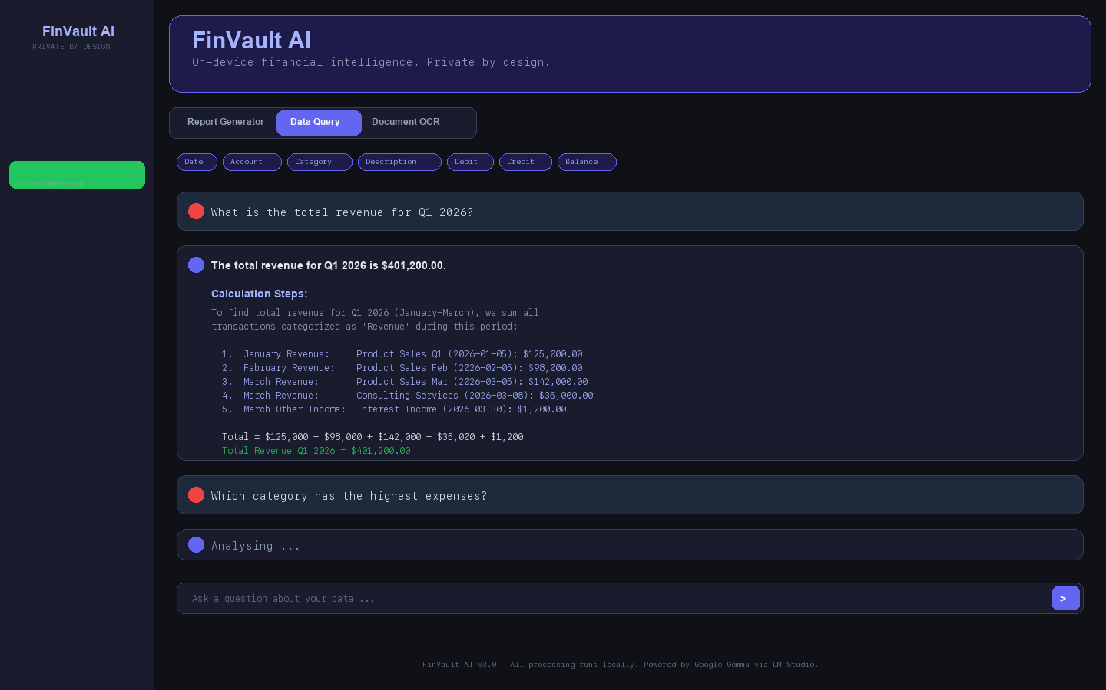
Figure 2: Natural Language Query interface with chat history and column chips

2.3 Document OCR
The OCR module processes scanned financial documents — invoices, work orders, receipts, and purchase orders. Tesseract 5.5 performs local text extraction with confidence scoring, then Gemma 4 parses structured fields (invoice numbers, dates, amounts, line items). A vision-based fallback is available when Tesseract is not installed.
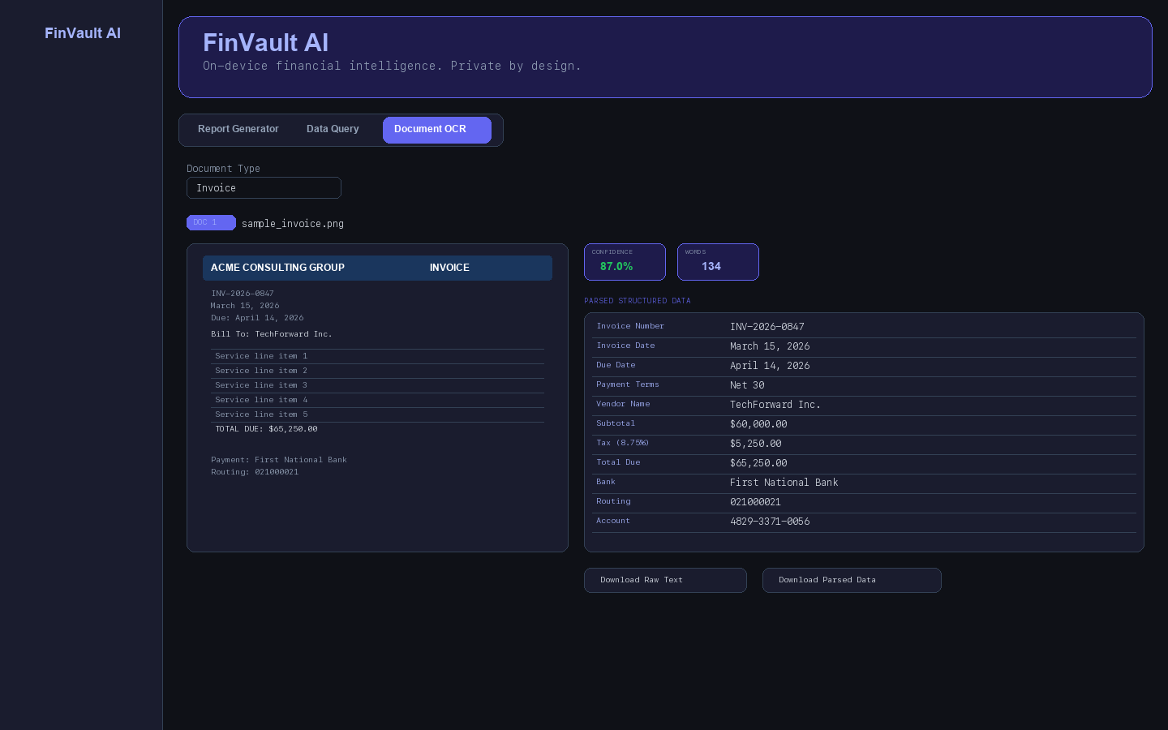
Figure 3: OCR processing with confidence metrics and parsed structured data

2.4 Admin Panel
The sidebar Admin section displays real-time model information (Gemma 4 model card), inference configuration (temperature, max tokens, top-p), and system health status (OCR engine availability, LLM server connectivity).
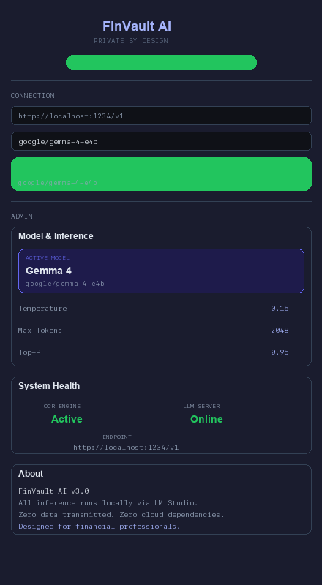
Figure 4: Admin panel showing model info, inference settings, and system health

3. System Architecture

3.1 Architecture Overview
FinVault AI follows a strictly local architecture where all components run on the user's machine. The system consists of four layers: the Streamlit web UI, the Python application layer, the LM Studio inference server, and the local Tesseract OCR engine.
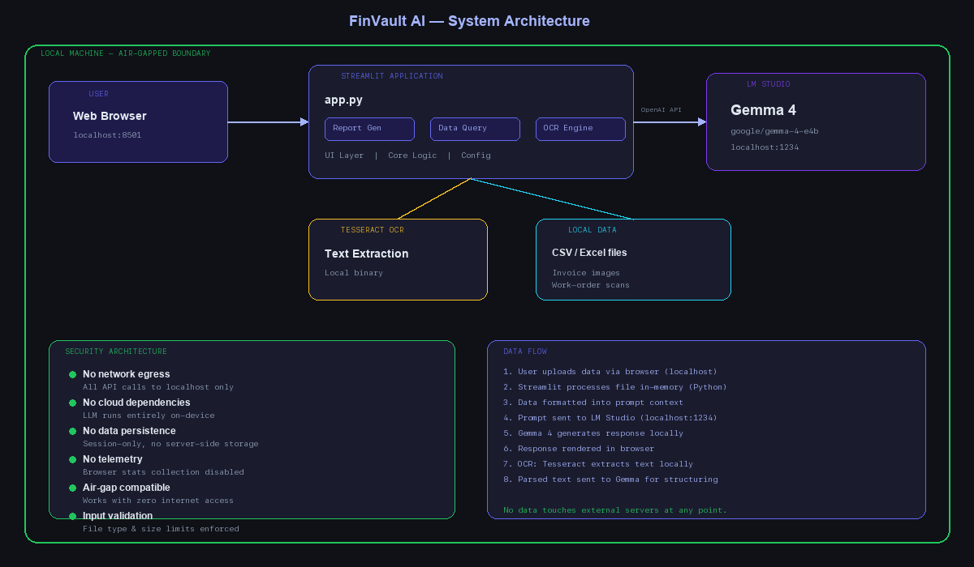
Figure 5: System architecture — all processing stays local

3.2 Component Stack
Frontend | Streamlit 1.x with custom dark theme (indigo accent #6366F1)
Application | Python 3.14 — modular structure with core/, ui/, utils/, config/
LLM Engine | Google Gemma 4 (google/gemma-4-e4b) via LM Studio localhost:1234
OCR Engine | Tesseract 5.5 (Homebrew) with PIL preprocessing pipeline
API Protocol | OpenAI-compatible REST API (openai Python SDK → localhost)
Data Format | CSV, Excel (xlsx/xls), PNG, JPG, PDF
Charts | Plotly Express for interactive financial visualizations

3.3 Data Flow
- Step 1: User uploads accounting data (CSV/Excel) or scanned document (image/PDF) via browser
- Step 2: Streamlit receives file into session memory (never written to disk)
- Step 3: Application layer preprocesses data: pandas for tabular, PIL for images
- Step 4: For OCR: Tesseract extracts text locally, returns confidence + word count
- Step 5: Prompt is constructed with system context + user data + instructions
- Step 6: Request sent to LM Studio at http://localhost:1234/v1/chat/completions
- Step 7: Gemma 4 processes request entirely on-device (GPU/CPU inference)
- Step 8: Response streamed back to application layer
- Step 9: Results displayed in Streamlit UI with download options
- Step 10: Session ends → all data purged from memory. Nothing persists.

4. Development Guide

4.1 Project Structure
FinVault AI/
├── app.py # Main Streamlit entry point
├── config/
│ └── settings.py # All constants, prompts, defaults
├── core/
│ ├── llm_client.py # OpenAI SDK wrapper for LM Studio
│ ├── report_generator.py # Report prompt construction
│ ├── data_query.py # NL query prompt construction
│ └── ocr_engine.py # Tesseract wrapper + preprocessing
├── ui/
│ ├── sidebar.py # Branding, connection, admin panel
│ ├── tab_reports.py # Report Generator UI
│ ├── tab_query.py # Data Query chat UI
│ └── tab_ocr.py # Document OCR UI
├── utils/
│ ├── data_loader.py # CSV/Excel file loading
│ └── formatters.py # Currency formatting, metrics
├── sample_data/ # Synthetic test documents
├── scripts/ # Generation utilities
├── docs/ # Documentation & screenshots
├── .streamlit/
│ └── config.toml # Dark theme configuration
└── requirements.txt

4.2 Prerequisites
- Python 3.11+ (tested with 3.14)
- LM Studio with Gemma 4 model loaded (google/gemma-4-e4b)
- Tesseract OCR 5.x (optional but recommended): brew install tesseract
- pip packages: streamlit, openai, pandas, plotly, Pillow, pytesseract

4.3 Installation & Setup
# 1. Clone the repository
git clone <repository-url>
cd FinVaultAI
# 2. Install Python dependencies
pip install -r requirements.txt
# 3. Install Tesseract OCR (macOS)
brew install tesseract
# 4. Start LM Studio and load google/gemma-4-e4b
# Ensure server is running on localhost:1234
# 5. Launch the application
streamlit run app.py

4.4 Configuration
All application configuration is centralized in config/settings.py. Key parameters include:
LM_STUDIO_URL | http://localhost:1234/v1 (default)
DEFAULT_TEMPERATURE | 0.15 (low for deterministic financial output)
DEFAULT_MAX_TOKENS | 2048
DEFAULT_TOP_P | 0.95
SUPPORTED_IMAGE_TYPES | png, jpg, jpeg, tiff, bmp, webp
DOC_TYPES | Invoice, Work Order, Receipt, Purchase Order, Statement

5. Agent Engineering & LLM Configuration

5.1 Prompt Engineering Strategy
FinVault AI employs specialized system prompts that establish domain expertise for each module. Each prompt follows a structured pattern: role definition, behavioral constraints, output format specification, and safety guardrails.

Report Generator Prompt Design
The report system prompt establishes a 'Senior CPA / Financial Analyst' persona. It instructs the model to use Markdown formatting, include specific sections (Executive Summary, Key Findings, Detailed Analysis, Recommendations), cite exact figures from the data, and flag anomalies or risks.
Key prompt elements:
- Role: 'You are a senior CPA and financial analyst'
- Output structure: Enforced Markdown with H2/H3 headers
- Data context: Full CSV excerpt + pre-computed statistics
- Numeric precision: 'Always cite exact figures from the data provided'
- Anomaly detection: 'Highlight any anomalies, risks, or unusual patterns'

Query Module Prompt Design
The query prompt creates a 'financial data analyst' that receives the full data context (column names, types, row count, and CSV content). It is instructed to show calculations step-by-step, reference specific data points, and provide precise numerical answers.

OCR Parsing Prompt Design
Two prompts serve the OCR pipeline: (1) Vision prompt for direct image-to-text extraction when Tesseract is unavailable, and (2) Parse prompt that transforms raw OCR text into structured fields using document-type-specific templates (invoice fields differ from work order fields).

5.2 Inference Configuration Best Practices
- Temperature 0.15: Low creativity ensures deterministic financial outputs — critical for audit consistency
- Max Tokens 2048: Sufficient for detailed reports while preventing runaway generation
- Top-P 0.95: Slight nucleus sampling allows natural language flow without hallucination risk
- System prompts are immutable: Users control temperature/tokens but cannot modify core prompts
- Context window management: Data is truncated to fit model context with priority on recent/relevant rows

5.3 LLM Client Architecture
The LLM client (core/llm_client.py) wraps the OpenAI Python SDK, pointing it at the local LM Studio server. The LMStudioState dataclass tracks connection status, model name, and server URL. Key functions:
connect(url) | Establishes connection to LM Studio, retrieves model list
chat(state, system_prompt, user_prompt, ...) | Standard text completion via /v1/chat/completions
vision_chat(state, system_prompt, text, image) | Multimodal vision request with base64-encoded image

6. Security Architecture

6.1 Data Isolation Model
FinVault AI implements a zero-trust data isolation model. Every data path is local:
- Network: All API calls target localhost:1234 only. No DNS resolution, no outbound connections.
- Storage: No data is written to disk. All processing occurs in-memory within the Streamlit session.
- Session lifecycle: When the browser tab closes, all data is garbage-collected.
- Model weights: Gemma 4 runs entirely on-device via LM Studio. No cloud API fallback exists.
- OCR: Tesseract processes images locally. No cloud OCR services are invoked.

6.2 LLM Security Considerations
Running an LLM locally eliminates the primary attack vector of cloud-based AI (data exfiltration via API calls), but introduces new considerations:
- Prompt injection defense: System prompts are hardcoded and not user-modifiable. User input is clearly delimited with markdown fences.
- Output sanitization: AI responses are rendered as Markdown. No raw HTML execution from model output.
- Token budget limits: Max tokens are capped to prevent resource exhaustion attacks.
- No persistent memory: The model has no access to previous sessions or user history beyond the current conversation.
- Model integrity: LM Studio loads verified model weights. No fine-tuning or weight modification occurs at runtime.

6.3 Compliance Matrix
SOX Compliance | All financial data remains on-premises; audit trail via session logs
GDPR Article 44 | No cross-border data transfer — processing is 100% local
CCPA | No personal data collection, storage, or sale
HIPAA (if applicable) | PHI never leaves the device; no BAA required
Air-Gap Ready | Operates without any network connectivity

7. Deployment Guide

7.1 System Requirements
Operating System | macOS 13+, Ubuntu 22.04+, Windows 11
RAM | 16 GB minimum, 32 GB recommended
GPU | Optional but recommended (Metal on Mac, CUDA on Linux/Windows)
Storage | ~8 GB for Gemma 4 model weights + 500 MB for application
Python | 3.11 or later
LM Studio | Latest version with local server enabled

7.2 Deployment Process Flow
- 1. Environment Setup: Install Python, LM Studio, Tesseract OCR
- 2. Model Download: Load google/gemma-4-e4b in LM Studio (~8 GB)
- 3. Server Configuration: Start LM Studio server on localhost:1234
- 4. Application Install: Clone repo, pip install requirements
- 5. Theme Configuration: .streamlit/config.toml sets dark theme defaults
- 6. Validation: Run streamlit run app.py, verify connection status in sidebar
- 7. Testing: Upload sample data, run each module (Reports, Query, OCR)
- 8. Production: Configure auto-start scripts for LM Studio + Streamlit

7.3 Health Checks
The Admin panel provides real-time system health monitoring:
- LLM Server: Green indicator when LM Studio is reachable at localhost:1234
- OCR Engine: Shows Tesseract version or warns if not installed (AI vision fallback activates)
- Model Info: Displays loaded model name, confirming Gemma 4 is active
- Inference Config: Shows current temperature, max tokens, and top-p values

8. User Demo Guide
This section provides a step-by-step walkthrough for demonstrating FinVault AI to stakeholders. The demo uses sample data included in the repository.

8.1 Pre-Demo Checklist
- LM Studio is running with Gemma 4 loaded and server active on port 1234
- Streamlit app is launched (streamlit run app.py)
- Browser is open to localhost:8501
- Sidebar shows green 'Connected' status with model name
- Sample data is available in sample_data/ directory

8.2 Demo Script: Report Generator (3 min)
- Step 1: Click the 'Report Generator' tab
- Step 2: Check 'Use sample data' → select sample_accounts.csv
- Step 3: Point out: Data Preview table, column chips, quick metrics, and the bar chart
- Step 4: Select report type: 'Executive Summary'
- Step 5: Click 'Generate Report' — wait for AI analysis (~10-15 seconds)
- Step 6: Highlight: Structured report with Executive Summary, Key Findings, Recommendations
- Step 7: Show 'Download Report' button — emphasize no data left the machine

8.3 Demo Script: Data Query (3 min)
- Step 1: Switch to 'Data Query' tab
- Step 2: Check 'Use sample data' → same CSV is loaded
- Step 3: Point out column chips showing available fields
- Step 4: Type: 'What is the total revenue for Q1 2026?'
- Step 5: Show the AI response with step-by-step calculations
- Step 6: Follow up: 'Which category has the highest expenses?'
- Step 7: Emphasize: Context is maintained across questions

8.4 Demo Script: Document OCR (3 min)
- Step 1: Switch to 'Document OCR' tab
- Step 2: Check 'Use sample docs' → select sample_invoice.png
- Step 3: Click 'Extract & Parse'
- Step 4: Show: OCR confidence score, word count, raw extracted text
- Step 5: Scroll to: AI-parsed structured data (invoice number, date, amounts)
- Step 6: Highlight: 'Download Raw Text' and 'Download Parsed Data' buttons
- Step 7: Optional: Toggle 'Pre-process' checkbox for low-quality scans

8.5 Key Talking Points
- Privacy: 'Notice the URL — localhost:8501. Everything runs on this machine.'
- Speed: 'Report generated in under 15 seconds — no API latency.'
- Compliance: 'Zero cloud means SOX/GDPR compliance is built into the architecture.'
- Cost: 'No API fees. No subscriptions. One-time setup.'
- Flexibility: 'The model handles financial jargon, calculates metrics, and parses any document type.'

9. Product Roadmap
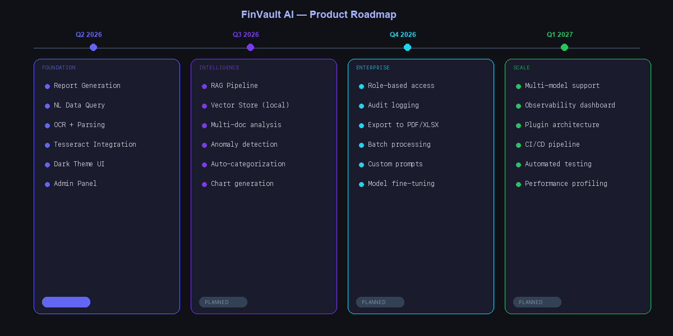
Figure 6: Product roadmap — phased delivery through Q1 2027

Q2 2026 — Current Release (v3.0)
- Core platform: Report Generator, Data Query, Document OCR
- Google Gemma 4 integration via LM Studio
- Tesseract 5.5 OCR with vision fallback
- Dark theme UI with Admin panel
- Sample data and synthetic test documents

Q3 2026 — Intelligence Layer
- RAG (Retrieval-Augmented Generation) pipeline for document-grounded answers
- Anomaly detection engine with configurable thresholds
- Multi-document cross-referencing (e.g., match invoices to purchase orders)
- Batch processing mode for bulk document OCR
- Export to PDF format for reports

Q4 2026 — Enterprise Features
- Multi-user support with role-based access control (RBAC)
- Audit logging and compliance reporting
- API endpoints for integration with existing ERP systems
- Custom report templates with branding options
- Scheduled report generation (cron-based)

Q1 2027 — Scale & Observability
- Model performance monitoring and inference analytics
- A/B testing framework for prompt optimization
- Advanced agentic workflows: multi-step financial analysis pipelines
- Kubernetes deployment option for team environments
- Telemetry dashboard (local-only) for usage metrics

10. Appendix

A. API Reference
LM Studio exposes an OpenAI-compatible API at localhost:1234:
GET /v1/models | List available models
POST /v1/chat/completions | Text/vision chat completion
GET /v1/models/{id} | Model metadata

B. Supported Document Types
Invoice | Invoice #, Date, Vendor, Line Items, Subtotal, Tax, Total
Work Order | WO #, Date, Client, Description, Labor, Materials, Total
Receipt | Store, Date, Items, Subtotal, Tax, Total, Payment Method
Purchase Order | PO #, Vendor, Items, Quantities, Unit Prices, Total
Statement | Account, Period, Opening Balance, Transactions, Closing Balance

C. Troubleshooting
- Connection failed: Ensure LM Studio server is running on port 1234. Check sidebar status.
- Low OCR confidence: Enable 'Pre-process' checkbox. Use 300+ DPI scans for best results.
- Slow inference: Ensure GPU acceleration is enabled in LM Studio preferences.
- Module not found: Run pip install -r requirements.txt to install all dependencies.
- Tesseract not detected: Install via 'brew install tesseract' (macOS) or 'apt install tesseract-ocr' (Ubuntu).

FinVault AI v3.0 — Confidential Technical Documentation — April 2026
All processing runs locally. No data is transmitted. Powered by Google Gemma 4 via LM Studio.

