BENEDICT UDEH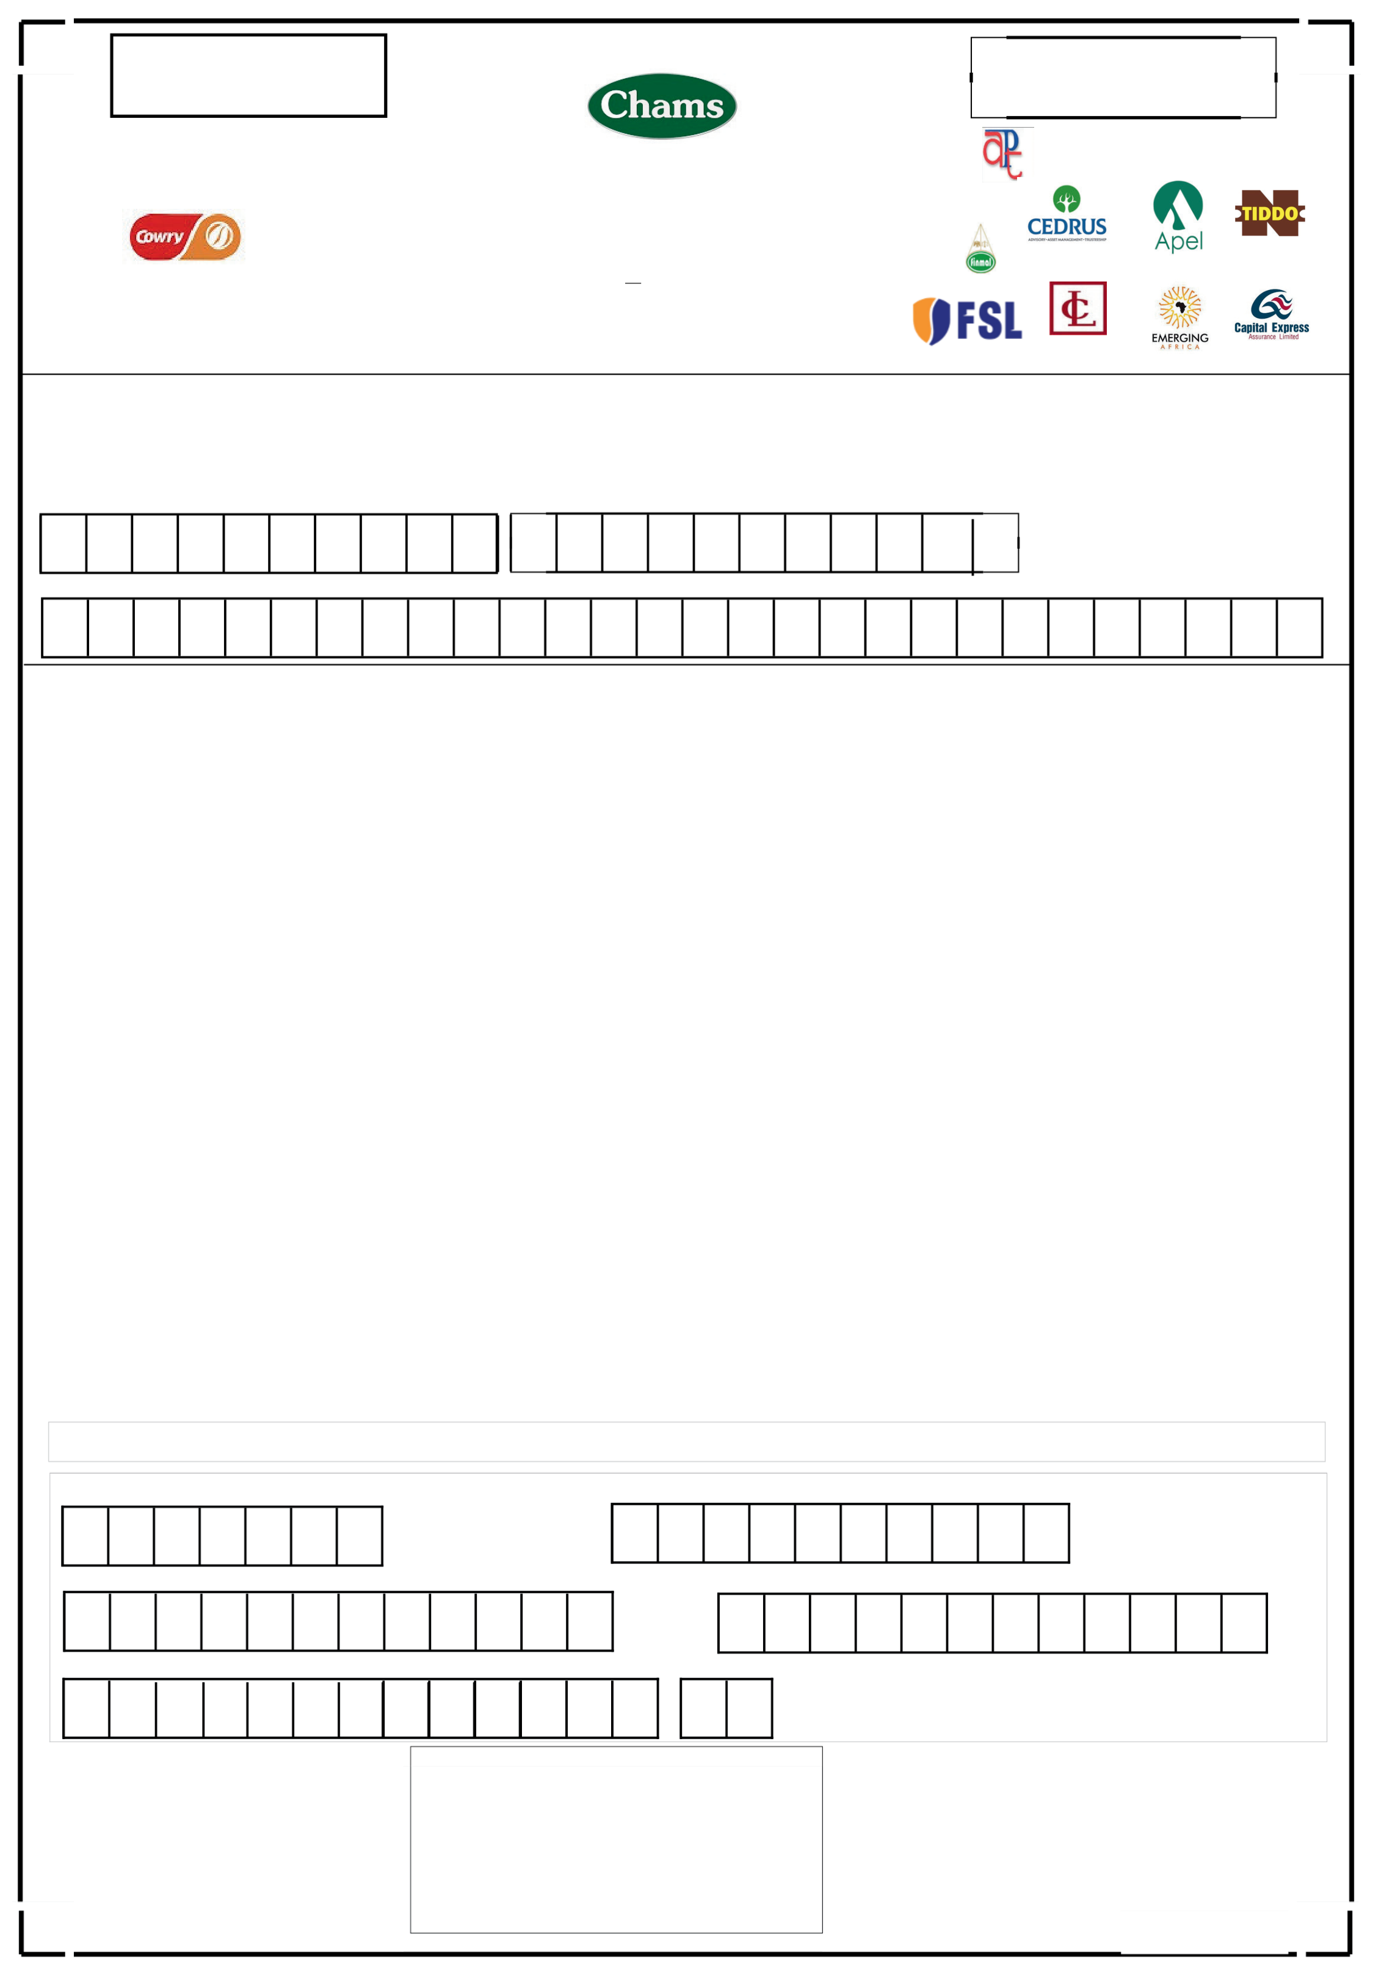

|  |  |  |  |  |  |  |
| --- | --- | --- | --- | --- | --- | --- |
| Application List Opens | Application List Closes | | | | | |
| **Friday, August 8, 2025** | **Friday, September 12, 2025** | | | | | |
| RC.76807 | | | | **JOINT ISSUING HOUSES** | | |
| **LEAD ISSUING HOUSE** | **CHAMS HOLDING COMPANY PLC**  RIGHTS ISSUE OF 2,348,030,000 ORDINARY | | RC: 165189 | | | |
| RC: 617327 | SHARES OF 50 KOBO EACH ON THE BASIS OF 1 | RC: 105859 | | RC: 69215 | RC: 606031 | RC: 155716 |
| NEW ORDINARY SHARE FOR EVERY 2 ORDINARY |
| SHARES HELD AT N1.70 PER SHARE   RC:116443 | | | | | | |
| RC:139396 | | | | RC:1498096 | | RC:158080 |
| **Bank details (for E-Dividend):**  Bank Name........……………………………............................ Branch……………….................................................. ACCESS BANK | | | | | | |
| Account Number | **BVN** | | | | | |

0 0 2 2 1 5 1 4 7 3 2 2 2 3 5 1 3 2 1 5 6 Email Address   
U D E H B U D E H @ G M A I L . C O M

**INSTRUCTION FOR COMPLETING THE ACCEPTANCE/RENUNCIATION FORM**

|  |  |
| --- | --- |
| 1.  2.  3.  4.  5. | Acceptance and/or renunciation must be made on the prescribed form. Photocopies of the Acceptance/Renunciation Form will be rejected.  Allottees should complete only ONE of the boxes marked B or C on the reverse of this form.  Shareholders accepting the provisional allotment in full should complete box B and submit their Acceptance/Renunciation Forms to any of the Receiving agents listed on page 70 of the Rights Circular together with a cheque or bank draft payable to the Receiving agent for the full amount payable on acceptance. The cheque or draft must be drawn on a bank in the same town or city in which the Receiving Agent is located and crossed **"CHAMS HOLDING COMPANY PLCRights"** with the name, address and day time telephone number (if any) of the shareholder written on the back. If payment is not received by September 12, 2025**,** the provisional allotment will be deemed to have been declined and will be cancelled.  Shareholders accepting their provisional allotment partially should complete box C and submit their Acceptance/Renunciation Form to any of the Receiving Agents listed on page 70 of the Rights Circular together with a cheque or bank draft made payable to the Receiving Agent for the amount payable for the partial acceptance.  Shareholders who wish to trade their renounced rights on the floor of The Nigerian Exchange Limited (" The Exchange") should complete item (ii) of box C. They should obtain a Transfer form from their stockbroker, complete it in accordance with his instructions and return it to |

the stockbroker together with the completed Acceptance/Renunciation Form and a cheque or bank draft made payable to the stockbroker for any partial acceptance. If payment is not received by September 12, 2025, the provisional allotment will be deemed to have been declined and will be cancelled.

6. Shareholders who wish to acquire additional shares over and above their provisional allotment may purchase renounced rights and/or apply for

additional shares by completing item (ii) of box B

|  |  |
| --- | --- |
| 7.  8.  9. | All cheques and bank drafts will be presented upon receipt and all acceptances in respect of which bank drafts are returned unpaid will be rejected and cancelled. Shareholders are advised to obtain an acknowledgement of the amount paid from the Receiving Agent through which the Acceptance/Renunciation Form is submitted.  Joint Allottees must all sign the appropriate box in the Acceptance/Renunciation Form.  Acceptance/Renunciation Forms of the corporate allottees must bear the corporate seal, RC Number and be completed under the hand of duly authorized officials who should state their designations. |

For further information on the Company's recapitalisation efforts, including access to the Right Circular, shareholders are encouraged to visit

the website: https://chamsplc.com

**FOR REGISTRAR'S USE ONLY**

|  |  |
| --- | --- |
| Control No:  Number of shares Accepted  Value of shares applied for / Amount Paid | Account No  Additional Shares applied for  . |

Stamp of Receiving Agent

|  |  |  |
| --- | --- | --- |
| Application List Opens |  | Application List Closes |
| **Friday, August 8, 2025** | **Friday, September 12, 2025** |

|  |  |  |  |
| --- | --- | --- | --- |
| **(A)**  i.  ii.  iii.  iv. | **Acceptance/Renunciation Form**  **TRADING IN RIGHTS**  Shareholders who renounce their Rights partially or in full may trade their Rights on the floor of The Exchange. The renounced Rights will be traded actively on the floor of The Exchange.  Shareholders who wish to acquire additional shares over and above their provisional allotment may purchase renounced Rights (see A.iv. below) and/or apply for additional shares by completing item (ii) of box B below.  Shareholders who purchase Rights on the floor of The Exchange are guaranteed the number of shares purchased. They will not be subject to the allotment process in respect of shares so purchased. Those that apply for additional shares by completing item (ii) of box B will be subject to the allotment process i.e. they may be allotted a smaller number of additional shares than what they applied for.  If you wish to purchase renounced Rights please contact your stockbroker who will guide you regarding payment and the procedure for purchasing **CHAMS HOLDING COMPANY PLC** Rights. | | |
| unit No.: | | AcctNo: 25244 |
| **DETAILS OF** | Unit Held: | BENEDICT UDEH |
| **SHAREHOLDER'S** | 89,393 |
| **PROVISIONAL** | Right Due: |
| 44,696 |
| **ALLOTMENT** |
| Amount: | NGN 75,983.20 |

|  |  |  |  |  |
| --- | --- | --- | --- | --- |
| **PLEASE COMPLETE SECTION B OR C AS APPLICABLE** | | | | |
| **(B)** | **FORM OF FULL ACCEPTANCE AND REQUEST FOR ADDITIONAL SHARES** | | | |
| i. | I/We accept this allotment in full as shown above. | | | |
| ii. | I/We also apply for the following additional shares. | | | |
| This section should be | | No. of Additional  Shares Applied for | Additional Amount payable at 1.70kobo per share | |
| completed if you wish to | | 190,598 | **N**= | 324,016.6 |
| apply for additional shares | |
| iii. | I/We agree to accept the same or smaller number of additional shares in respect of which allotment may be made to me/us in accordance | | | |
| iv. | with the Provisional Allotment Letter contained in the Rights Circular.  I/We enclose my/our bank draft for N=……………….............................................. being the amount payable as shown above, plus any 399,999.8 | | | |

additional amount payable as shown in item (ii) above.

|  |  |  |
| --- | --- | --- |
| **(C)FORM OF RENUNCIATION OR PARTIAL ACCEPTANCE** | | 3  **No. of Shares Renounced** |
| 1 | 2 |
| **No. of Shares Accepted** | **Amount payable at 1.70 kobo per share** |

|  |  |  |  |
| --- | --- | --- | --- |
| **N**= | | | |
| i. | I/We accept the number of shares as shown in Column (1) above and enclose my/our bank draft for N………………………………… shown in column (2) above. | | |
| ii. | I/We hereby renounce my/our right to Ordinary Shares shown in Column (3) above being the balance of the Ordinary Shares allotted to me/us. | | |
| iii. | I/We confirm that I/We wish to trade my/our rights to ………………........................................ Ordinary Shares (being my/our renounced shares as shown in Column (3) above on the floors of The Exchange. I/We shall obtain a Transfer Form from my/our stockbroker, complete it in accordance with his instructions and return it to the stockbroker with the form. | | |
| **(for either B or C)** Signature………………….......................................2nd Signature ……………………………...................................... **(for joint/Corporate Allottees)**  Date..................................................Next of Kin....................................................................................................... 11/09/2025 | | | |
| Clearing House Number (CHN): | | CSCS NO (if you want shares allotted credited to your CSCS A/C) | |
| **C** | 0 7 7 6 2 9 1 B C | 1 3 1 7 4 7 5 0 2 | |
| Name of your Stockbroker | | GSM (for SMS) | |
| A T L A S P O R T F O L I O | | | 0 7 0 6 7 3 0 3 3 9 4 |
|  | | Stamp of Receiving Agent | SEAL OF CORPORATE ALLOTTEE |