AGENIS-NEVERS Marc
Publication : 27/06/2017
Version : 1.0

Shiny application for text reading with alignment method.
Context
Online literature on the subject of reading methods is rich; in March, 2014, a start-up namefd Spritz released an app claiming to enable people to read up to a pace of 1000 words per minute. One would finish Harry Potter bestseller during a standard lunch break.
The idea behind this innovation is to suppress any eye movement between the lines of a book and present the words one by one, rapidly, in such a way that the middle letter of each word is centered on a fixed red line.
I’ve reproduced the basics of this technology on a Shiny application. Shiny is a framework developed by R-Studio that allows quick publishing of any R algorithm as an online user interface.
Application
  - Issues and features
Several issues arose when developing this application.
First, we needed to wrap the file upload and the text processing downstream in a reactive context, thus avoiding reprocessing each time the user changes an input.
The second issue was how to control the time interval between consecutive words and let the user select it with a slider. The change in the slider must not reset the reading at its beginning, only a new text upload; we set up a global index $i$ for the index of the word being read. Then, the function invalidateLater allows us to control how we reset the display of a word: the time argument is dependent on both the slider and the pause button. Whenever the pause button increment switches from an odd to an even number it delays the next word by an infinite number of seconds:
invalidateLater( ifelse(input$PAUSE %% 2, 1e10, round(6e4/input$speed)), session )

Eventually, a radio button allows to bypass the file import and display some dummy text in English. Five examples are randomly selected:
- A speech of Winston Churchill during WW2
- St Crispin's Day Speech from Shakespeare’s Henri V
- The preface of Democracy in America by Tocqueville
- The speech of Morpheus in Matrix: Reloaded
- Fable de la Fontaine (le Loup et le Chien)

  - Overview
The application is available at this URL:
https://agenis.shinyapps.io/symetric_readaer_basic/
A screen shot of the application is provided hereafter:
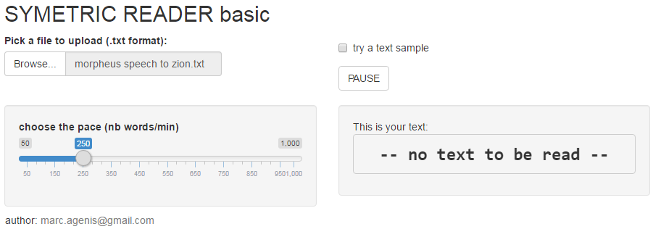
  - Pending improvements
Improvements are welcome, however each additional piece of code might cause a delay in the execution of the script that can be visible at high reading paces.
Some improvements are considered:
- Add a text-input zone, in order to copy and paste free text from the web.
- Color the central letter in red like in Spritz (requires some java code)
- Add a button to replay a text
- Improve the regex process to eliminate some special characters, punctuation or extra blank lines.

