

**O**fficeworks **S**tore **I**nitialisation **R**out**i**ne and **S**cripts

**Forward**

OSIRiS is an extension and graphical redesign of the older OSACS (Officeworks Setup and Cleaning System) script that was previously used to configure store demo computers. Whilst OSIRiS makes use of the 'setup' and 'sell' scripts from OSACS, they have been modified specially for OSIRiS. In addition, the master control program (OSIRiS.exe) is completely new from the ground up along with the supporting help files.

OSIRiS is written in C# using Windows Forms under Visual Studio. The scripts are written in mixed BATCH and PowerShell.

**Overview**

This manual is designed to give you a complete guide to the various functions of OSIRiS and also to allow a new user to get started with no prior knowledge.   
The manual is split up into three sections, Setup, Sell and Format.  
  
These three sections detail the main functions of OSIRiS so you can skip ahead to the part you are most interested in.

**Setup**

This section details the steps required to setup a demo/display computer and the functions OSIRiS will perform on that computer.

Power on the machine and wait for the initial configuration screen to appear.   
Set a colour and give the machine any name you like. (OSIRiS will change this later)  
Click Next.

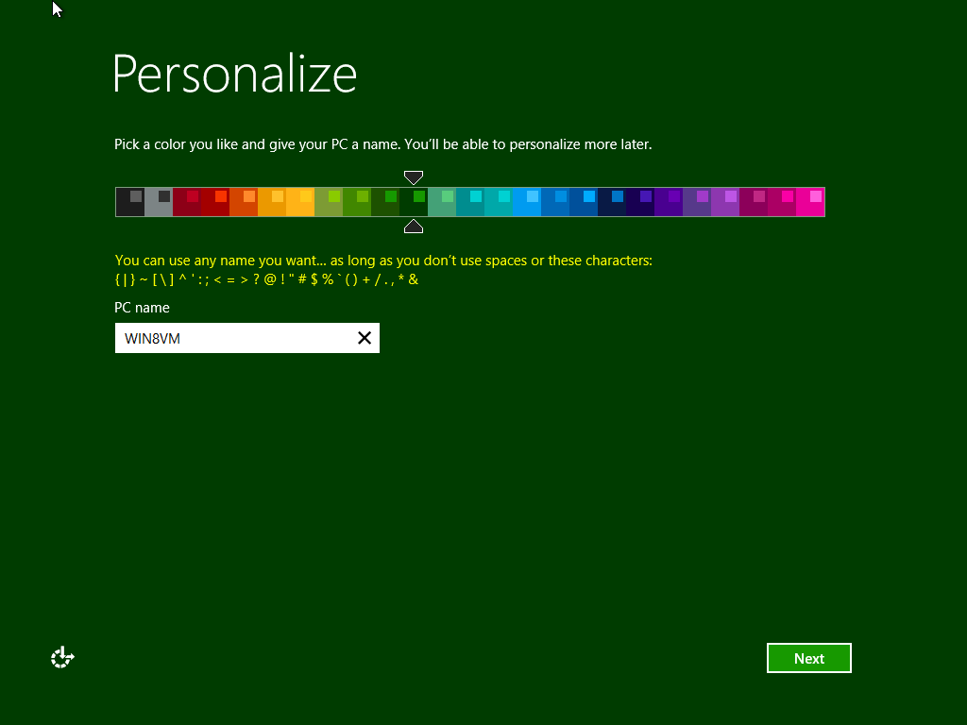

If prompted for a network connection via wireless, choose 'Skip' or 'Connect to Wireless Later' for ease of setup.   
(If wireless is configured at this point then the machine will prompt you for a Microsoft account, to bypass this do the following, Create New Account → Continue without a Microsoft Account / Use Local Account.)

Next choose, 'Use express settings'.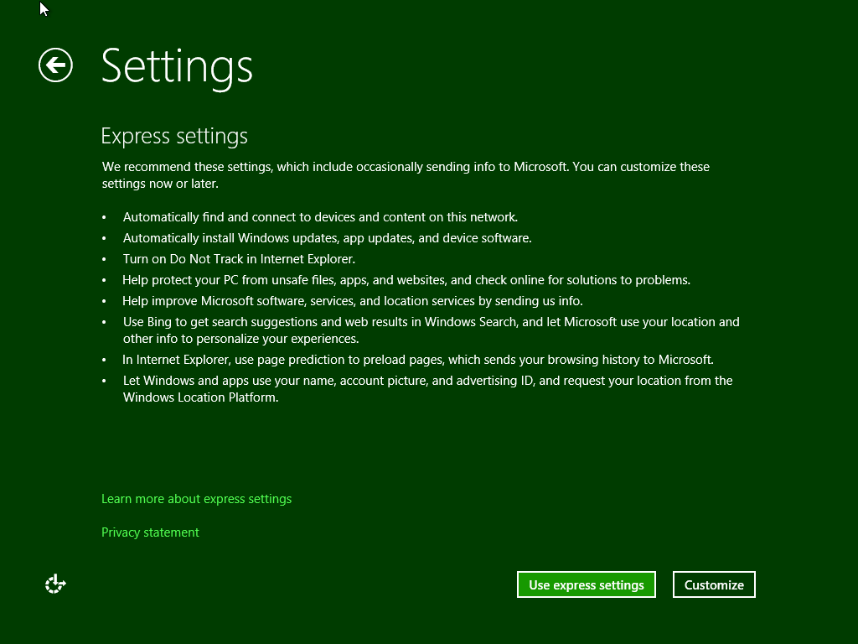

At the account setup screen use any name and password you like, something like 'USERSETUP' is a good choice. (OSIRiS will delete this later) Click Finish.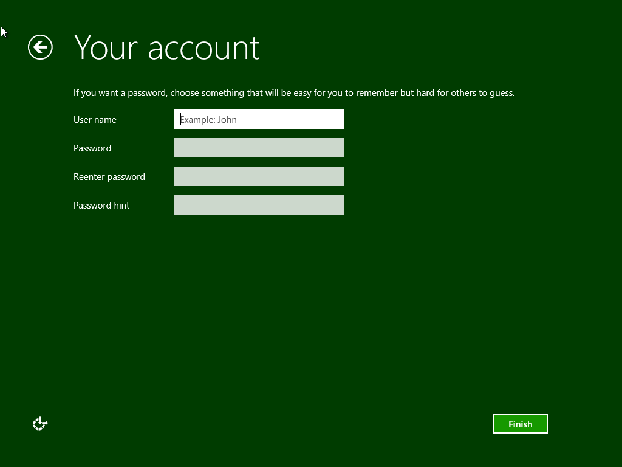

Once arrived at the newly configured system we can move onto using OSIRiS to finish the job.

To begin, insert the USB Flash Drive attached to select technology keys, into the USB port of the machine you are working on.   
Next click on the 'File Explorer' icon either on the task bar as shown here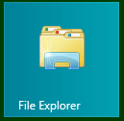 or on the start screen as show here.  
  
If you cannot find the 'File Explorer' icon, please type File Explorer while looking at the start screen and Windows will search for it for you.

Once at the File Explorer window, double click the USB Flash Drive you inserted earlier.   
Double click the OSIRiS main program icon which should look like this.  


OSIRiS will now start after asking for permission from the user and present 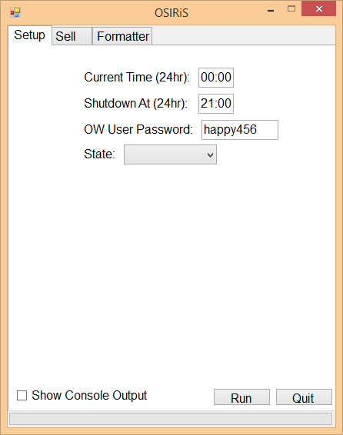its main window.

Most of the details can be left to their defaults if you desire, however at least two pieces of information MUST be entered. Both the current time and the state must be changed or OSIRiS will not run, the time must be entered in 24 hour terms (21:00).  
  
Set the current time, the shutdown time, the password that you would like for the Officeworks admin user (make sure it's the same on all machines) and the state the store resides in.

Decide whether you would like to see console output messages by checking the appropriate box and then press run. If you decide not to see console output then progress will simply be indicated with a scrolling bar.

Once OSIRiS has finished setting up the machine, it will reboot   
automatically.   
Once the machine has rebooted, click the 'Customer' account and you are done. The 'Officeworks' account does not ever need to be logged in, if a task requires admin rights, such as running OSIRiS to sell a machine, Windows will ask you for Officeworks' password that you set during setup.

**What does it do?**

When setting up a new machine, OSIRiS runs through the following actions.

1. Renames the machine based on the manufacturers model number as extracted from the firmware.

2. Deletes all the user accounts on the machine.

3. Creates two new accounts, 'Customer' and 'Officeworks' which has its password set to whatever the user chooses.

4. Configures a new power plan called 'Officeworks' that never sleeps nor hibernates.

5. Disables 'Windows Update' to prevent the display machines from eating all the bandwidth.

6. Configures the 'OFW-Display' wireless network.

7. Sets the time zone.

8. Sets the time to whatever the user chose.

9. Configures the machine to automatically shutdown at the user designated time.

10. Schedules a task to reset the wireless card on every boot of the machine. This prevents the machines being in airplane mode at the start of the day.

11. Reboots the machine.

**Sell**

This section details the steps required to sell a demo/display computer and the functions OSIRiS will perform on that computer.

To begin, insert the USB Flash Drive attached to select technology keys, into the USB port of the machine you are working on.   
Next click on the 'File Explorer' icon either on the task bar as shown here or on the start screen as show here.  
  
If you cannot find the 'File Explorer' icon, please type File Explorer while looking at the start screen and Windows will search for it for you.

Once at the File Explorer window, double click the USB Flash Drive you inserted earlier.   
Double click the OSIRiS main program icon which should look like this.  


OSIRiS will now start after asking for permission from the user and present 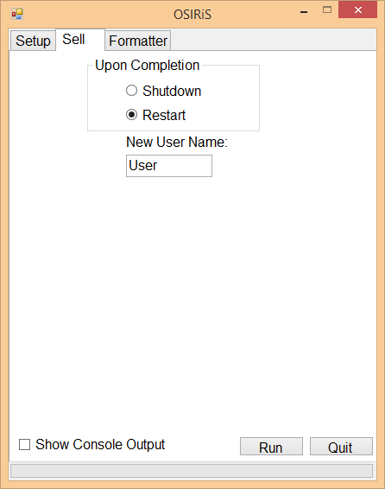its main window. Choose the Sell tab from the top of the window.

These settings can be left to their defaults and no information needs to be changed, however if the customer is in hurry, you can elect to have the machine shutdown when OSIRiS is finished.

You can also set a username for the new account that OSIRiS creates, this can be the customer’s name if they want to personalise the machine, or it could be the name of a person who is receiving the machine as a gift. Either way, this option allows for a bit more freedom than just the standard 'User', it is however, entirely optional.

Once you have decided upon the settings you and the customer would like, decide whether you would like to see console output messages by checking the appropriate box and then press run. If you decide not to see console output then progress will simply be indicated with a scrolling bar.

OSIRiS will either shutdown the machine or reboot it once it has finished, depending upon the choice you made.

**What does it do?**

1. Switches 'Windows Update' back on.

2. Deletes the 'Officeworks' and 'Customer' users.

3. Creates a new user based on whatever the user chooses.

4. Copies over two cleanup scripts to tidy up the OSIRiS left overs on machine reboot.

5. Creates a scheduled task which executes upon reboot and login of the new user account, this task bootstraps the cleanup scripts.

6. Deletes the computer shutdown scheduled task and the wi-fi check scheduled task.

7. Deletes the Officeworks power plan and sets the balanced plan as the default one.

8. Disconnects the wireless radio and deletes the directory containing the profile data. It then forces a reset of the radio to make sure it's disconnected.

9. Reboots the machine into the new user account or alternatively shuts down.

**Format**

This section details the steps required to format an external hard disk drive or USB flash drive.

To begin, insert the USB Flash Drive attached to select technology keys, into the USB port of the machine you are working on.   
Next click on the 'File Explorer' icon either on the task bar as shown here or on the start screen as show here.  
  
If you cannot find the 'File Explorer' icon, please type File Explorer while looking at the start screen and Windows will search for it for you.

Once at the File Explorer window, double click the USB Flash Drive you inserted earlier.   
Double click the OSIRiS main program icon which should look like this.  


OSIRiS will now start after asking for permission from the user and present 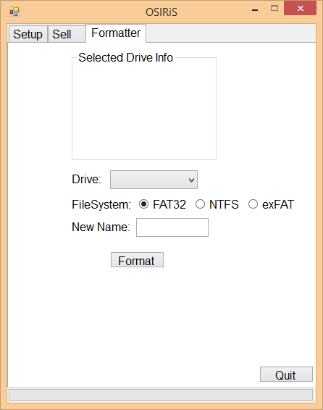its main window. Choose the Formatter tab from the top of the window.

Firstly, choose a drive from the drop down box, taking special care to select the correct drive letter.



The details of the drive should appear in the top section of OSIRiS labeled 'Selected Drive info'.

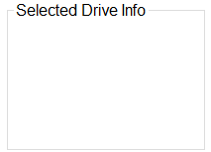  
  
Next choose a file system, the different file systems have different pros and cons, for a breakdown of the different file systems, click the 'Help' button in the OSIRiS main window and navigate to the file system breakdown topic.   
Alternatively, hovering over the various file system labels in OSIRiS will yield a brief description of each one.

  
  
Once you have chosen a file system, type a drive name into the 'New Name' box and press format. A blank name is not valid.

  
  
For any issues with formatting disks, see the help topic 'Troubleshooting' within the 'Help' option of the OSIRiS main window.

**Licenses**

OSIRiS and its companion scripts are licensed under the GNU GPLv3.

OSIRiS uses the 'fat32format' command line program available from <http://www.ridgecrop.demon.co.uk> full source code is also available from the same site and the program is licensed under the GPL.