

**O**fficeworks **S**cripted **I**nitialization **R**out**i**ne for **S**tores

**Forward**

OSIRiS is an extension and graphical redesign of the older OSACS (Officeworks Setup and Cleaning System) script that was previously used to configure store demo computers. Whilst OSIRiS makes use of the 'setup' and 'sell' scripts from OSACS, they have been modified specially for OSIRiS. In addition, the master control program (OSIRiS.exe) is completely new from the ground up.

OSIRiS is written in C# using Windows Forms under Visual Studio. The scripts are written in mixed BATCH and PowerShell.

**Overview**

This manual is designed to give you a complete guide to the various functions of OSIRiS and also to allow a new user to get started with no prior knowledge.   
The manual is split up into three sections, Setup, Sell and Format.  
  
These three sections detail the main functions of OSIRiS so you can skip ahead to the part you are most interested in.

# **Setup**

This section details the steps required to setup a demo/display computer and the functions OSIRiS will perform on that computer.

Power on the machine and wait for the initial configuration screen to appear.   
Set the country and language to English and make sure the keyboard layout is US.  
Click Next.

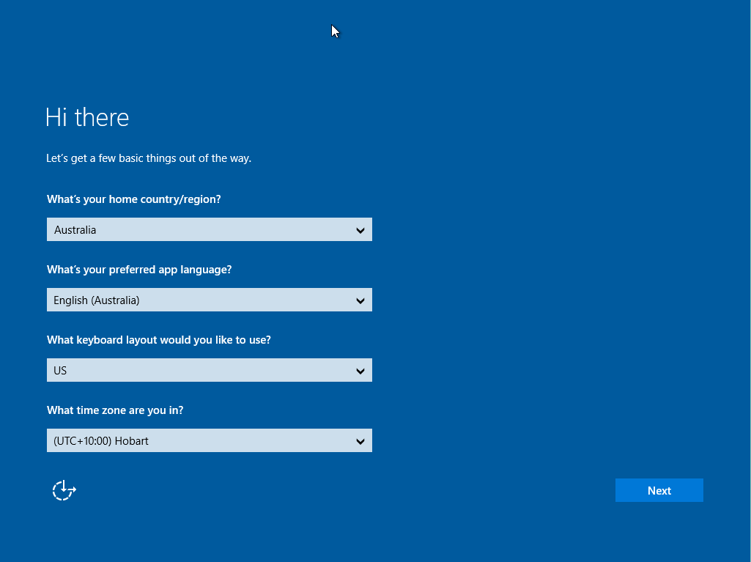

If prompted for a network connection via wireless, choose 'Skip' or 'Connect to Wireless Later' for ease of setup.   
(If wireless is configured at this point then the machine will prompt you for a Microsoft account, to bypass this do the following, Create New Account → Continue without a Microsoft Account / Use Local Account.)

Next choose, 'Use express settings'.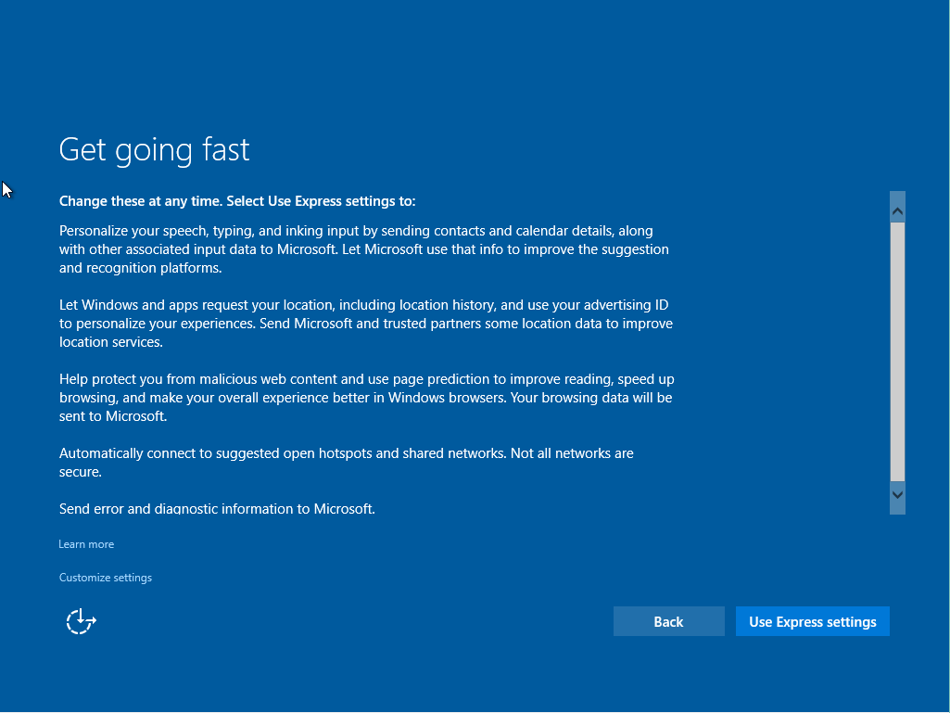

At the next screen, choose ‘I own it’ regardless of the current status of the machine, as we do not want it to join a corporate domain.

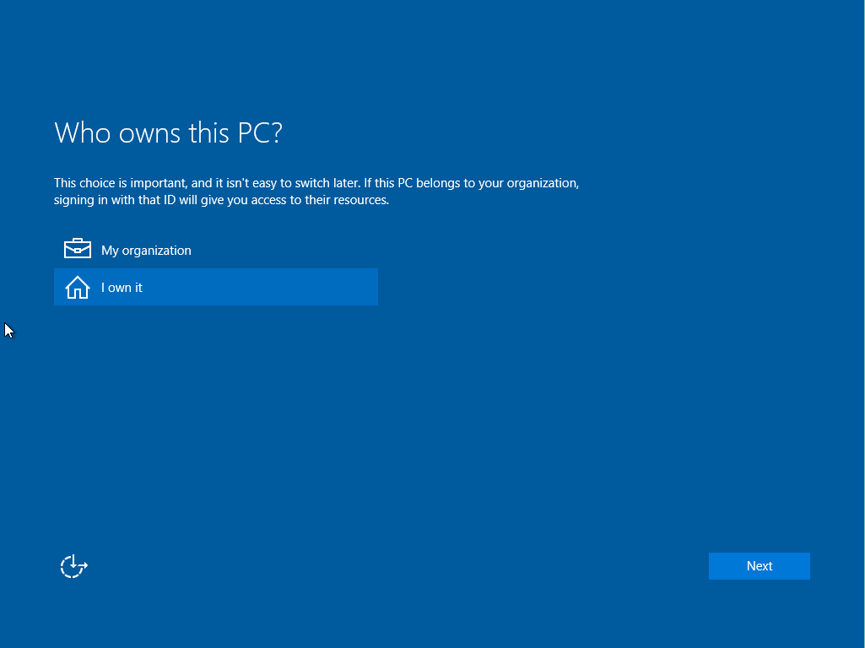

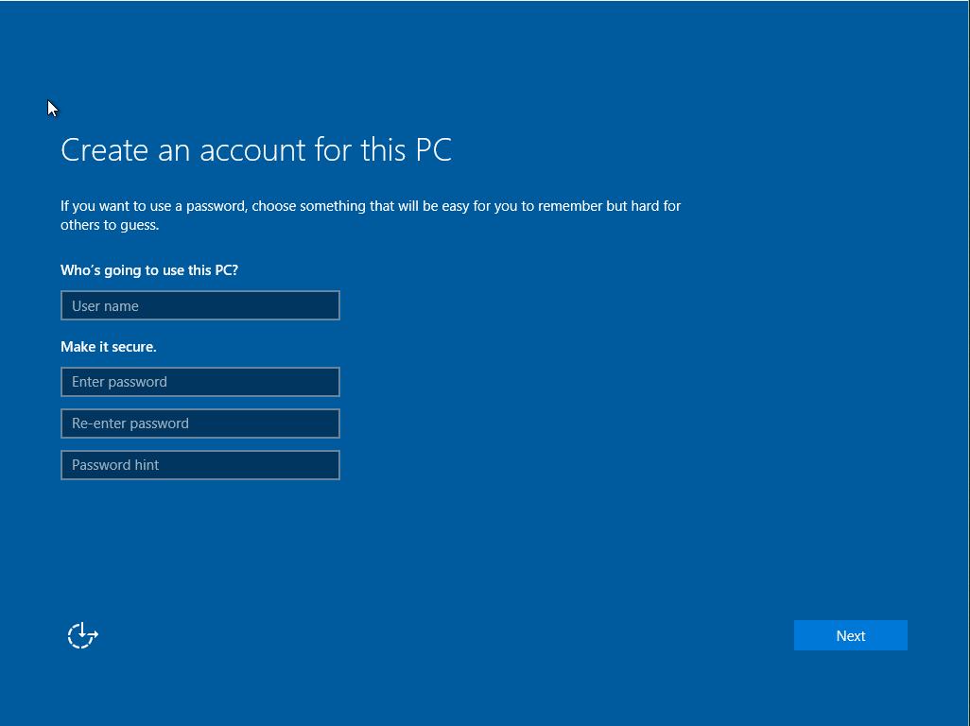

At the account setup screen use any name and password you like, something like 'USERSETUP' is a good choice. (OSIRiS will delete this later) Click Finish.

Once arrived at the newly configured system we can move onto using OSIRiS to finish the job.

To begin, insert the USB Flash Drive attached to select technology keys, into the USB port of the machine you are working on.   
Next click on the 'File Explorer' icon either on the task bar as shown here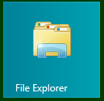 or on the start menu as show here.  
  
If you cannot find the 'File Explorer' icon, please type File Explorer into the search box at the bottom of the screen and Windows/Cortana will search for it for you.

Once at the File Explorer window, double click the USB Flash Drive you inserted earlier.   
Double click the OSIRiS main program icon which should look like this.  


OSIRiS will now start after asking for permission from the user and present 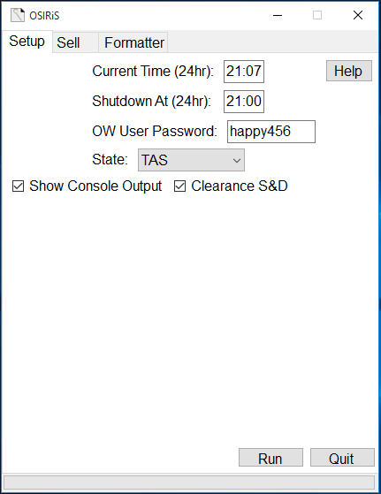its main window.

Most of the details can be left to their defaults if you desire, however at least two pieces of information MUST be entered. Both the current time and the state must be changed or OSIRiS will not run, the time must be entered in 24 hour terms (21:00). (OSIRiS remembers the shutdown time, state selection and password on a per-USB basis)  
  
Set the current time, the shutdown time, the password that you would like for the Officeworks admin user (make sure it's the same on all machines) and the state the store resides in.

Decide whether you would like to see console output messages by checking the appropriate box and then press run. If you decide not to see console output then progress will simply be indicated with a scrolling bar.



If the machine being setup is a Clearance model or perhaps an S&D repair or return, check the ‘Clearance S&D’ option. This will place a banner on the wallpaper when the machine is setup so customers can be aware that the machine is a clearance model.

Click ‘Run’.

Once OSIRiS has finished setting up the machine, it will reboot   
automatically.

Once the machine has rebooted, it will start the 'Customer' account automatically and you are done. The 'Officeworks' account does not ever need to be logged in and in fact the ‘Customer’ account cannot be logged out. If a task requires admin rights, such as running OSIRiS to sell a machine, Windows will ask you for Officeworks' password that you set during setup.

**What does it do?**

When setting up a new machine, OSIRiS runs through the following actions.

1. Renames the machine based on the manufacturers model number as extracted from the firmware.  
  
2. Sets a custom wallpaper based on the CPU type detected.

3. Deletes all the user accounts on the machine.

4. Creates two new accounts, 'Customer' and 'Officeworks' which has its password set to whatever you chose. The ‘Customer’ account automatically logs in on system start.

5. Configures a new power plan called 'Officeworks' that never sleeps nor hibernates.

6. Disables 'Windows Update' to prevent the display machines from eating all the network bandwidth.

7. Configures the 'OFW-Display' wireless network.

8. Sets the time zone.

9. Sets the time to whatever the user chose.

10. Configures the machine to automatically shut down at the time you chose.

11. Schedules a task to reset the wireless card on every boot of the machine. This prevents the machines being in airplane mode at the start of the day.

12. Reboots the machine.

# **Sell**

This section details the steps required to sell a demo/display computer and the functions OSIRiS will perform on that computer.

To begin, insert the USB Flash Drive attached to select technology keys, into the USB port of the machine you are working on.   
Next click on the 'File Explorer' icon either on the task bar as shown here or on the start screen as show here.  
  
If you cannot find the 'File Explorer' icon, please type File Explorer into the search box at the bottom of the screen and Windows/Cortana will search for it for you.

Once at the File Explorer window, double click the USB Flash Drive you inserted earlier.   
Double click the OSIRiS main program icon which should look like this.  


OSIRiS will now start after asking for permission from the user and present its main window. Choose the Sell tab from the top of the window.

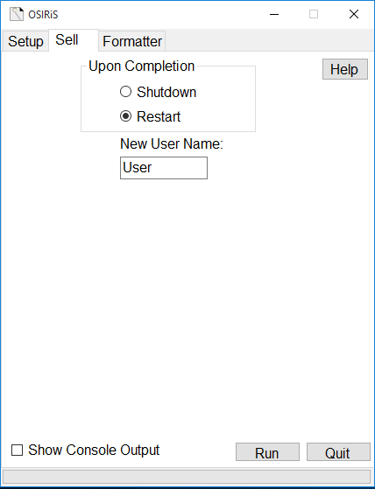These settings can be left to their defaults and no information needs to be changed, however if the customer is in hurry, you can elect to have the machine shutdown when OSIRiS is finished.

You can also set a username for the new account that OSIRiS creates, this can be the customer’s name if they want to personalize the machine, or it could be the name of a person who is receiving the machine as a gift. Either way, this option allows for a bit more freedom than just the standard 'User', it is however, entirely optional.

Once you have decided upon the settings you and the customer would like, decide whether you would like to see console output messages by checking the appropriate box and then press run. If you decide not to see console output then progress will simply be indicated with a scrolling bar.

OSIRiS will either shutdown the machine or reboot it once it has finished, depending upon the choice you made.

A small script will start when the computer next starts into the new   
account. Let this run to completion, either in store or alert the customer to this fact so they can have it run at home.

**What does it do?**

1. Switches 'Windows Update' back on.

2. Deletes the 'Officeworks' and 'Customer' users.

3. Creates a new user based on whatever you chose.

4. Copies over two cleanup scripts to tidy up the OSIRiS left overs on machine reboot.

5. Creates a scheduled task which executes upon reboot and login of the new user account, this task bootstraps the cleanup scripts.

6. Deletes the computer shutdown scheduled task and the Wi-Fi check scheduled task.

7. Deletes the Officeworks power plan and sets the balanced plan as the default one.

8. Disconnects the wireless radio and deletes the directory containing the profile data. It then forces a reset of the radio to make sure it's disconnected.

9. Reboots the machine into the new user account or alternatively shuts down.

# **Format**

This section details the steps required to format an external hard disk drive or USB flash drive.

To begin, insert the USB Flash Drive attached to select technology keys, into the USB port of the machine you are working on.   
Next click on the 'File Explorer' icon either on the task bar as shown here or on the start screen as show here.  
  
If you cannot find the 'File Explorer' icon, please type File Explorer into the search box at the bottom of the screen and Windows/Cortana will search for it for you.

Once at the File Explorer window, double click the USB Flash Drive you inserted earlier.   
Double click the OSIRiS main program icon which should look like this.  


OSIRiS will now start after asking for permission from the user and present 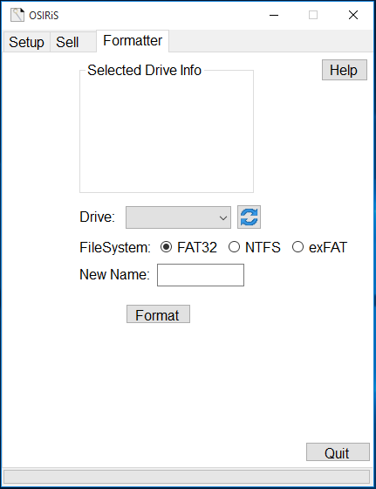its main window. Choose the Formatter tab from the top of the window.

Firstly, choose a drive from the drop down box, taking special care to select the correct drive letter. If the drive is not listed, press the refresh button.



The details of the drive should appear in the top section of OSIRiS labeled 'Selected Drive info'.

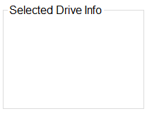  
  
Next choose a file system, the different file systems have different pros and cons, for a breakdown of the different file systems, click here to visit the file system breakdown section.   
Alternatively, hovering over the various file system labels in OSIRiS will yield a brief description of each one.

  
  
Once you have chosen a file system, type a drive name into the 'New Name' box and press format. A blank name is not valid.



# **File System Breakdown**

OSIRiS supports formatting external hard disk drives and USB flash drives

to a variety of different file systems.  
  
What is a file system?

A file system is a method for storing information on a storage medium.  
Every modern storage device has a file system of some description

and these file systems have different advantages and limitations.  
For more information on file systems see [here](http://en.wikipedia.org/wiki/File_system).

File systems supported by OSIRiS

FAT32  
exFAT

NTFS

**FAT32**

**F**ile **A**llocation **T**able 32 bit is an extension of the older FAT16 file system

which in turn is an extension of FAT. It is almost universally compatible with most operating systems and hardware and is usually chosen by manufacturers of devices like flash drives and memory cards for this reason.   
No fancy licensing is required to include FAT32 support or code into an

operating system and so it has a very low barrier for entry.   
  
**Limitations: -** FAT32 comes from a time before very large hard disk drives.  
It has a hard limit of 2TB per volume, you can have more than one 2TB volume on one disk so as to utilize a 4TB disk for example.   
FAT32 also has to load its entire table into RAM when it is mounted, this might not be an issue for modern systems with lots of RAM, but the table can get very large if the drive has lots of files on it.

FAT32 can only handle a single file size of 4GB, this becomes a problem if the drive in question contains, or is going to contain, lots of video files. Video files often top the 4GB file size limit and so if a drive is to be used in this manner try exFAT or NTFS instead. (Or one of the Mac file systems such as HFS+)

**exFAT**

**Ex**tended **F**ile **A**llocation **T**able is a further extension of the FAT file system.  
It requires licensing from Microsoft and so only a handful of operating systems include it from the get go. exFAT support is present in Windows and Mac OS X out of the box and can be added to Linux and other operating systems. This makes exFAT an ideal file system for use on a drive that needs to be used on both a Windows PC and a Mac. (fuse-exfat or exfat-utils are needed on Linux)

**Limitations: -**exFAT technically has a volume size limit of 128PB but 512TB is the recommended maximum which in the modern day is considered infinite size for the average consumer.

exFAT does not have the facility to journal any changes made to the file system and does not support advanced permissions. These limitations make it less than ideal for a disk that is accessed rapidly and regularly, such as an OS boot disk. If power is lost during a read or write, the chances of data corruption are high and with no journal to write back from, data is usually lost.

**NTFS**

**N**ew **T**echnology **F**ile **S**ystem is the default file system for Windows operating system boot disks and large hard drives. (For large flash drives and memory cards, exFAT is the default)  
Supporting journaling, this file system can recover from basic data corruption and power loss during read/writes and advanced permission management is available making NTFS ideal for multi-user systems.

**Limitations: -**NTFS can only be read by Mac OS X but not written to and so makes a poor choice for cross platform compatibility. In addition, very few media players and third party devices support NTFS and so it is best used in a Windows only environment.

Microsoft has not released any specifications on NTFS and so any future support in anything not made by Microsoft is subject to reverse engineering attempts.

**Future Support**

**reFS**

If and when Microsoft finalises the **Re**silient **F**ile **S**ystem a future version of Windows, support will likely be added to OSIRiS. reFS will support incredibly large disks on the Exabyte scale and will be able to recover from data corruption in a manner similar to the already established ZFS and the upcoming BTRFS.

**Licenses**

OSIRiS and its companion scripts are licensed under the GNU GPLv3.

For a copy of the source code, download it from [Github](https://github.com/agent-squirrel/) or email:

[forwarder@gnuplusadam.com](mailto:forwarder@gnuplusadam.com?subject=OSIRiS%20Source%20Request)

OSIRiS uses the 'fat32format' command line program available from <http://www.ridgecrop.demon.co.uk> full source code is also available from the same site and the program is licensed under the GPL.