

OSIRiS **R**ec**o**very **Sy**stem  
Team Member Guide

**Forward**

ROSY is designed to recover a machine/system that has been sent home with a customer in an un-sold state. That is to say, OSIRiS has either failed to run correctly or has not been run at all.   
  
Assuming the customer can access a user account (any account) and can get to the internet, this tool can get them back on track.  
ROSY essentially runs the ‘sell’ portion of OSIRiS on its own.

Despite being directly forked from OSIRiS, ROSY is not a substitute for the OSIRiS sell routine.

ROSY is not recommended to be kept on store USBs or on customer’s computers as it is updated regularly and unlike OSIRiS, has no auto-updater.

**Disclaimer**

You (Team Member) MUST read this disclaimer to the customer before starting.

Explain that you will be directing them to download a file from the internet to run, this file is perfectly safe and contains no malicious code, however it does require special permissions to do its job.

The software (ROSY) is for use in scenarios where OSIRiS has failed to be used correctly and/or at all. This software will return the machine to a clean state without performing a full factory reset which ordinarily would take hours.   
  
The software is unable to differentiate between files created by the customer or files that where created when the machine was on display at Officeworks. As such you are required to backup any important data you may have written to the machines hard disk drive before running this software. Any and all data left on any of the machine’s user accounts will be deleted in favour of the new account created.

If you do not have a current backup, please create one now.

Officeworks takes no responsibility for loss of data past this point.

**Step by Step**

1. Instruct the customer to navigate to C:\profiles\ on their new machine and double click ROSY.exe. If for some reason ROSY.exe is missing, or if the machine was set up pre-2016, then

instruct the customer to visit the following URL either by manually reading it out, or by E-Mailing the link to them.  
<https://gnuplusadam.com/OSIRiS/ROSY/ROSY.exe>  
(The customer’s browser may ask if they want to keep the file or may flag it as malicious, in this case select ‘keep’ or ‘allow’.)

1. Once downloaded, ask the customer to start ROSY.exe from whatever folder the downloaded it to.
2. The customer will be presented with a UAC (User Account Control) dialog box. If the customer is logged in as our limited ‘Customer’ account, then they will be prompted for the admin password. (Usually happy456) If they are somehow logged in as an admin, simply instruct them to press ‘Yes’.
3. ROSY will now start and present its main window, which looks like this:

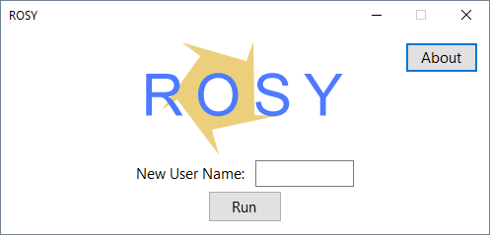

1. Instruct the customer to input a username of their choice. (A blank name will be rejected)
2. When the customer has a current back up of their data and is confident that they can proceed. Tell them to press ‘Run’.
3. ROSY will present a list of tasks it will perform and a final warning as follows:  
   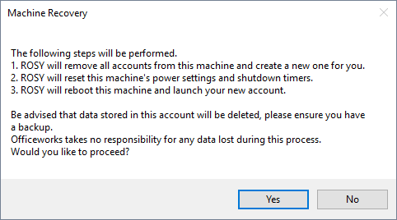
4. Again check the customer is comfortable and instruct them to proceed by pressing ‘Yes’.
5. ROSY will now perform the list of tasks required to get the machine back under the customer’s control with a window like this:  
   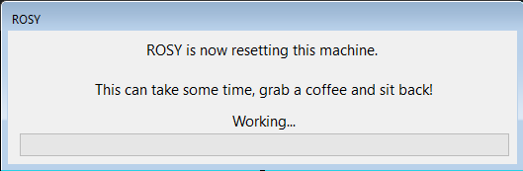
6. This can take some time so if the customer is happy at this point you may disengage from them. Alert them to the fact that a completion message will appear once this process has completed and upon pressing ‘OK’, ROSY will reboot the machine automatically.
7. When the new account is started the usual ‘Cleaning Officeworks Left-Over Data’ window will appear, just as if the machine had been sold using OSIRiS.

**FAQ**

Q: The customer complains that ‘SmartScreen’ captures the application when attempting to run it.

A: When the customer attempts to run ROSY, ‘Smart Screen Filter’ appears as follows; 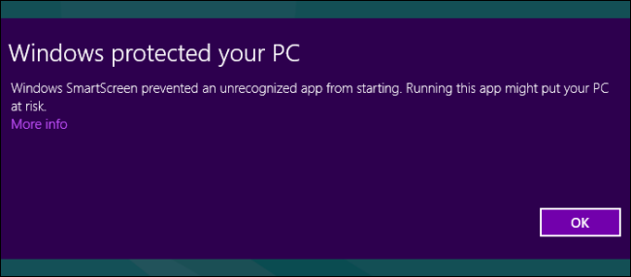

Instruct the customer to click the ‘More Info’ link and then click ‘Run Anyway’.

Q: The customer is concerned about data they have written to the hard disk of the machine.

A: Instruct the customer to backup any and all data they wish to keep and then proceed. If the data content is particularly large, get the customers contact details and call them back in a few hours once they have completed the backup procedure.

**Licenses**

OSIRiS/ROSY and their companion scripts are licensed under the GNU GPLv3.

For a copy of the source code, download it from [Github](https://github.com/agent-squirrel/) or email:

[forwarder@gnuplusadam.com](mailto:forwarder@gnuplusadam.com?subject=OSIRiS%20Source%20Request)



