CCNP ENCOR: Configure and Verify
an IEEE 802.1Q Trunk
SW1 · SW2 · PC1 · PC2 | Cisco Modeling Labs
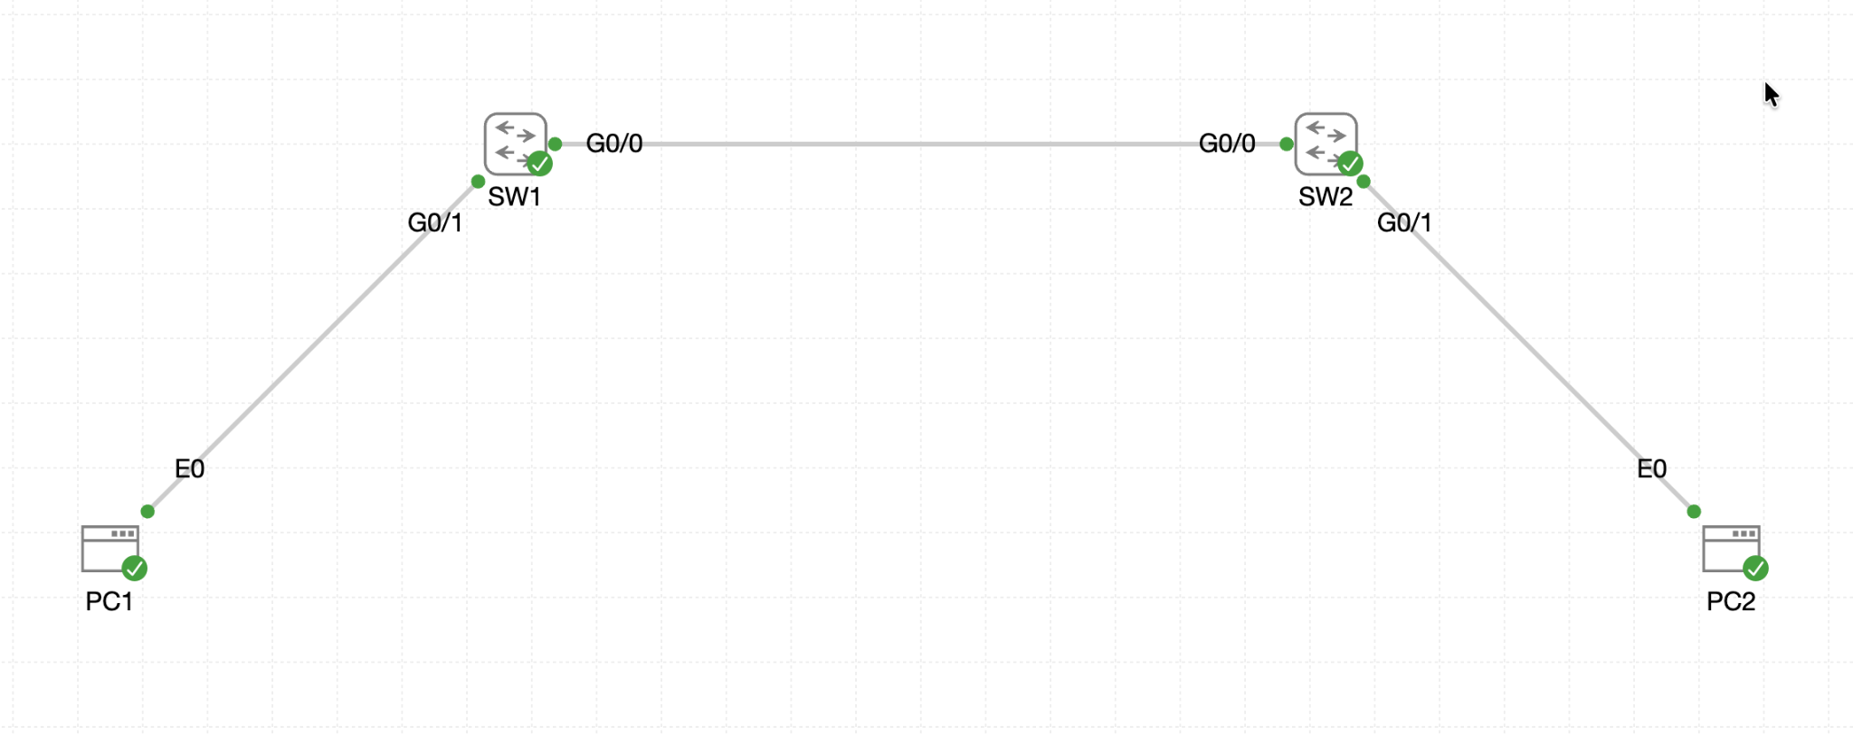
Figure 1. Lab topology: PC1—SW1—802.1Q trunk—SW2—PC2
Objective: Configure Gi0/0 on SW1 and SW2 as a static 802.1Q trunk, use VLAN 99 as the native VLAN, allow only VLANs 10, 20, and 99, and verify host and management connectivity.

1. ENCOR Alignment and Learning Outcomes
This lab targets ENCOR Infrastructure, Layer 2 troubleshooting of static and dynamic 802.1Q trunking. The learner will:
- Explain how an 802.1Q trunk carries multiple VLANs across one physical link.
- Configure a static trunk and disable DTP negotiation.
- Configure and validate the native VLAN and allowed VLAN list.
- Correlate trunk state, VLAN activity, spanning-tree forwarding, MAC learning, and end-to-end reachability.
- Diagnose common failures such as access-mode links, native VLAN mismatches, and missing allowed VLANs.

2. Topology and Addressing
Node | Interface | Role / VLAN | Address
PC1 | eth0 | VLAN 10 host | 10.10.10.11/24
SW1 | Gi0/1 | Access VLAN 10 | Layer 2
SW1 | Gi0/0 | 802.1Q trunk | VLANs 10,20,99
SW1 | Vlan99 | Management SVI | 10.99.99.11/24
SW2 | Gi0/0 | 802.1Q trunk | VLANs 10,20,99
SW2 | Gi0/1 | Access VLAN 10 | Layer 2
SW2 | Vlan99 | Management SVI | 10.99.99.12/24
PC2 | eth0 | VLAN 10 host | 10.10.10.12/24

3. Key 802.1Q Concepts
- A trunk is a point-to-point Layer 2 link that carries traffic for multiple VLANs.
- 802.1Q inserts a 4-byte tag into tagged Ethernet frames so the receiving switch can identify the VLAN.
- Native VLAN traffic is sent untagged by default. The native VLAN must match on both ends.
- The allowed VLAN list controls which VLANs may cross the trunk. A VLAN must also exist and be active locally to appear in the active list.
- A static trunk uses switchport mode trunk. switchport nonegotiate disables DTP frame transmission on the interface.

4. Base Configuration Validation
The supplied CML lab already creates VLANs 10, 20, and 99; assigns PC-facing Gi0/1 as access VLAN 10; configures management SVIs; and assigns IP addresses to PC1 and PC2. Before configuring the trunk, validate the base state on both switches:
show vlan brief
show ip interface brief
show interfaces gigabitEthernet 0/1 switchport
show running-config interface gigabitEthernet 0/0
Expected base state: Gi0/1 is a static access port in VLAN 10, VLANs 10/20/99 exist, and Gi0/0 has no trunk configuration.

5. Configure the 802.1Q Trunk

SW1
enable
configure terminal
interface gigabitEthernet 0/0
description 802.1Q TRUNK TO SW2 Gi0/0
switchport mode trunk
switchport trunk native vlan 99
switchport trunk allowed vlan 10,20,99
switchport nonegotiate
no shutdown
end
write memory

SW2
enable
configure terminal
interface gigabitEthernet 0/0
description 802.1Q TRUNK TO SW1 Gi0/0
switchport mode trunk
switchport trunk native vlan 99
switchport trunk allowed vlan 10,20,99
switchport nonegotiate
no shutdown
end
write memory
Platform note: IOSvL2 uses 802.1Q for the trunk and does not require switchport trunk encapsulation dot1q. On older platforms that support both ISL and 802.1Q, the encapsulation command may be required before switchport mode trunk.

6. Verify the Trunk

6.1 Trunk summary
show interfaces trunk
Confirm all of the following for Gi0/0:
- Mode is on.
- Encapsulation is 802.1Q.
- Status is trunking.
- Native VLAN is 99.
- Allowed VLANs are exactly 10,20,99.
- VLANs 10,20,99 are allowed and active.
- VLANs 10,20,99 are in the spanning-tree forwarding state and not pruned.

6.2 Interface operational detail
show interfaces gigabitEthernet 0/0 switchport
show running-config interface gigabitEthernet 0/0
Confirm Administrative Mode and Operational Mode are trunk, trunk encapsulation is dot1q, the native VLAN is 99, and negotiation is off.

6.3 VLAN and STP state
show vlan brief
show spanning-tree vlan 10,20,99
show spanning-tree interface gigabitEthernet 0/0 detail
Gi0/0 normally does not appear as an access member in show vlan brief. Use show interfaces trunk to validate trunk VLAN membership. Confirm Gi0/0 is forwarding for the required VLANs.

6.4 MAC learning
show mac address-table dynamic vlan 10
show mac address-table interface gigabitEthernet 0/0
After PC1 and PC2 exchange traffic, each switch should learn the remote PC MAC address through Gi0/0 and the local PC MAC address through Gi0/1.

7. End-to-End Tests

PC1 to PC2
ping -c 4 10.10.10.12

PC2 to PC1
ping -c 4 10.10.10.11

SW1 management SVI to SW2 management SVI
ping 10.99.99.12 source vlan 99

SW2 management SVI to SW1 management SVI
ping 10.99.99.11 source vlan 99
Successful VLAN 10 host tests demonstrate tagged VLAN 10 forwarding across the trunk. Successful VLAN 99 SVI tests demonstrate native VLAN connectivity between the switches.

8. ENCOR-Level Troubleshooting Workflow
Symptom | Likely cause | Verification / correction
Gi0/0 not listed as trunking | One or both ports not in trunk mode | show interfaces trunk; configure switchport mode trunk on both ends
PC1 cannot reach PC2 | VLAN 10 missing, blocked, or host/access-port issue | Check VLAN 10 existence, Gi0/1 access assignment, trunk allowed list, STP state, and host IPs
Vlan99 SVI ping fails | Native VLAN mismatch or VLAN 99 unavailable | Compare both trunks; verify native VLAN 99 and VLAN 99 active
Only some VLANs cross | Allowed VLAN lists differ | show interfaces trunk; set 10,20,99 identically on both ends
Native VLAN mismatch warning | Different native VLAN on each end | Set switchport trunk native vlan 99 on both ends
MAC missing on trunk | No traffic, VLAN not forwarding, or wrong VLAN | Generate ping, inspect STP, allowed list, and MAC table
SVI line protocol down | No active forwarding port for that VLAN | Verify VLAN exists and at least one associated access/trunk port is up and forwarding

9. Fault-Injection Practice
Apply one fault at a time, predict the impact, verify the failure, and restore the correct configuration.
- On SW2, remove VLAN 10 from the allowed list. Verify PC1-to-PC2 failure while checking show interfaces trunk.
- On SW2, change the native VLAN to 20. Observe mismatch indicators and test the VLAN 99 SVI path.
- On SW1, change Gi0/0 to access mode. Verify the trunk disappears and then restore static trunking.
- On SW1, remove VLAN 20 from the VLAN database while leaving VLAN 20 allowed. Compare the allowed list with the allowed-and-active list.
- Restore the validated configuration after each exercise.
interface gigabitEthernet 0/0
switchport mode trunk
switchport trunk native vlan 99
switchport trunk allowed vlan 10,20,99
switchport nonegotiate

10. Completion Criteria
- Gi0/0 is operationally trunking on SW1 and SW2.
- 802.1Q encapsulation is in use.
- Native VLAN 99 matches on both ends.
- Only VLANs 10, 20, and 99 are allowed.
- Required VLANs are active and forwarding across the trunk.
- PC1 and PC2 can ping each other in VLAN 10.
- SW1 and SW2 can ping each other through the VLAN 99 management SVIs.
- MAC address learning occurs on the expected access and trunk interfaces.
- The running configuration is saved.

11. Command Quick Reference
show interfaces trunk
show interfaces gigabitEthernet 0/0 switchport
show running-config interface gigabitEthernet 0/0
show vlan brief
show spanning-tree vlan 10,20,99
show mac address-table dynamic
show ip interface brief
ping 10.99.99.12 source vlan 99

References
Cisco: Configure 802.1Q Trunking Between Catalyst Switches
Cisco: VLAN Configuration Guide, Configuring VLAN Trunks
Lab source: CCNP_ENCOR_-_802.1Q_Trunk_Practice.yaml

