CCNP ENCOR: Configure and Verify
Single-Area OSPFv2
R1 · R2 · R3 | Area 0 · Full Route Exchange
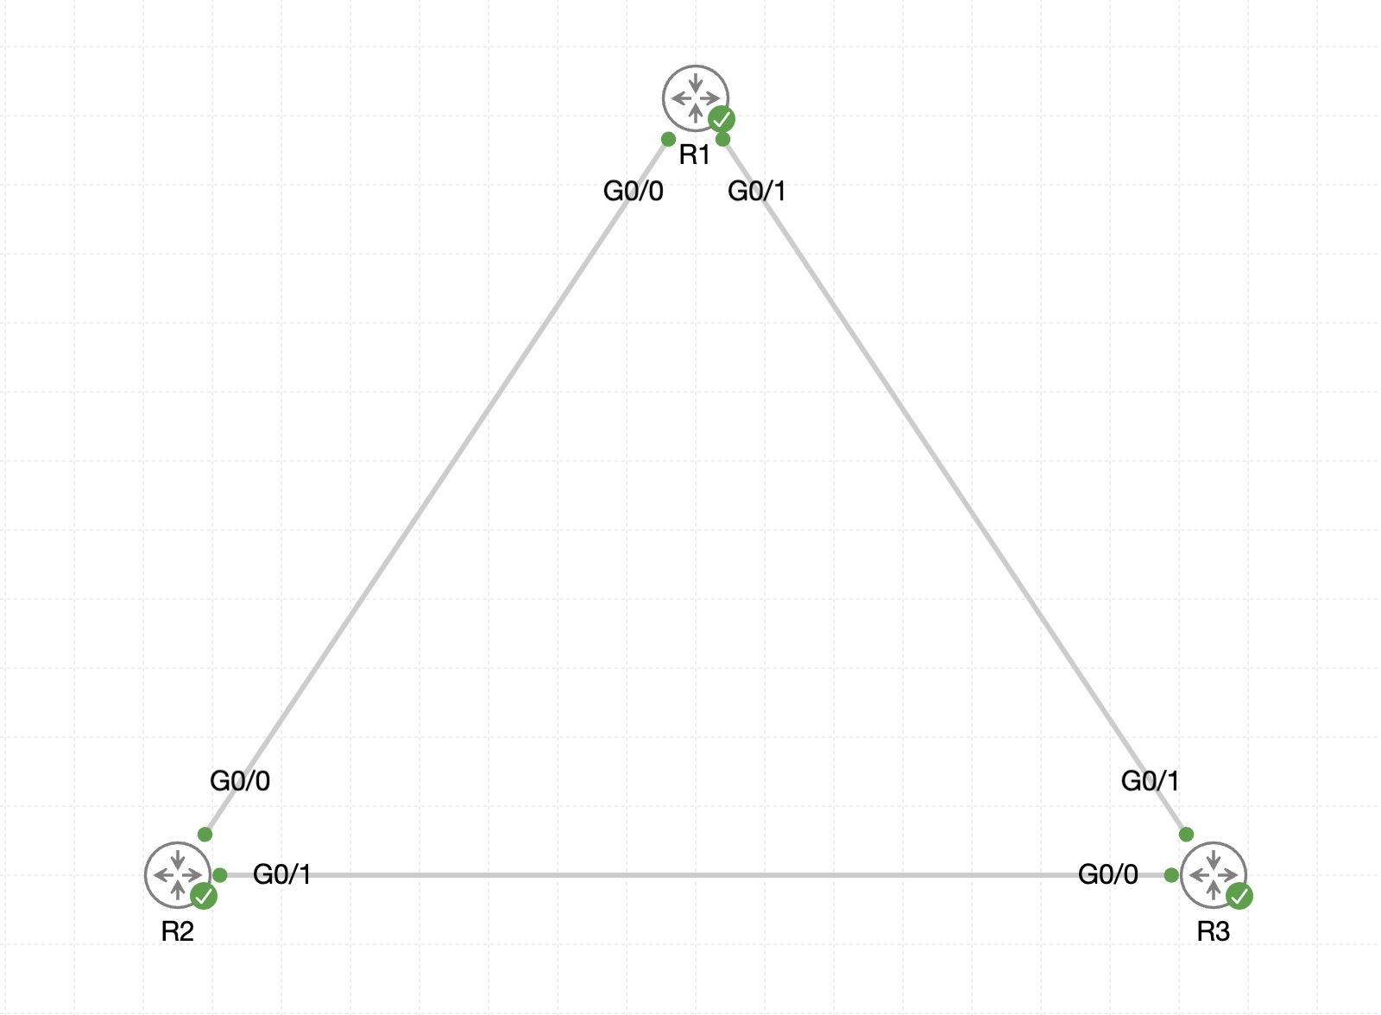
Figure 1. Three-router full-mesh OSPFv2 topology
Objective: Configure OSPFv2 process 10 on R1, R2, and R3; place all interfaces in area 0; advertise loopbacks without unnecessary Hellos; and verify complete route exchange.

1. ENCOR Alignment and Outcomes
This lab supports ENCOR Infrastructure objective 3.2.b for configuring and verifying OSPFv2 environments, including neighbor adjacency, broadcast behavior, and passive interfaces.
- Validate Layer 3 reachability before enabling a routing protocol.
- Configure explicit router IDs and single-area OSPFv2.
- Explain neighbor discovery, adjacency, LSDB synchronization, SPF calculation, and route installation.
- Verify neighbors, interfaces, protocols, LSDB content, and learned routes.
- Troubleshoot OSPF parameter mismatches and observe reconvergence.

2. Addressing
Router | Interface | Address | Neighbor / Purpose
R1 | Loopback0 | 1.1.1.1/32 | Router ID and test network
R1 | Gi0/0 | 10.12.0.1/30 | R2 Gi0/0
R1 | Gi0/1 | 10.13.0.1/30 | R3 Gi0/1
R2 | Loopback0 | 2.2.2.2/32 | Router ID and test network
R2 | Gi0/0 | 10.12.0.2/30 | R1 Gi0/0
R2 | Gi0/1 | 10.23.0.1/30 | R3 Gi0/0
R3 | Loopback0 | 3.3.3.3/32 | Router ID and test network
R3 | Gi0/0 | 10.23.0.2/30 | R2 Gi0/1
R3 | Gi0/1 | 10.13.0.2/30 | R1 Gi0/1

3. Core Concepts
- OSPFv2 is a link-state routing protocol for IPv4. OSPF routers use Hello packets to discover compatible neighbors.
- Adjacent routers synchronize link-state databases by exchanging LSAs. Each router runs the SPF algorithm and installs best paths in the routing table.
- The router ID uniquely identifies an OSPF router. This lab explicitly assigns each Loopback0 address as the router ID.
- All links use area 0. The OSPF process ID is locally significant, although process 10 is used consistently in this lab.
- Loopback0 is advertised but configured passive, preventing OSPF Hello packets on an interface that has no OSPF neighbor.

4. Pre-OSPF Connectivity

R1
ping 10.12.0.2
ping 10.13.0.2

R2
ping 10.12.0.1
ping 10.23.0.2

R3
ping 10.23.0.1
ping 10.13.0.1
Resolve interface, addressing, or CML-link failures before configuring OSPF.

5. Configure OSPFv2
The configuration uses precise network statements. Loopback0 is passive but remains advertised.

R1
enable
configure terminal
router ospf 10
router-id 1.1.1.1
passive-interface loopback0
network 1.1.1.1 0.0.0.0 area 0
network 10.12.0.0 0.0.0.3 area 0
network 10.13.0.0 0.0.0.3 area 0
end
copy running-config startup-config

R2
enable
configure terminal
router ospf 10
router-id 2.2.2.2
passive-interface loopback0
network 2.2.2.2 0.0.0.0 area 0
network 10.12.0.0 0.0.0.3 area 0
network 10.23.0.0 0.0.0.3 area 0
end
copy running-config startup-config

R3
enable
configure terminal
router ospf 10
router-id 3.3.3.3
passive-interface loopback0
network 3.3.3.3 0.0.0.0 area 0
network 10.13.0.0 0.0.0.3 area 0
network 10.23.0.0 0.0.0.3 area 0
end
copy running-config startup-config

6. Verify Adjacencies and Interfaces
show ip ospf neighbor
show ip ospf interface brief
show ip ospf interface gigabitEthernet 0/0
show ip ospf interface gigabitEthernet 0/1
- Each router should have two neighbors in FULL state.
- All OSPF-enabled interfaces should be in area 0.
- Loopback0 should appear as passive in protocol output and should not form a neighbor.
- Ethernet links use the broadcast network type by default, so DR and BDR roles are visible per segment.

7. Verify OSPF Process and LSDB
show ip ospf
show ip protocols
show ip ospf database router
- Confirm process 10 and the intended router ID.
- Confirm the routing protocol advertises the three local networks and Loopback0 is passive.
- Confirm router LSAs for router IDs 1.1.1.1, 2.2.2.2, and 3.3.3.3 are present in area 0.

8. Verify Full Route Exchange
show ip route ospf
show ip route 1.1.1.1
show ip route 2.2.2.2
show ip route 3.3.3.3
Each router should learn both remote loopback /32 routes and the transit /30 network that is not directly connected. Connected networks remain marked C or L, not O.
Router | Remote loopbacks expected | Remote transit network expected
R1 | 2.2.2.2/32, 3.3.3.3/32 | 10.23.0.0/30
R2 | 1.1.1.1/32, 3.3.3.3/32 | 10.13.0.0/30
R3 | 1.1.1.1/32, 2.2.2.2/32 | 10.12.0.0/30

9. End-to-End Loopback Tests

R1
ping 2.2.2.2 source loopback0
ping 3.3.3.3 source loopback0

R2
ping 1.1.1.1 source loopback0
ping 3.3.3.3 source loopback0

R3
ping 1.1.1.1 source loopback0
ping 2.2.2.2 source loopback0
Source-specific pings verify both the forward path and a learned return route to the originating loopback.

10. ENCOR Troubleshooting Workflow
Symptom | Likely cause | Verification / correction
No neighbor discovered | Layer 3 failure or OSPF absent on link | Ping directly connected peer; check interfaces and network statements
Neighbor stuck INIT | One-way Hello communication | Check link, ACLs, multicast handling, and reciprocal OSPF enablement
Neighbor stuck EXSTART/EXCHANGE | MTU mismatch or database-exchange issue | Compare interface MTU and inspect OSPF interface detail
Neighbor never reaches FULL | Area, timer, authentication, network type, or subnet mismatch | Compare show ip ospf interface output on both ends
Neighbor FULL but route missing | Prefix not advertised, passive misunderstood, or more-specific route issue | Check show ip protocols, LSDB, route table, and network statement
Wrong router ID | Existing process selected another ID before explicit configuration | Configure router-id and reset the OSPF process during a controlled lab window
Loopback ping fails | Remote loopback or return path absent | Check remote /32 route and source-specific return route

11. Optional ENCOR Challenges
- Compare DR and BDR roles on all three Ethernet segments using show ip ospf neighbor and interface output.
- Shut one transit interface, observe adjacency loss and route reconvergence, then restore it.
- Change an interface OSPF cost, predict the preferred path to a remote loopback, and verify the routing table and CEF path.
- Configure ip ospf network point-to-point on both ends of one Ethernet link, then compare neighbor output and LSDB behavior.
- Use passive-interface default with no passive-interface on transit links as an alternative hardening pattern.
interface gigabitEthernet 0/0
ip ospf cost 50
!
router ospf 10
passive-interface default
no passive-interface gigabitEthernet 0/0
no passive-interface gigabitEthernet 0/1

12. Success Criteria
- R1, R2, and R3 each have two OSPF neighbors in FULL state.
- All OSPF interfaces are in area 0.
- Router IDs are 1.1.1.1, 2.2.2.2, and 3.3.3.3.
- Each router learns both remote loopbacks and the non-directly-connected transit network as OSPF routes.
- Loopback0 is advertised while passive.
- All source-specific loopback pings succeed.
- The final configuration is saved on all routers.

13. Command Quick Reference
show ip ospf neighbor
show ip ospf interface brief
show ip ospf interface
show ip protocols
show ip route ospf
show ip ospf database router
show ip cef <prefix>
ping <remote-loopback> source loopback0
clear ip ospf process

References
Cisco: Configuring OSPFv2
Cisco: Enabling OSPFv2 on an Interface Basis
Lab source: CCNP_ENCOR_-_Single-Area_OSPFv2_Practice.yaml

