CCNP ENCOR: Secure Remote
Router Management with SSH
R1 · PC1 | Local Users · SSHv2 · VTY Authentication
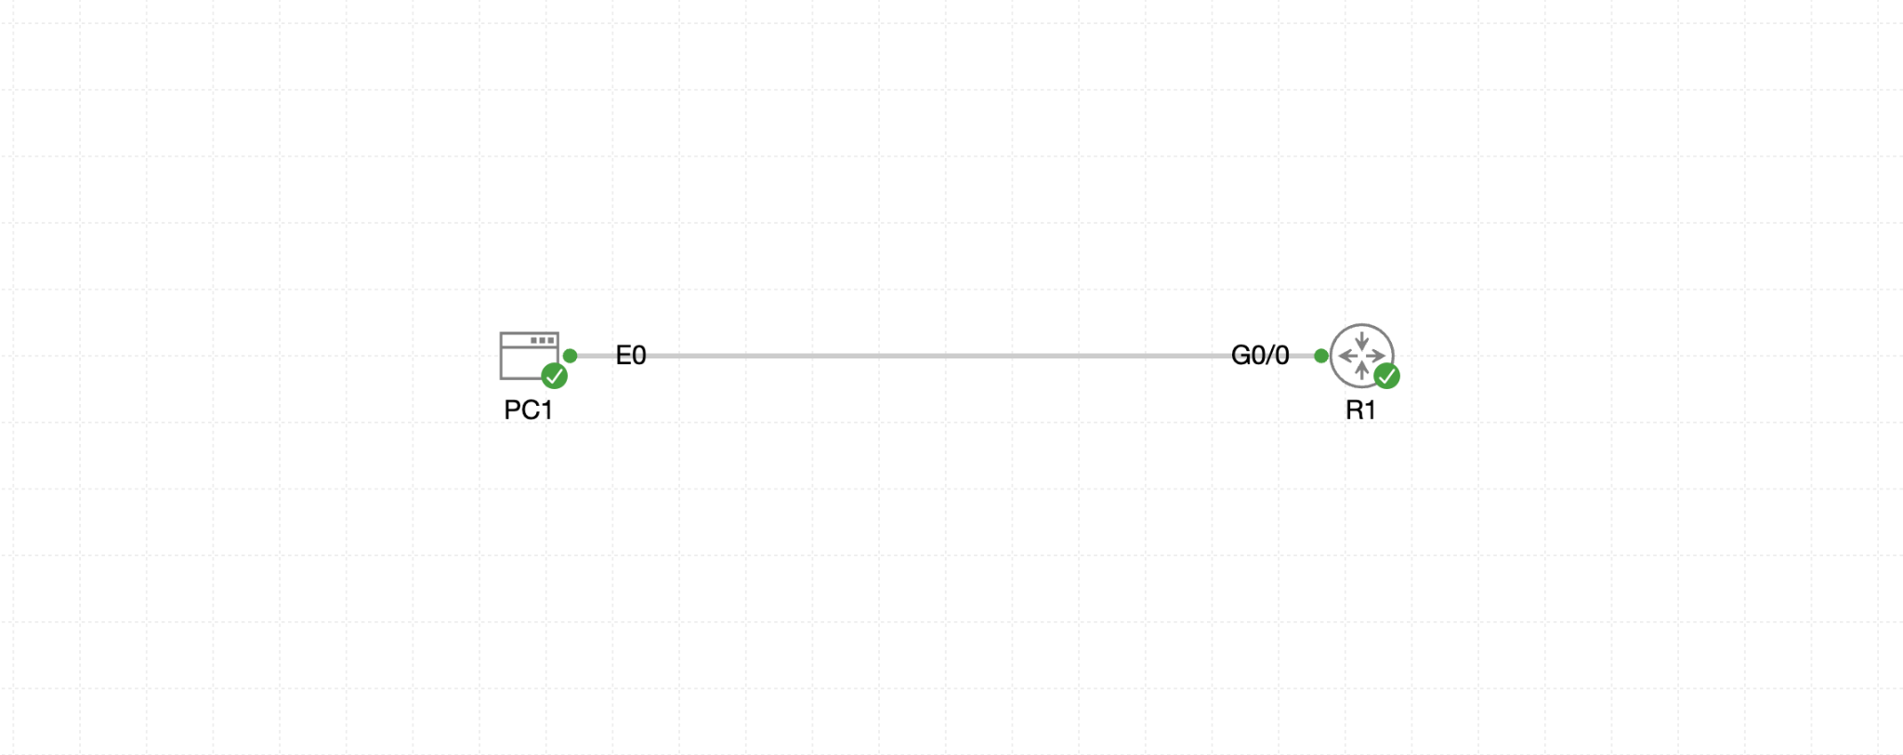
Figure 1. Cisco CML topology: PC1 eth0 directly connected to R1 Gi0/0
Objective: Configure R1 for secure remote administration using a local privilege-15 user, RSA keys, SSH version 2, and VTY lines that accept SSH only.

1. ENCOR Alignment and Learning Outcomes
This lab supports the ENCOR Security objective for configuring and verifying device access control, including lines and local user authentication. The learner will:
- Explain the role of hostname, domain name, RSA keys, SSH version, local users, and VTY lines.
- Configure an encrypted SSH management plane and disable Telnet access.
- Authenticate remote users against the local user database.
- Validate SSH server status, RSA key strength, active sessions, and VTY behavior.
- Troubleshoot reachability, key-generation, authentication, and client compatibility failures.

2. Topology and Addressing
Node | Interface | Address | Role
R1 | GigabitEthernet0/0 | 192.168.10.1/24 | SSH server / managed router
PC1 | eth0 | 192.168.10.10/24 | SSH client
PC1 | Default gateway | 192.168.10.1 | Gateway supplied by lab config
The supplied lab intentionally leaves SSH, local users, RSA keys, and VTY authentication unconfigured. Console access remains available for recovery.

3. Security Concepts
- SSH provides encrypted remote CLI access. Telnet is not permitted in this lab.
- The router hostname and domain name are used when creating the RSA identity key pair.
- The username secret command stores a local credential and assigns the requested privilege level.
- login local instructs VTY lines to authenticate against the local username database.
- transport input ssh limits inbound VTY transport to SSH.
- exec-timeout 5 0 disconnects an idle VTY session after five minutes.

4. Validate Base Connectivity

On R1
show ip interface brief
show running-config interface gigabitEthernet 0/0
show running-config section line vty
show ip ssh

On PC1
ip -br address
ip route
ping -c 4 192.168.10.1
Do not begin SSH troubleshooting until PC1 can reach 192.168.10.1 with ICMP.

5. Configure Secure SSH Management
Apply the following configuration from the R1 console. The credential is defined by the supplied practice lab and is intended only for the isolated CML exercise.
enable
configure terminal
hostname R1
ip domain-name ccnplab.local
username netadmin privilege 15 secret CcnpLab2026!
ip ssh version 2
crypto key generate rsa general-keys modulus 2048
line vty 0 4
login local
transport input ssh
exec-timeout 5 0
end
copy running-config startup-config
If IOS does not accept the one-line RSA modulus syntax, enter crypto key generate rsa and specify 2048 when prompted. If existing RSA keys use the wrong hostname, domain, or modulus, remove and regenerate them only while console access is available.

6. Verify the Router Configuration

6.1 SSH server status
show ip ssh
Verify SSH version 2 is enabled and record the displayed authentication timeout and retry values.

6.2 RSA key pair
show crypto key mypubkey rsa
Verify an RSA general-purpose key exists and the modulus is at least 2048 bits.

6.3 Local user and SSH settings
show running-config | include ^hostname|^ip domain-name|^username|^ip ssh
show running-config | section line vty
Verify netadmin uses privilege 15 and a secret, VTY lines 0 through 4 use login local, inbound transport is SSH only, and the EXEC timeout is five minutes.

6.4 Saved configuration
show startup-config | include ^hostname|^ip domain-name|^username|^ip ssh
show startup-config | section line vty

7. Test Remote Access from PC1

7.1 SSH login
ssh netadmin@192.168.10.1
Enter the configured local secret when prompted. A privilege-15 user should arrive at the privileged EXEC prompt.
show privilege
show users

7.2 Older IOS host-key compatibility
If the lab client rejects the IOS host-key algorithm, use the compatibility option provided in the supplied lab notes:
ssh -o HostKeyAlgorithms=+ssh-rsa netadmin@192.168.10.1

7.3 Confirm Telnet is rejected
nc -vz 192.168.10.1 23
The TCP connection to port 23 should fail after the VTY lines are restricted to SSH.

7.4 Observe an active SSH session
Keep the PC1 SSH session open and use the R1 console to run:
show ssh
show users

8. ENCOR-Level Troubleshooting Workflow
Symptom | Likely cause | Verification / correction
PC1 cannot ping R1 | Interface, address, or link problem | Check show ip interface brief, PC1 address/route, and CML link state
RSA generation fails | Hostname or domain name missing; unsupported crypto image | Verify hostname, ip domain-name, and IOS crypto support
SSH reports disabled | No RSA keys or SSH configuration incomplete | Check show ip ssh and show crypto key mypubkey rsa
Username rejected | Local user missing or VTY not using local login | Check username and login local under line vty 0 4
Telnet still connects | VTY transport permits telnet or all transports | Set transport input ssh and recheck each applicable VTY range
SSH client rejects host key | Client algorithm policy and older IOS key algorithm differ | Use the supplied HostKeyAlgorithms compatibility option for this lab
Session drops after inactivity | VTY idle timer expired | Expected after five minutes; verify exec-timeout 5 0
Login succeeds but prompt is > | User privilege lower than 15 | Verify username netadmin privilege 15 secret ...

9. Optional Hardening Exercise
Apply only after the required lab works and console access is available.
configure terminal
login block-for 120 attempts 3 within 60
login delay 2
banner login ^CAuthorized access only. Activity may be monitored.^C
end
copy running-config startup-config
The login block feature can impose a quiet period after repeated failed remote login attempts. Test carefully to avoid locking out the management client.

10. Fault-Injection Practice
- Remove ip domain-name and attempt RSA key generation. Identify the prerequisite failure, then restore ccnplab.local.
- Change transport input ssh to transport input telnet and test the security impact. Restore SSH-only transport.
- Remove login local from VTY 0 through 4 and test authentication. Restore local database authentication.
- Change the local user privilege to 1, reconnect, and compare show privilege. Restore privilege 15.
- Set exec-timeout 0 30 for a short test, observe the idle disconnect, and restore 5 0.
- Restore and save the validated configuration after every fault.

11. Success Criteria
- PC1 can ping R1 at 192.168.10.1.
- SSH version 2 is enabled.
- An RSA key of at least 2048 bits exists.
- netadmin authenticates from PC1 using the local user database.
- The login receives privilege level 15.
- VTY lines 0 through 4 permit SSH and reject Telnet.
- The VTY idle timeout is five minutes.
- An active SSH session appears in show ssh and show users.
- The final running configuration is saved to startup configuration.

12. Command Quick Reference
show ip interface brief
show ip ssh
show ssh
show users
show crypto key mypubkey rsa
show running-config | include ^hostname|^ip domain-name|^username|^ip ssh
show running-config | section line vty
ssh netadmin@192.168.10.1
nc -vz 192.168.10.1 23
copy running-config startup-config

References
Cisco: Configure SSH on Routers
Cisco: Secure Shell Version 2 Support
Cisco: IOS Login Enhancements - Login Block
Lab source: CCNP_ENCOR_-_Secure_SSH_Management_Practice.yaml

