1.Log-in

User logs into the Payroll System.

1.1 Employee

①Input:

Email:wangjj@qq.com

Password:123456

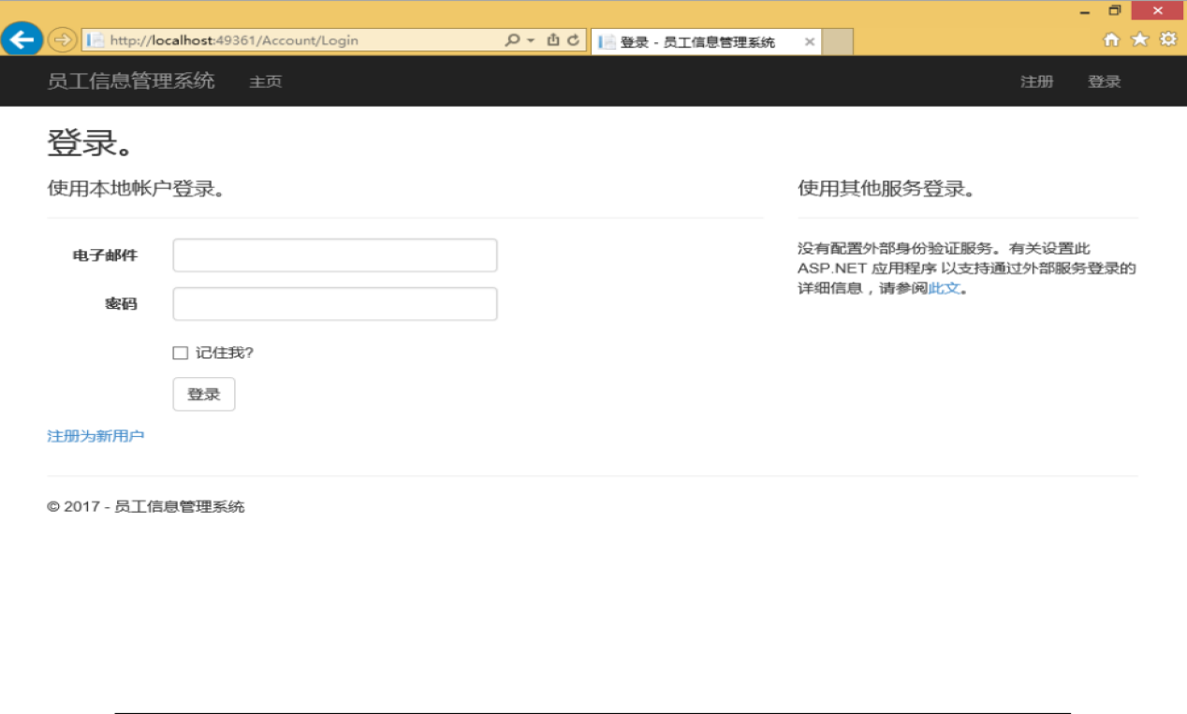

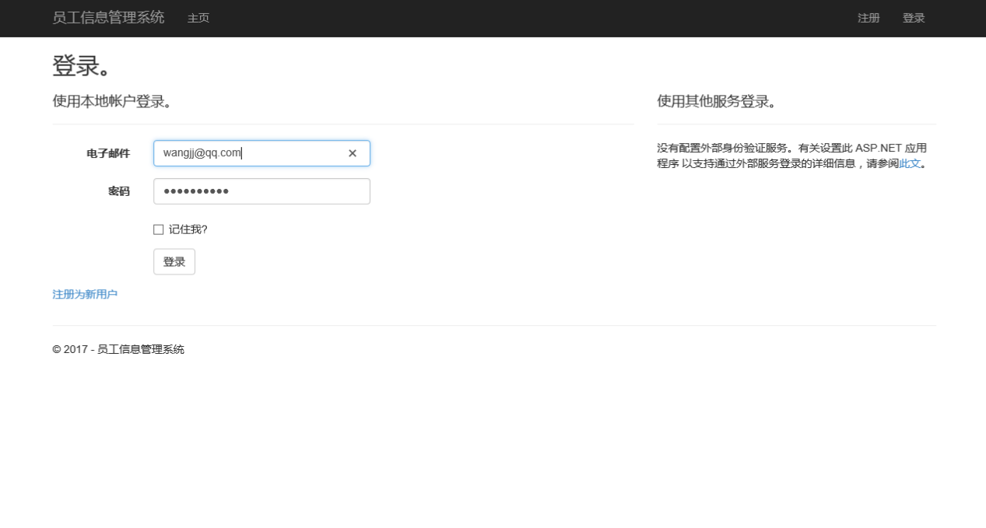

Output:

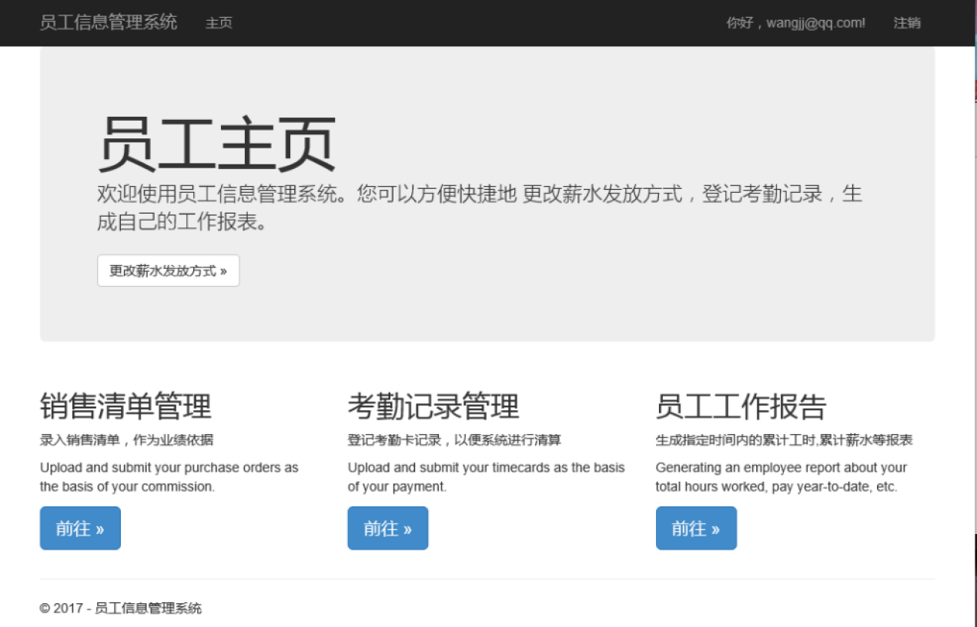

Verification point：database

Expected results：entry Payroll System

Actual results: Succeed

Bug:none

Bug location and overview:none

②Input:

Name：Zhangshan

Password: qwerty

Output:

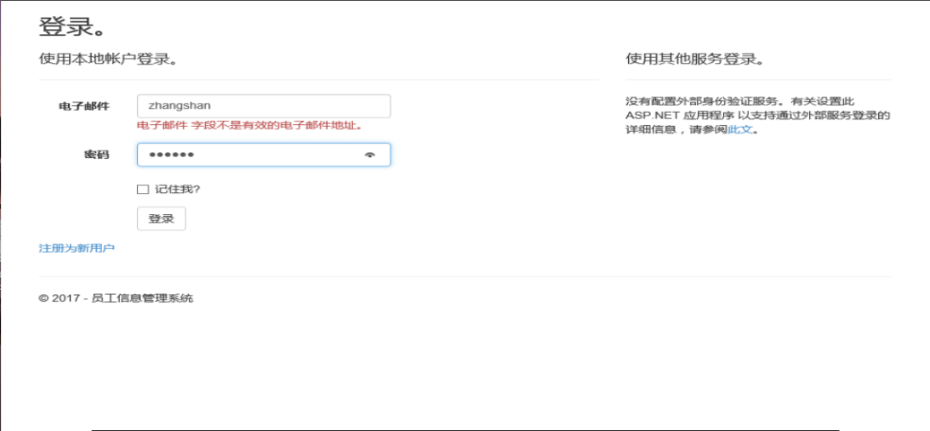

Verification point：database

Expected results：Invalid Name/Password

Actual results: Fail

Bug:none

Bug location and overview:none

1.2 System Administrator

①Input:

Name:Admin@admin.com

Password:123456

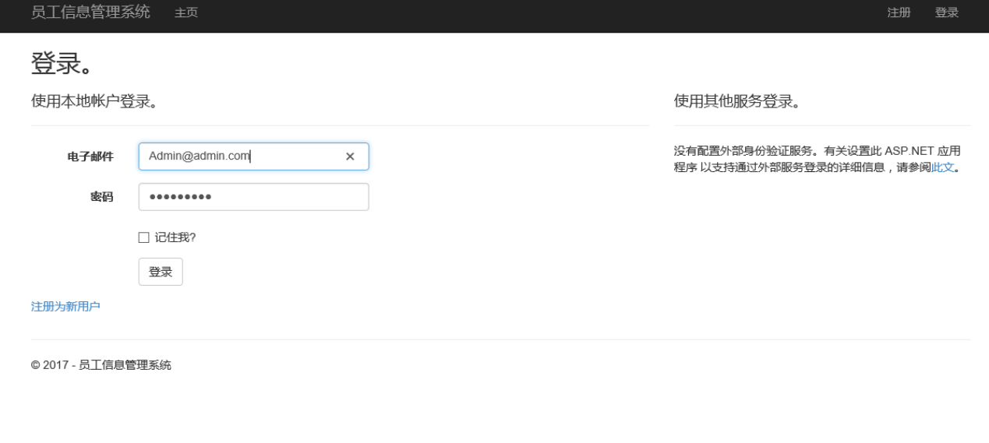

Output:

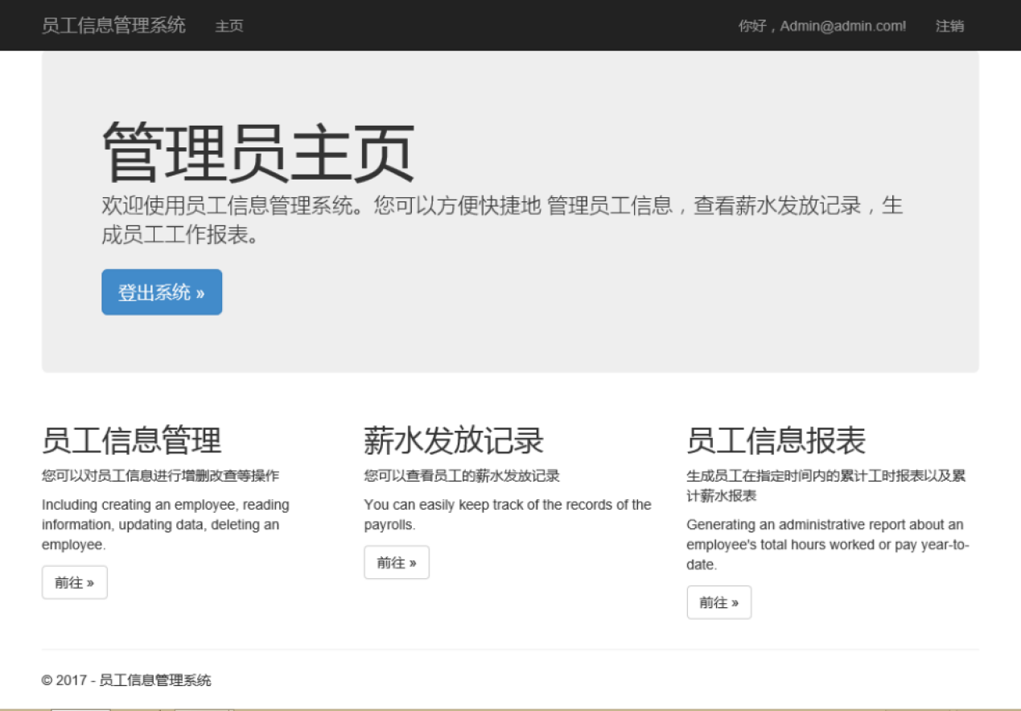

Verification point：database

Expected results：entry Payroll System

Actual results: Succeed

Bug:none

Bug location and overview:none

②Input:

Name：Linzheyu@qq.com

Password: qwerty

Output:

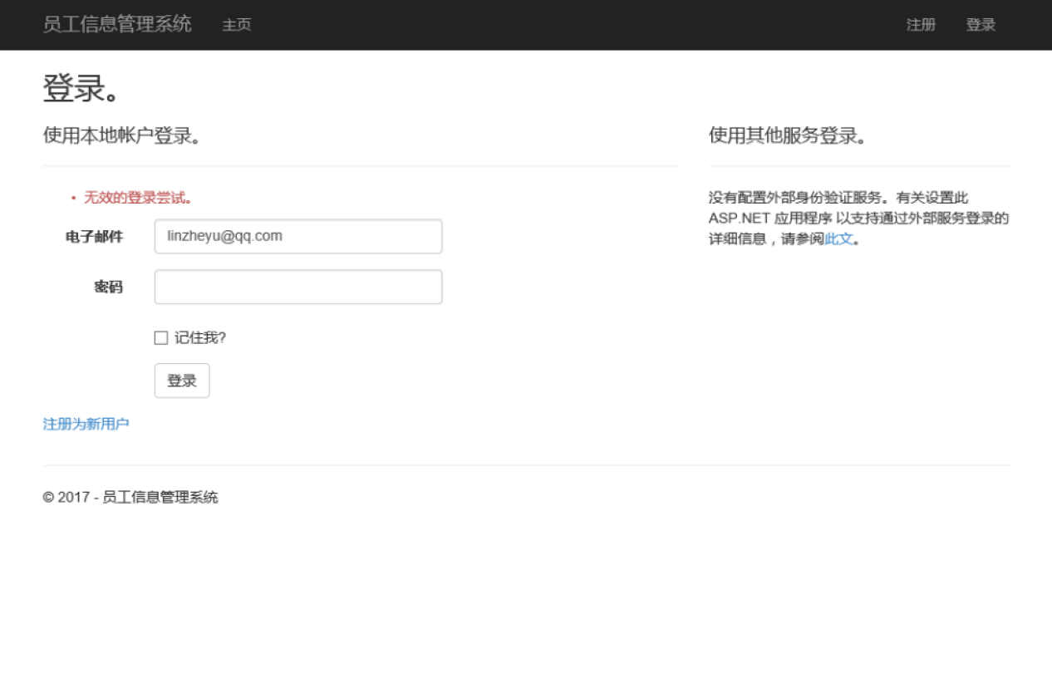

Verification point：database

Expected results：Invalid Name/Password

Actual results: Fail

Bug:none

Bug location and overview:none

1. Maintain Employee Information

2.1 Add

Input:

Email:123456@163.com

Name:wangsf

Position:Hour

MailAddress:

SSN:8

Deduction:

Phone:

HourRate:30

Salary:1000

CommisonRate:0.15

HourLimit:8

PaymentMrthod:PICKUP

Vacation:12

BankName:

BankAccount:

isDelete:

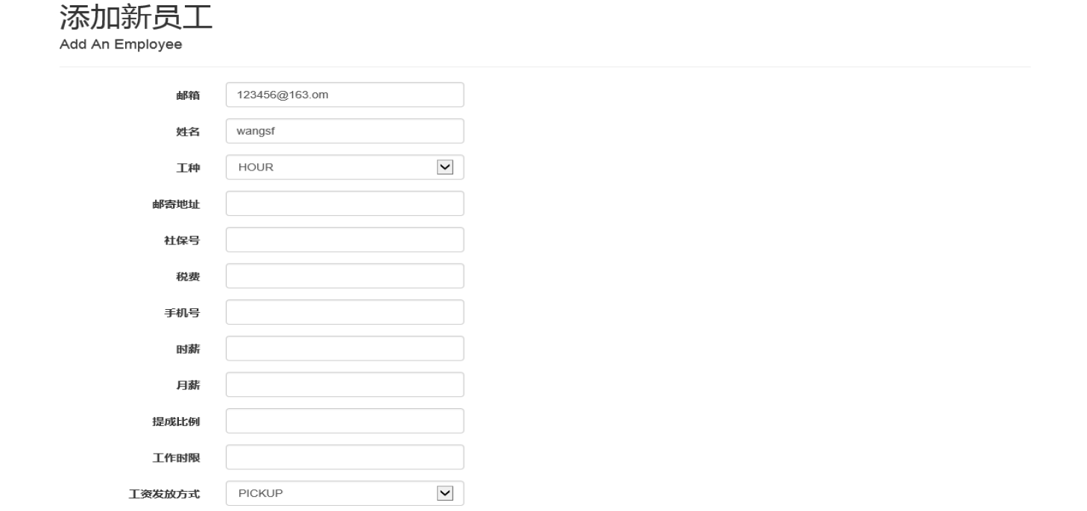

Output:

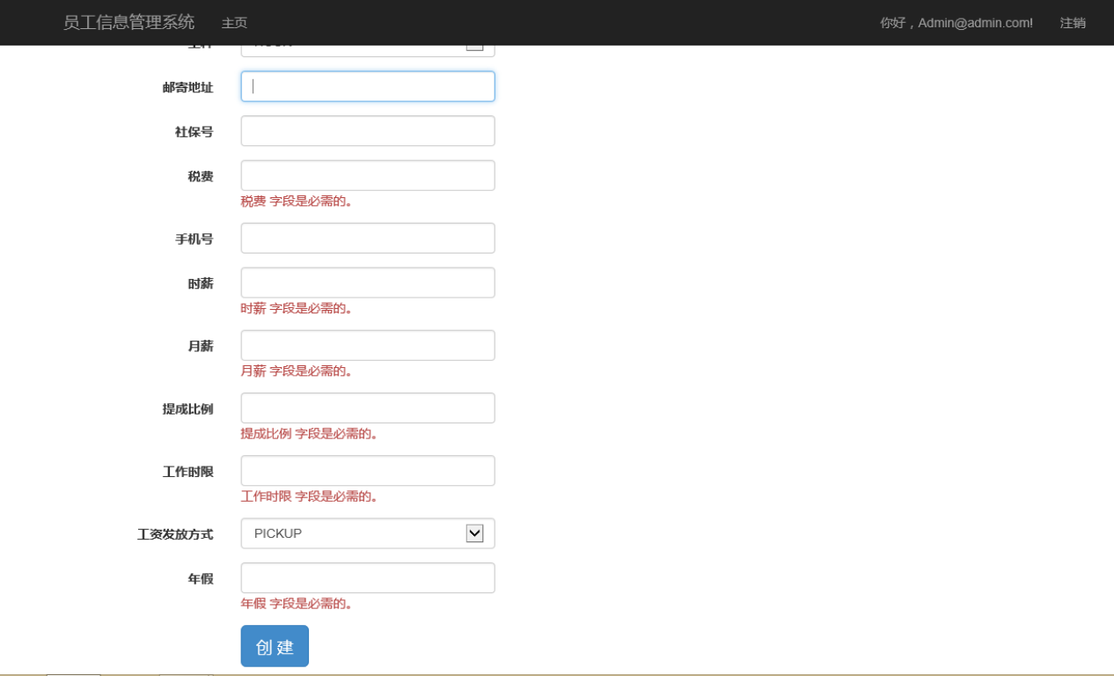

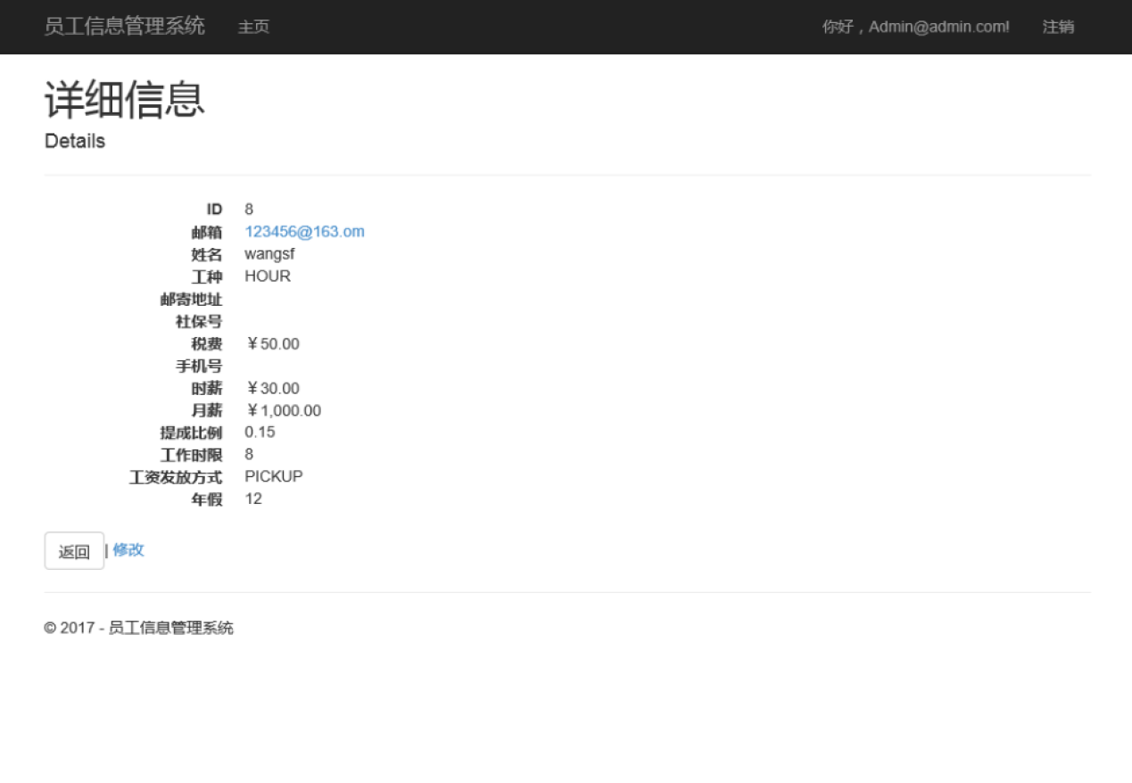

Verification point：Database

Expected results：succeed

Actual results:Valid

Bug:none

Bug location and overview:none

2.2 Update

Input: Click the button which named “edit”

Output:

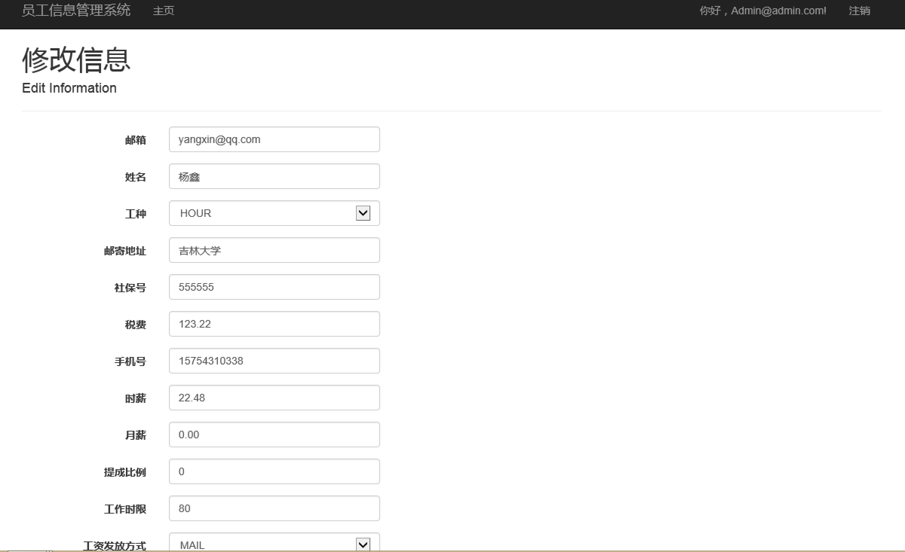

Verification point：Database

Expected results：Update completely

Actual results: Succeed

Bug:none

Bug location and overview:none

2.3 Delete

Input: Click the button which named “delete”

Output:

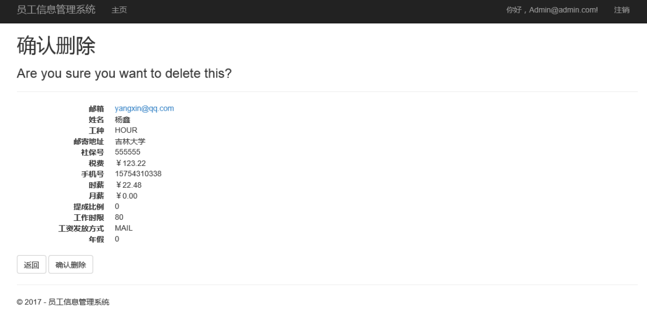

Verification point：Database

Expected results：Delete completely

Actual results: Succeed

Bug:none

Bug location and overview:none

1. Administrator Report

3.1 Search

Input: item,start date,end date,name

Output:

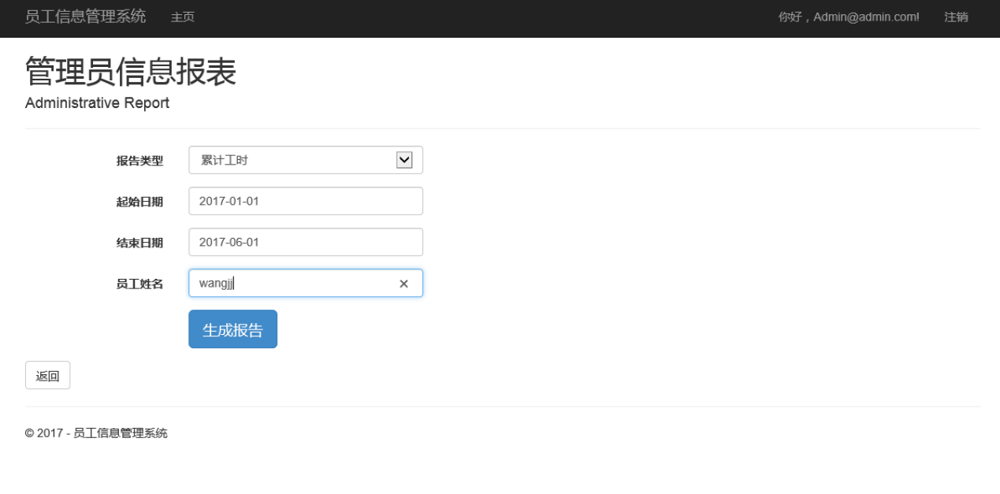

Verification point：Search Database

Expected results：Search completely

Actual results: Succeed

Bug:none

Bug location and overview:none

3.2 aggregate

Input: none

Output:

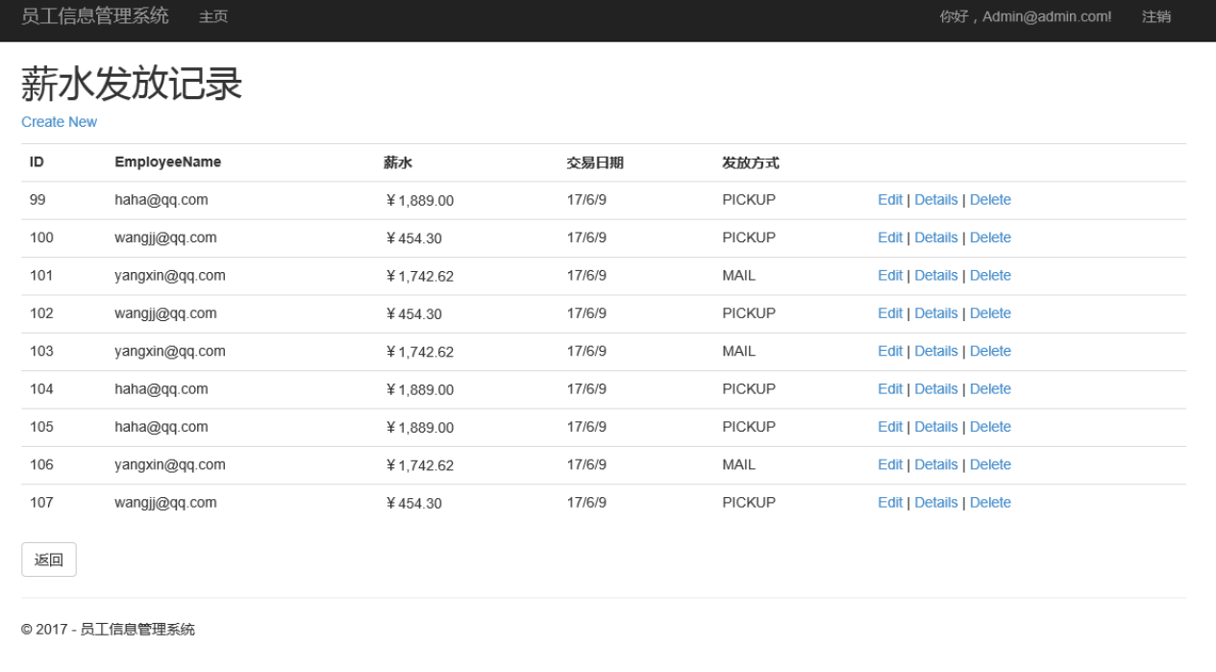

Verification point：Search Database

Expected results：Search completely

Actual results: Succeed

Bug:none

Bug location and overview:none

1. Employee Report

Input: kind,start date,end date,project-id

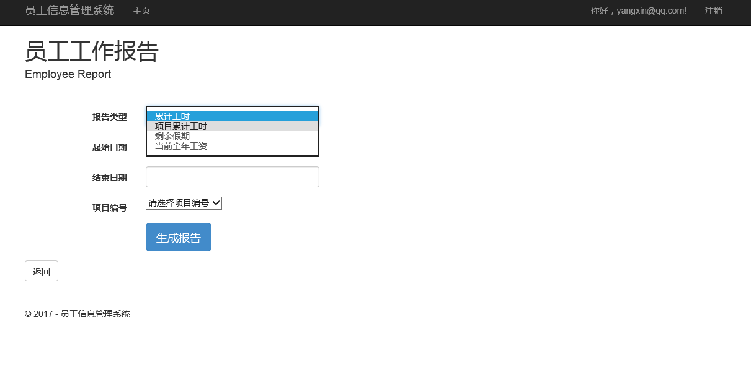

Output:

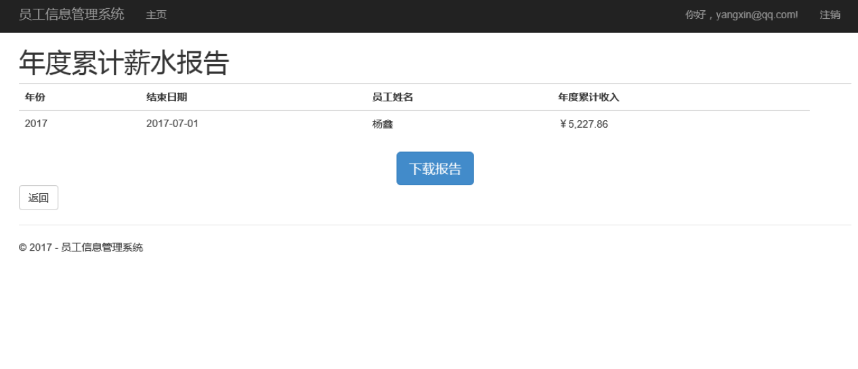

Verification point：Search Database

Expected results：Search completely

Actual results: Succeed

Bug:none

Bug location and overview:none

1. Payment Method

Input:①PICKUP : none

②MAIL : Email address

③Transfer : Bank name

Account number

Output:

①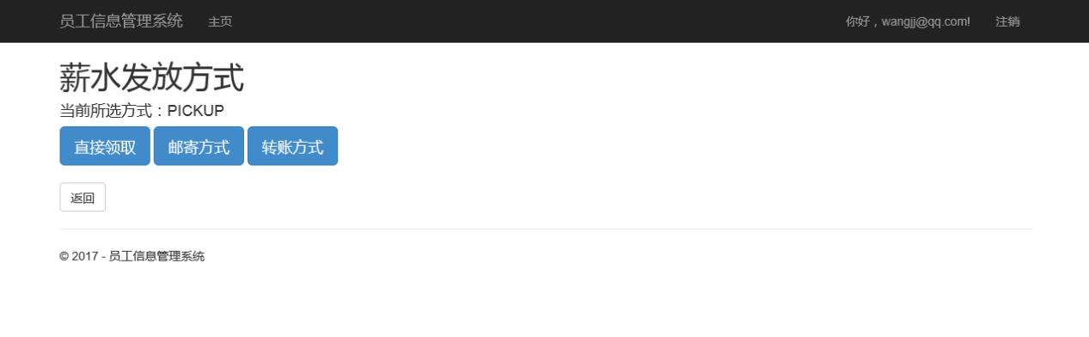

②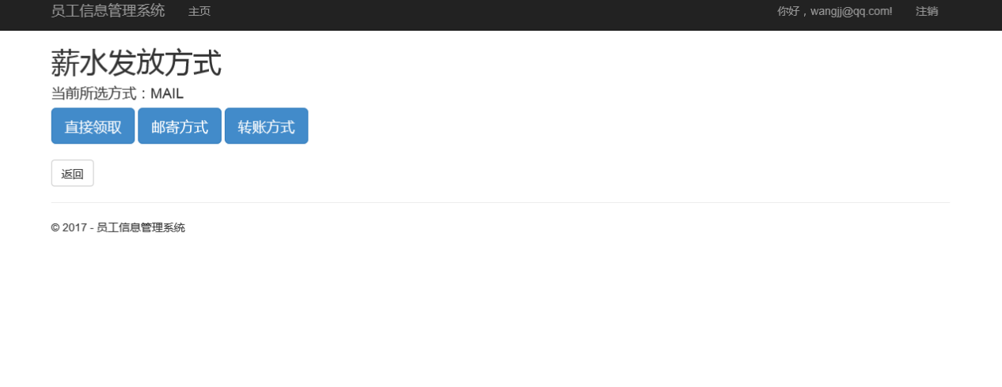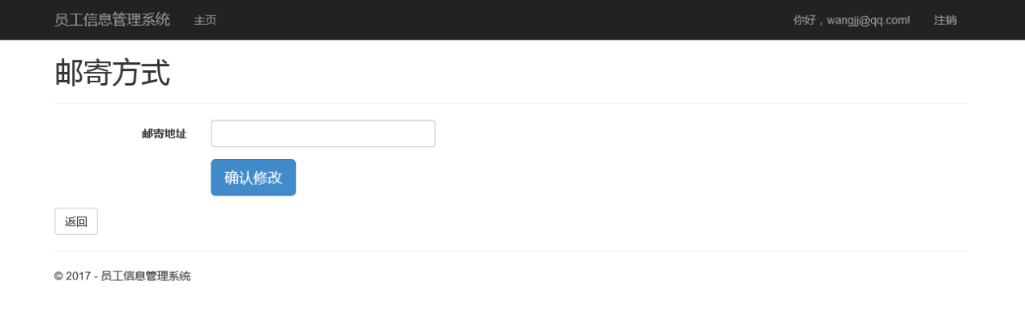

③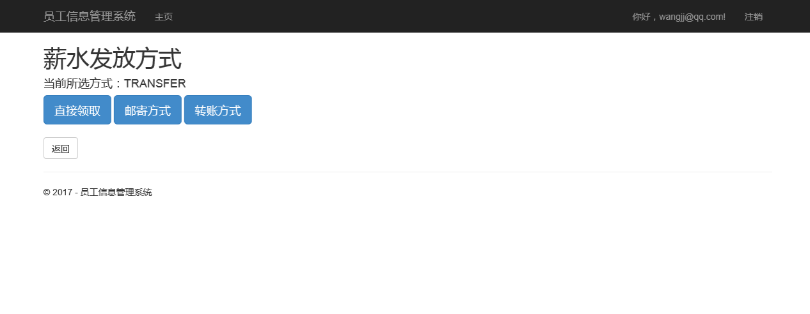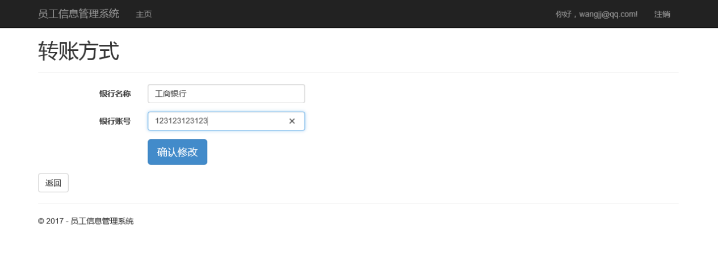

Verification point：Database,Web pages

Expected results：Changing the payment method

Actual results: succeed

Bug:none

Bug location and overview:none

1. Maintaining Time-card

Input:Project-ID,Hours,Date

Output:

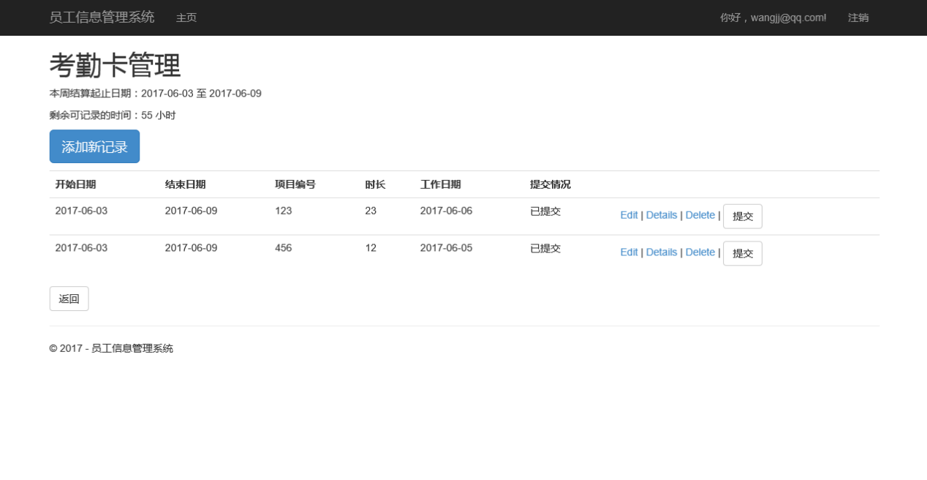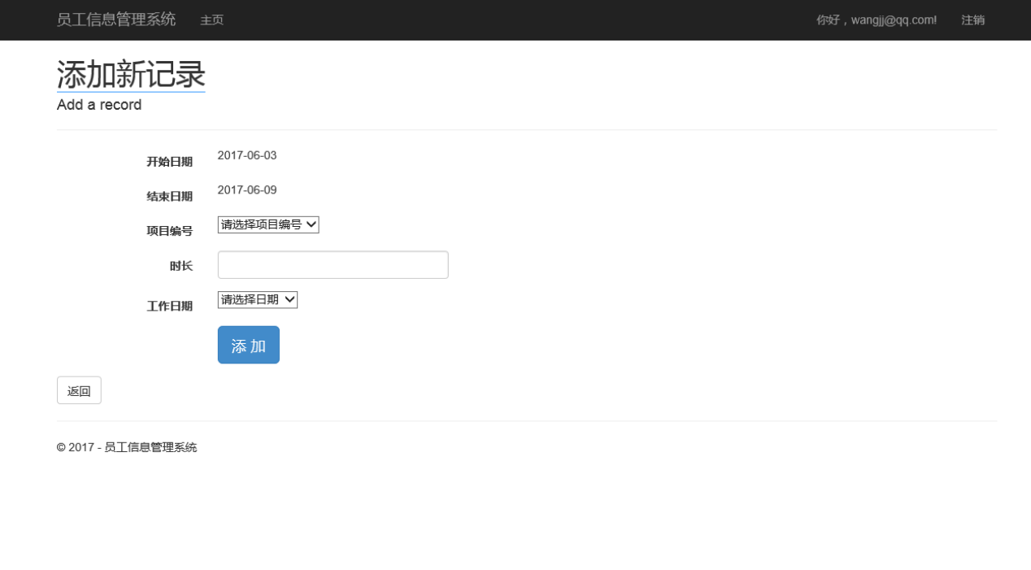

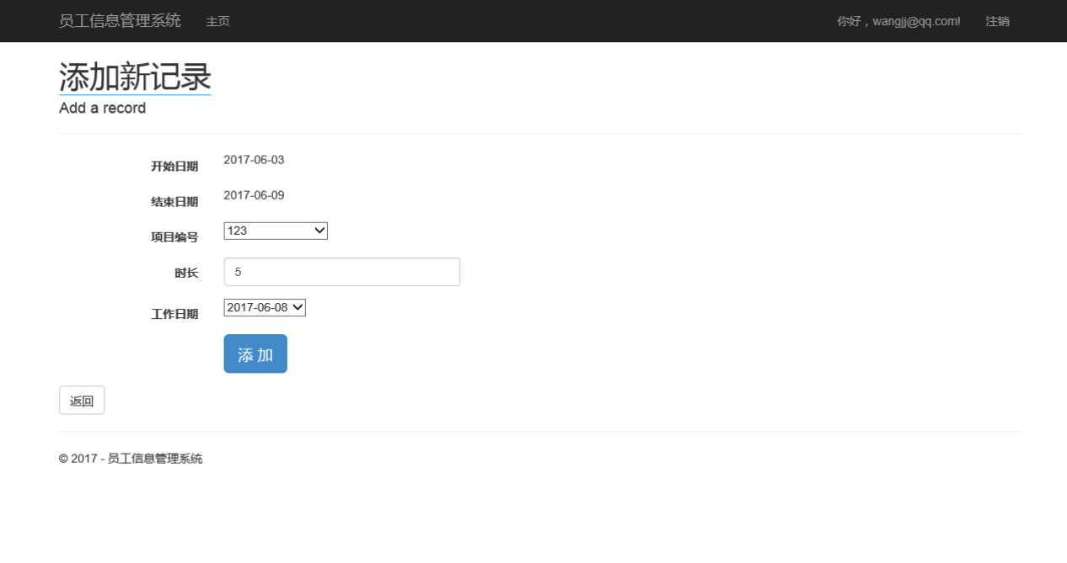

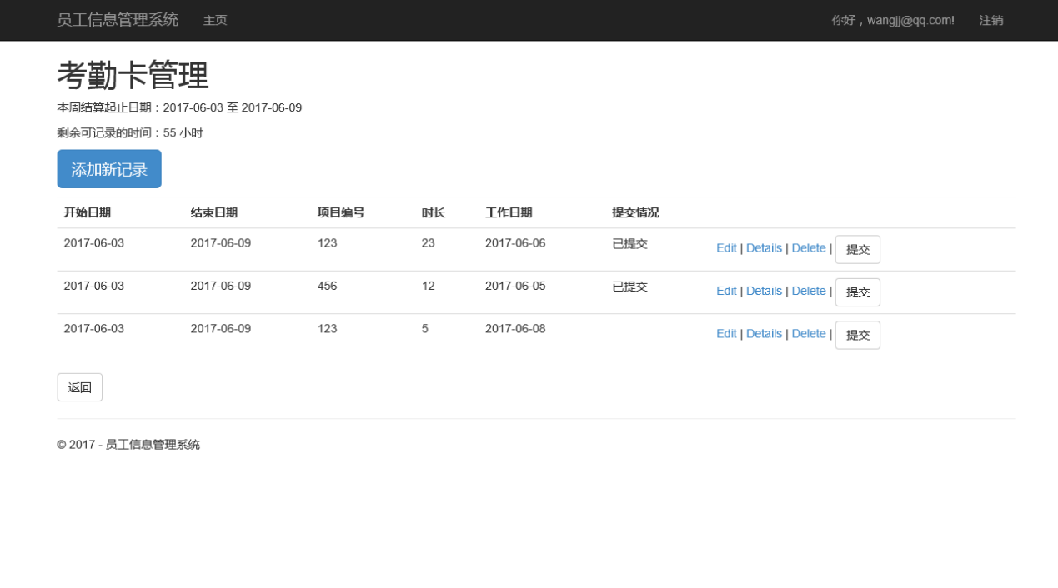

Verification point：Database

Expected results：Succeed

Actual results: Valid

Bug:none

Bug location and overview:none

1. Maintaining Purchase Order

7.1 Create

Input: date,name,Mail-address,commodity,amount

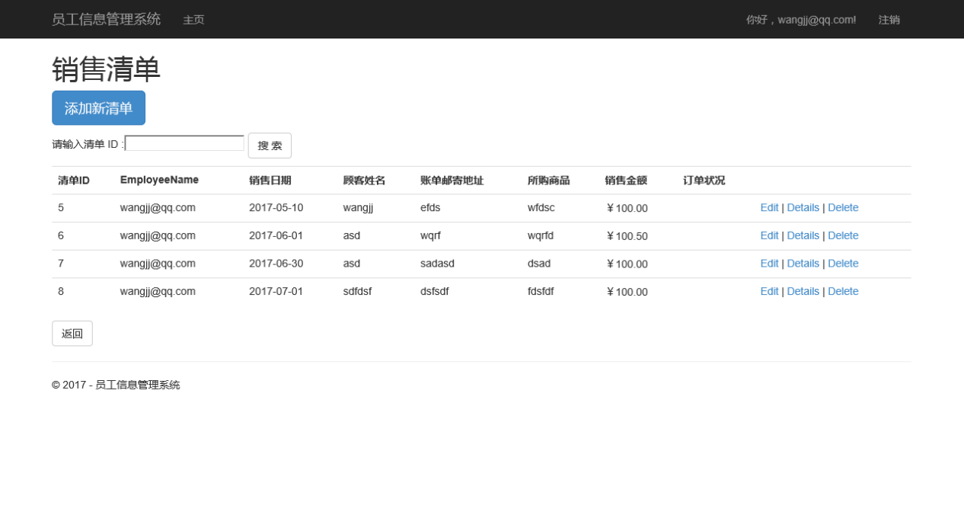

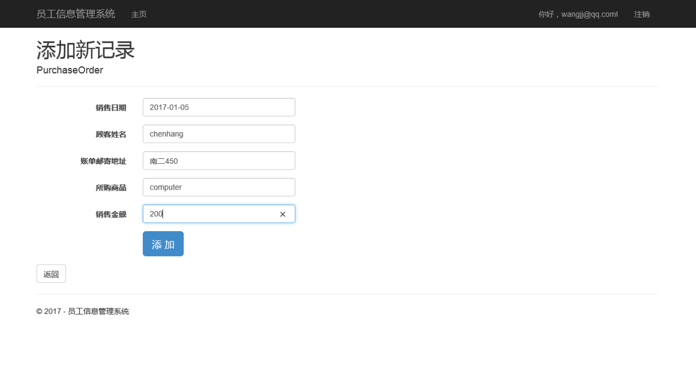

Output:

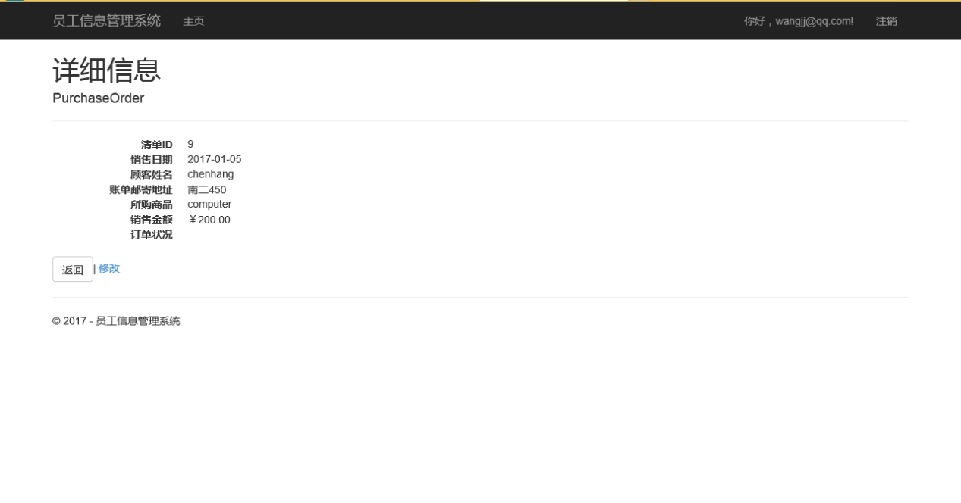

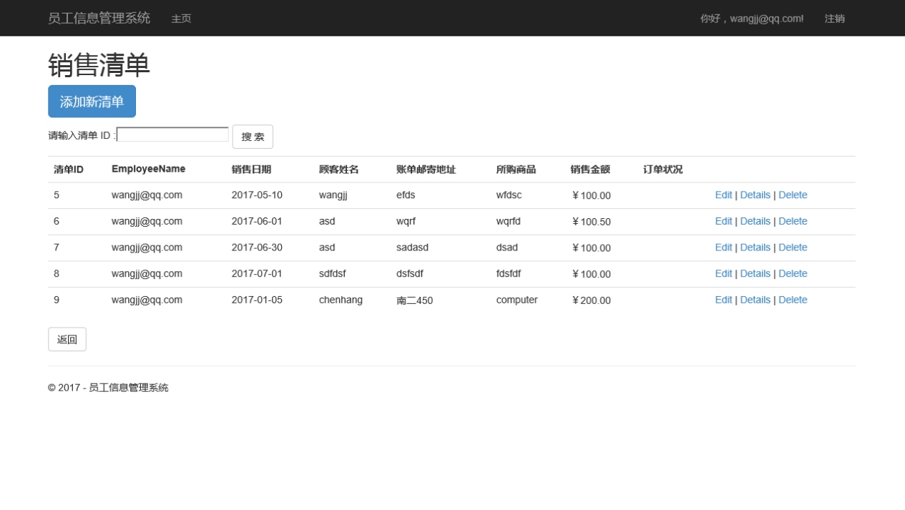

Verification point：Database

Expected results：Succeed

Actual results: Succeed

Bug:none

Bug location and overview:none

7.2 Update

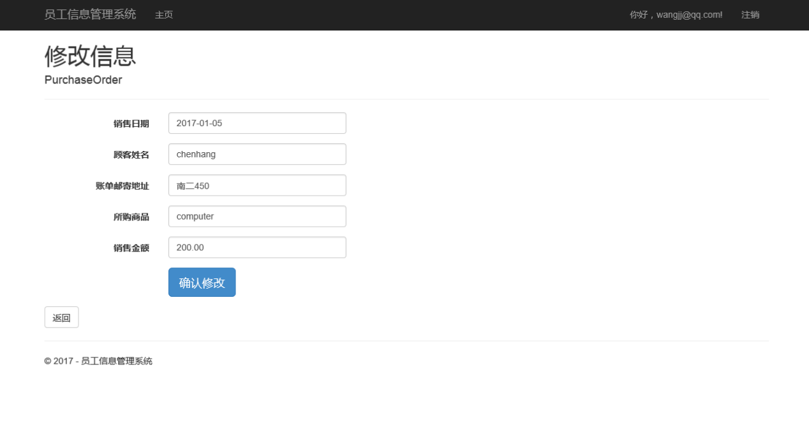

7.3 Delete

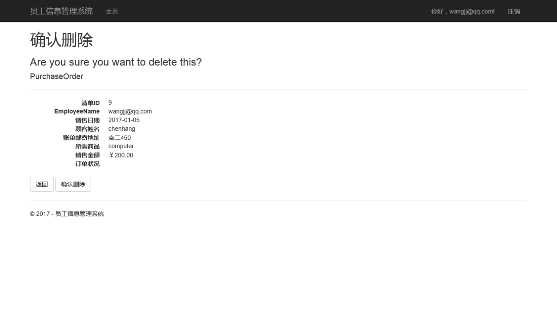

1. Automatically generate payroll and payment (Module test)

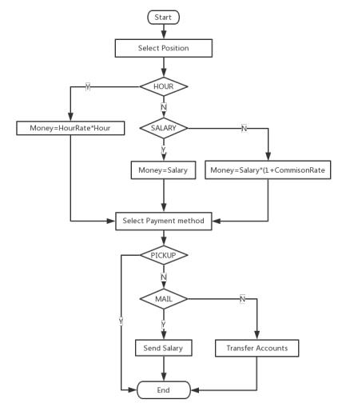

Bug:none

Bug location and overview:none

1. Automatically run payroll system

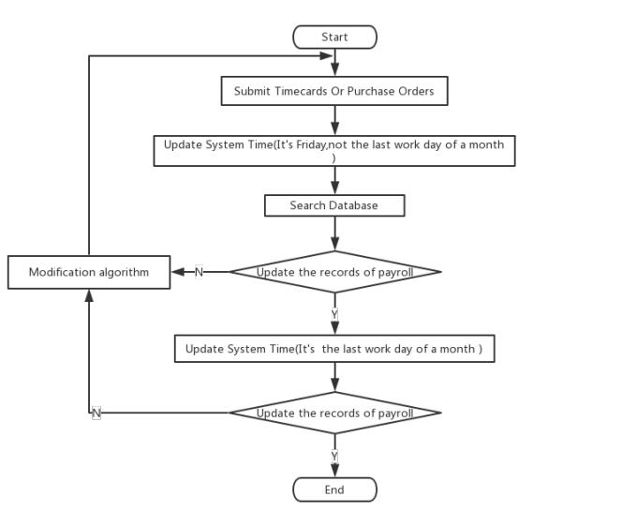

Bug:none

Bug location and overview:none