arXiv:2406.15483v1 [cs.CL] 17 Jun 2024

Duplicate Detection with GenAI

Ian Ormesher

ZEISS Digital Partners

Munich

ian.ormesher@zeiss.com

June 25, 2024

Abstract

Customer data is often stored as records in Customer Relations Man-agement systems (CRMs). Data which is manually entered into such systems by one of more users over time leads to data replication, partial duplication or fuzzy duplication. This in turn means that there no longer a single source of truth for customers, contacts, accounts, etc. Downstream business processes become increasing complex and contrived without a unique mapping between a record in a CRM and the target customer. Current methods to detect and de-duplicate records use traditional Natural Language Processing techniques known as “Entity Matching”. In this paper we show how using the latest advancements in Large Language Models and Generative AI can vastly improve the identification and repair of duplicated records. On common benchmark datasets we find an improvement in the accuracy of data de-duplication rates from 30% using NLP techniques to almost 60% using our proposed method.

- Introduction

The task of identifying duplicate records is often done by pairwise record com-parisons and is referred to as “Entity Matching” (EM). Whilst EM is broader in it’s scope and definition, we describe a technique here that can be used to identify duplicate records within a table using embedding vectors and distance metrics.

- Traditional Approach

The five steps of a typical duplicate detection pipeline based on pairwise record comparisons (EM) is described by Panse et al. [1].

This detection pipeline consists of several steps which include the following:

- Candidate Generation

1

Duplicate Detection with GenAI

- Blocking

- Matching

- Clustering

These steps are illustrated by their diagram shown in Figure 1.
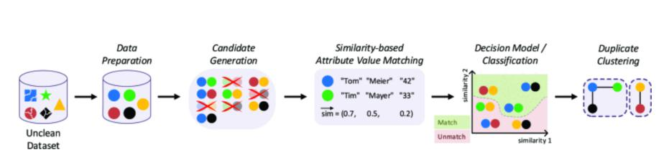

Figure 1: The five steps of a typical duplicate detection pipeline based on pairwise record comparisons

2.1 Candidate Generation

In the usual EM method, we would produce candidate records by combining all the records in the table with themselves to produce a cartesian product. For example, row_{i} is combined with row_{j} and produces a candidate record of (row_{i} + row_{j} ). This process is repeated for all the rows with all the other rows. For a table of N rows this would produce (N x N) – N candidate records. We subtract N from the total because we never combine a row with itself. As an example, a table of 200 records would produce (200 x 200) – 200 = 39,800 candidate records.

2.2 Blocking

The idea of blocking is to eliminate those records that we know could not be duplicates of each other because they have different values for the “blocked” column. As an example, If we were considering customer records, a potential column to block on could be something like “City”. This is because we know that even if all the other details of the record are similar enough, they cannot be the same customer if they’re located in different cities. Once we have generated our candidate records, we then use blocking to eliminate those records that have different values for the blocked column.

2.3 Matching

Following on from blocking we now examine all the candidate records and calculate traditional NLP similarity-based attribute value metrics with the fields

2

Duplicate Detection with GenAI

from row_{i} and row_{j} . Using these metrics, we can determine if we have a potential match or un-match.

2.4 Clustering

Now that we have a list of candidate records that match, we can then group them into clusters.

- Proposed Method

There are several steps to the proposed method, but the most important thing to note is that we no longer need to perform the “Candidate Generation” step of the traditional method. The new steps become:

- Create Match Sentences

- Create Embedding Vectors

- Clustering

3.1 Create Match Sentences

First a “Match Sentence” is created by concatenating the attributes we are interested in and separating them with spaces.

As an example, let’s say that we have a customer record which looks like the one shown in Table 1.

Table 1: Example Customer Record

name1 | name2 | name3 | address | city
John | Hartley | Smith | 20 Main Street | London

We would create a "Match Sentence" by concatenating with spaces the name1, name2, name3, address and city attributes to make the following:

John Hartley Smith 20 Main Street London

3.2 Create Embedding Vectors

Once our “Match Sentence” has been created it is then encoded into vector space using our chosen embedding model. This is achieved by using “Sentence Transformers” [2]. The output of this encoding will be a floating-point vector of pre-defined dimensions. These dimensions relate to the embedding model that is used. We used the all-mpnet-base-v2[3] embedding model which has a vector space of 768 dimensions. This embedding vector is then appended to the record. This is done for all the records, as shown in Figure 2.

3

Duplicate Detection with GenAI
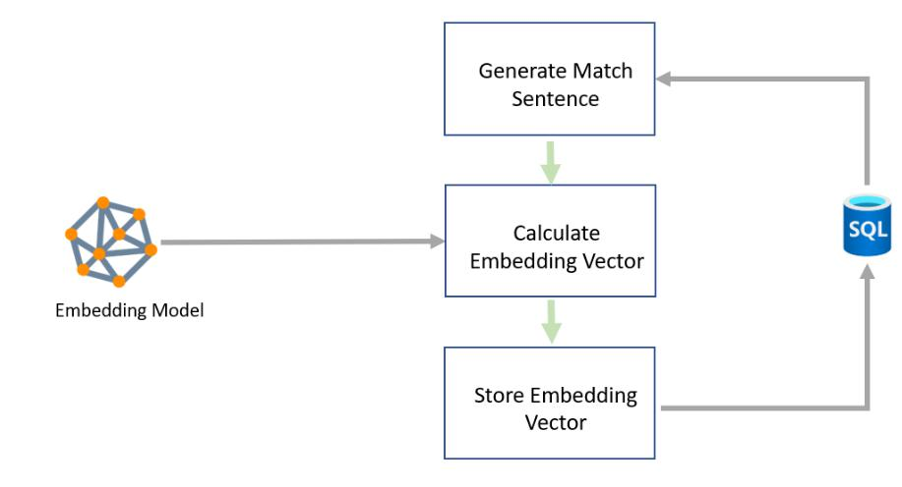

Figure 2: The steps to creating the embedding vector

3.3 Clustering

Once embedding vectors have been calculated for all the records, the next step is to create clusters of similar records. To do this we use the DBSCAN technique. DBSCAN works by first selecting a random record and finding records that are close to it using a distance metric. There are 2 different kinds of distance metrics that were used:

- L2 Norm distance

- Cosine Similarity

For each of these metrics an epsilon value was used as a threshold value. All records that were within the epsilon distance and had the same value for the “blocked” column were then added to this cluster. Once that cluster was complete another random record was selected from the unvisited records and a cluster then created around it. This then continues until all the records have been visited. See the description of this algorithm using pseudo code 1.

- Experiments

There were two sets of experiments that were performed:

- with our existing customer data

- with the musicbrainz data

4

