Guardrails for avoiding harmful medical product recommendations

and off-label promotion in generative AI models

Daniel Lopez-Martinez

Amazon

Santa Clara, CA

kdlopezm@amazon.com

arXiv:2406.16455v1 [cs.AI] 24 Jun 2024

Abstract

Generative AI (GenAI) models have demonstrated re-markable capabilities in a wide variety of medical tasks. However, as these models are trained using generalist datasets with very limited human oversight, they can learn uses of medical products that have not been adequately evaluated for safety and efficacy, nor approved by regula-tory agencies. Given the scale at which GenAI may reach users, unvetted recommendations pose a public health risk. In this work, we propose an approach to identify potentially harmful product recommendations, and demonstrate it us-ing a recent multimodal large language model.

1. Introduction

Rapid advancements in generative artificial intelligence (GenAI) have led to the development of sophisticated mod-els such as DALL-E [18], GPT-4 [53], PaLM2 [7], Llama 2 [63] and Claude 3 [8, 10]. These have the capability to model complex relationships from massive multimodal datasets, generate new content and perform tasks they were never trained for. Their potential applications in medicine include medical image analysis [3, 33], providing differen-tial diagnoses [34], summarizing charts [67], writing letters to patients [5], providing medical education [6, 41, 61], aid-ing pharmacy providers (e.g. prescription generation, safety evaluation, decision support) [6, 42, 45, 52], or working as a chatbot to answer questions about patients’ specific con-cerns or medical products [6], among others. Medicine is inherently a multimodal discipline, and new GenAI mod-els such as multimodal large language models (MLLMs) continue to be developed that integrate diverse multimodal data streams [64]. Moreover, general-purpose GenAI mod-els are often used for medical-related tasks, despite not be-ing specifically developed for those.

While these technologies hold great promise, they also present numerous ethical and legal challenges, can pose sig-

nificant risk to public health, and cause harm to individuals and organizations [2, 4, 13, 32, 36, 48, 69]. Therefore, it is paramount that GenAI models comply with legal or reg-ulatory regimes. Given that existing laws and regulations written to govern the use of AI often struggle to address the amplified challenges associated with GenAI [48, 50], new ones are rapidly being developed [48, 69]. Meanwhile, there is an imperative for model developers to adhere to the existing frameworks and the trust and safety principles that guided them, to mitigate potential harm and maintain public trust in these breakthrough technologies.

In this work, we shed light into an overlooked issue that impacts most GenAI models, that is, the potential to promote unapproved and potentially harmful uses of med-ical products. Traditionally, specialized ML models have been trained to address a specific task using highly domain and problem-specific training data [20]. However, GenAI models are typically not developed to do particular medical tasks. Moreover, GenAI models are trained on much more broadly available generalist datasets [44] with less hands-on human oversight in their development. Therefore, they can learn complex unvetted relationships from the training data and produce outputs about medical products that do not strictly adhere to the approved product labels. Promoting a medical product for anything other than its approved use is unsafe and illegal, and ought to be avoided.

To avoid this issue, we propose a method to identify in-stances of off-label promotion in GenAI outputs (Sec.3). We demonstrate it using a recently introduced MLLM (Sec.4), and surface examples where it is producing poten-tially harmful responses (Sec.5). Finally, we briefly discuss how guardrails may be introduced so that GenAI models strictly adhere to product labels when producing outputs re-lated to medical products (Sec.6).

2. Background

Here we discuss the regulatory framework governing the promotion of medical products in the USA (Sec.2.1), the

specific concerns impacting GenAI (Sec.2.2), and previous work on detecting off-label promotion (Sec.2.3)

2.1. Regulatory framework

In the US, under the Federal Food, Drug and Cosmetic Act (FDCA), regulated by the Food and Drug Administration (FDA), medical products such as pharmaceutics, biologics or medical devices, must be approved, authorized, or oth-erwise cleared for each intended use by the FDA before a company can market it [65]. Off-label use refers to using or prescribing marketed medical products for indications (e.g. a disease or symptom) that are not included in their FDA-approved labeling information. Hence, the specific use is “off-label” (i.e. not approved by the FDA and not listed in FDA-required labeling information). This term can also ap-ply to the use of a marketed product in a patient population (e.g. pediatric, pregnant, etc.), dosage, or dosage form that does not have FDA approval.

Off-label use can be motivated by several factors [57,

68]. For example, a product may be used for a specific population for which it has not been approved. Also, if a medication has been approved to treat a specific condition, medications from the same class of drugs may also be used to treat that condition. Finally, if the features of two medi-cal conditions are similar, a physician may use a medication approved for one of these conditions to treat both.

Off-label use is quite common in clinical practice; up to one-fifth prescriptions are off-label [68]. There are many reasons why it remains common. For example, adding ad-ditional indications for an already approved medication can be costly and time-consuming, and revenues for the new indication may not offset the expense and effort of obtain-ing approval. Moreover, generic medications may not have the requisite funding foundations needed to pursue FDA ap-proval. Therefore, drug proprietors may never seek FDA approval for common uses.

Although off-label use is not illegal, off-label marketing is prohibited. Off-label marketing refers to directly promot-ing or advertising a medical product for any indication that the FDA has not approved. In fact, this is considered to be fraud and is punishable under the False Claims Act (FCA) [14, 17, 66].

2.2. Harms of off-label promotion by GenAI

Social media websites, including online health communi-ties, Twitter, Facebook, Amazon, and others, as well as scientific articles in academic journals, are potentially the largest source of data related to off-label use of medi-cal products [23]. Because LLMs are trained on massive datasets, they can learn these off-label uses and remain in parametric memory, or alternatively be surfaced via re-trieved augmented generation (RAG) [28].
This poses potential dangers to public health. For exam-

ple, a user may be misled to believe that an off-label use of a prescription drug or medical product is safe or effec-tive, exposing them to the potential adverse side effects of a product that has not been adequately tested for safety and effectiveness in treatment of a particular condition. They may also be recommended treatments that are ineffective, or even nonsensical treatments, or be recommended more expensive, yet inadequately tested products. Given the mas-sive scale at which GenAI models operate, this can lead to significant public health risk and potential penalties [2, 66].
From a regulatory perspective, it is not clear what tech-nical category GenAI will fall into, nor what regulations they will be subjected to. For example, the FDA does not categorically prohibit discussing off-label uses, making a nuanced distinction between communication and promo-tion. Moreover, based on the differences between GenAI and prior ML methods, new regulatory frameworks may be developed to address these GenAI-specific challenges and risks [48]. Regardless of this, off-label promotion poses po-tential dangers to public health that ought to be minimized.

2.3. Detecting off-label use with ML

Previous work has focused on applying ML to detecting off-label use in electronic health records [37, 38], online health communities such as MedHelp, WebMD, Drugs.com, and HealthBoards.com [51, 71, 73, 74], and more recently so-cial media sites [23, 35, 46]. Recent work has leveraged transformer-based methodologies (e.g. BERT [31]) to iden-tify these off-label uses. However, to the best of our knowl-edge, the issue of off-label promotion by GenAI models has not been explored.

3. Methods

Fig.2 contains a diagram outlining the overall approach to off-label promotion detection. It focuses on evaluating the output of a MLLM that consumes image and text and pro-duces text. In this work, we specifically consider the use case where the user provides the MLLM model with an im-age of a product label, and asks a question about it. The proposed method evaluates the model response, taking into account the user query, to detect instances of off-label pro-motion.

The evaluation algorithm consists of the following 4 se-quential steps: (1) input standardization, (2) named entity recognition, (3) product and indication recognition, and (4) off-label identification.

3.1. Input standardization

This step aims to standardize the language of the user query by correcting irregular spellings and orthographic errors. Specifically, we used a context-sensitive spelling correction model for clinical text [40]. Note that abbreviations may

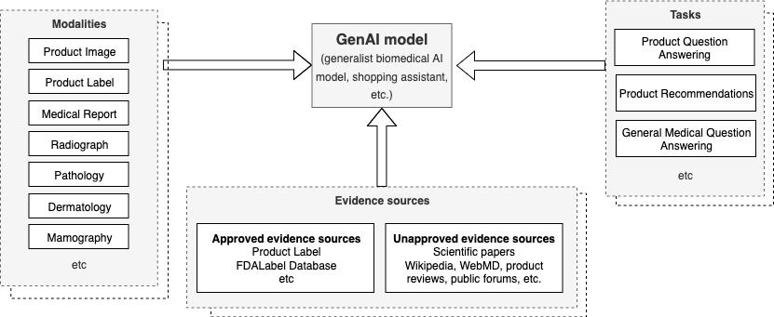

Figure 1. Overview of a generative artificial intelligent system for medical product question answering, product recommendation, and general medical question answering. Such system may handle a handle a diverse range of biomedical data modalities, and use a number of evidence sources, some of which are not approved by the FDA.

Figure 2. Process flow for GenAI model generation (top) and eval-uation of the responses for off-label identification (bottom).
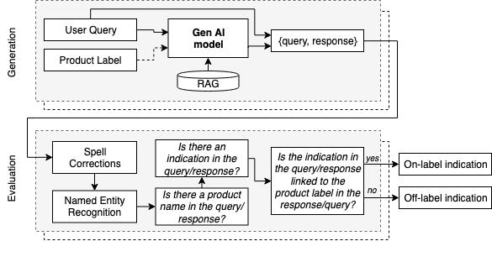

be present in the input query, and although not done in this work, these can also be standardized [59].

3.2. Named entity recognition

This second step identifies medical product names and in-dications (i.e. diseases, conditions) in the GenAI model re-sponses. To do so, we leverage existing named entity recog-nition (NER) methods for biomedical terms. There exist a large number of such methods [24]. In this work, we specif-ically used two BioBERT-based [43] biomedical represen-tation language models fine-tuned to perform NER for drug names and diseases respectively. We found that these BERT models perform significantly better than previous rule- and dictionary-based approaches such as cTAKES [62].

3.3. Product and indication recognition

Products and indications identified in the previous step (Sec.3.2) are matched to those in the FDALabel database

[25]. This web-based application¹ was developed by the FDA and allows access to the most up-to-date medical la-beling data for over 147,000 human prescription and over-the-counter (OTC) drugs and devices. It contains images of the product labels as well as information about approved indications, active ingredients, usage, dosage, contraindica-tions, side effects, etc.

This matching was done by computing word embeddings and using the cosine similarity to match the NER entities to those in FDALabel. We specifically used an embedding developed for medical concepts, BioBERT [43] , but other embeddings may be used [19, 21, 29, 39, 60, 72].

3.4. Off-label identification

The final step identifies any product-indication association between the user query and the GenAI response that is not FDA-approved. For each product identified in the query, we extract the list of FDA-approved indications from the FDALabel dataset. If any disease not listed in the list of FDA-approved indications is identified in the GenAI re-sponse (following Sec.3.3), we zero-shot prompt a T5-large model [58] to determine if the association entails a recom-mendation. If so, we conclude that it constitutes an instance of off-label promotion.

4. Experimental Setup

To narrow down the experimentation, we considered a shop-ping context where a user interacts with a MLLM model that helps customers find answers to product questions (see Fig.1). The user provides the model with a picture of a prod-uct label, and asks a question about it. The model responds with a textual output. Additionally, but not considered here,

- https://nctr-crs.fda.gov/fdalabel/

Product Name | FDA-approved indications | Off-label indications
Lorazepam | Anxiety, status epilepticus, preanesthetic | Insomnia, panic disorder, delirium
Prazosin | Hypertension | PTSD nightmares, prostatic hypertrophy, Raynaud phenomenon
Quetiapine | Schizophrenia, bipolar disorder depression | Anxiety, insomnia
Donepezil | Dementia of the Alzheimer’s type | Lewy body dementia, vascular dementia
Citalopram | Depression | Obsessive-compulsive disorder, panic disorder, premature ejaculation
Sildenafil | Erectile dysfunction, pulmonary hypertension | Female sexual arousal disorder, altitude-induced hypoxemia

Table 1. Examples of off-lab

