1

Strategic Demand-Planning in Wireless Networks: Can Generative-AI Save Spectrum and Energy?

Berk C¸iloglu˘^{1,2}, Gorkem¨ Berkay Koc¸^{1,2}, Afsoon Alidadi Shamsabadi², Metin Ozturk^{1,2}, Halim Yanikomeroglu²
- Electrical and Electronics Engineering, Ankara Yıldırım Beyazıt University, Ankara, Turkiye¨
²Non-Terrestrial Networks Lab, Systems and Computer Engineering, Carleton University, Ottawa, Canada

arXiv:2407.02292v1 [cs.NI] 2 Jul 2024

Abstract—Wireless communications advance hand-in-hand with artificial intelligence (AI), indicating an interconnected advancement where each facilitates and benefits from the other. This synergy is particularly evident in the development of the sixth-generation technology standard for mobile networks (6G), envisioned to be AI-native. Generative-AI (GenAI), a novel technology capable of producing various types of outputs, in-cluding text, images, and videos, offers significant potential for wireless communications, with its distinctive features. Tradi-tionally, conventional AI techniques have been employed for predictions, classifications, and optimization, while GenAI has more to offer. This article introduces the concept of strate-gic demand-planning through demand-labeling, demand-shaping, and demand-rescheduling. Accordingly, GenAI is proposed as a powerful tool to facilitate demand-shaping in wireless networks. More specifically, GenAI is used to compress and convert the content of various kind (e.g., from a higher bandwidth mode to a lower one, such as from a video to text), which subsequently enhances performance of wireless networks in various usage sce-narios such as cell-switching, user association and load balancing, interference management, and disaster scenarios management. Therefore, GenAI can serve a function in saving energy and spectrum in wireless networks. With recent advancements in AI, including sophisticated algorithms like large-language-models and the development of more powerful hardware built exclusively for AI tasks, such as AI accelerators, the concept of demand-planning, particularly demand-shaping through GenAI, becomes increasingly relevant. Furthermore, recent efforts to make GenAI accessible on devices, such as user terminals, make the imple-mentation of this concept even more straightforward and feasible.

- INTRODUCTION

The growing demand for coverage and capacity, along with the shift towards the sixth-generation technology stan-dard for mobile networks (6G), is driving the development of technologies that ensure immersive, hyper-reliable, and low-latency communication as well as massive connectiv-ity. 6G introduces innovative applications, such as extended reality (XR), holographic communication, tactile and haptic Internet applications, to name a few, which require much higher levels of key performance indicators (KPIs) compared to applications in legacy networks [1]. Emergence of novel use cases, aligned with the ambitious requirement of KPIs in 6G, necessitates employment of cutting-edge technologies, such as artificial intelligence (AI) and advanced network platforms, including non-terrestrial networks (NTN) [2]. As wireless net-works become denser and various network tiers integrate ver-

This research has been sponsored in part by The Scientific and Technolog-ical Research Council of Turkiye¨ (TUBITAK).

tically, forming vertical heterogeneous networks (VHetNets), energy consumption and resource utilization increase tremen-dously, requiring robust and efficient algorithms. Given the scale of future wireless networks and the need to optimize various metrics from both user and network perspectives, wireless networks will inevitably experience a shift towards autonomous and self-optimizing infrastructures [1]. This lies in the maturation of self-organization and the advanced uti-lization of AI technologies in future wireless networks. The revolutionary enhancements in AI are expected to have a noticeable impact on the telecommunications field to create a sustainable, dynamic, and resilient network that can manage various conditions and scenarios efficiently [3].

In recent years, AI has emerged as a promising tool for designing solutions in wireless networks in the form of ma-chine learning algorithms. Despite efforts to develop efficient algorithms using conventional AI and optimization methods as well as increasing available resources (such as power, time, frequency, and hardware) through advanced technologies, in-cluding terahertz (THz) communications, and ultra-massive multiple-input multiple-output (umMIMO) antennas, proposed algorithms still fall short in scenarios where a large number of users demand a huge volume of traffic. Consequently, these algorithms are unable to fulfill users demand and achieve the best possible performance [4]. To tackle this challenge, strate-gic demand-planning can be considered a potential approach in managing the user traffic, and therefore optimizing the resource utilization and energy consumption of the network.

In wireless networks, as seen in Fig. 1, user demand-planning involves demand-labeling, demand-shaping, and demand-rescheduling. Through demand-labeling, user data can be labeled as either critical or non-critical based on its importance and priority. Accordingly, demand-shaping entails compressing user-demanded data or converting it to another format, depending on the network’s resource utilization status. In scenarios of network congestion, where available resources are insufficient to fulfill user’s requirement, the user data that needs to be sent with high priority and can be shaped without meaning change or information loss, can be shaped, and transmitted using fewer allocated resources. On the other hand, user data with lower priority level or requiring precise transmission of bits can be rescheduled to a time slot where available resources are sufficient for reliable transmission.

Recently, there has been a noticeable interest in employ-ing generative-AI (GenAI) models in the telecommunications field. Several studies have been conducted to investigate the

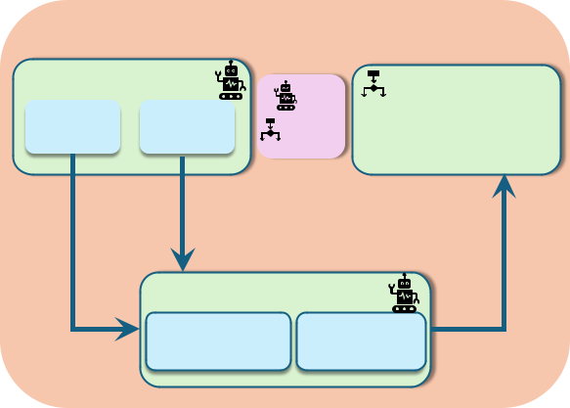

Demand Planning

Demand-Labeling |  | AI |  |  |  | Demand-
Critical | Non- | AI |  |  |  | Demand-
Critical | Non- | Non-AI |  | Rescheduling
Critical | critical | Non-AI
 | Possible
meaning is | Possible
conserved | reschedule
 | Demand-Shaping
No | Compression | Conversion
reschedule

Fig. 1. Demand-planning workflow in wireless networks.

2

TABLE I

GENAI MODELS COMPARISON

Model Type | Fundamental Concepts | Applications
 | Consists of two neural | - Channel modeling
GANs | networks: generator creates | and simulation.
GANs | data, and the discriminator | - Generating synthetic
 | evaluates it. | network traffic for testing.
 | Utilizes a probabilistic | - Anomaly detection in
VAEs | Utilizes a probabilistic | network traffic.
VAEs | approach to understand | network traffic.
VAEs | approach to understand | - Network performance
 | data distribution. | - Network performance
 | data distribution. | optimization.
 | Gradually adds and then | - Noise reduction in
DMs | Gradually adds and then | communication signals.
DMs | removes noise from data | communication signals.
DMs | removes noise from data | - Enhancing data clarity
 | to generate new samples. | - Enhancing data clarity
 | to generate new samples. | in low-quality signals.
 | Processes data in parallel | - Enhancing customer
Transformers | Processes data in parallel | service.
Transformers | and captures dependencies | service.
Transformers | and captures dependencies | - Adaptive optimization
 | over sequences. | - Adaptive optimization
 | over sequences. | of network data.

potentials of utilizing GenAI in wireless networks, thereby unveiling new technological possibilities towards 6G [5]–[7]. Besides the conventional applications of GenAI in traditional communications that guarantee the accurate transmission and reception of the user’s data, GenAI has the potential to play a crucial role in semantic communications [8]. Additionally, GenAI is a powerful tool to facilitate demand-planning in wireless networks and can be utilized at the user terminal or base stations (BSs) to facilitate demand-planning in scenarios where the available resources are insufficient to accommodate the entire demanded traffic. Through demand-shaping, GenAI improves the performance of wireless networks from resource utilization and energy consumption perspectives, i.e., energy and spectrum are saved. Therefore, demand-planning, and particularly demand-shaping through GenAI, can be a high-potential remedy to enhance future ultra-dense wireless net-works, making them more sustainable, dynamic, and resilient.

- DEMAND-PLANNING WITH GENAI: CONCEPT AND MODELS

GenAI technology has undergone rapid enhancements, lead-ing to the development of novel generative models. Each GenAI model comprises various components, and has been designed to achieve a specific objective. In this section, we first discuss the basics of GenAI along with the key models. Next, we introduce the concept of demand-planning, explore how to apply demand-planning in wireless networks, and discuss the associated advantages.

A. GenAI Basics

GenAI is an AI technology capable of generating orig-inal and intricate content, including texts, images, videos, etc., using patterns and information, learned from exten-sive datasets [9]. GenAI plays an important role in vari-ous fields, such as data augmentation, sentiment analysis, question-answering, conversational interfaces, and automation, by improving human-machine interactions and generating new content. Additionally, GenAI is a potential tool for optimiz-ing the performance of future wireless networks, such that it can improve data optimization with the help of highly

efficient and versatile models. Among these, generative ad-versarial networks (GANs) are used for adversarial training; variational autoencoders (VAEs) for probabilistic encoding; diffusion models (DMs) for data diversity; and transformers for sequence processing [5].

Two competing neural network models exist in GANs, engaged in a zero-sum game, i.e., if one model gains, the other loses. The first neural network, referred to as generator, generates fake data samples (i.e., synthetic data) based on the training set, and the second one, named discriminator, determines how realistic the fake data seems. These two parts work together to generate new data with the same statistics as the training set. GAN models have been widely used in the wireless networks literature to analyze transmitted data, and to model traffic patterns and user behaviors. This supports wireless networks in estimating network demand and required resources more efficiently. VAEs are another type of GenAI approaches, that are generative models created by combining deep learning and probabilistic graphic models. VAEs are used to learn complex probabilistic distributions from data sets and generate new data samples. Therefore, they are poten-tial algorithms for anomaly detection and data compression. In particular, VAEs can be instrumental in user’s demand-planning in future wireless networks, enabling the optimization of the resource utilization and energy consumption, where the available resources are not adequate to fulfill system level agreements.

DMs are two-stage deep learning models: in the first stage, noise is incrementally added to real data samples until the data is transformed into complete noise, while in the second stage, the model reduces this noise step-by-step, approaching the original data. In this way, the model learns how to generate realistic data from random data by removing the noise. GenAI DMs are essential in noise reduction and traffic prediction in wireless networks. Transformers, on the other hand, capture long-term dependencies and contextual information within se-quences, making them particularly effective for data compres-sion and data optimization tasks. They can efficiently encode sequences into compact representations, reducing the amount of data needed to capture important information. Furthermore, compared to conventional sequential models, transformers can

3
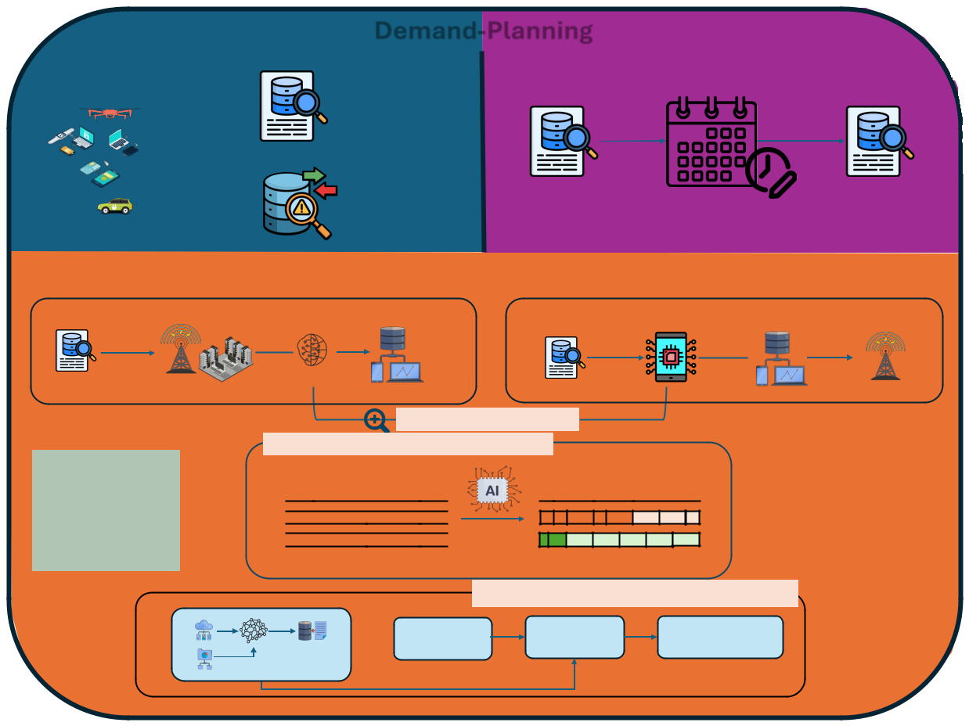

 | Demand-Labeling |  |  |  | ^{Demand-Planning} Demand-Rescheduling
 | User Demand |  |  |  | Non-critical |  | Rescheduled
 |  |  |  |  | Data
 |  |  |  |  | Critical Data | Non-critical Data |  | Non-critical Data
 |  |  |  |  | Demand-Shaping
 | Demand-shaping on BSs
 |  |  |  |  |  |  | Demand-shaping on device | Transmission
 | Resource allocation of user demand |  |  |  |  |  |  | Transmission
 |  |  |  |  | Shaped demand |  | GenAI on device | shaped demand
Non-critical Data |  |  |  | VAEs/DMs/Transformers
 |  | RAN |  |  |  |  | Non-critical Data | RAN

For critical data: If the

network is dense and

the resources are low,

critical data is also

subject to demand-

shaping without any

information loss.

Zoom in to demand shaping

GenAI algorithms perform demand-shaping

Original data Data after shaping processes Data1

Data2 Data3

Pre-trained model

Demand-shaping workflow in a nutshell

Collected Data GANs ModelPre-trained Model
 |  | GenAI demand- | Organizing and packeting
 | User demand data | shaping algorithms | new compressed/shaped
 |  | perform | demand data
Synthetic Data
 | Different scenarios trained

Fig. 2. GenAI demand-planning concept model and methodology.

process entire sequences in parallel, leading to faster and more efficient optimization processes. The comparisons of GenAI models are summarized in Table I.
In order to justify that the use and integration of GenAI into devices can be regarded as a near-future concept, it is worth noting that major manufacturers, such as Apple, have started forming partnerships with AI companies for on-device GenAI usage [10], thereby proving the applicability of the concept introduced in this work.

B. Demand-Planning through GenAI

The primary objective of demand-planning in wireless net-works is to reorganize user requests to minimize resource utilization (e.g., energy and spectrum) as much as possible. To facilitate this, a plug-in software incorporating GenAI models can be installed on user terminals or at BSs to perform demand-planning in uplink or downlink communications. As illustrated in Fig. 1, demand-planning in wireless networks is implemented through demand-labeling, demand-shaping, and demand-rescheduling processes.

- Demand-labeling: Considering the importance and pri-ority of user data, it can be categorized as either critical or non-critical. Critical data requires high-priority transmission, while non-critical data can be sent with lower priority. In

cases of insufficient network resources, critical data transmis-sion may encounter significant challenges. In such scenarios, non-critical data can be rescheduled for transmission at a later time, while critical data, whose meaning is supposed to remain unaffected, can be processed by demand-shaping algorithms and transmitted with fewer required resources. It is noteworthy that the critical data, which cannot be shaped due to the information loss risk, should be transmitted promptly using the available resources.

- Demand-shaping: With the help of the aforementioned models, GenAI can compress or convert the user data to optimize the network’s traffic through demand-shaping. Data compression can support shaping user data into a lower volume, which requires lower data rates and fewer allocated resources to be transmitted. For instance, the size of high-resolution videos can be reduced through video compression algorithms provided by GenAI at the transmitter, and the shaped video can be converted back to its original format (i.e., decompression) using DMs at the receiver side. Data conversion is another approach to perform demand-shaping in wireless networks. In particular, contents such as multimedia and video, which require relatively more resources, can be converted to a lower-data-rate format before being transmitted through the network. Another way to shape the demand can be by analyzing and optimizing the content of the data. In other

4

 | Sustainability through Cell-Switching |  |  |  |  |  |  |  | User Association and Load Balancing
 |  |  | HIBS and data center |  |  |  | HIBS User |  |  |  | HIBS and data center
 | User of SBS A |  |  |  |  |  | MBS User
 | User of SBS B |  |  |  |  |  |  |  |  |  |  | HIBS wireless
 |  |  |  |  |  |  | Users with shaped demand
 |  |  |  |  |  |  |  |  |  |  |  | backhaul link
 |  |  | MBS and data center
 |  |  |  |  |  |  |  |  |  | MBS
Active-SBS A |  |  |  |  | Active-SBS B |  |  |  |  |  |  |  | Ground
 |  |  |  |  |  |  |  |  |  |  |  |  | station
 | Switched-off SBS |  |  | Switched-off SBS
 |  |  |  |  |  |  |  |  | BS |  | Critical users
 |  |  |  |  | Desired Signal |  |  |  | BS |  | Non-critical users
HIBS User |  |  | HIBS |  |  |  |  |  |  |  | Non-critical users
 |  |  | HIBS |  |  |  |  |  |  |  | Demand prioritization
MBS User |  |  |  |  |  |  |  |  |  |  | Demand prioritization
 |  |  |  |  | Interference Signal
SBS User
 |  |  | MBS
 | SBS |  |  | SBS
 |  | SBS | SBS
 |  |  |  |  |  |  |  |  |  | Towards Resilient Networking: Managing
 |  | Interference Management
 |  |  |  |  |  |  |  |  |  |  | Disasters and Unusual Gatherings
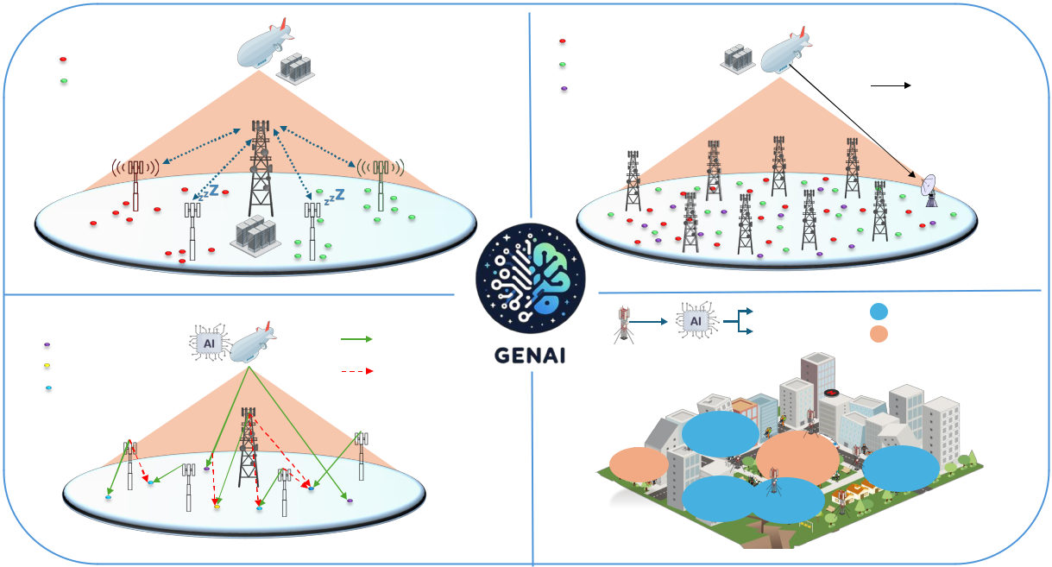

Fig. 3. GenAI demand-shaping usage scenarios in wireless networks. The GenAI logo in the middle of the figure has been created by the DALL·E 2 which is a text-to-image model developed by OpenAI.

words, GenAI can make comprehensions from the meaning of the data, and optimize the content. To this end, voice and text messages can be summarized using GenAI, without loss of inference from its original type, in order to compress the user data to further relax the network traffic.

- Demand-rescheduling: Although demand-shaping is a powerful tool for managing network traffic, applying this process is not feasible for certain types of data due to the risk of information loss. To address this issue, demand can be rescheduled, meaning that content can be transmitted at a different time, such as when data traffic is idle or relatively low. Furthermore, if the network’s available resources are insufficient to accommodate both critical and non-critical data, demand-rescheduling can be a potential solution for non-critical data to decrease the network traffic load.

Fig. 2 illustrates the concept and methodology of demand-planning through GenAI in wireless networks. The process begins with user data labeling and proceeds to demand-shaping. Pre-trained GAN models generate synthetic data to complement the collected data in demand-shaping; therefore, a comprehensive dataset is ensured. The user demand can then be compressed and optimized using VAEs, DMs, or trans-former algorithms. Hence, the resource allocation and network performance become more efficient thanks to the optimized dataset as well as the compression process. Additionally, the transmission of non-critical data can be rescheduled when necessary.

- USAGE SCENARIOS IN WIRELESS NETWORKS

Employing GenAI models for demand-planning in wireless networks provides advantages in various usage scenarios.

Particularly, demand-planning can be implemented in uplink or downlink communications to improve the resource utilization of the wireless networks, in scenarios where the resources are insufficient to fulfill the users’ demand. According to the network’s available resources and specific requirements of the users, a GenAI model can be employed, at the user terminal and/or the network side, i.e., at the BS, to facilitate demand-planning.

In this section, we introduce potential usage scenarios, where demand-planning through GenAI can improve the per-formance of wireless networks in terms of energy consumption and spectral efficiency. These usage scenarios, illustrated in Fig. 3, include sustainability through cell-switching, user asso-ciation and load balancing, interference management, and dis-asters and unusual gatherings that necessitate quick decision-making. Each usage scenario contains a diverse set of users and BS types, such as small BS (SBS), macro BS (MBS), and high altitude platform stations (HAPS) as international mobile telecommunications (IMT) BS (HIBS). It is worth mentioning that the GenAI logo at the center of Fig. 3 has been created by the DALL·E, a text-to-image model developed by OpenAI.

A. Sustainability through Cell-Switching

Cell-switching is a viable solution that seeks idle or lightly loaded SBSs, offloads their traffic to MBSs, and puts them into sleep mode as they are no longer needed to operate [11]. The operating principle of cell-switching is based on the density of the resource blocks (RBs) of BSs (i.e., data traffic loads). GenAI-based demand-planning allows for adjusting the RBs demanded by each user, thereby optimizing the resource utilization of a BS. Therefore, the available capacity of the

