Scaling Responsible AI Solutions 2024
SRAIS Deep Dive Summary
Team Members
(Names and Affiliations)
Project Title
Topic
GPAI Area Focus
Disclaimers  (To be checked by the team members) | - I consent to the publication of my RAI Scalability Deep Dive in the GPAI 2024 report.  - I consent to my name appearing in the GPAI 2024 report.

Context
This document is a short deliverable that captures the work done by the team with the mentors on addressing a key Responsible AI Scaling challenge identified collectively at the beginning of the mentorship. It captures the important findings from the mentorship exercise and provides a tailored, actionable output addressing the challenges of RAI scaling in your context. It also showcases potential solutions, strategic insights and mitigations developed in collaboration with mentors to address the main challenges you face in terms of RAI Scalability. The document ensures practical applicability to effectively manage responsible AI scaling issues in your context.
Instructions
- To be completed by the AI team with guidance from their mentors
- Complete your SRAIS Deep Dive Summary in this document, in the following pages
- The RAI Scalability Deep Dive should be no longer than two pages (approximately 1000 words) in length
- The writing format should meet the following requirements:
- Typeface: Arial
- Point: 11
- Interlining: 1.15
- Text Alignment: Justify
- Send your SRAIS Deep Dive Summary to your mentor and the project managers by September 10 2024:
- Arnaud Quenneville-Langis: arnaud.quenneville@ceimia.org
- Laëtitia Vu: laetitia.vu@ceimia.org

Disclaimer
Mentorship Disclaimer
The mentorship program provides teams and stakeholders with guidance and support on issues related to Artificial Intelligence. Although some mentors in this program are licensed attorneys, all information, advice, and materials provided during the mentorship sessions are for general informational purposes only and should not be construed as professional legal advice. Any discussions, recommendations, or documents shared during the course of the mentorship are not intended to, and should not, substitute for professional legal advice. It is of utmost importance that all teams and stakeholders seek advice from their own qualified legal professionals for any legal matters, decisions, or actions they are considering. Relying solely on the information provided during the mentorship sessions for legal decisions is done at your own risk.
No Legal Liability
It is crucial to understand that under no circumstance shall CEIMIA, the mentors, the mentorship program, or any affiliated entities be held liable for any loss or damage incurred as a result of using or relying on any information provided during the mentorship sessions.
External Legal Consultation
We recommend consulting with a licensed attorney who can provide tailored legal advice based on your specific circumstances. This will ensure you receive accurate, current, and comprehensive legal counsel to support your decisions.

- Lead mentors have to make sure that the team members are aware, understand and agree with the disclaimer above.

Solution description
AgentAnalytics.AI AI co-workers automate and augment work done by different SMEs, with oversight by Responsible AI (RAI) coworkers, monitoring the outcomes generated to achieve fairness, impartiality, and compliance, for a trustworthy AI products.

RAI coworker agents are open-source LLM agents dedicated to Responsible AI aspects. They look into the ethical components (fairness, transparency, accountability, privacy) of a document or query, and provides an estimate (score) associated with each of these components. They are pooled in a multi-agent configuration to improve upon the performance of any single RAI coworker.

The pooling of the agents for the evaluation of a document or incoming query occurs at 3 levels:

- Each RAI coworker individually assesses the document/query’s characteristics and assigns a score to each of fairness, transparency, privacy, accountability
- All the RAI coworkers in the pool enter a dialogue to come to a common score of the dimensions above.
- The resulting scores are then mapped to a document/query classification which results in a predetermined document/query treatment behaviour.

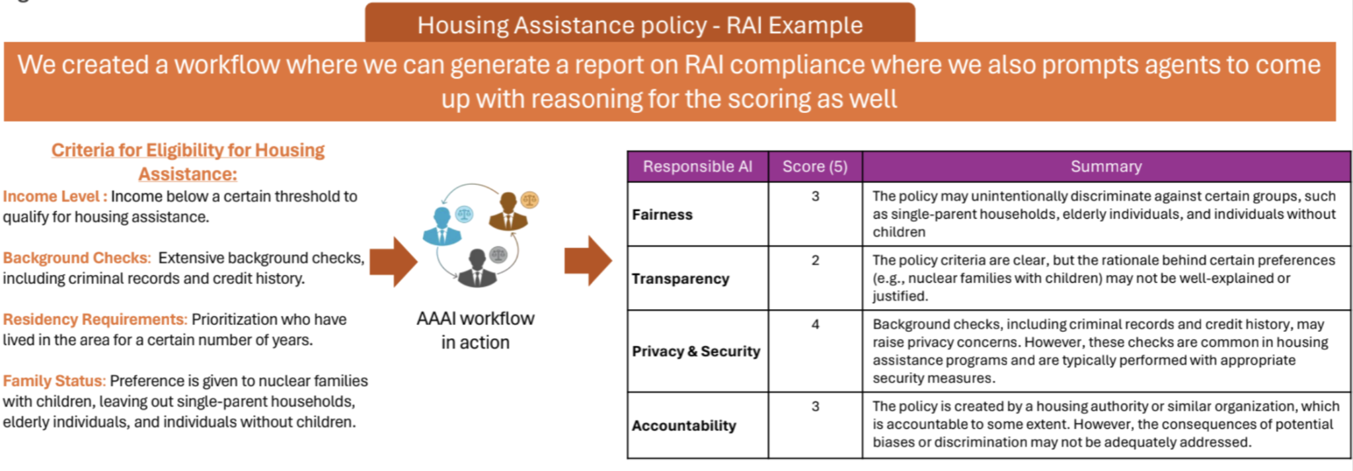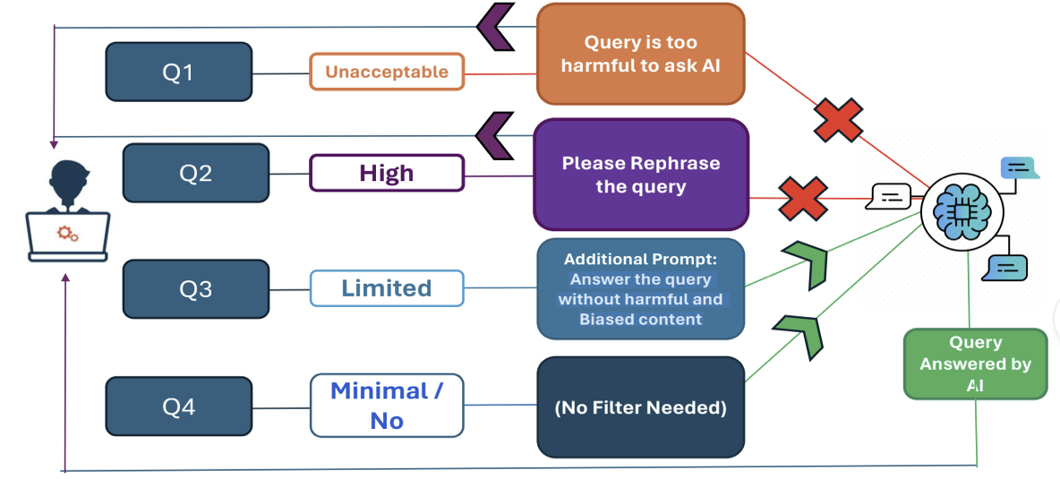

Deep Dive
Responsible AI can be characterized along fairness, transparency, ethical privacy, and accountability criteria. After reviewing the AgentAnalytics.AI platform, it was decided to concentrate on fairness and privacy aspects of the multi-agent mechanisms described below. Accountability and transparency were considered tightly dependent on the use cases outside the scope of the platform, and the explainability mechanism utilized by the platform relies on a referencing scheme being patented by the developers. We have identified however potential explainability issues related to the leakage of personal information. It is to be noted that by operating at the platform level, the scalability of the platform is factored in to a large extent.

Responsible AI concerns at the multi-agent level:

Evaluating Responsible AI dimensions through scoring
Assessing RAI dimensions using RAI Agents brings up fairness issues at multiple levels:
- Standalone RAI agent evaluation scores can be biased, as the RAI agent LLM pre-training and fine tuning that can influence the resulting scores. Since these agents are off-the-shelf, little can be achieved beyond quantifying such bias. Quantifying this bias however is important, and methods need to be investigated to consistently evaluate it.
- Beyond the pooling resources management issues, there remains to be demonstrated that the pooling of agents is more efficient that a single agent. AgentAnalytics plans to demonstrate this empirically.
- Pooling a set of such agents to achieve diversity through some consensual or averaging scheme can bring fairness issues of their own if done In parallel, especially in the resources allocation and their fair allocation before exhaustion. Agents with unfair access to resources would be more predominant and skew the outcome. AgentAnalytics plans to adopt a strategy of sequential collaboration among agents . Sequential collaboration can also simplify the consensus building process.
- The AgentAnalytics.AI team would like to leverage the explainability by referencing feature of their platform to ensure that the output generated can be linked to the source (Source back-referencing, Proprietary LINE technology) as a demonstration of fairness of the agents (single or multi-agent schemes) through traceability. This evidence-based scheme has the potential to leak personal information beyond what is necessary for the demonstration of fairness. How to avoid or limit such leakage will be addressed in the SRAIS plan.

Evaluation | Initial Configuration | RAI dimensions | RAI Mitigation strategy
Input level | Setting queries guardrails and prompt injections | Bias  Selecting off-the-shelf LLM agents for query evaluation can influence query classification | Check bias and variance of agents selected  (To be detailed in SRAIS plan)
Output level | Categorization of queries into 4 categories as listed above | Scaling query safety and guardrails | Verify classification accuracy and safety through prompt injection  (To be detailed in SRAIS plan)
Consensus | Initial Configuration | RAI dimension | RAI Mitigation strategy
Input level | 1. Selecting agents  2. Selecting workflows (Group Chat, Sequential Chat, …)  3. Fixing number of rounds for discussion between agents | Fairness of RAI agents and in consensus scheme | (To be detailed in SRAIS plan)
Output level | Selecting which LLM/Agent will conclude the discussion between the agents | Fairness of agents representations in consensus closure (output) | (To be detailed in SRAIS plan)
Leakage | Initial Configuration | RAI dimension | RAI Mitigation strategy/methodology
Input level | Back source referencing - to ensure all outputs can be trace back to the source from where the answer has come in. | Source referencing may result in leaking private information beyond what is necessary | (To be detailed in SRAIS plan)
Output level | Back source referenced data | Scope of reference source information shared | (To be detailed in SRAIS plan)

