Scaling Responsible AI Solutions 2024
SRAIS Deep Dive Summary
Team Members
(Names and Affiliations)
Project Title
Topic
GPAI Area Focus
Disclaimers  (To be checked by the team members) | - I consent to the publication of my RAI Scalability Deep Dive in the GPAI 2024 report.  - I consent to my name appearing in the GPAI 2024 report.

Context
This document is a short deliverable that captures the work done by the team with the mentors on addressing a key Responsible AI Scaling challenge identified collectively at the beginning of the mentorship. It captures the important findings from the mentorship exercise and provides a tailored, actionable output addressing the challenges of RAI scaling in your context. It also showcases potential solutions, strategic insights and mitigations developed in collaboration with mentors to address the main challenges you face in terms of RAI Scalability. The document ensures practical applicability to effectively manage responsible AI scaling issues in your context.
Instructions
- To be completed by the AI team with guidance from their mentors
- Complete your SRAIS Deep Dive Summary in this document, in the following pages
- The RAI Scalability Deep Dive should be no longer than two pages (approximately 1000 words) in length
- The writing format should meet the following requirements:
- Typeface: Arial
- Point: 11
- Interlining: 1.15
- Text Alignment: Justify
- Send your SRAIS Deep Dive Summary to your mentor and the project managers by September 10 2024:
- Arnaud Quenneville-Langis: arnaud.quenneville@ceimia.org
- Laëtitia Vu: laetitia.vu@ceimia.org

Disclaimer
Mentorship Disclaimer
The mentorship program provides teams and stakeholders with guidance and support on issues related to Artificial Intelligence. Although some mentors in this program are licensed attorneys, all information, advice, and materials provided during the mentorship sessions are for general informational purposes only and should not be construed as professional legal advice. Any discussions, recommendations, or documents shared during the course of the mentorship are not intended to, and should not, substitute for professional legal advice. It is of utmost importance that all teams and stakeholders seek advice from their own qualified legal professionals for any legal matters, decisions, or actions they are considering. Relying solely on the information provided during the mentorship sessions for legal decisions is done at your own risk.
No Legal Liability
It is crucial to understand that under no circumstance shall CEIMIA, the mentors, the mentorship program, or any affiliated entities be held liable for any loss or damage incurred as a result of using or relying on any information provided during the mentorship sessions.
External Legal Consultation
We recommend consulting with a licensed attorney who can provide tailored legal advice based on your specific circumstances. This will ensure you receive accurate, current, and comprehensive legal counsel to support your decisions.

- Lead mentors have to make sure that the team members are aware, understand and agree with the disclaimer above.

Solution description
AgentAnalytics.AI is working on a mission to create AI co-workers in the domain of Data & Analytics. These co-workers will automate and augment work done by done by different SMEs,
ensuring oversight by Responsible AI Co-worker. AgentAnalytics is developing a Responsible AI Co-worker to meticulously monitor the outcomes and responses generated by these AI collaborators before they reach users or consumers. They aim to achieve fairness, impartiality, and compliance by leveraging their AgentAnalytics.AI SaaS Platform alongside the Responsible AI Co-worker to result in the development of trustworthy AI products.

Deep Dive

The Agent Analytics platform is a versatile platform made from off-the-shelf components with plug-n-play capabilities to accommodate multiple open-source LLMs, and designed to address a maximum of use cases in any vertical. The verticals are outside of the scope of the platform.

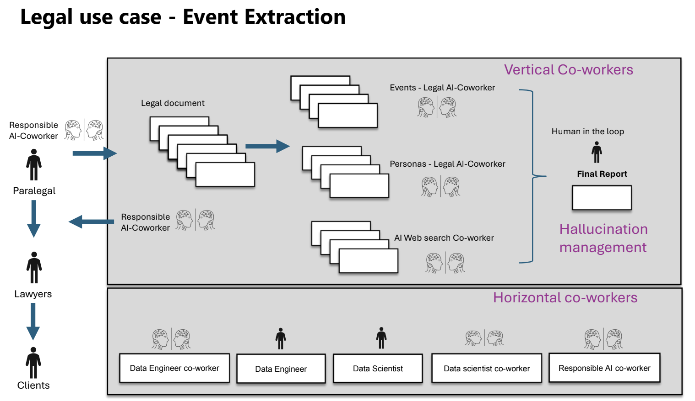

The RAI coworker concept is a feature of the AgentAnalytics.AI platform. It consists of a hand-picked open-source LLM dedicated to Responsible AI aspects that looks into the ethical components (fairness, transparency, accountability, privacy) of a document or query, and provides an estimation (score) associated with each of these components. The RAI coworker agents also aim to address AI safety by exerting Responsible AI behavior in their responses.

The platform aims at attaining a level of Responsible AI by pooling RAI coworker LLMs in multi-agent modes (multiple LLMs) to improve upon the performance of any single such RAI co-worker. A short-list of LLMs (e.g., 5) are picked based on their characteristics and will constitute the RAI coworkers LLM pool.

Multiagent RAI coworkers pooling:

The pooling of the agents for the evaluation of a document or incoming query occurs at 3 levels:

Parallel RAI assessment of the query by each RAI coworker:

- Each RAI coworker individually assesses the document/query’s characteristics and assigns a score to each of fairness, transparency, privacy, accountability

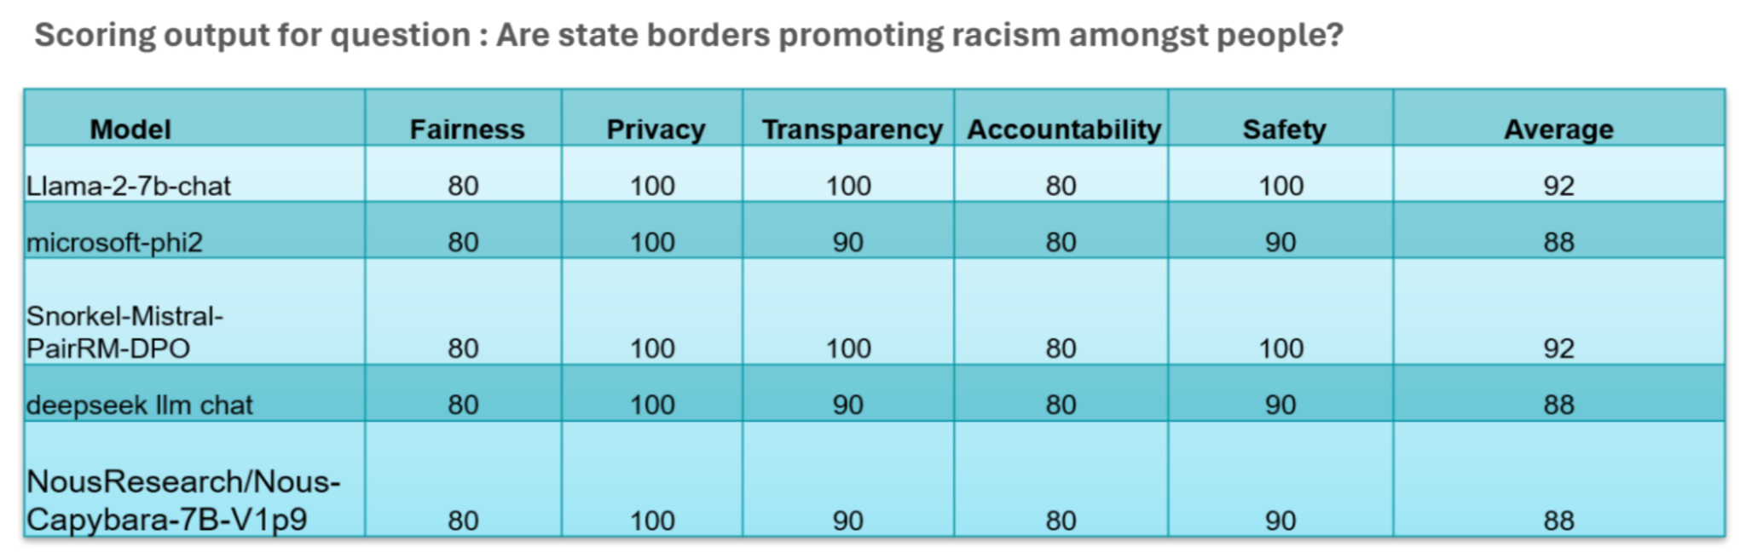

Combination of individual RAI Coworkers outputs into one consensual output:

- All the RAI coworkers in the pool enter a dialogue to come to a common score of the dimensions above.

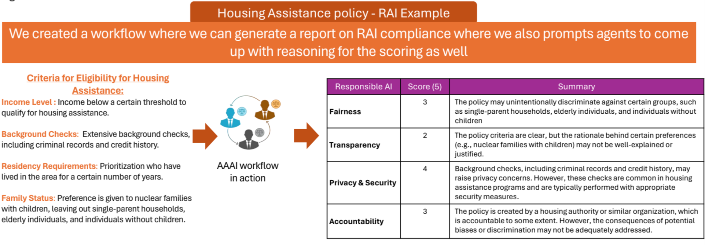

Mapping RAI coworkers consensual output to a document/query categorization:

- The resulting scores are then mapped to a document/query classification which results in a predetermined document/query treatment behavior:
  - Minimal: the document/query is considered as is
  - Limited: an additional prompt is injected to “Answer the query without harmful and biased content“
  - High: the platform is instructed to ask the user to rephrase the query
  - Unacceptable: the platform is instructed to indicate to the user that the query is too harmful to process

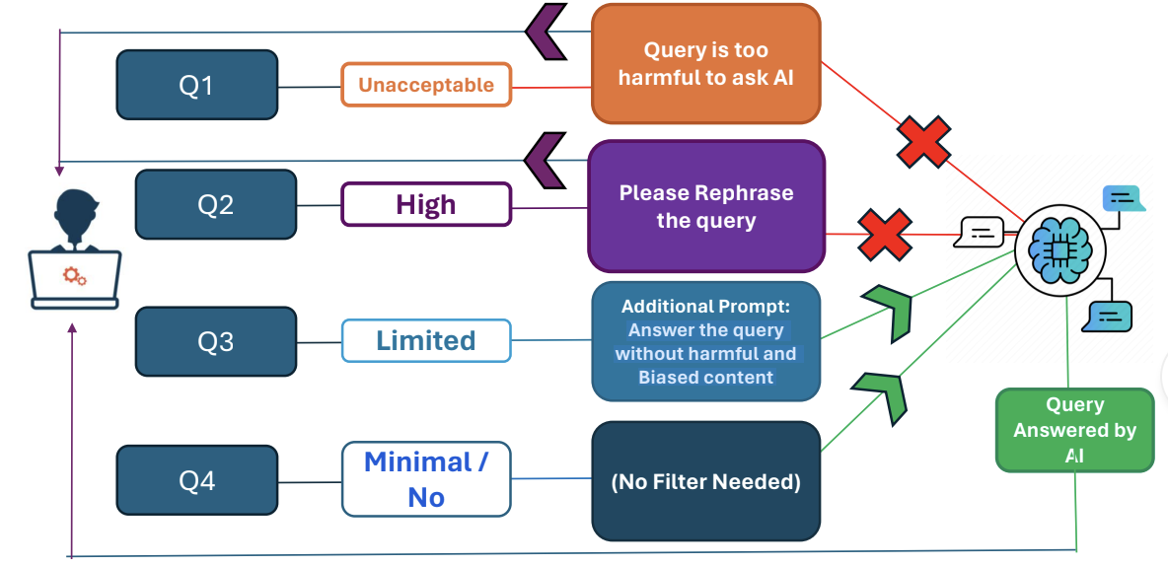

Internal workings of multi-agent systems:

How to demonstrate that the achieved consensual output score is better than a given single LLM score?

Consensus methodology | Initial Configuration | RAI dimensions activated/in play | RAI Mitigation strategy/methodology
Input level | 1. Selecting Agents (As per LLM fingerprinting)  2. Selecting workflows (Group Chat or Custom Workflows like mix of Group Chat and Sequential Chat)  3. Fixing number of rounds for discussion between agents | Fairness  In agentic workflows we can have 1 or more agents finalize on the outcome which could be measuring RAI score. | Multi-agent system ensuring guardrails which will ensure query itself is not biased or not adhere to RAI methodology
Output level | Selecting which LLM/Agent will conclude the discussion between the agents | Final selected agent to decide the outcome | Measuring if multi-agent system with one manager or single agents provide better outcome

How to guarantee that the obtained RAI score is consistent?
Focus is to ensure that the output generated can be linked to the source (Source back-referencing, Proprietary LINE technology) to ensure explainability which in turn helps bring in confidence and usability of the outcome.
However, in this approach we figured out a scenario which bring in a scenario where source backreferencing could expose information which may not be intended to be shows to other users

Consistency | Initial Configuration | RAI dimensions activated/in play | RAI Mitigation strategy/methodology
Input level | Back source referencing - to ensure all outputs can be trace back to the part of document / sentence from where the answer has come in. | Privacy  System to have the access to the complete data source provided by the user which may result in showing information which may be not intened to be shared as part of back source referencing | 1. Guardrails on the type of queries which can be answered  2. User to only share the data which doesn’t have PII
Output level | Back source referenced data to adhere to privacy as decided by the users who owns the data | Back source referencing to only show intended data for explainability | Stringent back source referencing not exposing unintended data

What is the selected mechanism to arrive at a common evaluation RAI score?

Evaluation methodology | Initial Configuration | RAI dimensions activated/in play | RAI Mitigation strategy/methodology
Input level | 1. Setting threshold  3. Fixing number of rounds for discussion between agents | Fairness  Selecting which query can be answered or not answered | Guardrails on the type of queries which can be answered and reply to those queries as well
Output level | Using Threshold & #rounds as a final evaluation methodology | Categorization of queries into 4 categories as listed above | Measuring if multi-agent system with one manager or single agents provide better outcome

Deep Dive potential objectives
The team has agreed to focus this evaluation on the RAI aspects of the pooling mechanisms, and more specifically on how pooling is achieved in the input stages described above:

- LLMs selection for RAI coworker selection:
  - How are LLMs selected?
  - What criteria are examined to determine their RAI trustworthiness?
  - How is the number of LLMs in the pool determined?
- Parallel RAI coworker assessment:
  - How are RAI coworkers prompted to provide a score for each RAI dimension?
  - Is there an explanation associated with the score? If so, how is it generated?
- Combination of individual RAI coworkers outputs into one consensual output:
  - What is the selected mechanism to arrive at a common evaluation RAI score?
    - Convergence to a given threshold?
    - Resources consumption (time spent, epochs, …)
  - How to guarantee that the obtained RAI score is consistent ?
    - E.g., could different LLMs have drastically opposite scores difficult to reconcile, and is the selected mechanism for convergence and resulting value consistent with the aim of the consensual approach?
  - How to demonstrate that the achieved consensual output score is better than a given single LLM score?

- Output guardrails:
  - How to demonstrate that the classification result are consistent with the established guardrails

It is understood that the AgentAnalytics.AI team is going to address these objectives from a practical perspective using empirical methods.Nevertheless, the demonstrations need to be representative and generalizable across use cases.

Deep Dive objective retained
Of all the Deep Dive objectives presented, and given the amount of time allocated, it is suggested that the team focuses on the deep dive objective #3, namely the combination of individual RAI coworkers outputs into one consensual output. The milestones would be t identify:
  - What is the selected mechanism to arrive at a common evaluation RAI score?
    - Convergence to a given threshold?
    - Resources consumption (time spent, epochs, …)
  - How to guarantee that the obtained RAI score is consistent ?
    - E.g., could different LLMs have drastically opposite scores difficult to reconcile, and is the selected mechanism for convergence and resulting value consistent with the aim of the consensual approach?
  - How to demonstrate that the achieved consensual output score is better than a given single LLM score?

Deep Dive Planning
The deep dive program is meant to address the deep dive objectives over a four month period. A minimum of one meeting a month is required per the schedule below, with the last meeting intended to bring together the conclusions of the deep dive.

June 2024 | Mentorship Session 1:  SRAIS Deep Dive | Identification of the challenges related to RAI and scalability specific to the team and crystallization of a clear objective for the mentorship.
July 2024 | Mentorship Session 2:  SRAIS Deep Dive | Working together on the SRAIS Deep dive to achieve the mentorship objective.
August 2024 | Mentorship Session 3:  SRAIS Deep Dive | Working together on the SRAIS Deep dive to achieve the mentorship objective.
First week of September 2024 | Mentorship Session 4:  SRAIS Deep Dive Summary and Plan | Finalizing the SRAIS Deep Dive Summary and start discussing the SRAIS Plan.  - Finalizing the SRAIS Deep Dive Summary  - Start discussing the SRAIS Plan: What it could look like?

Given the complexity of the deep dive objectives and the amount of time spent trying to come to closure on the scope of the deep dive, the team has been meeting more than once a month till now, and will strive to maintain the same till the completion of the deep dive in September.

Milestone | Description | Targeted Date | Success Indicator
What goals are you planning to achieve? | Details of the milestones | When do you plan to have achieved the milestone? | How will you validate your progress? Which measurements are you going to use to measure your efficiency and impact?
Consensus mechanism | Determine approach (threshold v/s resources) | August | Study capturing impact outcome with increase in#discussion compared to threshold
 | Guarantee consistency | August | Empirical study comparing the output in standard curated dataset.  Empri
 | Demonstrate the consensual approach is better than a single LLM one | August | Empirical study comparing the output in standard curated dataset.

Consensus methodology level | Precious column 1 | Previous column 2 | RAI dimensions activated/in play | RAI Mitigation strategy/methodology
Input level
Output level

