# Transcription of DanF16Ride

Transcription using AWS Transcribe automatic speech recognition.

Document produced on Friday 21 February 2020 at 09:25:55 using the 'tscribe' python package.

Grey text has less than 98% confidence.

|  |  |  |
| --- | --- | --- |
| Confidence | Count | Percentage |
| 98% - 100% | 277 | 44.68% |
| 90% - 97% | 63 | 10.16% |
| 80% - 89% | 30 | 4.84% |
| 70% - 79% | 32 | 5.16% |
| 60% - 69% | 18 | 2.9% |
| 50% - 59% | 15 | 2.42% |
| 40% - 49% | 11 | 1.77% |
| 30% - 39% | 10 | 1.61% |
| 20% - 29% | 3 | 0.48% |
| 10% - 19% | 1 | 0.16% |
| 0% - 9% | 0 | 0.0% |

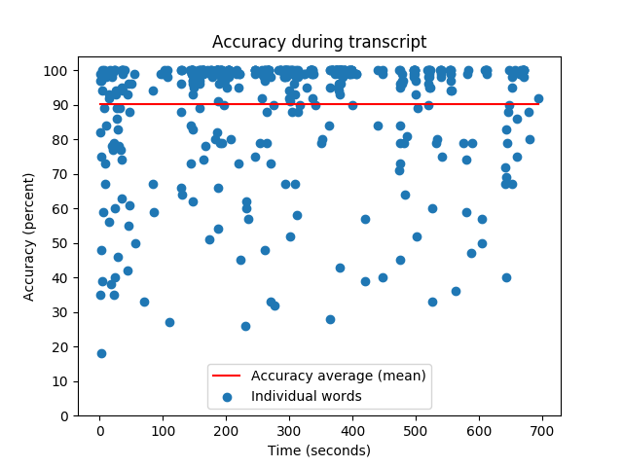

|  |  |  |
| --- | --- | --- |
| Time | Speaker | Content |
| 0:00:00 | spk_0 | altitude. So our practice attacks with different. It's interactive additional drone aircraft threat communications at 10. |
| 0:00:08 | spk_0 | Too far. |
| 0:00:10 | spk_0 | It's like |
| 0:00:14 | spk_0 | down below. You |
| 0:00:16 | spk_0 | trailing reds |
| 0:00:19 | spk_0 | set you up for a shot. |
| 0:00:21 | spk_0 | Your ass |
| 0:00:22 | spk_0 | thing does not turn well. |
| 0:00:24 | spk_0 | Hans, slow down. Slow down. |
| 0:00:28 | spk_0 | She limited |
| 0:00:30 | spk_0 | your service. |
| 0:00:33 | spk_1 | Five e above us there on a 53 of their |
| 0:00:40 | spk_1 | next. |
| 0:00:43 | spk_1 | I don't. |
| 0:00:45 | spk_1 | That's it. |
| 0:00:47 | spk_1 | I'm so |
| 0:00:50 | spk_1 | level |
| 0:00:54 | spk_1 | down. |
| 0:00:56 | spk_1 | Mmm |
| 0:01:10 | spk_1 | huh? |
| 0:01:23 | spk_1 | Yes. Yeah. |
| 0:01:26 | spk_1 | It's |
| 0:01:36 | spk_1 | this |
| 0:01:39 | spk_1 | that |
| 0:01:43 | spk_1 | Yeah, |
| 0:01:46 | spk_1 | I'm stolen. |
| 0:01:49 | spk_1 | Really? |
| 0:02:08 | spk_1 | Let's go with five e |
| 0:02:10 | spk_1 | The three. |
| 0:02:21 | spk_1 | Yeah, |
| 0:02:23 | spk_1 | it was. |
| 0:02:25 | spk_1 | So I basically want to kind of go on the heading. I'm going and then pull behind him, right? |
| 0:02:36 | spk_1 | Yeah. |
| 0:02:38 | spk_1 | How do I don't how far he is. |
| 0:02:42 | spk_1 | Oh, I can't get a radar lock on him yet. |
| 0:02:47 | spk_1 | Okay. |
| 0:02:49 | spk_1 | Yeah, |
| 0:02:54 | spk_1 | yeah, yeah. Wait. Which one is fire? My |
| 0:03:02 | spk_1 | Oh, |
| 0:03:04 | spk_1 | yeah. Okay. Yeah. I wasn't sure if it was. I guess this gun's No, it's not engaged. |
| 0:03:09 | spk_1 | Okay. |
| 0:03:11 | spk_1 | Oh, you can't just fire him, okay? |
| 0:03:16 | spk_1 | Oh, |
| 0:03:18 | spk_1 | no |
| 0:03:20 | spk_1 | manuals. |
| 0:03:23 | spk_1 | I'm a fighter, jock. I don't need no manual |
| 0:03:27 | spk_1 | reestablishing. |
| 0:03:35 | spk_1 | There is. |
| 0:03:39 | spk_1 | Oh, there's a serious |
| 0:03:42 | spk_1 | further. |
| 0:03:50 | spk_1 | Oh, |
| 0:03:51 | spk_1 | box, too. |
| 0:03:55 | spk_1 | What? |
| 0:04:05 | spk_1 | Yeah, I think he went down. |
| 0:04:12 | spk_1 | Okay. |
| 0:04:16 | spk_1 | Is there an afterburner? |
| 0:04:20 | spk_1 | Oh, I am running full afterburner. |
| 0:04:23 | spk_1 | Oh, I see. Okay, |
| 0:04:25 | spk_1 | I'm trying to catch up to this, dude. |
| 0:04:30 | spk_1 | Well, fuck that. |
| 0:04:34 | spk_1 | What? |
| 0:04:37 | spk_1 | Watching? |
| 0:04:42 | spk_1 | Yeah, |
| 0:04:45 | spk_1 | I think I'm getting |
| 0:04:50 | spk_1 | the I r. Target acquisition of Super Quick on these. |
| 0:04:55 | spk_1 | It's just instant. |
| 0:04:58 | spk_1 | Oh, right. Ame ni a Fox two |
| 0:05:03 | spk_1 | I think that hit. |
| 0:05:04 | spk_1 | Yeah. |
| 0:05:05 | spk_1 | Splash |
| 0:05:07 | spk_1 | splash from bogey |
| 0:05:10 | spk_1 | one left. |
| 0:05:12 | spk_1 | Don't I killed two already. |
| 0:05:17 | spk_1 | Oh, |
| 0:05:22 | spk_1 | go |
| 0:05:23 | spk_1 | go |
| 0:05:26 | spk_1 | hotel. |
| 0:05:32 | spk_1 | Oh, so it is. I should probably stop Just going full afterward, huh? |
| 0:05:41 | spk_1 | Oh, |
| 0:05:50 | spk_1 | okay. Okay. |
| 0:06:02 | spk_1 | Yeah, |
| 0:06:04 | spk_1 | That be five minutes. |
| 0:06:07 | spk_1 | That is five minutes of fuel. |
| 0:06:12 | spk_1 | No, that's not That's three minutes of fuel. |
| 0:06:16 | spk_1 | Two minutes of shit. |
| 0:06:18 | spk_1 | I gotta do math and trying to fly. I can't do math in my head. Will I fly 60? Divided by five. That's |
| 0:06:27 | spk_1 | three minutes of fuel. |
| 0:06:34 | spk_1 | I don't see the other. Dude, |
| 0:06:37 | spk_1 | can you give me infinite fuel? |
| 0:06:39 | spk_1 | Oh, |
| 0:06:45 | spk_1 | what else? |
| 0:06:59 | spk_1 | Oh, yeah, |
| 0:07:19 | spk_1 | it's 50. |
| 0:07:27 | spk_1 | Yeah, almost there. |
| 0:07:53 | spk_1 | No, these They're past that. These air passive drones |
| 0:07:57 | spk_1 | turning red smoke? |
| 0:08:00 | spk_1 | No. |
| 0:08:02 | spk_1 | Okay, |
| 0:08:03 | spk_1 | it's |
| 0:08:06 | spk_1 | it's |
| 0:08:16 | spk_1 | Oh, how do I get out of here? Oh, God. |
| 0:08:20 | spk_1 | I hit uptown. |
| 0:08:22 | spk_1 | Um, |
| 0:08:39 | spk_1 | is there an economy button? There's no economy. There is, though. Haha. |
| 0:08:46 | spk_1 | Watch it. |
| 0:08:52 | spk_1 | Okay, Okay, |
| 0:08:58 | spk_1 | look I fly like I drive. Okay. |
| 0:09:14 | spk_1 | I like speed. And I'm not concerned. Fuel economy? |
| 0:09:23 | spk_1 | No. |
| 0:09:35 | spk_1 | Okay. |
| 0:09:39 | spk_1 | Fox two |
| 0:09:42 | spk_1 | backing off |
| 0:09:48 | spk_1 | one. Okay. |
| 0:10:04 | spk_1 | Fox two. |
| 0:10:08 | spk_1 | Yeah, |
| 0:10:11 | spk_1 | I think I'm too far |
| 0:10:41 | spk_1 | box, too. |
| 0:10:43 | spk_0 | Marks, too. Winchester. |
| 0:10:45 | spk_0 | Have |
| 0:10:47 | spk_0 | track is good. |
| 0:10:52 | spk_0 | Splash one bogey. |
| 0:10:56 | spk_0 | Nice. |
| 0:11:00 | spk_0 | Uh huh. |
| 0:11:04 | spk_0 | Graduation? Yeah. |
| 0:11:06 | spk_0 | Yeah, |
| 0:11:08 | spk_0 | it's It's been about 20 years since I've landed. |
| 0:11:19 | spk_0 | Get out, |
| 0:11:34 | spk_0 | lecture. |