FIELD NOTE · AI & THE VALUE CHAIN
The System, Not the Task
Sangeet Paul Choudary’s Reshuffle, and what it means for how we build software
Choudary’s central claim is that AI’s real economic impact is not automation — it is coordination. This paper sets out his concepts, the examples he uses to make the case, and a phase-by-phase mapping onto the software development lifecycle (SDLC).
THE MECHANIC IN ONE LINE
A job is a bundle of tasks (draft · look up · classify · judge · verify) that AI unbundles, then rebundles around what stays scarce: judgment, orchestration, verification.
A synthesis of Reshuffle: Who Wins When AI Restacks the Knowledge Economy (2025). Internal explainer — share freely.

Contents
00 If you read nothing else
01 Coordination, not automation
02 Four ideas that do the work
03 The examples he uses
04 Mapping the reshuffle to the SDLC
05 Honest limits
06 What to do about it
— Sources & further reading

00 · The short version

If you read nothing else
Most teams adopt AI by asking what it can automate. Choudary’s argument is that this is the wrong question — and that teams who only ask it will optimise themselves into the part of the system that is about to lose its value.
- The reframe. AI’s leverage is not doing existing tasks faster; it is letting parts of a system coordinate that never could before. Automation is the first-order effect; the reshuffle of who holds value is the real one.
- The mechanic. When AI removes a constraint, the system built around it — a job, a team, a value chain — unbundles into components and rebundles around whatever is now scarce.
- The rule. Scarcities erode; constraints persist and move. Value migrates to whoever sits at the new constraint — usually upstream (defining the work) and at verification (judging it).
- For the SDLC. As the cost of producing code collapses, value leaves implementation and moves to specification, evaluation, orchestration and verification. The pipeline reshuffles from a relay race into an orchestrated system.
- The trap. Bolting AI onto today’s process as a tool makes you faster at the old game. Using it as the engine changes the game — and that is where advantage is created.
01 · The reframe

Coordination, not automation
The central argument of Reshuffle is that we are misreading AI the same way the world misread the shipping container in 1956 — as a faster way to do the work we already do.
Choudary calls the automation framing the “intelligence distraction.” Asking how clever AI is, or which tasks it can take over, keeps attention on first-order effects: cheaper, faster, fewer people. His claim is that the deeper impact comes from how AI restructures the system around a task — letting domains, teams and tools coordinate where they previously couldn’t, and in doing so reshuffling where value and power sit.
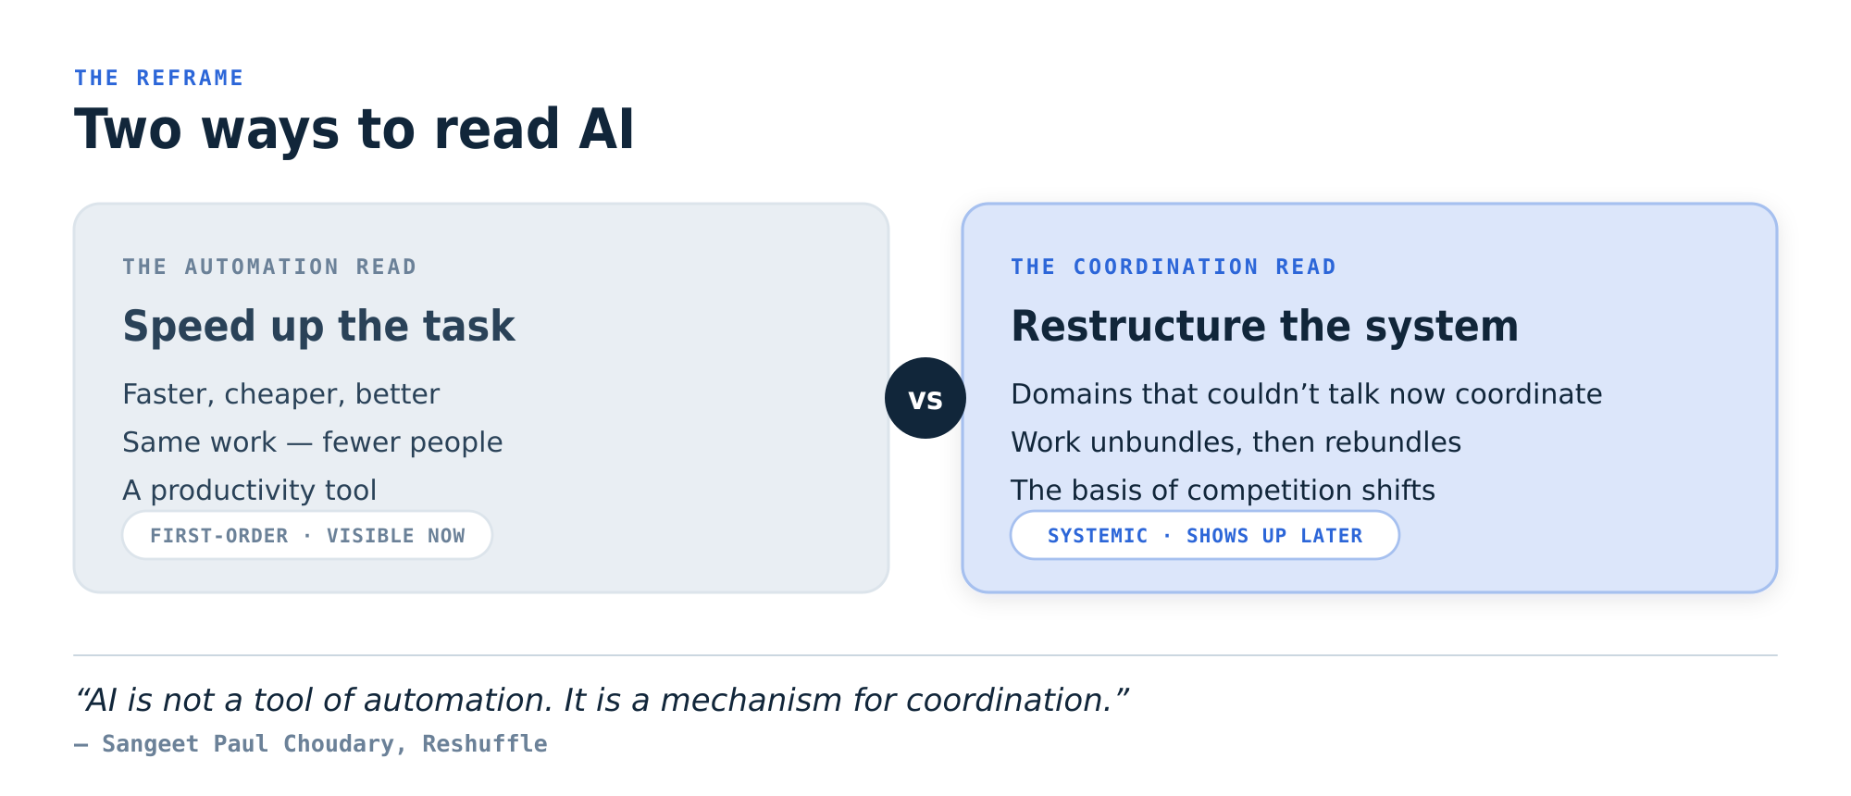
Fig 1 — Two readings of AI. The automation read is visible immediately and mostly priced in; the coordination read is systemic and shows up later — which is why it is underestimated.
“AI is not a tool of automation. It is a mechanism for coordination.”
— Sangeet Paul Choudary, Reshuffle
02 · The concepts

Four ideas that do the work
The book rests on a small set of interlocking ideas. Understand these four and the rest — including the software mapping — follows.

2.1 Systems organise around constraints
A job, a firm, an industry — each exists to manage some constraint. Choudary names three kinds: scarcity (rare expertise), risk (liability and uncertainty), and coordination (aligning fragmented actors). Value accrues to whoever resolves the binding constraint. When AI removes one — makes expertise abundant, execution cheap, access easy — the value on that constraint doesn’t evaporate. It migrates to the next constraint. Scarcities erode; constraints persist and move.
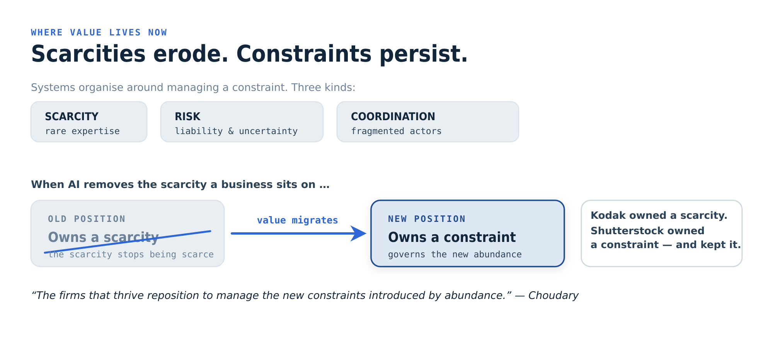
Fig 2 — Follow the constraint. The strategic question is not “what new skill should we acquire?” but “where is the new constraint, and what would it take to reposition around it?”
“When AI removes a scarcity, the firms that thrive aren’t the ones that double down on what they used to do best. They reposition to manage the new constraints introduced by abundance.”
— Sangeet Paul Choudary, Reshuffle

2.2 Unbundling and rebundling — the universal mechanic
This is the engine of the whole book. A job is really a bundle of tasks — draft, look up, classify, judge, own the relationship, verify — held together because it was historically cheaper to keep them in one person than to split them. AI unbundles that bundle into components that can each be performed, audited or replaced separately. Some commoditise first (and, Choudary notes, not the ones you’d guess). The job doesn’t disappear; it rebundles around the constraints that remain — judgment, orchestration, and verification.
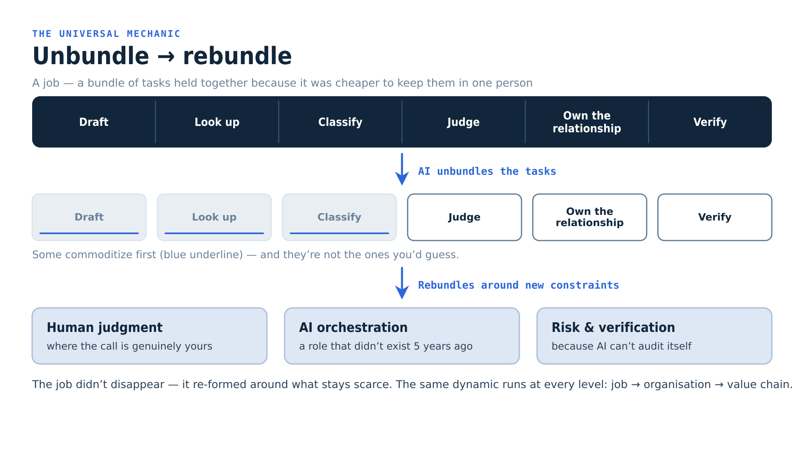
Fig 3 — The universal mechanic. The same dynamic runs at every level: the job, then the organisation (which functions centralise vs. disperse), then the value chain (which firms become orchestrators vs. commoditised suppliers).
A useful distinction
Economic value vs. contextual value. Economic value comes from scarcity, and AI collapses it wherever output is “good enough” — eroding the skill premium experts once charged. What survives is contextual value: judgment tied to a specific situation, accountability for an outcome, and the trust to own a decision. Work that is pure economic-value-from-scarcity is most exposed; work rich in context is where people rebundle.

2.3 Coordination without consensus
Here is the part with no historical precedent. The container only worked once every port, carrier and trucker agreed on one standard — ISO dimensions, a single bill of lading. The format had to be settled before anything could move. AI doesn’t need that. It learns each silo’s language and translates between them without forcing anyone to standardise: support keeps writing tickets, engineering keeps writing bug reports, legal keeps writing briefs, and AI moves meaning across. Translation cost falls to near zero, so coordination can start before anyone agrees.
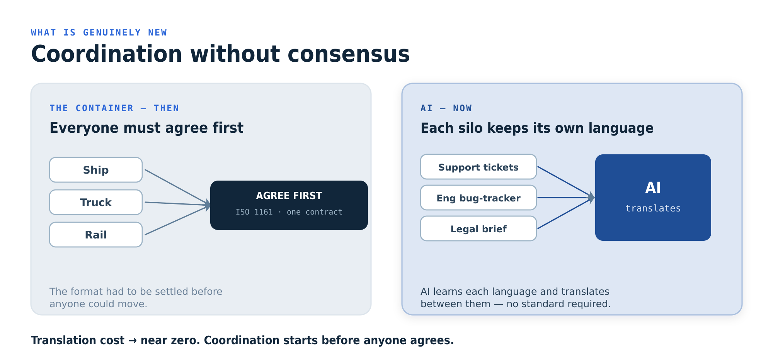
Fig 4 — Coordination without consensus. The real impact won’t show up as cost savings on existing tasks; it shows up in domains that have talked past each other for years suddenly working together.

2.4 AI as the engine, not a tool
Most companies use AI as a tool: they bolt it onto an existing architecture to do the current job better. The prize goes to those who use it as the engine — who let the system reorganise around what AI makes possible. The difference decides whether you compete harder at the old game or change the rules of the game entirely.
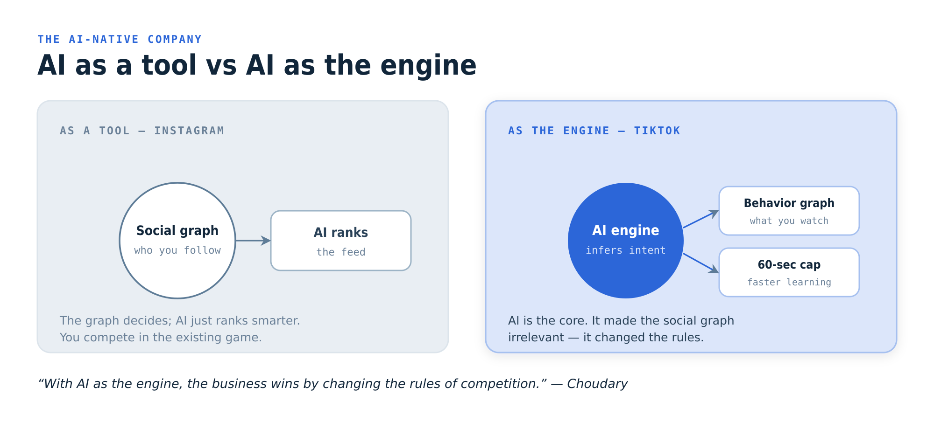
Fig 5 — Tool vs. engine. Instagram used AI to rank a feed its social graph still governed; TikTok made AI the core and rendered the social graph irrelevant. Same business, two architectures, one winner.
03 · The evidence

The examples he uses
Choudary argues by analogy and case, not assertion. These are the stories the book turns on — worth knowing because they are the lens he then points at every industry.

The shipping container — the anchor
In April 1956, Malcolm McLean loaded 58 standardised steel boxes onto a converted tanker and sent them from Newark to Houston. Everyone read it as port automation: faster cranes, bigger ships, fewer dockworkers. They missed it. The real unlock wasn’t speed — it was coordination. Once every mode of transport agreed on the same box and a single contract, the chain became predictable, and a whole new economy got built on that reliability.
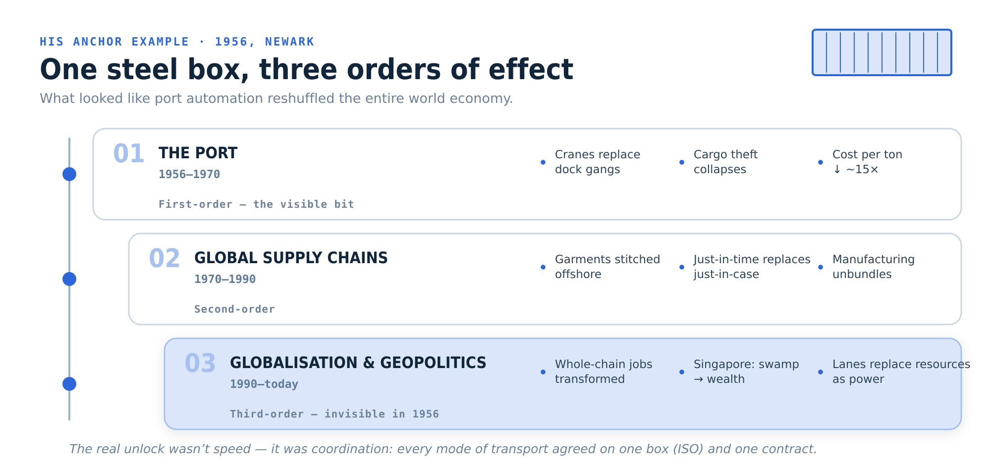
Fig 6 — One steel box, three orders of effect. Singapore rose from a swamp to one of the wealthiest places on earth; control of shipping lanes replaced control of resources as geopolitical power. None of it was visible in 1956. Choudary’s wager: AI is the container, and we are standing in 1956.

Kodak vs. Shutterstock — value migration
Two firms, the same shock — the commoditisation of a scarcity-based business — and opposite outcomes. It is the cleanest illustration of “follow the constraint.”
Kodak — owned a scarcity | Shutterstock — owned a constraint
Value lived in physical imaging: film, paper, chemistry. Digital killed film; the smartphone killed the print. The scarcity stopped being scarce, and value walked through layers Kodak didn’t own — storage and search, then sharing and editing, then attention. | Started as a licensable library, but followed the constraint customers actually felt: workflow, rights clearance, compliance, brand governance. When AI then commoditised image generation, Shutterstock was already sitting at the constraint that just got louder — governing infinite images.
The lesson: Kodak owned a scarcity; Shutterstock owned a constraint. Scarcities erode — constraints shift but persist, and the firm positioned at the constraint inherits the value as it migrates.

The knowledge job, unbundled
Take any knowledge role — lawyer, analyst, engineer. It bundles drafting, looking things up, classifying, judging, owning a relationship and verifying. Slide AI’s capability up and the tasks commoditise one by one. What’s left — and what the role rebundles around — is a smaller set of durable constraints: human judgment, AI orchestration, and risk & verification. Hold onto these three; they reappear, almost unchanged, when we get to software.

TikTok vs. Instagram — engine beats tool
Instagram, Facebook and YouTube used AI to rank feeds their social graph still governed — AI as a tool inside the old architecture. TikTok made AI the engine: the feed was driven by a behaviour graph inferred from what you watched, not who you followed. A deliberate constraint — the early sixty-second cap — tightened the feedback loop so the engine learned faster. Analysts thought the incumbents’ network effects were unassailable. TikTok didn’t beat the social graph; it made it irrelevant.

And the quick hits
- Walmart. Built a barcode-native architecture — letting a standardised data interface reorganise everything from shelves to supply chain.
- Shein. Drinks from the firehose of social media, scraping emerging trends off TikTok and Instagram to reinvent how apparel is designed and made.
- Airbus. Constantly-evolving digital twins changed how it designs, builds and supports aircraft — the technology reorganises the work around it.
- Music. Digital distribution unbundled songs from the album; curation and algorithms rebundled them into the playlist. The mechanic, in miniature.
04 · The application

Mapping the reshuffle to the SDLC
Now the part we actually care about. If Choudary is right, the interesting question about AI and software delivery is not which tasks we can automate — it is which new system of building software we can coordinate.
The question to stop asking | The question to ask instead
“What can AI automate in our pipeline?” Leads to faster typing, generated tests, autocompleted tickets — real, but first-order. It optimises the existing relay and quietly invests effort in the phase whose value is about to fall. | “What new system of building software can AI coordinate?” Leads to re-architecting how intent becomes a running system — and to repositioning people at the constraints that survive: specification, judgment, orchestration and verification.

Every phase manages a constraint
Run the lifecycle through Choudary’s lens. Each phase exists not to perform a task but to manage a constraint. When AI collapses that constraint, the phase’s old centre of gravity loses value and a new bottleneck appears — and value migrates toward it.
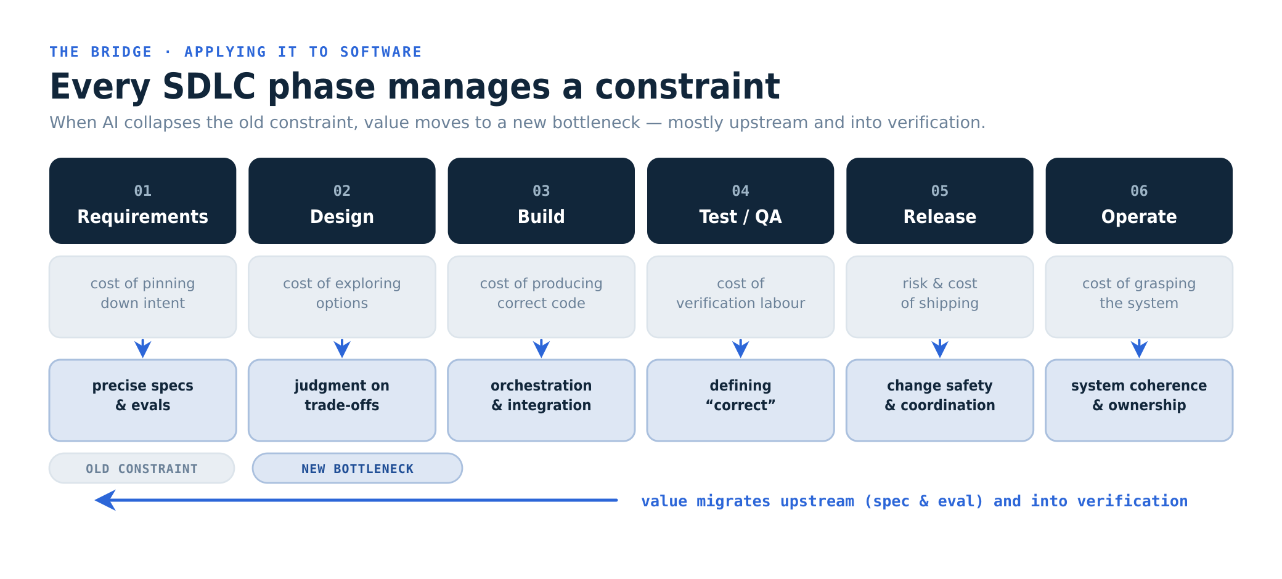
Fig 7 — The SDLC, re-read as constraints. The new bottlenecks cluster upstream (knowing what to build, precisely enough for a machine) and at verification (deciding what “correct” means and owning the risk).
Phase | Constraint it managed | What AI collapses | New bottleneck — where value goes | Who owns it
Requirements & discovery | Turning fuzzy intent into a precise, agreed spec | Drafting PRDs, summarising research, translating between stakeholders | Knowing what to build — and encoding it as a spec and evals precise enough for an agent to build against | Product + spec/eval owner
Design & architecture | Cost of exploring options; irreversibility of decisions | Generating variants, boilerplate, option sketches | Judgment on trade-offs, interfaces and what is genuinely hard to reverse | Senior engineers / architects
Build / implementation | Scarcity and cost of producing correct code | Writing code, scaffolding, refactors, glue | Orchestrating many generated components into a coherent whole; integration | Developers as orchestrators
Test & QA | Cost of verification labour | Generating tests, fixtures, coverage | Defining what “correct” means — the oracle problem — and what risk is acceptable | QA / verification owner
Release & deploy | Risk and cost of shipping a change | Pipeline config, release notes, rollback scripts | Coordinating safe change across systems as change-volume rises | Platform / SRE
Operate & maintain | Cost of understanding and modifying a live system | Reading code, summarising incidents, drafting fixes | Keeping the system coherent under a flood of cheap change; owning the truth | Owning teams

Unbundling and rebundling our roles
The linear SDLC is itself a bundle — it exists to manage hand-off cost and to manufacture consensus before anyone commits expensive work. PM hands to design, design to engineering, engineering to QA, QA to ops. Once AI drops both the cost of producing each artifact and the cost of translating between roles, that bundle comes apart. The roles rebundle around the three constraints that survived in every knowledge job: judgment, orchestration, verification.
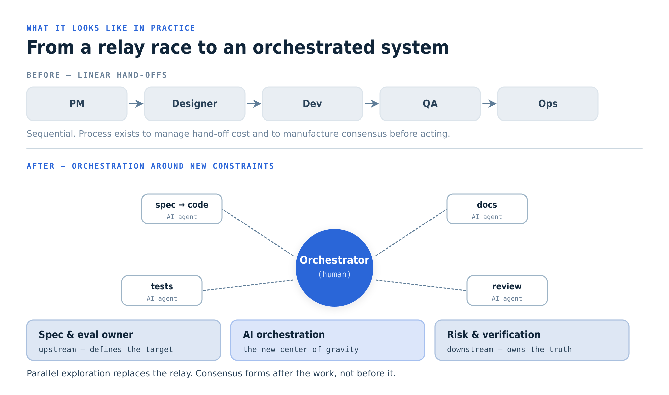
Fig 8 — From a relay race to an orchestrated system. The pipeline becomes a human orchestrating parallel agent work, anchored by three durable roles: who defines the target, who runs the orchestration, and who owns the truth about whether it is right.

Coordination without consensus — inside delivery
The most underrated payoff is internal. Software organisations are a pile of silos that talk past each other: product specs, design files, tickets, code, logs, support conversations, customer calls. Historically we spent enormous effort — meetings, rituals, documents — translating between them to reach enough agreement to act. AI drops that translation cost toward zero. A support thread can update a backlog; a failing log can draft a fix; a spec can become a test. The win isn’t a faster standup — it is domains that never coordinated now doing so without first agreeing on one tool or format.

AI as the engine of the software org
This is the trap to avoid. Treating AI as a tool means a faster IDE and generated boilerplate bolted onto today’s process — the “tool-integration trap.” Treating it as the engine means redesigning the lifecycle around it: the spec and its evals become the durable source of truth, generation is cheap and disposable, and the human work concentrates at the constraints. The first approach makes you quicker at shipping the way you ship now; the second changes what your delivery system is.

Where value lands
Choudary’s prediction for value chains — that value moves toward the start of the chain and toward whoever governs the new abundance — maps cleanly onto software. As writing code commoditises, advantage concentrates in three places:
- Upstream: the people who can state the problem precisely and encode it as a spec and an evaluation an agent can be measured against. The spec becomes the asset; the code becomes a build artifact.
- At verification: whoever can decide what “correct” means and stand behind it. When generation is infinite, judging and governing output is the job — the Shutterstock position.
- At orchestration: whoever can compose many cheap, generated components into a coherent, reliable system — the new centre of gravity that didn’t exist as a role a few years ago.
05 · Where the mapping strains

Honest limits
Choudary’s framework is value-chain economics, not an engineering law. It is a powerful lens on where work and value relocate — and weaker as a claim that the hard parts of software simply dissolve.
Read this before you over-rotate
Some constraints don’t collapse. Distributed-systems complexity, security and safety, regulatory accountability, and the verification oracle problem are real engineering constraints. AI shifts who works on them and how, but it doesn’t make them cheap. The model says value migrates to these constraints — not that they disappear.
Cheaper change is not lower risk. AI lowers the cost of producing a change; it does not automatically lower the systemic risk of shipping one. A flood of cheap change makes coordination and verification more load-bearing, not less.
The analogies persuade; they don’t prove. Containers, Kodak and TikTok are vivid and directionally useful, but they are selected cases. Treat the framework as a way to ask better questions about our own system, not a forecast to execute literally.
06 · The playbook

What to do about it
Concrete moves that follow from the framework — chosen to reposition us at the constraints that survive, rather than to automate the tasks that won’t matter.
- Map your constraints before you reskill. For each team, name the constraint the work actually resolves — scarcity, risk, or coordination. Skills are only valuable in relation to the constraint they resolve; chase new tooling without this and you risk getting very good at something that no longer matters.
- Make specs and evals the source of truth. Invest where value is moving: precise specifications and the evaluations that define “correct.” Treat the spec as the durable asset and generated code as a disposable build artifact. This is the upstream position.
- Build a verification layer, and name who owns it. When generation is cheap and infinite, judging output is the job. Stand up the harness — automated checks, evals, human review at the points that carry risk — and give it a clear owner. That is the Shutterstock move.
- Create the orchestration role explicitly. Someone has to compose parallel agent work into a coherent system. Don’t leave it implicit inside “developer” — recognise orchestration as the new centre of gravity and staff it deliberately.
- Pick one workflow and use AI as the engine, end-to-end. Resist bolting AI onto every step as a tool. Choose a single delivery flow and redesign it around AI from intent to running system. Learn what changes when the system reorganises — then spread it.
- Exploit coordination without consensus. Find two silos that have talked past each other for years — support and engineering, design and QA — and let AI translate between them without a standardisation project. The payoff is in the seams, not the steps.
- Measure system outcomes, not task speed. “Lines per hour” or “tickets closed” is the intelligence distraction in metric form. Track cycle time from intent to verified value, escaped-defect and rework rates, and system coherence. Reward the reshuffle, not the typing.
“You don’t need an AI strategy. You need a strategy for the conditions AI creates.”
— Sangeet Paul Choudary, Reshuffle
Sources & further reading

Go to the originals
Everything here is a synthesis of Choudary’s published work; the framing, examples and quoted lines are his.
■ Choudary, S. P. (2025). Reshuffle: Who Wins When AI Restacks the Knowledge Economy.
■ Companion site (container, Kodak/Shutterstock, TikTok walk-throughs): reshufflebook.com
■ Ongoing writing: platforms.substack.com
■ Earlier work: Platform Revolution (2016) and Platform Scale.
About this document
Prepared as an internal explainer — an independent synthesis for discussion, not affiliated with or endorsed by the author. Concepts and quotations © Sangeet Paul Choudary; the diagrams are our own interpretation of his frameworks.

