Agentic Voice Wearable
Architecture stack & 5-week build plan
A body-worn, cellular push-to-talk device for a remote AI agent
Team: 1 EE (electronics) + 2 CS (software) · UW–Madison makerspace
Prepared June 2026 · Concept-to-prototype engineering plan

1. Executive summary
This plan turns the concept into a concrete, buildable project. The honest headline: a custom-PCB, cellular voice wearable is achievable in five weeks, but only if the carrier board is built around a pre-certified, hand-solderable cellular module rather than a bare radio chip. That one decision removes the two biggest schedule killers in any first cellular design — RF/antenna layout and reflowing a fine-pitch modem — and lets the two CS students develop the entire voice pipeline on a development board from day one, in parallel with the board work.
The recommended brain is the Actinius Icarus SoM, a castellated module built on the Nordic nRF9160 (Arm Cortex-M33 + LTE-M modem, with the antenna network, power, crystal, accelerometer and an on-board eSIM already integrated and certified). You solder it to a simple carrier board the way you would solder any through-hole-friendly module, and you write firmware for it with the same Nordic nRF Connect SDK (Zephyr RTOS) that runs on the dev kit.
Scope discipline is what makes the timeline real. The MVP is the single-press task flow (speak an instruction, the remote agent does the work, you press to hear the spoken answer) plus the long-press voice memo. The double-press real-time conversation is the one genuinely hard feature over a narrowband cellular link, so it is scoped as a clearly-labeled stretch goal.

Three decisions that de-risk the whole project
- Pre-certified module, not a bare chip. The Icarus SoM owns all the RF, so your board has essentially no radio design and is hand-assemblable at the makerspace.
- Keep on-device audio “dumb.” Send raw 16 kHz PCM or simple ADPCM and let the server do every heavy transcode. No real-time Opus on the microcontroller — this is the single biggest firmware simplification.
- The core flow needs no server push. A button press wakes the modem, sends the request, and holds the connection open for the few seconds until the reply returns. The device can otherwise sleep deeply (PSM), sidestepping the whole always-connected battery problem for the MVP.

Feasibility verdict
Realistic in 5 weeks if scoped as above. The biggest hardware risk is the antenna / cellular link and battery droop during transmit bursts; mitigate with the module’s u.FL connector + a pre-made flexible antenna and generous bulk capacitance. The biggest software risk is the end-to-end audio round-trip on real LTE-M; mitigate by building the entire backend against a laptop/Wi-Fi client first, so the agent works before hardware exists. Treat real-time conversation as a stretch goal, not a commitment.

2. Key decisions at a glance
Decision | Choice | Why
Cellular brain | Actinius Icarus SoM (nRF9160) | Castellated, hand-solderable, on-board antenna + eSIM; removes RF design and reflow risk
Connectivity | LTE-M data (not VoLTE, not NB-IoT) | Enough bandwidth for compressed voice; lower latency than NB-IoT; all intelligence is remote over IP
Microphone | PDM MEMS mic (TDK T5837) | I2S hobby mics are now end-of-life; nRF9160 has a hardware PDM peripheral
Speaker out | MAX98357A I2S amp + micro speaker | Takes I2S directly — no separate audio codec chip needed
On-device codec | Raw PCM / IMA-ADPCM | Real-time Opus on a Cortex-M33 is risky; server does transcoding
Board | 2-layer carrier, KiCad | Module contains the RF, so the carrier has no controlled-impedance radio trace
Antenna | u.FL + flexible LTE-M antenna | No tuning, no VNA, multiband — lowest RF risk for a first board
Firmware | nRF Connect SDK (Zephyr RTOS) | Nordic’s standard stack; huge sample base; same on dev kit and custom board
Agent | Claude API + tool use | Web/browser/file tools; the core thing the CS team builds
STT / TTS | Deepgram / Cartesia (or ElevenLabs) | Low-latency, voice-agent-oriented; swappable
Hosting | Render or Railway (Python) | Zero-friction for a student team; move to a small VPS if needed

3. System architecture
The device is a thin client; a remote server is the brain. Everything intelligent — transcription, the agent’s reasoning, tool use, browser control, file access, and speech synthesis — lives on the server. The device only captures audio, plays audio, and signals notifications. Keeping the brain remote is what lets the hardware stay small and cheap.
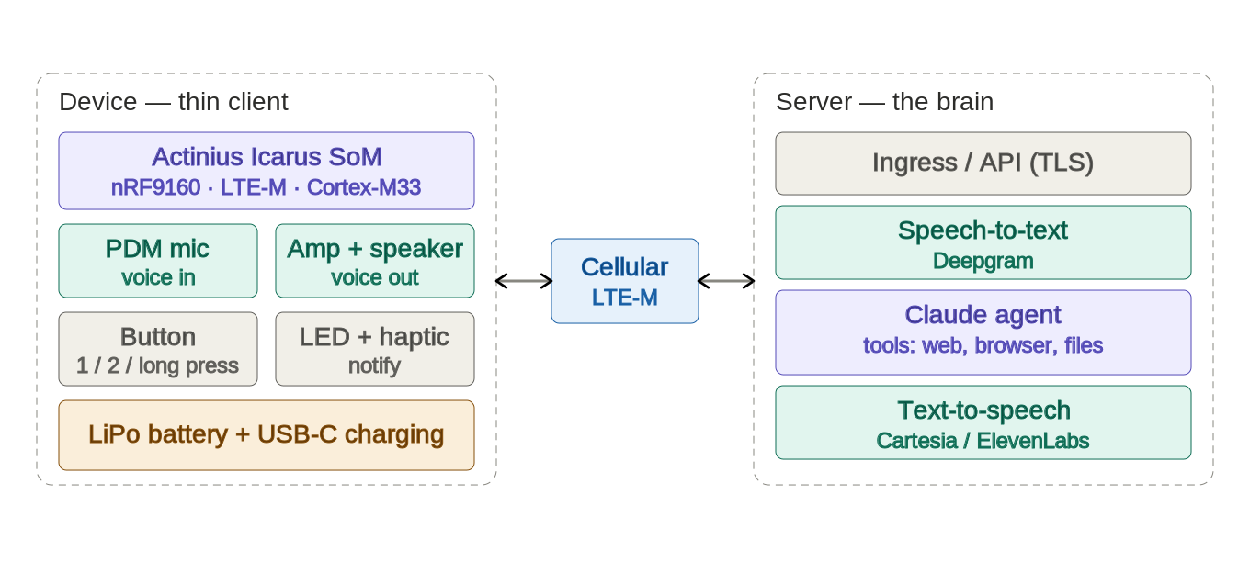
Figure 1. The thin-client device and the remote agent server, connected over LTE-M.

3.1 The voice loop
The core data flow for a single-press task is a request/response round-trip over an encrypted cellular socket:
- You press and speak. The button wakes the modem and starts the PDM microphone capture.
- The device buffers the audio and (optionally) applies light ADPCM compression — no transcription happens on the device.
- It opens a TLS connection over LTE-M and POSTs the audio bytes to the server.
- The server transcribes the speech (STT), hands the text to the Claude agent, which decides what to do and uses its tools (web search, browser automation, file access) to carry out the task.
- The agent’s answer is converted to speech (TTS) and the audio is returned over the same connection.
- The device plays the reply through the speaker and triggers the buzz + LED; then it returns to deep sleep.
Because the user initiated the exchange, the device can simply hold the connection open while the agent works (seconds), so the MVP needs no server-initiated push and the radio can stay off the rest of the time.

3.2 The interaction model
Gesture | Action | Implementation notes
Single press | Speak an instruction; agent does a task | Record while held or until silence; round-trip to server; press to hear the answer
Double press | Live real-time voice conversation | Streaming over a WebSocket — scoped as a stretch goal (see §7.4)
Long press | Record a voice memo | Record until release; upload and store server-side
Task done | Buzz + LED ring lights up | Driven by the firmware state machine on reply / async completion

4. Hardware deep-dive

4.1 The brain: Actinius Icarus SoM
The Icarus SoM integrates the nRF9160 (LTE-M Cat-M1 + NB-IoT + GPS), the cellular RF front-end and antenna matching, power regulation, a crystal, an accelerometer, and an on-board eSIM with a software-switchable nano-SIM — in an 18.5 × 28 mm castellated module. You run your own firmware on its Cortex-M33 exactly as you would on the dev kit. Crucially, the nRF9160 exposes both I2S and PDM audio peripherals, so a digital mic and an I2S amplifier connect directly.
Why a module instead of a bare nRF9160 chip: the bare SiP is a fine-pitch LGA that effectively requires a stencil, reflow, and ideally X-ray inspection, plus your own 50-ohm RF layout, matching network, and antenna — any of which can silently kill a first student board. The SoM’s castellated edge pads are hand- and reflow-solderable and visually inspectable, and the hard RF is done inside the module.
Backup option: the bare Nordic nRF9160 / nRF9151 SiP (cheaper per unit but reflow-only and you own the RF), or the Quectel BG95-M3 (only if you specifically want true VoLTE telephony, which this architecture does not need). Note u-blox SARA modules should be avoided for a new design — u-blox has exited the cellular module business.

4.2 Audio path
Microphone: a PDM MEMS mic (TDK T5837) into the nRF9160’s PDM peripheral, which produces PCM via on-chip decimation. The once-standard I2S hobby mics (ICS-43434, SPH0645) are now end-of-life, so PDM is the future-proof path. Speaker output: a MAX98357A Class-D amplifier that accepts I2S directly — no separate codec chip — driving a small 8-ohm micro speaker mounted on the top face. On the SoM, route the PDM and I2S signals to the exposed GPIO castellations — the nRF9160’s flexible pin mapping lets any GPIO serve these peripherals — and confirm enough free GPIOs in your pin plan. Place both mic and speaker on the top face so they point toward your mouth and ear when the device is clipped on.

4.3 Power & charging
A single-cell LiPo (400–500 mAh is a good balance for a wearable given LTE-M’s spiky transmit current) charged over USB-C. For simplest bring-up use a Microchip MCP73831 charger (one resistor sets the current); for a nicer always-on experience use a TI BQ24074, whose power-path lets the device run from USB even with a flat or missing battery. Add generous bulk capacitance near the module’s supply to absorb transmit-burst droop — under-decoupling here is a common cause of dropped cellular attaches. A through-hole USB-C connector (e.g. GCT USB4085) is the most hand-solderable choice.

4.4 Supporting components
- Haptics: TI DRV2605L driver (I2C, effect library) with an LRA for a crisp buzz, or a cheap ERM motor driven by PWM for the simplest path.
- Notification LED: an addressable RGB (SK6812/WS2812 or an Adafruit NeoPixel — only three pads to wire) for an “LED ring” feel, or plain LEDs on GPIOs for minimum risk.
- Button: a light-action tactile switch (Omron B3F / B3FS) — the single user control, read by the gesture state machine.
- Antenna: plug a u.FL pigtail into the module’s on-board LTE u.FL and route to a pre-made flexible LTE-M antenna (cover ~700 MHz–2.1 GHz).
- Optional IMU (later): the SoM already carries a basic accelerometer (ST LIS2DH12), which is enough for simple step counting; add an ST LSM6DSO 6-axis only for richer sleep/motion tracking, and defer it until the voice loop works.

4.5 Bill of materials (summary)
A full editable BOM with manufacturer part numbers, DigiKey numbers, unit prices, extended cost and lead-time flags is provided in the companion spreadsheet. Summary of the core line items:
Category | Part | ~Unit | Note
Cellular brain | Actinius Icarus SoM | $55 | Single-source — order first
Microphone | TDK T5837 (PDM) | $2.40 | In stock
Speaker amp | MAX98357A | $3.70 | I2S in, no codec needed
Speaker | PUI AS01808 / CUI CDM-20008 | $2–4 | Top-face mount
Haptics | DRV2605L + LRA | $8 | Use VSSOP, not BGA
LED | NeoPixel / SK6812 | $0.45 | Easy 3-pad wiring
Button | Omron B3F-1000 | $0.35 | Light action
Battery | LiPo 400–500 mAh | $8 | JST-PH, protected
Charging | MCP73831 or BQ24074 + USB-C | $1–3 | THT USB-C is easiest
Antenna | u.FL flex LTE-M + pigtail | $4–7 | No tuning needed
IMU (optional) | ST LSM6DSO | $4 | Defer to v2
Plan to also buy a development kit up front (nRF9160 DK, Thingy:91 X, or the Icarus IoT board) so the team can start coding immediately — see procurement, §10.

5. PCB design guide

5.1 Tool and approach
Use KiCad (free, no size or layer limits, the best beginner ecosystem, and Actinius publishes Icarus footprints/symbols you can import). Avoid Autodesk EAGLE (end-of-life June 2026) and CircuitMaker (2-layer cap is fine here but the tool is weaker). A motivated EE can reach a usable simple board in about a week of focused work. Suggested split: the EE owns KiCad and layout; the CS students help with the BOM, datasheet research, and design-rule checks.

5.2 Layers and RF
Because the Icarus SoM contains the entire cellular radio and its antenna network, your carrier board carries no controlled-impedance radio trace — so a 2-layer board is genuinely acceptable here, which is cheaper and faster. (If you were laying out a bare nRF9160 instead, you would need a 4-layer stackup with a solid ground plane under a 50-ohm antenna trace; that is exactly the work the module saves you.) Whichever you choose, give the module a clean, well-decoupled power supply with a solid ground pour and bulk capacitance for transmit bursts.

5.3 Antenna
Use the module’s u.FL connector with a pre-made, pre-tuned flexible LTE-M antenna. This is the low-risk consensus choice: no on-board matching network and no VNA tuning, and it covers the multiple LTE-M bands (~700 MHz to ~2.1 GHz in the US). An on-board chip antenna is smaller but makes you the antenna designer — avoid it on a first board with a tight deadline.

5.4 Workflow
- Learn the tool on something trivial first (a breakout for the button + LED) to get through KiCad’s schematic → layout → Gerber loop once.
- Draw the full schematic: SoM, audio (PDM mic, MAX98357A + speaker), haptics, LED, button, charger + USB-C, battery connector, test points.
- Lay out the board: place the SoM and its decoupling first, keep the audio amp away from noisy switching, pour ground on both layers, add mounting and the u.FL route.
- Run DRC, generate Gerbers + a stencil paste layer, and do a final footprint/courtyard check against datasheets.
- Order bare boards (with a stencil) and assemble in-house — see §5.5.

5.5 Fabrication & assembly
For speed, order bare 4- or 2-layer boards from JLCPCB (cheapest, ~2–3 day build) with DHL express, or from OSH Park if you want US-domestic boards with no customs risk. Then hand-assemble at the makerspace with a stencil + reflow/hot-air: the castellated SoM and the few leadless parts (mic, amp, charger) are all reflow-friendly, and doing it in-house saves the parts-sourcing week that turnkey PCBA assembly would add. Order a stencil with the boards. Realistic calendar time from “upload Gerbers” to “boards in hand” is roughly one to one-and-a-half weeks with express shipping — which is why the layout must be done by the end of week 3 (see §9–10).

6. Device firmware guide

6.1 SDK and structure
Build with Nordic’s nRF Connect SDK, which is Zephyr RTOS plus Nordic’s cellular libraries. The cellular modem runs as its own firmware image; your application talks to it through the modem library and the LTE Link Control API, then uses an ordinary BSD-style sockets API (TLS included) for networking. There are ready-made samples for LTE connect, HTTPS, and MQTT to start from. Expect about a week of ramp on Zephyr’s devicetree and build system; the EE should own firmware, and it should start on the dev kit on day one.

6.2 Audio on the device
Capture from the PDM mic using the nrfx PDM driver, which yields PCM directly. For the task flow there is no real-time constraint (you are waiting seconds on the agent anyway), so send raw 16 kHz/16-bit PCM, or apply simple IMA-ADPCM (~4:1) — both fit comfortably in LTE-M’s uplink for short clips, and the server does all heavy transcoding. Do not attempt real-time Opus on the Cortex-M33 for the MVP. For playback, feed the reply audio to the MAX98357A over I2S.

6.3 Button-gesture state machine
Implement gestures with a small debounced finite-state machine driven by GPIO interrupts and timers. States: idle, debounce, wait-for-double, recording, waiting-for-reply, playing. A release under ~300 ms that is not followed by a second press within ~250 ms is a single press; a second press is a double; a hold beyond ~800 ms is a long press (record until release).

6.4 Record → send → receive → play
On a single press: wake the modem and start capture; buffer PCM/ADPCM while held or until a short silence/timeout; open a TLS socket and POST the audio; keep the connection open and wait for the reply audio; play it over I2S and fire the buzz + LED on completion; then return to sleep. The LED and haptic are simple GPIO/PWM outputs driven from state transitions.

6.5 Power management
LTE has two relevant power-save mechanisms. PSM (Power Saving Mode) keeps the device registered on the network but with the radio fully off until it wakes — lowest power, but unreachable while asleep. eDRX wakes the receiver periodically to check for pages — reachable, with bounded latency, at a higher power cost. The tradeoff is fast notifications versus battery life.
Recommended MVP approach: use PSM as the default sleep state and treat the button press as the wake event. Because the user starts every exchange and the device holds the connection open for the reply, you do not need server-initiated push for the core flow at all. Add eDRX (or an MQTT keep-alive, or an SMS-wake) later only if you want unsolicited “your task finished” notifications to a sleeping device.

7. Backend & agent guide (CS team)
Build the backend in Python (best SDK and voice-framework support) and, critically, develop the whole pipeline first against a laptop or phone client over Wi-Fi, so the agent is working before the custom hardware exists.

7.1 Transport
For the task flow, a plain HTTPS POST (audio up, audio back) is simplest and entirely adequate — request/response, TLS, no connection state to manage. Use MQTT only if you later want asynchronous “task done” push. For the real-time stretch feature, a WebSocket carrying audio frames is the right primitive on a microcontroller (full WebRTC is too heavy for the nRF9160 in this timeframe).

7.2 Speech-to-text and text-to-speech
STT: Deepgram is the recommended default for low streaming latency and voice-agent ergonomics; OpenAI’s transcription models are a fine one-vendor alternative for a batch task flow. TTS: Cartesia for the lowest time-to-first-audio (matters for real-time), or ElevenLabs for the most natural single-answer voice. All three are swappable behind a small interface, so don’t over-invest early.

7.3 The Claude agent (the core build)
This is where the team’s effort should concentrate. Use the Claude API with tool use: you define tools as JSON schemas, Claude returns tool calls, your server executes them and returns results, and the loop continues until a final answer. Claude Sonnet is the sweet spot for the agent loop; use Haiku for cheap sub-tasks. The three required capabilities map to tools:
- Web browsing: Anthropic’s hosted web-search tool for quick lookups; Playwright or browser-use (or Claude computer use) when the agent must actually operate a website.
- File access: expose read/write/list tools over a sandboxed directory.
- Task automation: custom tools that call scripts or HTTP APIs.
A hand-rolled tool loop (about a hundred lines) is clearer than a heavy framework under time pressure. Add Playwright/browser automation only when a demo actually needs real site interaction.

7.4 Real-time conversation (stretch goal)
The double-press live conversation is the riskiest feature, because LTE-M is narrowband with bursty latency that spikes when the radio leaves power-save — vendor “10–15 ms” figures are best-case radio time, not real round-trips. Treat it as a stretch goal: prototype the pipeline first over Wi-Fi to prove it out, then test LTE-M tolerance separately. The OpenAI Realtime API is the fastest path to a speech-to-speech demo; Pipecat or LiveKit Agents let you keep Claude in the loop with Deepgram + Cartesia and handle turn-taking.

7.5 Hosting
Render (real free tier, no credit card) or Railway (best developer experience) are the lowest-friction options to start; a single always-on small instance avoids cold-start delays during a demo. A ~$6/month VPS is the fallback if you want full control.

8. Connectivity & SIM
The nRF9160 modem is IP-data-only, and the IoT data SIMs below are data-only — so voice is always VoIP over the LTE-M data bearer (which the architecture already assumes). In the US these providers reach LTE-M primarily by roaming on AT&T’s network. Provisioning is a day-one action: physical SIMs add shipping and activation can lag a day.
Provider | Starter | Notes
Dev-kit eSIM | Bundled | Fastest start; activate immediately on the dev kit
Onomondo SoftSIM | 30-day trial | Software SIM integrated with nRF Connect SDK — best for the custom board
Hologram | Free SIM + test data | Best-documented on the nRF9160; $1/mo + ~$0.03/MB
1NCE | $14 / 500 MB / 10 yr | Cheapest flat rate; 500 MB is eaten quickly by continuous voice
Soracom / EMnify | Trial credit | Good tooling/analytics; multi-carrier options
Validate voice over LTE-M in week 1 on the dev kit with your actual SIM. Bandwidth is fine for compressed voice; latency under power-save is the real constraint. If full-duplex feels bad, the push-to-talk task flow still works well — which is exactly why it is the MVP.

9. Five-week timeline
Two workstreams run in parallel: the EE on electronics/PCB/firmware, the two CS students on the backend agent and voice pipeline, meeting at integration. The plan is front-loaded: order long-lead items and prove the voice loop on the dev kit in week 1, so the custom board only has to confirm what already works.
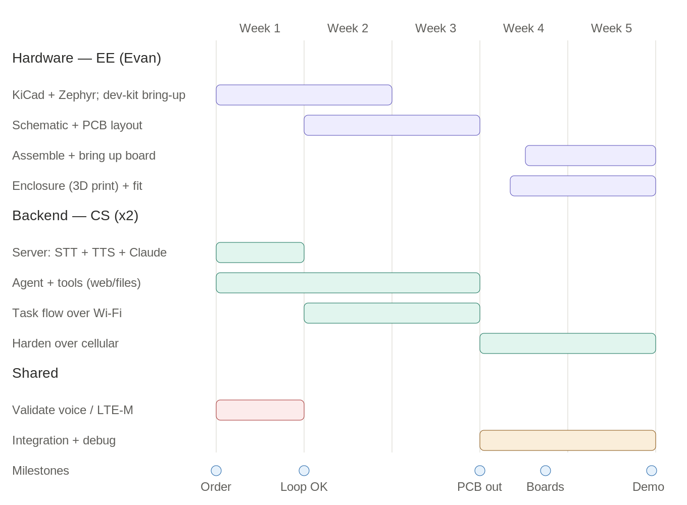
Figure 2. Parallel hardware (purple), backend (teal) and shared (amber/red) tracks, with milestones.
Week | Hardware (EE) | Backend (CS ×2) | Milestone
1 | Order everything; learn KiCad; bring up cellular + audio on the dev kit | Stand up server; wire STT + TTS + Claude; task flow over Wi-Fi | Voice loop works on dev board (go/no-go)
2 | Schematic, then start PCB layout | Build agent tools (web, browser, files); end-to-end task flow
3 | Finish layout + DRC; order bare boards + stencil + remaining parts | Harden the agent; add long-press memo; begin cellular testing | PCB + parts ordered (end of week)
4 | Boards arrive mid-week; assemble + bring up the custom board | Point firmware at the real backend; integrate over cellular | Boards in hand
5 | 3D-print enclosure; final assembly + debug | Integration, polish, optional real-time conversation | Working device + demo (with buffer)
If anything slips, the dev-kit build remains a fully working demonstrator of the whole system, so the project always has something to show.

10. Procurement & lead times
Lead time is the hidden critical path. Order the long-lead and single-source items on day one; order the PCB by the end of week 3 or the boards will not arrive with time to assemble and debug.
Item | Source | Typical lead | Order by
Development kit | DigiKey (in stock) | 2–5 days | Day 1
Icarus SoM (+spare) | Actinius / Adafruit | Ships from vendor; single-source | Day 1
Cellular SIM | Onomondo / Hologram | Instant–24 h activation | Day 1
DigiKey parts | DigiKey (in stock only) | 2–6 days ground | Week 3
Bare PCB + stencil | JLCPCB (DHL express) | ~1–1.5 weeks to hand | End of week 3
3D-print filament | Makerspace | On hand | Week 4
Buy only in-stock parts (verify quantity before finalizing the design); some cellular semiconductors carry multi-week factory lead times even when distributors show stock. Keep a spare SoM in case of an assembly mishap.

11. Risks & mitigations
Risk | Severity | Mitigation
Cellular link / antenna underperforms | High | Pre-certified module + u.FL flexible antenna; test attach on the dev kit first; strong power decoupling
Audio round-trip flaky over LTE-M | High | Keep on-device audio dumb (raw PCM); build backend on Wi-Fi first; generous timeouts/retries
Single-source SoM unavailable | Medium | Order on day 1 with a spare; bare nRF9160 as a fallback brain
PCB arrives too late | Medium | Layout done by end of week 3; DHL express; dev kit is the fallback demo
Real-time conversation doesn’t work | Low | Scoped as a stretch goal; MVP is push-to-talk
Hand-assembly damages a part | Medium | Stencil + reflow (not iron) for leadless parts; order spares; practice on the trivial board first
Zephyr learning curve | Medium | EE starts on the dev kit day 1; lean on Nordic samples

12. Rough cost
Indicative one-prototype budget (USD), excluding API usage and the SIM data plan, which are small for a student project. Buying a couple of dev kits and a few board sets is the bulk of the spend.
Item | Estimate
Development kit (1–2) | $120–360
Icarus SoM × 3 (incl. spares) | $165
All other components (~5 sets) | $80–140
PCBs + stencil (5 boards, express) | $40–80
Cellular SIM + data (project) | $10–30
Cloud APIs (STT/TTS/Claude, dev) | $20–60
Estimated total | $435–850

13. Day-1 checklist
- Order a development kit (nRF9160 DK / Thingy:91 X / Icarus board) and 2–3 Icarus SoMs (plus a u.FL flexible antenna + pigtails).
- Provision connectivity: activate the dev-kit eSIM now; set up an Onomondo SoftSIM and order a Hologram/1NCE SIM as backup.
- EE: install nRF Connect SDK + VS Code extension and KiCad; flash an LTE “hello world” on the dev kit.
- CS: stand up the server skeleton (Python) with Claude tool use + a placeholder STT/TTS, callable from a laptop over Wi-Fi.
- Whole team: by end of week 1, get audio captured on the dev kit, sent over LTE-M, processed by the agent, and played back — the go/no-go milestone.

14. Key references
- Nordic nRF9160 / nRF9151 product pages and nRF Connect SDK (Zephyr) docs — nordicsemi.com, docs.nordicsemi.com
- Actinius Icarus SoM datasheet and Icarus IoT board — actinius.com, docs.actinius.com
- Audio: TDK T5837 PDM mic; Analog Devices/Maxim MAX98357A — digikey.com
- KiCad — kicad.org; JLCPCB fab/assembly and impedance docs — jlcpcb.com; OSH Park — oshpark.com
- Connectivity: Hologram, Onomondo (SoftSIM), Soracom, 1NCE — hologram.io, onomondo.com, soracom.io, 1nce.com
- Backend: Anthropic Claude tool use & computer use — platform.claude.com/docs; Deepgram, Cartesia, ElevenLabs; Pipecat / LiveKit Agents; OpenAI Realtime API
- Power-save: PSM and eDRX explainers — onomondo.com, zipitwireless.com
Prices, stock and lead times are mid-2026 snapshots and move — re-verify at order time. This document captures architecture and approach; specific component values, dimensions and detailed schematics are the next design step.

