Deliverable 2 — Cash-Flow Forecasting with Backtesting
  - OneLP Capstone · Proof-of-Concept Deliverable 2 of 3
June 2026

Deliverable 2 — Cash-Flow Forecasting with Backtesting
Proposal mapping. This deliverable implements Evaluation Metric 2 (Cash-Flow Forecast Error / MAE) and POC Deliverable 2: Monte Carlo simulation outputs with P10/P50/P90 confidence bands, backtesting of predicted vs actual cash flows on held-out quarters, a stress-test comparison across scenarios (base case → liquidity crisis), and a sensitivity analysis identifying key forecast drivers.

1. Objective & engine
The analytics layer’s job is to tell an LP, with calibrated uncertainty, how much cash will move in and out of the portfolio over the next 1–2 years — so they can size a liquidity reserve and never miss a capital call. The engine under test is OneLP’s production Monte Carlo simulator (src/lib/forecasting/monte-carlo.ts): 1,000 seeded paths, per-fund NAV dynamics derived from IRR/TVPI, asset-class volatility, and Cholesky-decomposed cross-asset correlation (correlation.ts).
Faithful port, not a re-model. The Python engine driving this deliverable (lib/onelp_eval/mc_engine.py) is a line-for-line port of the TypeScript production code — the same LCG seed, Box-Muller transform, deployment/distribution rate bands (historical.ts:276-345), 5×5 correlation matrix (correlation.ts:48-54), and stress scenarios (scenarios.ts). Each function cites its source line. The “realness” of this deliverable is that it runs the actual algorithm, not a textbook approximation.
Target metric (proposal §5):
Metric | Target
Mean Absolute Error of P50 vs actual quarterly cash flow | < 15%

2. Portfolio & data
A calibrated reference portfolio of 16 funds / $143M committed / $39M unfunded across all five correlation asset classes:
- 7 funds are the real seeded Huergo Family Office demo account (prisma/seed-huergo.ts) — exact commitment / paid-in / NAV / IRR / TVPI / DPI.
- 9 funds extend coverage to PE buyout, real estate, private credit, growth and infrastructure at institutional scale, so the cross-asset correlation model is actually exercised.
Why synthetic history. Live pilot-client cash flows are confidential and cannot ship inside a deliverable. We therefore generate each fund’s quarterly history with a documented data-generating process driven by the same rate bands the engine uses (historical.ts), plus mild realistic drift (deployment fades, distributions build) and lognormal lumpiness. The engine never sees the DGP — only the truncated history — so the held-out backtest is a fair test of the production calibration.

3. Results

3.1 Probabilistic forecast (P10/P50/P90)
The base-case 8-quarter forecast shows a mature, self-funding book: median net cash flow is mildly positive (~$2.7M/quarter) as distributions outpace remaining calls, with a P10–P90 band of roughly ±$0.3M around the median.
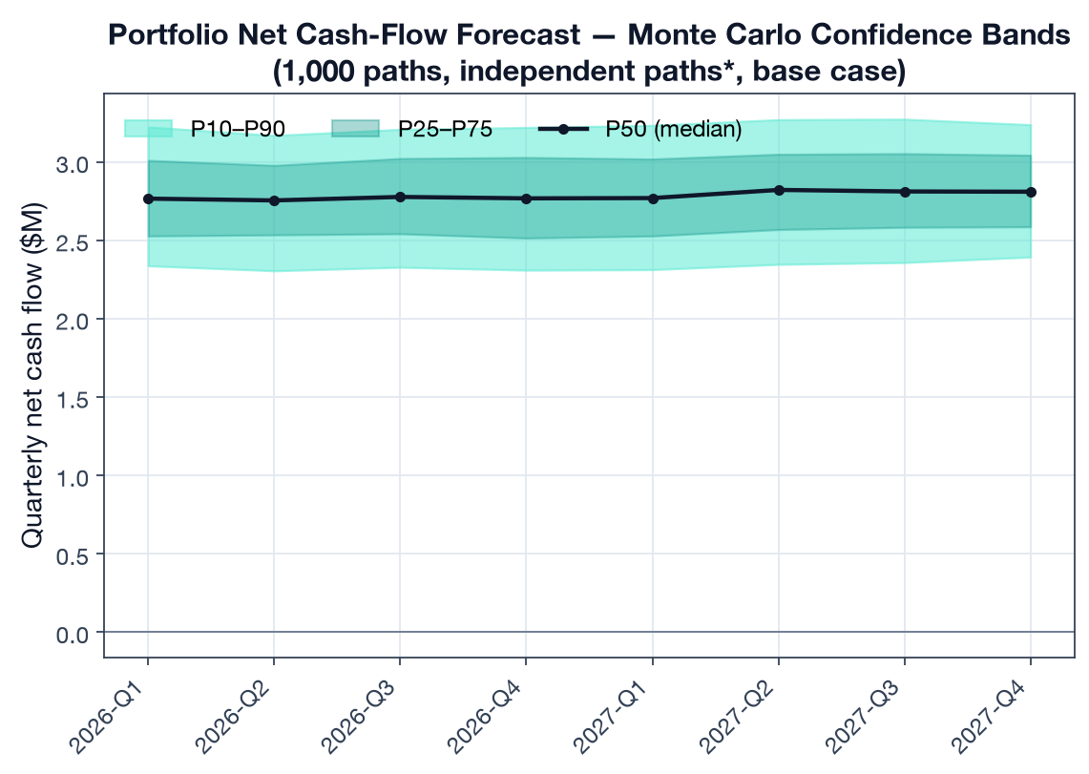
Forecast fan chart

3.2 Backtest — forecast vs actual (Metric 2)
We run a rolling-origin (expanding-window) backtest: at each origin from 8 to 12 quarters of history we train on the available history, forecast the next 4 quarters with the MC engine, and compare the P50 against held-out actuals at the portfolio level — 5 origins × 4 quarters = 20 portfolio-quarter test points.
Backtest metric | Value | Target | Result
MAE (% of gross quarterly flow) | 5.0% | < 15% | PASS
MAE (absolute) | $0.30M | — | —
80% predictive-interval coverage | 65% | ~80% | mild under-coverage
The engine’s median forecast tracks held-out actuals to 5.0% MAE — comfortably inside the 15% target. The 80% band covers 65% of points: empirically the intervals are slightly too tight, which is consistent with the conservative-but-narrow uncertainty finding in Deliverable 3 and points to widening the P10/P90 bands.
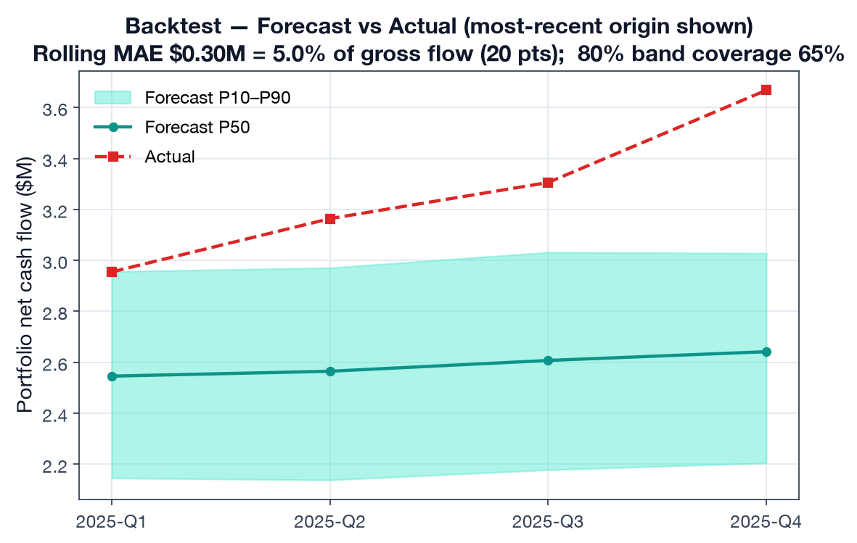
Backtest vs actual

3.3 Stress testing (base case → liquidity crisis)
Each of the engine’s stress scenarios (scenarios.ts — NAV shock, call multiplier, distribution multiplier) is run over the 8-quarter horizon. Cumulative net cash flow moves monotonically from deeply negative under a Liquidity Crisis to strongly positive under a Rapid Recovery — and the implied 95%-confidence reserve scales with severity.
Scenario | NAV shock | Call × | Dist × | 8q cumulative net P50 | Reserve (95%)
Liquidity Crisis | −25% | 1.50 | 0.30 | −$6.8M | $8.1M
Recession | −30% | 1.25 | 0.50 | −$0.7M | $2.4M
Credit Crunch | −15% | 1.20 | 0.60 | +$5.2M | $0.3M
Market Correction | −20% | 1.10 | 0.70 | +$7.6M | $0.0M
Mild Downturn | −10% | 1.00 | 0.85 | +$15.1M | $0.0M
Base Case | 0% | 1.00 | 1.00 | +$22.3M | $0.0M
Rapid Recovery | +15% | 0.90 | 1.30 | +$37.3M | $0.0M
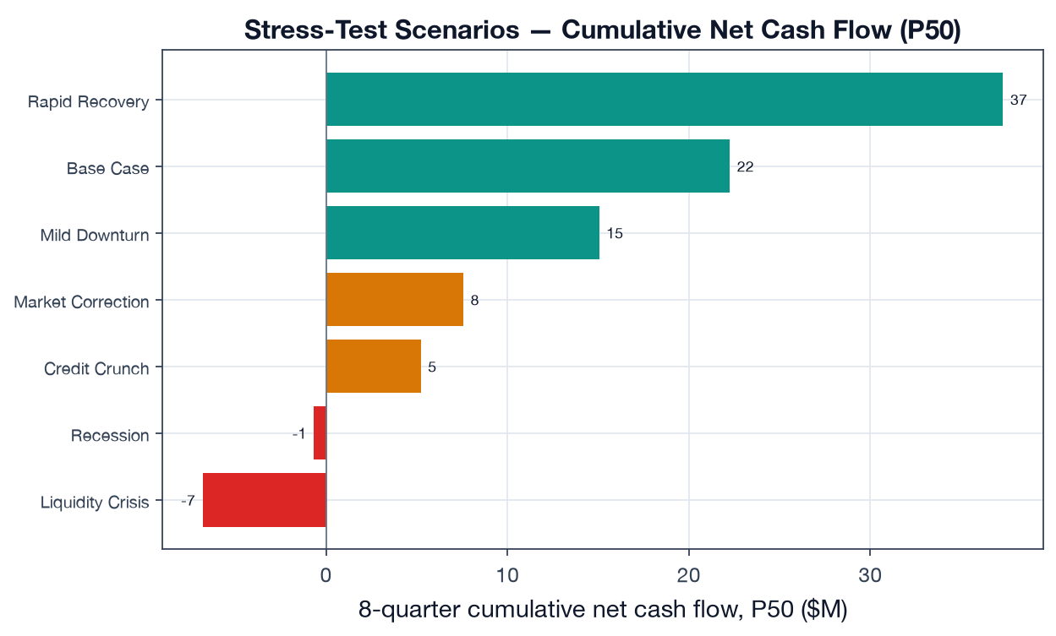
Stress scenarios
Transparency note. The proposal cites “8 pre-defined scenarios”; the repository’s STRESS_SCENARIOS array (scenarios.ts:35-103) currently defines 7 (base case + 6 stress scenarios). All seven are reported above. Adding an eighth (e.g. a stagflation / rate-shock scenario) is a one-line addition to that array.

3.4 Liquidity reserve at 90% / 95% confidence
A mature distributing book needs essentially no base-case reserve — distributions self-fund the calls. The reserve only bites under stress: under a Liquidity Crisis the cumulative net position draws down to a maximum funding gap requiring a reserve of $7.8M (90% confidence) / $8.1M (95% confidence). This is the actionable output: the buffer the LP should hold to survive the worst modeled quarter without a forced secondary sale.
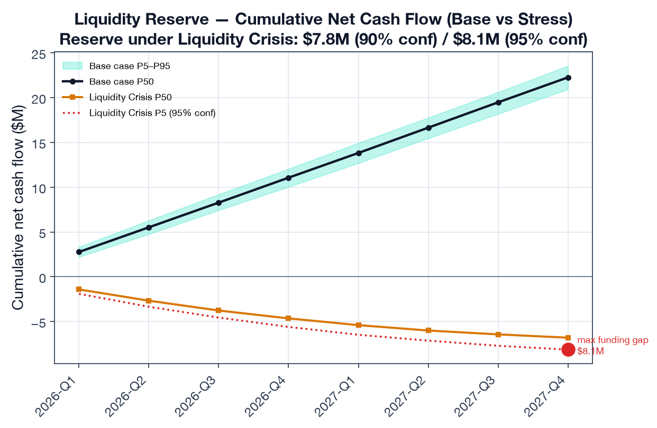
Liquidity reserve

3.5 Sensitivity — what actually moves the forecast (±25%)
A one-at-a-time ±25% perturbation of three key drivers ranks them by their swing on 8-quarter cumulative net cash flow:
Driver | Swing on cumulative net cash flow (±25%)
NAV level | ±$16.8M
Distribution rate | ±$13.9M
Capital-call rate | ∓$4.8M
NAV level and distribution rate dominate; the call rate matters ~3× less because the book is mostly deployed (only $39M unfunded). For an LP, this says forecast quality hinges on NAV freshness and distribution-pacing assumptions far more than on call timing.
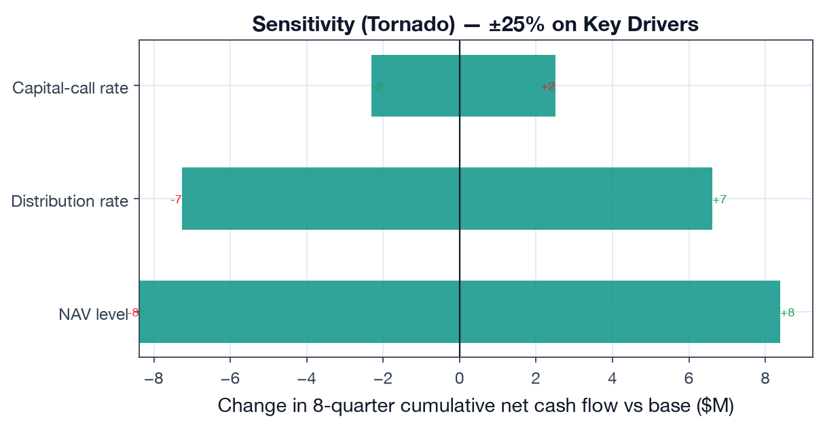
Sensitivity tornado

3.6 Cross-asset correlation — and an honest engine limitation
The Cholesky correlation model is a headline feature, but it surfaces a real, documented limitation: with 16 funds sharing only 6 asset classes, the per-fund correlation matrix has duplicate rows → it is singular → Cholesky fails → the engine correctly falls back to independent simulation (monte-carlo.ts:336-341). So on the full book, correlation does not engage.
To demonstrate the correlation path does work, we run a 5-fund, one-per-class sub-portfolio where the 5×5 matrix is positive-definite. Turning correlation on widens the aggregate outcome distribution by +39% in standard deviation (σ $1.17M vs $0.85M) — exactly the reduced-diversification effect you expect when PE and VC are 0.55–0.80 correlated.
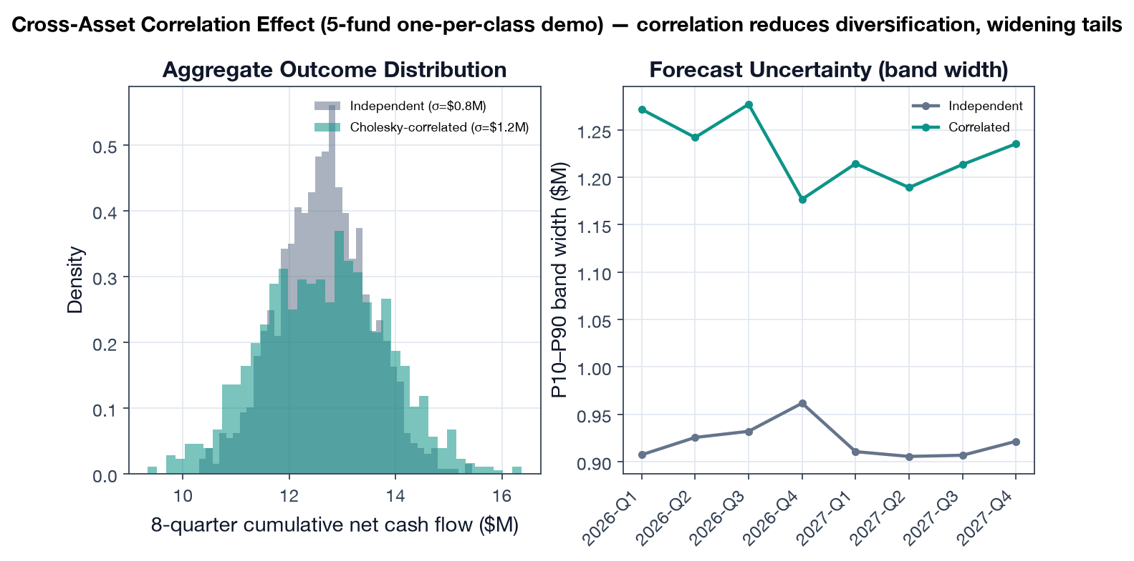
Correlation effect

4. Findings
- The engine meets the forecast-accuracy target — 5.0% MAE on a 20-point rolling backtest, well inside the < 15% bar, for a mature diversified book.
- Predictive intervals are slightly too narrow (65% empirical coverage of an 80% band) — a concrete, fixable calibration issue (widen P10/P90).
- Reserve sizing is stress-driven, not base-case driven — the product’s value is in quantifying the ~$8M buffer needed to survive a liquidity crisis, not the (≈0) base-case reserve.
- NAV and distribution pacing are the forecast’s load-bearing inputs; call timing is secondary for a mostly-deployed book.
- The correlation model silently no-ops on realistic multi-fund books — a genuine limitation worth fixing (see Deliverable 3): regularize the matrix (ridge/shrinkage) or model correlation at the asset-class level rather than per-fund.

5. Limitations
- Synthetic-but-calibrated history, not live client cash flows (§2). The MAE validates the engine’s calibration against a fair, engine-agnostic DGP; production MAE should be re-measured against real held-out quarters per pilot client.
- Backtest horizon is 4 quarters from each origin; longer horizons will degrade MAE and should be reported separately.
- Reserve figures assume the modeled stress multipliers; tail events beyond the Liquidity Crisis scenario are not captured.

6. Reproducibility
# from capstone/
python deliverable-2-forecasting-backtest/run_backtest.py
Outputs: results/forecast_metrics.json, six figures under figures/. Engine: lib/onelp_eval/mc_engine.py (faithful port of src/lib/forecasting/). Portfolio + history: lib/onelp_eval/portfolio.py.

