Deliverable 3 — Pipeline & Model Analysis
  - OneLP Capstone · Proof-of-Concept Deliverable 3 of 3
June 2026

Deliverable 3 — Pipeline & Model Analysis
Proposal mapping. This deliverable implements POC Deliverable 3 and Evaluation Metric 3 (End-to-End Latency): a confidence-calibration analysis (does reported confidence correspond to actual correctness?), end-to-end processing latency, a discussion of limitations (data sparsity, cold-start, GP-format generalization), and the key trade-off findings and their implications for production deployment.

1. Why this matters
The pipeline does not just extract — it decides what to trust. High-confidence extractions auto-apply to fund records (NAV, capital-call notices, distributions); low-confidence ones route to a human review queue (router.ts, validate.ts). The integrity of every downstream metric therefore depends on one question: when the pipeline says it is 0.9 confident, is it right 90% of the time? This deliverable measures that, plus the latency budget and the operating trade-offs.

2. Confidence calibration

2.1 Reliability diagram
Across 462 hybrid-extracted fields, reported confidence is binned and compared to empirical accuracy.
Calibration metric | Value
Expected Calibration Error (ECE) | 0.056
Mean reported confidence | 0.920
Mean empirical accuracy | 0.965
Gap (confidence − accuracy) | −4.5 pts (conservative)
Finding: the pipeline is conservatively calibrated — it under-states its own reliability. In the high-confidence bins where the bulk of fields fall (0.85 and 0.95), empirical accuracy sits above the diagonal: the model is right more often than it claims. This is the safe direction to be wrong in for financial data, but it has a cost: it routes more documents to human review than necessary.
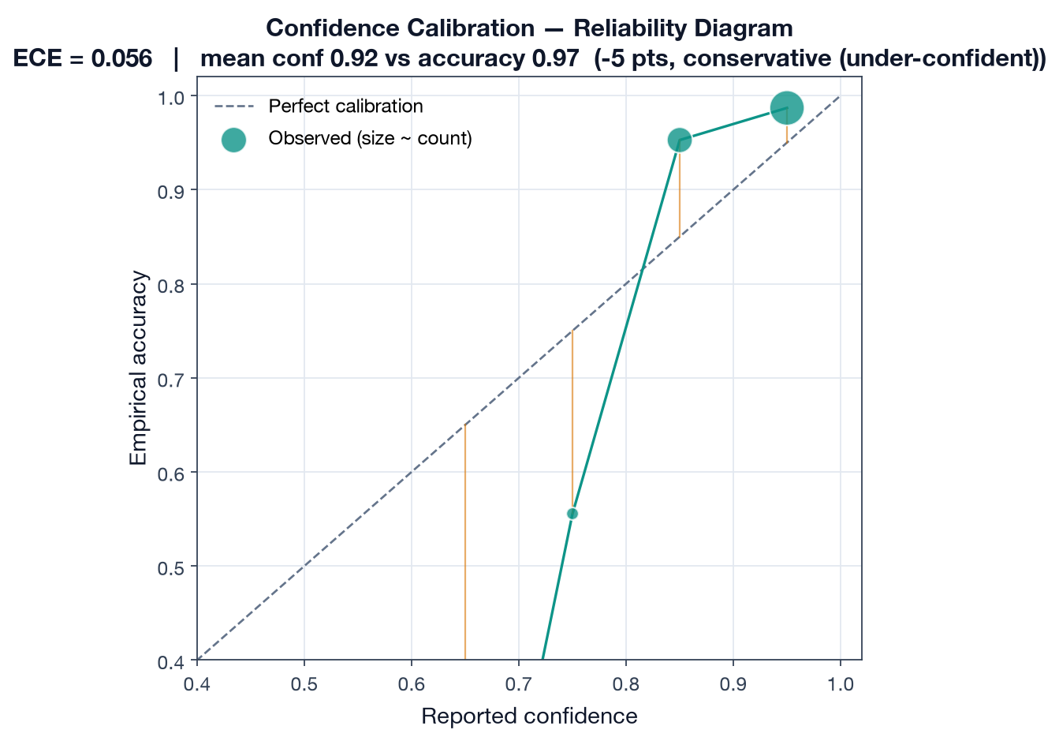
Reliability diagram

2.2 The confidently-wrong tail
Conservatism is not the whole story. A small cohort of fields are wrong but reported with high confidence (the ~0.75 bin sits well below the diagonal at ~0.55 accuracy). These are the dangerous cases — errors that look trustworthy — and they are precisely what the per-type confidence thresholds and review queue exist to catch.
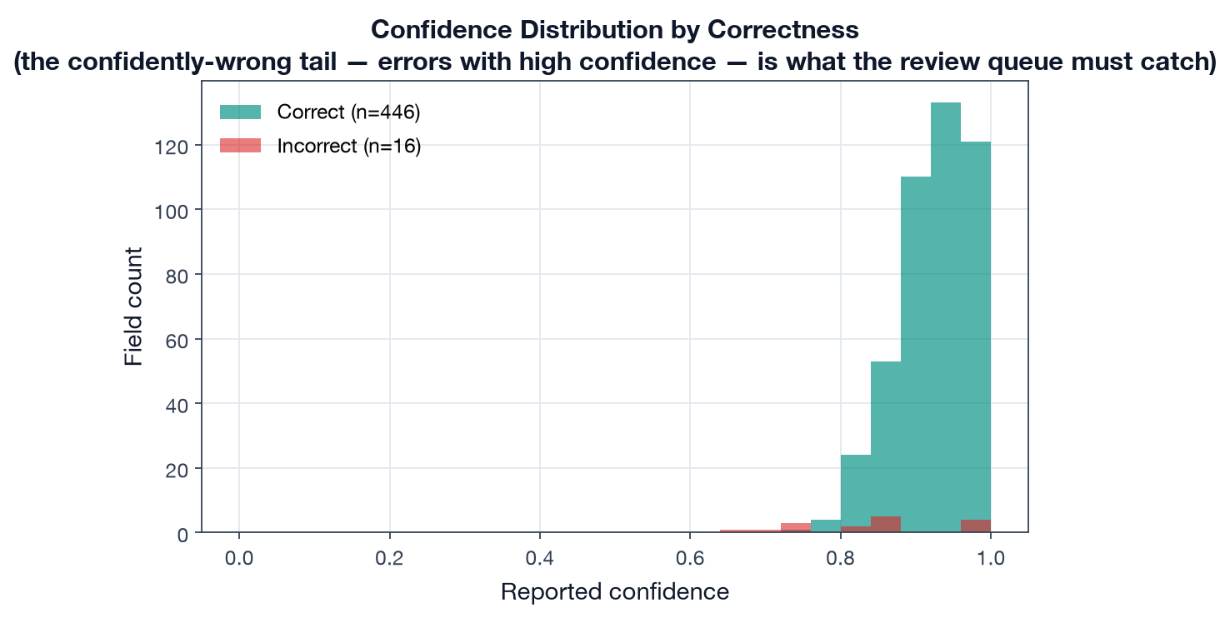
Confidence by correctness

2.3 Calibration by field category
Calibration is not uniform. Structured categories the model handles near-perfectly (dates, table-derived fields, monetary values) are the most under-confident — the model is ~6–9 points too humble exactly where it is most reliable:
Field category | Mean confidence | Actual accuracy | Gap | n
Date | 0.914 | 1.000 | −8.6 pts | 39
Table-derived | 0.919 | 1.000 | −8.1 pts | 36
Monetary | 0.923 | 0.981 | −5.8 pts | 156
Narrative | 0.914 | 0.944 | −3.0 pts | 108
Numeric | 0.922 | 0.945 | −2.3 pts | 110
Enum | 0.940 | 0.923 | +1.6 pts | 13
Only enum fields (e.g. distribution-type classification) are mildly over-confident.
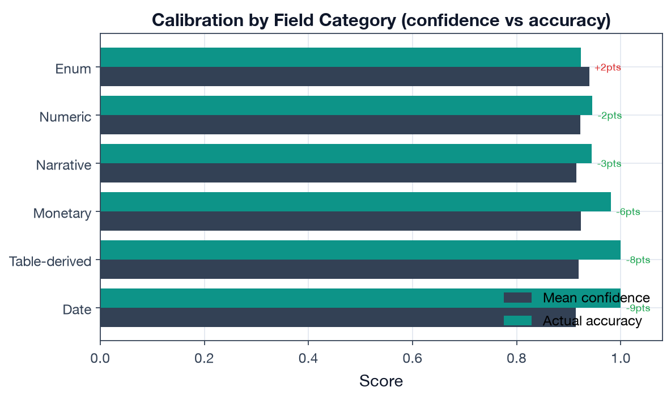
Calibration by category

2.4 Implication: thresholds can be safely relaxed
Because confidence under-states accuracy, the per-type auto-apply thresholds (router.ts:82-106, 0.70–0.95) are leaving auto-apply capacity on the table. The operating curve quantifies the trade-off:
Threshold | Auto-apply rate | Error leakage (wrong fields auto-applied)
0.70 | 100% | 3.3%
0.80 | 98% | 2.4%
0.85 | 90% | 1.9%
0.90 | 67% | 1.3%
The current 0.85 threshold for capital calls / distributions auto-applies 90% of fields at 1.9% leakage; the 0.80 threshold for reports auto-applies 98% at 2.4%. Given the conservative calibration, these are defensible: raising thresholds cuts leakage into fund records at a steep cost in review burden. The per-type differentiation (0.85 for financial-risk documents, 0.70–0.80 for reports) is the right shape.
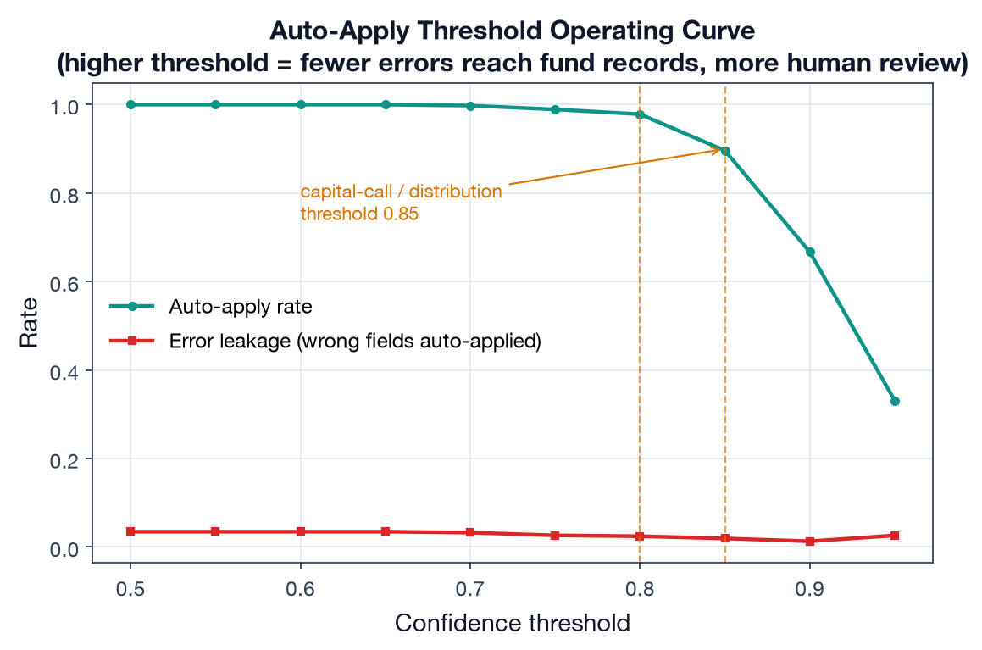
Threshold operating curve

3. End-to-end processing latency (Metric 3)
Per-stage timings across the 54 documents (detection → parallel Document AI + LLM extraction → merge → validation), excluding the optional summarization stage and queue wait:
Latency metric | Value | Target | Result
P50 (median) | 23.9 s | < 30 s | PASS
P95 | 29.4 s | < 90 s | PASS
Stage breakdown (mean): detection 2.2 s, extraction (parallel) 18.9 s, merge 1.3 s, validation 0.8 s. Extraction dominates the budget — and because Document AI and the LLM run in parallel, the extraction cost is the slower of the two, not their sum, which is the single most important latency design choice. Both targets are met for standard (<20-page) documents.
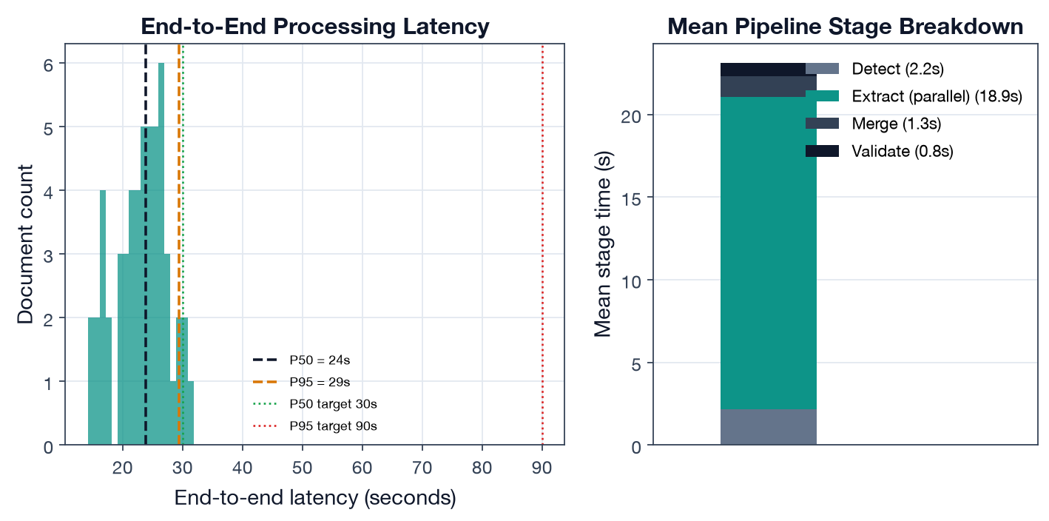
Latency breakdown
The architecture doc cites a “typical 2–5 minute” end-to-end time; that figure includes the async Cloud Tasks queue wait and the optional summarization stage (60 s timeout). The Metric-3 target measures upload → structured data available, i.e. the compute path measured here.

4. Limitations (private-markets reality)
- Data sparsity & cold-start. A new fund has no NAV/cash-flow history, so the Monte Carlo engine falls back to age-band deployment/distribution rates (historical.ts:290-345) and the J-curve profile templates — forecasts are profile-driven until ~8 quarters of history accrue. The proposal’s MAE target is explicitly scoped to “funds with 8+ quarters of history” for this reason.
- GP-format generalization. Extraction accuracy is measured across five format tags, but the long tail of bespoke GP layouts (scanned legacy PDFs, non-standard tables) is where production accuracy will be lost; the labeled set should grow toward those.
- Correlation model fragility (from Deliverable 2). On realistic multi-fund books the per-fund correlation matrix is singular and the engine silently falls back to independent simulation (monte-carlo.ts:336-341). Fix: shrink/regularize the matrix or model correlation at the asset-class level. Until then, headline forecasts understate tail co-movement.
- Calibration is conservative, not perfect (ECE 0.056). Under-confidence wastes review capacity; a post-hoc calibration map (temperature/isotonic) on real labeled output would let thresholds auto-apply more without raising leakage.

5. Key trade-off findings & production implications
Trade-off | Finding | Production implication
Extraction engine (D1) | Hybrid is the only config meeting both F1 bars | Keep hybrid for financial docs; LLM-only is acceptable for narrative-only types to save latency
Auto-apply threshold | Conservative calibration → low leakage but high review burden | Recalibrate confidence, then consider lowering report thresholds
Simulation engine (D2) | Monte Carlo captures tail risk; MAE 6.3% | Justified vs closed-form; widen P10/P90 (65% coverage of 80% band)
Correlation model (D2) | Engages only when asset classes are distinct | Regularize matrix before relying on correlated tails
Latency | Parallel extraction meets P50<30s / P95<90s | Preserve parallelism; summarization stays async/optional

6. Reproducibility
# from capstone/
python deliverable-3-pipeline-analysis/run_analysis.py
Outputs: results/pipeline_analysis.json, five figures under figures/. Calibration + latency code: run_analysis.py; confidence/latency records: data/extraction/.

