*Федеральное государственное бюджетное образовательное учреждение высшего профессионального образования*

***«Московский государственный технический университет имени Н.Э. Баумана»   
(МГТУ им. Н.Э. Баумана)***

***Кафедра ИУ3, 3 курс, 6 семестр.***

**Отчёт**

**по лабораторной работе №3**

**“ Работа с плагинами и Apache Jena”**

**по курсу**

**“Разработка ПО”**

Выполнила: Крайникова А.В.

Группа: ИУ3-62

Проверил: Иванов А. М.

Москва, 2014

Оглавление

Цель работы 2

Задание 2

Вариант диаграммы 2

Работа с Protege 3

Исходный код 4

# Цель работы

* Углубление навыков работы с системой контроля версий
* Ознакомление на практике с основами графовых БД и технологий Semantic Web

# Задание

Создать тестовый Eclipse-проект, в котором происходит формирование информационной модели данных диаграммы и работа с данными в соответствии со своим вариантом задания и требованиями.

Добавить созданные проект в репозитарий системы контроля версий.

# Вариант диаграммы

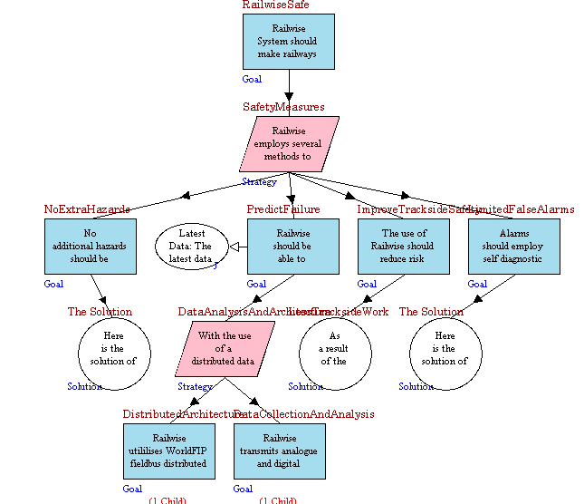

Рис.1 SafetyCaseModelDiagram

## Работа с Protege

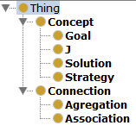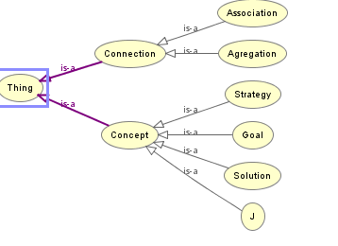

Рис.2 Иерархия классов

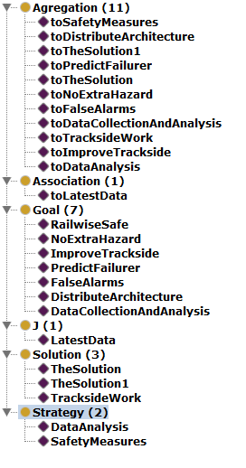

Рис.3 Список индивидуалов

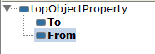

Рис.4 Свойства объектов

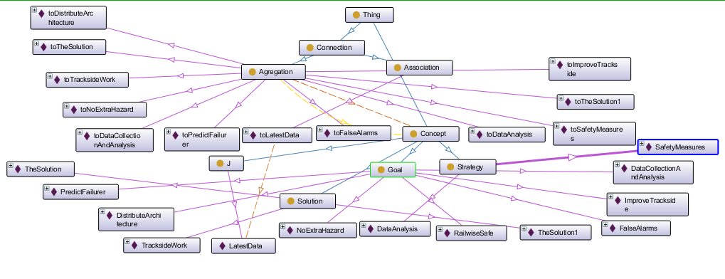

Рис.5 Граф онтологии

## Исходный код

**package** ru.agentlab.jfxed.diagrammssafetycasemodeldiagramm;

**import** java.io.FileWriter;

**import** com.hp.hpl.jena.ontology.Individual;

**import** com.hp.hpl.jena.ontology.ObjectProperty;

**import** com.hp.hpl.jena.ontology.OntClass;

**import** com.hp.hpl.jena.ontology.OntModel;

**import** com.hp.hpl.jena.rdf.model.ModelFactory;

**public** **class** SafetyCaseModelTest {

**static** String *SOURCE* = "http://www.agentlab.ru/jfxed/onto/safetycasemodel";

**static** String *NS* = *SOURCE* + "#";

//test from sourcetree

**public** **static** **void** main (String[] args){

OntModel m = ModelFactory.*createOntologyModel*();//создается пустая база знаний

OntClass goalClass = m.createClass(*NS* + "Goal");

OntClass strategyClass = m.createClass(*NS* + "Strategy");

OntClass jClass = m.createClass(*NS* + "J");

OntClass solutionClass = m.createClass(*NS* + "Solution");

OntClass conceptClass = m.createClass (*NS* + "Concept");

goalClass.addSuperClass(conceptClass);

strategyClass.addSuperClass(conceptClass);

jClass.addSuperClass(conceptClass);

solutionClass.addSuperClass(conceptClass);

OntClass connectionClass = m.createClass(*NS* + "Connection");

OntClass associationClass = m.createClass(*NS* + "Association");

OntClass aggregationClass = m.createClass(*NS* + "Agregation");//связь

aggregationClass.addSuperClass(connectionClass);//родительская связь

associationClass.addSuperClass(connectionClass);//родительская связь

ObjectProperty propTo = m.createObjectProperty(*NS* + "To");//объекты - свойства

ObjectProperty propFrom = m.createObjectProperty(*NS* + "From");

propTo.addDomain(aggregationClass);//свойства у aggregation

propFrom.addDomain(aggregationClass);

propTo.addRange(conceptClass);

propFrom.addRange(conceptClass);

//наполнение базы

//сначала goalClass

Individual railwiseSafe = m.createIndividual(*NS* + "RailwiseSafe", goalClass);

Individual noExtraHazard = m.createIndividual(*NS* + "NoExtraHazard", goalClass);

Individual predictFailure = m.createIndividual(*NS* + "PredictFailurer", goalClass);

Individual improveTrackside = m.createIndividual(*NS* + "ImproveTrackside", goalClass);

Individual falseAlarms = m.createIndividual(*NS* + "FalseAlarms", goalClass);

Individual distributeArchitecture = m.createIndividual(*NS* + "DistributeArchitecture", goalClass);

Individual dataCollectionAndAnalysis = m.createIndividual(*NS* + "DataCollectionAndAnalysis", goalClass);

//теперь strategyClass

Individual safetyMeasures = m.createIndividual(*NS* + "SafetyMeasures", strategyClass);

Individual dataAnalysis = m.createIndividual(*NS* + "DataAnalysis", strategyClass);

//jClass

Individual latestData = m.createIndividual(*NS* + "LatestData", jClass);

// solutionClass

Individual theSolution = m.createIndividual(*NS* + "TheSolution", solutionClass);

Individual tracksideWork= m.createIndividual(*NS* + "TracksideWork", solutionClass);

Individual theSolution1 = m.createIndividual(*NS* + "TheSolution1", solutionClass);

//связи

Individual toSafetyMeasures = m.createIndividual(*NS* + "toSafetyMeasures", aggregationClass);

toSafetyMeasures.addProperty(propTo, safetyMeasures);

toSafetyMeasures.addProperty(propFrom, railwiseSafe);

//////////////////////

Individual toNoExtraHazard = m.createIndividual(*NS* + "toNoExtraHazard", aggregationClass);

toNoExtraHazard.addProperty(propTo, noExtraHazard);

toNoExtraHazard.addProperty(propFrom, safetyMeasures);

Individual toPredictFailurer = m.createIndividual(*NS* + "toPredictFailurer", aggregationClass);

toPredictFailurer.addProperty(propTo, predictFailure);

toPredictFailurer.addProperty(propFrom, safetyMeasures);

Individual toImproveTrackside = m.createIndividual(*NS* + "toImproveTrackside", aggregationClass);

toImproveTrackside.addProperty(propTo, improveTrackside);

toImproveTrackside.addProperty(propFrom, safetyMeasures);

Individual toFalseAlarms = m.createIndividual(*NS* + "toFalseAlarms", aggregationClass);

toFalseAlarms.addProperty(propTo, falseAlarms);

toFalseAlarms.addProperty(propFrom, safetyMeasures);

////////////////////////////

Individual toTheSolution = m.createIndividual(*NS* + "toTheSolution", aggregationClass);

toTheSolution.addProperty(propTo, theSolution);

toTheSolution.addProperty(propFrom, noExtraHazard);

Individual toDataAnalysis = m.createIndividual(*NS* + "toDataAnalysis", aggregationClass);

toDataAnalysis.addProperty(propTo, dataAnalysis);

toDataAnalysis.addProperty(propFrom, predictFailure);

Individual toTracksideWork = m.createIndividual(*NS* + "toTracksideWork", aggregationClass);

toTracksideWork.addProperty(propTo, tracksideWork);

toTracksideWork.addProperty(propFrom, improveTrackside);

Individual toTheSolution1 = m.createIndividual(*NS* + "toTheSolution1", aggregationClass);

toTheSolution1.addProperty(propTo, theSolution1);

toTheSolution1.addProperty(propFrom, falseAlarms);

//////////////////////////////////////

Individual toDistributeArchitecture = m.createIndividual(*NS* + "toDistributeArchitecture", aggregationClass);

toDistributeArchitecture.addProperty(propTo, distributeArchitecture);

toDistributeArchitecture.addProperty(propFrom, dataAnalysis);

Individual toDataCollectionAndAnalysis = m.createIndividual(*NS* + "toDataCollectionAndAnalysis", aggregationClass);

toDataCollectionAndAnalysis.addProperty(propTo, dataCollectionAndAnalysis);

toDataCollectionAndAnalysis.addProperty(propFrom, dataAnalysis);

////////////////////////////// связь1

Individual toLatestData = m.createIndividual(*NS* + "toLatestData", associationClass);

toLatestData.addProperty(propTo, latestData);

toLatestData.addProperty(propFrom, predictFailure);

**try** {

m.write(**new** FileWriter("D:/krain.owl"));

}

**catch**(Exception e)

{

e.printStackTrace();

}

}

}

## Сгенеренный файл owl

======CODE BEGIN

<rdf:RDF

xmlns:rdf="http://www.w3.org/1999/02/22-rdf-syntax-ns#"

xmlns:j.0="http://www.eswc2006.org/technologies/ontology#"

xmlns:owl="http://www.w3.org/2002/07/owl#"

xmlns:rdfs="http://www.w3.org/2000/01/rdf-schema#"

xmlns:xsd="http://www.w3.org/2001/XMLSchema#" >

<rdf:Description rdf:about="http://www.eswc2006.org/technologies/ontology#toDataAnalysis">

<j.0:From rdf:resource="http://www.eswc2006.org/technologies/ontology#PredictFailurer"/>

<j.0:To rdf:resource="http://www.eswc2006.org/technologies/ontology#DataAnalysis"/>

<rdf:type rdf:resource="http://www.eswc2006.org/technologies/ontology#Agregation"/>

</rdf:Description>

<rdf:Description rdf:about="http://www.eswc2006.org/technologies/ontology#NoExtraHazard">

<rdf:type rdf:resource="http://www.eswc2006.org/technologies/ontology#Goal"/>

</rdf:Description>

<rdf:Description rdf:about="http://www.eswc2006.org/technologies/ontology#toFalseAlarms">

<j.0:From rdf:resource="http://www.eswc2006.org/technologies/ontology#SafetyMeasures"/>

<j.0:To rdf:resource="http://www.eswc2006.org/technologies/ontology#FalseAlarms"/>

<rdf:type rdf:resource="http://www.eswc2006.org/technologies/ontology#Agregation"/>

</rdf:Description>

<rdf:Description rdf:about="http://www.eswc2006.org/technologies/ontology#toImproveTrackside">

<j.0:From rdf:resource="http://www.eswc2006.org/technologies/ontology#SafetyMeasures"/>

<j.0:To rdf:resource="http://www.eswc2006.org/technologies/ontology#ImproveTrackside"/>

<rdf:type rdf:resource="http://www.eswc2006.org/technologies/ontology#Agregation"/>

</rdf:Description>

<rdf:Description rdf:about="http://www.eswc2006.org/technologies/ontology#toDataCollectionAndAnalysis">

<j.0:From rdf:resource="http://www.eswc2006.org/technologies/ontology#DataAnalysis"/>

<j.0:To rdf:resource="http://www.eswc2006.org/technologies/ontology#DataCollectionAndAnalysis"/>

<rdf:type rdf:resource="http://www.eswc2006.org/technologies/ontology#Agregation"/>

</rdf:Description>

<rdf:Description rdf:about="http://www.eswc2006.org/technologies/ontology#Association">

<rdf:type rdf:resource="http://www.w3.org/2002/07/owl#Class"/>

</rdf:Description>

<rdf:Description rdf:about="http://www.eswc2006.org/technologies/ontology#TracksideWork">

<rdf:type rdf:resource="http://www.eswc2006.org/technologies/ontology#Solution"/>

</rdf:Description>

<rdf:Description rdf:about="http://www.eswc2006.org/technologies/ontology#TheSolution">

<rdf:type rdf:resource="http://www.eswc2006.org/technologies/ontology#Solution"/>

</rdf:Description>

<rdf:Description rdf:about="http://www.eswc2006.org/technologies/ontology#To">

<rdfs:range rdf:resource="http://www.eswc2006.org/technologies/ontology#Solution"/>

<rdfs:range rdf:resource="http://www.eswc2006.org/technologies/ontology#J"/>

<rdfs:range rdf:resource="http://www.eswc2006.org/technologies/ontology#Strategy"/>

<rdfs:range rdf:resource="http://www.eswc2006.org/technologies/ontology#Goal"/>

<rdfs:domain rdf:resource="http://www.eswc2006.org/technologies/ontology#Agregation"/>

<rdf:type rdf:resource="http://www.w3.org/2002/07/owl#ObjectProperty"/>

</rdf:Description>

<rdf:Description rdf:about="http://www.eswc2006.org/technologies/ontology#Goal">

<rdf:type rdf:resource="http://www.w3.org/2002/07/owl#Class"/>

</rdf:Description>

<rdf:Description rdf:about="http://www.eswc2006.org/technologies/ontology#From">

<rdfs:range rdf:resource="http://www.eswc2006.org/technologies/ontology#Solution"/>

<rdfs:range rdf:resource="http://www.eswc2006.org/technologies/ontology#J"/>

<rdfs:range rdf:resource="http://www.eswc2006.org/technologies/ontology#Strategy"/>

<rdfs:range rdf:resource="http://www.eswc2006.org/technologies/ontology#Goal"/>

<rdfs:domain rdf:resource="http://www.eswc2006.org/technologies/ontology#Agregation"/>

<rdf:type rdf:resource="http://www.w3.org/2002/07/owl#ObjectProperty"/>

</rdf:Description>

<rdf:Description rdf:about="http://www.eswc2006.org/technologies/ontology#Agregation">

<rdfs:subClassOf rdf:resource="http://www.eswc2006.org/technologies/ontology#Association"/>

<rdf:type rdf:resource="http://www.w3.org/2002/07/owl#Class"/>

</rdf:Description>

<rdf:Description rdf:about="http://www.eswc2006.org/technologies/ontology#toSafetyMeasures">

<j.0:From rdf:resource="http://www.eswc2006.org/technologies/ontology#RailwiseSafe"/>

<j.0:To rdf:resource="http://www.eswc2006.org/technologies/ontology#SafetyMeasures"/>

<rdf:type rdf:resource="http://www.eswc2006.org/technologies/ontology#Agregation"/>

</rdf:Description>

<rdf:Description rdf:about="http://www.eswc2006.org/technologies/ontology#toLatestData">

<j.0:From rdf:resource="http://www.eswc2006.org/technologies/ontology#PredictFailurer"/>

<j.0:To rdf:resource="http://www.eswc2006.org/technologies/ontology#LatestData"/>

<rdf:type rdf:resource="http://www.eswc2006.org/technologies/ontology#Agregation"/>

</rdf:Description>

<rdf:Description rdf:about="http://www.eswc2006.org/technologies/ontology#ImproveTrackside">

<rdf:type rdf:resource="http://www.eswc2006.org/technologies/ontology#Goal"/>

</rdf:Description>

<rdf:Description rdf:about="http://www.eswc2006.org/technologies/ontology#toNoExtraHazard">

<j.0:From rdf:resource="http://www.eswc2006.org/technologies/ontology#SafetyMeasures"/>

<j.0:To rdf:resource="http://www.eswc2006.org/technologies/ontology#NoExtraHazard"/>

<rdf:type rdf:resource="http://www.eswc2006.org/technologies/ontology#Agregation"/>

</rdf:Description>

<rdf:Description rdf:about="http://www.eswc2006.org/technologies/ontology#toTheSolution">

<j.0:From rdf:resource="http://www.eswc2006.org/technologies/ontology#NoExtraHazard"/>

<j.0:To rdf:resource="http://www.eswc2006.org/technologies/ontology#TheSolution"/>

<rdf:type rdf:resource="http://www.eswc2006.org/technologies/ontology#Agregation"/>

</rdf:Description>

<rdf:Description rdf:about="http://www.eswc2006.org/technologies/ontology#J">

<rdf:type rdf:resource="http://www.w3.org/2002/07/owl#Class"/>

</rdf:Description>

<rdf:Description rdf:about="http://www.eswc2006.org/technologies/ontology#Strategy">

<rdf:type rdf:resource="http://www.w3.org/2002/07/owl#Class"/>

</rdf:Description>

<rdf:Description rdf:about="http://www.eswc2006.org/technologies/ontology#DistributeArchitecture">

<rdf:type rdf:resource="http://www.eswc2006.org/technologies/ontology#Goal"/>

</rdf:Description>

<rdf:Description rdf:about="http://www.eswc2006.org/technologies/ontology#RailwiseSafe">

<rdf:type rdf:resource="http://www.eswc2006.org/technologies/ontology#Goal"/>

</rdf:Description>

<rdf:Description rdf:about="http://www.eswc2006.org/technologies/ontology#TheSolution1">

<rdf:type rdf:resource="http://www.eswc2006.org/technologies/ontology#Solution"/>

</rdf:Description>

<rdf:Description rdf:about="http://www.eswc2006.org/technologies/ontology#toPredictFailurer">

<j.0:From rdf:resource="http://www.eswc2006.org/technologies/ontology#SafetyMeasures"/>

<j.0:To rdf:resource="http://www.eswc2006.org/technologies/ontology#PredictFailurer"/>

<rdf:type rdf:resource="http://www.eswc2006.org/technologies/ontology#Agregation"/>

</rdf:Description>

<rdf:Description rdf:about="http://www.eswc2006.org/technologies/ontology#DataAnalysis">

<rdf:type rdf:resource="http://www.eswc2006.org/technologies/ontology#Strategy"/>

</rdf:Description>

<rdf:Description rdf:about="http://www.eswc2006.org/technologies/ontology#DataCollectionAndAnalysis">

<rdf:type rdf:resource="http://www.eswc2006.org/technologies/ontology#Goal"/>

</rdf:Description>

<rdf:Description rdf:about="http://www.eswc2006.org/technologies/ontology#LatestData">

<rdf:type rdf:resource="http://www.eswc2006.org/technologies/ontology#J"/>

</rdf:Description>

<rdf:Description rdf:about="http://www.eswc2006.org/technologies/ontology#toTheSolution1">

<j.0:From rdf:resource="http://www.eswc2006.org/technologies/ontology#FalseAlarms"/>

<j.0:To rdf:resource="http://www.eswc2006.org/technologies/ontology#TheSolution1"/>

<rdf:type rdf:resource="http://www.eswc2006.org/technologies/ontology#Agregation"/>

</rdf:Description>

<rdf:Description rdf:about="http://www.eswc2006.org/technologies/ontology#toDistributeArchitecture">

<j.0:From rdf:resource="http://www.eswc2006.org/technologies/ontology#DataAnalysis"/>

<j.0:To rdf:resource="http://www.eswc2006.org/technologies/ontology#DistributeArchitecture"/>

<rdf:type rdf:resource="http://www.eswc2006.org/technologies/ontology#Agregation"/>

</rdf:Description>

<rdf:Description rdf:about="http://www.eswc2006.org/technologies/ontology#toTracksideWork">

<j.0:From rdf:resource="http://www.eswc2006.org/technologies/ontology#ImproveTrackside"/>

<j.0:To rdf:resource="http://www.eswc2006.org/technologies/ontology#TracksideWork"/>

<rdf:type rdf:resource="http://www.eswc2006.org/technologies/ontology#Agregation"/>

</rdf:Description>

<rdf:Description rdf:about="http://www.eswc2006.org/technologies/ontology#PredictFailurer">

<rdf:type rdf:resource="http://www.eswc2006.org/technologies/ontology#Goal"/>

</rdf:Description>

<rdf:Description rdf:about="http://www.eswc2006.org/technologies/ontology#SafetyMeasures">

<rdf:type rdf:resource="http://www.eswc2006.org/technologies/ontology#Strategy"/>

</rdf:Description>

<rdf:Description rdf:about="http://www.eswc2006.org/technologies/ontology#Solution">

<rdf:type rdf:resource="http://www.w3.org/2002/07/owl#Class"/>

</rdf:Description>

<rdf:Description rdf:about="http://www.eswc2006.org/technologies/ontology#FalseAlarms">

<rdf:type rdf:resource="http://www.eswc2006.org/technologies/ontology#Goal"/>

</rdf:Description>

</rdf:RDF>

======CODE END