Федеральное государственное бюджетное образовательное учреждение высшего профессионального образования

***«Московский государственный технический университет имени Н.Э. Баумана»   
(МГТУ им. Н.Э. Баумана)***

***Кафедра ИУ3, 3 курс, 6 семестр.***

**Отчет по лабораторной работе №3**

“[Работа с плагинами и Apache Jena](http://www.agentlab.ru/confluence/pages/viewpage.action?pageId=54001702)**”**

**по курсу «Разработка ПО»**

Выполнил: Кудуретов М.Ш.

Группа: ИУ3-62

Преподаватель: Иванов А.М.

Москва 2014

# Цели лабораторной работы

* Углубление навыков работы с системой контроля версий
* Ознакомление на практике с основами графовых БД и технологий Semantic Web

# Задание

Создать тестовый Eclipse-проект, в котором происходит формирование информационной модели данных диаграммы и работа с данными в соответствии со своим вариантом задания и требованиями.

Добавить созданные проект в репозитарий системы контроля версий.

## Диаграмма:

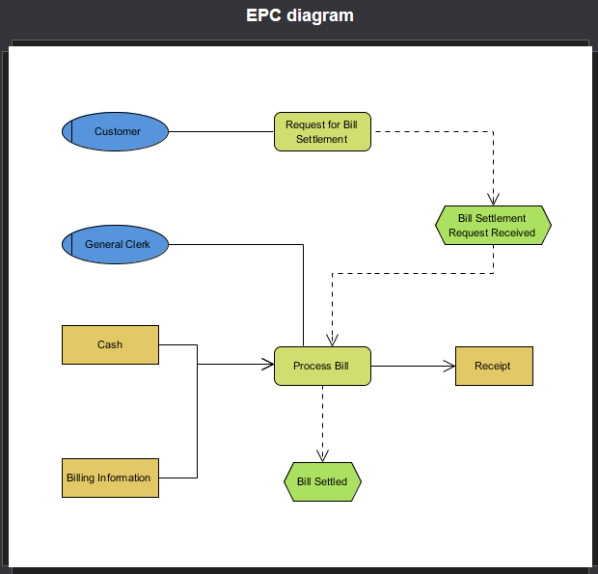

Рис.1. Диаграмма

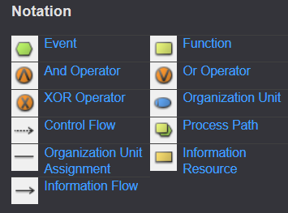

Рис.2. Обозначения

# Реализация:

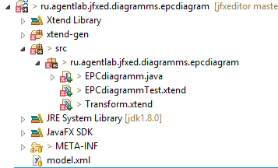

Рис.3. Структура папок

## Файл EPCdiadramm.java:

package ru.agentlab.jfxed.diagramms.epcdiagram;

import com.hp.hpl.jena.ontology.Individual;

import com.hp.hpl.jena.ontology.ObjectProperty;

import com.hp.hpl.jena.ontology.OntClass;

import com.hp.hpl.jena.ontology.OntModel;

import com.hp.hpl.jena.rdf.model.ModelFactory;

public class EPCDiagramm {

static String SOURCE = "http://www.eswc2006.org/technologies/ontology";

static String NS = SOURCE + "#";

//test from sourcetree

public static void main (String[] args){

/*

* Здесь объявляем объекты квадратики схемы

* */

OntModel m = ModelFactory.createOntologyModel();//создается пустая база знаний

/**

* Вершины графа

*/

OntClass unitClass = m.createClass(NS + "Organization Unit");

OntClass resourceClass = m.createClass(NS + "Information Resource");

OntClass functionClass = m.createClass(NS + "Function");

OntClass eventClass = m.createClass(NS + "Event");

OntClass controlClass = m.createClass(NS + "Control");//связь Control

OntClass orgClass = m.createClass(NS + "Organization");

OntClass infClass = m.createClass(NS + "Information");

// связи

ObjectProperty unitFuncTo = m.createObjectProperty(NS + "OrganizationTo");

unitFuncTo.addDomain(orgClass);

unitFuncTo.addRange(unitClass);

ObjectProperty unitFuncFrom = m.createObjectProperty(NS + "OrganizationFrom");

unitFuncFrom.addDomain(orgClass);

unitFuncFrom.addRange(functionClass);

ObjectProperty resFuncTo = m.createObjectProperty(NS + "InformationTo");

resFuncTo.addDomain(infClass);

resFuncTo.addRange(functionClass);

resFuncTo.addRange(resourceClass);

ObjectProperty resFuncFrom = m.createObjectProperty(NS + "InformationFrom");

resFuncFrom.addDomain(infClass);

resFuncFrom.addRange(functionClass);

resFuncFrom.addRange(resourceClass);

ObjectProperty eventFuncTo = m.createObjectProperty(NS + "ControlTo");

eventFuncTo.addDomain(controlClass);

eventFuncTo.addRange(eventClass);

eventFuncTo.addRange(functionClass);

ObjectProperty eventFuncFrom = m.createObjectProperty(NS + "ControlFrom");

eventFuncFrom.addDomain(controlClass);

eventFuncFrom.addRange(eventClass);

eventFuncFrom.addRange(functionClass);

// наполнение базы

Individual customer = m.createIndividual(orgClass);

Individual genClerk = m.createIndividual(orgClass);

Individual cash = m.createIndividual(resourceClass);

Individual billInf = m.createIndividual(resourceClass);

Individual receipt = m.createIndividual(resourceClass);

Individual billSetted = m.createIndividual(eventClass);

Individual billRec = m.createIndividual(eventClass);

Individual procBill = m.createIndividual(functionClass);

Individual reqBill = m.createIndividual(functionClass);

Individual orgIndividual = m.createIndividual(orgClass);

orgIndividual.addProperty(unitFuncFrom, customer);

orgIndividual.addProperty(unitFuncTo, reqBill);

orgIndividual.addProperty(unitFuncFrom, genClerk);

orgIndividual.addProperty(unitFuncTo, procBill);

Individual infIndividual = m.createIndividual(infClass);

infIndividual.addProperty(resFuncFrom, cash);

infIndividual.addProperty(resFuncTo, procBill);

infIndividual.addProperty(resFuncFrom, billInf);

infIndividual.addProperty(resFuncTo, procBill);

infIndividual.addProperty(resFuncFrom, procBill);

infIndividual.addProperty(resFuncTo, receipt);

Individual controlIndividual = m.createIndividual(controlClass);

controlIndividual.addProperty(eventFuncFrom, reqBill);

controlIndividual.addProperty(eventFuncTo, billRec);

controlIndividual.addProperty(eventFuncFrom, billRec);

controlIndividual.addProperty(eventFuncTo, procBill);

controlIndividual.addProperty(eventFuncFrom, procBill);

controlIndividual.addProperty(eventFuncTo, billSetted);

m.write(System.out);

}

}

## Файл EPCdiagrammTest.xtend

Тестирование полученной диаграммы производится при помощи запросов к полученному XML-файлу.

**package** ru.agentlab.jfxed.diagramms.epcdiagram

**import** com.hp.hpl.jena.query.QueryExecutionFactory

**import** com.hp.hpl.jena.query.QueryFactory

**import** com.hp.hpl.jena.query.ResultSetFormatter

**import** com.hp.hpl.jena.rdf.model.ModelFactory

**import** java.io.FileInputStream

**import** com.hp.hpl.jena.ontology.OntModel

**class** EPCdiagrammTest {

**static** String *SOURCE* = "http://www.agentlab.ru/jfxed/onto/epc"

**static** String *NS* = *SOURCE* + "#"

**protected** **var** OntModel m

**static** **def** **void** main(String[] args){

**val** me = **new** EPCdiagrammTest()

me.loadModel()

me.testQuery1()

me.testQuery2()

me.testQuery3()

}

**def** loadModel() {

m = ModelFactory.createOntologyModel() => [

**val** inputStream = **new** FileInputStream("model.xml")

read(inputStream, *NS*, "RDF/XML");

write(System.*out*, "RDF/XML");//пїЅ пїЅ пїЅпїЅпїЅпїЅпїЅпїЅпїЅ

]

}

**def** testQuery1(){

**val** queryString ='''

PREFIX rdf: <http://www.w3.org/1999/02/22-rdf-syntax-ns#>

PREFIX src: <http://www.eswc2006.org/technologies/ontology#>

select ?uri

where {

?uri rdf:type src:Information

}

'''

**val** query = QueryFactory.create(queryString);

// Execute the query and obtain results

**val** qe = QueryExecutionFactory.create(query, m);

**val** results = qe.execSelect();

// Output query results

ResultSetFormatter.out(System.*out*, results, query);

qe.close();

}

**def** testQuery2(){

**val** queryString ='''

PREFIX rdf: <http://www.w3.org/1999/02/22-rdf-syntax-ns#>

PREFIX src: <http://www.eswc2006.org/technologies/ontology#>

select ?uri

where {

?uri rdf:type src:Function

}

'''

**val** query = QueryFactory.create(queryString);

// Execute the query and obtain results

**val** qe = QueryExecutionFactory.create(query, m);

**val** results = qe.execSelect();

// Output query results

ResultSetFormatter.out(System.*out*, results, query);

qe.close();

}

**def** testQuery3(){

**val** queryString ='''

PREFIX rdf: <http://www.w3.org/1999/02/22-rdf-syntax-ns#>

PREFIX src: <http://www.eswc2006.org/technologies/ontology#>

select ?uri

where {

?uri rdf:type src:ControlTo

}

'''

**val** query = QueryFactory.create(queryString);

// Execute the query and obtain results

**val** qe = QueryExecutionFactory.create(query, m);

**val** results = qe.execSelect();

// Output query results

ResultSetFormatter.out(System.*out*, results, query);

qe.close();

}

}

## Результат программы:

<rdf:RDF

xmlns:rdf="http://www.w3.org/1999/02/22-rdf-syntax-ns#"

xmlns:j.0="http://www.eswc2006.org/technologies/ontology#"

xmlns:owl="http://www.w3.org/2002/07/owl#"

xmlns:j.1="http://www.eswc2006.org/technologies/ontology#Information "

xmlns:rdfs="http://www.w3.org/2000/01/rdf-schema#"

xmlns:xsd="http://www.w3.org/2001/XMLSchema#" >

<rdf:Description rdf:nodeID="A0">

<j.0:InformationTo rdf:nodeID="A1"/>

<j.0:InformationFrom rdf:nodeID="A2"/>

<j.0:InformationFrom rdf:nodeID="A3"/>

<j.0:InformationTo rdf:nodeID="A2"/>

<j.0:InformationFrom rdf:nodeID="A4"/>

<rdf:type rdf:resource="http://www.eswc2006.org/technologies/ontology#Information"/>

</rdf:Description>

<rdf:Description rdf:about="http://www.eswc2006.org/technologies/ontology#ControlFrom">

<rdfs:range rdf:resource="http://www.eswc2006.org/technologies/ontology#Function"/>

<rdfs:range rdf:resource="http://www.eswc2006.org/technologies/ontology#Event"/>

<rdfs:domain rdf:resource="http://www.eswc2006.org/technologies/ontology#Control"/>

<rdf:type rdf:resource="http://www.w3.org/2002/07/owl#ObjectProperty"/>

</rdf:Description>

<rdf:Description rdf:nodeID="A5">

<rdf:type rdf:resource="http://www.eswc2006.org/technologies/ontology#Event"/>

</rdf:Description>

<rdf:Description rdf:nodeID="A6">

<rdf:type rdf:resource="http://www.eswc2006.org/technologies/ontology#Function"/>

</rdf:Description>

<rdf:Description rdf:nodeID="A1">

<rdf:type rdf:resource="http://www.eswc2006.org/technologies/ontology#Information Resource"/>

</rdf:Description>

<rdf:Description rdf:about="http://www.eswc2006.org/technologies/ontology#OrganizationFrom">

<rdfs:range rdf:resource="http://www.eswc2006.org/technologies/ontology#Function"/>

<rdfs:domain rdf:resource="http://www.eswc2006.org/technologies/ontology#Organization"/>

<rdf:type rdf:resource="http://www.w3.org/2002/07/owl#ObjectProperty"/>

</rdf:Description>

<rdf:Description rdf:nodeID="A7">

<rdf:type rdf:resource="http://www.eswc2006.org/technologies/ontology#Organization"/>

</rdf:Description>

<rdf:Description rdf:about="http://www.eswc2006.org/technologies/ontology#InformationFrom">

<rdfs:range rdf:resource="http://www.eswc2006.org/technologies/ontology#Information Resource"/>

<rdfs:range rdf:resource="http://www.eswc2006.org/technologies/ontology#Function"/>

<rdfs:domain rdf:resource="http://www.eswc2006.org/technologies/ontology#Information"/>

<rdf:type rdf:resource="http://www.w3.org/2002/07/owl#ObjectProperty"/>

</rdf:Description>

<rdf:Description rdf:about="http://www.eswc2006.org/technologies/ontology#Control">

<rdf:type rdf:resource="http://www.w3.org/2002/07/owl#Class"/>

</rdf:Description>

<rdf:Description rdf:about="http://www.eswc2006.org/technologies/ontology#Information">

<rdf:type rdf:resource="http://www.w3.org/2002/07/owl#Class"/>

</rdf:Description>

<rdf:Description rdf:about="http://www.eswc2006.org/technologies/ontology#Function">

<rdf:type rdf:resource="http://www.w3.org/2002/07/owl#Class"/>

</rdf:Description>

<rdf:Description rdf:about="http://www.eswc2006.org/technologies/ontology#OrganizationTo">

<rdfs:range rdf:resource="http://www.eswc2006.org/technologies/ontology#Organization Unit"/>

<rdfs:domain rdf:resource="http://www.eswc2006.org/technologies/ontology#Organization"/>

<rdf:type rdf:resource="http://www.w3.org/2002/07/owl#ObjectProperty"/>

</rdf:Description>

<rdf:Description rdf:nodeID="A8">

<j.0:ControlTo rdf:nodeID="A9"/>

<j.0:ControlFrom rdf:nodeID="A2"/>

<j.0:ControlTo rdf:nodeID="A2"/>

<j.0:ControlFrom rdf:nodeID="A5"/>

<j.0:ControlTo rdf:nodeID="A5"/>

<j.0:ControlFrom rdf:nodeID="A6"/>

<rdf:type rdf:resource="http://www.eswc2006.org/technologies/ontology#Control"/>

</rdf:Description>

<rdf:Description rdf:about="http://www.eswc2006.org/technologies/ontology#Organization">

<rdf:type rdf:resource="http://www.w3.org/2002/07/owl#Class"/>

</rdf:Description>

<rdf:Description rdf:nodeID="A2">

<rdf:type rdf:resource="http://www.eswc2006.org/technologies/ontology#Function"/>

</rdf:Description>

<rdf:Description rdf:nodeID="A10">

<j.0:OrganizationTo rdf:nodeID="A2"/>

<j.0:OrganizationFrom rdf:nodeID="A7"/>

<j.0:OrganizationTo rdf:nodeID="A6"/>

<j.0:OrganizationFrom rdf:nodeID="A11"/>

<rdf:type rdf:resource="http://www.eswc2006.org/technologies/ontology#Organization"/>

</rdf:Description>

<rdf:Description rdf:nodeID="A3">

<rdf:type rdf:resource="http://www.eswc2006.org/technologies/ontology#Information Resource"/>

</rdf:Description>

<rdf:Description rdf:about="http://www.eswc2006.org/technologies/ontology#Event">

<rdf:type rdf:resource="http://www.w3.org/2002/07/owl#Class"/>

</rdf:Description>

<rdf:Description rdf:nodeID="A9">

<rdf:type rdf:resource="http://www.eswc2006.org/technologies/ontology#Event"/>

</rdf:Description>

<rdf:Description rdf:nodeID="A4">

<rdf:type rdf:resource="http://www.eswc2006.org/technologies/ontology#Information Resource"/>

</rdf:Description>

<rdf:Description rdf:about="http://www.eswc2006.org/technologies/ontology#Information Resource">

<rdf:type rdf:resource="http://www.w3.org/2002/07/owl#Class"/>

</rdf:Description>

<rdf:Description rdf:nodeID="A11">

<rdf:type rdf:resource="http://www.eswc2006.org/technologies/ontology#Organization"/>

</rdf:Description>

<rdf:Description rdf:about="http://www.eswc2006.org/technologies/ontology#InformationTo">

<rdfs:range rdf:resource="http://www.eswc2006.org/technologies/ontology#Information Resource"/>

<rdfs:range rdf:resource="http://www.eswc2006.org/technologies/ontology#Function"/>

<rdfs:domain rdf:resource="http://www.eswc2006.org/technologies/ontology#Information"/>

<rdf:type rdf:resource="http://www.w3.org/2002/07/owl#ObjectProperty"/>

</rdf:Description>

<rdf:Description rdf:about="http://www.eswc2006.org/technologies/ontology#ControlTo">

<rdfs:range rdf:resource="http://www.eswc2006.org/technologies/ontology#Function"/>

<rdfs:range rdf:resource="http://www.eswc2006.org/technologies/ontology#Event"/>

<rdfs:domain rdf:resource="http://www.eswc2006.org/technologies/ontology#Control"/>

<rdf:type rdf:resource="http://www.w3.org/2002/07/owl#ObjectProperty"/>

</rdf:Description>

<rdf:Description rdf:about="http://www.eswc2006.org/technologies/ontology#Organization Unit">

<rdf:type rdf:resource="http://www.w3.org/2002/07/owl#Class"/>

</rdf:Description>

</rdf:RDF>