**Лабораторная работа №3**

**по курсу «Разработка ПО»**

**Выполнил: Яндиев И.Б.**

**Проверил: Иванов А.М.**

## Задание

Создать тестовый Eclipse-проект, в котором происходит формирование информационной модели данных диаграммы и работа с данными в соответствии со своим вариантом задания и требованиями.

Добавить созданные проект в репозитарий системы контроля версий.

## Цель лабораторной работы

* Углубление навыков работы с системой контроля версий
* Ознакомление на практике с основами графовых БД и технологий Semantic Web

## Картинка-задание

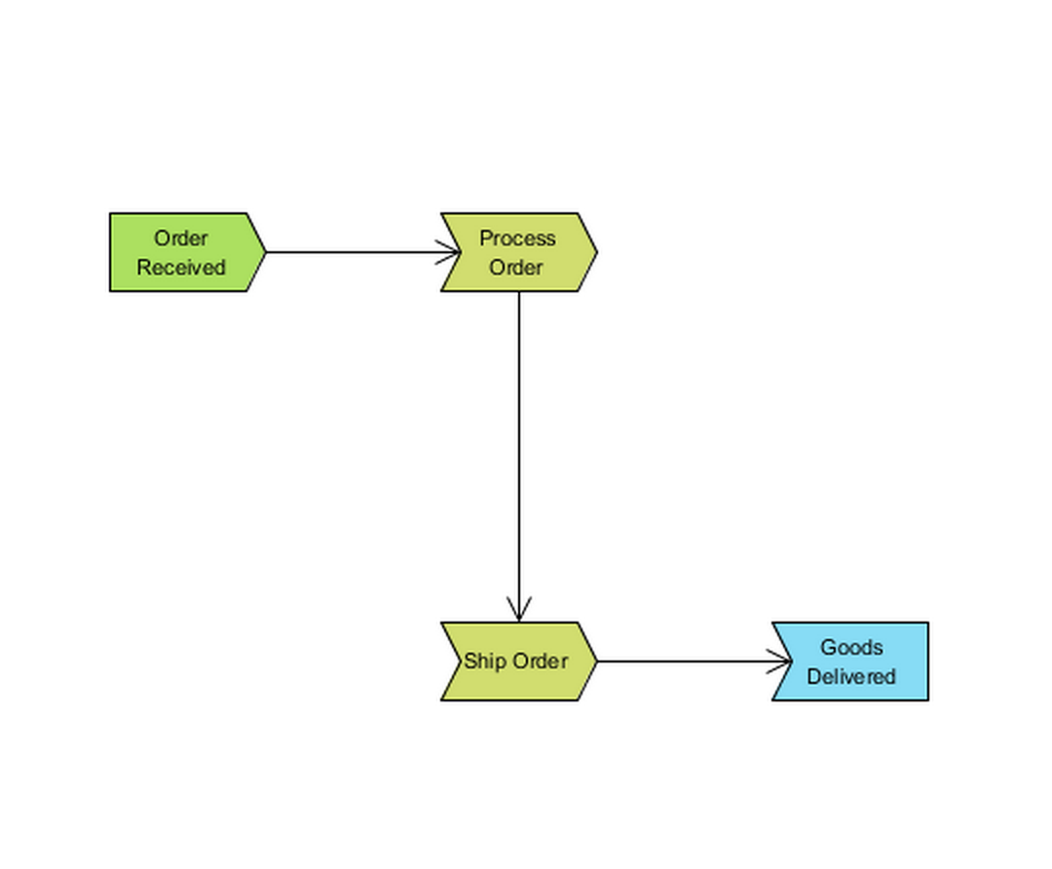

Рисунок 1. Задание

## Выполнение

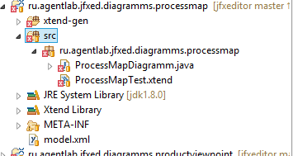

Рисунок 2. Структура папок

Файл ProcessMapTest.xtend

+package ru.agentlab.jfxed.diagramms.processmap   
  
+   
  
+import com.hp.hpl.jena.query.QueryExecutionFactory   
  
+import com.hp.hpl.jena.query.QueryFactory   
  
+import com.hp.hpl.jena.query.ResultSetFormatter   
  
+import com.hp.hpl.jena.rdf.model.ModelFactory   
  
+import java.io.FileInputStream   
  
+import com.hp.hpl.jena.ontology.OntModel   
  
+   
  
+class ProcessMapTest {   
  
+ static String SOURCE = "[http://www.agentlab.ru/jfxed/onto/epc](http://vk.com/away.php?utf=1&to=http%3A%2F%2Fwww.agentlab.ru%2Fjfxed%2Fonto%2Fepc)"   
  
+ static String NS = SOURCE + "#"   
  
+   
  
+ protected var OntModel m   
  
+   
  
+ static def void main(String[] args){   
  
+ val me = new ProcessMapTest()   
  
+   
  
+ me.loadModel()   
  
+   
  
+ me.testQuery1()   
  
+ me.testQuery2()   
  
+ me.testQuery3()   
  
+ }   
  
+   
  
+ def loadModel() {   
  
+ //   
  
+ m = ModelFactory.createOntologyModel() => [   
  
+ // m m.   
  
+   
  
+ val inputStream = new FileInputStream("model.xml")   
  
+ read(inputStream, NS, "RDF/XML");   
  
+ write(System.out, "RDF/XML");//   
  
+ ]   
  
+ }   
  
+   
  
+ def testQuery1(){   
  
+ //   
  
+ // php   
  
+ val queryString ='''   
  
+ PREFIX rdf: <[http://www.w3.org/1999/02/22-rdf-syntax-ns#](http://vk.com/away.php?utf=1&to=http%3A%2F%2Fwww.w3.org%2F1999%2F02%2F22-rdf-syntax-ns%23)>   
  
+ PREFIX src: <[http://www.eswc2006.org/technologies/ontology#](http://vk.com/away.php?utf=1&to=http%3A%2F%2Fwww.eswc2006.org%2Ftechnologies%2Fontology%23)>   
  
+ select ?uri   
  
+ where {   
  
+ ?uri rdf:type src:Process   
  
+ }   
  
+ '''   
  
+ val query = QueryFactory.create(queryString);   
  
+ // Execute the query and obtain results   
  
+ val qe = QueryExecutionFactory.create(query, m);   
  
+ val results = qe.execSelect();   
  
+   
  
+ // Output query results   
  
+ ResultSetFormatter.out(System.out, results, query);   
  
+ qe.close();   
  
+ }   
  
+   
  
+ def testQuery2(){   
  
+ //   
  
+ // php   
  
+ val queryString ='''   
  
+ PREFIX rdf: <[http://www.w3.org/1999/02/22-rdf-syntax-ns#](http://vk.com/away.php?utf=1&to=http%3A%2F%2Fwww.w3.org%2F1999%2F02%2F22-rdf-syntax-ns%23)>   
  
+ PREFIX src: <[http://www.eswc2006.org/technologies/ontology#](http://vk.com/away.php?utf=1&to=http%3A%2F%2Fwww.eswc2006.org%2Ftechnologies%2Fontology%23)>   
  
+ select ?uri   
  
+ where {   
  
+ ?uri rdf:type src:ProcessTo   
  
+ }   
  
+ '''   
  
+ val query = QueryFactory.create(queryString);   
  
+ // Execute the query and obtain results   
  
+ val qe = QueryExecutionFactory.create(query, m);   
  
+ val results = qe.execSelect();   
  
+   
  
+ // Output query results   
  
+ ResultSetFormatter.out(System.out, results, query);   
  
+ qe.close();   
  
+ }   
  
+   
  
+ def testQuery3(){   
  
+ //   
  
+ // php   
  
+ val queryString ='''   
  
+ PREFIX rdf: <[http://www.w3.org/1999/02/22-rdf-syntax-ns#](http://vk.com/away.php?utf=1&to=http%3A%2F%2Fwww.w3.org%2F1999%2F02%2F22-rdf-syntax-ns%23)>   
  
+ PREFIX src: <[http://www.eswc2006.org/technologies/ontology#](http://vk.com/away.php?utf=1&to=http%3A%2F%2Fwww.eswc2006.org%2Ftechnologies%2Fontology%23)>   
  
+ select ?uri   
  
+ where {   
  
+ ?uri rdf:type src:Send   
  
+ }   
  
+ '''   
  
+ val query = QueryFactory.create(queryString);   
  
+ // Execute the query and obtain results   
  
+ val qe = QueryExecutionFactory.create(query, m);   
  
+ val results = qe.execSelect();   
  
+   
  
+ // Output query results   
  
+ ResultSetFormatter.out(System.out, results, query);   
  
+ qe.close();   
  
+ }   
  
+}

Файл ProcessMapDiagramm.java

package ru.agentlab.jfxed.diagramms.processmap;  
import java.io.FileNotFoundException;  
import java.io.FileOutputStream;  
  
import com.hp.hpl.jena.ontology.Individual;  
import com.hp.hpl.jena.ontology.ObjectProperty;  
import com.hp.hpl.jena.ontology.OntClass;  
import com.hp.hpl.jena.ontology.OntModel;  
import com.hp.hpl.jena.rdf.model.ModelFactory;  
  
public class ProcessMapDiagramm {  
  
static String SOURCE = "[http://www.eswc2006.org/technologies/ontology](http://vk.com/away.php?utf=1&to=http%3A%2F%2Fwww.eswc2006.org%2Ftechnologies%2Fontology)";  
static String NS = SOURCE + "#";  
  
//test from sourcetree  
public static void main (String[] args){  
  
/*  
* Здесь объявляем объекты квадратики схемы  
* */  
OntModel m = ModelFactory.createOntologyModel();//создается пустая база знаний  
  
  
/**  
* Вершины графа  
*/  
  
OntClass processClass = m.createClass(NS + "Process");  
OntClass receiveClass = m.createClass(NS + "Receive");  
OntClass sendClass = m.createClass(NS + "Send");  
  
OntClass procLinkClass = m.createClass(NS + "Process Link");  
  
// связи  
  
ObjectProperty procTo = m.createObjectProperty(NS + "ProcessTo");  
procTo.addDomain(procLinkClass);  
procTo.addRange(processClass);  
procTo.addRange(sendClass);  
ObjectProperty procFrom = m.createObjectProperty(NS + "ProcessFrom");  
procFrom.addDomain(procLinkClass);  
procFrom.addRange(processClass);  
procFrom.addRange(receiveClass);  
  
// наполнение базы  
Individual order = m.createIndividual(sendClass);  
Individual procOther = m.createIndividual(processClass);  
Individual shipOther = m.createIndividual(processClass);  
Individual goods = m.createIndividual(receiveClass);  
  
Individual procLinkIndividual = m.createIndividual(procLinkClass);  
procLinkIndividual.addProperty(procFrom, order);  
procLinkIndividual.addProperty(procTo, procOther);  
procLinkIndividual.addProperty(procFrom, procOther);  
procLinkIndividual.addProperty(procTo, shipOther);  
procLinkIndividual.addProperty(procFrom, shipOther);  
procLinkIndividual.addProperty(procFrom, goods);  
  
FileOutputStream out;  
try {  
out = new FileOutputStream("model.xml");  
m.write(out, "RDF/XML");  
} catch (FileNotFoundException e) {  
// TODO Auto-generated catch block  
e.printStackTrace();  
}  
  
}  
}

Вывод программы:

xmlns:rdf="[http://www.w3.org/1999/02/22-rdf-syntax-ns#](http://vk.com/away.php?utf=1&to=http%3A%2F%2Fwww.w3.org%2F1999%2F02%2F22-rdf-syntax-ns%23)"   
  
+ xmlns:j.0="[http://www.eswc2006.org/technologies/ontology#](http://vk.com/away.php?utf=1&to=http%3A%2F%2Fwww.eswc2006.org%2Ftechnologies%2Fontology%23)"   
  
+ xmlns:j.1="[http://www.eswc2006.org/technologies/ontology#Process](http://vk.com/away.php?utf=1&to=http%3A%2F%2Fwww.eswc2006.org%2Ftechnologies%2Fontology%23Process)"   
  
+ xmlns:owl="[http://www.w3.org/2002/07/owl#](http://vk.com/away.php?utf=1&to=http%3A%2F%2Fwww.w3.org%2F2002%2F07%2Fowl%23)"   
  
+ xmlns:rdfs="[http://www.w3.org/2000/01/rdf-schema#](http://vk.com/away.php?utf=1&to=http%3A%2F%2Fwww.w3.org%2F2000%2F01%2Frdf-schema%23)"   
  
+ xmlns:xsd="[http://www.w3.org/2001/XMLSchema#](http://vk.com/away.php?utf=1&to=http%3A%2F%2Fwww.w3.org%2F2001%2FXMLSchema%23)" >   
  
+ <rdf:Description rdf:about="[http://www.eswc2006.org/technologies/ontology#Process](http://vk.com/away.php?utf=1&to=http%3A%2F%2Fwww.eswc2006.org%2Ftechnologies%2Fontology%23Process)">   
  
+ <rdf:type rdf:resource="[http://www.w3.org/2002/07/owl#Class](http://vk.com/away.php?utf=1&to=http%3A%2F%2Fwww.w3.org%2F2002%2F07%2Fowl%23Class)"/>   
  
+ </rdf:Description>   
  
+ <rdf:Description rdf:nodeID="A0">   
  
+ <j.0:ProcessFrom rdf:nodeID="A1"/>   
  
+ <j.0:ProcessFrom rdf:nodeID="A2"/>   
  
+ <j.0:ProcessTo rdf:nodeID="A2"/>   
  
+ <j.0:ProcessFrom rdf:nodeID="A3"/>   
  
+ <j.0:ProcessTo rdf:nodeID="A3"/>   
  
+ <j.0:ProcessFrom rdf:nodeID="A4"/>   
  
+ <rdf:type rdf:resource="[http://www.eswc2006.org/technologies/ontology#Process](http://vk.com/away.php?utf=1&to=http%3A%2F%2Fwww.eswc2006.org%2Ftechnologies%2Fontology%23Process) Link"/>   
  
+ </rdf:Description>   
  
+ <rdf:Description rdf:nodeID="A4">   
  
+ <rdf:type rdf:resource="[http://www.eswc2006.org/technologies/ontology#Send](http://vk.com/away.php?utf=1&to=http%3A%2F%2Fwww.eswc2006.org%2Ftechnologies%2Fontology%23Send)"/>   
  
+ </rdf:Description>   
  
+ <rdf:Description rdf:about="[http://www.eswc2006.org/technologies/ontology#ProcessTo](http://vk.com/away.php?utf=1&to=http%3A%2F%2Fwww.eswc2006.org%2Ftechnologies%2Fontology%23ProcessTo)">   
  
+ <rdfs:range rdf:resource="[http://www.eswc2006.org/technologies/ontology#Send](http://vk.com/away.php?utf=1&to=http%3A%2F%2Fwww.eswc2006.org%2Ftechnologies%2Fontology%23Send)"/>   
  
+ <rdfs:range rdf:resource="[http://www.eswc2006.org/technologies/ontology#Process](http://vk.com/away.php?utf=1&to=http%3A%2F%2Fwww.eswc2006.org%2Ftechnologies%2Fontology%23Process)"/>   
  
+ <rdfs:domain rdf:resource="[http://www.eswc2006.org/technologies/ontology#Process](http://vk.com/away.php?utf=1&to=http%3A%2F%2Fwww.eswc2006.org%2Ftechnologies%2Fontology%23Process) Link"/>   
  
+ <rdf:type rdf:resource="[http://www.w3.org/2002/07/owl#ObjectProperty](http://vk.com/away.php?utf=1&to=http%3A%2F%2Fwww.w3.org%2F2002%2F07%2Fowl%23ObjectProperty)"/>   
  
+ </rdf:Description>   
  
+ <rdf:Description rdf:about="[http://www.eswc2006.org/technologies/ontology#Receive](http://vk.com/away.php?utf=1&to=http%3A%2F%2Fwww.eswc2006.org%2Ftechnologies%2Fontology%23Receive)">   
  
+ <rdf:type rdf:resource="[http://www.w3.org/2002/07/owl#Class](http://vk.com/away.php?utf=1&to=http%3A%2F%2Fwww.w3.org%2F2002%2F07%2Fowl%23Class)"/>   
  
+ </rdf:Description>   
  
+ <rdf:Description rdf:nodeID="A2">   
  
+ <rdf:type rdf:resource="[http://www.eswc2006.org/technologies/ontology#Process](http://vk.com/away.php?utf=1&to=http%3A%2F%2Fwww.eswc2006.org%2Ftechnologies%2Fontology%23Process)"/>   
  
+ </rdf:Description>   
  
+ <rdf:Description rdf:nodeID="A3">   
  
+ <rdf:type rdf:resource="[http://www.eswc2006.org/technologies/ontology#Process](http://vk.com/away.php?utf=1&to=http%3A%2F%2Fwww.eswc2006.org%2Ftechnologies%2Fontology%23Process)"/>   
  
+ </rdf:Description>   
  
+ <rdf:Description rdf:about="[http://www.eswc2006.org/technologies/ontology#Process](http://vk.com/away.php?utf=1&to=http%3A%2F%2Fwww.eswc2006.org%2Ftechnologies%2Fontology%23Process)Link">   
  
+ <rdf:type rdf:resource="[http://www.w3.org/2002/07/owl#Class](http://vk.com/away.php?utf=1&to=http%3A%2F%2Fwww.w3.org%2F2002%2F07%2Fowl%23Class)"/>   
  
+ </rdf:Description>   
  
+ <rdf:Description rdf:about="[http://www.eswc2006.org/technologies/ontology#Send](http://vk.com/away.php?utf=1&to=http%3A%2F%2Fwww.eswc2006.org%2Ftechnologies%2Fontology%23Send)">   
  
+ <rdf:type rdf:resource="[http://www.w3.org/2002/07/owl#Class](http://vk.com/away.php?utf=1&to=http%3A%2F%2Fwww.w3.org%2F2002%2F07%2Fowl%23Class)"/>   
  
+ </rdf:Description>   
  
+ <rdf:Description rdf:nodeID="A1">   
  
+ <rdf:type rdf:resource="[http://www.eswc2006.org/technologies/ontology#Receive](http://vk.com/away.php?utf=1&to=http%3A%2F%2Fwww.eswc2006.org%2Ftechnologies%2Fontology%23Receive)"/>   
  
+ </rdf:Description>   
  
+ <rdf:Description rdf:about="[http://www.eswc2006.org/technologies/ontology#Process..](http://vk.com/away.php?utf=1&to=http%3A%2F%2Fwww.eswc2006.org%2Ftechnologies%2Fontology%23ProcessFrom)">   
  
+ <rdfs:range rdf:resource="[http://www.eswc2006.org/technologies/ontology#Receive](http://vk.com/away.php?utf=1&to=http%3A%2F%2Fwww.eswc2006.org%2Ftechnologies%2Fontology%23Receive)"/>   
  
+ <rdfs:range rdf:resource="[http://www.eswc2006.org/technologies/ontology#Process](http://vk.com/away.php?utf=1&to=http%3A%2F%2Fwww.eswc2006.org%2Ftechnologies%2Fontology%23Process)"/>   
  
+ <rdfs:domain rdf:resource="[http://www.eswc2006.org/technologies/ontology#Process](http://vk.com/away.php?utf=1&to=http%3A%2F%2Fwww.eswc2006.org%2Ftechnologies%2Fontology%23Process) Link"/>   
  
+ <rdf:type rdf:resource="[http://www.w3.org/2002/07/owl#ObjectProperty](http://vk.com/away.php?utf=1&to=http%3A%2F%2Fwww.w3.org%2F2002%2F07%2Fowl%23ObjectProperty)"/>   
  
+ </rdf:Description>

--------

| uri |

========

| _:b0 |

| _:b1 |

| _:b2 |

| _:b3 |

--------

-------

| uri |

=======

-------

--------

| uri |

========

| _:b0 |

| _:b1 |

| _:b2 |

Результаты моделирования в Protégé:

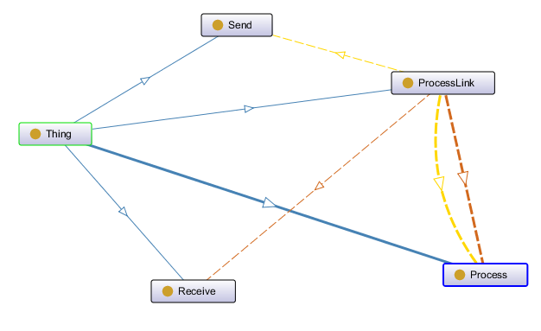

Рис.3.Модель