Solution Architecture — TAG RE × Agentryx (EstateOS)
Version: 0.1 (draft) Audience: Internal — Agentryx engineering, AU partner, future hires Status: Pre-Sunday-meeting working draft. Open questions to be closed after first TAG discovery session. Author: Agentryx Australia

1. Purpose and scope of this document
This document defines the technical architecture of EstateOS, the AI operating layer Agentryx is building for Australian real estate agencies. TAG Real Estate is the anchor / build-partner customer; the architecture is designed from day zero to be productised and resold to other agencies.
In scope:
- The full system architecture across data, AI, workflow, integration, and UI layers
- The AI Provider Abstraction Layer in detail (a load-bearing component)
- Data architecture, residency, and security posture
- Deployment topology (cloud-agnostic, on-prem capable)
- Phase-tagged components — each component is annotated with the phase it lands in
Out of scope (handled in companion documents):
- Phasing rationale and rollout sequence — see Phasing Plan
- Per-phase requirements with user stories and acceptance criteria — see Phase N PRD documents
- The POC simulation harness — see POC PRD
- Commercial structure and TAG-specific pricing
This is a living document. Several sections contain [OPEN] markers where assumptions need confirmation from TAG (typically after the first discovery session). Update in place; do not let v0.1 calcify.

2. Guiding principles
The architecture is shaped by six principles. When trade-offs arise, these principles arbitrate.
P1. Don’t replace systems of record. TAG already owns MRI Vault, PropertyMe, REA, and Eagle. EstateOS reads from and acts on top of these systems. We do not build a CRM, a trust accounting system, or a listings portal. Replacing any of those would take years and provide no AI-specific value.
P2. AI provider-agnostic from day one. Every LLM call routes through a Provider Abstraction Layer. No workflow, agent, or component calls a vendor SDK directly. Switching providers — including to self-hosted open-weights models in the future — must be a configuration change, not a code change.
P3. Cloud and deployment-target agnostic. The architecture must run on AWS, Azure, GCP, or on-premises. We will recommend a default deployment (Azure Australia East for residency reasons), but the system is containerised and stateless wherever possible to preserve portability.
P4. Multi-tenant from day one, single-tenant deployable. TAG is tenant zero in a multi-tenant SaaS architecture. The same code can be deployed as a single-tenant private installation if a future customer demands it (with degraded operational economics, accepted as a customer-driven trade-off).
P5. Human-in-the-loop is the default for outbound actions. AI drafts; humans approve; the system sends. We do not auto-send vendor emails, auto-dispatch maintenance vendors, or auto-publish content without an explicit human approval gate, in v1. Auto-execution is a per-workflow opt-in setting that some customers may enable later, never the default.
P6. Every AI action is observable and reversible. Every call to an LLM is logged with full context, cost, latency, and output. Every approved action has an undo path. We can always answer “what did the AI do, when, why, and at what cost.”

3. System context
The system context shows EstateOS in relation to the people and systems it interacts with.
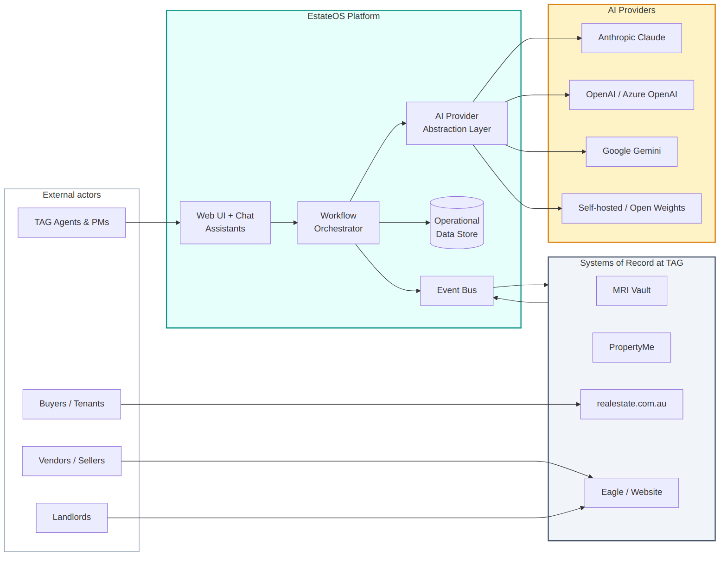
System context

3.1 Actors
Actor | Interaction
TAG agents and PMs | Primary daily users — operate via web console and embedded chat assistants
Vendors / sellers | Receive AI-drafted, human-approved campaign updates; their replies feed back into the system
Buyers / tenants | Source of inbound enquiries (REA), maintenance requests, inspection bookings
Landlords | Receive churn-protective outreach; approve maintenance work via SMS / email
TAG admins | Configure AI behaviour, review audit logs, manage user access
Agentryx ops (us) | Manage shared control plane, observability, billing, tenant lifecycle

3.2 Systems of record (TAG-owned)
System | Role | Integration mode [OPEN]
MRI Vault | Trust accounting, document custody, compliance certificates | Likely: scheduled exports + email parsing fallback. Confirm API availability.
PropertyMe | PM workflow — tenants, maintenance, inspections, arrears | Likely: official API + webhooks. Confirm scope of API.
realestate.com.au | Listings publication and lead capture | Confirmed: REA has agent APIs and lead webhook delivery.
Eagle / Proptech Group website | Public-facing site, appraisal forms, CRM | Likely: lead webhooks + scheduled CRM exports. Confirm.
[OPEN: TAG-Q1] Confirm API/webhook/export availability for each of the four systems in the first discovery session. Architecture supports all three modes; choice affects only the integration adapter, not anything above it.

3.3 External AI providers
EstateOS routes AI workloads to one or more of: Anthropic (Claude), OpenAI (direct or via Azure), Google (Gemini direct or via Vertex), AWS Bedrock, and self-hosted open-weights models. See section 6 (AI Provider Abstraction Layer) for routing logic.

4. Component architecture (the layer cake)
EstateOS is structured as six logical layers. Each layer has well-defined responsibilities and can evolve independently.
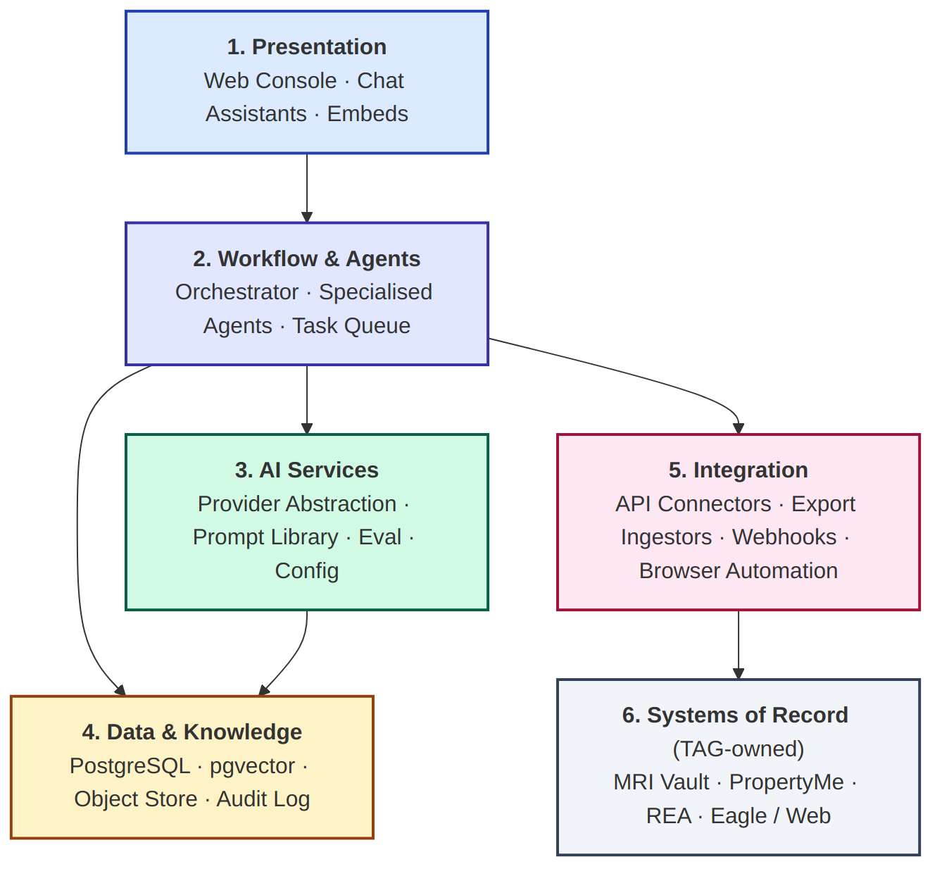
Component layers

4.1 Layer 1 — Presentation
Purpose: All human interaction surfaces.
Component | Phase | Description
Web Console | Phase 1+ | React/Next.js single-page app. Agent-facing dashboard, approval queues, configuration.
Conversational Assistants | Phase 5 | Role-specific chat UIs (Sales Assistant, PM Assistant, Admin Assistant). Each is the same chat engine with different prompt context, tools, and data access.
Embeds | Phase 3+ | Lightweight panels embeddable inside PropertyMe, Eagle CRM, or via browser extension where direct integration isn’t possible.
Notes. The web console is the workhorse; embeds and assistants are layered on later. Mobile is a Phase 5+ concern — until then, the console is responsive but desktop-first.

4.2 Layer 2 — Workflow & Agent Layer
Purpose: The business logic of the system. Where “AI does work” lives.
Component | Phase | Description
Workflow Orchestrator | Phase 0 | Coordinates multi-step processes (e.g., weekly vendor email cycle: fetch data → draft → queue for approval → send → track). Built on a durable workflow engine (recommendation: Temporal or a lighter alternative like Inngest; final choice in Phase 0).
Specialised Agents | Phase 1+ | One agent per wedge: Vendor Email Agent, Maintenance Triage Agent, Churn Scorer, Doc Parser, Coaching Analyzer, Suburb Content Generator. Each agent is a focused module with its own prompt library, tool set, and evaluation harness.
Task Queue | Phase 0 | Async work execution. Background jobs, retries, rate limits, scheduled triggers. Recommendation: Celery (Python) on Redis, or equivalent.
Critical design decision: agents are not autonomous loops in v1. Each agent is a function that takes input, calls the LLM (with tools), produces output. The orchestrator decides when agents run. We do not have agents that run in long autonomous loops making decisions and acting unsupervised — too risky for real estate workflows where wrong actions have legal consequences. Autonomous loops can be considered in Phase 5+ for low-stakes workflows.

4.3 Layer 3 — AI Services Layer
Purpose: All AI-specific concerns isolated from business logic.
Component | Phase | Description
Provider Abstraction Layer | Phase 0 | The unified interface for all LLM calls. Detailed in section 6.
Prompt Library | Phase 0 | Versioned, reviewable prompts. Each prompt is a code artifact with version, owner, last-eval-score, and rollback.
Eval & Observability | Phase 0 | Per-task evaluation harness. For every prompt/model pair, we maintain a test set and run regressions before deploying changes.
AI Configuration Service | Phase 0 | Backend for the AI Configuration UI. Stores per-tenant provider credentials, per-task model assignments, policies.
The AI Services Layer being its own layer (rather than mixed into agents) is the most important structural decision in this architecture. It is the difference between EstateOS being a maintainable product and being a tangled mess in 18 months.

4.4 Layer 4 — Data & Knowledge Layer
Purpose: Persistence, retrieval, and audit.
Component | Phase | Description
Operational DB (PostgreSQL) | Phase 0 | Primary store. Normalised schemas for properties, listings, leads, vendors, tenants, landlords, campaigns, maintenance tickets, etc.
Vector Store (pgvector) | Phase 1+ | Embeddings for semantic search: comparable properties, similar maintenance issues, suburb similarity, document retrieval. We use pgvector (Postgres extension) rather than a separate vector DB to reduce operational surface.
Document Store (S3-compatible) | Phase 0 | Raw documents (leases, contracts, photos, PDFs, audio recordings of calls). Encrypted at rest. Lifecycle policies for retention.
Audit Log | Phase 0 | Append-only log of every AI invocation, every approval action, every outbound communication. Separate from operational DB for write-perf and immutability.
[OPEN: ARCH-Q1] Decision pending: separate vector DB (e.g., Qdrant, Pinecone) vs pgvector. Default to pgvector for v1 simplicity; revisit if RAG performance demands it.

4.5 Layer 5 — Integration Layer
Purpose: Talk to TAG’s existing systems.
Component | Phase | Description
API Connectors | Phase 0–4 | First-class adapters for each system that exposes a real API (REA confirmed; PropertyMe likely; MRI/Eagle TBC).
Export Ingestors | Phase 0–4 | For systems without APIs: scheduled CSV/SFTP/email-parsing pipelines. Slower, less rich, but works for everything.
Webhook Receivers | Phase 0–4 | Inbound event endpoints for systems that push (REA leads, possibly PropertyMe events).
Browser Automation | Phase 4+ if needed | Last-resort fallback for systems that have no API and no useful exports. Only used when no other option exists; treated as technical debt.
Key principle: every external system has one canonical adapter in EstateOS. Workflows never know whether the data came from an API, a CSV import, or a webhook — they see normalised internal models only. This is what allows us to swap integration modes without rewriting workflows.

4.6 Layer 6 — Systems of record (TAG-owned)
External; not built by us. Listed for completeness:
- MRI Vault
- PropertyMe
- realestate.com.au
- Eagle / Proptech Group website
We do not modify these systems. We read from them and write back to them via their official integration surfaces.

5. Component catalogue (detailed)
This section catalogues each component with its purpose, inputs, outputs, internal logic, failure modes, and phase. Read this when you need to know exactly what something does.

5.1 Workflow Orchestrator
Phase: 0 Purpose: Coordinate multi-step business processes that span data fetch → AI call → human approval → outbound action → audit.
Inputs:
- Scheduled triggers (e.g., weekly vendor email job at 09:00 AEST Mondays)
- Event triggers (e.g., new maintenance ticket arrives in PropertyMe → trigger triage workflow)
- User-initiated triggers (agent clicks “draft update for this campaign”)
Outputs:
- Side effects: agent invocations, queue entries, audit log entries, outbound API calls
- State: workflow execution history, current status of every in-flight workflow
Internal logic:
- Each workflow is defined declaratively (steps, retries, timeouts, compensation actions on failure)
- Workflows are durable — survive crashes, redeploys, restarts
- Idempotency is enforced at step level (re-running a step doesn’t double-send an email)
Failure modes:
- LLM provider outage → retry with backoff, fall back to secondary provider, eventually queue for manual handling and notify ops
- Downstream system rejection (e.g., REA refuses an API call) → log, alert, do not silently drop
- Long-running workflow stuck → automatic alerting at SLA boundaries
Recommendation: Use a durable workflow engine. Top candidates: Temporal (most mature, more ops overhead), Inngest (lighter, hosted option), custom on Postgres + Celery (cheapest, most work). Phase 0 decision; default to Inngest unless cost/control concerns favour Temporal.

5.2 Vendor Email Agent (Wedge 1)
Phase: 1 Purpose: Draft personalised weekly campaign updates for vendors with active listings.
Inputs:
- Campaign ID
- Listing details (address, price guide, listed date)
- Activity data (enquiries, inspection bookings, attendances, second inspections, written offers) for the past period
- Comparable sales (recent + ongoing in same suburb / building / segment)
- Vendor profile (preferences, comms history, tone)
- Agent’s voice profile (writing samples, tone calibration)
Outputs:
- Draft email (subject + body) tagged as “pending review”
- Highlighted recommendation (e.g., “consider price guide adjustment because X”)
- Confidence score and reasoning trace (for agent review)
Internal logic:
- Fetch all inputs from operational DB
- Compose structured prompt with campaign data + comparables + agent voice samples
- Call PAL with task=vendor_email_draft (default model: high-tier; configurable)
- Validate output: contains required sections, doesn’t contain prohibited content (price predictions, legal commitments, financial advice)
- Store as pending; surface in agent’s approval queue
Failure modes:
- Insufficient data (new campaign, fewer than N inspections) → skip, mark as “insufficient data,” notify agent
- LLM output fails validation → retry once with corrective prompt, otherwise escalate to manual draft
- Agent voice samples missing → fall back to TAG house style; log a warning
Acceptance criteria (for use in Phase 1 PRD):
- Draft generated within 60 seconds of trigger for 95% of cases
- Cost per draft under AUD $0.30 (with default model)
- Agent edit-rate (% of drafts modified before approval) measured and reported as a quality metric

5.3 Maintenance Triage Agent (Wedge 4)
Phase: 2 Purpose: Classify, prioritise, and propose action for inbound tenant maintenance requests.
Inputs:
- Tenant submission (text + optional photo + optional video + optional voice)
- Property metadata (age, type, current tenant, owner preferences, prior issues at the property)
- Vendor rate card (available trades, pre-approved providers, agreed rates)
- Owner preferences (auto-approve threshold $, preferred vendors, special instructions)
Outputs:
- Issue classification (plumbing | electrical | HVAC | structural | cosmetic | etc.)
- Urgency tier (P1 emergency | P2 within 24h | P3 within 7 days | P4 routine)
- Estimated cost range from rate card
- Suggested action (auto-approve and dispatch | request owner approval | escalate to PM | reject as tenant responsibility)
- Drafted SMS to owner (if approval needed) and to tenant (acknowledgement)
Internal logic:
- If photo/video present, use vision-capable model to assess severity
- Cross-reference against historical issues at this property and similar issues across portfolio
- Apply owner preferences to determine the right action path
- Always include a human-in-the-loop checkpoint for any work above the owner’s auto-approve threshold
Failure modes:
- Ambiguous submission (“something’s wrong with the kitchen”) → request clarification from tenant before dispatching
- No matching rate card entry → flag for PM, do not guess
- Photo/video parsing fails → fall back to text-only triage with reduced confidence
Sensitive considerations:
- Emergency classification (P1) must be conservative — if uncertain, escalate. Better to disturb a PM at 2am for a non-emergency than miss a real one.
- Auto-approve thresholds must be per-owner, never platform-wide defaults.

5.4 Landlord Churn Scorer (Wedge 3)
Phase: 4 Purpose: Identify landlords at risk of leaving the rent roll before they signal intent.
Inputs (signals tracked daily):
- Maintenance avg-resolution-time trending up
- Arrears frequency on their property
- Rent vs current suburb median (gap widening)
- Communication volume + sentiment (email/calls in/out of PM)
- Compliance friction (cert renewal chases, complaints from tenants)
- Portfolio behaviour (added new property elsewhere, ABN searches, etc.) [OPEN] legality of monitoring third-party signals
Outputs:
- Per-landlord risk score (0–100), updated daily
- Top 3 contributing factors per high-score landlord
- Recommended intervention (BDM call, rent review, maintenance recovery plan)
- Alert routed to BDM queue for landlords above threshold
Internal logic:
- Mostly classical ML / rule-based scoring, not an LLM (cheaper, more interpretable, more legally defensible than LLM scoring)
- LLM is used for generating the human-readable explanation of why a landlord scored as they did, and for drafting the intervention
- Models retrained quarterly on outcome data (which interventions actually saved which landlords)
Failure modes:
- Insufficient history (new landlord) → flag as “insufficient data,” do not score
- All signals tracked but no model yet trained → return rule-based score with explicit “rule-based” flag
Important: This component generates outputs that humans will use to make commercial decisions about real customers. It must be:
- Auditable (why did this landlord score 87?)
- Bias-tested (no disparate impact across protected attributes)
- Override-able (BDM can dismiss a score, with reason logged)

5.5 Document Parser
Phase: 2 (initial), 3 (expanded) Purpose: Extract structured information from real estate documents.
Document types in scope:
- Phase 2: Residential leases, condition reports, smoke alarm certificates
- Phase 3: Sales contracts, Section 32 (or NSW equivalents), trust account statements, REA performance reports, supplier invoices
Outputs (per document type):
- Structured extraction (JSON conforming to per-type schema)
- Confidence per field
- Flagged anomalies (missing signatures, inconsistent dates, unusual clauses)
- Compliance check (e.g., does the lease cover all NSW-required clauses)
Internal logic:
- OCR if needed (Tesseract or cloud OCR; cloud preferred for scanned docs)
- Vision-capable LLM for extraction with structured output enforcement
- Per-field validation rules
- Cross-reference against expected document templates
Important: Parsing real estate documents must err on the side of “flag for human review” rather than confidently extracting wrong values. A wrong rent amount in a lease is a legal problem.

5.6 Coaching Analyzer
Phase: 5 Purpose: Score sales calls against the TAG playbook and surface coaching insights.
Out of scope for v1 detail; covered in Phase 5 PRD. Architectural notes:
- Requires explicit consent capture from all parties on the call (legal requirement in NSW)
- Recordings stored with strict access control; only the principal and the agent see analyses of their own calls
- LLM scoring against a rubric, not against arbitrary “good vs bad” — the rubric is published, reviewable, and adjustable by the principal

5.7 Suburb Content Generator
Phase: 3 Purpose: Generate monthly suburb reports, social posts, blog content for each of TAG’s 15+ suburbs.
Out of scope for v1 detail; covered in Phase 3 PRD. Architectural notes:
- Pulls market data from REA + public sources + TAG’s own sales history
- Always human-approved before publication
- SEO-aware (structured data, meta tags) but not SEO-spam

6. AI Provider Abstraction Layer (PAL)
This section is intentionally detailed because PAL is load-bearing for everything else. If PAL is wrong, every workflow above it is forced into wrong shapes.
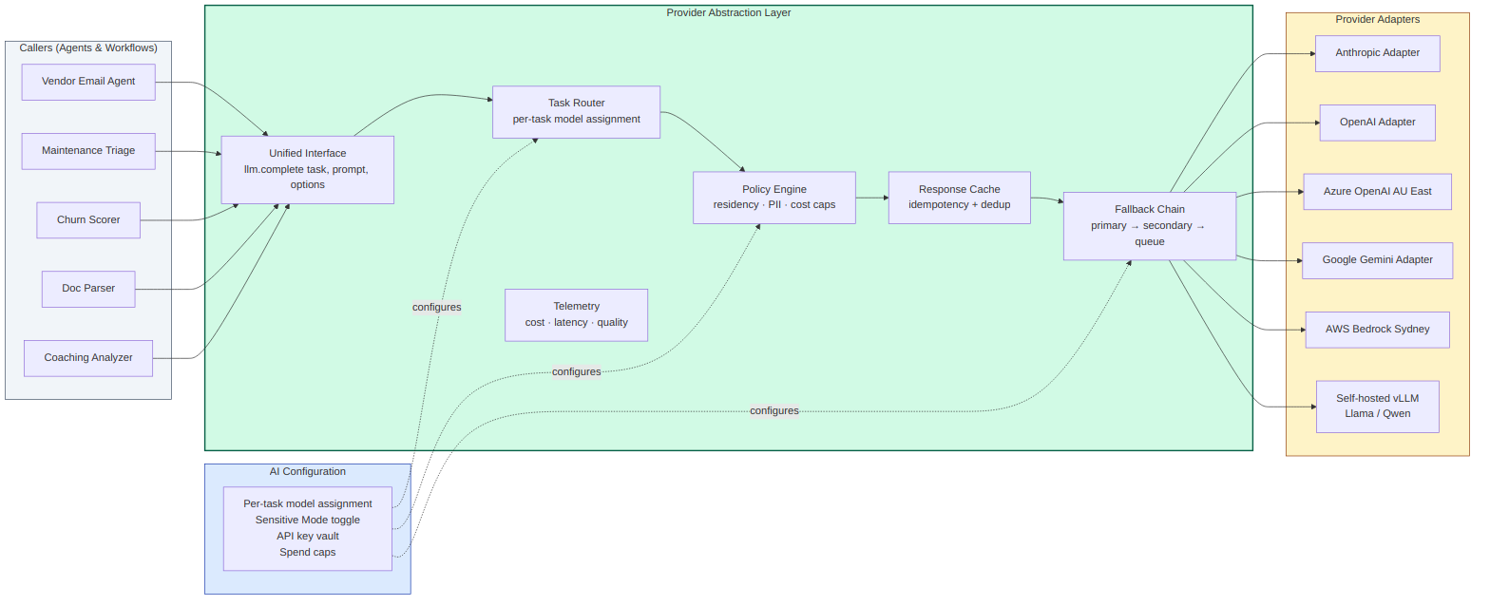
AI Provider Abstraction Layer

6.1 The unified interface
Every AI call in EstateOS passes through one function (signature illustrative, not final):
LLMService.complete(
task: TaskName, # e.g. 'vendor_email_draft'
inputs: dict, # task-specific structured inputs
options: CompletionOptions # overrides (temperature, max_tokens, etc.)
) -> CompletionResult
CompletionResult includes the output, the model used, the cost, the latency, the trace ID, and any tool-use sequence.
Key consequence: no agent or workflow ever imports an Anthropic SDK, an OpenAI SDK, or a Gemini SDK. All vendor-specific code lives behind PAL adapters. This is enforced architecturally and by code review.

6.2 Task router
Each LLM call is associated with a TaskName. The router maps TaskName → ProviderConfig, where ProviderConfig specifies:
- Primary provider and model (e.g., Anthropic, claude-opus-4)
- Secondary fallback provider and model
- Tertiary fallback (often a cheaper / faster model for last-resort)
- Override flags: temperature, max_tokens, stop sequences, JSON mode
Task assignment is editable at runtime via the AI Configuration UI without redeploying code.
Default task assignments (proposed, configurable per tenant):
Task | Default Provider | Default Model | Rationale
vendor_email_draft | Anthropic | Claude Opus | High-stakes, voice-sensitive, top-tier needed
maintenance_triage | Anthropic | Claude Sonnet | Fast classification, vision-capable
maintenance_classify_text_only | Anthropic | Claude Haiku | Bulk text classification, cheap
lease_parse | Anthropic | Claude Sonnet | Long-context document parsing strength
churn_explain | Anthropic | Claude Sonnet | Generate human-readable explanations
coaching_score | Anthropic | Claude Opus | Nuanced scoring against rubric
suburb_content | Anthropic | Claude Sonnet | Long-form content, structured
embeddings | OpenAI | text-embedding-3-large | Cost-effective, high quality
These defaults are recommendations. Customers can reassign via the configuration UI.

6.3 Policy engine
Before any call is dispatched, it passes through the policy engine. Policies are tenant-scoped configuration:
- Residency policy. Tasks tagged contains_pii or contains_financial_data may only be routed to providers matching the tenant’s residency requirements (e.g., AU-only). Violations reject the call before dispatch with a clear error.
- Cost cap policy. Per-task and per-tenant monthly spend limits. Soft alerts at 50%/80%; hard cutoff at 100% (with an override path for ops).
- Sensitive Mode (global toggle). When on, all contains_pii and contains_financial_data tasks must use AU-region providers; non-AU providers are blocked entirely for those tasks.
- PII redaction policy. For tasks where the prompt unavoidably contains PII (e.g., drafting a tenant-specific email), redact-on-log: the audit log stores hashed identifiers, not raw names. Raw content is retained encrypted in the operational store with strict access control.

6.4 Fallback chain
If the primary provider fails (timeout, rate limit, 5xx, unavailable), PAL automatically falls back: 1. Primary provider/model 2. Secondary provider/model 3. Tertiary (typically a cheaper/faster model) 4. Queue for retry with exponential backoff 5. Eventually surface to ops with explicit alert
Fallback events are logged. If we see frequent fallbacks, that’s a signal to reconsider the primary assignment.

6.5 Response cache
Identical task+inputs requests within a configurable TTL return cached results. This is critical because:
- Many workflows are re-runnable (e.g., a user clicks “regenerate draft” — should not pay 2x if nothing changed)
- LLM responses can be expensive; cache hits save real money
- Idempotency reduces accidental duplication
Cache keys are hashes of (task, inputs, model_config). Cache is opt-out per task (some tasks should always re-run).

6.6 Telemetry
For every call PAL emits:
- Request: tenant, user, task, provider, model, input token count, prompt version
- Response: output token count, latency, cost (calculated from per-provider pricing tables), success/failure, fallback chain followed
- Quality (where available): eval score, agent edit rate (for drafts), downstream outcome
This data feeds the AI Configuration UI’s dashboards and informs reassignment decisions.

6.7 Provider adapters
Each adapter is a thin module that:
- Authenticates with its provider
- Translates LLMService.complete calls into the provider’s native API format
- Translates responses back into the unified format
- Reports cost based on the provider’s pricing model
Adapters in scope (Phase 0–6):
Adapter | Phase | Notes
Anthropic (Claude) | 0 | Default for most tasks
OpenAI direct | 0 | For embeddings, GPT-4 class drafting
Azure OpenAI Australia East | 0 | For PII-heavy tasks under Sensitive Mode
Google Gemini direct | 1 | For multimodal (vision/video) tasks
AWS Bedrock Sydney | 2 | AU-region multi-model option
Self-hosted vLLM | 5+ | For Llama, Qwen, or fine-tuned models — Phase 5+ for cost optimisation
Adding a new adapter is the only code change required to support a new provider. Everything else (UI, policies, telemetry) generalises.

6.8 AI Configuration UI
The user-facing surface of PAL. Lives under /admin/ai in the web console.
Sections:
- Providers. Paste API keys (encrypted at rest, never shown in plaintext after entry). Test connection. Mark provider as “active” or “inactive.”
- Task assignments. A table: row per task, columns for primary/secondary/tertiary provider+model, plus override settings. Bulk-edit support.
- Policies. Sensitive Mode toggle. Per-task residency tags. Cost caps.
- Spend & telemetry. Dashboard: spend by task, by provider, by user, by office; latency p50/p95/p99; success rates; quality scores where available.
- Audit. Search and filter the AI call log. Drill into individual calls to see full prompt, output, and metadata. Export for compliance.
UX principle: a non-technical operator (Vedant, Hailey) should be able to read the dashboard and know whether the system is healthy. A technical operator (engineering) should be able to drill into anything.
[OPEN: ARCH-Q2] Decision pending: do tenants share a global default task-assignment table, or does each tenant have its own from day one? Recommendation: each tenant has its own, seeded from a global template. Deferred to Phase 0 design.

7. Data architecture

7.1 Data model overview
EstateOS maintains its own normalised data model rather than mirroring any one source system. This is what allows multiple sources of record to coexist (PropertyMe + MRI Vault both have “tenant” data; we resolve into one canonical tenant record).
Top-level entities:
- Property (with relationships to Listings, Leases, MaintenanceTickets, Inspections, Sales)
- Person (resolved across vendors, buyers, tenants, landlords; one person can play multiple roles over time)
- Campaign (sales or rental; spans listing + activity + outcome)
- MaintenanceTicket (with workflow state, vendor, costs, resolution)
- Document (lease, contract, certificate, with extraction state)
- AICall (every LLM invocation; the audit backbone)
- Tenant (in the SaaS sense — one row per customer agency, holds tenant-scoped configuration)
[OPEN: ARCH-Q3] Detailed schema design is Phase 0 work. This document defines the entity boundaries; the field-level schema is in the Phase 0 PRD.

7.2 Data residency
Default posture: TAG’s tenant data is stored in Australia (Azure Australia East, AWS Sydney, or GCP Sydney depending on cloud choice). This applies to:
- Operational database
- Document store (lease PDFs, photos, audio recordings)
- Vector store
- Audit log
- Backups (also AU)
AI provider routing: Sensitive Mode (default ON for TAG) restricts AI calls touching PII/financial data to AU-region providers (Azure OpenAI Australia East, AWS Bedrock Sydney). Non-sensitive workloads (e.g., generic suburb content generation that doesn’t touch a real customer) can route globally for cost/quality reasons.
[OPEN: COMPLIANCE-Q1] Confirm with TAG’s lawyers: do Australian Privacy Principles, NSW real estate regulations, or REINSW codes impose stricter requirements than our default posture? If yes, tighten before Phase 1 launch.

7.3 Data retention
Data type | Retention | Rationale
Operational records (properties, campaigns, etc.) | Indefinite while tenant active; 7 years post-tenancy-end | Aligns with NSW record-keeping requirements
Documents (leases, contracts) | Indefinite while active; 7 years post-conclusion | Legal hold requirements
Maintenance tickets | 7 years | Liability window
AI call audit log | Indefinite while tenant active | Compliance, incident investigation
Call recordings (Phase 5) | 12 months by default; tenant-configurable | Storage cost + privacy
Embeddings | Recomputable, so retention flexible | Can be regenerated from source
[OPEN: COMPLIANCE-Q2] Confirm retention schedule with TAG and a NSW real estate compliance lawyer.

7.4 Encryption and access
- At rest: All data encrypted with cloud-native KMS (AES-256). Document store uses per-object encryption.
- In transit: TLS 1.3 everywhere. mTLS for service-to-service.
- Access control: Role-based access control with these roles at minimum: tenant_admin, principal, sales_lead, sales_associate, pm_lead, pm_officer, admin_staff, accounts, agentryx_ops. Permissions matrix defined in Phase 0 PRD.
- Tenant isolation: Row-level security in Postgres scoped by tenant_id. No query is allowed without a tenant filter. Enforced at the ORM/repository layer with audited code review.

8. Integration architecture

8.1 Integration modes
Each external system is integrated through one of three modes, in order of preference:
Mode A — API. Real-time read and write via official REST/GraphQL APIs. Best fidelity, lowest latency. Used wherever the source system supports it.
Mode B — Webhook + scheduled poll. Source system pushes events; we also poll on a schedule for safety. Common pattern for “mostly real-time” systems.
Mode C — Scheduled export. Source system sends CSV/JSON dumps via SFTP, S3, or email. Higher latency (typically 1–24h delay), more brittle, but always works.
Mode D — Browser automation. Last resort. Headless browser scripted to perform actions a human would. Treated as technical debt; we accept it but plan to retire each instance as APIs become available.

8.2 Per-system integration plan
System | Preferred mode | Fallback mode | Phase
REA | A (API) | B (webhook) | 0
PropertyMe | A (API) [OPEN] | C (export) | 0
MRI Vault | C (export) [OPEN] | D (browser) | 1
Eagle / Web | A (API) [OPEN] | C (export) | 0
[OPEN: TAG-Q1] confirm preferred modes after first discovery session.

8.3 Internal event bus
Inside EstateOS, all integration events flow onto an internal event bus (Redis Streams or equivalent). Components subscribe to events they care about. This decouples ingestion from processing.
Example events:
- lead.created (from REA webhook)
- maintenance.submitted (from PropertyMe webhook)
- lease.uploaded (from document drop folder)
- appraisal.requested (from Eagle web form)
Events are durable and replayable — if a downstream consumer was offline or deployed wrongly, we can replay events to catch up.

8.4 Outbound actions
When EstateOS acts on the world (sends an email, dispatches a vendor, posts a listing change), the action is: 1. Dispatched via the appropriate integration adapter 2. Logged in the audit log with full payload 3. Tagged with the AI call ID that produced it (if AI-originated) 4. Tracked for outcome (delivery status, response, follow-on events)
We do not send anything to vendors, tenants, or landlords without:
- Human approval (in v1)
- Rate limits (no more than X messages per recipient per period)
- Suppression list checks (do-not-contact lists)

9. Security and compliance

9.1 Threat model (abridged)
The four threats we design against:
T1. Tenant data leak across tenants. A bug or misconfiguration causes one customer’s data to be visible to another. Mitigation: row-level security, mandatory tenant_id on every query, integration tests that try to cross tenants.
T2. Credential theft (LLM provider keys). An attacker gains tenant LLM keys and runs up bills or exfils data. Mitigation: keys encrypted at rest with per-tenant KEK, never logged, never returned to UI in plaintext after entry. Per-tenant cost caps prevent runaway billing.
T3. PII exfiltration via AI. An attacker crafts inputs that cause the AI to leak training data or context-window data. Mitigation: PII redaction in logs, no shared context between tenants, regular adversarial testing, content policies enforced at PAL.
T4. Insider misuse. An authorised user uses access for inappropriate purposes (e.g., looking up a personal acquaintance’s rent records). Mitigation: comprehensive audit log, anomaly detection on access patterns, periodic access review.

9.2 Compliance scope
[OPEN: COMPLIANCE-Q3] Confirm full applicable regulatory list. Initial assumption set:
- Australian Privacy Principles (APPs) — handling of personal information
- NSW Privacy and Personal Information Protection Act
- NSW Property and Stock Agents Act + Regulation — real estate agency conduct
- Trust Account regulation — strict; most of this is handled by MRI Vault, but our reads/writes must not break their compliance posture
- REINSW codes of conduct — industry self-regulation
- GDPR — only if EstateOS handles EU residents’ data; not expected for TAG but possible for future customers

9.3 Audit and observability
Every action that affects customer-visible state is logged with:
- Who (user ID, IP, session)
- What (operation + parameters)
- When (timestamp, monotonic clock)
- Why (workflow ID, AI call ID, manual trigger)
- Result (success / failure / partial)
The audit log is append-only, separately backed up, and retained per the retention schedule in 7.3.

10. Non-functional requirements
[OPEN: NFR baselines] These targets are starting points; revise after observing real load.
Property | Target | Notes
Availability (Phase 1) | 99.0% | One-tenant pilot; lower bar acceptable
Availability (Phase 4+) | 99.9% | Multi-tenant production; higher bar
LLM call latency p95 | 30s | Drafting tasks; large outputs are slow
UI interactive latency p95 | < 1s | Web console responsiveness
Background job lag p95 | < 5 min | Time from event to AI processing
Recovery point objective (RPO) | 1 hour | DB + document store
Recovery time objective (RTO) | 4 hours | Phase 1; tighten in Phase 4+
Per-tenant cost ceiling (LLM) | AUD $5K/month default | Configurable; alerts at 80%

11. Deployment architecture
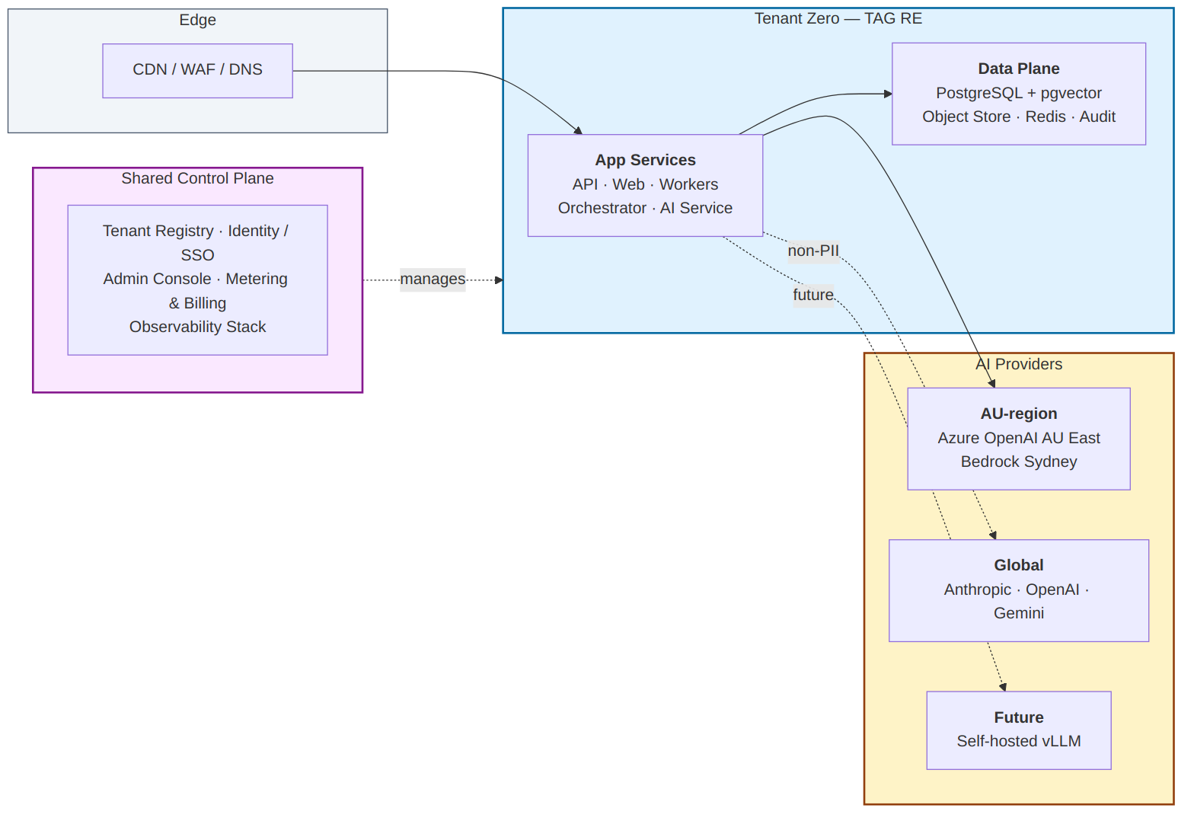
Deployment topology

11.1 Topology
EstateOS runs as containerised services. The deployment has two parts:
Tenant-scoped data plane (per customer agency):
- Operational PostgreSQL (with pgvector extension)
- Object storage (documents)
- Redis (cache + queue)
- Logs and audit storage
- All tenant-scoped, isolated by network and IAM
Shared control plane (Agentryx-operated, multi-tenant):
- Tenant registry
- Identity / SSO
- Admin console (Agentryx ops)
- Metering and billing
- Centralised observability
Application services are stateless and run per-tenant or shared depending on customer tier. Phase 1 runs everything per-tenant for isolation; Phase 6 introduces a shared application tier with strict per-request tenant scoping for cost efficiency.

11.2 Cloud preference (recommendation)
Default deployment: Azure Australia East.
Rationale:
- Strongest AU-region story for OpenAI workloads (Azure OpenAI in Australia East is the cleanest data residency option)
- Mature managed Postgres (Azure Database for PostgreSQL)
- Mature object storage (Azure Blob)
- Familiar to many Australian enterprise buyers (lower selling friction)
Acceptable alternatives:
- AWS Sydney (ap-southeast-2) — if customer / partner preference. Bedrock provides good in-region AI.
- GCP Sydney (australia-southeast1) — if customer / partner preference. Vertex AI in-region.
- On-premises — for customers with strict isolation requirements. Higher operational cost; we deploy via Docker Compose or Kubernetes.
Architectural commitment: No service uses cloud-vendor-locked APIs without an abstraction. We use S3-compatible object storage (works on Azure Blob, GCS, MinIO), standard Postgres, standard Redis, standard container runtimes.

11.3 Environments
- Development. Per-engineer local Docker Compose stack.
- CI. Ephemeral envs spun up per pull request for integration tests.
- Staging. One shared multi-tenant staging environment with synthetic data.
- Production. Per-tenant or shared depending on tier (see 11.1).
Deployment is GitOps-style: code → CI → image → environment promotion via PRs to environment manifests.

12. Phase tagging summary
Components with phase tags, for quick reference. See companion Phasing Plan document for rationale and dependencies.
Phase | Components introduced
Phase 0 — Foundation | Operational DB, document store, audit log, integration layer (REA + PropertyMe + Eagle adapters), workflow orchestrator, task queue, PAL (full), AI configuration UI, prompt library, eval harness, web console shell, identity/SSO, baseline observability
Phase 1 — Vendor Communication | Vendor Email Agent, agent voice profiles, approval queue UI, vendor reply tracking, MRI Vault adapter (read-only)
Phase 2 — Maintenance Triage | Maintenance Triage Agent, vendor rate card management, owner approval flows (SMS/email), document parser (leases)
Phase 3 — Top-of-funnel + Content | Appraisal-to-Listing Intelligence, Suburb Content Generator, vector store + embeddings (full RAG), document parser (sales contracts)
Phase 4 — Predictive layer | Landlord Churn Scorer, Compliance & Trust Watchdog, BDM intervention queue, ML training pipeline
Phase 5 — Coaching + Assistants | Coaching Analyzer, conversational assistants (Sales / PM / Admin), call recording infrastructure, mobile responsive UI
Phase 6 — Productisation (EstateOS) | Multi-tenant control plane hardening, self-serve onboarding, marketplace for prompt packs, public API for partners, self-hosted inference adapter

13. Open questions
A consolidated list. Each must be closed before the architecture can be considered final for the relevant phase.
ID | Question | Owner | Needed by
TAG-Q1 | API/webhook/export availability for MRI Vault, PropertyMe, Eagle | TAG IT + Vedant | Phase 0 start
TAG-Q2 | Volume baseline: listings/year, rentals under management, maintenance tickets/month, vendor email volume | Vedant | Phase 0 start
TAG-Q3 | Existing data: years of historical CRM data available; quality/completeness | TAG IT | Phase 0 start
TAG-Q4 | Trust account boundary: read-only or any write-back ever needed? | Vedant + accountant | Phase 0 start
ARCH-Q1 | Vector store: pgvector vs separate (Qdrant/Pinecone) | Engineering | Phase 0 design
ARCH-Q2 | Tenant task-assignment defaults: shared global vs per-tenant from day one | Engineering | Phase 0 design
ARCH-Q3 | Detailed schema design for top-level entities | Engineering | Phase 0 PRD
ARCH-Q4 | Workflow engine choice: Temporal vs Inngest vs custom | Engineering + AU partner | Phase 0 design
COMPLIANCE-Q1 | Confirm AU residency requirements vs default posture | TAG legal counsel | Phase 1 launch
COMPLIANCE-Q2 | Confirm retention schedule | TAG + compliance lawyer | Phase 1 launch
COMPLIANCE-Q3 | Full applicable regulatory list | TAG + compliance lawyer | Phase 1 launch
NFR-Q1 | Realistic load baselines (translates target SLOs to capacity) | After Phase 1 observation | Phase 2 design

14. Glossary
- EstateOS — the Agentryx product name for this platform
- PAL — Provider Abstraction Layer (section 6)
- Wedge — a discrete AI-powered workflow (Vendor Comm, Maintenance Triage, etc.)
- System of record (SOR) — TAG’s existing source-of-truth systems (MRI, PropertyMe, REA, Eagle)
- Tenant — a customer agency in the SaaS sense; TAG is “tenant zero”
- Sensitive Mode — global toggle that restricts PII/financial AI workloads to AU-region providers
- Wedge vs Phase — a phase delivers one or more wedges plus supporting infrastructure

End of document. Companion documents: Phasing Plan, Phase 0 PRD, Phase 1 PRD, Phases 2–6 PRDs (light), POC PRD.

