Meltwater source regions and the Glas δ¹⁸O record: importance, variability and alignment
Laura Endres
2026-09-29

Questions
At the NISA location, which meltwater source region is the most important, and which is the most variable, contributor to the δ¹⁸O anomaly over time? Is there alignment between abrupt δ¹⁸O changes in the Glas data and the modelled discharge, and how can that alignment be quantified?

Data
Discharge series. data/Discharge_Glac1d_regional-withd18O.csv and data/Discharge_ice6g_regional-withd18O.csv are the meltwater forcing series of the impulse-response (Green’s function) forward model of Endres et al. (in prep.; Impulse_Response_Revisions_v1.pdf in this repository, Sect. 5.2.3 and 5.3.3). They give river-routed meltwater discharge (in Sv) into nine North Atlantic dye-tracer source regions, computed from the GLAC-1D reconstruction (26–0 ka, 100-yr steps) and the ICE-6G reconstruction (28 ka to 2 ka after present, 500-yr steps), following the meltwater protocol described in the draft (after Ivanovic et al., 2018, and Romé et al., 2022, as cited there). Time is taken as years BP (negated time and t_adj); both series place their largest pulse at 14.4 (GLAC-1D) and 14.0 ka (ICE-6G), i.e. Meltwater Pulse 1A, which supports this convention. The region codes are those of the forward-model draft (Med, Bri, Fen, EurArc, AmeArc, GIS, NLau, SLau, GoM) and correspond, in the same order, to the input regions of Endres et al. (2026b) (Table 1). Each file also gives the discharge converted to a δ¹⁸O anomaly per region for three ice-sheet end-members (−30, −35, −40 ‰); this is the forcing that the forward model convolves with the site kernels. Within every region the anomaly is a fixed multiple of the discharge, and that multiple, times the region’s surface volume from Endres et al. (2026b), is the same constant for all nine regions (3.14 ± 0.01 × 10¹³ m³ s⁻¹ yr, Table 1), equal to one year of discharge. The anomaly columns are thus the surface δ¹⁸O anomaly of the source region per year of injection, Δδ¹⁸O = Q · 1 yr · δ¹⁸O_{ice} / V_{region}, before propagation to NISA. The convolved anomaly at the NISA site (Fig. 5.13C, E of the draft) is not part of the repository data, so “contribution at NISA” is evaluated here on the forcing side. All results below use the −35 ‰ end-member; the other end-members rescale every anomaly by 6/7 or 8/7 and cannot change any ranking, correlation or event timing.
Glas. Entity 903 (La Vallina cave, NISA), 532 δ¹⁸O samples on the original Bchron chronology, 11.9–23.8 ka BP (see the companion manuscript on the Glas age range). Abrupt δ¹⁸O transitions identified by Endres et al. (2026a, Table 1) are used as reference events.
Table 1: Source-region codes in the discharge files, the corresponding input regions of Endres et al. (2026b), their surface volume V, and the empirical scaling k = anomaly / (Q · δ¹⁸O_ice) in the GLAC-1D file. k · V is constant, showing that the anomaly is the source-region anomaly per year of discharge.
Code | Input region | Ice sheet | V (10¹² m³) | k (‰ Sv⁻¹ ‰⁻¹) | k·V (10¹³)
Med | EIS_MedSea | European | 17.90 | 1.77 | 3.16
Bri | EIS_BayOfBiscay | European | 4.92 | 6.34 | 3.12
Fen | EIS_NorwegianSea | European | 5.85 | 5.36 | 3.13
EurArc | EIS_Arctic | European | 7.02 | 4.47 | 3.14
AmeArc | LAU_Arctic | Laurentide | 13.40 | 2.32 | 3.11
GIS | GIS_GreenlandSea | Greenland | 4.49 | 7.02 | 3.15
NLau | LAU_LabradorSea | Laurentide | 13.30 | 2.34 | 3.12
SLau | LAU_StLawrence | Laurentide | 15.80 | 1.99 | 3.14
GulofMex | LAU_GulfOfMexico | Laurentide | 11.90 | 2.63 | 3.13

Methods
Importance and variability. For each reconstruction the per-region anomaly series was summarised over the full series and over the Glas interval (11.9–23.8 ka). Importance is the time-mean anomaly (equivalently the time-integrated contribution) and its share of the summed anomaly of all regions. Variability is the standard deviation of the anomaly over time; the coefficient of variation (SD / |mean|) is given as a scale-free complement. Because the anomaly is proportional to discharge, the same rankings hold for discharge itself.
Alignment with Glas. Glas δ¹⁸O was averaged into the time bins of each reconstruction (100 yr for GLAC-1D, 500 yr for ICE-6G). Three complementary quantifications were used:
- Correlation at lag 0 between binned Glas δ¹⁸O and the total and per-region anomalies (Pearson r). A negative anomaly means fresher surface water, and a negative Glas δ¹⁸O shift is read as freshening, so alignment corresponds to positive r. Both series are strongly autocorrelated, so significance was assessed against 2,000 AR(1) surrogates of the Glas series with the same lag-1 autocorrelation.
- Lead–lag cross-correlation between binned Glas δ¹⁸O and the GLAC-1D total anomaly for lags of ±2,000 yr, with the same surrogate envelope.
- Event matching. Discharge pulses were defined on the GLAC-1D total anomaly as 100-yr steps whose change exceeds one standard deviation of all steps (freshening pulses: anomaly becoming more negative; recoveries: anomaly becoming less negative), merging consecutive steps into one pulse at the largest step. Glas events are the six δ¹⁸O transitions of Endres et al. (2026a, Table 1), plus data-driven steps where the change between consecutive 100-yr bins exceeds two standard deviations. A Glas event is matched if a discharge pulse of the same sign lies within ±300 yr. The number of matches was compared with 5,000 random placements of the same events in the Glas interval.

Results

Importance and variability of source regions
Figure 1 shows the regional anomalies through time and Table 2 ranks the regions within the Glas interval. The two reconstructions disagree on the single most important region. In GLAC-1D the three largest contributors are nearly tied: EIS_NorwegianSea (mean -1.28 ‰, 20 % of the summed anomaly), followed by EIS_Arctic and LAU_Arctic, and the European sectors together supply 53 % of the anomaly versus 47 % from the Laurentide. In ICE-6G the most important region is LAU_GulfOfMexico (mean -1.38 ‰, 22 %), and the Laurentide sectors dominate (57 % versus 39 % European). Over the full series (Table 3) the most important region is LAU_Arctic in GLAC-1D and LAU_Arctic in ICE-6G, because both reconstructions route most of Meltwater Pulse 1A and the Holocene melt through the Laurentide sectors.
The most variable contribution over the Glas interval is EIS_NorwegianSea in GLAC-1D (SD 1.71 ‰, with EIS_Arctic almost equal) and LAU_Arctic in ICE-6G (SD 1.60 ‰). In both reconstructions the variability is concentrated in a few short pulses rather than in a fluctuating background (Figure 1): the regions with the largest SD also have the most negative single values (Table 2). GIS_GreenlandSea and EIS_MedSea are negligible in GLAC-1D and small and steady in ICE-6G, so they are the least variable in both cases.
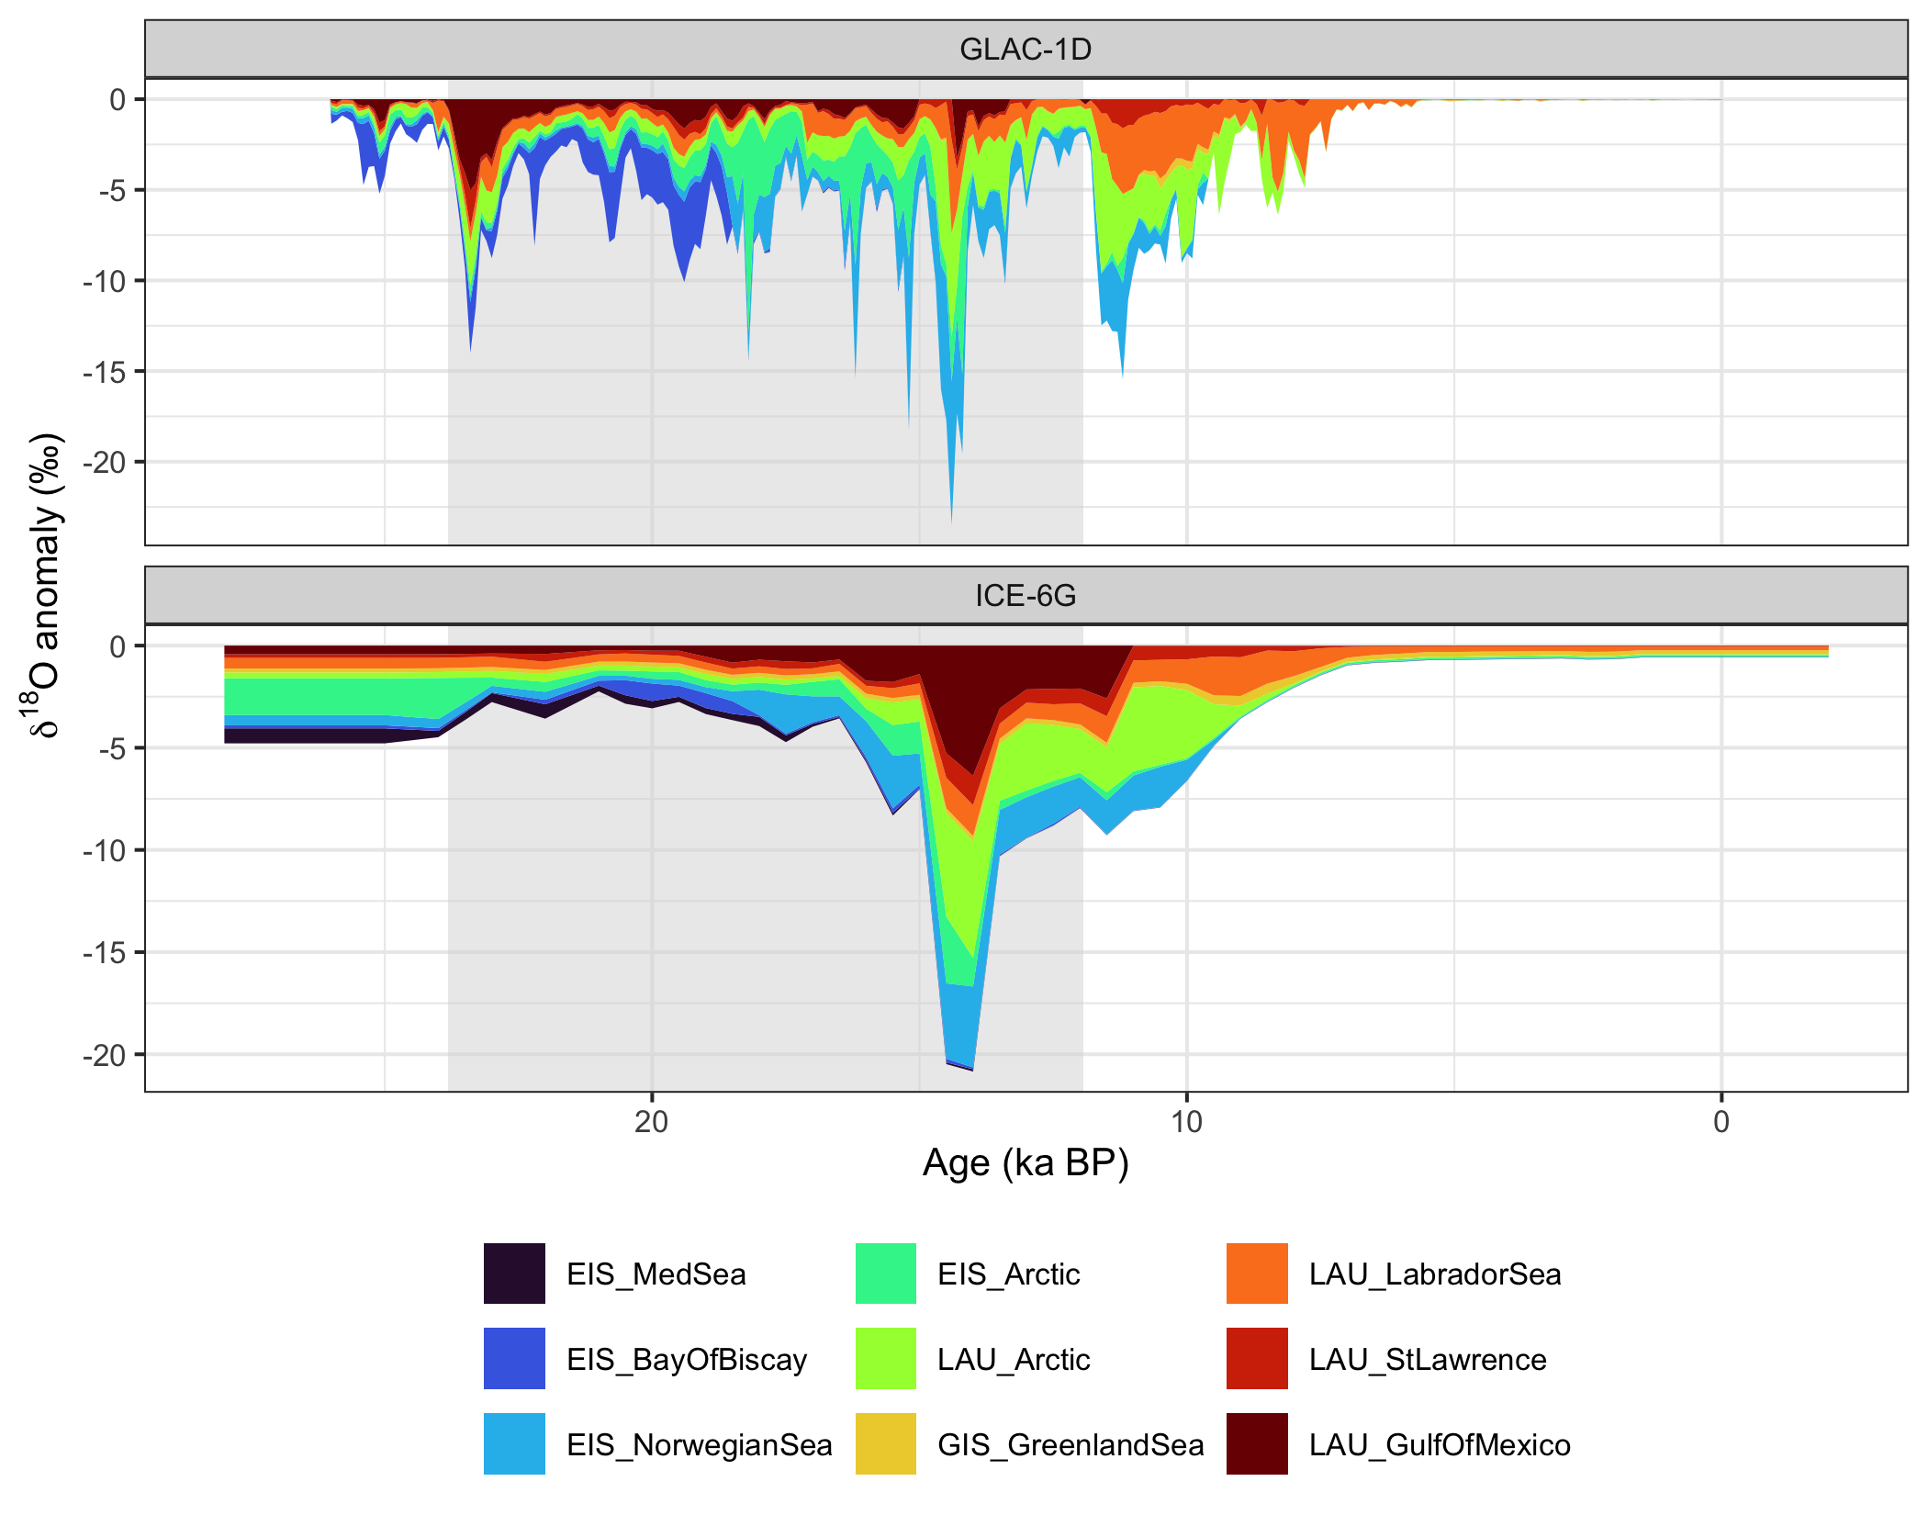
Figure 1: Source-region δ¹⁸O anomalies (−35 ‰ end-member) through time for GLAC-1D (top) and ICE-6G (bottom), stacked so that the envelope is the summed anomaly of all nine regions. Grey shading marks the interval covered by Glas.
Table 2: Source regions within the Glas interval, ranked by mean anomaly (importance). Share is the region’s fraction of the summed anomaly; SD is the temporal standard deviation (variability) and CV = SD / |mean|. Values in ‰ for the −35 ‰ end-member.
Reconstruction | Region | Mean (‰) | Share (%) | Min (‰) | SD (‰) | CV
GLAC-1D | EIS_NorwegianSea | -1.28 | 19.6 | -9.30 | 1.71 | 1.3
 | EIS_Arctic | -1.27 | 19.3 | -11.71 | 1.70 | 1.3
 | LAU_Arctic | -1.22 | 18.6 | -6.89 | 1.15 | 0.9
 | EIS_BayOfBiscay | -0.93 | 14.2 | -5.38 | 1.27 | 1.4
 | LAU_GulfOfMexico | -0.82 | 12.5 | -5.03 | 0.95 | 1.2
 | LAU_LabradorSea | -0.76 | 11.6 | -5.11 | 0.61 | 0.8
 | LAU_StLawrence | -0.26 | 4.0 | -2.25 | 0.32 | 1.2
 | GIS_GreenlandSea | -0.01 | 0.2 | -0.12 | 0.02 | 1.9
 | EIS_MedSea | -0.00 | 0.0 | -0.06 | 0.01 | 2.9
ICE-6G | LAU_GulfOfMexico | -1.38 | 22.3 | -6.38 | 1.58 | 1.1
 | EIS_NorwegianSea | -1.24 | 20.0 | -3.96 | 1.09 | 0.9
 | LAU_Arctic | -1.19 | 19.2 | -5.73 | 1.60 | 1.3
 | EIS_Arctic | -0.70 | 11.3 | -3.26 | 0.68 | 1.0
 | LAU_LabradorSea | -0.56 | 9.0 | -1.51 | 0.34 | 0.6
 | LAU_StLawrence | -0.43 | 7.0 | -1.43 | 0.33 | 0.8
 | EIS_MedSea | -0.25 | 4.0 | -0.70 | 0.20 | 0.8
 | EIS_BayOfBiscay | -0.24 | 3.9 | -0.85 | 0.25 | 1.0
 | GIS_GreenlandSea | -0.21 | 3.4 | -0.26 | 0.02 | 0.1

Table 3: As Table 2, but over the full length of each discharge series.
Reconstruction | Region | Mean (‰) | Share (%) | Min (‰) | SD (‰) | CV
GLAC-1D | LAU_Arctic | -0.95 | 22.1 | -6.89 | 1.30 | 1.4
 | LAU_LabradorSea | -0.83 | 19.2 | -5.11 | 1.02 | 1.2
 | EIS_NorwegianSea | -0.75 | 17.5 | -9.30 | 1.39 | 1.8
 | EIS_Arctic | -0.63 | 14.6 | -11.71 | 1.29 | 2.1
 | EIS_BayOfBiscay | -0.50 | 11.7 | -5.38 | 1.00 | 2.0
 | LAU_GulfOfMexico | -0.40 | 9.2 | -5.03 | 0.76 | 1.9
 | LAU_StLawrence | -0.21 | 4.8 | -2.25 | 0.33 | 1.6
 | GIS_GreenlandSea | -0.03 | 0.8 | -0.55 | 0.08 | 2.5
 | EIS_MedSea | -0.00 | 0.0 | -0.06 | 0.01 | 3.8
ICE-6G | LAU_Arctic | -0.79 | 19.2 | -5.73 | 1.33 | 1.7
 | EIS_NorwegianSea | -0.68 | 16.5 | -3.96 | 0.91 | 1.3
 | LAU_GulfOfMexico | -0.65 | 15.9 | -6.38 | 1.20 | 1.8
 | EIS_Arctic | -0.59 | 14.3 | -3.26 | 0.73 | 1.2
 | LAU_LabradorSea | -0.57 | 14.0 | -1.90 | 0.44 | 0.8
 | LAU_StLawrence | -0.28 | 6.8 | -1.43 | 0.30 | 1.1
 | GIS_GreenlandSea | -0.22 | 5.4 | -0.50 | 0.06 | 0.3
 | EIS_MedSea | -0.20 | 4.9 | -0.74 | 0.26 | 1.3
 | EIS_BayOfBiscay | -0.12 | 3.0 | -0.85 | 0.19 | 1.5

Alignment between Glas δ¹⁸O and discharge
Correlation at lag 0. Table 4 lists the correlations. Binned Glas δ¹⁸O is only weakly correlated with the GLAC-1D total anomaly (r = 0.20, n = 119 bins) and moderately with the ICE-6G total (r = 0.55, n = 25). The strongest regional correlation in both reconstructions is with EIS_NorwegianSea (r = 0.53 in GLAC-1D, 0.77 in ICE-6G), the sector that discharges into the Norwegian Sea close to the NISA moisture source. EIS_BayOfBiscay is negatively correlated in GLAC-1D (r = -0.64) because its discharge peaks at 22–23 ka while Glas records re-salinisation. The binned Glas series has a lag-1 autocorrelation of 0.95 at 100-yr resolution, so the effective sample size is small. Against AR(1) surrogates only the EIS_NorwegianSea (positive) and EIS_BayOfBiscay (negative) correlations in GLAC-1D reach p < 0.05 (p = 0.041 and 0.043); the total anomalies do not (p = 0.383 and 0.243), and nothing does in ICE-6G with 25 bins. Correlation of first differences is likewise weak (r = 0.11). Level correlations therefore do not demonstrate alignment: both series share a long-term deglacial trend and a few pulses, which is not enough to separate from red noise.
Table 4: Pearson correlation between binned Glas δ¹⁸O and the total and per-region source anomalies at lag 0. p is the two-sided fraction of AR(1) surrogates of the Glas series with |r| at least as large.
Series | r (GLAC-1D) | p | r (ICE-6G) | p
Total (all regions) | 0.20 | 0.383 | 0.55 | 0.243
EIS_MedSea | 0.09 | 0.734 | -0.79 | 0.052
EIS_BayOfBiscay | -0.64 | 0.043 | -0.42 | 0.328
EIS_NorwegianSea | 0.53 | 0.041 | 0.77 | 0.051
EIS_Arctic | 0.25 | 0.362 | 0.40 | 0.177
LAU_Arctic | 0.31 | 0.365 | 0.46 | 0.391
GIS_GreenlandSea | 0.25 | 0.396 | 0.72 | 0.183
LAU_LabradorSea | 0.21 | 0.412 | 0.36 | 0.494
LAU_StLawrence | -0.05 | 0.713 | 0.46 | 0.360
LAU_GulfOfMexico | -0.22 | 0.298 | 0.57 | 0.230

Lead–lag. The cross-correlation between Glas δ¹⁸O and the GLAC-1D total anomaly (Figure 2) is highest at a lag of -700 yr (r = 0.40), i.e. with the Glas record leading the GLAC-1D discharge by about 700 yr, compared with r = 0.20 at zero lag. The peak lies within the 95 % surrogate envelope. This is consistent with the observation in Endres et al. (2026a) that GLAC-1D places the deglacial melt events roughly 500 yr later than Glas.
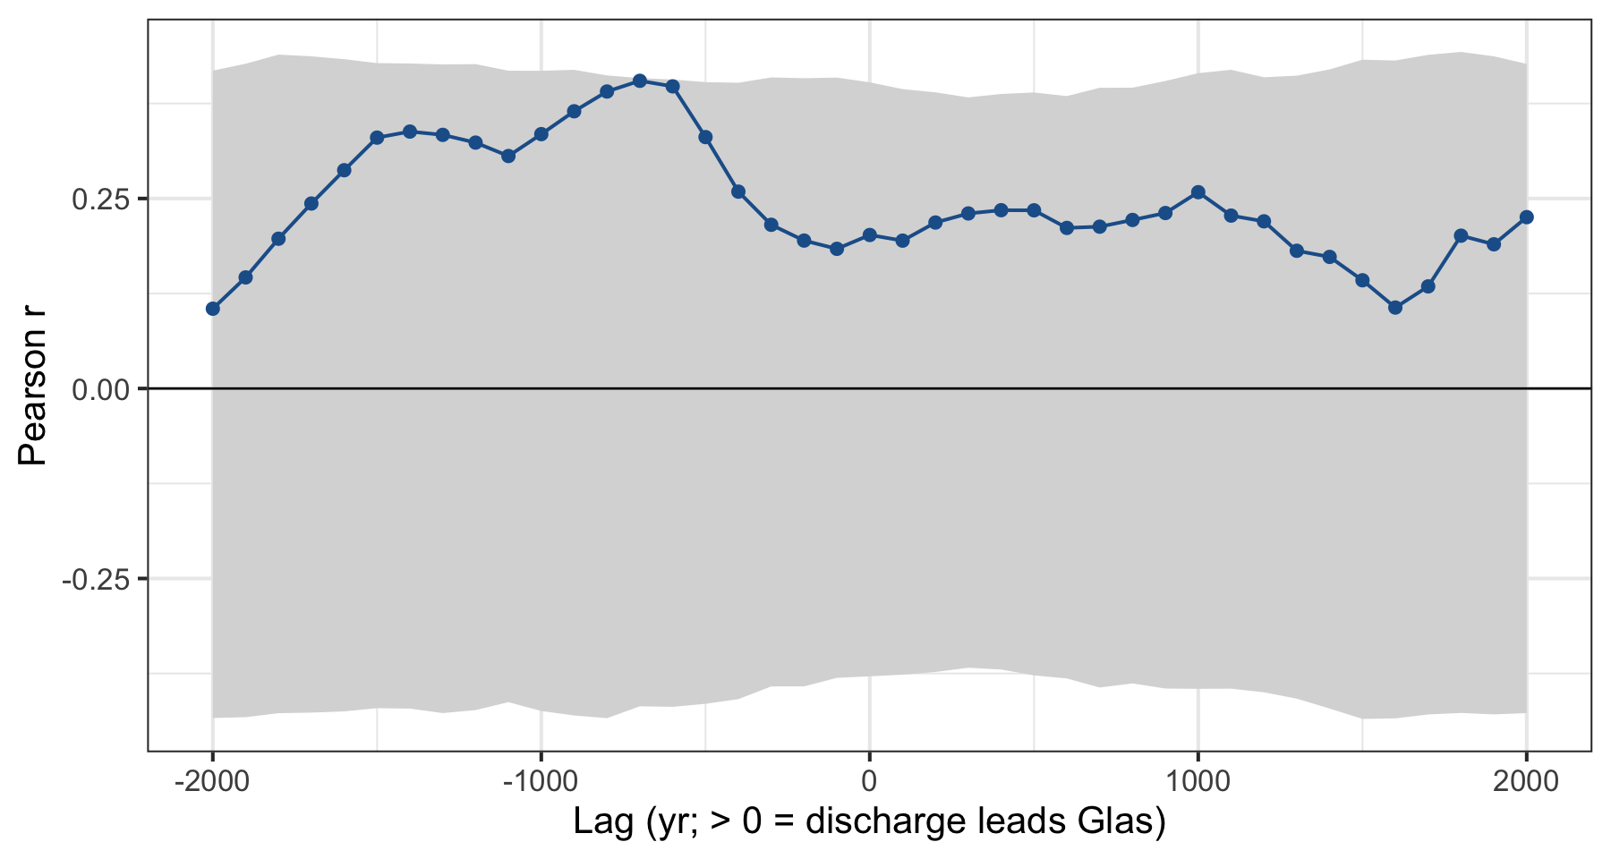
Figure 2: Cross-correlation between binned Glas δ¹⁸O and the GLAC-1D total source anomaly. Positive lags mean the discharge leads Glas; negative lags mean Glas leads. Shading: 95 % envelope from 2,000 AR(1) surrogates of the Glas series.
Event matching. The GLAC-1D total anomaly within the Glas interval has 12 freshening pulses and 9 recoveries exceeding the 1-SD threshold of 2.9 ‰ per 100 yr (Figure 3, Table 6). Of the six δ¹⁸O events of Endres et al. (2026a), 4 have a same-sign pulse within ±300 yr; random placement of six such events gives 2.5 matches on average (p = 0.179), because with 21 pulses in 11.9 kyr a ±300-yr window is rarely empty. Including the 4 data-driven steps, 5 of 10 events match (p = 0.387). Table 5 shows how this depends on the pulse threshold and the tolerance. With tolerances of ±200–300 yr the match count is at or above the random expectation for every threshold but not significant (p ≥ 0.103). With a ±500-yr tolerance 6 of 6 events are matched at the 1-SD threshold and 5 of 6 at the 2-SD threshold (the 9 largest pulses), with p = 0.047 and 0.016. The Glas events thus coincide with GLAC-1D pulses at the ~500-yr level, which is also the scale of the age-model offsets between the two archives, but not at the 100–300-yr level. The offsets of the Table 1 events range from -360 to 380 yr (median 55 yr, positive = Glas earlier), i.e. the events show no consistent lead or lag at the event level; the ~700-yr lead in the cross-correlation reflects the broad shape of the Heinrich Stadial 1 trough rather than the individual pulses.
The correspondences are specific rather than statistical. The Heinrich Stadial 1 freshening events 16.4kS, 16.1kS and 15.3kS fall within 130 yr of the GLAC-1D pulses at 16.2–16.4 and 15.2 ka. The abrupt freshening onset at 17.8kS follows the GLAC-1D pulse at 18.2 ka (the Eurasian Arctic peak) by 360 yr, just outside the ±300-yr window; the forward-model draft discusses this either as a delayed response to that Arctic pulse or, on the timing of AMOC proxies, as meltwater retained at the surface by AMOC weakening. The re-salinisation at 14.7kS coincides with Meltwater Pulse 1A, the largest freshening pulse of the series, an alignment of opposite sign that the draft reproduces as AMOC re-strengthening cancelling the anomaly at NISA. The data-driven Glas steps at 12.9–12.3 ka have no counterpart within 300 yr, and the large GLAC-1D pulses of the Younger Dryas (13.3 and 11.7 ka) have no counterpart in Glas, which the draft also notes as the main mismatch besides the LGM Bay of Biscay discharge.
Table 5: Sensitivity of the event matching (six Table 1 events) to the pulse threshold (multiples of the SD of 100-yr steps in the GLAC-1D total anomaly) and the matching tolerance. Null mean and p are from 2,000 random placements of the six events.
Threshold (SD) | Tolerance (yr) | Pulses | Matched (of 6) | Null mean | p
1.0 | 200 | 21 | 3 | 1.8 | 0.248
1.0 | 300 | 21 | 4 | 2.5 | 0.179
1.0 | 500 | 21 | 6 | 3.5 | 0.047
1.5 | 200 | 15 | 3 | 1.2 | 0.110
1.5 | 300 | 15 | 3 | 1.8 | 0.248
1.5 | 500 | 15 | 5 | 2.6 | 0.062
2.0 | 200 | 9 | 2 | 0.8 | 0.198
2.0 | 300 | 9 | 3 | 1.3 | 0.103
2.0 | 500 | 9 | 5 | 1.9 | 0.016

Table 6: Abrupt Glas δ¹⁸O events and the nearest same-sign pulse in the GLAC-1D total anomaly. Sign: −1 freshening, +1 re-salinisation. Offset is Glas age minus pulse age (positive: Glas earlier). Matched: |offset| ≤ 300 yr.
Event | Source | Midpoint (ka) | 95 % CI (ka) | Sign | Nearest pulse (ka) | Offset (yr) | Matched
23.4kS | Endres et al. (2026a), Table 1 | 23.4 | 23.3–24.1 | 1 | 23.2 | 240 | yes
17.8kS | Endres et al. (2026a), Table 1 | 17.8 | 17.8–18.0 | -1 | 18.2 | -360 | no
16.4kS | Endres et al. (2026a), Table 1 | 16.4 | 16.1–16.6 | -1 | 16.4 | 40 | yes
16.1kS | Endres et al. (2026a), Table 1 | 16.1 | 15.9–16.4 | -1 | 16.2 | -130 | yes
16.0k (step) | Bin step > 2 SD | 16.0 |  | -1 | 16.2 | -200 | yes
15.3kS | Endres et al. (2026a), Table 1 | 15.3 | 15.1–15.4 | -1 | 15.2 | 70 | yes
14.7kS | Endres et al. (2026a), Table 1 | 14.7 | 14.5–14.8 | 1 | 14.3 | 380 | no
12.9k (step) | Bin step > 2 SD | 12.9 |  | 1 | 13.3 | -400 | no
12.4k (step) | Bin step > 2 SD | 12.4 |  | -1 | 11.7 | 700 | no
12.3k (step) | Bin step > 2 SD | 12.3 |  | 1 | 13.3 | -1,000 | no

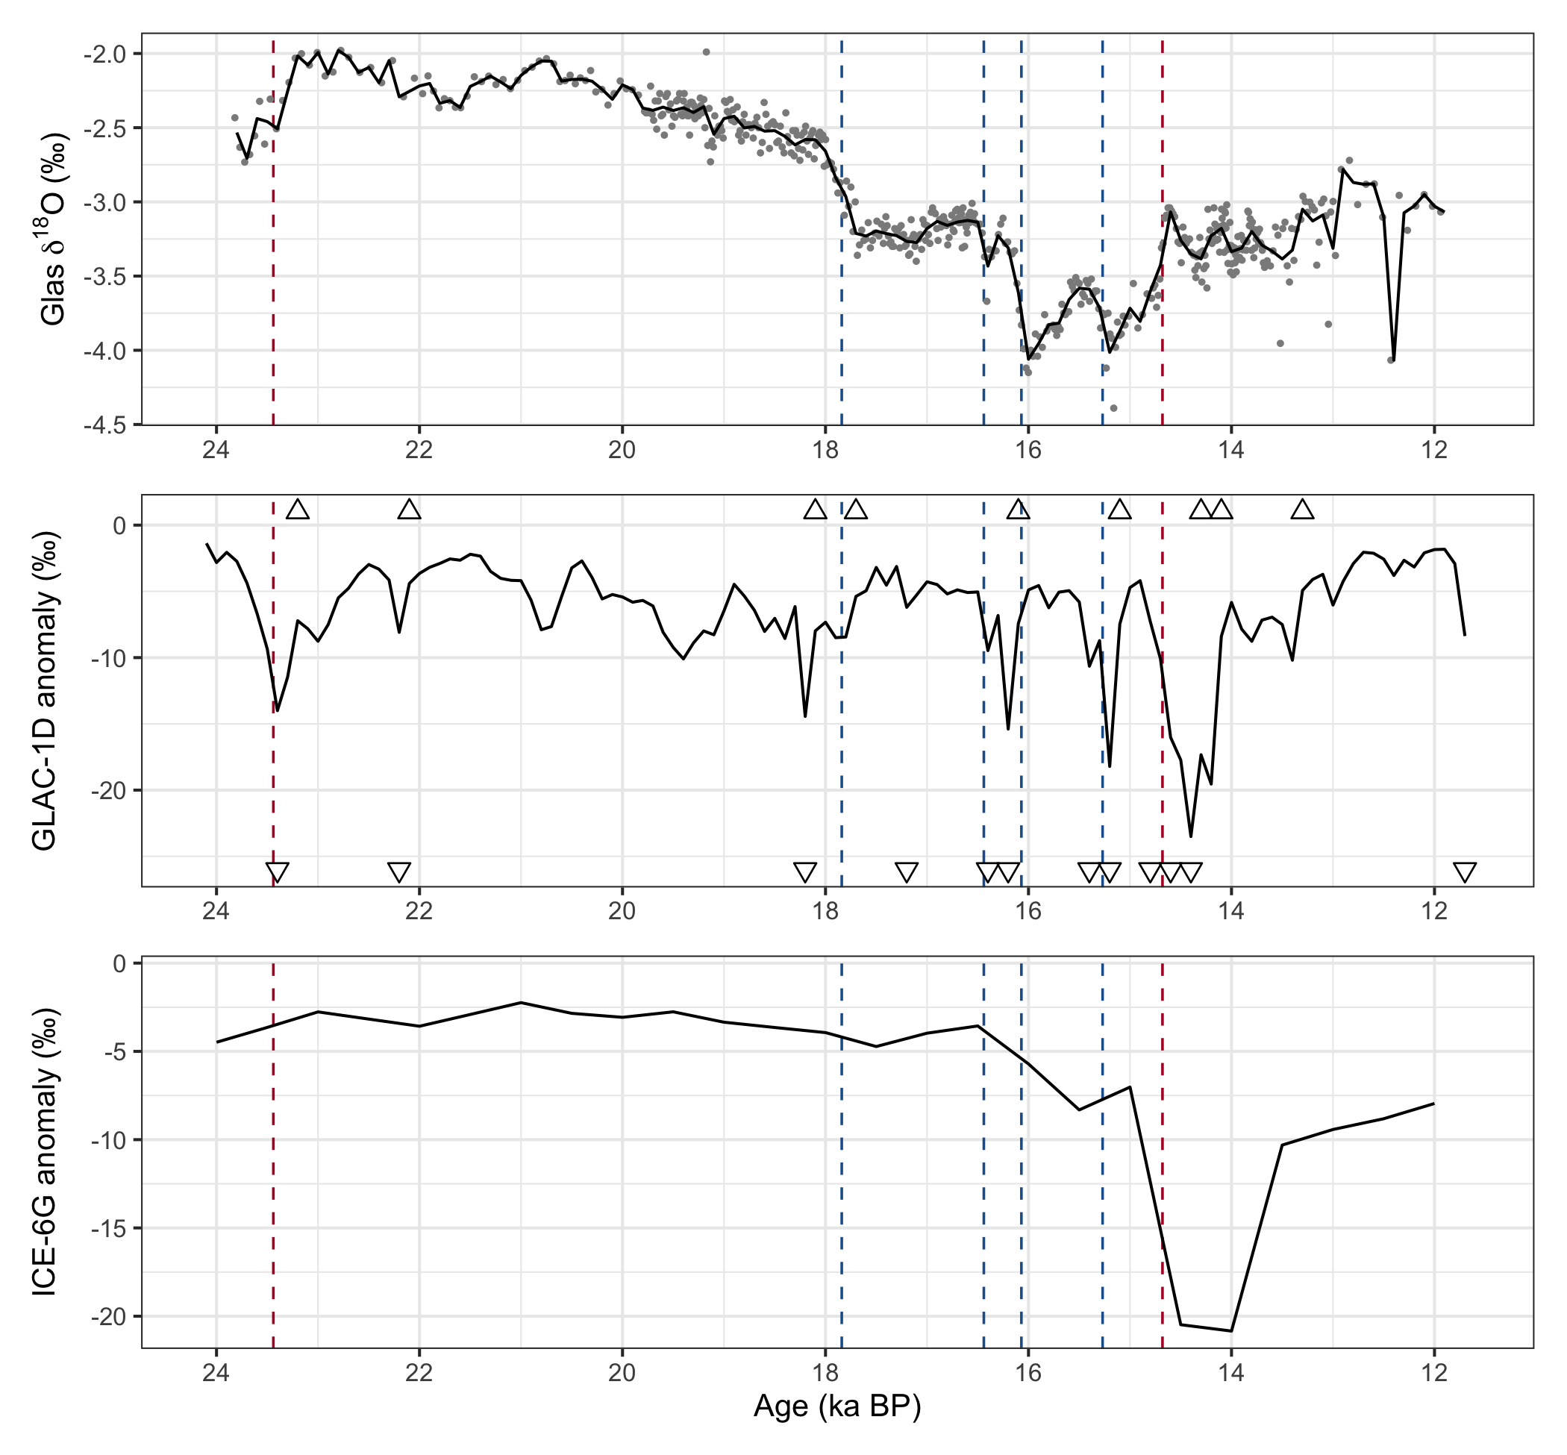
Figure 3: Glas δ¹⁸O (top; points are samples, line is the 100-yr bin mean) and the total source anomaly of GLAC-1D (middle) and ICE-6G (bottom). Dashed lines: δ¹⁸O events of Endres et al. (2026a), blue = freshening, red = re-salinisation. Triangles: GLAC-1D pulses (down = freshening, up = recovery).

Answer
Most important source region. It depends on the ice-sheet reconstruction. Within the Glas interval (11.9–23.8 ka), GLAC-1D gives EIS_NorwegianSea (20 % of the summed source anomaly), with EIS_Arctic and LAU_Arctic almost equal, and the European sectors together provide 53 %. ICE-6G gives LAU_GulfOfMexico (22 %), with the Laurentide sectors providing 57 %. Over the full series both reconstructions put a Laurentide sector first (LAU_Arctic and LAU_Arctic).
Most variable source region. EIS_NorwegianSea in GLAC-1D (SD 1.71 ‰ over the Glas interval; EIS_Arctic is a close second) and LAU_Arctic in ICE-6G (SD 1.60 ‰). In both cases the variability comes from a small number of large, short pulses.
Alignment with Glas. Level correlations are weak to moderate (r = 0.20 with GLAC-1D, 0.55 with ICE-6G) and not significant against red-noise surrogates; the highest regional correlation is with EIS_NorwegianSea. Two quantifications do show structure: (i) the lead–lag cross-correlation with GLAC-1D peaks with Glas leading by about 700 yr (r = 0.40, within the red-noise envelope), and (ii) 4 of the six published abrupt Glas events have a same-sign GLAC-1D pulse within ±300 yr, against 2.5 expected by chance (p = 0.179), with offsets between -360 and 380 yr; widening the tolerance to ±500 yr matches 5 of six events against the 9 largest pulses (p = 0.016), so the coincidence is significant at the ~500-yr but not the centennial scale. The alignment is event-specific: the three Heinrich Stadial 1 freshening events match GLAC-1D pulses to within a few hundred years, the 17.8 ka onset lags the GLAC-1D Arctic pulse by ~360 yr, and the 14.7 ka re-salinisation coincides with Meltwater Pulse 1A with opposite sign. The appropriate quantification is therefore event-level matching (offset per event, plus a Monte-Carlo null for the match count) rather than correlation of the series, and, for a physically consistent test, the comparison should be made with the convolved forward-model output at NISA, which carries the AMOC-state dependence that explains the opposite-sign case.
Caveats. The anomaly columns are the forward model’s forcing: source-region anomalies that scale with discharge divided by region volume. They do not include the transport from each region to NISA, which Endres et al. (2026b) and the forward-model draft show is weak for the Arctic sectors and strong for the Bay of Biscay and Norwegian Sea sectors, nor the AMOC-mode dependence of the kernels. Weighting by that transport would shift the “most important” ranking further toward the European sectors. The event analysis uses the GLAC-1D series only, because the 500-yr resolution of ICE-6G is coarser than the events themselves.

References
Endres, L., Pérez-Mejías, C., Ivanovic, R., Gregoire, L., Hughes, A. L. C., Cheng, H., & Stoll, H. (2026a). Interplay of North Atlantic freshening and deep convection during the last deglaciation constrained by Iberian speleothems. Climate of the Past, 22(4), 797–824. https://doi.org/10.5194/cp-22-797-2026
Endres, L., Ivanovic, R., Rome, Y., Tindall, J., Thurnherr, I., Sprenger, M., & Stoll, H. (2026b). Tracing meltwater from northern ice sheets to palaeoclimate archives during the early last deglaciation: a conservative tracer approach. ESS Open Archive (preprint). https://doi.org/10.22541/essoar.15007256/v1
Endres, L., Ivanovic, R., Rome, Y., & Stoll, H. (in prep.). A dye tracer forward-model for meltwater-related surface ocean anomalies. Draft (Impulse_Response_Revisions_v1.pdf, this repository).

