Age range of stalagmite Glas (La Vallina cave, northern Iberia)
Laura Endres
2026-09-29

Question
What age range do the data from the NISA stalagmite Glas cover?

Data and methods
The analysis uses the SISAL-format database excerpt in data/. Stalagmite Glas is entity 903 (324-GLAS), from La Vallina cave (43.41 °N, 4.8067 °W, 70 m a.s.l.) in northern Iberia. The entity is linked to Endres, L., Pérez-Mejı́as, C., Ivanovic, R., Gregoire, L., Hughes, A. L. C., Cheng, H., & Stoll, H. (2025). Interplay of north atlantic freshening and deep convection during the last deglaciation constrained by iberian speleothems. EGUsphere, 2025, 1–37.
The age range comes from the original, author-published chronology (original_chronology.csv, age model type: Bayesian Bchron), joined to the entity’s samples in sample.csv. No Glas samples have SISAL-generated chronologies in sisal_chronology.csv (0 rows), so the original age model is the only sample-level chronology available. The U–Th dates in dating.csv (25 dates, all flagged date_used = yes) are used to check the age model. Ages are reported as years before present (BP, present = 1950 CE), the SISAL convention; the database excerpt’s schema does not state units explicitly.

Results
The Glas record contains 532 samples between 3.9 mm and 39.6 mm depth from the top. Each sample has δ¹⁸O (n = 532), δ¹³C, Mg/Ca and Sr/Ca measurements.
The data cover 11,939 to 23,819 years BP (about 11.9–23.8 ka), a span of 11,880 years. This runs from the Last Glacial Maximum through the last deglaciation to the Younger Dryas / early Holocene transition.
Table 1: Youngest and oldest samples of stalagmite Glas in the original (Bchron) chronology. Uncertainties are as given in the database (+ older / − younger).
Endpoint | Depth (mm) | Age (yr BP) | + uncert. (yr) | − uncert. (yr)
Youngest (top) | 3.9 | 11,939 | 590 | 598
Oldest (base) | 39.6 | 23,819 | 1223 | 290

The record has no hiatuses (0 entries in hiatus.csv). The median sampling resolution is 15 years, and the largest step between consecutive samples is 108 years. The U–Th dates span 10,956–23,524 years BP (3.3–38.3 mm) and bracket the sampled interval (Figure 1). The youngest date lies at 3.3 mm, above the uppermost isotope sample, so the stalagmite grew into the early Holocene. The measured data, however, stop at about 11.9 ka.
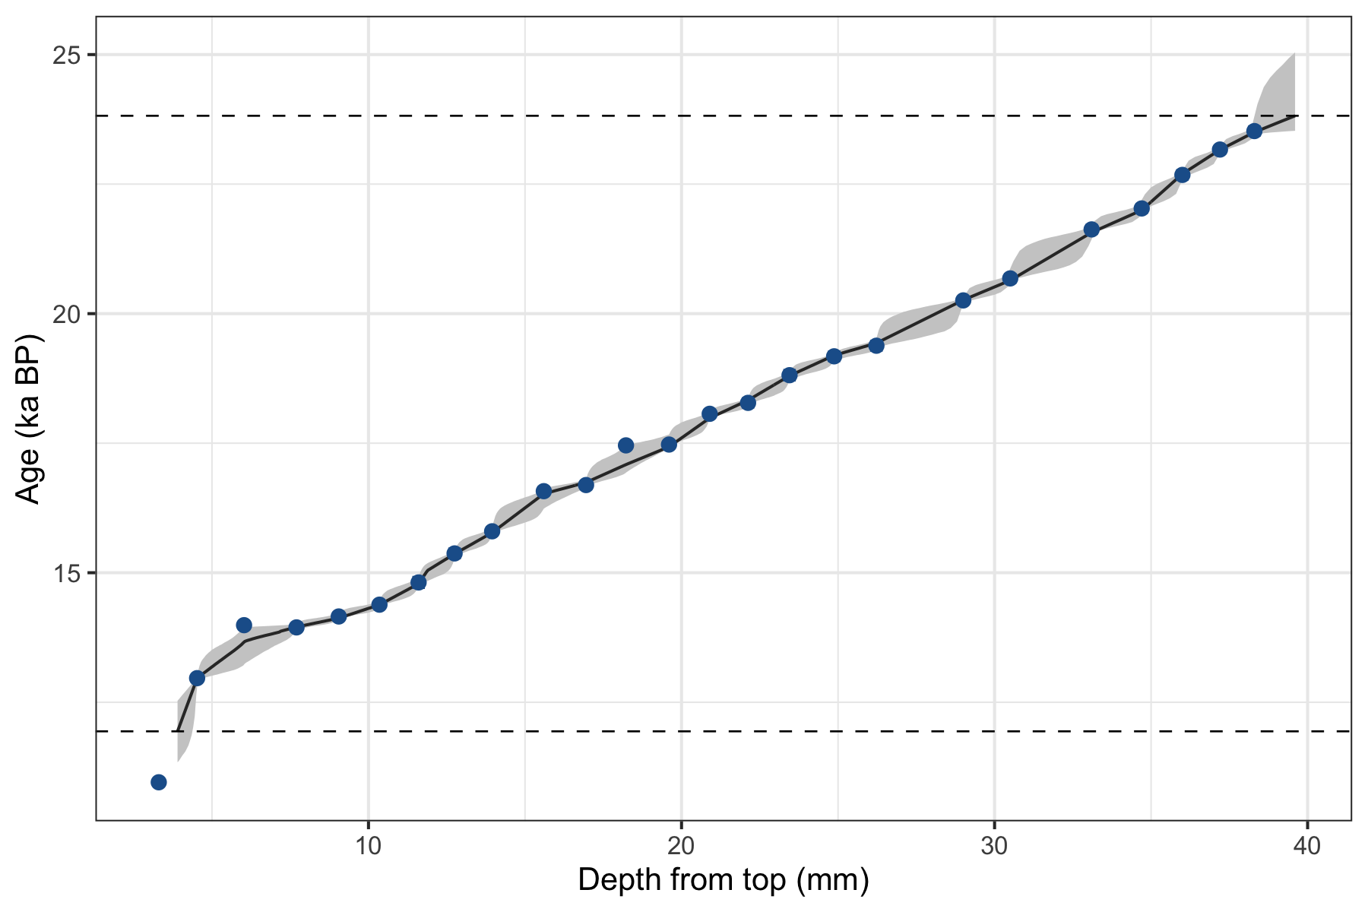
Figure 1: Age–depth model of stalagmite Glas. The line and shading show the original Bchron chronology with its uncertainty envelope, and the points show U–Th dates with their uncertainties as given in the database. Dashed lines mark the age range covered by the sampled data.

Answer
The published data from stalagmite Glas (La Vallina cave, entity 903) cover 11.9 to 23.8 ka BP (11,939–23,819 years BP; about 11.9 kyr). This range is based on 532 continuously sampled δ¹⁸O, δ¹³C and trace-element measurements on the original Bchron age model. Allowing for the age-model uncertainties at the endpoints, the range widens to about 11.3–25.0 ka.

