Total time spent on pit emptying jobs in Mzuzu, Malawi
Padraic Casserly
2026-09-29
Abstract
We use task-level timing data recorded with the Gulper Timer app during ridealong observations of manual pit latrine emptying in Mzuzu, Malawi, to quantify the total time spent on pit emptying jobs. Time is reported in two ways: labour time (person-hours, the sum of all task durations across all workers) and elapsed time (clock hours from the first to the last recorded task of each job).
_{Source: Article Notebook}

1. Introduction
Time-driven activity-based costing (TDABC) allocates costs to activities based on the time resources spend on them. A first step is therefore to establish how much time is consumed by the service being costed. This short manuscript answers the question: What is the total amount of time spent on pit emptying jobs?

2. Data and methods
The dataset (data/all_tasks.csv) contains 10,784 task entries recorded for 36 pit emptying jobs between 08 May 2026 and 14 September 2026, performed by 19 anonymised pit emptiers (“gulpers”). Each entry records one worker performing one task (e.g. Fluidizing, Extraction, Rest) with a start time, end time and duration in seconds.
Because several gulpers often work simultaneously on the same job, “time spent” can be measured in two ways:
- Labour time (person-hours): the sum of duration_seconds over all entries, i.e. every worker’s recorded time added together. This is the measure relevant for TDABC, where labour capacity is the resource being costed.
- Elapsed time (clock hours): for each job, the interval from the earliest entry_start_time to the latest entry_end_time, summed across jobs. This measures how long the jobs took on the calendar.
All recorded tasks, including Rest, Communication and in-job Travel (errands and trips to the disposal site), are counted as time spent on the job. Travel from the gulpers’ base to the job site is not part of the task categories recorded.
Data checks: the file has no missing values except subtask, which is empty by design for the Rest and Disposal tasks. Recorded durations agree with the difference between end and start times to within ±1 second (rounding). No job crosses midnight, so elapsed time can be computed from clock times directly.

3. Results
Across the 36 observed jobs, gulpers spent a total of 509.0 person-hours on pit emptying. The jobs took a total of 139.4 elapsed clock hours, so on average 3.7 gulpers’ worth of time was being recorded at any moment of a job. Per job, the mean labour time was 14.1 person-hours (median 11.0, range 2.4–58.2) and the mean elapsed time was 3.9 hours (median 3.4, range 0.8–9.7).
Table 1 breaks the labour time down by main task. Rest is the largest single category (150.4 person-hours, 29.5 % of the total).
Table 1: Labour time by main task, summed over all 36 jobs.
Task | Entries | Person-hours | Share (%)
Rest | 3,103 | 150.4 | 29.5
Earthworks | 1,098 | 69.7 | 13.7
Fluidizing | 1,470 | 63.5 | 12.5
Equipment | 1,353 | 62.9 | 12.4
Extraction | 1,381 | 62.9 | 12.4
Travel | 149 | 36.2 | 7.1
Communication | 1,342 | 25.1 | 4.9
Superstructure | 371 | 16.6 | 3.3
Disposal | 257 | 14.2 | 2.8
Sludge handling | 260 | 7.5 | 1.5
Total | 10,784 | 509.0 | 100.0

_{Source: Article Notebook}
Figure 1 shows the same breakdown, with tasks coloured by the kind of work they belong to.
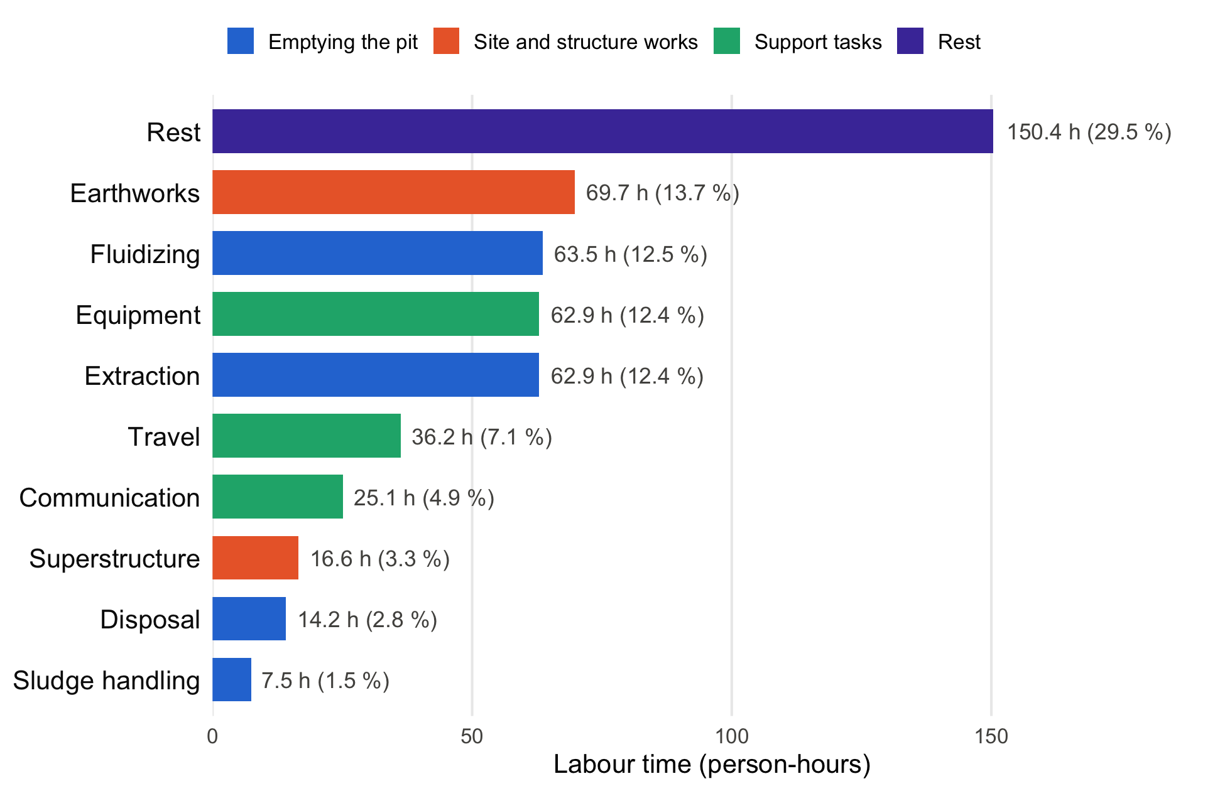
Figure 1: Labour time by main task across all 36 jobs, coloured by activity group. Labels give person-hours and share of total labour time.
_{Source: Article Notebook}
Grouped this way, the tasks that directly empty the pit (fluidizing, extraction, sludge handling and disposal) account for 148.1 person-hours (29.1 %), about the same as Rest (150.4 person-hours). Support tasks take 124.2 person-hours (24.4 %) and site and structure works 86.3 person-hours (16.9 %).
Figure 2 shows the labour time of each job. Labour time varies widely between jobs; Table 2 in the appendix lists the values for every job.
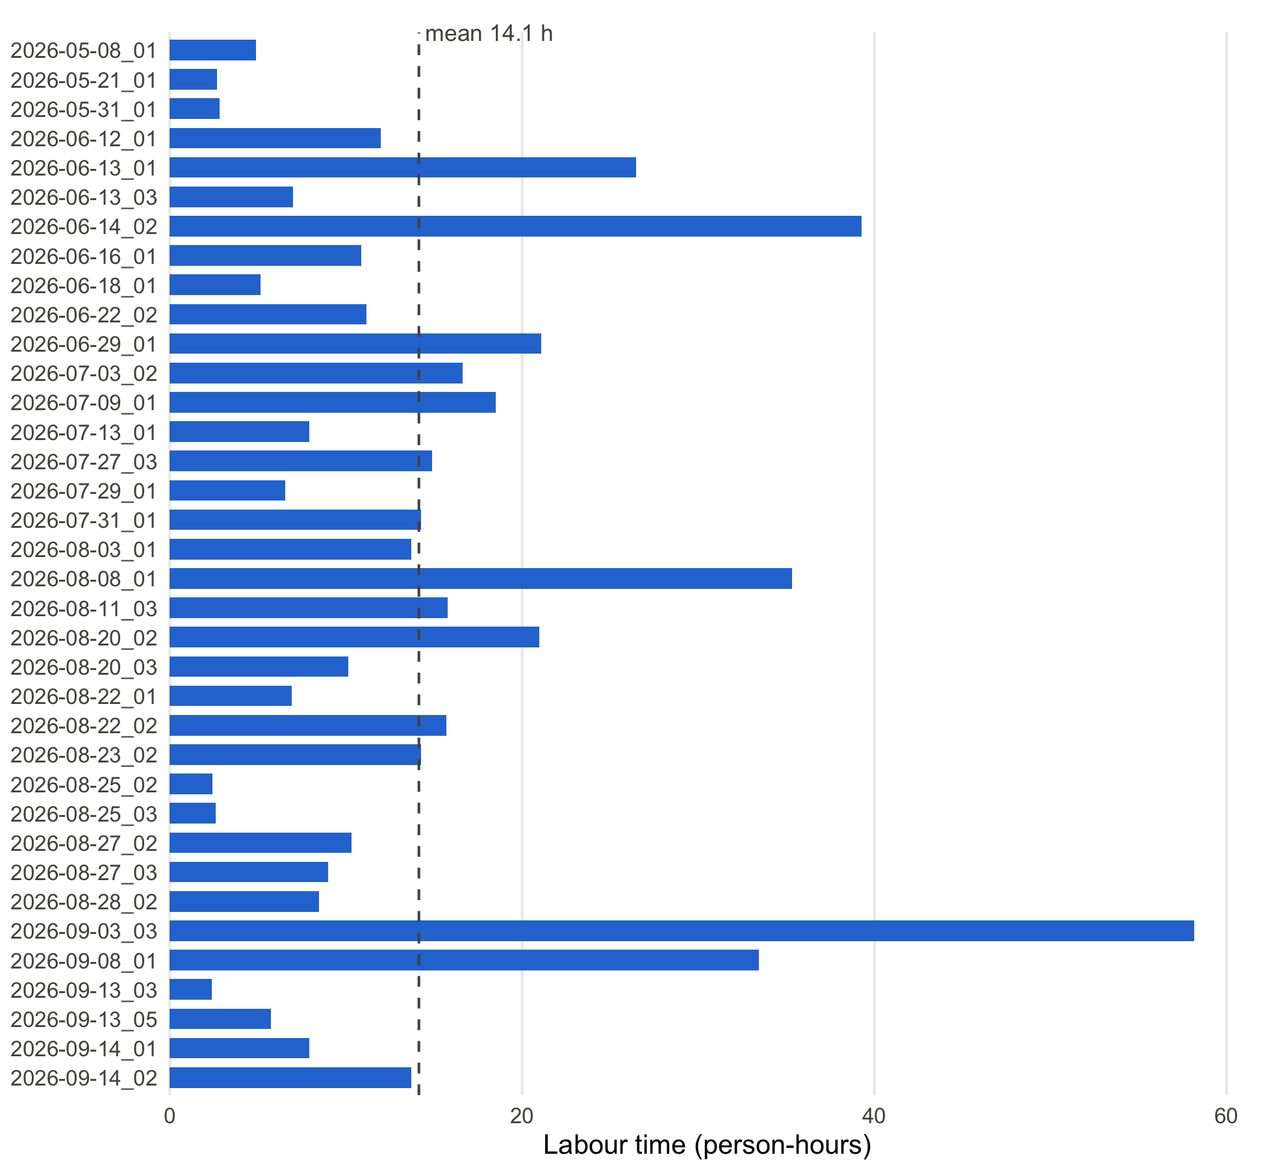
Figure 2: Labour time (person-hours) per pit emptying job, ordered by date.
_{Source: Article Notebook}

4. Conclusion
The total amount of time spent on the 36 observed pit emptying jobs was 509.0 person-hours of recorded labour (139.4 elapsed clock hours). For TDABC purposes the person-hour figure is the relevant quantity, since it reflects the labour capacity consumed by the service.

5. Appendix A: Job-level results
Table 2: Workers, labour time and elapsed time for each job.
Job | Gulpers | Entries | Labour (person-h) | Elapsed (h)
2026-05-08_01 | 2 | 162 | 4.9 | 2.5
2026-05-21_01 | 2 | 121 | 2.7 | 1.5
2026-05-31_01 | 1 | 91 | 2.8 | 2.9
2026-06-12_01 | 4 | 375 | 12.0 | 3.1
2026-06-13_01 | 8 | 1,139 | 26.5 | 4.6
2026-06-13_03 | 3 | 241 | 7.0 | 2.3
2026-06-14_02 | 7 | 1,187 | 39.3 | 8.3
2026-06-16_01 | 3 | 199 | 10.9 | 3.7
2026-06-18_01 | 3 | 71 | 5.2 | 1.7
2026-06-22_02 | 4 | 159 | 11.2 | 2.8
2026-06-29_01 | 4 | 228 | 21.1 | 6.1
2026-07-03_02 | 4 | 295 | 16.6 | 4.4
2026-07-09_01 | 4 | 340 | 18.5 | 5.5
2026-07-13_01 | 3 | 175 | 7.9 | 2.6
2026-07-27_03 | 4 | 511 | 14.9 | 4.5
2026-07-29_01 | 3 | 347 | 6.6 | 2.2
2026-07-31_01 | 4 | 456 | 14.3 | 3.6
2026-08-03_01 | 3 | 199 | 13.7 | 4.6
2026-08-08_01 | 4 | 651 | 35.3 | 9.7
2026-08-11_03 | 4 | 404 | 15.8 | 4.0
2026-08-20_02 | 4 | 290 | 21.0 | 6.2
2026-08-20_03 | 4 | 270 | 10.1 | 2.5
2026-08-22_01 | 4 | 224 | 6.9 | 2.0
2026-08-22_02 | 4 | 375 | 15.7 | 3.9
2026-08-23_02 | 4 | 213 | 14.3 | 3.6
2026-08-25_02 | 3 | 35 | 2.4 | 0.8
2026-08-25_03 | 3 | 74 | 2.6 | 0.9
2026-08-27_02 | 4 | 220 | 10.3 | 4.4
2026-08-27_03 | 3 | 151 | 9.0 | 3.0
2026-08-28_02 | 3 | 224 | 8.5 | 2.8
2026-09-03_03 | 7 | 630 | 58.2 | 8.4
2026-09-08_01 | 4 | 377 | 33.4 | 8.4
2026-09-13_03 | 2 | 54 | 2.4 | 1.2
2026-09-13_05 | 2 | 103 | 5.7 | 2.9
2026-09-14_01 | 3 | 92 | 7.9 | 3.2
2026-09-14_02 | 3 | 101 | 13.7 | 4.6
Total | 19 | 10,784 | 509.0 | 139.4

_{Source: Article Notebook}

6. Appendix B: Relevant literature
The five references in the author’s Zotero library most relevant to this dataset, with one sentence on why each matters here:
- Yesaya et al. (2021) apply time-driven activity-based costing to compost production in Blantyre, Malawi, making it the closest methodological precedent for turning task-level timing data like these into activity costs.
- Wilcox et al. (2026) analyse the costs of 23 formal manual emptying providers in Malawi and Uganda and find labour is what makes manual emptying expensive, which is why the person-hours measured here are the key input for costing.
- Chipeta et al. (2017) designed and tested the pedal-powered Gulper pump in Mzuzu and estimated that a pit can be emptied in 1–2 hours when trash content is low, a benchmark for the job durations recorded here.
- Chiposa et al. (2017) characterise pit latrines in peri-urban Mzuzu, reporting that 90 % of households also dispose of domestic waste in their pits, which helps explain the time spent on tasks such as pulling out trash.
- Burt et al. (2019) estimate the cost of delivering pit emptying services in Kigali, Rwanda, at different scales, giving a comparison point for costs derived from the labour time reported here.

7. References
Burt, Zachary, Rachel Sklar, and Ashley Murray. 2019. “Costs and Willingness to Pay for Pit Latrine Emptying Services in Kigali, Rwanda.” International Journal of Environmental Research and Public Health 16 (23): 4738. https://doi.org/10.3390/ijerph16234738.
Chipeta, W. C., R. H. Holm, J. F. Kamanula, W. E. Mtonga, and F. L. de los Reyes. 2017. “Designing Local Solutions for Emptying Pit Latrines in Low-Income Urban Settlements (Malawi).” Physics and Chemistry of the Earth, Parts A/B/C 100: 336–42. https://doi.org/10.1016/j.pce.2017.02.012.
Chiposa, Rashid, Rochelle H. Holm, Chimuleke Munthali, Russel C. G. Chidya, and Francis L. de los Reyes III. 2017. “Characterization of Pit Latrines to Support the Design and Selection of Emptying Tools in Peri-Urban Mzuzu, Malawi.” Journal of Water, Sanitation and Hygiene for Development 7 (1): 151–55. https://doi.org/10.2166/washdev.2017.096.
Wilcox, Jonathan D. T., Carlos E. V. Batarda, Julita C. Chinseu, Yvonne S. Lugali, Jamie K. Bartram, and Barbara E. Evans. 2026. “Formal Manual Fecal Sludge Emptying and Transport Services: Cost Analysis of 23 Service Providers in Malawi and Uganda.” Environmental Science & Technology 60 (21): 15008–19. https://doi.org/10.1021/acs.est.6c01385.
Yesaya, Mabvuto, Wrixon Mpanang’ombe, and Elizabeth Tilley. 2021. “The Cost of Plastics in Compost.” Frontiers in Sustainability 2. https://doi.org/10.3389/frsus.2021.753413.

