Time spent travelling to the disposal site during pit emptying jobs in Mzuzu, Malawi
Padraic Casserly
2026-09-29
Abstract
We use task-level timing data recorded with the Gulper Timer app during ridealong observations of manual pit latrine emptying in Mzuzu, Malawi, to quantify how much time a pit emptying team spends travelling to the sludge disposal site, for the jobs in which such a trip was made. Travel time is reported per job in two ways: elapsed time (clock hours during which the team was on a trip, with simultaneous travel by several workers counted once) and labour time (person-hours, the sum of every worker’s recorded travel).
_{Source: Article Notebook}

1. Introduction
Time-driven activity-based costing (TDABC) allocates costs to activities based on the time resources spend on them. Manual pit emptying in Mzuzu involves not only emptying the pit but also transporting the extracted sludge to a disposal site, an activity that takes the whole team away from the site and consumes labour capacity that must be costed. This short manuscript answers the question: What is the average time spent per job travelling to the disposal site, when a team travels to the disposal site?

2. Data and methods
The dataset (data/all_tasks_clean.csv) contains 10,778 task entries recorded for 36 pit emptying jobs between 08 May 2026 and 14 September 2026, performed by 19 anonymised pit emptiers (“gulpers”). Each entry records one worker performing one task with a start time, end time and duration in seconds. The Travel task has two subtasks: On errand, for short in-job errands, and Travel to disposal site, for transporting sludge away from the site. Only the second is analysed here. The 104 errand entries (15.5 person-hours in 23 jobs) are excluded. Travel from the gulpers’ base to the job site is not among the recorded tasks, so the figures below cover disposal trips made during a job only.
Gulpers travel to the disposal site together, so each trip appears in the data as several near-identical entries, one per worker. Within each job, entries that overlap in time are merged into a single trip running from the earliest start to the latest end. Travel time per job is then reported in two ways:
- Elapsed time (clock hours): the summed duration of the job’s trips. A trip made by four gulpers together counts once. This is the headline measure, since it answers how long the team was away.
- Labour time (person-hours): the sum of duration_seconds over all disposal-site entries, i.e. every worker’s travel added together. This is the measure relevant for TDABC, where labour capacity is the resource being costed, and it matches the measure used in the companion manuscript on total job time.
The population is the set of jobs in which the team travelled to the disposal site. Genuine trips last 28–46 minutes. A few disposal-site entries are far shorter and cannot represent a trip: 3 merged intervals of under 5 minutes (3, 42, 69 seconds), each recorded by one or two workers and including a 2.9-second entry already flagged in the data review. These are treated as accidental taps and dropped, which removes 3.0 person-minutes. One job (2026-09-03_03) has only such an entry and therefore does not count as a job with a disposal trip. The effect of keeping these entries is reported in the Results.
The file is the cleaned version of the raw app export, produced by data-review/clean.R and documented in data-review/README.md: accidental taps shorter than 2 seconds were dropped, one subtask label was harmonised and job identities were corrected from field knowledge. None of the corrections touches a job with a disposal trip. Recorded durations agree with the difference between end and start times to within ±1 second, and no trip crosses midnight.

3. Results
A team travelled to the disposal site in 7 of the 36 observed jobs, making 11 trips in total. In those jobs, the team spent on average 0.9 clock hours (52 minutes) per job travelling to the disposal site (median 0.6 hours, range 0.5–1.7). In labour time this is 3.0 person-hours per job (median 2.2, range 0.9–6.0).
A job with a disposal trip had 1.6 trips on average, each lasting 33 minutes and made by 3.4 gulpers together, so labour time is 3.4 times elapsed time. Within these jobs, disposal travel took up 17 % of the job’s labour time on average (range 9–24 %). Across all 36 jobs, disposal travel accounts for 4.1 % of the 509.0 person-hours recorded. Table 1 lists each job and Figure 1 shows the elapsed travel time per job.
Table 1: Disposal-site travel for each job in which a trip was made. Elapsed time counts a trip once regardless of how many gulpers made it; labour time adds every gulper’s travel. Share is labour travel time as a percentage of the job’s total labour time.
Job Date | Trips | Gulpers | Elapsed (h) | Labour (person-h) | Share of job (%)
2026-05-08 | 1 | 2 | 0.5 | 0.9 | 19.2
2026-08-08 | 3 | 4 | 1.7 | 6.0 | 17.0
2026-08-11 | 1 | 4 | 0.6 | 2.2 | 14.0
2026-08-20 | 1 | 4 | 0.5 | 1.9 | 9.3
2026-09-08 | 2 | 4 | 1.3 | 5.4 | 16.1
2026-09-13 | 1 | 2 | 0.5 | 1.0 | 16.9
2026-09-14 | 2 | 3 | 1.1 | 3.2 | 23.5
Mean | 1.6 | 3.3 | 0.9 | 3.0 | 16.6
Median | 1.0 | 4.0 | 0.6 | 2.2 | 16.9

_{Source: Article Notebook}
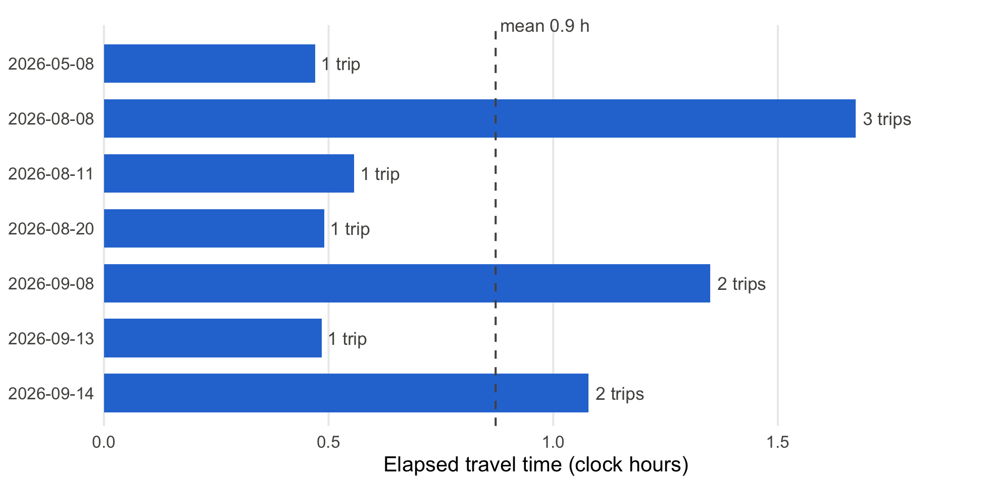
Figure 1: Elapsed time spent travelling to the disposal site per job, for the jobs in which a trip was made, ordered by date. Labels give the number of trips. The dashed line is the mean.
_{Source: Article Notebook}
Travel time per job is driven mainly by the number of trips: jobs with one trip take about half an hour of elapsed time, and the two jobs with the most travel (08 August 2026 and 08 September 2026) made 3 and 2 trips respectively.
As a sensitivity check, keeping the short entries dropped in the Methods adds one job and changes the mean elapsed travel time to 0.8 hours over 8 jobs (2.6 person-hours); this is lower only because the added job contributes a 0.7-minute entry.

4. Conclusion
When a pit emptying team in Mzuzu travels to the disposal site, it spends on average 0.9 clock hours (52 minutes) per job on that travel, corresponding to 3.0 person-hours of labour because 3.4 gulpers travel together. A single trip takes about 33 minutes, and jobs vary mainly in how many trips they need. Such trips occurred in 7 of the 36 observed jobs. For TDABC purposes the person-hour figure is the quantity to cost, and it should be applied only to jobs that require a disposal trip.

5. Appendix A: Relevant literature
The five references in the author’s Zotero library most relevant to this analysis, with one sentence on why each matters here:
- Yesaya et al. (2021) apply time-driven activity-based costing to compost production in Blantyre, Malawi, making it the closest methodological precedent for turning the per-job travel times measured here into an activity cost.
- Wilcox et al. (2026) analyse the costs of 23 formal manual emptying providers in Malawi and Uganda and find labour is what makes manual emptying expensive, which is why the person-hours that a team spends travelling to the disposal site are a key costing input.
- Chipeta et al. (2017) designed and tested the pedal-powered Gulper pump in Mzuzu and estimated a pit can be emptied in 1–2 hours when trash content is low, so a half-hour disposal trip is a substantial addition to a job.
- Chiposa et al. (2017) characterise pit latrines in peri-urban Mzuzu, reporting that 90 % of households also dispose of domestic waste in their pits, which affects how much material must be removed and hence how many disposal trips a job needs.
- Burt et al. (2019) estimate the cost of delivering pit emptying services in Kigali, Rwanda, at different scales, giving a comparison point for costs derived from the travel times reported here.

6. References
Burt, Zachary, Rachel Sklar, and Ashley Murray. 2019. “Costs and Willingness to Pay for Pit Latrine Emptying Services in Kigali, Rwanda.” International Journal of Environmental Research and Public Health 16 (23): 4738. https://doi.org/10.3390/ijerph16234738.
Chipeta, W. C., R. H. Holm, J. F. Kamanula, W. E. Mtonga, and F. L. de los Reyes. 2017. “Designing Local Solutions for Emptying Pit Latrines in Low-Income Urban Settlements (Malawi).” Physics and Chemistry of the Earth, Parts A/B/C 100: 336–42. https://doi.org/10.1016/j.pce.2017.02.012.
Chiposa, Rashid, Rochelle H. Holm, Chimuleke Munthali, Russel C. G. Chidya, and Francis L. de los Reyes III. 2017. “Characterization of Pit Latrines to Support the Design and Selection of Emptying Tools in Peri-Urban Mzuzu, Malawi.” Journal of Water, Sanitation and Hygiene for Development 7 (1): 151–55. https://doi.org/10.2166/washdev.2017.096.
Wilcox, Jonathan D. T., Carlos E. V. Batarda, Julita C. Chinseu, Yvonne S. Lugali, Jamie K. Bartram, and Barbara E. Evans. 2026. “Formal Manual Fecal Sludge Emptying and Transport Services: Cost Analysis of 23 Service Providers in Malawi and Uganda.” Environmental Science & Technology 60 (21): 15008–19. https://doi.org/10.1021/acs.est.6c01385.
Yesaya, Mabvuto, Wrixon Mpanang’ombe, and Elizabeth Tilley. 2021. “The Cost of Plastics in Compost.” Frontiers in Sustainability 2. https://doi.org/10.3389/frsus.2021.753413.

