Time spent on manual pit emptying jobs in Mzuzu, Malawi: total job time and travel to the disposal site
Padraic Casserly
2026-09-29
Abstract
We use task-level timing data recorded with the Gulper Timer app during ridealong observations of manual pit latrine emptying in Mzuzu, Malawi, to answer two questions that time-driven activity-based costing (TDABC) needs answered first: how much time is spent on a pit emptying job in total, and how much of a job is spent travelling to the sludge disposal site when the team makes such a trip. Time is reported in two ways throughout: labour time (person-hours, every worker’s recorded time added together) and elapsed time (clock hours, with simultaneous work by several workers counted once).
_{Source: Article Notebook}

1. Introduction
Time-driven activity-based costing (TDABC) allocates costs to activities based on the time resources spend on them. A first step is therefore to establish how much time the service being costed consumes, and how that time is split between activities that every job needs and activities that only some jobs need. Manual pit emptying in Mzuzu involves not only emptying the pit but, for some jobs, transporting the extracted sludge to a disposal site, an activity that takes the whole team away from the site. This manuscript answers two questions:
- What is the total amount of time spent on pit emptying jobs?
- What is the average time spent per job travelling to the disposal site, when a team travels to the disposal site?

2. Data and methods

2.1 Data
The dataset (data/all_tasks_clean.csv) contains 10,778 task entries recorded for 36 pit emptying jobs between 08 May 2026 and 14 September 2026, performed by 19 anonymised pit emptiers (“gulpers”). Each entry records one worker performing one task (e.g. Fluidizing, Extraction, Rest) with a start time, end time and duration in seconds.
The file is the cleaned version of the raw app export, produced by data-review/clean.R and documented in data-review/README.md. Relative to the raw export, six accidental taps shorter than 2 seconds were dropped, the Equipment subtask “Repair” was recoded to “Repairing”, and job identities were corrected from field knowledge: the recordings filed as 2026-06-12_01 and 2026-06-13_01 are one job carried out over two days by two crews, and the two recording sessions filed under 2026-06-14_02 are two separate jobs. The file has no missing values except subtask, which is empty by design for the Rest and Disposal tasks, and recorded durations agree with the difference between end and start times to within ±1 second. Sixteen entries longer than 50 minutes are kept as recorded; 4 of them, in one job, look like timers left running over a break and are used in a sensitivity check. Jobs are identified below by their date; where two jobs were recorded on the same day they are numbered (1) and (2).

2.2 Two measures of time
Several gulpers usually work simultaneously on the same job, so “time spent” is measured in two ways throughout:
- Labour time (person-hours): the sum of duration_seconds over all entries, i.e. every worker’s recorded time added together. This is the measure relevant for TDABC, where labour capacity is the resource being costed.
- Elapsed time (clock hours): for each job, the interval from the earliest entry_start_time to the latest entry_end_time on each recorded day, summed across days and jobs. This measures how long the jobs took on the calendar.
All recorded tasks, including Rest, Communication and in-job Travel, are counted as time spent on the job. Travel from the gulpers’ base to the job site is not among the recorded tasks.

2.3 Travel to the disposal site
The Travel task has two subtasks: On errand, for short in-job errands, and Travel to disposal site, for transporting sludge away from the site. Only the second is analysed for question 2; the 104 errand entries (15.5 person-hours in 23 jobs) remain part of total job time but are not counted as disposal travel.
Gulpers travel to the disposal site together, so each trip appears in the data as several near-identical entries, one per worker. Within each job, entries that overlap in time are merged into a single trip running from the earliest start to the latest end. A job’s elapsed travel time is the summed duration of its trips, counting a trip made by four gulpers once; its labour travel time adds every gulper’s entry.
The population for question 2 is the set of jobs in which the team travelled to the disposal site. Genuine trips last 28–46 minutes. A few disposal-site entries are far shorter and cannot represent a trip: 3 merged intervals of under 5 minutes (3, 42, 69 seconds), each recorded by one or two workers. These are treated as accidental taps and dropped, which removes 3.0 person-minutes. One job has only such an entry and therefore does not count as a job with a disposal trip.

3. Results

3.1 Total time spent on pit emptying jobs
Across the 36 observed jobs, gulpers spent a total of 509.0 person-hours on pit emptying. The jobs took a total of 143.6 elapsed clock hours, so on average 3.5 gulpers’ worth of time was being recorded at any moment of a job. Per job, the mean labour time was 14.1 person-hours (median 11.0, range 2.4–58.2) and the mean elapsed time was 4.0 hours (median 3.6, range 0.8–9.7).
Table 1 breaks the labour time down by main task. Rest is the largest single category (150.4 person-hours, 29.5 % of the total).
Table 1: Labour time by main task, summed over all 36 jobs.
Task | Entries | Person-hours | Share (%)
Rest | 3,101 | 150.4 | 29.5
Earthworks | 1,098 | 69.7 | 13.7
Fluidizing | 1,470 | 63.5 | 12.5
Equipment | 1,352 | 62.9 | 12.4
Extraction | 1,381 | 62.9 | 12.4
Travel | 147 | 36.2 | 7.1
Communication | 1,342 | 25.1 | 4.9
Superstructure | 371 | 16.6 | 3.3
Disposal | 256 | 14.2 | 2.8
Sludge handling | 260 | 7.5 | 1.5
Total | 10,778 | 509.0 | 100.0

_{Source: Article Notebook}
Figure 1 shows the same breakdown, with tasks coloured by the kind of work they belong to.
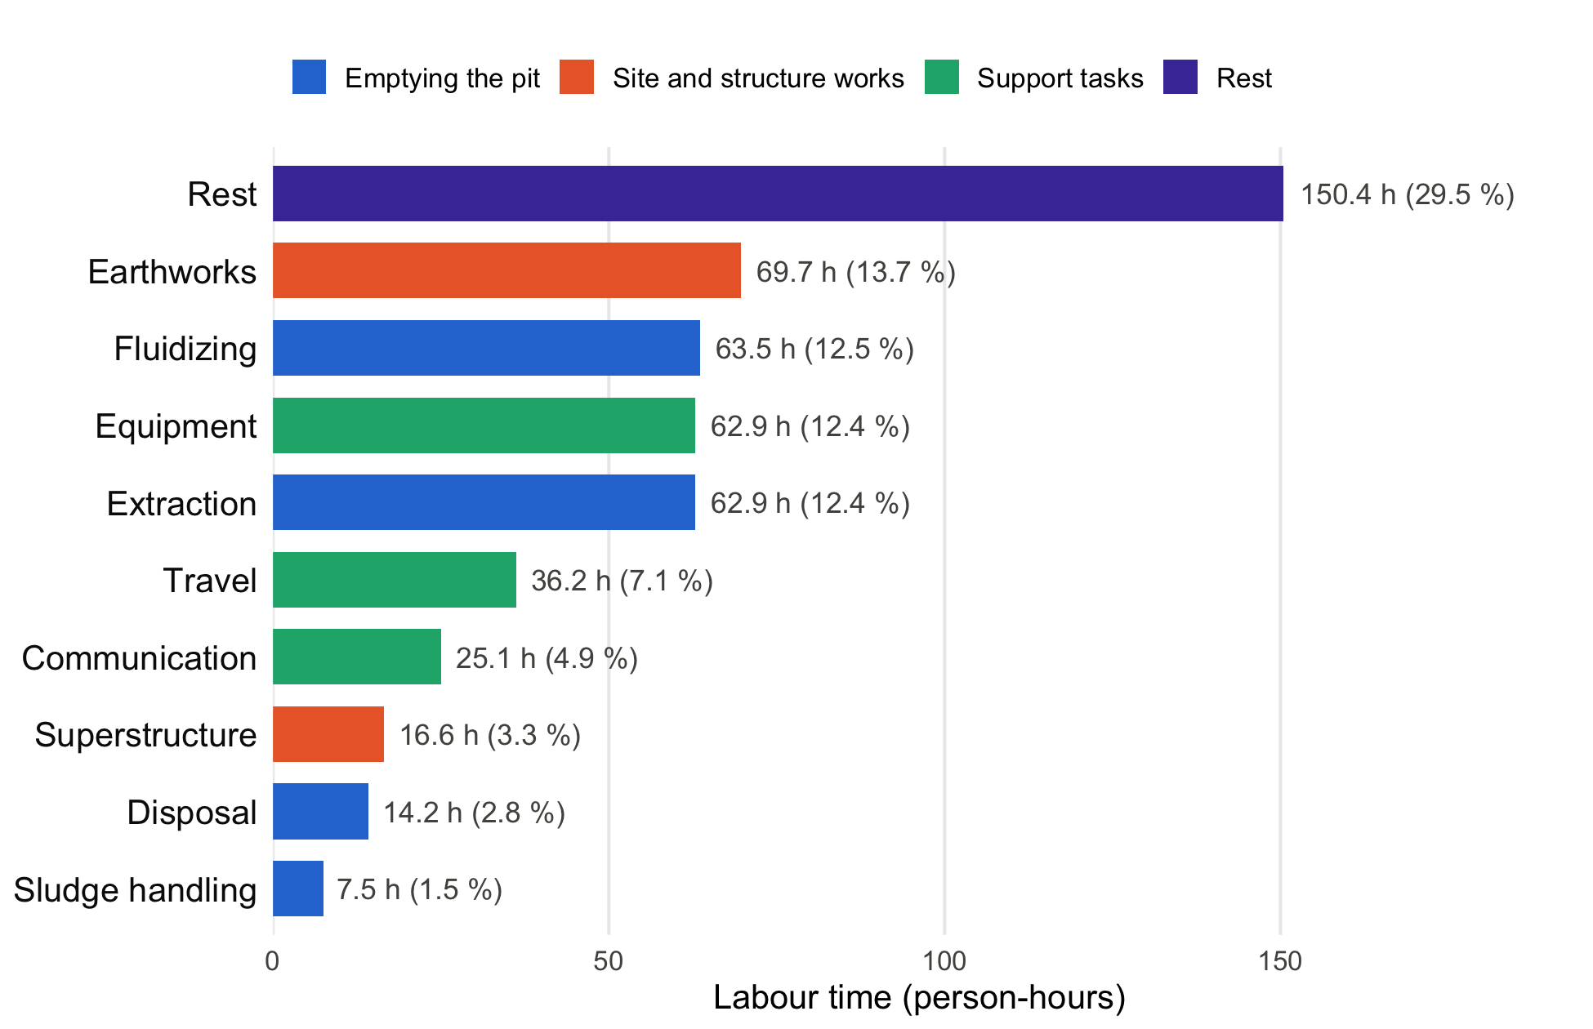
Figure 1: Labour time by main task across all 36 jobs, coloured by activity group. Labels give person-hours and share of total labour time.
_{Source: Article Notebook}
Grouped this way, the tasks that directly empty the pit (fluidizing, extraction, sludge handling and disposal) account for 148.1 person-hours (29.1 %), about the same as Rest (150.4 person-hours). Support tasks take 124.2 person-hours (24.4 %) and site and structure works 86.3 person-hours (16.9 %).
Figure 2 shows the labour time of each job. Labour time varies widely between jobs; Table 3 in the appendix lists the values for every job.
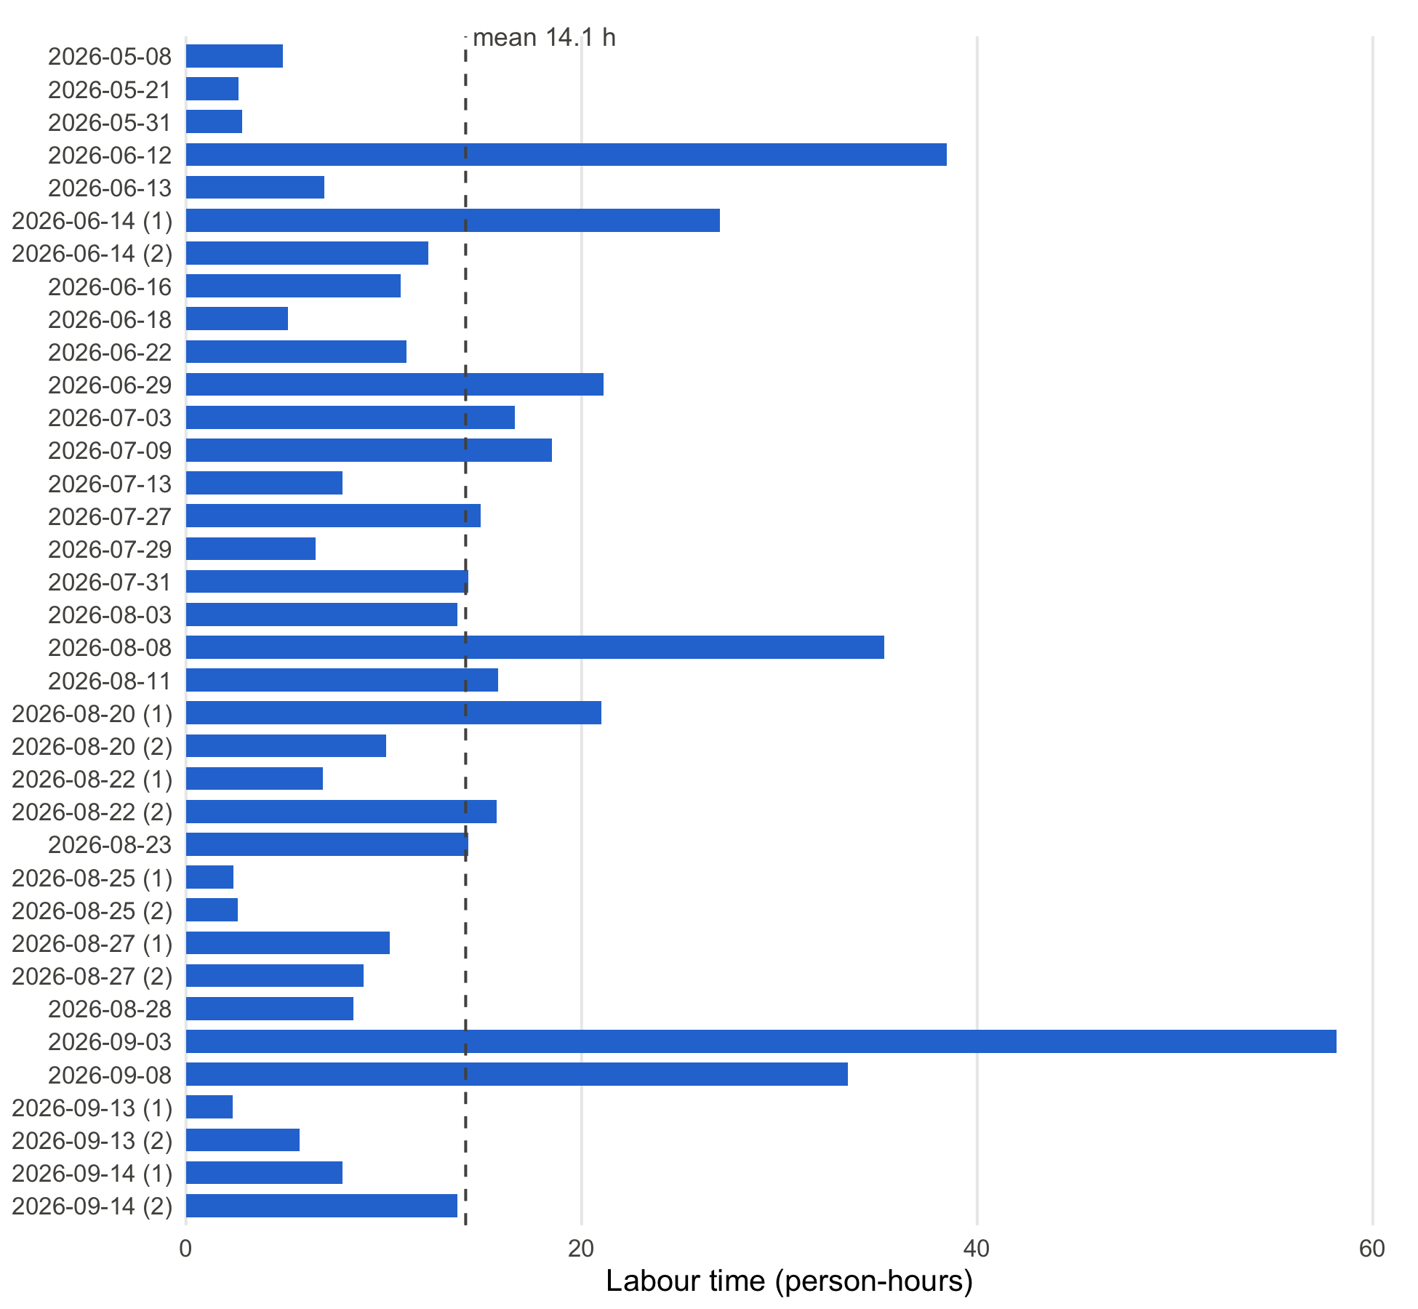
Figure 2: Labour time (person-hours) per pit emptying job, ordered by date. The dashed line is the mean.
_{Source: Article Notebook}

3.2 Time spent travelling to the disposal site
A team travelled to the disposal site in 7 of the 36 observed jobs, making 11 trips in total. In those jobs, the team spent on average 0.9 clock hours (52 minutes) per job travelling to the disposal site (median 0.6 hours, range 0.5–1.7). In labour time this is 3.0 person-hours per job (median 2.2, range 0.9–6.0).
A job with a disposal trip had 1.6 trips on average, each lasting 33 minutes and made by 3.4 gulpers together, so labour time is 3.4 times elapsed time. Within these jobs, disposal travel took up 17 % of the job’s labour time on average (range 9–24 %). Across all 36 jobs, disposal travel accounts for 4.1 % of the 509.0 person-hours recorded. Table 2 lists each job with a trip and Figure 3 shows the elapsed travel time per job.
Table 2: Disposal-site travel for each job in which a trip was made. Elapsed time counts a trip once regardless of how many gulpers made it; labour time adds every gulper’s travel. Share is labour travel time as a percentage of the job’s total labour time.
Job Date | Trips | Gulpers | Elapsed (h) | Labour (person-h) | Share of job (%)
2026-05-08 | 1 | 2 | 0.5 | 0.9 | 19.2
2026-08-08 | 3 | 4 | 1.7 | 6.0 | 17.0
2026-08-11 | 1 | 4 | 0.6 | 2.2 | 14.0
2026-08-20 (1) | 1 | 4 | 0.5 | 1.9 | 9.3
2026-09-08 | 2 | 4 | 1.3 | 5.4 | 16.1
2026-09-13 (2) | 1 | 2 | 0.5 | 1.0 | 16.9
2026-09-14 (2) | 2 | 3 | 1.1 | 3.2 | 23.5
Mean | 1.6 | 3.3 | 0.9 | 3.0 | 16.6
Median | 1.0 | 4.0 | 0.6 | 2.2 | 16.9

_{Source: Article Notebook}
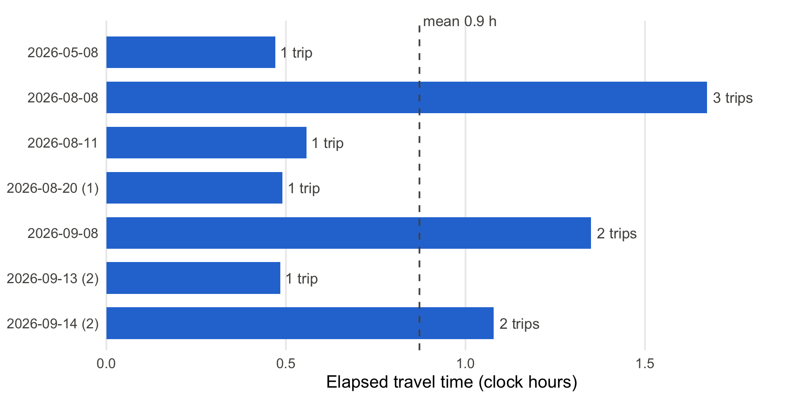
Figure 3: Elapsed time spent travelling to the disposal site per job, for the jobs in which a trip was made, ordered by date. Labels give the number of trips. The dashed line is the mean.
_{Source: Article Notebook}
Travel time per job is driven mainly by the number of trips: jobs with one trip take about half an hour of elapsed time, and the two jobs with the most travel (2026-08-08 and 2026-09-08) made 3 and 2 trips respectively.

3.3 Sensitivity checks
Capping the 4 entries that look like timers left running at 50 minutes would lower the total labour time to 506.8 person-hours, a change of 2.2 person-hours (0.4 %). Keeping the short disposal-site entries dropped in the Methods adds one job and changes the mean elapsed travel time to 0.8 hours over 8 jobs (2.6 person-hours); this is lower only because the added job contributes a 0.7-minute entry.

4. Conclusion
The 36 observed pit emptying jobs consumed 509.0 person-hours of recorded labour (143.6 elapsed clock hours), a mean of 14.1 person-hours per job. When a team travels to the disposal site, which happened in 7 of the 36 jobs, it spends on average 0.9 clock hours (52 minutes) per job on that travel, corresponding to 3.0 person-hours of labour because 3.4 gulpers travel together. A single trip takes about 33 minutes, and jobs vary mainly in how many trips they need. For TDABC purposes the person-hour figures are the quantities to cost: total labour time applies to every job, and disposal travel should be added only to the jobs that require a trip.

5. Appendix A: Job-level results
Table 3: Workers, labour time, elapsed time and disposal-site travel for each job. Travel columns are blank for jobs without a trip.
Job Date | Gulpers | Entries | Labour (person-h) | Elapsed (h) | Travel elapsed (h) | Travel labour (person-h)
2026-05-08 | 2 | 162 | 4.9 | 2.5 | 0.5 | 0.9
2026-05-21 | 2 | 120 | 2.7 | 1.5
2026-05-31 | 1 | 91 | 2.8 | 2.9
2026-06-12 | 8 | 1,514 | 38.5 | 7.7
2026-06-13 | 3 | 241 | 7.0 | 2.3
2026-06-14 (1) | 4 | 455 | 27.0 | 8.3
2026-06-14 (2) | 3 | 731 | 12.3 | 4.2
2026-06-16 | 3 | 199 | 10.9 | 3.7
2026-06-18 | 3 | 71 | 5.2 | 1.7
2026-06-22 | 4 | 159 | 11.2 | 2.8
2026-06-29 | 4 | 228 | 21.1 | 6.1
2026-07-03 | 4 | 295 | 16.6 | 4.4
2026-07-09 | 4 | 340 | 18.5 | 5.5
2026-07-13 | 3 | 175 | 7.9 | 2.6
2026-07-27 | 4 | 511 | 14.9 | 4.5
2026-07-29 | 3 | 347 | 6.6 | 2.2
2026-07-31 | 4 | 455 | 14.3 | 3.6
2026-08-03 | 3 | 199 | 13.7 | 4.6
2026-08-08 | 4 | 651 | 35.3 | 9.7 | 1.7 | 6.0
2026-08-11 | 4 | 403 | 15.8 | 4.0 | 0.6 | 2.2
2026-08-20 (1) | 4 | 290 | 21.0 | 6.2 | 0.5 | 1.9
2026-08-20 (2) | 4 | 270 | 10.1 | 2.5
2026-08-22 (1) | 4 | 224 | 6.9 | 2.0
2026-08-22 (2) | 4 | 375 | 15.7 | 3.9
2026-08-23 | 4 | 213 | 14.3 | 3.6
2026-08-25 (1) | 3 | 35 | 2.4 | 0.8
2026-08-25 (2) | 3 | 74 | 2.6 | 0.9
2026-08-27 (1) | 4 | 220 | 10.3 | 4.4
2026-08-27 (2) | 3 | 151 | 9.0 | 3.0
2026-08-28 | 3 | 224 | 8.5 | 2.8
2026-09-03 | 7 | 628 | 58.2 | 8.4
2026-09-08 | 4 | 377 | 33.4 | 8.4 | 1.3 | 5.4
2026-09-13 (1) | 2 | 54 | 2.4 | 1.2
2026-09-13 (2) | 2 | 103 | 5.7 | 2.9 | 0.5 | 1.0
2026-09-14 (1) | 3 | 92 | 7.9 | 3.2
2026-09-14 (2) | 3 | 101 | 13.7 | 4.6 | 1.1 | 3.2
Total | 19 | 10,778 | 509.0 | 143.6 | 6.1 | 20.7

_{Source: Article Notebook}

6. Appendix B: Relevant literature
The five references in the author’s Zotero library most relevant to this dataset, with one sentence on why each matters here:
- Yesaya et al. (2021) apply time-driven activity-based costing to compost production in Blantyre, Malawi, making it the closest methodological precedent for turning task-level timing data like these into activity costs.
- Wilcox et al. (2026) analyse the costs of 23 formal manual emptying providers in Malawi and Uganda and find labour is what makes manual emptying expensive, which is why the person-hours measured here, for the whole job and for disposal travel, are the key costing inputs.
- Chipeta et al. (2017) designed and tested the pedal-powered Gulper pump in Mzuzu and estimated that a pit can be emptied in 1–2 hours when trash content is low, a benchmark for the job durations recorded here and one against which a half-hour disposal trip is substantial.
- Chiposa et al. (2017) characterise pit latrines in peri-urban Mzuzu, reporting that 90 % of households also dispose of domestic waste in their pits, which helps explain the time spent on tasks such as pulling out trash and affects how much material must be removed.
- Burt et al. (2019) estimate the cost of delivering pit emptying services in Kigali, Rwanda, at different scales, giving a comparison point for costs derived from the labour and travel times reported here.

7. References
Burt, Zachary, Rachel Sklar, and Ashley Murray. 2019. “Costs and Willingness to Pay for Pit Latrine Emptying Services in Kigali, Rwanda.” International Journal of Environmental Research and Public Health 16 (23): 4738. https://doi.org/10.3390/ijerph16234738.
Chipeta, W. C., R. H. Holm, J. F. Kamanula, W. E. Mtonga, and F. L. de los Reyes. 2017. “Designing Local Solutions for Emptying Pit Latrines in Low-Income Urban Settlements (Malawi).” Physics and Chemistry of the Earth, Parts A/B/C 100: 336–42. https://doi.org/10.1016/j.pce.2017.02.012.
Chiposa, Rashid, Rochelle H. Holm, Chimuleke Munthali, Russel C. G. Chidya, and Francis L. de los Reyes III. 2017. “Characterization of Pit Latrines to Support the Design and Selection of Emptying Tools in Peri-Urban Mzuzu, Malawi.” Journal of Water, Sanitation and Hygiene for Development 7 (1): 151–55. https://doi.org/10.2166/washdev.2017.096.
Wilcox, Jonathan D. T., Carlos E. V. Batarda, Julita C. Chinseu, Yvonne S. Lugali, Jamie K. Bartram, and Barbara E. Evans. 2026. “Formal Manual Fecal Sludge Emptying and Transport Services: Cost Analysis of 23 Service Providers in Malawi and Uganda.” Environmental Science & Technology 60 (21): 15008–19. https://doi.org/10.1021/acs.est.6c01385.
Yesaya, Mabvuto, Wrixon Mpanang’ombe, and Elizabeth Tilley. 2021. “The Cost of Plastics in Compost.” Frontiers in Sustainability 2. https://doi.org/10.3389/frsus.2021.753413.

