How complete is Colombia’s drinking-water quality data?
  - Missing values, missing municipalities and missing years in the Calidad del Agua para Consumo Humano en Colombia dataset
Adriana Clavijo Daza
2026-09-29
Abstract
This note answers the second question posed for the Colombian drinking-water quality dataset held in this repository: how complete are the data? Completeness is examined at three levels. At the level of individual values, no cell in the file is empty, and the overall Water Quality Risk Index (IRCA) is always present, but the urban and rural components are frequently replaced by the placeholder ND; the rural IRCA is unavailable in about half of all municipal records. At the level of observational units, the file covers 1,095 municipality codes, and about 6% of the municipality-years in the implied 2007 to 2024 grid are absent. These gaps are concentrated in a few departments, above all Chocó, where five out of six municipality-years are missing, and in the Amazon and Orinoco departments. Departmental aggregate rows are absent in 25 department-years. At the level of time, every calendar year from 2007 to 2024 is present at the national level, but roughly one municipality in four has at least one interruption in its series. The dataset is therefore complete in its core measurement and in its calendar coverage, but unbalanced as a panel and sparse in its rural component.

1. Introduction
The first note in this series established that the water quality dataset held in this repository is a panel whose observational unit is the municipality-year: each row carries the annual Índice de Riesgo de la Calidad del Agua para Consumo Humano (IRCA), the Water Quality Risk Index, for one municipality in one calendar year, together with the same index computed for the municipality’s urban and rural areas, and a smaller set of department-year aggregates is stacked in the same file. The second question listed in questions.md asks how complete these data are, and breaks the question into three parts: are there missing values in the water quality measurements, are there observational units missing, and are there missing years?
The three parts correspond to three different ways in which a panel can be incomplete. A row can be present but carry a missing value in one of its measurement columns. A municipality can be absent from a year in which other municipalities are reported, or absent from the file altogether. And a whole calendar year can be absent from the file, or from the series of a particular municipality. This note treats each in turn, using only the structure of the file itself.

2. Data and methods
The file was imported with all columns as character strings, as in the first note, and the year was converted to an integer after removing its thousands separator. Municipal rows were separated from the department-level aggregates, which are marked by the code #TODOS in the municipality columns.
Missing values were assessed by counting empty cells and cells containing the placeholder ND in each measurement column, overall and by year, and by examining how the urban and rural placeholders co-occur within a row and within a municipality’s series.
Missing observational units require a reference set against which absence can be measured. The file carries no list of the municipalities that ought to be present, so the reference set was defined internally as the set of every municipality code that appears at least once in the file, combined with every year that appears at least once. This defines a rectangular grid of municipality-years, and a municipality-year is counted as missing when the grid has a cell for it but the file has no row. The same construction was applied to the department-year aggregates. This internal reference cannot detect a municipality that never appears in the file; that limitation is discussed in Section 3.2.
Missing years were assessed at the national level, by checking the sequence of calendar years for gaps, and at the municipal level, by comparing each municipality’s number of observed years with the span between its first and last observed year.
All computations are embedded in the source of this document and are re-executed from the data file when it is rendered.

3. Results

3.1 Missing values in the measurements
No cell in the file is empty: all 19,160 rows have a value in every one of the 11 columns (0 empty cells). Missingness is instead encoded by the string ND, which appears only in the four urban and rural measurement columns. The overall IRCA and its risk category are never missing, in either the municipal or the departmental rows (Table 1). The numeric value and the risk category of each component are always missing together (0 rows where one is ND and the other is not), so ND behaves as a single missing-value marker per component rather than as two independent gaps.
Table 1: Number of rows in which each measurement column holds the placeholder ND, by level of aggregation.
Level | Rows | IRCA | Nivel de riesgo | IRCAurbano | Nivel de riesgo urbano | IRCArural | Nivel de riesgo rural
Department | 569 | 0 | 0 | 4 | 4 | 77 | 77
Municipality | 18,591 | 0 | 0 | 1,264 | 1,264 | 9,538 | 9,538

Within the municipal rows, the rural component is missing far more often than the urban one: the rural IRCA is ND in 51% of rows, the urban IRCA in 7%. Table 2 shows how the two combine. Fewer than half of all municipal rows carry all three indices. In 917 rows both components are missing while the overall IRCA is present, which shows that the overall index is not simply computed from the two components as they appear in the file.
Table 2: Co-occurrence of missing urban and rural IRCA values within municipal rows.
Urban IRCA | Rural IRCA | Rows | Share
present | present | 8,706 | 46.8%
present | missing | 8,621 | 46.4%
missing | present | 347 | 1.9%
missing | missing | 917 | 4.9%

The share of missing component values is not constant over time (Figure 1). The rural share fell from about three quarters of municipal rows in 2007 to around 40% by 2010, then drifted back up to roughly 55% from 2016 onwards. The urban share is usually below 10%, but rises sharply in 2016 and 2017, peaking at 24% in 2017, before falling to near zero from 2021. The 2016 and 2017 spike affects both components simultaneously and is most plausibly a reporting artefact of those years rather than a real change in surveillance coverage.
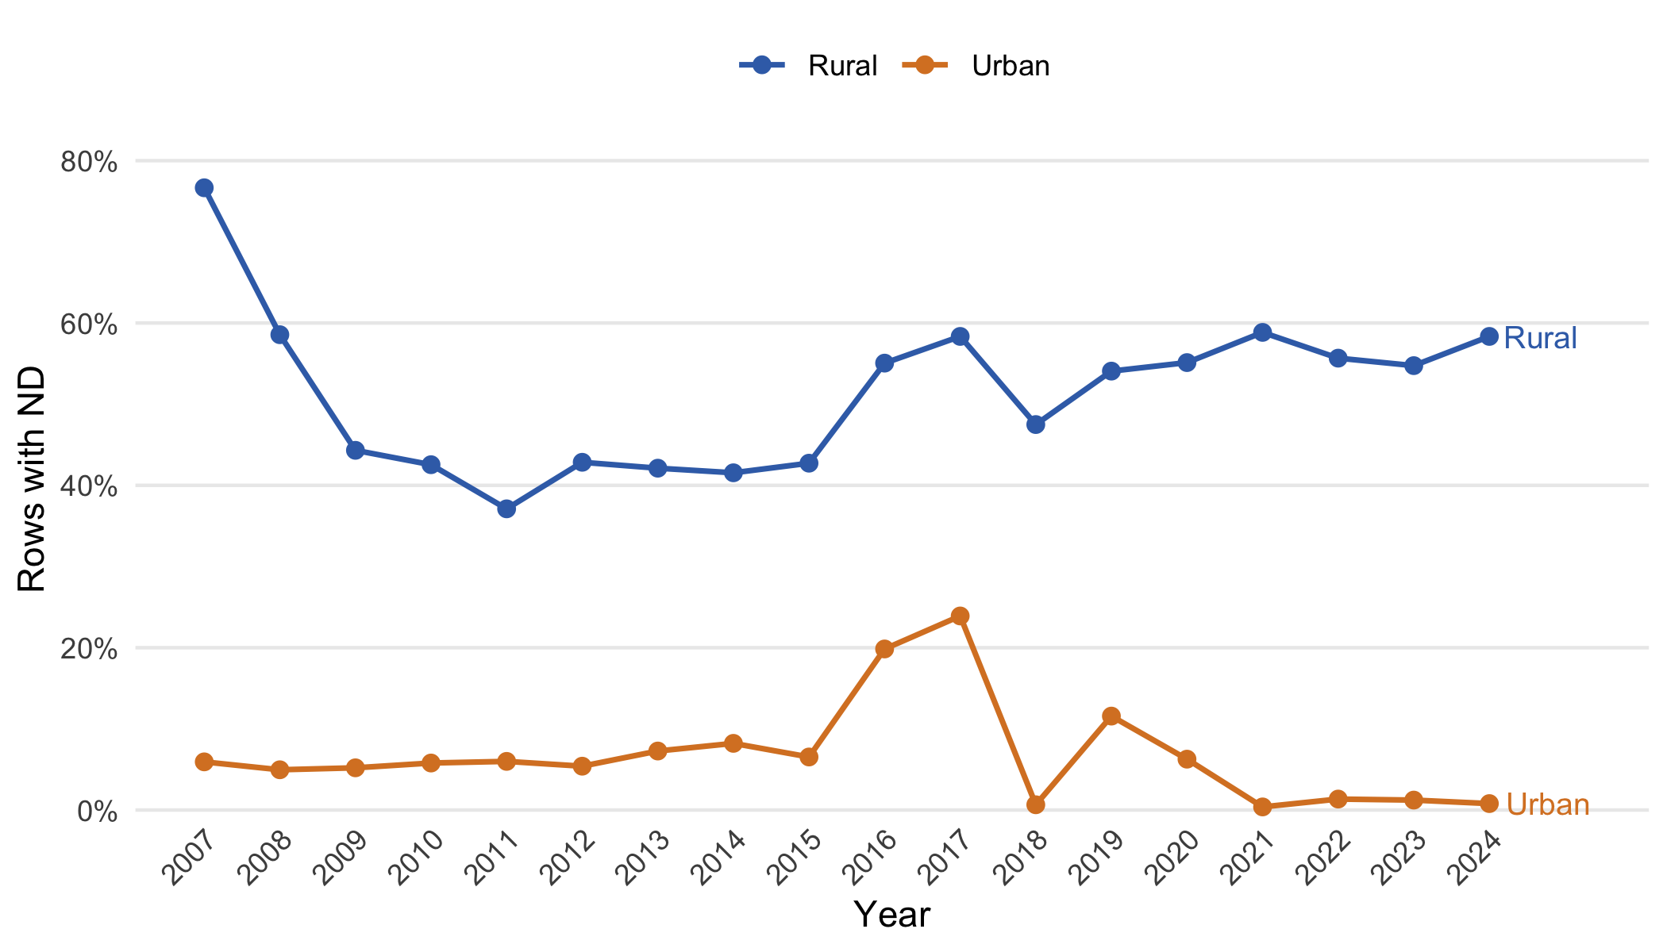
Figure 1: Share of municipal rows in which the urban and rural IRCA are missing (ND), by year.
Seen from the municipality’s side, the rural gap is mostly intermittent rather than structural. Only 148 municipalities never report a rural IRCA in any year, and only 48 report one in every year they appear; the remaining municipalities report it in some years and not in others. A structural explanation, such as municipalities with no rural water supply under surveillance, therefore accounts for only a small part of the missing rural values.
Finally, ND does not always mean that no rural samples entered the overall index. Among rows where the rural IRCA is ND and the urban IRCA is present, the overall IRCA equals the urban IRCA in 87% of cases, as one would expect if the overall index were computed from urban samples only; but in 785 rows the two differ by more than one point, which implies that rural samples contributed to the overall index even though the rural component is reported as unavailable. Analysts should treat ND as “not reported” rather than “not sampled”.

3.2 Missing observational units
The municipal rows contain 1,095 distinct municipality codes. Combined with the 18 years in the file, these define a grid of 19,710 municipality-years, of which 18,591 are present and 1,119 (5.7%) are absent. The panel is therefore unbalanced, though not severely so at the national level. Table 3 shows the count of missing municipality-years by year. Coverage improves from 2007 to 2019, when only 15 municipalities are absent, and then deteriorates: the three most recent years are among the least complete in the file, and 2022 is the least complete year of all.
Table 3: Municipality-years absent from the file, by year, relative to the set of all municipality codes that appear at least once.
Year | Observed | Missing | Share
2,007 | 994 | 101 | 9.2%
2,008 | 1,028 | 67 | 6.1%
2,009 | 1,038 | 57 | 5.2%
2,010 | 1,053 | 42 | 3.8%
2,011 | 1,051 | 44 | 4.0%
2,012 | 1,055 | 40 | 3.7%
2,013 | 1,059 | 36 | 3.3%
2,014 | 1,059 | 36 | 3.3%
2,015 | 1,025 | 70 | 6.4%
2,016 | 1,028 | 67 | 6.1%
2,017 | 1,054 | 41 | 3.7%
2,018 | 1,076 | 19 | 1.7%
2,019 | 1,080 | 15 | 1.4%
2,020 | 1,005 | 90 | 8.2%
2,021 | 1,040 | 55 | 5.0%
2,022 | 961 | 134 | 12.2%
2,023 | 979 | 116 | 10.6%
2,024 | 1,006 | 89 | 8.1%

The gaps are very unevenly distributed across departments (Table 4 and Figure 2). Only 5 departments are complete over the whole period. At the other extreme, Chocó is missing 84% of its municipality-years: 24 municipality codes from Chocó appear in the file, but most of them appear only in a handful of years between 2014 and 2021, and in most years the department is represented by only a few municipalities. The sparsely populated departments of the Amazon and Orinoco regions (Guainía, Vaupés, Guaviare, Amazonas, Vichada) and Córdoba also show substantial gaps. Of the 23 municipalities that appear in five or fewer years, 21 are in Chocó.
Table 4: Municipality-years absent from the file, by department, for the ten departments with the largest share of missing municipality-years.
Department | Municipalities | Grid cells | Missing | Share
Chocó | 24 | 432 | 363 | 84.0%
Guainía | 2 | 36 | 16 | 44.4%
Vaupés | 3 | 54 | 19 | 35.2%
Guaviare | 4 | 72 | 19 | 26.4%
Córdoba | 30 | 540 | 121 | 22.4%
Amazonas | 2 | 36 | 8 | 22.2%
La Guajira | 15 | 270 | 30 | 11.1%
Vichada | 4 | 72 | 7 | 9.7%
Putumayo | 13 | 234 | 20 | 8.5%
San Andrés y Providencia | 2 | 36 | 3 | 8.3%

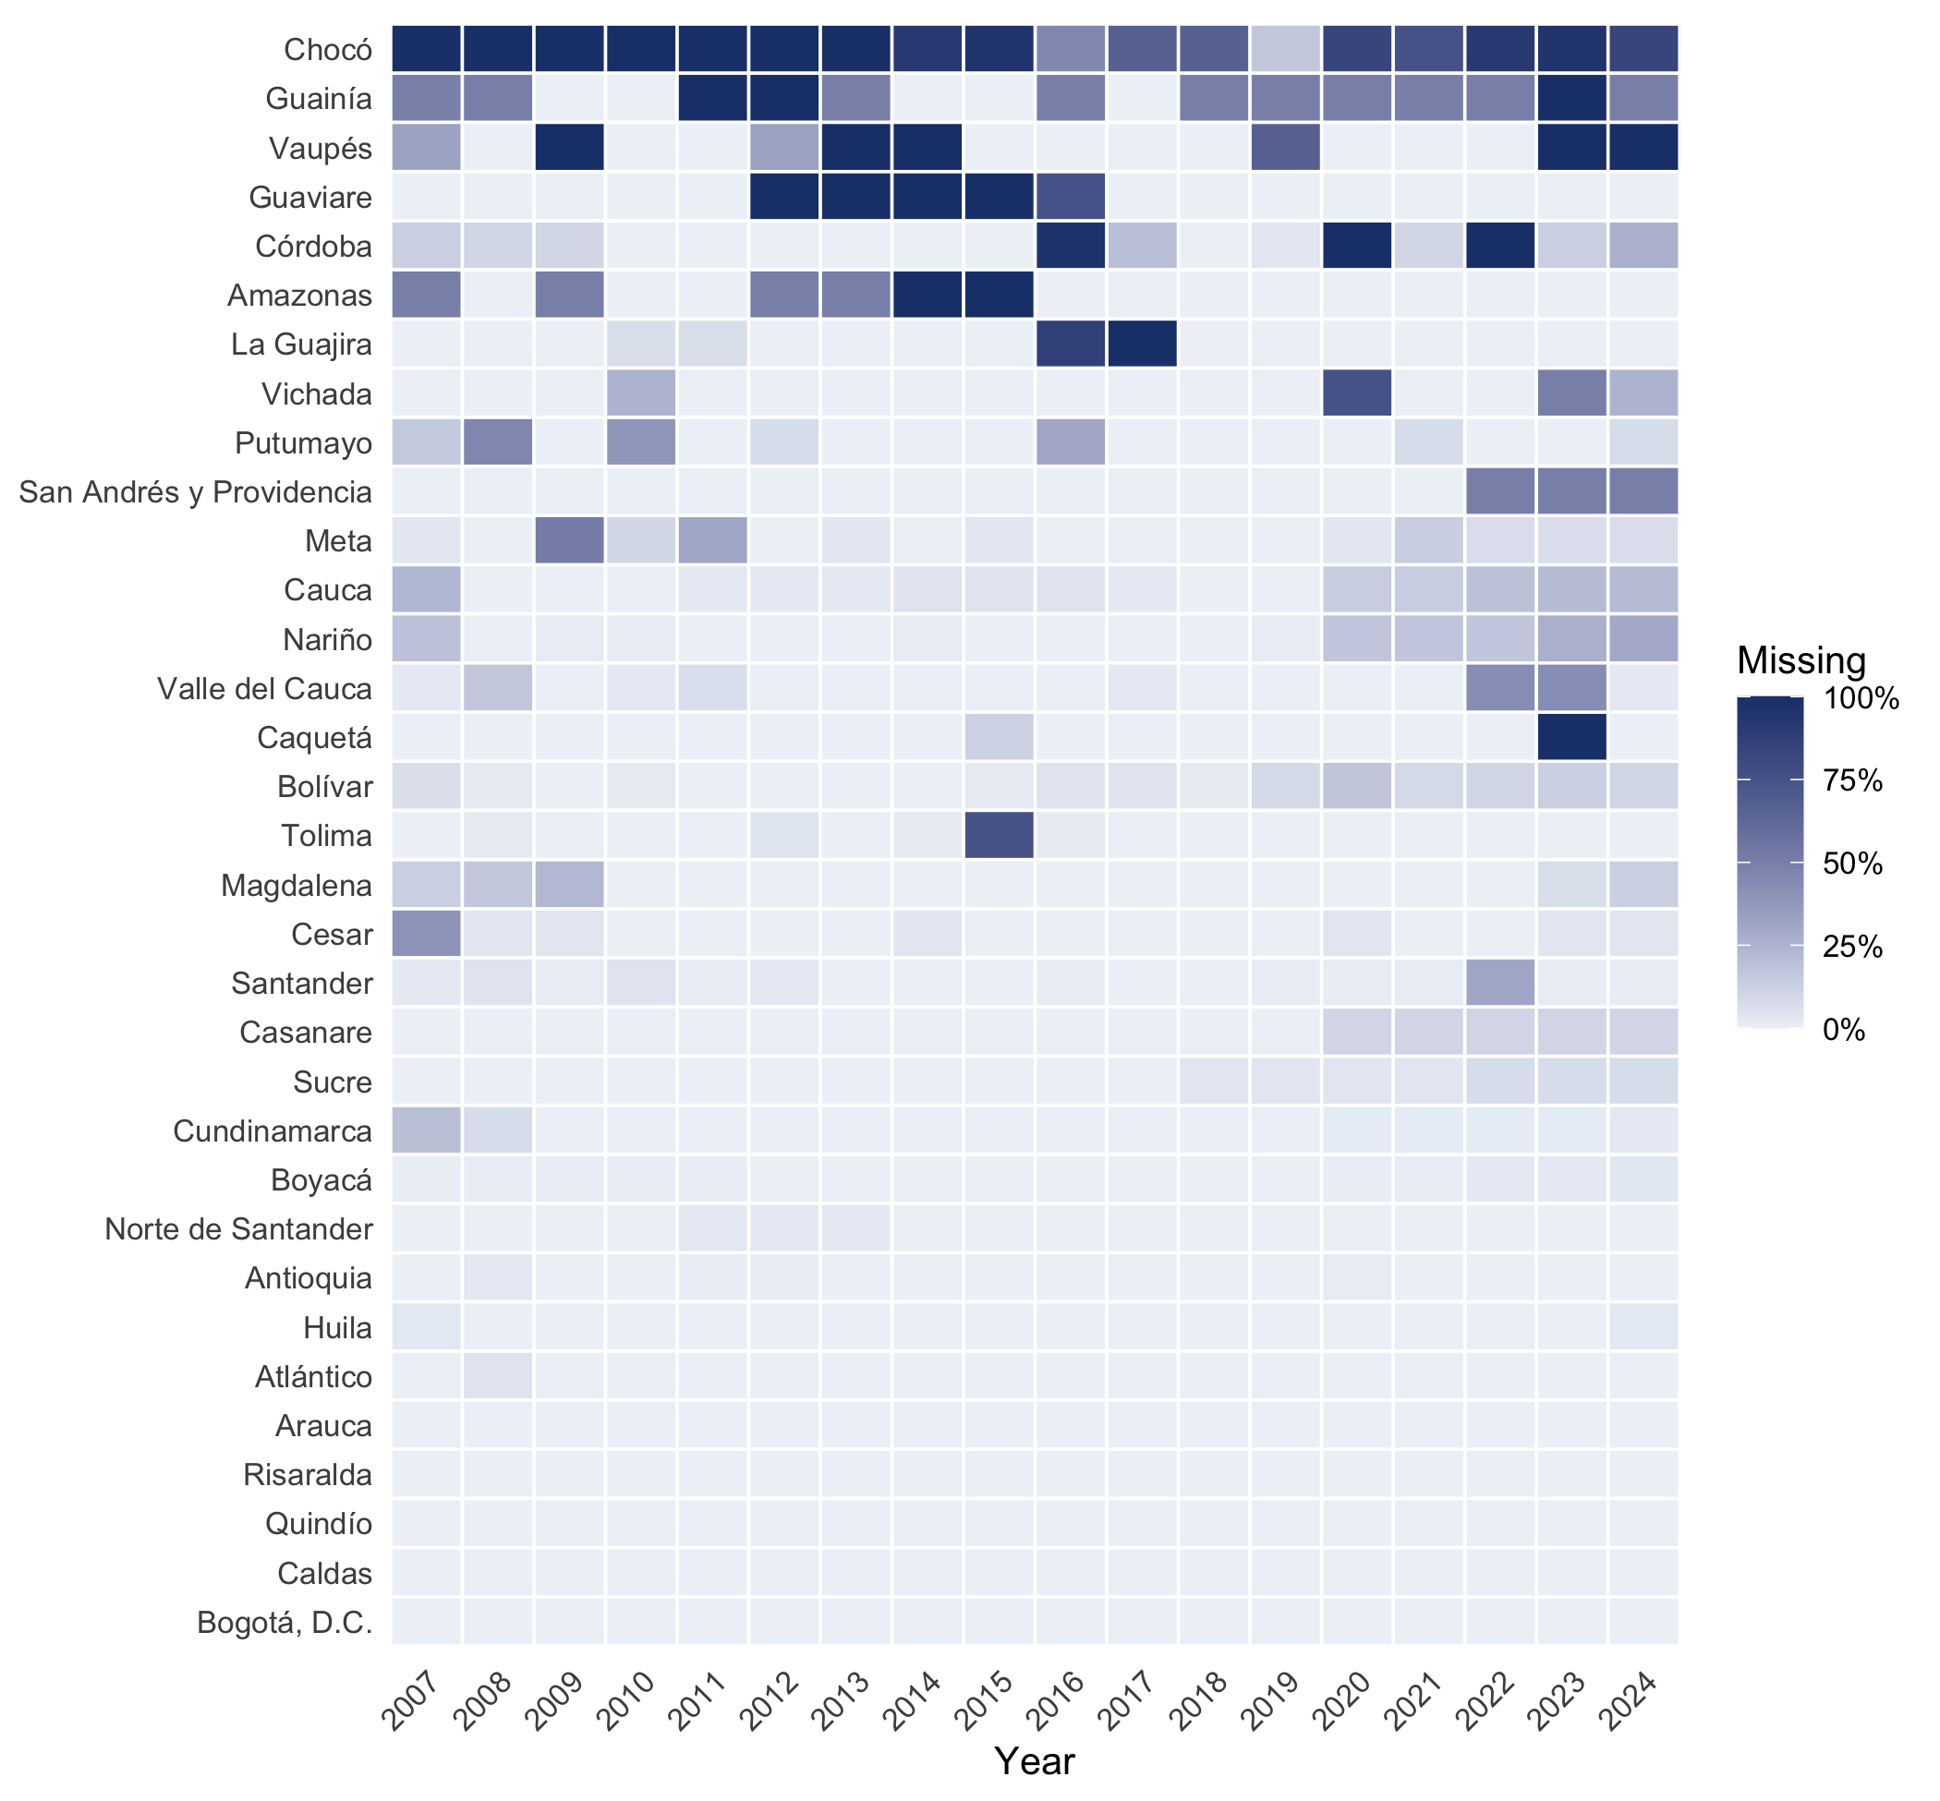
Figure 2: Share of each department’s municipalities that are absent from the file in each year. Departments are ordered by their overall share of missing municipality-years.
The department-level aggregates show the same picture on a smaller scale. The 33 department codes and 18 years define 594 department-years, of which 569 are present and 25 are absent (Table 5). The departmental and municipal rows are mutually consistent: a department has an aggregate row for a year if and only if at least one of its municipalities has a row for that year (0 exceptions). A missing department-year therefore always means that the department reported no municipality at all in that year. Chocó has no rows of any kind before 2014.
Table 5: Department-years for which the file has no department-level aggregate row.
Department | Years without a department row
Chocó | 2007, 2008, 2009, 2010, 2011, 2012, 2013
Vaupés | 2009, 2013, 2014, 2023, 2024
Guaviare | 2012, 2013, 2014, 2015
Guainía | 2011, 2012, 2023
Amazonas | 2014, 2015
Córdoba | 2020, 2022
Caquetá | 2023
La Guajira | 2017

An internal reference set cannot reveal municipalities that never appear in the file. Colombia’s official territorial register (DANE’s DIVIPOLA) lists on the order of 1,100 municipalities plus a number of non-municipalised areas, so the 1,095 codes seen here suggest that a small number of municipalities is absent throughout; the file also contains no codes for the non-municipalised areas of the Amazon departments. Confirming which municipalities are missing requires joining the file to the official register, which lies outside the scope of this note.

3.3 Missing years
At the national level there are no missing years: the file covers every calendar year from 2007 to 2024 (0 gaps in the sequence). The file was downloaded in September 2026, so the absence of 2025 most likely reflects the lag with which annual surveillance results are consolidated and published rather than a gap in the series.
At the municipal level, years are missing in two ways. First, the series of many municipalities start late or end early: 101 municipalities are first observed after 2007, and 89 are last observed before 2024. Second, 259 municipalities have at least one interruption inside their series, that is, a year between their first and last observation with no row, accounting for 460 missing municipality-years in total. Figure 3 shows the distribution of the number of observed years: 732 municipalities (67%) are observed in all 18 years, and most of the remainder miss only one or two years.
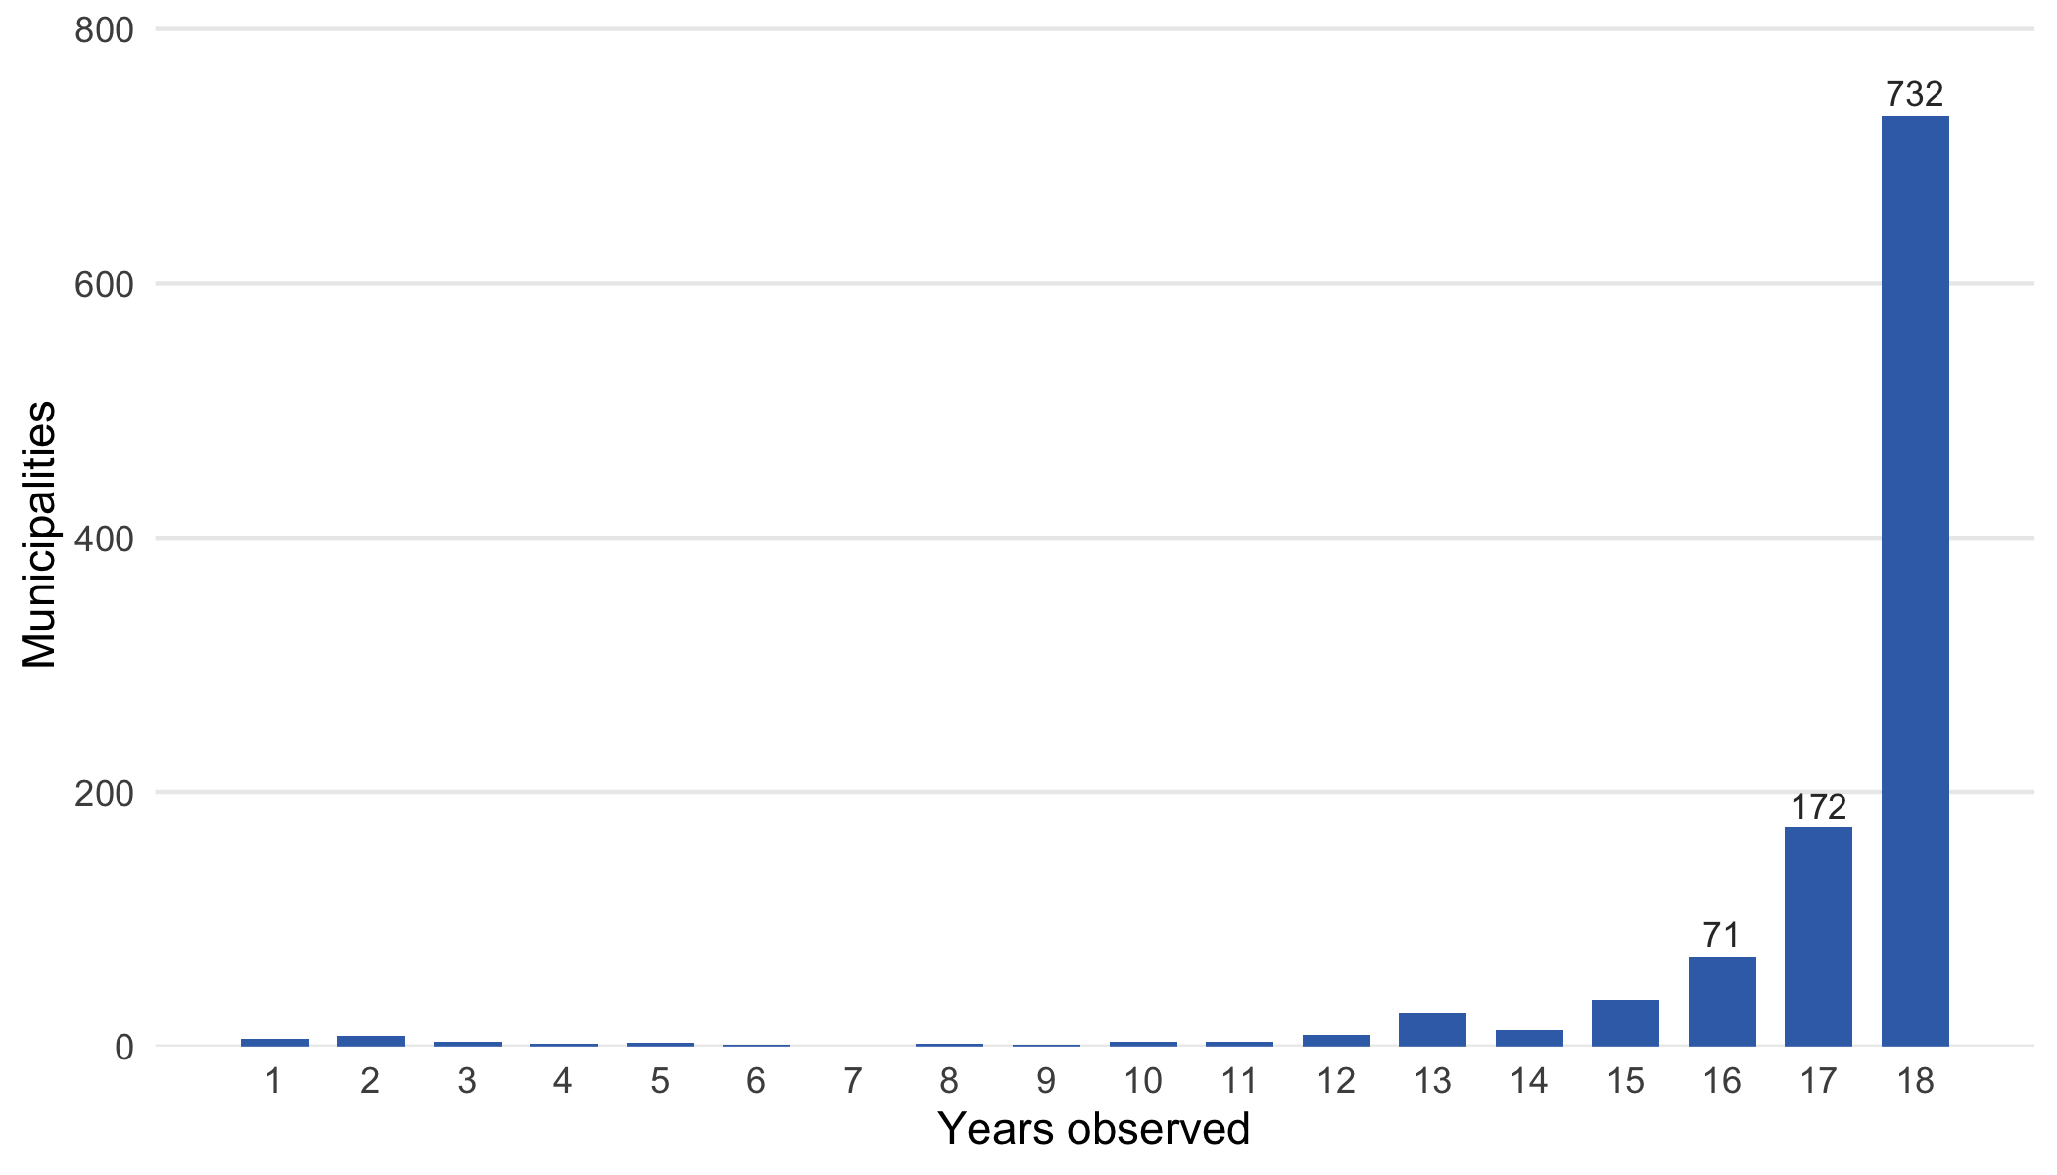
Figure 3: Number of municipalities by the number of years in which they have a row in the file.

4. Conclusion
The dataset is complete in the two respects that matter most for a national time series. The overall IRCA and its risk category are never missing, and every calendar year from 2007 to 2024 is present. Its incompleteness lies elsewhere. The rural component of the index is unavailable in about half of all municipal rows, the urban component in a smaller but time-varying share with a marked spike in 2016 and 2017, and these placeholders do not reliably indicate that no samples were taken. The panel of municipalities is unbalanced: about 6% of municipality-years are absent, with most of the shortfall concentrated in Chocó, where coverage is fragmentary, and in the Amazon and Orinoco departments, and coverage has weakened since 2020. Roughly a quarter of municipalities have an interrupted series. Analyses that use the urban and rural components, that compare departments, or that follow individual municipalities over time must therefore account for missingness explicitly; analyses of the overall index at the national level over the full period can proceed with fewer reservations.

