What the Colombian drinking-water quality file measures, and how much of it is there
  - Structure and completeness of the Calidad del Agua para Consumo Humano en Colombia dataset
Adriana Clavijo Daza
2026-09-29
Abstract
This note describes what the Colombian drinking-water quality file held in this repository measures and how complete it is. The observational unit is the municipality-year: each row carries the annual Water Quality Risk Index (IRCA) of one municipality in one calendar year, with separate values for the whole municipality, its urban area and its rural area, and department-year aggregates are stacked in the same file. The overall IRCA is never missing and every calendar year from 2007 to 2024 is present, but the rural index is unavailable in about half of the municipal rows, about 6% of the municipality-years that the national municipal register implies are absent, two thirds of municipalities have an uninterrupted series, and Chocó is missing more than four fifths of its municipality-years.

1. Data and validation
The repository holds one file, Calidad_del_Agua_para_Consumo_Humano_en_Colombia_20260915.csv, published on Colombia’s open-data portal from the national drinking-water surveillance system (Instituto Nacional de Salud and Ministerio de Salud y Protección Social 2026). Territorial health authorities sample water supplies through the year, and the samples are consolidated into the Índice de Riesgo de la Calidad del Agua para Consumo Humano (IRCA), a 0 to 100 score of deviation from the standards of Resolution 2115 of 2007, classed into five risk bands: no risk (0 to 5), low (5.1 to 14), medium (14.1 to 35), high (35.1 to 80) and sanitarily unviable (above 80) (Ministerio de la Protección Social and Ministerio de Ambiente, Vivienda y Desarrollo Territorial 2007). This note describes the structure of the file and then assesses its completeness.
The file was imported with every column as text, and the structure that the rest of this note relies on was asserted in code rather than assumed: the column set, the row count, the absence of empty cells, the format of the codes, the parsing of the year, the fact that the token ND is the only non-numeric value in the index columns, the spelling set of the risk labels, and the uniqueness of the keys (27 checks, all passing at render time). Table 1 describes the columns and what was done to each on import.
Table 1: Columns of the data file, their role, and how each was treated on import.
Column | Role | Cleaned type | Note on import
DepartamentoCodigo | Identifier | Character key | Two-digit DANE code, leading zero kept
Departamento | Identifier | Label | Name; one department has two spellings
MunicipioCodigo | Identifier | Character key | Five-digit DANE code; #TODOS marks a department aggregate
Municipio | Identifier | Label | Name; not stable across years
Año | Identifier | Integer | Stored as text with a thousands separator (2,024)
IRCA | Measurement | Numeric 0–100 | Annual index, whole unit
Nivel de riesgo | Measurement | 5-level factor | Two spellings per band mapped to one
IRCAurbano | Measurement | Numeric 0–100 | Urban area; ND read as missing
Nivel de riesgo urbano | Measurement | 5-level factor | Missing when the value is ND
IRCArural | Measurement | Numeric 0–100 | Rural area; ND read as missing
Nivel de riesgo rural | Measurement | 5-level factor | Missing when the value is ND

Completeness needs a reference set of units that ought to be present. Two are used. The internal frame is every municipality code that appears at least once, crossed with every year that appears at least once; it asks whether the file is balanced on its own terms. The external frame is the municipal register of the DANE Marco Geoestadístico Nacional 2020 (Departamento Administrativo Nacional de Estadística (DANE) 2020), which lists 1,122 units, minus the 19 non-municipalised areas of Amazonas, Guainía and Vaupés, which have no municipal administration and never appear in the file; that leaves 1,103 municipalities and asks whether the country is covered. The register is a 2020 snapshot, so the few municipalities created after 2007 slightly overstate the external shortfall in early years. Figure 1 shows the measurement and the coverage on that register.
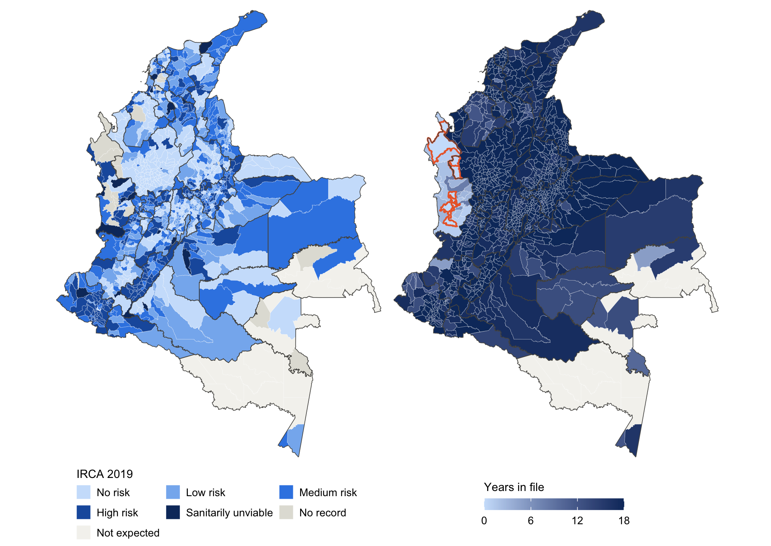
Figure 1: Annual IRCA by municipality in 2019 (left) and number of years, out of 18, in which each municipality appears in the file (right). Municipalities that never appear are outlined in orange; non-municipalised areas are not expected. Boundaries: DANE 2020.

2. The observational unit

2.1 What a row looks like
The file has 19,160 rows and 11 columns. Table 2 reproduces four rows verbatim. Each row names a place and a year and reports three indices: one for the whole territorial unit, one for its urban area and one for its rural area, each accompanied in the full file by a risk band derived from it. The same municipality code recurs year after year, so a row is not a place but a place in a year. The name attached to a code can change between years while the code stays fixed. The token ND stands in for a component that was not reported. The fourth row carries #TODOS in place of a municipality: it describes the department as a whole for that year, and 569 such rows are interleaved with the 18,591 municipal rows.
Table 2: Four rows of the file, reproduced verbatim: the same municipality in two consecutive years under two names, a municipality with no rural index, and the department-level aggregate for the same department and year.
DepartamentoCodigo | MunicipioCodigo | Municipio | Año | IRCA | IRCAurbano | IRCArural
76 | 76001 | Cali | 2,024 | 0.2 | 0.1 | 2.5
76 | 76001 | Santiago de Cali | 2,023 | 0.3 | 0.3 | 0.0
76 | 76111 | Guadalajara de Buga | 2,024 | 0 | 0 | ND
76 | #TODOS | #TODOS | 2,024 | 3.9 | 0.4 | 12.5

2.2 What identifies a row
Table 3 tests candidate identifiers on the municipal rows. A municipality code alone recurs across years. A municipality name with a year is not unique either, because 63 names are shared by municipalities in different departments. Adding the department name makes the key unique, but names are not stable: municipality 76001 appears as “Santiago de Cali” and as “Cali”, and over the period more than one name is attached to 1 of the 1,095 codes. The municipality code with the year identifies every municipal row exactly once, and because the first two digits of every municipality code equal the department code, the department adds no information. On the aggregate rows, department code with year is likewise unique.
Table 3: Candidate identifiers tested on the municipal rows and, in the last line, on the department aggregate rows.
Candidate key | Distinct values | Rows | Duplicated rows
Municipality code | 1,095 | 18,591 | 17,496
Municipality name + year | 17,249 | 18,591 | 1,342
Department name + municipality name + year | 18,591 | 18,591 | 0
Municipality code + year | 18,591 | 18,591 | 0
Department code + year (aggregate rows) | 569 | 569 | 0

The municipal rows cover 1,095 municipality codes in 33 departments over 18 years, 2007 to 2024.

2.3 The municipality-year and its limits
The observational unit is therefore the municipality-year. One row records, for one municipality in one calendar year, the annual IRCA of the municipality as a whole and of its urban and rural areas, with the risk band of each. The department-year rows marked #TODOS are a second, coarser set of units derived from the same surveillance; they must be separated from the municipal rows before any count or average, or departments will be counted twice.
It is equally important what the unit is not. The IRCA of a municipality-year is a consolidation of many water samples taken over the year, but the samples, the supply systems, the sampling points and the months are not in the file, and the number of samples behind a value is unknown. A row is the annual summary of a municipality’s surveillance, not an observation of any water supply. For any join or panel construction the numeric code, not the name, is the key.

3. Completeness of the data
Incompleteness can occur at three levels, and the picture differs at each. A row can exist but lack a value (a missing value). A municipality can lack a row in a year in which other municipalities have one (a missing unit). A year can be absent altogether, or absent from the series of a particular municipality (a missing year).

3.1 Missing values within rows
No cell is empty (0 empty cells), and the overall IRCA and its band are never missing (0 rows). Missingness lives entirely in the urban and rural components, encoded by ND, always for the value and its band together. In the municipal rows the rural index is missing in 51% of rows and the urban index in 7%; only 47% of rows carry all three indices, and 917 rows carry an overall index with neither component. Department aggregates are better filled: the rural index is missing in 14% of them. Every reported band agrees with the band implied by its value (0 disagreements in 46,597 values).
The rural gap has changed over time (Figure 2). It affected 77% of rows in 2007, fell to around 40% by 2010, and has stayed above half since 2016. The urban index is rarely missing except in 2016 and 2017, peaking at 24% in 2017, when both components go missing together, which suggests a reporting artefact rather than a change in sampling. The rural gap is intermittent rather than structural: 148 municipalities never report a rural index, 48 always do, and 899 alternate.
Two things distinguish ND from a missing unit. Definitionally, a row with ND still carries an overall index, whereas an absent municipality-year carries nothing. Empirically, ND does not always mean that no rural samples were taken: among the 8,621 rows with a rural ND and an urban value, the overall index equals the urban index in 87% of cases, but in 785 rows the two differ by more than one point, so rural samples entered the overall index even though the rural component is reported as unavailable.
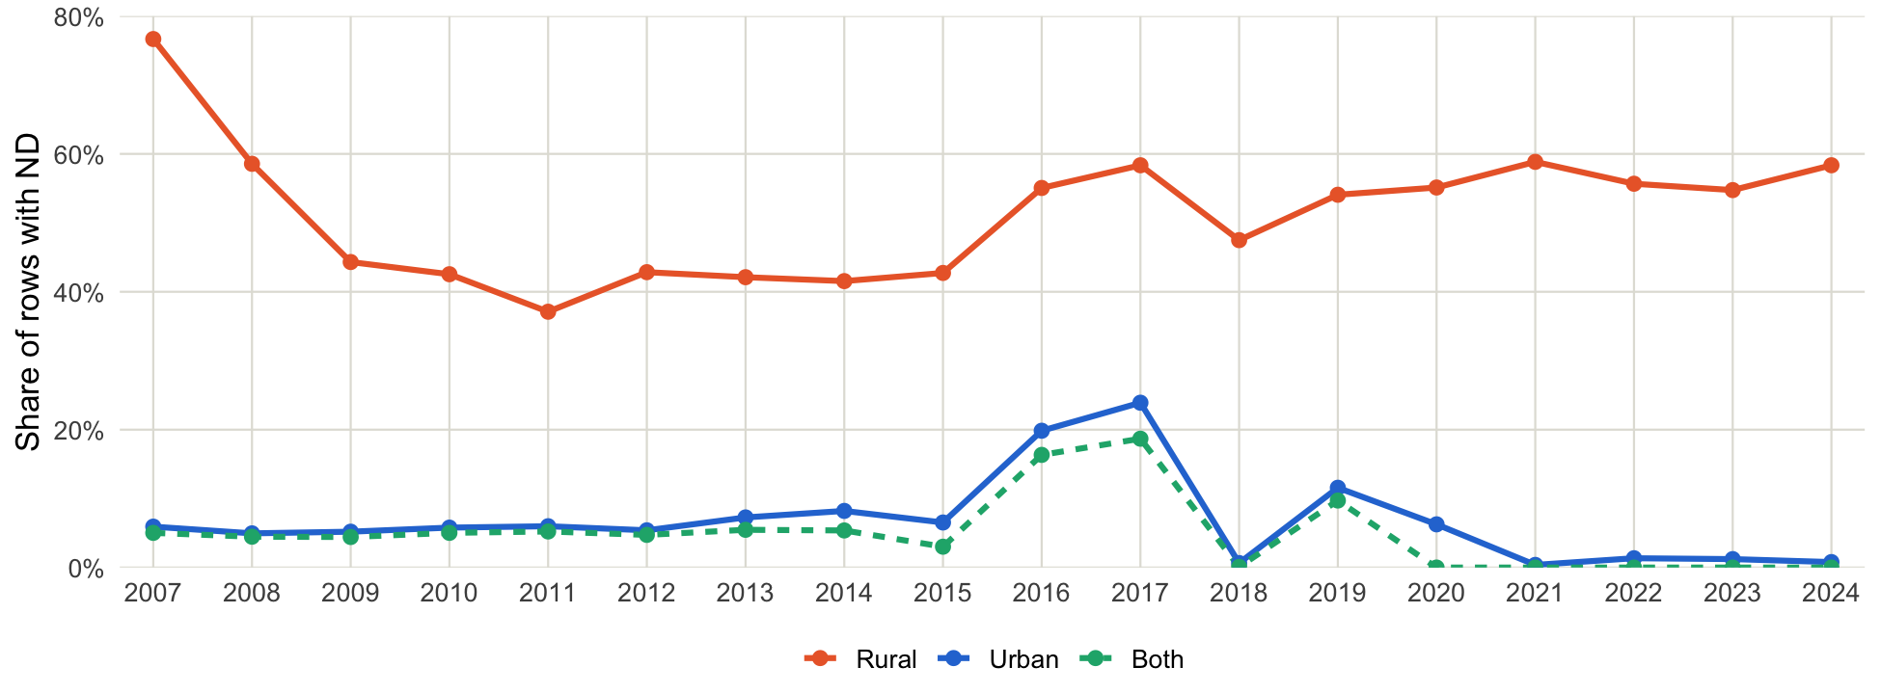
Figure 2: Share of municipal rows in which the urban index, the rural index, or both are reported as ND, by year.

3.2 Missing observational units
Table 4 counts the units that are expected and observed under each frame. Against the file’s own frame, 5.7% of municipality-years are absent; against the national register, 6.4%, because 8 municipalities never appear at all (Antioquia: Murindó, Vigía del Fuerte; Chocó: El Cantón del San Pablo, Istmina, Medio Baudó, Riosucio, Río Quito, Unguía). Coverage improved from 2007 to 2019, when only 23 municipalities were absent, and has weakened since 2020; 2022 is the least complete year, with 142 absent. Department aggregates are absent in 25 department-years, exactly those in which the department reported no municipality at all (0 exceptions), so the aggregate rows add no coverage of their own.
Table 4: Expected and observed units under the internal frame (codes present at least once by years present at least once) and the external frame (DANE 2020 municipal register, non-municipalised areas excluded).
Units | Expected | Observed | Missing | Share missing
Municipality-years, internal frame | 19,710 | 18,591 | 1,119 | 5.7%
Municipality-years, external frame | 19,854 | 18,591 | 1,263 | 6.4%
Municipalities, external frame | 1,103 | 1,095 | 8 | 0.7%
Department-years | 594 | 569 | 25 | 4.2%

The gaps are concentrated (Figure 3). Only 5 departments are complete over the whole period. Chocó has no rows of any kind before 2014 and is missing 87% of its municipality-years, 471 of the 1,263 absent nationally; Guainía, Vaupés, Guaviare, Córdoba and Amazonas each lack more than a fifth.
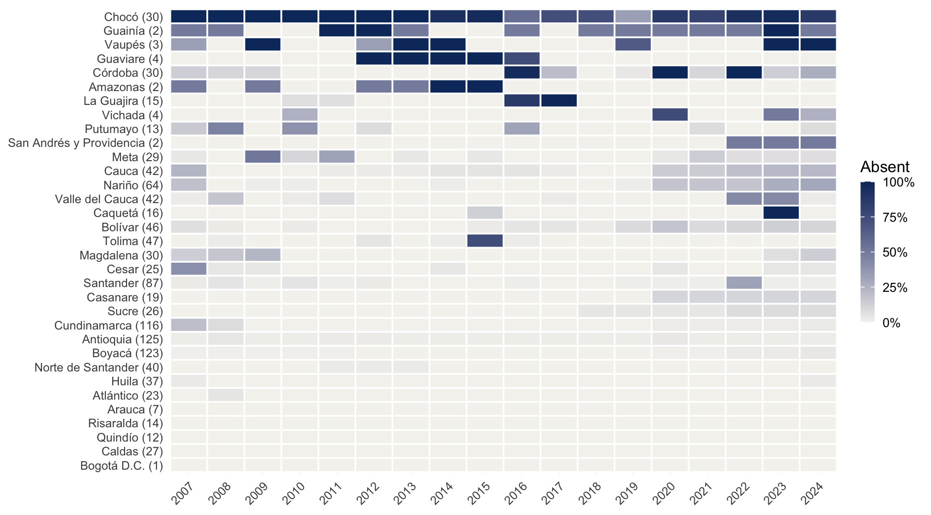
Figure 3: Share of each department’s municipalities absent from the file in each year, on the external frame. Departments are ordered by their overall share missing; the number of municipalities in the register follows each name.

3.3 Missing years and panel balance
At the national level no year is missing: every calendar year from 2007 to 2024 is present (0 gaps). The file was downloaded in September 2026, so the absence of 2025 most likely reflects publication lag rather than a gap. At the municipal level the picture is different (Table 5). 732 municipalities (67%) are observed in every year. Of the rest, 101 enter after 2007, 89 drop out before 2024, and 259 have at least one interruption inside their series, which together account for 460 interior gap-years. For anyone who needs a balanced panel, shortening the window helps only moderately: 811 of the 1,103 register municipalities are observed in every year from 2010, 835 from 2015 and 898 from 2019.
Table 5: Continuity of each municipality’s series on the internal frame. A series starts late if its first year is after 2007, ends early if its last year is before 2024, and has interior gaps if years are missing between its first and last.
Pattern | Municipalities | Share | Missing municipality-years
Complete series | 732 | 67% | 0
Starts late only | 49 | 4% | 64
Ends early only | 41 | 4% | 135
Interior gaps only | 209 | 19% | 339
Two or more of the above | 64 | 6% | 581

3.4 What is complete and what is not
The overall index is complete: it is present in every row, and every calendar year from 2007 to 2024 is in the file. The components are not. The rural index is unavailable in about half of the municipal rows, and ND sometimes hides rural samples that did enter the overall index. The panel is not complete either. About 6% of the municipality-years implied by the national register are absent, 8 municipalities never appear, the shortfall is concentrated in Chocó and the Amazon and Orinoco departments, and a third of municipalities have a series that starts late, ends early or is interrupted. Analyses of the overall index at the national level can therefore proceed with few reservations, whereas analyses of the urban or rural components, comparisons across departments and municipal time series must treat the missingness explicitly.

References
Departamento Administrativo Nacional de Estadística (DANE). 2020. “Marco Geoestadístico Nacional 2020: Límites Administrativos de Colombia (COD-AB).” Humanitarian Data Exchange, https://data.humdata.org/dataset/cod-ab-col.
Instituto Nacional de Salud, and Ministerio de Salud y Protección Social. 2026. “Calidad Del Agua Para Consumo Humano En Colombia.” Datos Abiertos Colombia, https://www.datos.gov.co.
Ministerio de la Protección Social, and Ministerio de Ambiente, Vivienda y Desarrollo Territorial. 2007. “Resolución 2115 de 2007: Características, Instrumentos Básicos y Frecuencias Del Sistema de Control y Vigilancia Para La Calidad Del Agua Para Consumo Humano.” Bogotá.

